3GPP TSG SA WG4 #112e S4-210156

E-meeting, 1st – 10th February 2021
CR-Form-v12.0
Pseudo CHANGE REQUEST
 | 26.804 | CR | <CR#> | rev | - | Current version: | 0.0.0
For HELP on using this form: comprehensive instructions can be found at
http://www.3gpp.org/Change-Requests.

Proposed change affects: | UICC apps |  | ME | X | Radio Access Network |  | Core Network | X

Title: | Discussion on Traffic Identification
Source to WG: | Ericsson LM
Source to TSG: | SA4
Work item code: | FS_5GMS_EXT |  |  |  |  |  | Date: |  |  | 2021-01-25
Category: | - |  |  |  |  |  | Release: |  |  | Rel-17
 | Use one of the following categories:  F (correction)  A (mirror corresponding to a change in an earlier release)  B (addition of feature),  C (functional modification of feature)  D (editorial modification)  Detailed explanations of the above categories can  be found in 3GPP TR 21.900. |  |  |  |  |  |  |  | Use one of the following releases:  Rel-8 (Release 8)  Rel-9 (Release 9)  Rel-10 (Release 10)  Rel-11 (Release 11)  Rel-12 (Release 12)  Rel-13 (Release 13)  Rel-14 (Release 14)  Rel-15 (Release 15)  Rel-16 (Release 16)
Reason for change: |  | The study item description identifes the key topic Traffic Identification and this is a first proposal
Summary of change: |  | This pCR starts identifying important collaboration models and start reviewing existing protocols.
Consequences if not approved:
Clauses affected:
 |  | Y | N
Other specs |  |  | X | Other core specifications |  |  |  | TS/TR ... CR ...
affected: |  |  | X | Test specifications |  |  |  | TS/TR ... CR ...
(show related CRs) |  |  | X | O&M Specifications |  |  |  | TS/TR ... CR ...
Other comments:
56
This CR's revision history:

===== CHANGE =====

2 References
The following documents contain provisions which, through reference in this text, constitute provisions of the present document.
- References are either specific (identified by date of publication, edition number, version number, etc.) or non-specific.
- For a specific reference, subsequent revisions do not apply.
- For a non-specific reference, the latest version applies. In the case of a reference to a 3GPP document (including a GSM document), a non-specific reference implicitly refers to the latest version of that document in the same Release as the present document.
[1] 3GPP TR 21.905: "Vocabulary for 3GPP Specifications".
[2] 3GPP TS 26.501: " 5G Media Streaming (5GMS); General description and architecture".
[3] 3GPP TS 26.511: "5G Media Streaming (5GMS); Profiles, codecs and formats".
[4] 3GPP TS 26.512: "5G Media Streaming (5GMS); Protocols".
[x1] https://httparchive.org/reports/state-of-the-web
[x2] https://quic.netray.io/stats.html
===== CHANGE =====

5 Key Topics

5.1 Introduction

5.9 Traffic Identification

5.9.1 Description
Traffic Identification: For different features within the 5G Media Streaming Architecture, it is necessary for the 5G System to identify the traffic flows. Multimedia streaming applications might not be able to uniquely identify the 5-Tuple of the streaming session, since the 5-Tuples are often changing. This is due to factors such as load balancing, CDN distribution, multiple concurrent requests for different types of resources, etc. This study will address how to properly configure the 5G System to enable efficient detection of application flows (service data flows) e.g. for event reporting, and QoS profile usage, etc.

5.9.2 Collaboration Scenarios
The most important collaboration scenarios for traffic identification are depicted below. Due to privacy concerns, the content hosting is provided by the Application Provider in an external data network. However, the 5GMSd Application Provider leverages the network features either via a 5GMSd AF in the trusted data network or via a 5GMSd AF in the external data network.
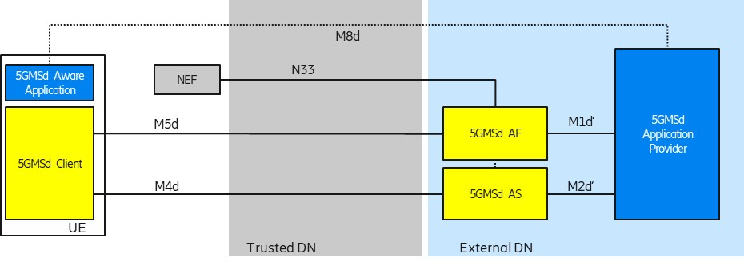
Figure 5.9.2-1: Collaboration 1 (Collaboration 3 of TS 26.501)
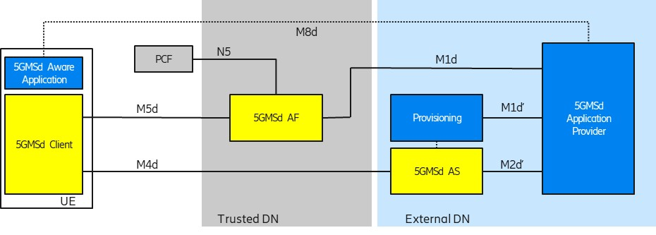
Figure 5.9.2-2: Collaboration 2 (Collaboration 4 of TS 26.501)
In order to use flow-based network features (such as different QoS classes or different charging policies), the 5G System needs to detect the relevant traffic. The 5G System uses so-called Packet Detection Rules (PDRs) in the UPF to detect the traffic. The PDRs are created based on Service Data Flow Templates. The Service Data Flow Templates are provided by the 5GMSd AF.

5.9.3 Status and usage of Web Protocols
The site HTTPArchive.org [x1] offers some insights into the uptake of different HTTP protocol versions by publicly accessible websites. The Report “State of the Web” contains statistics about the number of TCP connections per page and the number of HTTP/2 requests over a time period. The site crawls millions of URLs every month. The URLs are taken from the Chrome User Experience Report.
Currently, around 70% of websites support HTTP/2. Unfortunately, the site does not show statistics for video usage.
The site quic.netray.io [x2] offers some insights into the HTTP/3 ( QUIC) take-up.

5.9.4 M4d protocol usage
It is anticipated that MPEG-DASH would be used by many Application Providers on the M4d Interface if 5GMS services become widely deployed. MPEG-DASH defines the manifest format and also the media segment format. MPEG-DASH allows several different ways to use the underlying HTTP transport, depending on the DASH Profile.
For traffic identification, the identification of the transport protocol (TCP or UDP) used on interface M4d is essential, since the transport protocol needs to be described in the Service Data Flow Template. HTTP/1.1 and HTTP/2 both use TCP transport. HTTP/3 uses a UDP-based QUIC transport. Furthermore, HTTP/1.1. often leverages multiple TCP connections simultaneously, while HTTP/2 and HTTP/3 allow more efficient reuse of the transport through the technique of non-blocking request multiplexing on a single transport connection.

5.9.5 Results of HTTP protocol version usage study
Editor’s Note: It is currently unclear how to document the results of the transport connection usage study. It is clear, this this represents only a small snapshot on how the different HTTP versions are used and currently only focused on browser based clients.
Within a small study, the transport protocol usage of three major video-on-demand providers were studied, namely YouTube, Netflix and Amazon. The study leveraged browser-based DASH players, using the popular web browsers Google Chrome (version 87.0.4280.141, 64-bit running on XXXX) and Mozilla Firefox (version 84.0.2, 64-bit running on XXXX). The intention was to get more insights into HTTP usage.
a) Accessing YouTube with Chrome, we found that YouTube in a Chrome Browser uses MPEG-DASH with HTTP/3 transport. Several YouTube clips were selected, and HTTP/3 was consistently used for retrieving both media segments and other content. Detailed investigations showed that only a single HTTP/3 connection was established to the server.
b) Accessing Amazon Prime with Chrome, we found that Amazon Prime uses MPEG-DASH. For some movies, HTTP/2 is used for all content (including media segments). Some other movies used HTTP/1.1 for media segments and HTTP/2 for non-media segments. It is not clear on which basis the application protocol is selected.
c) Accessing Netflix with Firefox, we found that Netflix uses MPEG-DASH with HTTP/1.1. Some objects, such as images, are fetched using HTTP/2.
d) Accessing YouTube with Firefox, we found that YouTube uses MPEG-DASH with HTTP/1.1. Non-video transactions use HTTP/2.

5.9.6 Potential open issues
Editor’s Note: Identify the issues that need to be solved.

5.9.7 Candidate Solutions
Editor’s Note: Provide candidate solutions (including call flows) for each of the identified issues.

