3GPP TSG SA WG4 #112e S4-210155

E-meeting, 1st – 10th February 2021
CR-Form-v12.0
Pseudo CHANGE REQUEST
 | 26.804 | CR | <CR#> | rev | - | Current version: | 0.0.0
For HELP on using this form: comprehensive instructions can be found at
http://www.3gpp.org/Change-Requests.

Proposed change affects: | UICC apps |  | ME | X | Radio Access Network |  | Core Network | X

Title: | Collaboration Scenarios for Uplink streaming
Source to WG: | Ericsson LM
Source to TSG: | S4
Work item code: | FS_5GMS_EXT |  |  |  |  |  | Date: |  |  | 2021-01-25
Category: | B |  |  |  |  |  | Release: |  |  | Rel-17
 | Use one of the following categories:  F (correction)  A (mirror corresponding to a change in an earlier release)  B (addition of feature),  C (functional modification of feature)  D (editorial modification)  Detailed explanations of the above categories can  be found in 3GPP TR 21.900. |  |  |  |  |  |  |  | Use one of the following releases:  Rel-8 (Release 8)  Rel-9 (Release 9)  Rel-10 (Release 10)  Rel-11 (Release 11)  Rel-12 (Release 12)  Rel-13 (Release 13)  Rel-14 (Release 14)  Rel-15 (Release 15)  Rel-16 (Release 16)
Reason for change: |  | This contribution proposes a set of collaboration models and deployments for uplink streaming. It turned out to be usefull to depict at least a selection of collaboration options to identify key API requirements.
Summary of change: |  | A set of collaboration models is proposed for Uplink Streaming
Consequences if not approved:
Clauses affected:
 |  | Y | N
Other specs |  |  | X | Other core specifications |  |  |  | TS/TR ... CR ...
affected: |  |  | X | Test specifications |  |  |  | TS/TR ... CR ...
(show related CRs) |  |  | X | O&M Specifications |  |  |  | TS/TR ... CR ...
Other comments:
56
This CR's revision history:

===== CHANGE =====

2 References
The following documents contain provisions which, through reference in this text, constitute provisions of the present document.
- References are either specific (identified by date of publication, edition number, version number, etc.) or non-specific.
- For a specific reference, subsequent revisions do not apply.
- For a non-specific reference, the latest version applies. In the case of a reference to a 3GPP document (including a GSM document), a non-specific reference implicitly refers to the latest version of that document in the same Release as the present document.
[1] 3GPP TR 21.905: "Vocabulary for 3GPP Specifications".
[2] 3GPP TS 26.501: " 5G Media Streaming (5GMS); General description and architecture".
[3] 3GPP TS 26.511: "5G Media Streaming (5GMS); Profiles, codecs and formats".
[4] 3GPP TS 26.512: "5G Media Streaming (5GMS); Protocols".
===== CHANGE =====

5 Key Topics

5.1 Introduction

5.9 Uplink Streaming

5.9.1 Description
Editor’s Note: Document the above key topics in more detail, in particular how they relate to the 5GMS Architecture and protocols.

5.9.2 Collaboration Scenarios
Editor’s Note: Study collaboration scenarios between the 5G System and Application Provider for each of the key topics.

5.9.2.1 Overview
A set of collaboration scenarios between an 5GMSu Application Provider and the 5G System provider is identified. Only some key collaboration scenarios are presented.
Aligned with Downlink Streaming, Media Plane Only collaborations are presented first.

5.9.2.2 Collaboration Scenario 1
A media plane only collaboration in which the 5GMSu AS is deployed in the trusted domain. A 5GMS System provider may offer uplink streaming capabilities as a service to external or internal 5GMSu Application Providers.
NOTE: M2u and M4u might use identical media formats.
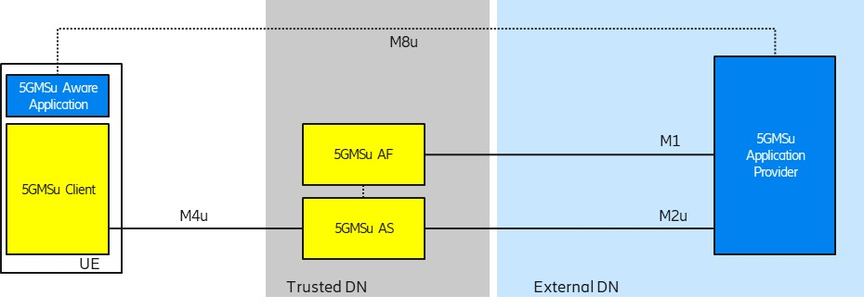
Figure 5.9.2.2-1: Collaboration 1

5.9.2.2 Collaboration Scenario 2
A media plane only collaboration in which the 5GMSu AS is deployed in the external domain and the 5GMSu AF is not involved. Specifically, the M2u′ protocol does not follow 3GPP specifications. The 5GMSu AS might even create a format which is already suitable for distribution, i.e., M2u’ might not be used.
NOTE: M1u’ and M2u’ denote Application .

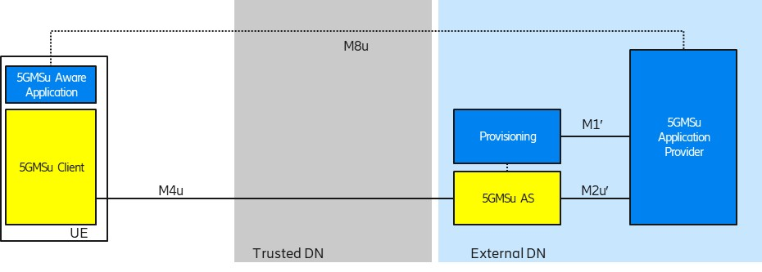
Figure 5.9.2.2-1: Collaboration 2

5.9.2.3 Collaboration Scenario 3
Both the 5GMSu AS and 5GMSu AF are present. The 5GMSu AS resides in the external domain and does not follow 5GMS protocols and formats. The 5GMSu AF is used to interact with the 5G System, e.g. for dynamic policy invokation or other network features .
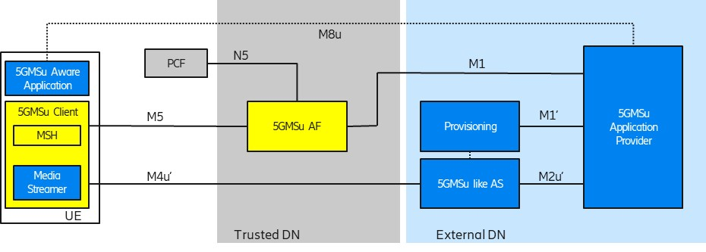
Figure 5.9.2.3-1: Collaboration 3

5.9.2.4 Collaboration Scenario 4
Both the 5GMSu AS and 5GMSu AF are present and follow 3GPP specifications. Both the 5GMSu AS and 5GMSu AF reside in the external domain.
NOTE: This collaboration scenario leverages only a 3GPP-defined protocol on the M4u and M5 interface. The 5GMSu AS might already create a format which is already suitable for distribution, i.e. M2u′ might not be used.
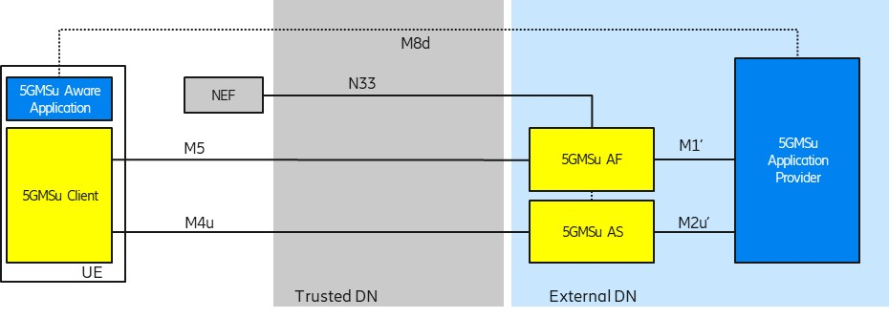
Figure 5.9.2.4-1: Collaboration 4

5.9.2.5 Collaboration Scenario 5
Similar to collaboration scenario 4, but with the 5GMSu AS and 5GMSu AF in the trusted DN. For external 5GMSu Application Providers, the M2u protocols are used for content egest.
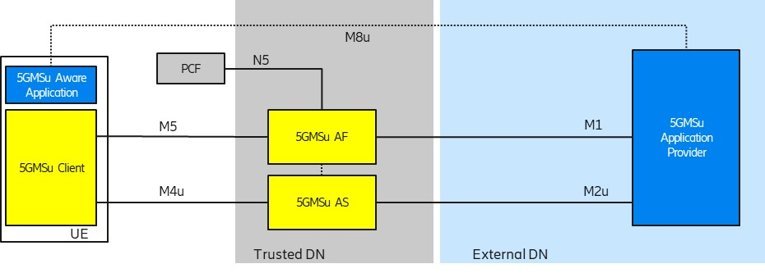
Figure 5.9.2.5-1: Collaboration 5

5.9.3 Deployment Architectures
Editor’s Note: Based on the 5GMS Architecture, develop one or more deployment architectures that address the key topics and the collaboration models.

5.9.4 Mapping to 5G Media Streaming and High-Level Call Flows
Editor’s Note: Map the key topics to basic functions and develop high-level call flows.

5.9.5 Potential open issues
Editor’s Note: Identify the issues that need to be solved.

5.9.6 Candidate Solutions
Editor’s Note: Provide candidate solutions (including call flows) for each of the identified issues.

