3GPP TSG-S4 Meeting #112e S4-210152

Online, Still safe at home, 1st - 10 February 2021
CR-Form-v12.1
CHANGE REQUEST
 | 26.802 | CR | <CR#> | rev | <Rev#> | Current version: | 0.1.8
For HELP on using this form: comprehensive instructions can be found at
http://www.3gpp.org/Change-Requests.

Proposed change affects: | UICC apps |  | ME |  | Radio Access Network |  | Core Network

Title: | Review of xMB-C wrt User Plane properties
Source to WG: | S4
Source to TSG: | Ericsson LM, BBC
Work item code: | FS_5GMSA-Multicast |  |  |  |  |  | Date: |  |  | <Res_date>
Category: | <Cat> |  |  |  |  |  | Release: |  |  | <Release>
 | Use one of the following categories:  F (correction)  A (mirror corresponding to a change in an earlier release)  B (addition of feature),  C (functional modification of feature)  D (editorial modification)  Detailed explanations of the above categories can  be found in 3GPP TR 21.900. |  |  |  |  |  |  |  | Use one of the following releases:  Rel-8 (Release 8)  Rel-9 (Release 9)  Rel-10 (Release 10)  Rel-11 (Release 11)  …  Rel-15 (Release 15)  Rel-16 (Release 16)  Rel-17 (Release 17)  Rel-18 (Release 18)
Reason for change: |  | The BM-SC is split into a control and a user-plane function and a new API between the two new functions should be defined. Accordingly, the control and the user plane aspects of the xMB API.
Summary of change: |  | A simplified functional model of the BM-SC Download Delivery function is drawn and the user plane related xMB-C propoerties is accrodingly identified. Similar models can be drawn for other delivery methods.
Consequences if not approved:
Clauses affected: |  | New Clause 4.5
 |  | Y | N
Other specs |  |  |  | Other core specifications |  |  |  | TS/TR ... CR ...
affected: |  |  |  | Test specifications |  |  |  | TS/TR ... CR ...
(show related CRs) |  |  |  | O&M Specifications |  |  |  | TS/TR ... CR ...
Other comments:
This CR's revision history:

**** First Change ****

5.x Key Issue #: Review of existing xMB interface

5.x.1 Description

5.x.1.1 Model of a BM-SC User-Plane Function
The model below assumes that a FLUTE function according to MBMS Download Delivery (Clause 7 in TS 26.346) is mapped into an MBSU. Similar models can be created for RTP streaming and transparent delivery. However, these are likely not needed.
The purpose of this simplified model is to help identify the xMB-C parameters (xMB Service and Session Parameters) needed to configure an MBSU.
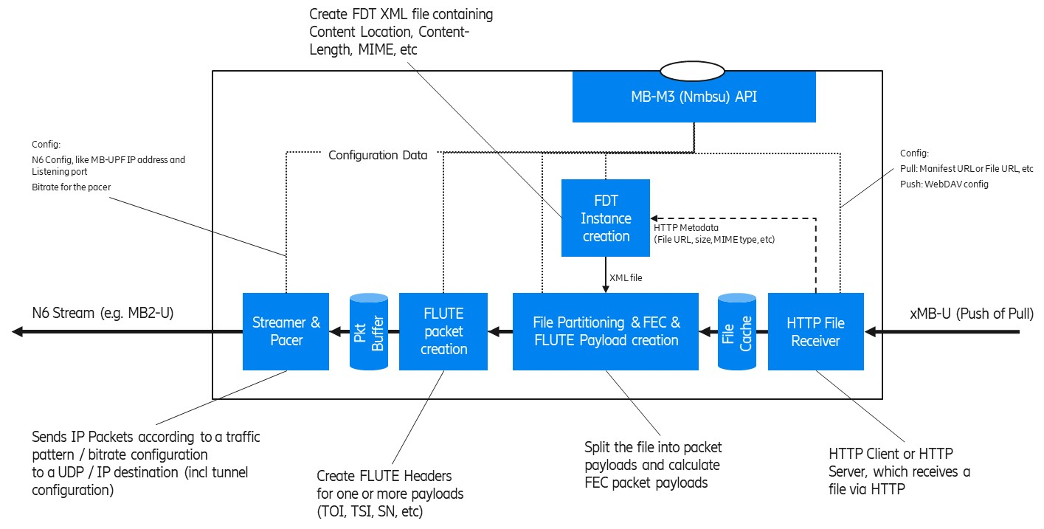
Figure 4.5.2.1-1: Simplified User Plane model for FLUTE (as a MBSU function)
The model depicts some key functions from an xMB-U ingest to an MB-UPF ingest (N6). In the case of 5MBS Download (e.g. used for DASH/HLS over MBMS or generic file delivery) the MBSU operates as follows:
1. The HTTP File Receiver is responsible for ingesting content resources intended for multicast transmission at xMB-U. It supports two basic content ingest modes:
a) HTTP Pull, in which the MBSU pulls resources from an upstream HTTP server, such as the 5GMSd AS. In this mode, xMB-C is used to provide individual URLs to be downloaded.
b) HTTP Push, in which resources are uploaded to the MBSU by an upstream client using HTTP PUT. In this mode, xMB-C is used to provide a base URL for ingesting data to the API invoker.
2. The MBSU may store partial or complete resources in a local File Cache prior to transmission at N6. Optimized implementations may pipe files through with only minimal buffering/caching.
3. HTTP metadata such as Content-Location (resource URL), Content-Length (resource size), and Content-Type (MIME content type) is provided by the HTTP File Receiver to the FDT Instance creation function. This acts as input (with other xMB-C parameters) to form the FDT Instance XML document.
4. The File partitioning function segments resources (including FDT Instances) into one or more multicast packet payloads. In the case where a Forward Error Correction scheme such as Raptor FEC (RFC 5053) or Compact No-Code FEC (RFC 5445) is used, there are recommended schemes and parameters to partition a resource into a sequence of packet paylods (called encoding symbols).
5. The FLUTE packet creation function inserts FLUTE header parameters such as the TSI, sequence number (FEC Symbol ID according to No-Code FEC, RFC 3695 [x] or Raptor FEC, RFC 5053 [y]), etc. As result, a complete UDP packet payload is created, which can be written to a UDP socket at the appropriate time of transmission.
6. Finally, the Streamer & Pacer function sends the multicast UDP packets according to a defined bit rate to the configured MP-UPF ingest point, which can be an MB2-U tunnel, some direct multicast, or similar.

5.x.1.2 Review of existing xMB properties
This section contains a copy of the xMB service (Clause 5.3.7) and Session (Clause 5.4.6) properties. The column “related to User Plane” indicates whether the property is related to the user plane handling, e.g. defining the xMB-U ingest, etc. In this case, the MBSU need to be provisioned with the property value. Likely, the property is exposed via MB-M3 (Nmbsu).
Table 4.5.2.2-1: List of existing xMB Service Properties
Property Name | Related to User Plane  (i.e. forwarded to MBSU) | Note
Id | No
ServiceID | No
Service Class | No
Service Languages | No
Service Names | No
Receive Only Mode | For Study | This flag is for ROM services.
Service Announcement Mode | No
Consumption Reporting Configuration | For Study
Push Notification URL | Yes
Push Notification Configuration | Yes

Table 4.5.2.2-2: List of existing xMB Session Properties
Property Name | Related to User Plane  (i.e. forwarded to MBSU) | Note
id
Session start | Yes | The MBSU needs to know when to start generating user plane packets.
Session stop | Yes | The MBSU needs to know when to stop generating user plane packets.
Max Bitrate | Yes
Max Delay | Yes
Session State | Partially | A session state is needed, but without the state “Session Announced”.
Service Announcement start time | No
Geographical Area | FFS
QoE Reporting | No
QoE Report URL | No
Session Type | yes
Header Compression | FFS | Unclear whether RoHC header compression is in RAN.
FEC | yes
Transport Mode
Session Description Parameters for User Plane | yes
Delivery Mode Configuration for user plane | yes
Delivery Session Description Parameters | yes
Streaming
SDP URL | yes
TimeShifting
Application (including DASH)
Application Service Description
Ingest Mode | yes
Application Entry Point URL
Push URL | yes
Unicast Delivery
Components
Files
Ingest Mode | yes
File List | yes | Except Unicast availability.  Target Reception Completion time is FFS, since unicast File Repair is included.
Carousel Mode
Carousel Scheduled Interval | yes
File delivery manifest URL | yes
Push URL | yes
Display Base URL | yes
SA file URL | no | An SA-file like concept is needed, but the MBSU is not handling it.
Mission Critical
MC-Extension
TMGI | no | The MBSU only need the MB-N6 tunnel information to ingest the data into the MB-UPF. The MBSF handles the TMGI.
QoS-Information | no | The MBSU is not responsible for control plane interactions with the MB-SMF.

5.x.2 Identified gaps
Editor’s Note: This section should summaries the identified issues

