3GPP TSG SA WG4 #112e S4-21xxxx

E-meeting, 1st – 10th February 2021
CR-Form-v12.0
Pseudo CHANGE REQUEST
 | 26.8xx | CR | <CR#> | rev | - | Current version: | 0.0.0
For HELP on using this form: comprehensive instructions can be found at
http://www.3gpp.org/Change-Requests.

Proposed change affects: | UICC apps |  | ME | X | Radio Access Network |  | Core Network | X

Title: | [FS_5GMS-EXT] Key Topic Network Event usage
Source to WG: | Qualcomm Incorporated
Source to TSG: | SA4
Work item code: | FS_5GMS-EXT |  |  |  |  |  | Date: |  |  | 2021-01-25
Category: | B |  |  |  |  |  | Release: |  |  | Rel-17
 | Use one of the following categories:  F (correction)  A (mirror corresponding to a change in an earlier release)  B (addition of feature),  C (functional modification of feature)  D (editorial modification)  Detailed explanations of the above categories can  be found in 3GPP TR 21.900. |  |  |  |  |  |  |  | Use one of the following releases:  Rel-8 (Release 8)  Rel-9 (Release 9)  Rel-10 (Release 10)  Rel-11 (Release 11)  Rel-12 (Release 12)  Rel-13 (Release 13)  Rel-14 (Release 14)  Rel-15 (Release 15)  Rel-16 (Release 16)
Reason for change: |  | The study item description identifes the key topic “Network Event usage”.
Summary of change: |  | Adds the structure and description for this key topic
Consequences if not approved: |  | Key topic not addressed
Clauses affected:
 |  | Y | N
Other specs |  |  | X | Other core specifications |  |  |  | TS/TR ... CR ...
affected: |  |  | X | Test specifications |  |  |  | TS/TR ... CR ...
(show related CRs) |  |  | X | O&M Specifications |  |  |  | TS/TR ... CR ...
Other comments:
56
This CR's revision history:

===== CHANGE =====

2 References
The following documents contain provisions which, through reference in this text, constitute provisions of the present document.
- References are either specific (identified by date of publication, edition number, version number, etc.) or non-specific.
- For a specific reference, subsequent revisions do not apply.
- For a non-specific reference, the latest version applies. In the case of a reference to a 3GPP document (including a GSM document), a non-specific reference implicitly refers to the latest version of that document in the same Release as the present document.
[1] 3GPP TR 21.905: "Vocabulary for 3GPP Specifications".
[2] 3GPP TS 26.501: " 5G Media Streaming (5GMS); General description and architecture".
[3] 3GPP TS 26.511: "5G Media Streaming (5GMS); Profiles, codecs and formats".
[4] 3GPP TS 26.512: "5G Media Streaming (5GMS); Protocols".

===== CHANGE =====

4 Introduction to 5G Media Streaming

4.1 Introduction

4.2 Collaboration Scenarios

4.3 Architectures

4.4 Summary of Stage-3 enablers

===== CHANGE =====

5 Key Topics

5.1 Introduction

5.8 Network Event usage

5.8.1 Description
The 5GMS AF performs several critical support operations for media streaming sessions. It also is responsible for collecting information about the progress and status of media streaming sessions. This information may be of interest to the AP or to other NFs in the network.
Thee 5G architecture defines exposure mechanisms by the AF to other NFs in the network. [TS 23.501] and [TS 23.502] define the stage 2 Exposure service that can be offered by the AF. In [TS 29.517], the stage 3 realization of the Exposure service is specified as a RESTful API.
The resource structure is replicated in the following figure for convenience:
An NF consumer subscribes to an application event and provides a URL on which it desires to receive the related notifications. Both periodic reporting and immediate reporting options are available. The ReportingInformation as defined in [TS 29.3] structure is used to indicate the desired type of reporting for the selected event set.
So far the following AfEvents are defined:
Enumeration value | Description | Applicability
SVC_EXPERIENCE | Indicates that the event subscribed is service experience data for an application. | ServiceExperience
UE_MOBILITY | Indicates that the event subscribed is UE mobility information. | UeMobility
UE_COMM | Indicates that the event subscribed is UE communication information. | UeCommunication
EXCEPTIONS | Indicates that the event subscribed is exceptions information. | Exceptions

Additional AFEvents may be defined.

5.8.2 Collaboration Scenarios
The Application Provider (AP) is outsourcing part of its content hosting to the MNO. The AP makes use of the Provisioning APIs to configure its content distribution. The AP would like to track the usage of the network resources for the distribution of its content as well as the QoE for its mobile consumers. At the same time, it wants to limit access to this information to protect their service secrets and user’s privacy. The AP configures data collection from UEs and the 5GMSd AS(s) to determine which data is collected and who can access it at what level. The 5GMSd AF triggers the data collection accordingly and uses the AF Event Exposure framework to notify consumers about collected data and events.

5.8.3 Deployment Architectures
The deployment architecture for the data collection and exposure by the 5GMSd AF is depicted by the following figure:
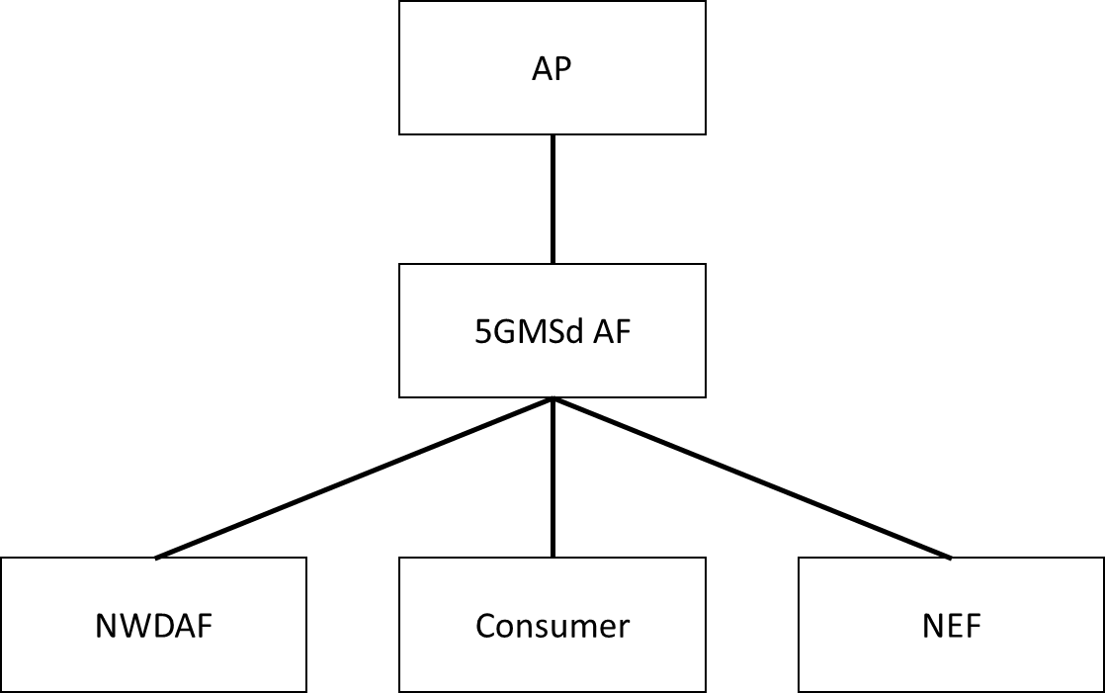

5.8.4 Mapping to 5G Media Streaming and High-Level Call Flows
The following is a sample call flow of the operation of the data collection and exposure:

5.8.5 Potential open issues
The following events are expected to be defined:
- Consumption reporting
- Quality of Experience reporting
- Network assistance
- QoS and Charging usage
- CDN access logs
For each of these events, the triggers for the data collection and the levels of access to the collected data need to be defined as well.

5.8.6 Candidate Solutions
Editor’s Note: Provide candidate solutions (including call flows) for each of the identified issues.

