3GPP TSG SA WG4 #112e S4-21xxxx

E-meeting, 1st – 10th February 2021
CR-Form-v12.0
Pseudo CHANGE REQUEST
 | 26.8xx | CR | <CR#> | rev | - | Current version: | 0.0.0
For HELP on using this form: comprehensive instructions can be found at
http://www.3gpp.org/Change-Requests.

Proposed change affects: | UICC apps |  | ME | X | Radio Access Network |  | Core Network | X

Title: | [FS_5GMS-EXT] Key Topic Additional / New transport protocols
Source to WG: | Qualcomm Incorporated
Source to TSG: | SA4
Work item code: | FS_5GMS-EXT |  |  |  |  |  | Date: |  |  | 2021-01-25
Category: | B |  |  |  |  |  | Release: |  |  | Rel-17
 | Use one of the following categories:  F (correction)  A (mirror corresponding to a change in an earlier release)  B (addition of feature),  C (functional modification of feature)  D (editorial modification)  Detailed explanations of the above categories can  be found in 3GPP TR 21.900. |  |  |  |  |  |  |  | Use one of the following releases:  Rel-8 (Release 8)  Rel-9 (Release 9)  Rel-10 (Release 10)  Rel-11 (Release 11)  Rel-12 (Release 12)  Rel-13 (Release 13)  Rel-14 (Release 14)  Rel-15 (Release 15)  Rel-16 (Release 16)
Reason for change: |  | The study item description identifes the key topic “Additional / New transport protocols”.
Summary of change: |  | Adds the structure and description for this key topic
Consequences if not approved: |  | Key topic not addressed
Clauses affected:
 |  | Y | N
Other specs |  |  | X | Other core specifications |  |  |  | TS/TR ... CR ...
affected: |  |  | X | Test specifications |  |  |  | TS/TR ... CR ...
(show related CRs) |  |  | X | O&M Specifications |  |  |  | TS/TR ... CR ...
Other comments:
56
This CR's revision history:

===== CHANGE =====

2 References
The following documents contain provisions which, through reference in this text, constitute provisions of the present document.
- References are either specific (identified by date of publication, edition number, version number, etc.) or non-specific.
- For a specific reference, subsequent revisions do not apply.
- For a non-specific reference, the latest version applies. In the case of a reference to a 3GPP document (including a GSM document), a non-specific reference implicitly refers to the latest version of that document in the same Release as the present document.
[1] 3GPP TR 21.905: "Vocabulary for 3GPP Specifications".
[2] 3GPP TS 26.501: " 5G Media Streaming (5GMS); General description and architecture".
[3] 3GPP TS 26.511: "5G Media Streaming (5GMS); Profiles, codecs and formats".
[4] 3GPP TS 26.512: "5G Media Streaming (5GMS); Protocols".
[5] 3GPP TR 26.925: "Typical traffic characteristics of media services on 3GPP networks".
[X] Akamai Blog, "A QUICk Introduction to HTTP/3", April 2020, https://developer.akamai.com/blog/2020/04/14/quick-introduction-http3
[A] Fielding, R., Nottingham, M., and J. Reschke, "HTTP/1.1", Work in Progress, Internet-Draft, draft-ietf-httpbis-messaging-13, 14 December 2020, http://www.ietf.org/internet-drafts/draft-ietf-httpbis-messaging-13.txt
[B] Belshe, M., Peon, R., and M. Thomson, Ed., "Hypertext Transfer Protocol Version 2 (HTTP/2)", RFC 7540, May 2015, https://www.rfc-editor.org/info/rfc7540
[C] draft-ietf-quic-http-33, "Hypertext Transfer Protocol Version 3 (HTTP/3)", 15 December 2020
[D] D. Bhat, A. Rizk, and M. Zink, "Not so QUIC: A Performance Study of DASH over QUIC," NOSSDAV'17: Proceedings of the 27th Workshop on Network and Operating Systems Support for Digital Audio and VideoJune 2017 Pages 13–18 https://doi.org/10.1145/3083165.3083175

===== CHANGE =====

4 Introduction to 5G Media Streaming

4.1 Introduction

4.2 Collaboration Scenarios

4.3 Architectures

4.4 Summary of Stage-3 enablers

===== CHANGE =====

5 Key Topics

5.1 Introduction

5.4 Additional / New transport protocols

5.4.1 Description
Media streaming applications are continued to use HTTP-based distribution protocols, but newer versions of HTTP such as HTTP/2 or HTTP/3 are introduced, see for example also TR 26.925 [5], clause 6.1.4. The architectural and performance impacts of such protocols for 5G-based media distribution is unclear and requires study. The study also considers how Media Players may use functionalities existing in new transport protocols, and also investigate the impact of new transport protocols on 5GMS usage and traffic identification (e.g. Service Data Flow Descriptions).
Based on [X], HTTP protocol (also known as web protocol), powers most websites, mobile apps, and videos. It was created by Tim Berners-Lee at CERN in 1989 and has been enhanced over the years to keep up with the ever-changing World Wide Web. Currently, the web is a mixture of HTTP/1.1 [A] and HTTP/2 [B] adoption. Most well-known websites are running HTTP/2, while smaller websites and late adopters plan to migrate to HTTP/2 in the near future as it is relatively easy to implement. HTTP/2 is used by about 45% of websites and supported by all major web browsers. HTTP/3 is only used by about 5% of websites now and not well-supported by web browsers yet. However. significant HTTP/3 deployments are emerging. For example, YouTube™ has for a long time been offering a pre-RFC draft version to any client that wants to use it, especially the Chrome™ browser. Other browsers are expected to follow soon after waiting for the QUIC and HTTP/3 RFCs to be published before mainlining that feature.
HTTP/2 provides on average a 5% to 15% performance improvement on page load times over HTTP/1.1. HTTP/1.1 allows persistent TCP connections, but requests still had to be serialized, resulting in the well-known "HTTP head of queue blocking". In order to improve downloads, many TCP flows still needed to be parallelized to speed up delivery.
HTTP/2 introduces the "Streams" concept at HTTP level and each stream can have different priorities. All objects can from a web-page can be multiplexed in single long-lived TCP connection. Also, HTTP/uses header compression (HPACK) to avoid verbose/clear text. Also, HTTP/2 pseudo-mandates TLS to prevent “middle boxes” from messing up with the content. However, HTTP/2 does not remove the drawbacks of TCP’s head-of-line blocking - packet loss on one stream will block all other streams until recovery even if packets for all other streams are correctly received
HTTP/2 testing shows [X] that the delivery of large objects over HTTP/2 can be slower than over HTTP/1.1 when there is packet loss. This is because HTTP/2 uses a single TCP connection, versus about six connections which most web browsers open over HTTP/1.1. In addition, the TCP congestion control algorithms reduce the TCP congestion window size, resulting in fewer bytes sent over the wire when using just one TCP connection.
The solution to this problem is to use HTTP/2 over a different transport protocol that provides more efficient congestion control. One option would be to upgrade and modify TCP. Replacing TCP still needs to be checked carefully. For example, middle boxes such as NAT, Firewalls, Load balancers are problematic, they get rarely upgraded which prevents any updates to TCP. TCP is also hard to evolve as it is tied to OS Kernel. Hence, it was considered easier to introduce transport functions on top of UDP in the user space – referred to as QuiC.
That, in essence, is what HTTP/3 is: HTTP/2 over User Datagram Protocol (UDP) based on IETF QUIC. HTTP/3 is a thin layer on top of QUIC including QPACK header compression. The main QUIC functions are connection and stream multiplexing, fast startup, TLS1.3 (messages), loss recovery, in-order delivery (within stream), congestion control and flow control.
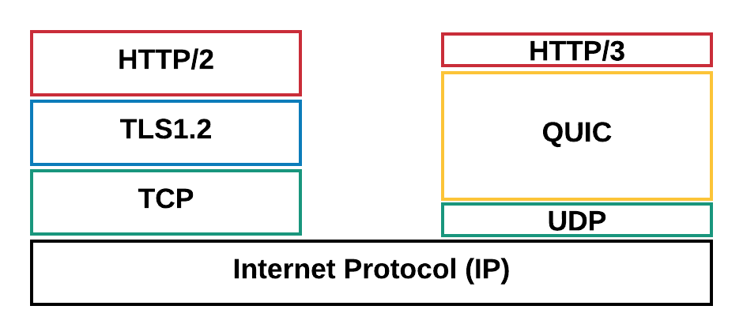
Figure 5.4-1 HTTP/2 and HTTP/ Protocol Stack
For an entertaining introduction to QUIC and HTTP/3, please check https://www.youtube.com/watch?v=B1SQFjIXJtc.
However, using QUIC for adaptive streaming still requires study as under certain circumstances, the quality using QUIC may even degrade for DASH-based streaming than it would increase [D]. The evaluation results show that using the unmodified DASH algorithms on top of QUIC may not provide the anticipated performance boost when compared to the standard DASH over TCP.
The main expected benefit of QUIC is being able to multiplex requests for all Adaptation Sets onto the same transport association, and then to manage the network QoS on that aggregate connection. This has a valuable operational benefit to a CDN operator (including the 5GMS AS) in reducing the number of UDP ports that a server needs to keep open. Another benefit is being able to migrate connections from one IP address to another with minimal interruption to either client or server. This is useful when the client moves, but it is also useful when the server changes (e.g. in edge computing relocation Use Cases).

5.4.2 Collaboration Scenarios
A service provider/content provider runs an adaptive media streaming service between HTTP/3 and QUIC enabled 5G Media Streaming AS and an HTTP/3 and QUIC enabled UE using 5G Media Streaming over M2d and M4d.
Editor’s Note: Study collaboration scenarios between the 5G System and Application Provider for each of the key topics.

5.4.3 Deployment Architectures
Editor’s Note: Based on the 5GMS Architecture, develop one or more deployment architectures that address the key topics and the collaboration models.

5.4.4 Mapping to 5G Media Streaming and High-Level Call Flows
Editor’s Note: Map the key topics to basic functions and develop high-level call flows.

5.4.5 Potential open issues
Editor’s Note: Identify the issues that need to be solved.

5.4.6 Candidate Solutions
Editor’s Note: Provide candidate solutions (including call flows) for each of the identified issues.

