Dear Colleagues,

Apple is pleased to invite you to the 3GPP SA4 #104 meeting in Cork.
Dates: July 1 – 5, 2019
Location: Cork, Ireland

The meeting will be held at the Apple Facility in Cork. The address of the venue is:
Hollyhill Industrial Estate
Cork, County Cork T23 YK84
Ireland.
See the map in Annex 5.

Attached to this invitation you will find:

- Meeting information
- General information (Annex 1)
- Hotel Information (Annex 2)
- Transportation Information (Annex 3)
- Visa information (Annex 4)
- Cork map (Annex 5)

We look forward to seeing you in Cork.

Yours sincerely,

David Singer
Software Engineering Standards, SA4 Delegate
Apple Inc.

Meeting Information

Meeting venue: Apple Holyhill 4, Cork

Visitors should come to reception in Holyhill 4. The conference rooms are all located close to reception.

Main room: Seamus Heaney/Thomas Kinsella (Capacity 60)
Breakout rooms: Oliver Goldsmith (Capacity 25)
Oak (Capacity 25)

The meeting will start at 9:00am on Monday 1st July and finish latest by 5:00pm on Friday the 5th of July. Local registration will take place at the front desk from 8:30am on Monday.
WLAN/Internet access will be available during the meeting.

Meeting registration
Please register for the meeting online at:
https://portal.etsi.org/webapp/MeetingCalendar/MeetingDetails.asp?m_id=33516

Please be sure to print your name badge prior to the meeting. Name badges will not be provided.

Agenda and document allocation
The Agenda will be provided by the SA4 Chairman and will be uploaded over the 3GU portal (in the '3GPP SA 4 / Meetings' area) by the SA4 Secretary.

Document submission:
For document number reservations and upload use the SA4 portal at https://portal.3gpp.org/.

Remember that you should first type your EOL username and password (top right) to login the portal. Then should select the TSG/WG of interest (3GPP SA 4) using the first (left) column.

All input documents must have been uploaded by Tuesday June 25th 23:59 Central European Summer Time.

In case of Tdoc allocations issues, please contact paolo.usai@etsi.org
ANNEX 1 General Information

Cork official visitor guides:
http://www.cork-guide.ie/corkcity.htm
https://www.ireland.com/en-us/destinations/republic-of-ireland/cork/cork-city/

Currency:
Ireland is a Euro country
Time Zone:
Irish Standard Time (IST)

Voltage:
230 V, 50Hz. For your convenience, please be sure you have adapters for your power plug. See illustration below. Voltage converters or power plug adaptors will not be provided at the meeting.



WLAN:
This will be a paperless meeting and participants are requested to use laptop equipped with WLAN. Wireless LAN access codes will be provided. WLAN tech support will be very limited.

Meeting host contacts:
David Singer
singer@apple.com
+1 (408) 398-3162

Local contact:
Dave Wiley, <wiley.coyote@apple.com> (please CC David Singer)

ANNEX 2 Hotel Information

Please find some recommended hotels in the Cork area.
PLEASE NOTE: Delegates are responsible for their own hotel reservations and arrangements. No block reservations are made, please contact the hotels directly for reservations as soon as possible.

The River Lee Hotel - https://www.doylecollection.com/hotels/the-river-lee-hotel

Clayton Hotel Cork City - https://www.claytonhotelcorkcity.com

Hayfield Manor - https://www.hayfieldmanor.ie
ANNEX 3 Transportation Information

Airport:
Cork airport (IATA code ORK).

The airport web site details various options to get to and from the airport. A typical taxi ride into the center costs around €20.

There is ample on-site parking. Some hotels (e.g. the River Lee) operate a shuttle to the Apple facility, but none have the capacity to shuttle the entire meeting. The facility is a stiff walk from even the nearest hotel; cars and carpools are recommended.

Cork airport site: https://www.corkairport.com
ANNEX 4 VISA Information

To enter Ireland for the meeting, you may need a letter of invitation from the host, which you will need to present in order to obtain your visa to enter the European Union. In order to obtain the invitation letter, please contact Maria Moreno <moreno_m@apple.com> and CC David Singer <singer@apple.com>.

Annex 5 – Holyhill/Cork map

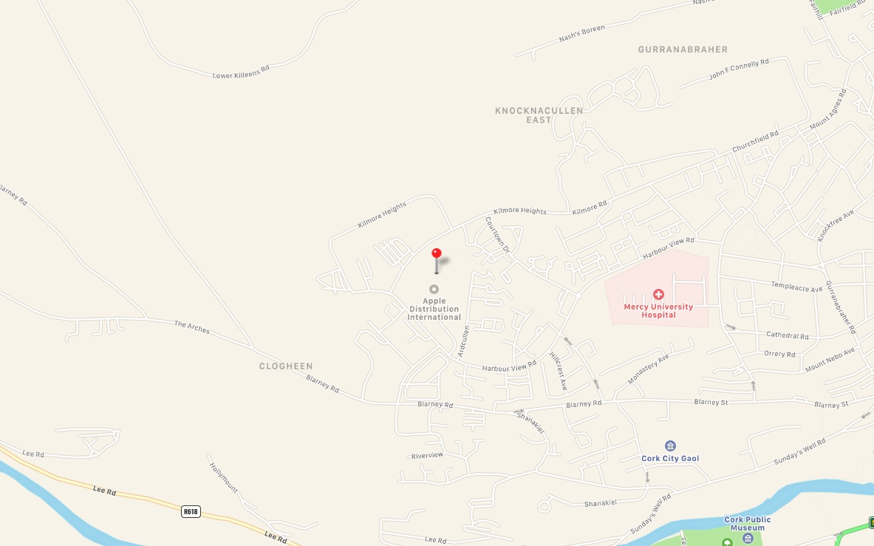

Full URL to the map:
<https://maps.apple.com/place?address=Apple%20Inc.,%20Hollyhill%20Industrial%20Estate,%20Hollyhill,%20Cork%20T23%20YK84,%20Ireland&auid=478390634141427789&ll=51.90572726456431,-8.512637973936366&q=Apple%20Distribution%20International>

