April 4, 2019

Invitation to the
SA4_MBS_SWG_AH_5GMSA
May 7-8, 2019
Paris, France
Dear Colleagues,

On behalf of the Expway-Enensys, I am pleased to invite you to the 3GPP SA4 MBS SWG AH ON 5GMSA in Paris, France

The meetings will be held at the Enensys Expway Premises.

We are looking forward to seeing you in Paris!

Sincerely,

Cedric Thienot,
Enensys Expway
Cedric.thienot@enensys.com

General Meeting Information

Meetings:
3GPP SA4 MBS SWG AH 5GMSA

Location:
125 rue de Saussure, Paris 75017 Paris, France

Meeting Schedule and Remote access

Monday May 6th 11 am- 7pm (CEST): Join Skype Meeting
Thursday May 7th 9am – 5 pm (CEST): Join skype meeting

Hosts:
Enensys Expway

Please direct any questions regarding the logistical arrangements of this meeting to the 3GPP Meeting Coordinators:
Karine Jacquet
Tel.: +1 44 54 29 28
Karine.jacquet@enensys.com

Hotel Address:

A regular hotel could be the Tim Hotel


You may try also small hotel near Square des Batignoles (to get a Breakfast in bar):

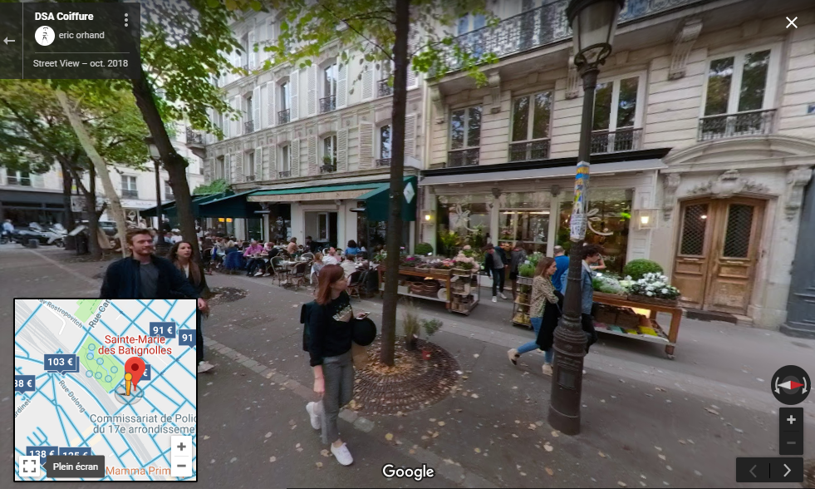

Wireless LAN:
Expway-Enensys will provide a WLAN for internet Access.

Phone charges:
Each delegate is responsible for verifying any toll charges that may be incurred by placing local, long distance and toll-free calls from a guest room.

Time Zone:
CEST

Airport:

Charles De Gaules airport:

Taxi: 50 € (fixed price) – 30-45 mn

Metro/RER: -1 h- google map direction

You may also bike from the Gare du nord:

The official website: https://www.velib-metropole.fr/en_GB
You would need to download the velib application:
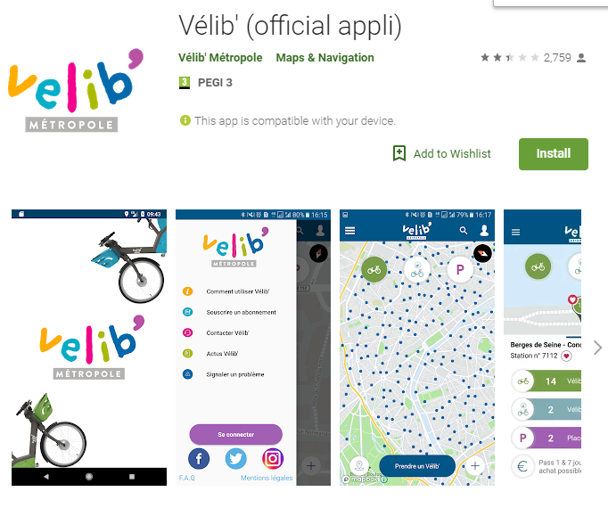

Direction: 125 rue de Saussure 75017 Paris on Google Map

Voltage:
220v
Please be sure you have the correct adapter. Voltage converters will not be provided at the meeting

Visa Information:
If any issue, send an email to cedric.thienot@enensys.com

Have a great meeting and enjoy your stay in Paris!

