3GPP TSG-SA3 Meeting #84-LI-e-a draft_s3i220044-r3

Online, , 24th Jan 2022 - 28th Jan 2022
CR-Form-v12.2
CHANGE REQUEST
 | 33.127 | CR | 0158 | rev | 1 | Current version: | 17.3.0
For HELP on using this form: comprehensive instructions can be found at
http://www.3gpp.org/Change-Requests.

Proposed change affects: | UICC apps |  | ME |  | Radio Access Network |  | Core Network | X

Title: | Corrections to 4G-5G Combo Node LI
Source to WG: | SA3LI (OTD)
Source to TSG: | SA3
Work item code: | LI17 |  |  |  |  |  | Date: |  |  | 2022-01-25
Category: | F |  |  |  |  |  | Release: |  |  | Rel-17
 | Use one of the following categories:  F (correction)  A (mirror corresponding to a change in an earlier release)  B (addition of feature),  C (functional modification of feature)  D (editorial modification)  Detailed explanations of the above categories can  be found in 3GPP TR 21.900. |  |  |  |  |  |  |  | Use one of the following releases:  Rel-8 (Release 8)  Rel-9 (Release 9)  Rel-10 (Release 10)  Rel-11 (Release 11)  …  Rel-16 (Release 16)  Rel-17 (Release 17)  Rel-18 (Release 18)  Rel-19 (Release 19)
Reason for change: |  | Previously agreed CRs in SA3-LI meeting SA3#83-LI-e-b added capabiliity to report LI events from 4G-5G interworked nodes such as the SMF+PGW-C. Some clarifications on the procedure related to this were seen as necessary. Those changes are contained in this CR.
Summary of change: |  | Modify 6.3.3.1.3 to clarify figure, modify 6.3.3.2 adding ability to provision 4G and 5G target identities to the combo node, add test to 6.3.3.3.1 regarding when xIRIs are generated.
Consequences if not approved: |  | Confusion regarding provisioning and xRI generation in Stage 3 specification (TS 33.128), potential for inability to implement LI feature correctly.
Clauses affected: |  | 6.3.3.1.3, 6.3.3.2, 6.3.3.3.1
 |  | Y | N
Other specs |  |  | X | Other core specifications |  |  |  | TS/TR ... CR ...
affected: |  |  | X | Test specifications |  |  |  | TS/TR ... CR ...
(show related CRs) |  |  | X | O&M Specifications |  |  |  | TS/TR ... CR ...
Other comments:
This CR's revision history: |  | S3i220044

***Start of Changes***
*** Start of First Change ***

6.3.3.1.1 General
In the EPC network, the SGW is the gateway which terminates the user plane interface as specified in TS 23.401 [22]. The PGW is the gateway which terminates the SGi interface towards the PDN as specified in TS 23.401 [22]. Additionally, the PGW is the user plane anchor for mobility between 3GPP access and non-3GPP access as specified in TS 23.402 [23].
NOTE : The present document supports LI for non-3GPP accesses connected to EPC using GTP-based S2a or GTP-based S2b as specified by TS 23.402 [23]. Other scenarios are covered by TS 33.107 [11].
As defined in TS 23.214 [75], the SGW and PGW may have separated control plane and user plane functions (CUPS). The control plane (CP) functions (SGW-C and PGW-C) provide the traffic forwarding rules (referred to as Forward Action Rules in TS 23.214 [75]) to the user plane (UP) functions (SGW-U and PGW-U). The UP functions forward the user plane traffic as per the Forward Action Rules.
In the following clauses, EPS architecture that does not separate the control plane and user plane functions of the SGW/PGW is referred to as non-CUPS EPS.
The LI architecture for non-CUPS EPS is defined in clause 6.3.3.1.2. For non-CUPS EPS architecture, the SGW and PGW function as both CP Entities and the UP Entities.
The LI architecture for CUPS EPS is defined in clause 6.3.3.1.3. For CUPS EPS architecture:
- The CP Entities are the SGW-C and the PGW-C.
- The UP Entities are the SGW-U and the PGW-U.
When CUPS architecture is used, unless otherwise specified, the term SGW/PGW refers to both the SGW-U/PGW-U and the SGW-C/PGW-C except in the following cases:
- The IRI-POI, IRI-TF and CC-TF are located in the SGW-C/PGW-C.
- The CC-POI is located in the SGW-U/PGW-U.
When EPC-5GC interworking architecture is used and the PGW-C and PGW-U are part of combined SMF+PGW-C and UPF+PGW-U respectively, unless otherwise specified, the term SGW/PGW refers to both the SMF+PGW-U and the SMF+PGW-C except in the following cases:
- The IRI-POI, IRI-TF and CC-TF are located in the SMF+PGW-C.
- The CC-POI is located in the SMF+PGW-U.
The SGW and PGW shall include an IRI-POI that has the LI capabilities to generate the target UE’s bearer related xIRI.
In addition, the SGW and PGW shall include a CC-POI that has the LI capabilities to duplicate the user plane packets from the EPS bearers related to a target UE.
*** Start of Next Change ***

6.3.3.1.3 EPS CUPS Architecture
Figure 6.3-3 shows the LI architecture for EPS CUPS SGW/PGW based interception.
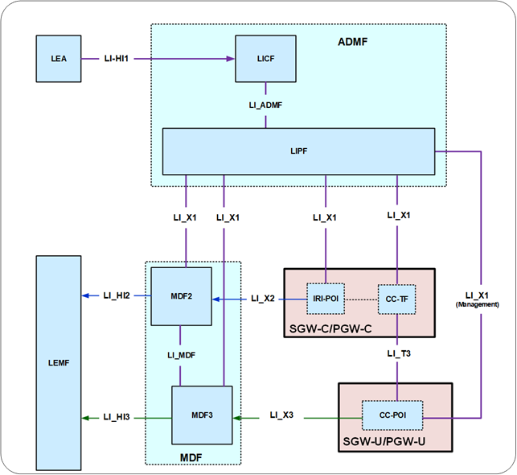
Figure 6.3-3: LI architecture for LI at EPS CUPS SGW/PGW
The LICF present in the ADMF receives the warrant from an LEA, derives the intercept information from the warrant and provides the same to the LIPF.
The LIPF present in the ADMF provisions IRI-POI present in the SGW-C/PGW-C and the MDF2 over the LI_X1 interfaces. To enable the interception of the target's user plane packets (e.g. when the warrant requires the interception of communication contents), the CC-TF present in the SGW-C/PGW-C is also provisioned with the intercept data.
NOTE: The IRI-POI and CC-TF represented in figure 6.3-3 are logical functions and require correlation information be shared between them; they may be handled by the same process within the SGW-C/PGW-C.
When PGW-C and PGW-U (represented in figure 6.3-3) are part of combined SMF+PGW-C and UPF+PGW-U respectively in the EPC-5GC interworking architectures as shown in clause A.2.2, figure A.2-1 of the present document, the SMF+PGW-C and UPF+PGW-U shall exhibit the LI functions as described in clause 6.3.3.3.1 with the following changes:
- The PGW shall be replaced with the SMF+PGW-C and UPF+PGW-U.
The IRI-POI present in the SGW-C/PGW-C detects the target UE's bearer activation, modification and deactivation and generates and delivers the xIRI to the MDF2 over LI_X2. The MDF2 delivers the IRI messages to the LEMF over LI_HI2.
The CC-TF present in the SGW-C/PGW-C detects the target UE's bearer activation, modification and deactivation and provisions the CC-POI in the SGW-U/PGW-U.
The CC-POI present in the SGW-U/PGW-U generates the xCC from the user plane packets and delivers the xCC (that includes the correlation number and the target identity) to the MDF3. The MDF3 delivers the CC to the LEMF over LI_HI3.
A warrant that does not require the interception of communication contents, may require IRI messages that have to be derived from the user plane packets. To support the generation of related xIRI (i.e. that requires access to the user plane packets), the present document supports two implementation approaches described in clause 7.12.2.
*** Start of Next Change ***

6.3.3.2 Target identities
The target identities which the LIPF provisions to the IRI-POI and CC-POI present in the SGW/PGW include the following:
- IMSI.
- MSISDN.
- ME (Mobile Equipment) Identity.
Interception performed on the above three identities are mutually independent, even though, an xIRI may contain the information about the other identities when available.
In the case of EPC-5GC interworking via combined SMF+PGW-C and UPF+PGW-U, the target identities which the LIPF may provision to the IRI-POI and CC-TF present in the SMF+PGW-C include the following:
- IMSI.
- MSISDN.
- ME (Mobile Equipment) Identity.
- SUPI.
- PEI.
- GPSI.
Interception performed on the above three identities are mutually independent, even though, an xIRI may contain information about the other identities when available.

6.3.3.3 IRI events

6.3.3.3.1 Option A
When Option A described in clause 6.3.1 is used, xIRI provided by the IRI-POI in the PGW based on the events specified in TS 33.107 [11] shall not be generated; the IRI-POI in the PGW shall generate xIRI when it detects the following specific events or information specified in TS 33.128 [15]:
- PDN connnection establishment.
- PDN connection modification.
- PDN connection release.
- Start of interception with an established PDN connection.
- PGW unsuccessful procedure.
The PDN connection establishment xIRI is generated when the IRI-POI present in the PGW detects that a PDU session with mapped EBIs has been established for the target UE or when the IRI-POI present on the PGW detects that a PDN connection has been established for the target UE.
The PDN connection modification xIRI is generated when the IRI-POI present in the PGW detects that a PDU session or EBIs are modified for the target UE or when a PDN connection from EPC is migrated to the 5GS or when a dedicated EPS bearer is added or terminated.
The PDN connection release xIRI is generated when the IRI-POI present in the PGW detects that a PDU session or default EBI is released for the target UE.
The start of interception with an established PDN connection xIRI is generated when the IRI-POI present in a PGW detects that interception is activated on the target UE that has an already established PDN connnection in EPS or an already establised PDU session in the 5GS that is mapped to a PDN connection. When a target UE has multiple PDN Connections in EPC or multiple 5GC PDU sessions mapped to multiple PDN connections in EPC, this xIRI shall be sent for each PDU session with a different value of correlation information.
When additional warrants are activated on a target UE, MDF2 shall be able to generate and deliver the start of interception with an established PDU session related IRI messages to the LEMF associated with the warrants without receiving the corresponding start of interception with an established PDU session xIRI.
When the warrant requires the packet header information reporting, the following xIRI shall be generated:
- Packet header information report (see clause 7.12.2).
The generation of packet header information reporting can be done by either the IRI-POI present in the PGW or the MDF2.

***End of Changes***

