3GPP TSG SA WG3 LI Meeting#29 S3LI08_036
22th -24th April. 2008
Vancouver; Canada
Source: ZTE Corporation
Title: LI interface for COMMON IMS
Document for: Discussion
Agenda Item: 33.108 Release 8

Introduction
Following the recent decisions, 3GPP SA3 decided to include requirements and solutions for all access methods to a common IMS platform. The overall aim is to develop a new approach to IMS LI which would allow anybody using the Common 3GPP IMS architecture and also use a common IMS LI specification.
The existing handover interface for IMS interception in 33.108 is specific for GPRS/UMTS access network and the handover interface for PS and IMS is defined together(Chapter B3), however common IMS should allow any network access technology.
A new draft for COMMON IMS in 33.107 has been launched, so it is the right time for 33.108 to take the common interception interface into account.

Note: the LI handover interface for common IMS generally refers to the HI2 as IMS don’t output CC directly, see the figure below.

Figure 1: common IMS Interception
Note: This picture is only used for clarification. CC Triggering interface between CSCF and Bearer Device maybe exist depending on the lawful interception scenarios.

Discussion

LI Handover Interface for COMMON IMS
The existing LI handover interface for IMS need some improvement to satisfy the need for common IMS LI.
Two alternative approaches about common IMS handover interface are presented in the following two sub-sections.
Option A: Independent LI handover interface definition for common IMS
In this option, it is proposed that new chapter is developed which specially cover the LI handover interface definition for the common IMS.
It will be flexible and easy for extension for the common IMS need.

Option B. Revision of the current handover interface definition
In this option, it is proposed to revise the current specification in chapter B.3, which is the HI definition for both PS and IMS, to cover the common IMS LI handover interface.
Because the interface is defined together with PS, it is not so logically clear for common IMS and is not smooth to do extension when needed.

Option A is proposed to be adopted.

Correlation for CSCF IRI and bearer CC
For IMS-enabled multimedia communication scenarios involving a lawful intercept target, it will be necessary for the LEMF to be able to correlate the media streams (as provided in the CC from bearer device) with the specific SIP signalling (as provided in the IRI intercepted by the CSCFs) used to establish those media streams. The principal reason for this is that the SDP content within the SIP signalling may provide the information required to even be able to decode the media streams.

In one IMS call session, it could generate several media streams, for example a video call. In this case for interception, LEMF could receive one IRI session and several CC sessions (for example, the GSN CC). There should be a way to correlate the one IRI with multiple CC sessions as a handover interface requirement.

The correlation method has been given in 33.107, but it is based on the UMTS/GPRS access scenarios.

There will be different implementation method for correlation based on different access scenarios and the LI solutions.

Compatible LI HI for different access scenarios
Example.1 3GPP IMS LI

In the following two figures, which are from 33.107, they show the interception architecture for IMS-enabled multimedia communication based on UMTS/GPRS access scenarios. The GSN and CSCF are intercepted independently so the GSN CC and CSCF IRI is supplied to LEMF independently. In the chapter Annex F. of 33.107, the correlation indication is given and it is mainly based on Charging ID, which is access network specific .

Figure 1b: Packet Switched Intercept configuration
Figure 1d: IMS-CSCF Intercept configuration

Example 2: TISPAN NGN LI

In the following figure, which is from the TISPAN NGN LI specification (ts187005), it give the interception architecture of a TISPAN NGN subscriber. Because the correlation identifiers could be exchanged between CSCF and the C-BGF through the LI control interface, there will be a way for correlation. But this correlation solution will be different from the above 3GPP solution and there also could be other correlation realization solutions.

Example 3: Possible IMS LI based on CC Dynamic Triggering

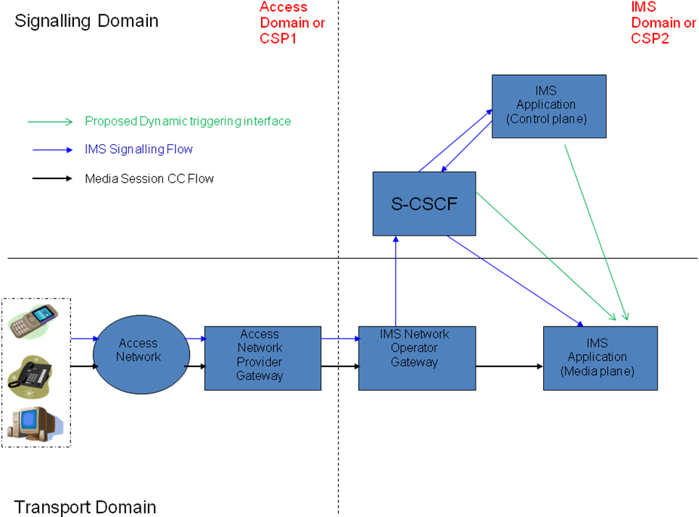
Note: referred from SA3LI08_026 ‘IMS Dynamic CC Triggering’

The correlation realization varies from different access scenarios and LI solutions.
But there should be a general method/parameter for the handover interface to be compatible for different scenarios and make the correlation between CSCF IRI and the bearer CC easy.

Furthermore, there should be an explanation for each access scenario how they realize correlation under the common IMS LI HI definitions.

Common correlation parameter be preferred by LEMF

For the LEMF in IMS LI, it should not have to care the different access technologies. So the correlation should be easy to be achieved by a general correlation identifiers in CSCF IRI but not need to analyze the SIP messages.

For the future extension
The common IMS handover interface should satisfy the need for the latent extension, for example, to supply the service information, etc. It depends on the future study.

Proposal
First, it is proposed that SA3-LI should consider the LI HI extend to the COMMON IMS and select one option presented in section 2.1. And the option A is proposed to be adopted.

Secondly, it is proposed the issues discussed above should be taken into account:
- To supply a general correlation method/parameter in the CSCF HI2 for the correlation CSCF IRI with the bearer CC, which could be general for different access network
- To give the indication for each access scenarios how to realize the correlation in the CSCF and bearer device
- To be easy for the extension when needed.

