Invitation and General information
on 3GPP SA3#92 meeting

Beijing, 10 May 2018

3GPP SA3#92
from Monday 20 to Friday 24 of August 2018 in Dalian, China

Dear Delegate,

The Chinese Friends of 3GPP (CF3) have the pleasure of inviting you to the 3GPP SA3#92 meeting in Dalian, China.

- SA3#92 Meeting will be held in the InterContinental Dalian

We look forward to seeing you all in Dalian, China.

Yours sincerely,
the Chinese Friends of 3GPP

Accommodation
Meeting Venue for 3GPP SA3#92
InterContinental Dalian
No.6 Youhao Square, Zhongshan District, Dalian, Liaoning, China
Tel: +86-411-82366666

Website

Group Rates:
- Superior King Room： CNY 700 net per room per night with one breakfast
- Superior King Room： CNY 800 net per room per night with two breakfasts
- Superior Twin Room： CNY 700 net per room per night with one breakfast
- Superior Twin Room： CNY 800 net per room per night with two breakfasts
* Above room rate are inclusive of 10% service charge and 6% VAT. Broadband Internet access is complimentary in guest rooms.
Hotel cut-off date, 11 August 2018
Meeting Registration
Please register for the meetings online at:
on-line registration

CF3 is not responsible for reservation confirmations, cancelled or changed reservations or no-shows. Please contact the hotel directly to make any change.

Visa letter

****VISA LETTER****
If you need an invitation letter for applying a VISA, complete the provided request form and send it to the person below no later than 24 July, 2018 (Beijing time, GMT+8). Late submission will not be accepted. It is recommended for each company to designate one delegate from your company to collect all the information of your delegates who need the invitation letter and to send one request e-mail by the designated person. Please contact the Chinese Embassy at your country for further information.

Contact person for invitation letter:

Mr. Xu Qi (CCSA)
E-mail: visa@ccsa.org.cn
Tel: +86-10-6230-4200

Time Zone:
GMT +8 hours

Voltage:
Commercial power in China is 220V. Please be sure you have the correct adapter. Voltage converters will not be provided at the meeting.


City Profile/ Area Attractions:
http://en.dl.gov.cn/

Host Contact
For any questions about anything relating to the meeting please contact:
Mr. Xu QI
Tel.: +86-10-6230 4200
E-mail: qixu@ccsa.org.cn

Attachment 1: Invitation letter request form for VISA
Attachment 2: Transport Information about the meeting venue
Attachment 1: Invitation letter request form for VISA

INVITATION LETTER REQUEST FORM

To enter China for the meetings indicated above, you may need a letter of invitation from the Chinese host, which you will need to present to the Chinese Embassy/Consulate in your area in order to obtain your visa. In order to obtain the invitation letter, please:

- fill out the form below
- Send it to ( please reference “Invitation letter request for 3GPP SA3#92 meeting” as the subject):

Mr. Xu Qi

China Communications Standards Association (CCSA)

visa@ccsa.org.cn
(It’s recommended to scan your passport page and email to us so that it’s discernible and can be used.)
Fax number: +86-10-6230 1849-4200 (if your passport page is photocopied and enlarged)
Company
Applicant Information | [ Click and Type in your full name ] |  |  | Mr Ms Mrs
Applicant Information | [ Nationality ] |  |  | [ Passport No.]
Applicant Information | Date of birth : |  |  | [ Job Title ]
Applicant Information | Is this your first visit to China? |  |  | __ Yes ___ No
Applicant Information | If the country in which you'll obtain your visa is different from your nationality, please indicate it here:  [ Country to obtain your visa]
Applicant Information | The name and the address of the Chinese Embassy/Consulate, which you are going to apply your visa.  Name:  Address:
Your Address
Place to visit after entry | In this case, it is Dalian by default.
Date of arrival at China |  |  | Date of departure from China
End of form
(Please do not forget to attach a copy of your passport photograph page before sending.)
Your information should be sent out before 24 July, 2018.

Attachment 2: Transport Information about Meeting Venue

Transportation from Dalian International Airport (Dalian Zhoushuizi Airport) (IATA: DLC)
InterContinental Dalian is about 13 km and 30 mins by car from Dalian Zhoushuizi International Airport.
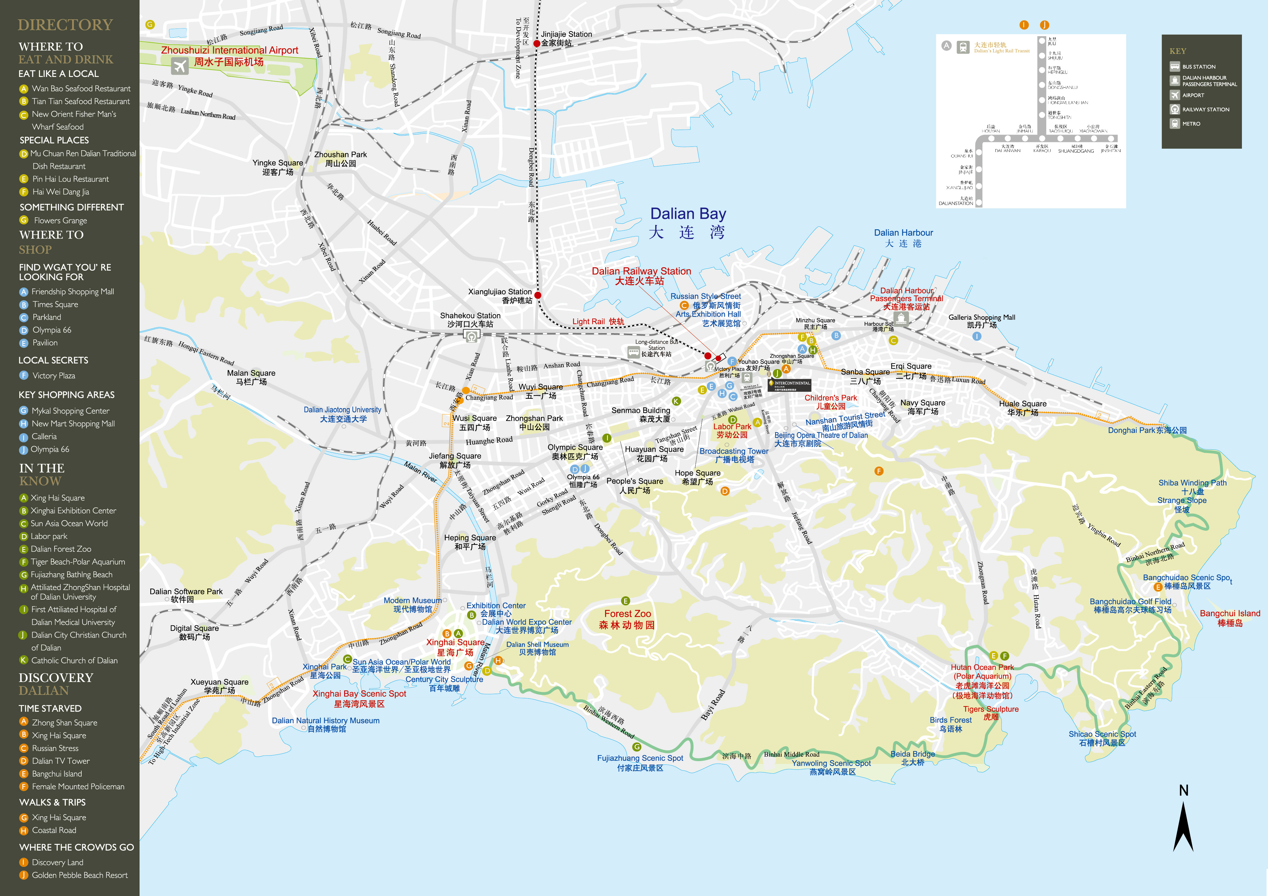
1. Taxi (30 mins)
The fare for taxi from the Airport to the hotel is around CNY 35 per way. (Please take the taxi which can provide the invoice for your trip)

In case of taking a taxi, please print the following note which shows taxi driver the address of InterContinental Dalian in both English and Chinese.

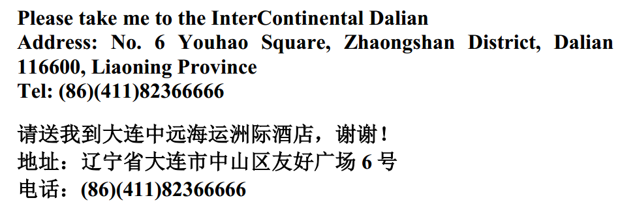
2. Hotel Transportation Service
You may book a transportation service from our hotel refer to reservation form. Please contact our hotel for detail.
Have a successful meeting and enjoy your stay in Dalian!

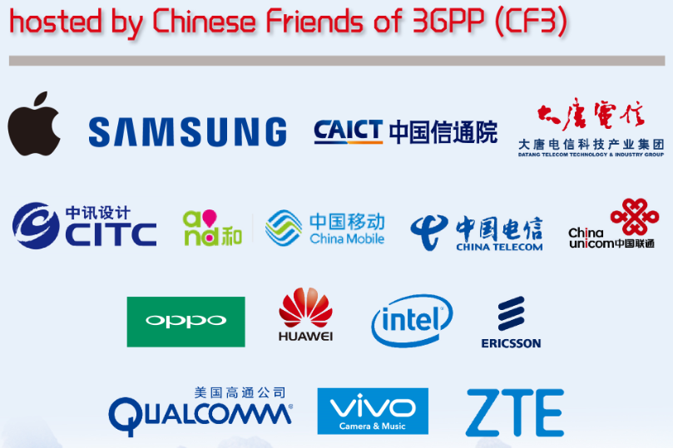

- Apple Computer Trading Co., Ltd.
- BEIJING SAMSUNG TELECOM R&D CENTER
- China Academy of Information and Communications Technology
- China Academy of Telecommunication Technology
- China Information Technology Design & Consulting Institute Co., Ltd.
- China Mobile Communications Corporation
- China Telecommunications Corporation
- China Unicom
- Guangdong OPPO Mobile Telecommunications Corp., Ltd.
- Huawei Technologies Co.,Ltd.
- Intel China Ltd.
- Nanjing Ericsson Panda Com Ltd.
- Qualcomm Wireless Communication Technologies (China) Limited.
- vivo Mobile Communication Co., Ltd.
- ZTE Corporation

