Invitation to
3GPP SA3#92-Bis Meeting
September 24 – 28, 2018
Harbin, P. R. China

Dear 3GPP colleagues,

On behalf of Huawei Technologies, we are pleased to invite you to the 3GPP SA3#92-Bis meeting in Harbin, P. R. China.

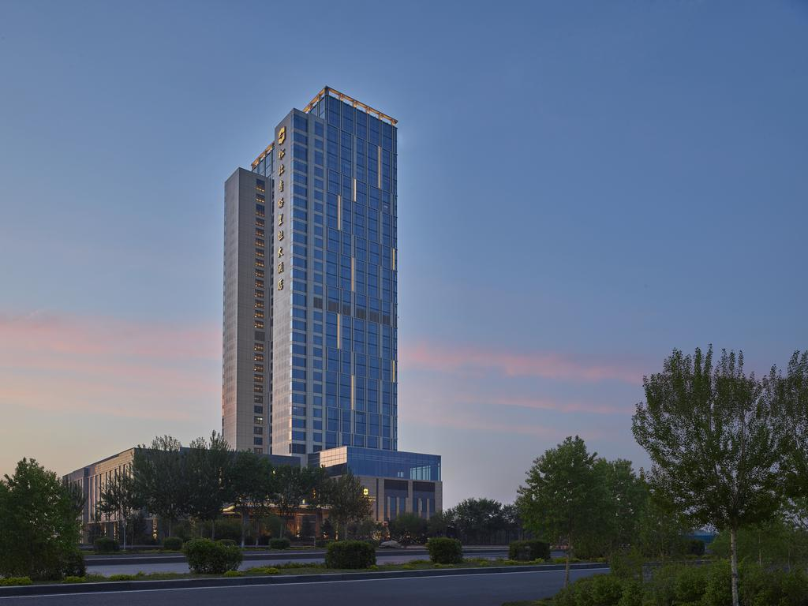

The meeting will be held at the Songbei Shangri-La, Harbin. A block of rooms has been reserved at the hotel. The group rate is ￥557 CNY per night for deluxe room including buffet breakfast and Internet access, subject to 10% service charge and 6% tax. Please refer to the hotel reservation information in the following pages for more on group rates. Delegates are responsible for their own hotel reservations. Please book your room before the cutoff date, 31 August 2018. (Note that reservation beyond this point may be expensive and subject to availability.)

In addition to making your hotel reservation, it is also very important to register for the meeting on the 3GPP website. This provides the MCC and meeting planners with important planning information. Please visit https://webapp.etsi.org/3GPPRegistration/fMain.asp?mid=33238 to register on line. Please be sure to print your name badge prior to the meeting. Name badges will no longer be provided at meetings.

Should you require a personal letter of invitation for your business visa application, please contact the host listed in Appendix A via email. Your email should attach the form in Appendix A filled with all necessary information and be sent out before 31 August 2018. For Chinese Embassy or Consulate information, please visit website http://www.fmprc.gov.cn/eng/.

Travel and general information is provided in the following pages.

We are looking forward to seeing you in Harbin, China.

Sincerely yours,
Wan, Lei
On behalf of Huawei Technologies Co., Ltd.

General Meeting Information

Meeting & Date:
SA3#92-Bis September 24-28, 2018

Location:
Harbin, Heilongjiang

Contact from the Host:
Ms. Kathy Wu Ms. Tianqing Zheng
Tel: +86 10 82829060 Tel: +86 13095715056
Email: kathy.wu@huawei.com Email: zhengtianqing@huawei.com

Hotel Information:
Songbei Shangri-La, Harbin
Address: No. 1 Songbei Avenue, Songbei District, Harbin, 150028, China
Phone: +86 451 5862 9999
Website: http://www.shangri-la.com/harbin/songbeishangrila/about/
Kind Reminder: There are two Shangri-La hotels in Harbin. We are in the Songbei Shangri-La.

Wireless LAN:
This will be a paperless meeting.
MCC will provide and administer a WLAN during the meeting.

Hotel Reservation Information

Songbei Shangri-La, Harbin will be providing the accommodations for the meeting.

Group Rate:
Deluxe room (king/twin) ￥557 CNY per room per night

The above rate includes one buffet breakfast (for single occupancy) or two buffet breakfasts (for double occupancy) and Internet access, subject to 10% service charge and 6% tax.

Cut-off Date: 31 August 2018
Please make your reservation before the cutoff date to ensure the reduced group rate. Reservation beyond this point may be expensive and subject to availability.

Check-in/Check-out Time:
Check in after 02:00 PM
Check out before 12:00 PM

Reservations Link:
This direct hyperlink can be used to access to the web booking engine of the hotel. Our meeting hotel and Group Code will be pre-selected if this direct hyperlink is used:
http://www.shangri-la.com/reservations/booking/en/index.aspx?hid=SHAS&group_code=GPP220918&check_in=20180922&check_out=20180930

If they have problem accessing the above link, delegates can make their bookings directly on the hotel website using the Group Code:
1) Go to the hotel website, http://www.shangri-la.com/harbin/songbeishangrila/reservations/.
2) Enter all the necessary stay requirements like check-in date, check-out date, number of rooms, and adults and children.
3) Under the "Special Rate" area, select "Group Code" and enter the Group Code, “GPP220918”.
4) Click the Check Availability button to continue.
5) If all the search criteria are correct and rooms are still available for the group, the group rate will be returned in the availability search result. Simply follow the on-screen instructions to complete the online booking.

Cancellation Policy:
Guaranteed reservations cancelled after 4pm (local hotel time) one day prior to arrival will incur a one night’s charge.
Please refer to the information on the webpage for more on cancellation policy.

Please Note:
The host is not responsible for reservation confirmations, cancelled or changed reservations, or no-shows. Please contact the hotel directly to make any changes.

Transportation Information

The Songbei Shangri-La, Harbin is located in the Songbei business district, close to the Songhua River and many major scenic spots.

Airport:

- Harbin Taiping International Airport (IATA code: HRB; ICAO code: ZYHB)

https://en.wikipedia.org/wiki/Harbin_Taiping_International_Airport

https://www.travelchinaguide.com/cityguides/heilongjiang/harbin/airport.htm

Tel: +86-451-82894230

Hotel direction: 41 km south-west, 45 minutes by car.

Taxi
Taxi fare is about ￥140 CNY (one way).

Please Note: Taxi drivers may not speak English, so make sure you have the name of your hotel or address written in Chinese. The following is the name, address and phone number of the Songbei Shangri-La, Harbin in Chinese; please print it for your convenience:

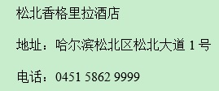
General Information for Stay in Harbin

GSM/UMTS/LTE Coverage:
There is GSM/UMTS/LTE coverage in Harbin.

Currency:
Until June 2018, 1 U.S. dollar was worth ￥ 6.47 CNY and 1 Euro was worth ￥ 7.5 CNY. Most foreign currencies are easily changed at banks or hotels. Local banks are typically open from 9am to 5pm from Monday to Friday, while weekend working hours may vary by institution. You will be required to present your identification card or passport in order to access foreign exchange services.

Time Zone:
GMT +8 hours

Voltage:
Commercial power in China is 220V. Please be sure you have the correct adapter. Voltage converters will not be provided at the meeting.

Harbin Travel Guide:
https://www.travelchinaguide.com/cityguides/heilongjiang/harbin/

Please don’t hesitate to direct any questions regarding the logistical arrangements of this meeting to the Meeting Coordinators:

Ms. Kathy Wu
Or
Ms. Tianqing Zheng

Have a successful meeting and enjoy your stay in Harbin!
Appendix A
3GPP SA3#92-Bis
Harbin, China
September 24-28, 2018
INVITATION LETTER REQUEST FORM

To enter China for the meetings indicated above, you may need a letter of invitation from the Chinese host, which you will need to present to the Chinese Embassy/Consulate in your area in order to obtain your visa. In order to obtain the invitation letter, please:
- fill out the form below
- a scanned copy of your passport (the name, date of birth, nationality, passport number, passport validity date, etc. must be seen clearly; to ensure readability; a scanned photograph page is preferred.)
- a scanned copy of the latest Chinese visa (one or two records) if your entry is not the first time
- send all of the above via email to sa3_visa@huawei.com before 31 August 2018

NOTE: please send your application form in WORD file.

Full Name of Company
Surname |  | Given Name
Gender | □ Male □ Female
Birthday (YYYY-MM-DD) |  | Nationality
Tel No. |  | Job Title
Passport No. |  | Place of Issue Passport
Expired Date of Passport (YYYY-MM-DD)
Destination Country/Area & City/ Places to visit after entry (In this case, it is Harbin by default; if you want to visit other places than Harbin, please indicate here)
Country |  | City
Visa Issued Country/Area & City (If the country in which you'll obtain your visa is different from your nationality, please indicate it here:[ Country to obtain your visa])
Country |  | City
Duration (YYYY-MM-DD)
From |  | To
Applicant Information
Applicant Address
Applicant Fax No.
Applicant Email Address
End of form
(Please do not forget to attach a copy of your passport photograph page before sending.)

