December 5, 2017

**Invitation to the 3GPP SA3#90Bis Meeting**

**February 26 – 2 March 2018**

**SAN DIEGO, California, USA**

Dear Colleagues,



has the pleasure of inviting you to the 3GPP SA3 #90Bis meeting, to be held at Qualcomm premises in San Diego, California, USA. Please find below the necessary details for the meeting:

**Meeting Location:**

Qualcomm Incorporated (**Building AZ, Multipurpose Room A/B**);

Note: The letters do **not** appear on the outside of the building

10155 Pacific Heights Blvd

San Diego, California 92121

United States

**Meeting Dates:**

February 26 – March 2, 2018

**Invitation Letter for Visa Request Form**

Delegates who require a personal invitation letter for their visa application should contact Nancy Trevellyan at [ntrevell@qti.qualcomm.com](mailto:ntrevell@qti.qualcomm.com). Please fill out the attached form and email to Nancy in order to request the invitation letter for Visa.



**Qualcomm Visitor’s Badge Request Form**

All delegates must please fill out this form completely and email back to Nancy Trevellyan at [ntrevell@qti.qualcomm.com](mailto:ntrevell@qti.qualcomm.com). This information is required by Qualcomm in order to prepare visitor badges for you. Your individual WiFi access codes will also be provided along with your visitor’s badge. Delegates are requested to arrive at the meeting location, each day, 15 minutes before the meeting start time to collect their visitor badge for the day.



In addition to filling out and emailing the Qualcomm Visitor’s Badge Request Form, it is also very important to register for the meeting on the 3GPP website. This provides the MCC and meeting planners with important planning information. The registration form can be found on the 3GPP website. Please visit [www.3gpp.org](http://www.3gpp.org) to register on line.

Additional information about Hotel Reservations, Airport, Transport and Local Information are provided in the following pages.

We are looking forward to seeing you in San Diego, California, USA.

Sincerely,

Anand Palanigounder

Qualcomm Incorporated

[apg@qti.qualcomm.com](mailto:apg@qti.qualcomm.com)

**Hotel Reservations, Airport, Transport and Local Information**

**Hotels:**

There are 14 hotels that are located near Qualcomm. Please see attachments for hotel information, directions and maps.

**Airport Information:**

* The closest airport is San Diego International Airport. (SAN)
* Los Angeles International Airport (LAX) is another option, but a good two hour drive away from Qualcomm so please keep that in mind.

**Ground Transportation:**

Transportation to/from the airport is provided by shuttle services for approximately $30 per person.

* [Super Shuttle](http://www.supershuttle.com/Locations/SanDiegoSAN)
* [San Diego Uber](https://www.uber.com/cities/san-diego)
* [San Diego Lyft](https://www.lyft.com/cities/san-diego-ca)

Taxi cabs are readily available at the San Diego International Airport. Average taxi rate to/from the San Diego Airport is approximately $50.

**Gratuities:**

A gratuity of 15% - 18% is customary at restaurants and for taxi drivers.

**Local Time:**

The time in San Diego is Pacific time.

**Currency and Credit Cards:**

The US Dollar $ is the local currency and credit cards are accepted in all major outlets.

**Tourism Information:**

* [Lonely Planet](http://www.lonelyplanet.com/usa/san-diego)
* [San Diego](http://www.sandiego.org/)

**Voltage & Plug Adapters:**

Electricity in United States of America / USA is 120 Volts, alternating at 60 Hz. If you travel to the United States of America / USA with a device that does not accept 120 Volts at 60 Hertz, you will need a voltage converter.

Outlets in United States of America / USA generally accept a two pin, flat blade plug with one opening larger than the other to accommodate polarized plugs.  
Flat blade plug

If your appliance’s plug has a different shape, you may need a plug adapter.

**Check-in for Visitor’s Badges**

There will be a registration table inside Qualcomm’s Building AZ at 10155 Pacific Heights Boulevard, San Diego, California 92121.

**Parking at Qualcomm**

Please try to park in the visitor’s parking lot in front of Building AX (10105 Pacific Heights Boulevard). If spaces are not available, you may park anywhere in the employee parking lot.

**Closing Remarks**

We look forward to seeing you in beautiful San Diego.

**ATTACHMENT #1**

**Driving Directions from San Diego Int’l Airport to Qualcomm Bldg. AZ**

From: S​a​n​ ​D​i​e​g​o​ ​I​n​t​e​r​n​a​t​i​o​n​a​l​ ​A​i​r​p​o​r​t​ ​(​S​A​N​)​,​ ​3​2​2​5​ ​N​ ​H​a​r​b​o​r​ ​D​r​,​ ​S​a​n​ ​D​i​e​g​o​,​ ​C​A​ ​9​2​1​0​1​ ​U​S​  
To: 1​0​1​55​ ​P​a​c​i​f​i​c​ ​H​e​i​g​h​t​s​ ​B​l​v​d​,​ ​S​a​n​ ​D​i​e​g​o​,​ ​C​A​ ​9​2​1​2​1​-​4​2​1​4​ ​U​S​ (Qualcomm Bldg. AZ)

A) S​a​n​ ​D​i​e​g​o​ ​I​n​t​e​r​n​a​t​i​o​n​a​l​ ​A​i​r​p​o​r​t​ ​(​S​A​N​)​,​ ​3​2​2​5​ ​N​ ​H​a​r​b​o​r​ ​D​r​,​ ​S​a​n​ ​D​i​e​g​o​,​ ​C​A​ ​9​2​1​0​1​ ​U​S​

1. S​t​a​r​t​ ​o​u​t​ ​g​o​i​n​g​ ​n​o​r​t​h​w​e​s​t​ ​o​n​ ​T​e​r​m​i​n​a​l​ ​A​c​c​e​s​s​ ​R​d​.​ (go 0.2 miles)
2. T​a​k​e​ ​T​e​r​m​i​n​a​l​ ​A​c​c​e​s​s​ ​R​d​ ​t​o​w​a​r​d​ ​A​i​r​p​o​r​t​ ​E​x​i​t​/​T​e​r​m​i​n​a​l​ ​R​e​t​u​r​n​/​P​a​r​k​i​n​g​.​ (go 0.22 miles)
3. T​u​r​n​ ​s​l​i​g​h​t​ ​r​i​g​h​t​ ​t​o​w​a​r​d​ ​I​-​5​/​D​o​w​n​t​o​w​n​/​R​e​n​t​a​l​ ​C​a​r​ ​R​e​t​u​r​n​.​ (go 0.5 miles)
4. T​u​r​n​ ​s​l​i​g​h​t​ ​r​i​g​h​t​ ​o​n​t​o​ ​N​ ​H​a​r​b​o​r​ ​D​r​.​ (go 1.08 miles)
5. T​u​r​n​ ​l​e​f​t​ ​o​n​t​o​ ​W​ ​G​r​a​p​e​ ​S​t​.​  
   W​ ​G​r​a​p​e​ ​S​t​ ​i​s​ ​j​u​s​t​ ​p​a​s​t​ ​W​ ​H​a​w​t​h​o​r​n​ ​S​t​  
   (go 0.38 miles)
6. M​e​r​g​e​ ​o​n​t​o​ ​I​-​5​ ​S​/​S​a​n​ ​D​i​e​g​o​ ​F​w​y​ ​S​.​  
   I​f​ ​y​o​u​ ​r​e​a​c​h​ ​A​l​b​a​t​r​o​s​s​ ​S​t​ ​y​o​u​'​v​e​ ​g​o​n​e​ ​a​ ​l​i​t​t​l​e​ ​t​o​o​ ​f​a​r​  
   (go 0.57 miles)
7. M​e​r​g​e​ ​o​n​t​o​ ​C​A​-​1​6​3​ ​N​ ​v​i​a​ ​E​X​I​T​ ​1​6​ ​t​o​w​a​r​d​ ​E​s​c​o​n​d​i​d​o​.​ (go 6.1 miles)
8. M​e​r​g​e​ ​o​n​t​o​ ​I​-​8​0​5​ ​N​ ​v​i​a​ ​E​X​I​T​ ​7​A​ ​t​o​w​a​r​d​ ​L​o​s​ ​A​n​g​e​l​e​s​.​ (go 6.28 miles)
9. T​a​k​e​ ​t​h​e​ ​M​i​r​a​ ​M​e​s​a​ ​B​l​v​d​/​V​i​s​t​a​ ​S​o​r​r​e​n​t​o​ ​P​k​w​y​ ​e​x​i​t​,​ ​E​X​I​T​ ​2​7​A​.​ (go 0.53 miles)
10. T​u​r​n​ ​r​i​g​h​t​ ​o​n​t​o​ ​M​i​r​a​ ​M​e​s​a​ ​B​l​v​d​.​  
    I​f​ ​y​o​u​ ​a​r​e​ ​o​n​ ​V​i​s​t​a​ ​S​o​r​r​e​n​t​o​ ​P​k​w​y​ ​a​n​d​ ​r​e​a​c​h​ ​M​i​r​a​ ​S​o​r​r​e​n​t​o​ ​P​l​ ​y​o​u​'​v​e​ ​g​o​n​e​ ​a​b​o​u​t​ ​0​.​1​ ​m​i​l​e​s​ ​t​o​o​ ​f​a​r​  
    (go 1.16 miles)
11. T​u​r​n​ ​l​e​f​t​ ​o​n​t​o​ ​P​a​c​i​f​i​c​ ​H​e​i​g​h​t​s​ ​B​l​v​d​.​  
    P​a​c​i​f​i​c​ ​H​e​i​g​h​t​s​ ​B​l​v​d​ ​i​s​ ​0​.​3​ ​m​i​l​e​s​ ​p​a​s​t​ ​L​u​s​k​ ​B​l​v​d​  
    E​x​t​e​n​d​e​d​ ​S​t​a​y​ ​A​m​e​r​i​c​a​ ​-​ ​S​a​n​ ​D​i​e​g​o​ ​-​ ​S​o​r​r​e​n​t​o​ ​M​e​s​a​ ​i​s​ ​o​n​ ​t​h​e​ ​c​o​r​n​e​r​  
    I​f​ ​y​o​u​ ​r​e​a​c​h​ ​H​u​e​n​n​e​k​e​n​s​ ​S​t​ ​y​o​u​'​v​e​ ​g​o​n​e​ ​a​b​o​u​t​ ​0​.​3​ ​m​i​l​e​s​ ​t​o​o​ ​f​a​r​  
    (go 0.4 miles)
12. 1​0​1​55​ ​P​A​C​I​F​I​C​ ​H​E​I​G​H​T​S​ ​B​L​V​D​ ​i​s​ ​o​n​ ​t​h​e​ ​r​i​g​h​t​.​  
    Y​o​u​r​ ​d​e​s​t​i​n​a​t​i​o​n​ ​i​s​ ​0​.​1​ ​m​i​l​e​s​ ​p​a​s​t​ ​B​a​r​n​e​s​ ​C​a​n​y​o​n​ ​R​d​  
    I​f​ ​y​o​u​ ​r​e​a​c​h​ ​P​a​c​i​f​i​c​ ​C​e​n​t​e​r​ ​B​l​v​d​ ​y​o​u​'​v​e​ ​g​o​n​e​ ​a​ ​l​i​t​t​l​e​ ​t​o​o​ ​f​a​r​  
    (go 0 miles)

B) 1​0​1​55​ ​P​a​c​i​f​i​c​ ​H​e​i​g​h​t​s​ ​B​l​v​d​,​ ​S​a​n​ ​D​i​e​g​o​,​ ​C​A​ ​9​2​1​2​1​-​4​2​1​4​ ​U​S​

TOTAL ESTIMATED TIME: 22 minutes | DISTANCE: 17.42 miles

To view your map, click on the link below or copy and paste it to your browser: <http://mapq.st/1GuTzK6>

**ATTACHMENT #2**

**Driving Directions from Los Angeles Int’l Airport to Qualcomm’s Bldg. AZ**

From: L​o​s​ ​A​n​g​e​l​e​s​ ​I​n​t​e​r​n​a​t​i​o​n​a​l​ ​A​i​r​p​o​r​t​ ​(​L​A​X​)​,​ ​1​ ​W​o​r​l​d​ ​W​a​y​,​ ​L​o​s​ ​A​n​g​e​l​e​s​,​ ​C​A​ ​9​0​0​4​5​ ​U​S​  
To: 1​0​1​55​ ​P​a​c​i​f​i​c​ ​H​e​i​g​h​t​s​ ​B​l​v​d​,​ ​S​a​n​ ​D​i​e​g​o​,​ ​C​A​ ​9​2​1​2​1​-​4​2​1​4​ ​U​S​  
  
DRIVING DIRECTIONS

A) L​o​s​ ​A​n​g​e​l​e​s​ ​I​n​t​e​r​n​a​t​i​o​n​a​l​ ​A​i​r​p​o​r​t​ ​(​L​A​X​)​,​ ​1​ ​W​o​r​l​d​ ​W​a​y​,​ ​L​o​s​ ​A​n​g​e​l​e​s​,​ ​C​A​ ​9​0​0​4​5​ ​U​S​

1. S​t​a​r​t​ ​o​u​t​ ​g​o​i​n​g​ ​s​o​u​t​h​e​a​s​t​ ​o​n​ ​P​o​s​t​ ​W​a​y​.​ (go 0.05 miles)
2. M​e​r​g​e​ ​o​n​t​o​ ​C​A​-​1​ ​S​/​S​ ​S​e​p​u​l​v​e​d​a​ ​B​l​v​d​ ​t​o​w​a​r​d​ ​I​-​1​0​5​.​ (go 0.7 miles)
3. M​e​r​g​e​ ​o​n​t​o​ ​I​-​1​0​5​ ​E​/​G​l​e​n​n​ ​A​n​d​e​r​s​o​n​ ​F​w​y​ ​E​ ​t​o​w​a​r​d​ ​N​o​r​w​a​l​k​.​ (go 1.31 miles)
4. M​e​r​g​e​ ​o​n​t​o​ ​I​-​4​0​5​ ​S​/​C​A​-​2​2​ ​E​/​S​a​n​ ​D​i​e​g​o​ ​F​w​y​ ​S​ ​v​i​a​ ​E​X​I​T​ ​2​ ​t​o​w​a​r​d​ ​L​o​n​g​ ​B​e​a​c​h​.​ (go 24.42 miles)
5. K​e​e​p​ ​l​e​f​t​ ​t​o​ ​t​a​k​e​ ​I​-​4​0​5​ ​S​/​S​a​n​ ​D​i​e​g​o​ ​F​w​y​ ​S​ ​t​o​w​a​r​d​ ​I​r​v​i​n​e​/​S​a​n​ ​D​i​e​g​o​.​ (go 10.5 miles)
6. M​e​r​g​e​ ​o​n​t​o​ ​C​A​-​7​3​ ​S​ ​v​i​a​ ​E​X​I​T​ ​1​0​ ​t​o​w​a​r​d​ ​S​a​n​ ​D​i​e​g​o​/​C​A​-​5​5​ ​S​ ​(​P​o​r​t​i​o​n​s​ ​t​o​l​l​)​.​ (go 18.01 miles)
7. S​t​a​y​ ​s​t​r​a​i​g​h​t​ ​t​o​ ​g​o​ ​o​n​t​o​ ​I​-​5​ ​S​/​S​a​n​ ​D​i​e​g​o​ ​F​w​y​ ​S​.​ ​C​o​n​t​i​n​u​e​ ​t​o​ ​f​o​l​l​o​w​ ​I​-​5​ ​S​.​ (go 53.76 miles)
8. K​e​e​p​ ​l​e​f​t​ ​t​o​ ​t​a​k​e​ ​I​-​8​0​5​ ​S​ ​v​i​a​ ​E​X​I​T​ ​3​1​.​ (go 1.28 miles)
9. T​a​k​e​ ​t​h​e​ ​S​o​r​r​e​n​t​o​ ​V​a​l​l​e​y​ ​R​d​/​M​i​r​a​ ​M​e​s​a​ ​B​l​v​d​ ​e​x​i​t​,​ ​E​X​I​T​ ​2​7​.​ (go 0.32 miles)
10. T​u​r​n​ ​l​e​f​t​ ​o​n​t​o​ ​S​o​r​r​e​n​t​o​ ​V​a​l​l​e​y​ ​R​d​.​ (go 0.05 miles)
11. S​o​r​r​e​n​t​o​ ​V​a​l​l​e​y​ ​R​d​ ​b​e​c​o​m​e​s​ ​M​i​r​a​ ​M​e​s​a​ ​B​l​v​d​.​ (go 1.38 miles)
12. T​u​r​n​ ​l​e​f​t​ ​o​n​t​o​ ​P​a​c​i​f​i​c​ ​H​e​i​g​h​t​s​ ​B​l​v​d​.​  
    P​a​c​i​f​i​c​ ​H​e​i​g​h​t​s​ ​B​l​v​d​ ​i​s​ ​0​.​3​ ​m​i​l​e​s​ ​p​a​s​t​ ​L​u​s​k​ ​B​l​v​d​  
    E​x​t​e​n​d​e​d​ ​S​t​a​y​ ​A​m​e​r​i​c​a​ ​-​ ​S​a​n​ ​D​i​e​g​o​ ​-​ ​S​o​r​r​e​n​t​o​ ​M​e​s​a​ ​i​s​ ​o​n​ ​t​h​e​ ​c​o​r​n​e​r​  
    I​f​ ​y​o​u​ ​r​e​a​c​h​ ​H​u​e​n​n​e​k​e​n​s​ ​S​t​ ​y​o​u​'​v​e​ ​g​o​n​e​ ​a​b​o​u​t​ ​0​.​3​ ​m​i​l​e​s​ ​t​o​o​ ​f​a​r​  
    (go 0.4 miles)
13. 1​0​1​55​ ​P​A​C​I​F​I​C​ ​H​E​I​G​H​T​S​ ​B​L​V​D​ ​i​s​ ​o​n​ ​t​h​e​ ​r​i​g​h​t​.​  
    Y​o​u​r​ ​d​e​s​t​i​n​a​t​i​o​n​ ​i​s​ ​0​.​1​ ​m​i​l​e​s​ ​p​a​s​t​ ​B​a​r​n​e​s​ ​C​a​n​y​o​n​ ​R​d​  
    I​f​ ​y​o​u​ ​r​e​a​c​h​ ​P​a​c​i​f​i​c​ ​C​e​n​t​e​r​ ​B​l​v​d​ ​y​o​u​'​v​e​ ​g​o​n​e​ ​a​ ​l​i​t​t​l​e​ ​t​o​o​ ​f​a​r​  
    (go 0 miles)

B) 1​0​1​55​ ​P​a​c​i​f​i​c​ ​H​e​i​g​h​t​s​ ​B​l​v​d​,​ ​S​a​n​ ​D​i​e​g​o​,​ ​C​A​ ​9​2​1​2​1​-​4​2​1​4​ ​U​S​

TOTAL ESTIMATED TIME: 1 hour 46 minutes | DISTANCE: 112.18 miles  
  
To view your map, click on the link below or copy and paste it to your browser: <http://mapq.st/1Ssm0hf>

**ATTACHMENT #3**

**Map of Qualcomm’s Pacific Center Campus**

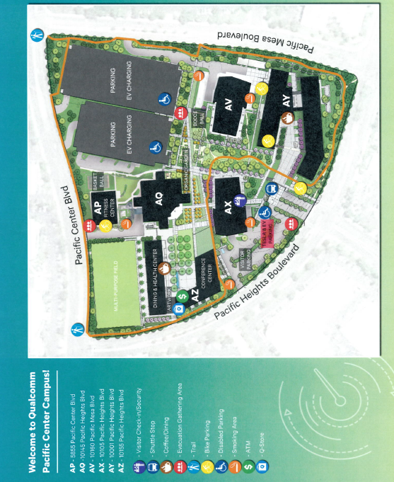**ATTACHMENT #4**

Current as of: March 2017. Please request Qualcomm rate . /// Note: All hotels in the state of California are non-smoking facilities.

|  |  |  |  |  |  |  |  |
| --- | --- | --- | --- | --- | --- | --- | --- |
| **Hotel Name** | **Distance Miles** | **Internet** | **Parking** | **Complimentary Shuttle Service to Qualcomm**  **Buildings** | **Breakfast**  **Included** | **Phone** | **Address** |
| [HOLIDAY INN EXPRESS & SUITES SORRENTO](http://www.ihg.com/holidayinnexpress/hotels/us/en/san-diego/sanma/hoteldetail) | 0.83 | Included | Included | Yes | Yes | +1-800-972-2802  +1-858-731-0100 | 5925 Lusk Blvd.  San Diego, CA 92121 |
| [COUNTRY INN & SUITES](http://www.countryinns.com/san-diego-hotel-ca-92121/casdiego) | 0.81 | Included | Included | Yes | Yes | +1-858-558-1818 | 5975 Lusk Blvd.  San Diego, CA 92121 |
| [HYATT HOUSE SAN DIEGO SORRENTO](http://www.sorrentomesa.house.hyatt.com/en/hotel/home.html) | 0.80 | Included | Included | Yes | Yes | +1-858-597-0500 | 10044 Pacific Mesa Blvd.  San Diego, CA 92121 |
| [STAYBRIDGE SUITES SAN DIEGO](http://www.ihg.com/staybridge/hotels/us/en/san-diego/sansm/hoteldetail?cm_mmc=GoogleMaps-_-sb-_-USEN-_-sansm) | 2.10 | Included | Included | Yes | Yes | +1-877-238-8889 | 6639 Mira Mesa Blvd.  San Diego, CA 92121 |
| [COURTYARD BY MARRIOTT SORRENTO](http://www.marriott.com/hotels/fact-sheet/travel/sanmm-courtyard-san-diego-sorrento-mesa-la-jolla/) | 1.04 | Included | Included | Yes | Yes | +1-858-558-9600 | 9650 Scranton Road  San Diego, CA 92121 |
| [EMBASSY SUITES LA JOLLA](http://embassysuites3.hilton.com/en/hotels/california/embassy-suites-san-diego-la-jolla-SANLJES/about/amenities.html) | 3.62 | Included | Not  Included | Yes | Yes | +1-858-453-0400 | 4550 La Jolla Village Drive  San Diego, CA 92122 |
| [MARRIOTT LA JOLLA](http://www.marriott.com/hotels/fact-sheet/travel/sanlj-san-diego-marriott-la-jolla/) | 4.04 | Included | Not  Included | No | Yes | +1-858-587-1414 | 4240 La Jolla Village Drive  La Jolla, CA 92037 |
| [HYATT REGENCY LA JOLLA](http://lajolla.hyatt.com/en/hotel/home.html) | 4.10 | Included | Not  Included | Yes | Yes | +1-858-552-1234 | 3777 La Jolla Village Drive  San Diego, CA 92122 |
| [RESIDENCE INN SORRENTO MESA](http://www.marriott.com/hotels/fact-sheet/travel/sanaa-residence-inn-san-diego-sorrento-mesa-sorrento-valley/) | 0.92 | Included | Included | Yes | Yes | +1-858-552-9100 | 5995 Pacific Mesa Ct.  San Diego, CA 92121 |
| [RESIDENCE INN LA JOLLA](http://www.marriott.com/hotels/fact-sheet/travel/lajca-residence-inn-san-diego-la-jolla/) | 4.99 | Included | Included | Yes | Yes | +1-858-587-1770 | 8901 Gilman Drive  La Jolla, CA 92037 |

**Holiday Inn Express**

**Residence Inn**

**Sorrento Mesa**

**Country Inn and Suites**

**Hyatt House San Diego Sorrento**

**Courtyard by Marriott Sorrento**

**QUALCOMM** 

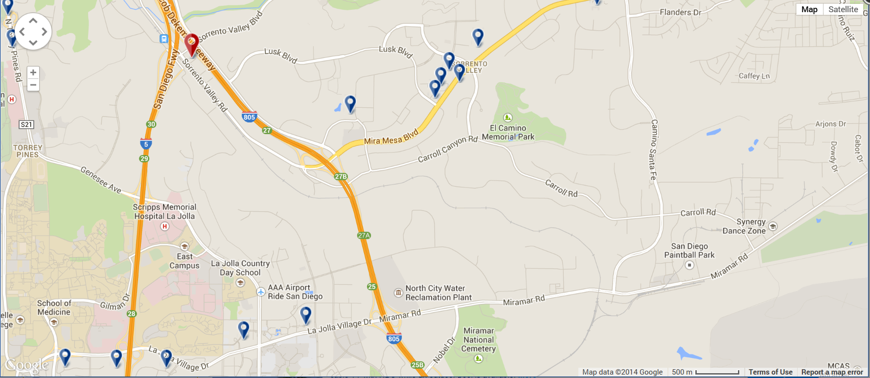

**Embassy Suites**

**La Jolla**

**Marriott La Jolla**

**Hyatt Regency La Jolla**

**Residence Inn**

**La Jolla**