Invitation and General information on 3GPP SA3#88 meeting

Dali, 19 May 2017

3GPP SA3#88
from Monday 7 to Friday 11 of August 2017 in Dali, China

Dear Delegate,

The Chinese Friends of 3GPP (CF3) have the pleasure of inviting you to the 3GPP SA3#88 meeting in Dali, China.

Meeting Venue for 3GPP SA3#88
HILTON DALI RESORT & SPA
Qili Bridge, South of Gantong Road, Dali City, Yunnan Province 671000, P. R. China
WEB SITE

Deluxe room (king/twin) @ RMB ¥900 B&B & internet included
Hotel cut-off date: 7th July 2017
Hotel booking form attached
Meeting Registration
Please register for the meetings online at:
on-line registration

We look forward to seeing you all in Dali.

Yours sincerely,
the Chinese Friends of 3GPP

Accommodation
CF3 is not responsible for reservation confirmations, cancelled or changed reservations or no-shows. Please contact the hotel directly to make any changes. Please make your own booking filling in the hotel registration form. Should you need to prolong your stay in Dali beyond meeting dates, please feel free to let us know. We’ll contact the hotel and try to guarantee the group rate for all nights.

HILTON DALI RESORT & SPA will be providing the accommodations for the meeting.

There are also local inns around, such as Dali courtyard boutique inn and Gantong Villa.
Group Rate:
Deluxe room (king/twin) ￥900 CNY per room per night
The above rate includes one buffet breakfast (for single occupancy) or two buffet breakfasts (for double occupancy), Internet access, service charge and taxes.
Cut-off Date: 7th July 2017
Please make your reservation before the cut-off date to ensure the reduced group rate. Reservation beyond this point may be subject to availability.
Check-in/Check-out Time:
Check in after 03:00 PM
Check out before 12:00 PM
Reservations:
Please fill out the form in Attachment 3 and email the completed form to the hotel and cc CCSA contact person.
Cancellation Policy:
Please refer to Attachment 3.
Host Contact
For any questions about anything relating to the meeting please contact:
Ms. Hongyan Jia
Tel.: +86-10-6230 2735
E-mail: jiahy@ccsa.org.cn

Visa letter

****VISA LETTER****
If you need an invitation letter for applying a VISA, complete the provided request form and send it to the person below no later than July 21, 2017 (Beijing time, GMT+8). Late submission will not be accepted. It is recommended for each company to designate one delegate from your company to collect all the information of your delegates who need the invitation letter and to send one request e-mail by the designated person. Please contact the Chinese Embassy at your country for further information.

Contact person for invitation letter:

Mr. Xu Qi (CCSA)
E-mail: qixu@ccsa.org.cn
Tel: +86-10-6230-4200

Attachment 1: Invitation letter request form for VISA
Attachment 2: Information about the meeting venue
Attachment 3: Hotel Reservation Form
Attachment 4: General Information
Attachment 1: Invitation letter request form for VISA

INVITATION LETTER REQUEST FORM

To enter China for the meetings indicated above, you may need a letter of invitation from the Chinese host, which you will need to present to the Chinese Embassy/Consulate in your area in order to obtain your visa. In order to obtain the invitation letter, please:

- fill out the form below
- Send it to ( please reference “Invitation letter request for 3GPP SA3#88 meeting” as the subject):

Mr. Xu Qi

China Communications Standards Association (CCSA)

qixu@ccsa.org.cn
(It’s recommended to scan your passport page and email to us so that it’s discernible and can be used.)
Fax number: +86-10-6230 1849-4200 (if your passport page is photocopied and enlarged)
Company
Applicant Information | [ Click and Type in your full name ] |  |  | Mr Ms Mrs
Applicant Information | [ Nationality ] |  |  | [ Passport No.]
Applicant Information | Date of birth : |  |  | [ Job Title ]
Applicant Information | Is this your first visit to China? |  |  | __ Yes ___ No
Applicant Information | If the country in which you'll obtain your visa is different from your nationality, please indicate it here:  [ Country to obtain your visa]
Applicant Information | The name and the address of the Chinese Embassy/Consulate, which you are going to apply your visa.  Name:  Address:
Your Address
Place to visit after entry | In this case, it is Dali by default.
Date of arrival at China |  |  | Date of departure from China
End of form
(Please do not forget to attach a copy of your passport photograph page before sending.)
Your information should be sent out before July 21, 2017.

Attachment 2: Information about Meeting Venue

Transportation from Dali Huangcaoba Airport (IATA: DLU, ICAO: ZPDL) to HILTON DALI RESORT & SPA
The HILTON DALI RESORT & SPA is about 25.0 km/15.5 miles and 30 mins by car from Dali Huangcaoba Airport.
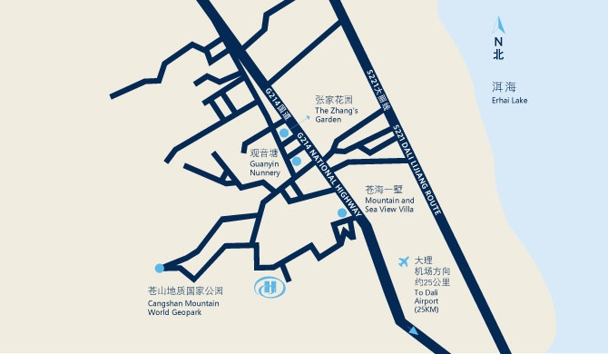
- Taxi (60 mins)
The fare for taxi from the Airport to the hotel is around CNY80 per way. (Please take the taxi which can provide the invoice for your trip)

In case of taking a taxi, please print the following note which shows taxi driver the address of Hilton Dali Resort & Spa in both English and Chinese.

Please take me to Hilton Dali Resort & Spa and give me an invoice
Qili Bridge, South of Gantong Road, Dali City, Yunnan Province 671000, P. R. China
Tel: +86-872-668 8888

请送我到大理实力希尔顿酒店并提供发票
地址：中国云南省大理市七里桥感通路以南
电话：+86-872-668 8888

- Protocol-transportation: One way
Type of the car:
Buick MPV: CNY 300 per way (6 persons).
All rates include 10% service charge & 6% VAT.
Attachment 3: Hotel Reservation Form
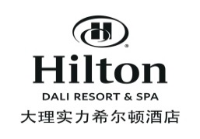
Hilton Dali Resort & Spa Room Reservation Form

3GPP SA3#88 August 7 – August 11, 2017 (Hosted by CF3)
Hotel |  | Hilton Dali Resort & SPA |  |  |  | Host |  | Chinese Friends of 3GPP
Address |  | Qili Bridge, South of Gantong Road, Dali City, Yunnan Province, China 671000 |  |  |  | Event |  | 3GPP SA3#88 August 7-August 11, 2017
Booking Channel |  | Res.Dali@hilton.com  (Please fill this reservation form and send to above email address) |  |  |  | Terms & Conditions |  | * This rate only applies to 3GPP SA3#88 delegates.  * This rate applies from August 6-12, 2017.  * Please book your room before the cut-off date, July 7, 2017. Reservation beyond the cut-off date will be subject to availability.  * This rate includes one breakfast for single occupancy or two breakfasts for double occupancy.  * This rate is per room per night.  * This rate is inclusive of 10% service charge and 6% VAT.  * CHECK-IN TIME is 3:00pm. To guarantee early check-in, please book one night prior to arrival.  * CHECK-OUT TIME is 12:00 noon. Extended use of guest room till 6:00pm on day of departure is subject to half day’s rate. Thereafter, is subject to full day’s rate.  * There are two types of rooms, deluxe king bed room and deluxe twin bed room.  * Reservation must be guaranteed by credit card. We only accept VISA, Master Card, Dinners Club, And American Express.  * Please provide your own credit card information to guarantee your booking.  * Cancellations after July 14, 2017 will be charged 100% of the room rate.
Conf. No
(Filled by Hotel Reservation)
Arrival Date | Departure Date | Personal information |  |  |  | Flight number |  | Room Type | Room Rate | Pax | Contact Info.  （Mobile & email) | Payment Info. |  |  | Special Request  (Smoking, Non-smoking, etc.)
Arrival Date | Departure Date | First Name | Last Name | Company | Nationality | Arrival | Departure |  |  |  |  | Issue Bank | Card number | Expiration | Special Request  (Smoking, Non-smoking, etc.)
2017.08.06 | 2017.08.12 |  |  |  |  |  |  | Deluxe King Bed Room | 900.00 | 1 |  |  |  | MM/YY e.g., 09/17

Attachment 4: General Information

GSM/UMTS/ LTE Coverage:
There is GSM/UMTS/LTE coverage in Dali.

Currency:
Until January 2017, 1 U.S. dollar was worth ￥ 6.95 CNY and 1 Euro was worth ￥ 7.25 CNY. Most foreign currencies are easily changed at banks or hotels. Local banks are typically open from 9am to 5pm from Monday to Friday, while weekend working hours may vary by institution. You will be required to present your identification card or passport in order to access foreign exchange services.

Time Zone:
GMT +8 hours

Voltage:
Commercial power in China is 220V. Please be sure you have the correct adapter. Voltage converters will not be provided at the meeting.



City Profile/ Area Attractions:
https://www.travelchinaguide.com/cityguides/dali.htm

Have a successful meeting and enjoy your stay in Dali!

