3GPP TSG-SA3 Meeting #110Ad-Hoc-e draft_S3-231937-r1

Electronic meeting, Online, 17 - 21 April 2023

Source: Huawei, HiSilicon

Title: Resolution of ENs and evaluation of Sol#7 KI#6

Document for: Approval
Agenda Item: 5.5

1 Decision/action requested
Approve the changes below for inclusion in TR 33.876 [1]

2 References
[1] 3GPP TR 33.876: "Study on Automated Certificate Management in SBA"

3 Rationale
This pCR is proposed to resolve the EN in Sol #9.
The EN is about the acknowledgement of certificate and NF correlation. A Note and clarification are added in clause 6.9.2.2 to explain that NRF is expected to maintain the information which enable relating an NF to its certificate.

4 Detailed proposal
*** 1st CHANGE ***

6.9 Solution #9: Certificates revocation query procedure based on NRF

6.9.1 Introduction
This solution addresses KI#6.
After a certificate expires or is revoked, the NF may still be discovered by the NRF during the NF service discovery procedure, when the certificate of a producer NF instance has been revoked without the knowledge of the NRF, it will lead to inconsistent status in NRF and reduce the service availability. For example, when the NF consumer setups a TLS connection with the NF producer, the connection between the NF consumer and the NF producer may fail because the certificate of the NF producer is no longer valid. This impact network efficiency.

6.9.2 Solution details

6.9.2.1 General
Based on an existing service discovery procedure, this solution combines the certificate revocation status query with the service discovery procedure, thereby optimizing the efficiency of certificate revocation status query.
This solution also prevents the NRF from providing an NF producer to an NF consumer after the NF producer’s certificate expires or is revoked, that may cause connection setup failures.

6.9.2.2 NF service Registration procedure
An NF carries its own certificate during registration. The NRF stores the certificate information as the NF context. In addition, when the certificate of the NF is renewed, this certificate needs to be updated in the NRF
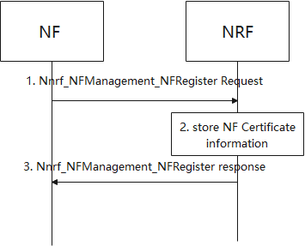
Figure 6.9.2.2-1 NRF store the certificate validity during NF registration
1. NF sends Nnrf_NFManagement_NFRegister Request message to NRF with all certificates of NF including the certificates in the certificate chain.
2. NRF stores the certificate information of certificates from NF. The certificate information can be certificate ID, certificate type and certificate validity information.
3. NRF acknowledge NF Registration is accepted via Nnrf_NFManagement_NFRegister response.

6.9.2.3 NF/NF service discovery in the same PLMN
In the service discovery procedure, the NRF determines whether to provide the NF producer to the NF consumer based on the certificate status of the NF producer.
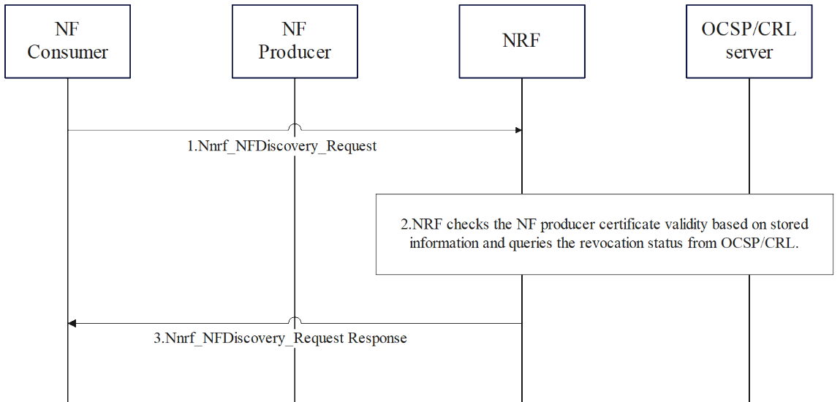
Figure 6.9.2.3-2 NRF queries NF producer certificate when NFDiscovery_request
1. NF consumer initiates service discover procedure. The NF consumer sends the Nnrf_NFDiscovery_Request message to discover an NF producer for the service. NRF determines a required candidate NF producer list as specified in 3GPP TS 23.501 [5].
2. After determining the candidate NF producer list, the NRF checks the NF producers’ certificate validities based on store information in 6.Y.2.2 and queries the certificate revocation status from the CRL or the OCSP server. The NRF can interact with the CRL/OCSP server directly or through a proxy depending on the implantation of the CRL/OCSP server. Certificate validity is the information preconfigured by CA/RA. The revocation status is to indicate whether the certificate is revoked. There are some cases that leads to the revocation (e.g., private key leak, the re-orchestration of NF, etc.)
NOTE: NRF can have a storage mechanism and can be aligned with the update period of the OCSP server (e.g. OCSP server can announce its thisUpdate time and nextUpdate Time as specified in IETF RFC 6960 [8]). it may be done in the implementation level to reduce the signalling.
3. NRF sends Nnrf_NFDiscovery_Request Response message to NF consumer.
If multiple NRFs are required to discovery a NF producer, NRF can forward the request to other NRFs as specified in 3GPP TS 23.502 [14].

6.9.3 Evaluation
In this solution, the NRF checks the certificate status from the OCSP/CRL server, so that the NF discovery service can only provide the NF producer with a valid certificate, which improve the service availability.
This solution is expected to add more storage requirement in the NRF, and more signalling and queries during the NF discovery request of NRF. The OCSP/CRL server query can be implemented during the existing NF producer checks specified in clause 6.3 in 3GPP TS 23.501 [2].
This solution assumes that the NRF can determine the mapping between the certificate and the NFp. This functionality is not defined as part of NRF role in any other 3GPP specifications. The NRF can maintain this mapping locally or indirectly in/through another network entity. Though this can be left to implementation, it does incur additional impact on the NRF.
Care must be taken when deploying such solutions in order to avoid unnecessary overhead such as when OCSP/CRL information is provided already in the certificates in which case the checks by the NRF would be also performed by the consumer during the TLS handshake.
Care must be taken when caching is used by the consumer in which case whatever information is cached in the consumer must be kept up-to-date, otherwise the solution will not completely eliminate the risk of "late" failure.
The optimization proposed by this solution works for the communication between the NFc and the NRp, not the communication between the NF and the NRF.

*** End 1st CHANGE ***

