SA WG3#103-e

This will be an all-electronic meeting with no face-to-face participation.

The meeting will start at 2021-05-17- 08:00 UTC and finish at 2021-05-28 15:00 UTC.

Most business will be conducted by email on the list [3gpp_tsg_sa_wg3@list.etsi.org](mailto:3gpp_tsg_sa_wg3@list.etsi.org) and conference calls may be held to address specific topics. To join these sessions you will receive joining instructions by email.

You are requested to register in the 3GU Portal in order to participate in the e-meeting:

<https://portal.3gpp.org/?tbid=375&SubTB=386#/registration?MtgId=39510>

Deadlines

Chaiman candidate submission deadline 30th of April 11:00 UTC

Contribution submission deadline: 10th of May 15:00 UTC

Agenda with tdoc allocation: 12th of May 11:00 UTC

Rapporteurs grouping of contributions: 13th of May 11:00 UTC

**Week 1**

Start of e-meeting: 17th of May 08:00 UTC

Registration deadline 17th of May 13:00 UTC

1st challenge deadline: 18th of May 11:00 UTC

1st ballot start 18th of May 13:00 UTC

2nd challenge deadline: 19th of May 11:00 UTC

1st ballot end 19th of May 13:00 UTC

Objections latest by: 19th of May 16:00 UTC

3rd challenge deadline: 20th of May 11:00 UTC

2nd ballot start 20th of May 13:00 UTC

Last revision: 20th of May 17:00 UTC

Last challenge deadline: 21st of May 11:00 UTC

2nd ballot end 21st of May 13:00 UTC

End of Week 1 of e-meeting: 21st of May 15:00 UTC

**Week 2**

Start of Week 2 of e-meeting: 24th of May 08:00 UTC

1st challenge deadline: 25 th of May 11:00 UTC

2nd challenge deadline: 26th of May 11:00 UTC

Objections latest by: 26th of May 16:00 UTC

3rd challenge deadline: 27th of May 11:00 UTC

Last revision: 27th of May 17:00 UTC

Last challenge deadline: 28th of May 11:00 UTC

End of e-meeting: 28th of May 15:00 UTC

Reservation and upload of agreed documents: 31st of May 15:00 UTC

**Email approval**

Document available: 1st of June 11:00 UTC

Last comments: 2nd of June 11:00 UTC

Last revision: 3rd of June 11:00 UTC

# Submission

Tdoc submission will follow the regular SA3 process, i.e. it will be handled via the 3GU portal in the same way as for a regular face to face meetings. The initial input will be scanned untill Wednesday, 12th of May, 11:00 UTC by the SA3 leadership, and the following Tdocs **will be withdrawn**:

* Tdocs applicable to areas not in the agenda of the meeting.
* Late Tdocs.

# e-Meeting

## 4.1 Preparation

Following the Agenda with tdoc allocation deadline, rapporteurs are requested to group the contributions by topics and propose such groups latest by the rapporteur grouping deadline (above). The identified group names will be added to the email subject line to help narrowing down the discussion even further. If no groups are identified by the rapporteur, then there is no need to provide or to use such group names.

## 4.2 Start

The electronic meeting will be kicked off by the chair with an e-mail to the SA3 exploder.

## 4.3 Email discussions

The process is similar to email approval. Comments can be made on the e-mail reflector using the following "**[SA3#103-e][AI#,<Group name>][S3-21wxyz] <exact Tdoc title>**" in the e-mail subject line. Everything between the quotation marks shall be shown as e-mail subject, including the squared brackets. For example:

[SA3#103-e][4.2, meaning of life][S3-214242] Answer to the ultimate Question of Life, The Universe, and …

When there are no group names:

[SA3#103-e][4.2][S3-214242] Answer to the ultimate Question of Life, The Universe, and Everything

Observe that authors are not required to start any email thread for their contributions in order to receive comments. Contributions on which there are no email threads are automatically approved by the last challenge deadline (see clause 2)

Please do not add any other information like the revision number to the e-mail subject. E-mail without the correct tag will **not** be considered as part of the email approval. Please **do not** make changes to the subject line of ongoing e-mails to avoid breaking an e-mail thread. Please don’t forget to indicate the Agenda Item number “AI#” according to the agenda document.

Rapporteurs are requested to follow and coordinate the email discussions and record objections. Rapporteurs will be asked to report the status of the discussions.

During the meeting and for any direct requests to the SA3 leadership please use the following prefix in the subject line of your email:

**[SA3#103-e][admin]** …

It is strongly recommended to observe email silence on the reflector during the weekend. The SA3 leadership will disregard any email on a contribution thread between the end of Week 1 and start of Week 2 (see clause 2). Such emails will not be monitored and will be considered out of the official discussions.

## 4.4 Revisions

Revisions are discussed on the same thread as the original document and are to be uploaded to the Drafts folder <https://www.3gpp.org/ftp/tsg_sa/WG3_Security/TSGS3_102-e/Inbox/Drafts> using the following file name convention: "**draft_S3-21wxyz-r#**" where S3-20wxyz is the revised Tdoc and r# is the revision number, e.g. "r1", "r2", "r3".

Delegates are encouraged to not revise papers too rapidly after getting comments, but rather acknowledge and collect comments and revise the paper when they find it relevant and convenient for the meeting, e.g. by indicating a time for the next revision.

For mergers, start or use the thread of the baseline document. It is expected that the authors of merged contributions acknowledge the merge by explicitly closing any email threads for their merged contributions. Even in case there is no email thread, the author is expected to send an email for the contribution to indicate that it is being merged (and where) and to close the thread.

For LSes on which there are no reply proposals, the SA3 leadership will initiate the discussion. During the discussions, reply proposals to such LSes must be uploaded as revisions of original LS in the Drafts folder. New tdoc numbers will be allocated in the end once there is concensus.

## 4.5 Decision taking

For each agenda item, the rapporteur shall keep track of the discussions pertaining to documents in the agenda and announce the final status **at the latest one hour after the last challenge deadline**.

If there are no comments/objections on a document by the last challenge deadline, it is approved at that time. Therefore, it is important that delegates explicitly state any objection on a document before this deadline. Observe that there are no means for block objections. Any objection must be raised in the target contribution thread.

On regular basis, the SA3 leadership may take preliminary decisions (approved/agreed) on certain documents. Such preliminary decisions will be sent on the reflector using the following email-subject line "**[SA3#103-e][AI#] Preliminary decisions**". They will as well be included in the daily chair notes. These decisions can be challenged until the following day's challenge deadline at 11:00 UTC. Unchallenged decisions will become effective. Challenged decision will then be reverted until a new preliminary decision is taken or consensus is reached before the last challenge deadline.

For the final status email please indicate "**[SA3#103-e][AI#] Final status**" in the e-mail subject line. For example:

[SA3#103-e][4.2] Final status

Following the final announcement by the rapporteur, the delegates are invited to upload the final approved revisions of their documents through the 3GU portal. More precisely, if a revised document is approved, the delegate needs to revise the original in 3GU. The delegate must upload the last agreed revision with the new Tdoc number. More information on how to revise documents in 3GU is available here: [https://www.3gpp.org/specifications-groups/3gu-help#h5-2-2-new-tdoc-based-on-an-existing-tdoc](https://protect2.fireeye.com/v1/url?k=ff544ad2-a1f4e41f-ff540a49-86073b36ea28-bcc20247f5623885&q=1&e=d5da0ca1-21e4-4e08-b3df-eea386293578&u=https%3A%2F%2Fwww.3gpp.org%2Fspecifications-groups%2F3gu-help%23h5-2-2-new-tdoc-based-on-an-existing-tdoc).

In case the rapporteur is not available, the SA3 leadership will send out the final status email.

Documents can be "noted", "postponed", "withdrawn", "not pursued", (by the chair and the author) and "revised" (by the author) at any time during the electronic meeting.

## 4.6 New documents

Since approved/agreed revisions will be uploaded through the 3GU portal, there is no need to allocate new Tdoc numbers during the e-meeting except in the following cases:

* New LSes
* Notes for conference calls (if needed)

Upon the obtention of a new number, the delegates must immediately trigger an email thread as described in clause 4.3.

* Exception sheets (only rapporteurs)
* Cover sheets (only rapporteurs)
* New CRs for converting living documents/DraftCRs (only rapporteurs)
* Draft specifications and reports (only rapporteurs)

If needed, the meeting will be followed by a short round of email approval to handle draft TSes, draft TRes and living documents.

## 4.7 Conference calls

There will be several scheduled conference calls during this meeting. These conference calls will be mainly used to cover any topics that could benefit from live discussions. Any decisions taken during a conference call will be tentative until the following day's challenge deadline.

For conference calls we will use the GoToMeeting (GTM) tool. Please put your company name or abbrevation before your first name so that in GTM control panel attendee list it would be easy for the chair to identify which company requests the floor, and also order the attendee list by the company.

We will use the [TOHRU](https://www.3gpp.org/tohru/) tool for hand raising. The meeting ID for TOHRU sessions will be "**3GPP-SA3#103e**". You will be asked to provide your name and affiliation and for that, please use the same convention as for the GTM tool.

Delegates and rapporteurs are free to announce additional conference calls during the e-meeting preferably not colliding with the ones organized by the SA3 leadership. Delegates are free to use their companies' systems or may ask for MCC's support. The SA3 leadership can assist with chairing these meetings whenever possible.

SA3#103e Conference call#1   
Mon, May 17, 2021 3:00 PM - 5:00 PM (CEST)   
  
**Please join my meeting from your computer, tablet or smartphone.**   
<https://www.gotomeet.me/ETSISTQ/sa3103e-conference-call1>

SA3#103e Conference call#2   
Tue, May 18, 2021 3:00 PM - 5:00 PM (CEST)   
  
**Please join my meeting from your computer, tablet or smartphone.**   
<https://www.gotomeet.me/ETSISTQ/sa3103e-conference-call2>

SA3#103e Conference call#3   
Wed, May 19, 2021 3:00 PM - 5:00 PM (CEST)   
  
**Please join my meeting from your computer, tablet or smartphone.**   
<https://www.gotomeet.me/ETSISTQ/sa3103e-conference-call3>

SA3#103e conference call#4   
Thu, May 20, 2021 3:00 PM - 5:00 PM (CEST)   
  
**Please join my meeting from your computer, tablet or smartphone.**   
<https://www.gotomeet.me/MirkoCano/sa3103e-conference-call4>

SA3#103e conference call#5   
Fri, May 21, 2021 3:00 PM - 5:00 PM (CEST)   
  
**Please join my meeting from your computer, tablet or smartphone.**   
<https://www.gotomeet.me/MirkoCano/sa3103e-conference-call5>

SA3#103e conference call#6   
Mon, May 24, 2021 3:00 PM - 5:00 PM (CEST)   
  
**Please join my meeting from your computer, tablet or smartphone.**   
<https://www.gotomeet.me/MirkoCano/sa3103e-conference-call6>

SA3#103e conference call#7   
Tue, May 25, 2021 3:00 PM - 5:00 PM (CEST)   
  
**Please join my meeting from your computer, tablet or smartphone.**   
<https://www.gotomeet.me/MirkoCano/sa3103e-conference-call7>

SA3#103e conference call#8   
Wed, May 26, 2021 3:00 PM - 5:00 PM (CEST)   
  
**Please join my meeting from your computer, tablet or smartphone.**   
<https://www.gotomeet.me/MirkoCano/sa3103e-conference-call8>

SA3#103e conference call#9   
Thu, May 27, 2021 3:00 PM - 5:00 PM (CEST)   
  
**Please join my meeting from your computer, tablet or smartphone.**   
<https://www.gotomeet.me/MirkoCano/sa3103e-conference-call9>

## 4.8 Closure

The electronic meeting will be closed by the chair by an e-mail to the SA3 exploder.

5 Election on e-Meeting

## 5.1 General

Based on 3GPP working procedure, WG elections shall be held when the corresponding terms of office expire or when an existing Chair or Vice Chair resigns. The rules concerning the election of TSG and WG Chair and Vice Chair can be found in Article 22 of the 3GPP working procedures (<https://www.3gpp.org/ftp/Information/Working_Procedures/3GPP_WP.pdf>).

As the election is happened on e-meeting, it will follow special procedure defined in Annex I, special procedures for exceptional situations restricting travel.

## 5.2 Voting tool

A tutorial on how the electronic voting works can be found at <https://help.3gpp.org/index.php?title=3GPP_voting_tool>

Here is a brief introduction for this chairman election based on such tutorial:

Election will be performed through 3GPP voting tool, which could be found as voting link in the top green bar via the 3GPP portal's main menu. It shall be logged in before accessing voting tool.

A delegate could submit a candidature for upcoming elections and/or cast a vote if representing a voting member in specific meeting which votes are held. Please be attention that proxies are not allowed based on Annex I of 3GPP working procedure.

When a delegate is logged in and accesses the 3GPP voting tools. A filter could be found at the left column of web page as following. Select 3GPP SA3 in working group drop down menu and 3GPPSA3#103-e in select a meeting menu. Be ware there is another choice 3GPPSA3#103 exists which is not the correct one for this election.

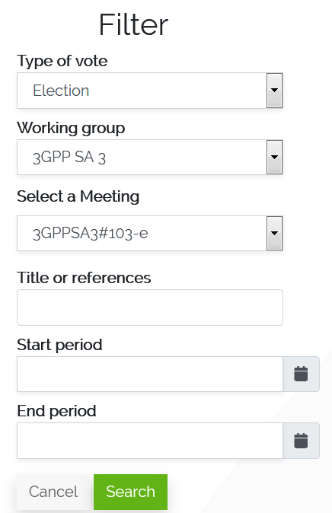

With filter SA3#103-e Chairman Election could be find and details pages could be accessed. An example of an election details page is visible as following.

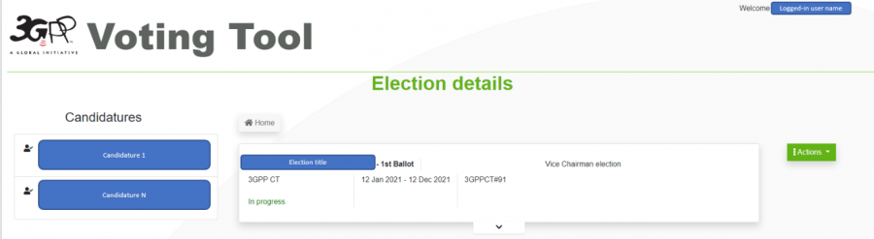

For upcoming election, delegate can submit a candidature via the “Submit candidature for this election” button.

To cast a vote, each ballot has its own voting page. An example of an election ballot’s voting page is as below.

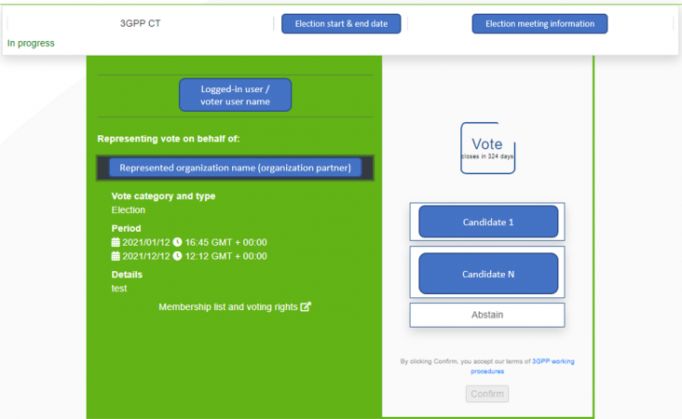

A logged in delegate who wants to cast a vote, can select the desired voting option on the right, i.e. a candidate name or “abstain”. And click on the “Confirm” button. Once the “Confirm” button is clicked, a pop-up message appears with a summary of the voting member represented and the voting option chosen. The user must verify the details and confirm them, by clicking on “Confirm” again.

## 5.3 Time line

Candidate shall submit his/her files before 11:00 UTC at 30th April, due to 3GPP working procedure that deadline expires at noon Central European Time on the Friday which falls between 20 and 14 days prior to the first day of the meeting

Delegate shall be registered before 13:00 UTC, Monday 17 May 2021. After this time, delegates will not be able to de-register and register for a different IM.

The 1st ballot will be started at 13:00 UTC, Tuesday 18 May 2021 and closed 24 hours later, i.e. 13:00 UTC, Wendesday 19 May 2021. The result of the election is announced.

If needed, the 2nd ballot will be started one day later, at 13:00 UTC, Thursday 20 May 2021 and closed at 13:00 UTC, Friday 21 May 2021. After that, result of the election is announced.

Editor’s Note: The voting time will be changed from 24 hours to 18 hours. The time line will be updated when the changes is formally approved in PCG/OP level.

## 5.4 Meeting authority

Once new chairman is elected, he/she can hold the position and chair the meeting immediately.

# Annex A: Handling of living documents

A living document is a document maintained by a rapporteur or a delegate to record the progress on a particular topic. This is usually the case when a TR or TS are not available. Contributions to the topic are brought as pCRs to the living document. Therefore, it is important that the latest version of the living document, i.e. the baseline, is made available in due time. Since unlike draft TRs, living documents are entirely maintained by the responsible delegate, the following guidelines are proposed to harmonize the handling of living documents.

As an example, we assume a Work Item **EX_WI** targeting two different TSes example **TS 33.601**, **TS 33.602**. Typically, in such case, the progress would be recorded in two living documents of type **draftCR** each pertaining to a specification and both maintained by the rapporteur. To ensure that the baseline is available in time, the following handling rules apply:

* A living document is to be submitted by the responsible delegate to each meeting where the topic is covered. In the example above the rapporteur must submit the latest version of the draftCRs in each meeting where **EX_WI** is in the agenda.
* The title of a living document must be of the form "**Living document for *<****feature or WI acronym****>****<: optionally any informative text>*". For example: "**Living document for EX_WI: draftCR to TS 33.601**".
* Contributions to a living document are to be reserved in the 3GU Portal as type **"Other"**.
* By the end of any meeting where the topic is treated, the living document must be revised by the responsible delegate to include the approved input documents if any. The revised living document becomes then the baseline for the next meeting and any future contributions. In the example, the rapporteur must revise the two draftCRs to include any approved input documents. The revisions are typically sent for email approval similarly to how new draft TRs and draft TSes are handled.
* When the work is completed or mature enough, the responsible delegate may propose that the living document is no longer needed and undertake the necessary actions to implement the outcome of the work on the topic. In the example, the rapporteur must convert the **draftCRs** to **CRs** to be agreed by the group. From that point on, there is no longer need for the draftCRs.

Mirko Cano Soveri [mirko.cano@etsi.org](mailto:mirko.cano@etsi.org)

MCC Technical Officer