3GPP TSG-SA3 Meeting #88-LI-e-a s3i230087

Online, , 23rd Jan 2023 - 27th Jan 2023
CR-Form-v12.2
CHANGE REQUEST
 | 33.127 | CR | 0205 | rev | 1 | Current version: | 18.2.0
For HELP on using this form: comprehensive instructions can be found at
http://www.3gpp.org/Change-Requests.

Proposed change affects: | UICC apps |  | ME |  | Radio Access Network |  | Core Network | X

Title: | Alignment of Cell Site Information reporting Stage 2
Source to WG: | SA3- LI (OTD)
Source to TSG: | SA3
Work item code: | LI18 |  |  |  |  |  | Date: |  |  | 26 Jan 2023
Category: | C |  |  |  |  |  | Release: |  |  | Rel-18
 | Use one of the following categories:  F (correction)  A (mirror corresponding to a change in an earlier release)  B (addition of feature),  C (functional modification of feature)  D (editorial modification)  Detailed explanations of the above categories can  be found in 3GPP TR 21.900. |  |  |  |  |  |  |  | Use one of the following releases:  Rel-8 (Release 8)  Rel-9 (Release 9)  Rel-10 (Release 10)  Rel-11 (Release 11)  …  Rel-16 (Release 16)  Rel-17 (Release 17)  Rel-18 (Release 18)  Rel-19 (Release 19)
Reason for change: |  | There is currently a mismatch between the naming conventions of cell supplemental information in 33.127 vs the cell site report in 33.128. This CR aligns the terminology while adding new capability to report cell radio related information as part of cell database reporting.
Summary of change: |  | Add abbreviations for CSR and CRRR, Modification of text in clause 7.3.1, Modification of text in clause 7.3.4, Correction to diagram in Figure 7.3.4-1
Consequences if not approved: |  | There will be a mismatch of text in 33.127 and 33.128. Information available and reportable to LEAs will be missing.
Clauses affected: |  | 3.3, 7.3.1, 7.3.4, Figure 7.3.4-1
 |  | Y | N
Other specs |  |  | X | Other core specifications |  |  |  | TS/TR ... CR ...
affected: |  |  | X | Test specifications |  |  |  | TS/TR ... CR ...
(show related CRs) |  |  | X | O&M Specifications |  |  |  | TS/TR ... CR ...
Other comments:
This CR's revision history: |  | Was s3i230040

START OF FIRST CHANGE
END OF FIRST CHANGE

3.3 Abbreviations
For the purposes of the present document, the abbreviations given in 3GPP TR 21.905 [1] and the following apply. An abbreviation defined in the present document takes precedence over the definition of the same abbreviation, if any, in 3GPP TR 21.905 [1].
5GC 5G Core Network
5GMS 5G Media Streaming
5GS 5G System
AAnF AKMA Anchor Function
AC Application Client
ACR Application Context Relocation
ADMF LI Administration Function
AF Application Function
AF_ID Application Function Identity
AKA Authentication and Key Agreement
A-KID AKMA Key IDentifier
AKMA Authentication and Key Management for Applications
AMF Access and Mobility Management Function
AS Application Server
AUSF Authentication Server Function
BBIFF Bearer Binding Intercept and Forward Function
BSS Business Support System
CAG Closed Access Group
CC Content of Communication
CP Control Plane
CPIM Common Presence and Instant Messaging
CPS Call Placement Service
CRRR Cell Radio Related Report
CSI Cell Supplemental Information
CSP Communication Service Provider
CSR Cell Site Report
CUPS Control and User Plane Separation
DN Data Network
DNAI Data Network Access Identifier
DoNAS Data over NAS
EAP Extensible Authentication Protocol
EAS Edge Application Server
eCNAM Enhanced Calling Name
ECSP Edge Computing Service Provider
E-CSCF Emergency – Call Session Control Function
EDN Edge Data Network
EEC Edge Enabler Client
EECID Edge Enabler Client IDentifier
EES Edge Enabler Server
GPSI Generic Public Subscription Identifier
HMEE Hardware Mediated Execution Enclave
HR Home Routed
IBCF Interconnection Border Control Functions
ICF Identity Caching Function
IEF Identity Event Function
IMS-AGW IMS Access Gateway
IM-MGW IM Media Gateway
IP Interception Product
IQF Identity Query Function
IRI Intercept Related Information
K_{AF} AKMA Application Key
K_{AKMA} AKMA Anchor Key
KID Key IDentifier
K_{LI} Decryption key(s) for services encrypted by CSP-provided keys
KSF Key Server Function
LAF Location Acquisition Function
LALS Lawful Access Location Services
LARF Location Acquisition Requesting Function
LBO Local Break Out
LEA Law Enforcement Agency
LEMF Law Enforcement Monitoring Facility
LI Lawful Interception
LI CA Lawful Interception Certificate Authority
LICF Lawful Interception Control Function
LI_HI1 Lawful Interception Handover Interface 1
LI_HI2 Lawful Interception Handover Interface 2
LI_HI3 Lawful Interception Handover Interface 3
LI_HI4 Lawful Interception Handover Interface 4
LI_HILA Lawful Interception Handover Interface Location Acquisition
LI_HIQR Lawful Interception Handover Interface Query Response
LIID Lawful Interception Identifier
LIPF Lawful Interception Provisioning Function
LIR Location Immediate Request
LI_SI Lawful Interception System Information Interface
LISSF Lawful Interception State Storage Function
LI_ST Lawful Interception State Transfer Interface
LI_T1 Lawful Interception Internal Triggering Interface 1
LI_T2 Lawful Interception Internal Triggering Interface 2
LI_T3 Lawful Interception Internal Triggering Interface 3
LI_X0 Lawful Interception Internal Interface 0
LI_X1 Lawful Interception Internal Interface 1
LI_X2 Lawful Interception Internal Interface 2
LI_X2_LA Lawful Interception Internal Interface 2 Location Acquisition
LI_X3 Lawful Interception Internal Interface 3
LI_X3A Lawful Interception Internal Interface 3 Aggregator
LI_XEM1 Lawful Interception Internal Interface Event Management Interface 1
LI_XER Lawful Interception Internal Interface Event Record
LI_XLA Lawful Interception Internal Interface Location Acquisition
LI_XQR Lawful Interception Internal Interface Query Response
LMF Location Management Function
LMISF LI Mirror IMS State Function
LMISF-CC LMISF for the handling of CC
LMISF-IRI LMISF for the handling of IRI
LTF Location Triggering Function
MA Multi-Access
MANO Management and Orchestration
MDF Mediation and Delivery Function
MDF2 Mediation and Delivery Function 2
MDF3 Mediation and Delivery Function 3
MRFP Multimedia Resource Function Processor
MSRP Message Session Relay Protocol
N3A Non-3GPP Access
N3IWF Non 3GPP Inter Working Function
N9HR N9 Home Routed
NAS Non-Access Stratum
NCGI NR Cell Global Identity
NEF Network Exposure Function
NFV Network Function Virtualisation
NFVI Network Function Virtualisation Infrastructure
NFVO Network Function Virtualisation Orchestrator
NIDD Non-IP Data Delivery
NPLI Network Provided Location Information
NR New Radio
NRF Network Repository Function
NSSF Network Slice Selection Function
OSS Operations Support System
PAG POI Aggregator
PCF Policy Control Function
P-CSCF Proxy - Call Session Control Function
PEI Permanent Equipment Identifier
PGW PDN Gateway
PGW-C PDN Gateway Control Plane
PGW-U PDN Gateway User Plane
POI Point Of Interception
PLMN Public Land Mobile Network
PTC Push to Talk over Cellular
RCD Rich Call Data
RCS Rich Communication Suite
S8HR S8 Home Routed
SCEF Service Capability Exposure Function
SCS Service Capability Server
SGW Serving Gateway
SGW-C Serving Gateway Control Plane
SGW-U Serving Gateway User Plane
SHAKEN Signature-based Handling of Asserted information using toKENs
SIRF System Information Retrieval Function
S-CSCF Serving - Call Session Control Function
SIP Session Initiation Protocol
SMF Session Management Function
SMSF SMS-Function
STF Security Terminating Function
STIR Secure Telephony Identity Revisited
SUCI Subscriber Concealed Identifier
SUPI Subscriber Permanent Identifier
TAI Tracking Area Identity
TF Triggering Function
TLS Transport Layer Security
TNGF Trusted Non-3GPP Gateway Function
TrGW Transit Gateway
TWIF Trusted WLAN Interworking Function
UDM Unified Data Management
UDR Unified Data Repository
UDSF Unstructured Data Storage Function
UPF User Plane Function
VNF Virtual Network Function
VNFC Virtual Network Function Component
W-AFG Wireline Access Gateway Function
xCC LI_X3 Content of Communication
xIRI LI_X2 Intercept Related Information

END OF FIRST CHANGE
START OF SECOND CHANGE

7.3 Location

7.3.1 General
This clause provides location reporting functionality for both UE location obtained as part of normal network access or user service usage and location actively triggered through location based services or other LALS reporting.
In addition, clause 7.3.4 describes Cell Supplemental Information (CSI) (e.g., civic address, geographical coordinates, azimuth, or operator specific information) derived from CSP databases.
For all UE locations obtained, generated or reported to the MDF2, the POI shall report the time at which the location was established by the location source (e.g. AMF, MME or HSS/UDM) and provide this to the MDF along with the location information.
For all UE locations obtained, generated or reported to the ICF, the IEF shall report the time at which the location was established by the location source (e.g. AMF) and provide this to the ICF along with the location information.
END OF SECOND CHANGE
START OF THIRD CHANGE

7.3.4 Cell database information reporting
When a cell identity is provided for the target's location in an IRI message, the CSP may also provide CSI for the reported cell identity. The CSI can be delivered in two types of information reports, Cell Site Reports (CSR) and Cell Radio Related Reports (CRRR). The MDF2 may retrieve CSI by access to a CSP maintained database (referred to as CSP Cell Database) as shown in figure 7.3.4-1. The CSP delivers the CSI either via the IRI message generated from the corresponding xIRI, or asynchronously in a stand-alone Cell Site Report (CSR) IRI message.
The following information shall be delivered when CSI is provided in IRI message or a MDF2 generated CSR:
- LIID.
- Cell identity.
- Date/time(s) established by MDF2.
- Cell site information.
CSR shall include the physical location (e.g. geographical coordinates) information and coverage area for the reported cell. If the reported cell is not fixed to a permanent location, the report should indicate the cell mobility type (e.g. nomadic cell, vehicle-mounted cell) as well as the time period of the location validity.
If CSI for a cell identity has been previously reported to the LEMF for the current interception, CSI may be omitted, if allowed by the warrant unless the CSI is for a cell that is not fixed to a permanent location.
CRRR includes specific information related to the reported cell. This information may be reported from the NG Interface or F1 interface and may include globalRANNode ID, radio band, PLMNs supported, and other operator specific information that may be reported independently from CSR.
If the CSP does not support CSR or CSI, the database can be provided by non-real-time means.

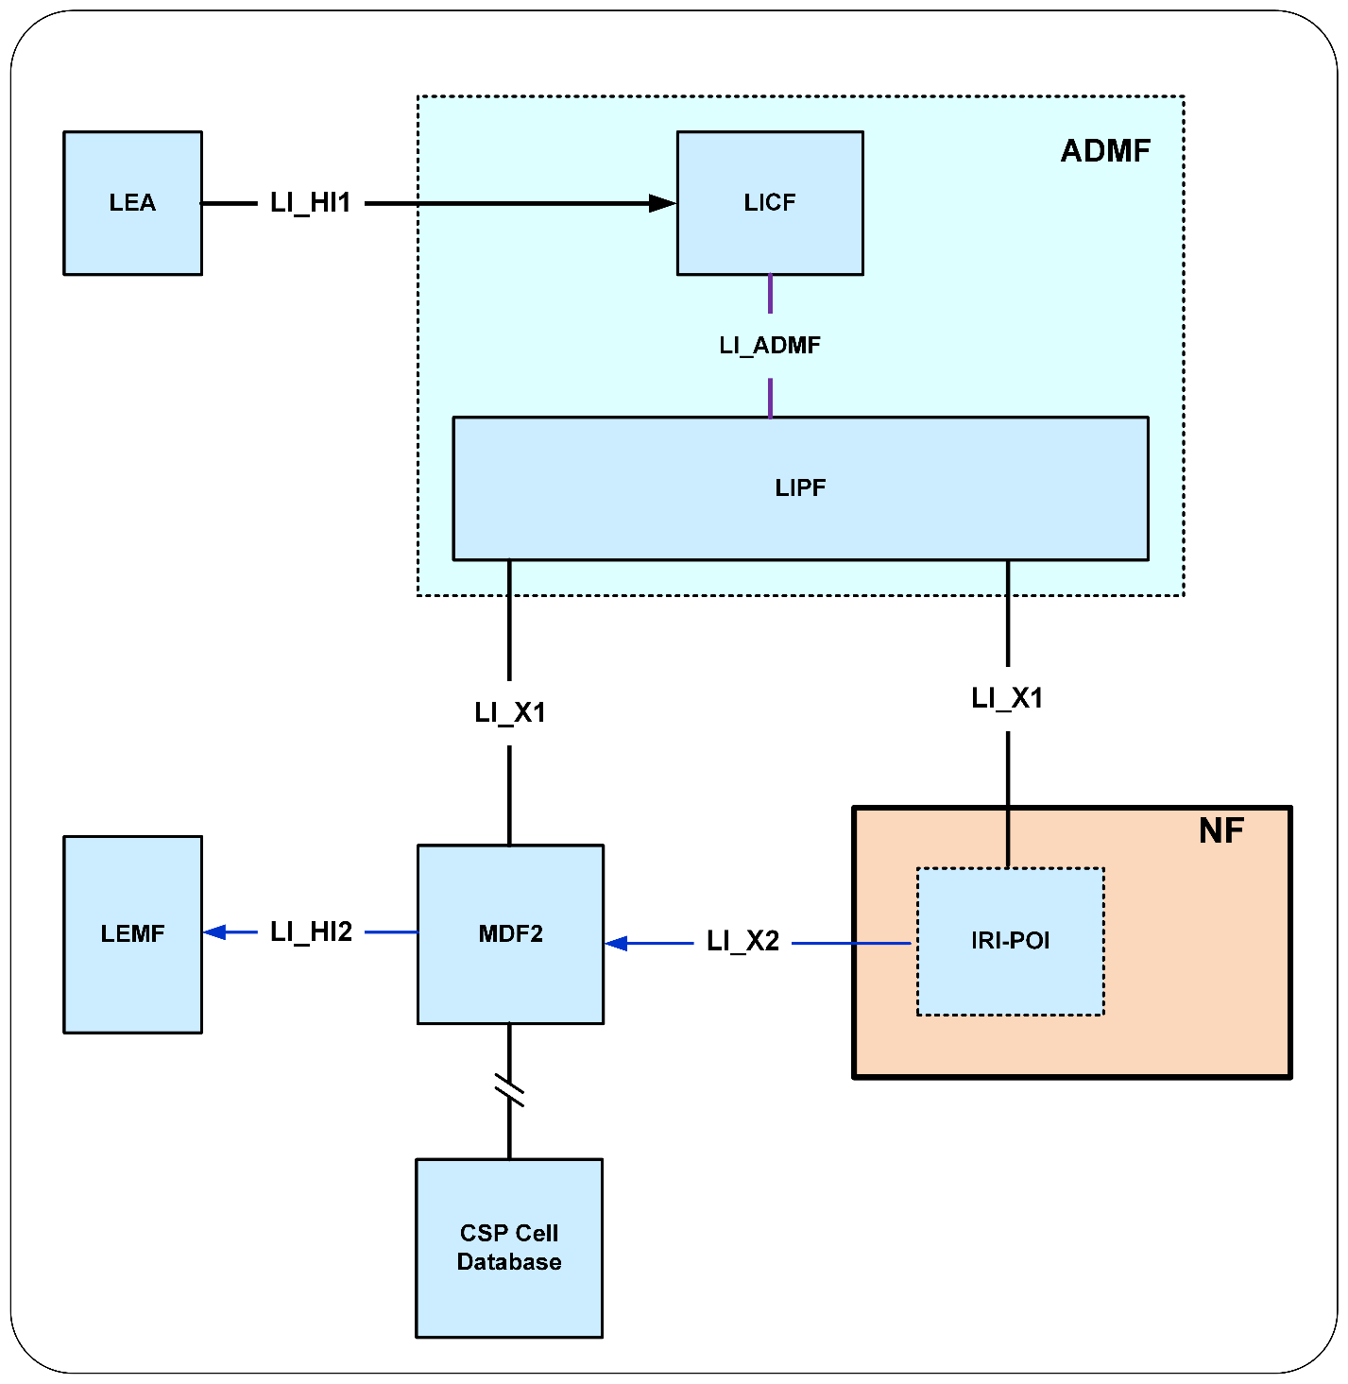Figure 7.3.4-1: CSP Cell Database

END OF THIRD CHANGE
END OF ALL CHANGES

