3GPP TSG-SA3 Meeting #88-LI-e-a s3i230087

Online, , 23rd Jan 2023 - 27th Jan 2023
CR-Form-v12.2
CHANGE REQUEST
 | 33.127 | CR | 0205 | rev | 1 | Current version: | 18.2.0
For HELP on using this form: comprehensive instructions can be found at
http://www.3gpp.org/Change-Requests.

Proposed change affects: | UICC apps |  | ME |  | Radio Access Network |  | Core Network | X

Title: | Alignment of Cell Site Information reporting Stage 2
Source to WG: | SA3- LI (OTD)
Source to TSG: | SA3
Work item code: | LI18 |  |  |  |  |  | Date: |  |  | 25 Jan 2023
Category: | C |  |  |  |  |  | Release: |  |  | Rel-18
 | Use one of the following categories:  F (correction)  A (mirror corresponding to a change in an earlier release)  B (addition of feature),  C (functional modification of feature)  D (editorial modification)  Detailed explanations of the above categories can  be found in 3GPP TR 21.900. |  |  |  |  |  |  |  | Use one of the following releases:  Rel-8 (Release 8)  Rel-9 (Release 9)  Rel-10 (Release 10)  Rel-11 (Release 11)  …  Rel-16 (Release 16)  Rel-17 (Release 17)  Rel-18 (Release 18)  Rel-19 (Release 19)
Reason for change: |  | There is currently a mismatch between the naming conventions of cell supplemental information in 33.127 vs the cell site report in 33.128. This CR aligns the terminology while adding new capability to report cell radio related information as part of cell database reporting.
Summary of change: |  | Modification of text in clause 7.3.1, Modification of text in clause 7.3.4, Correction to diagram in Figure 7.3.4-1
Consequences if not approved: |  | There will be a mismatch of text in 33.127 and 33.128. Information available and reportable to LEAs will be missing.
Clauses affected: |  | 7.3.1, 7.3.4, Figure 7.3.4-1
 |  | Y | N
Other specs |  |  | X | Other core specifications |  |  |  | TS/TR ... CR ...
affected: |  |  | X | Test specifications |  |  |  | TS/TR ... CR ...
(show related CRs) |  |  | X | O&M Specifications |  |  |  | TS/TR ... CR ...
Other comments:
This CR's revision history: |  | Was s3i230040

START OF CHANGES
START OF FIRST CHANGE

7.3 Location

7.3.1 General
This clause provides location reporting functionality for both UE location obtained as part of normal network access or user service usage and location actively triggered through location based services or other LALS reporting.
In addition, clause 7.3.4 describes Cell Supplemental Information (CSI) (e.g., civic address, geographical coordinates, azimuth, or operator specific information) derived from CSP databases.
For all UE locations obtained, generated or reported to the MDF2, the POI shall report the time at which the location was established by the location source (e.g. AMF, MME or HSS/UDM) and provide this to the MDF along with the location information.
For all UE locations obtained, generated or reported to the ICF, the IEF shall report the time at which the location was established by the location source (e.g. AMF) and provide this to the ICF along with the location information.
END OF FIRST CHANGE
START OF SECOND CHANGE

7.3.4 Cell database information reporting
When a cell identity is provided for the target's location in an IRI message, the CSP may also provide CSI for the reported cell identity. The CSI can be delivered in two types of information reports, Cell Site Reports and Cell Radio Related Reports. The MDF2 may retrieve CSI by access to a CSP maintained database (referred to as CSP Cell Database) as shown in figure 7.3.4-1. The CSP delivers the CSI either via the IRI message generated from the corresponding xIRI, or asynchronously in a stand-alone Cell Site Report (CSR) IRI message.
The following information shall be delivered when CSI is provided in IRI message or a MDF2 generated CSR:
- LIID.
- Cell identity.
- Date/time(s) established by MDF2.
- Cell site information.
Cell Site Reports (CSR) shall include the physical location (e.g. geographical coordinates) information and coverage area for the reported cell. If the reported cell is not fixed to a permanent location, the report should indicate the cell mobility type (e.g. nomadic cell, vehicle-mounted cell) as well as the time period of the location validity.
If CSI for a cell identity has been previously reported to the LEMF for the current interception, CSI may be omitted, if allowed by the warrant unless the CSI is for a cell that is not fixed to a permanent location.
Cell Radio Related Reports (CRRR) includes specific information related to the reported cell. This information may be reported from the NG Interface or F1 interface and may include globalRANNode ID, radio band, PLMNs supported, and other operator specific information that may be reported independently from CSR.
If the CSP does not support CSR or CSI, the database can be provided by non-real-time means.

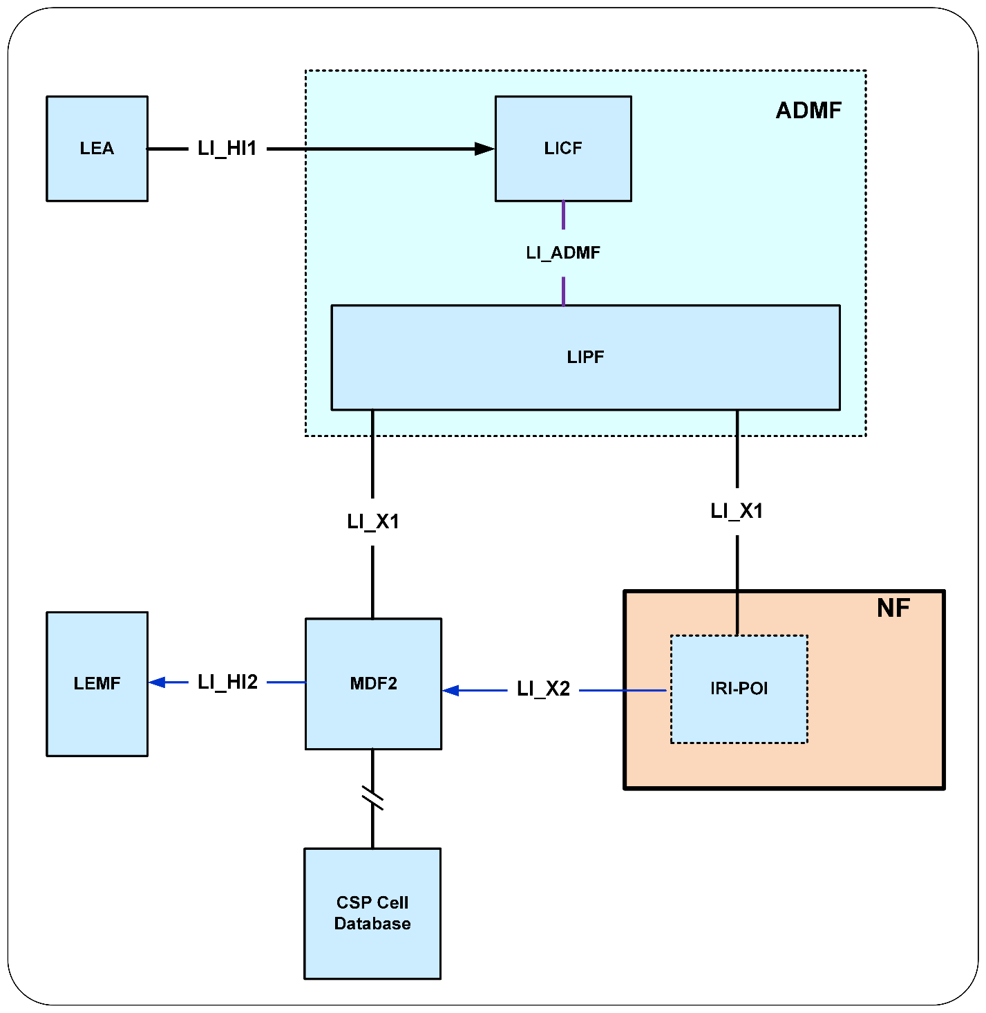Figure 7.3.4-1: CSP cell database

END OF SECOND CHANGE
END OF ALL CHANGES

