3GPP TSG-SA3 Meeting #81-LI-e-b s3i210347

Online, , 19th May 2021 - 21st May 2021
CR-Form-v12.1
CHANGE REQUEST
 | 33.127 | CR | 0132 | rev | 1 | Current version: | 17.0.0
For HELP on using this form: comprehensive instructions can be found at
http://www.3gpp.org/Change-Requests.

Proposed change affects: | UICC apps |  | ME |  | Radio Access Network |  | Core Network | X

Title: | Correction to LI Architecture for the SGW/PGW
Source to WG: | SA3-LI(OTD)
Source to TSG: | SA3
Work item code: | LI17 |  |  |  |  |  | Date: |  |  | 2021-05-19
Category: | B |  |  |  |  |  | Release: |  |  | Rel-17
 | Use one of the following categories:  F (correction)  A (mirror corresponding to a change in an earlier release)  B (addition of feature),  C (functional modification of feature)  D (editorial modification)  Detailed explanations of the above categories can  be found in 3GPP TR 21.900. |  |  |  |  |  |  |  | Use one of the following releases:  Rel-8 (Release 8)  Rel-9 (Release 9)  Rel-10 (Release 10)  Rel-11 (Release 11)  …  Rel-15 (Release 15)  Rel-16 (Release 16)  Rel-17 (Release 17)  Rel-18 (Release 18)
Reason for change: |  | The current description and diagram for LI at the SGW/PGW do not align and would not function correctly. Additionally, the current text does not provide a solution for CUPS EPS architecture.
Summary of change: |  | Aligns the description of LI architecture at the SGW/PGW with the diagrams and provides a working solution. Also, adds diagrams and descriptions for LI at the SGW/PGW in CUPS EPS architecture.  Moves PDHR/PDSR approaches to a general clause so they can be used by more than one implementation.
Consequences if not approved: |  | LI at the SGW/PGW would not function correctly.
Clauses affected: |  | 3.1, 3.3, 6.3.2.1, 6.3.1, 6.3.3, 7.C1
 |  | Y | N
Other specs |  | X |  | Other core specifications |  |  |  | TS 33.128 CR 0210 and CR 0211
affected: |  |  | X | Test specifications |  |  |  | TS/TR ... CR ...
(show related CRs) |  |  | X | O&M Specifications |  |  |  | TS/TR ... CR ...
Other comments: |  | TS 33.128 CR 0210 (s3i210349) and 0211 s3i210350 reference some of the changes made by this CR.
This CR's revision history: |  | S3i210347

*** Start of First Change ***

3.1 Definitions
For the purposes of the present document, the terms and definitions given in 3GPP TR 21.905 [1] and the following apply. A term defined in the present document takes precedence over the definition of the same term, if any, in 3GPP TR 21.905 [1].
Content of Communication (CC): The content of communication as forwarded from the Mediation and Delivery Function 3 (over the LI_HI3 interface) to the Law Enforcement Monitoring Facility.
Control Plane (CP) Entity: The network elements or network functions responsible for handling the Control Plane Functions. These include the SGW and PGW in EPS without CUPS, the SGW-C and PGW-C in EPS with CUPS and the SMF in 5GS.
CUPS: As defined in 3GPP TS 23.214 [12], represents PLMN with architecture enhancements for control and user plane separation of EPC nodes.
Intercept Related Information (IRI): The intercept related information as forwarded from the Mediation and Delivery Function 2 (over the LI_HI2 interface) to the Law Enforcement Monitoring Facility.
IRI event: The network procedure or event that created an xIRI in the Point Of Interception.
LI component: The function and equipment involved in handling the Lawful Interception functionality in the CSP's network.
Lawful Interception Identifier (LIID): Unique identifier that associates a warrant to Lawful Interception Product delivered by the CSP to the LEA.
LI system: The collection of all LI components involved in handling the Lawful Interception functionality in the CSP's network.
Non-local ID: An identity assigned and managed at a different CSP than the CSP performing LI.
Provisioning: The action taken by the CSP to provide its Lawful Interception functions information that identifies the target and the specific communication services of interest to the LEA, sourced from the LEA provided warrant.
Triggering: The action taken by a dedicated function (Triggering Function) to provide another dedicated function (Triggered POI), that Provisioning could not directly be applied to, with information that identifies the specific target communication to be intercepted.
User Plane (UP) Entity: The network elements or network functions responsible for handling the User Plane Functions. These include the SGW and PGW in EPS without CUPS, the SGW-U and PGW-U in EPS with CUPS and the UPF in 5GS.
Warrant: The formal mechanism to require Lawful Interception from a LEA served to the CSP on a single target identifier. Depending on jurisdiction also known as: intercept request, intercept order, lawful order, court order, lawful order or judicial order (in association with supporting legislation).
xCC: The content of communication as forwarded from the Point Of Interception (over the LI_X3) interface to the Mediation and Delivery Function 3.
xIRI: The intercept related information as forwarded from the Point Of Interception (over the LI_X2) interface to the Mediation and Delivery Function 2.
*** Start of Change 2 of ZXCV ***

3.3 Abbreviations
For the purposes of the present document, the abbreviations given in 3GPP TR 21.905 [1] and the following apply. An abbreviation defined in the present document takes precedence over the definition of the same abbreviation, if any, in 3GPP TR 21.905 [1].
5GC 5G Core Network
5GS 5G System
ADMF LI Administration Function
AMF Access and Mobility Management Function
AS Application Server
AUSF Authentication Server Function
BBIFF Bearer Binding Intercept and Forward Function
BSS Business Support System
CAG Closed Access Group
CC Content of Communication
CP Control Plane
CSI Cell Supplemental Information
CSP Communication Service Provider
CUPS Control and User Plane Separation
DN Data Network
DNAI Data Network Access Identifier
E-CSCF Emergency – Call Session Control Function
GPSI Generic Public Subscription Identifier
HMEE Hardware Mediated Execution Enclave
HR Home Routed
IBCF Interconnection Border Control Functions
ICF Identifier Caching Function
IEF Identifier Event Function
IMS-AGW IMS Access Gateway
IM-MGW IM Media Gateway
IP Interception Product
IQF Identifier Query Function
IRI Intercept Related Information
LALS Lawful Access Location Services
LBO Local Break Out
LEA Law Enforcement Agency
LEMF Law Enforcement Monitoring Facility
LI Lawful Interception
LI CA Lawful Interception Certificate Authority
LICF Lawful Interception Control Function
LI_HI1 Lawful Interception Handover Interface 1
LI_HI2 Lawful Interception Handover Interface 2
LI_HI3 Lawful Interception Handover Interface 3
LI_HI4 Lawful Interception Handover Interface 4
LI_HIQR Lawful Interception Handover Interface Query Response
LIID Lawful Interception Identifier
LIPF Lawful Interception Provisioning Function
LIR Location Immediate Request
LI_SI Lawful Interception System Information Interface
LI_T1 Lawful Interception Internal Triggering Interface 1
LI_T2 Lawful Interception Internal Triggering Interface 2
LI_T3 Lawful Interception Internal Triggering Interface 3
LI_X0 Lawful Interception Internal Interface 0
LI_X1 Lawful Interception Internal Interface 1
LI_X2 Lawful Interception Internal Interface 2
LI_X3 Lawful Interception Internal Interface 3
LI_X3A Lawful Interception Internal Interface 3 Aggregator
LI_XEM1 Lawful Interception Internal Interface Event Management Interface 1
LI_XER Lawful Interception Internal Interface Event Record
LI_XQR Lawful Interception Internal Interface Query Response
LMF Location Management Function
LMISF LI Mirror IMS State Function
LMISF-CC LMISF for the handling of CC
LMISF-IRI LMISF for the handling of IRI
LTF Location Triggering Function
MA Multi-Access
MANO Management and Orchestration
MDF Mediation and Delivery Function
MDF2 Mediation and Delivery Function 2
MDF3 Mediation and Delivery Function 3
MRFP Multimedia Resource Function Processor
N9HR N9 Home Routed
N3IWF Non 3GPP Inter Working Function
NFV Network Function Virtualisation
NFVI Network Function Virtualisation Infrastructure
NFVO Network Function Virtualisation Orchestrator
NPLI Network Provided Location Information
NR New Radio
NRF Network Repository Function
NSSF Network Slice Selection Function
OSS Operations Support System
PAG POI Aggregator
PCF Policy Control Function
P-CSCF Proxy - Call Session Control Function
PEI Permanent Equipment Identifier
PGW PDN Gateway
PGW-C PDN Gateway Control Plane
PGW-U PDN Gateway User Plane
POI Point Of Interception
PLMN Public Land Mobile Network
PTC Push to Talk over Cellular
S8HR S8 Home Routed
SGW Serving Gateway
SGW-C Serving Gateway Control Plane
SGW-U Serving Gateway User Plane
SIRF System Information Retrieval Function
S-CSCF Serving - Call Session Control Function
SMF Session Management Function
SMSF SMS-Function
SUCI Subscriber Concealed Identifier
SUPI Subscriber Permanent Identifier
TF Triggering Function
TrGW Transit Gateway
UDM Unified Data Management
UDR Unified Data Repository
UDSF Unstructured Data Storage Function
UPF User Plane Function
VNF Virtual Network Function
VNFC Virtual Network Function Component
xCC LI_X3 Communications Content
xIRI LI_X2 Intercept Related Information
*** Start of Change 3 of ZXCV ***

6.2.3.1 Architecture
In the 5GC network, user plane functions are separated from the control plane functions. The SMF that handles control plane actions (e.g. establishing, modifying, deleting) for the PDU sessions shall include an IRI-POI that has the LI capability to generate the related xIRI. The UPF that handles the user plane data shall include a CC-POI that has have the capability to duplicate the user plane packets from the PDU sessions based on the interception rules received from the SMF. Figure 6.2-4 shows the LI architecture for SMF/UPF based interception.
Figure 6.2-4: LI architecture showing LI at SMF/UPF
The LICF present in the ADMF receives the warrant from an LEA, derives the intercept information from the warrant and provides it to the LIPF.
The LIPF present in the ADMF provisions IRI-POI (present in the SMF), MDF2 and MDF3 over the LI_X1 interfaces. To enable the interception of the target's user plane packets (e.g. when the warrant requires the interception of communication contents), the CC-TF present in the SMF is also provisioned with the intercept data.
NOTE 1: The IRI-POI and CC-TF represented in figure 6.2-4 are logical functions and require correlation information be shared between them; they may be handled by the same process within the SMF.
The LIPF may interact with the SIRF (over LI_SI) present in the NRF to discover the SMFs and UPFs in the network. The IRI-POI present in the SMF detects the PDU session establishment, modification, and deletion related events, generates and delivers the related xIRI to the MDF2 over LI_X2. The MDF2 delivers the IRI messages to the LEMF over LI_HI2.
When interception of communication contents is required, the CC-TF present in the SMF sends a trigger to the CC-POI present in the UPF over the LI_T3 interface.
The trigger sent from the CC-TF to CC-POI includes the following information:
- User plane packet detection rules.
- Target identity.
- Correlation information.
- MDF3 address.
NOTE 2: When LI_T3 is used, the LI_X1 between LIPF and CC-POI present in the UPF is used to monitor the user plane data.
The CC-POI present in the UPF generates the xCC from the user plane packets and delivers the xCC (that includes the correlation number and the target identity) to the MDF3. The MDF3 delivers the CC to the LEMF over LI_HI3.
A warrant that does not require the interception of communication contents, may require IRI messages that have to be derived from the user plane packets. To support the generation of related xIRI (i.e. that requires access to the user plane packets), the present document supports two implementation approaches

as described in clause 7.C1.2.

Clause 8.6.2 defines a CC-PAG (CC-POI Aggregator) as an architectural extension option that is located between the MDF3 and CC-POI and performs the function of aggregating the xCC from different CC-POIs towards the MDF3.
*** Start of Change 3 of ZXCV ***

6.3.1 General
The present document specifies two options for EPC interception capabilities:
1. Use TS 33.107 [11] and TS 33.108 [21] natively as defined in those documents;
2. Use the capabilities specified below in the present document for stage 2 and in TS 33.128 [15] for stage 3.

*** Start of Change 4 of ZXCV ***

6.3.3 LI at SGW/PGW

6.3.3.1 Architecture

6.3.3.1.C1 General
In the EPC network, the SGW is the gateway which terminates the user plane interface as specified in TS 23.401 [22]. The PGW is the gateway which terminates the SGi interface towards the PDN as specified in TS 23.401 [22]. Additionally, the PGW is the user plane anchor for mobility between 3GPP access and non-3GPP access as specified in TS 23.402 [23].
NOTE 1: The present document supports LI for non-3GPP accesses connected to EPC using GTP-based S2a or GTP-based S2b as specified by TS 23.402 [23]. Other scenarios are covered by TS 33.107 [11].
As defined in 3GPP TS 23.214 [75], the SGW and PGW may have separated control plane and user plane functions (CUPS). The control plane (CP) functions (SGW-C and PGW-C) provide the traffic forwarding rules (referred to as Forward Action Rules in 3GPP TS 23.214 [75]) to the user plane (UP) functions (SGW-U and PGW-U). The UP functions forward the user plane traffic as per the Forward Action Rules.
In the following clauses, EPS architecture that does not separate the control plane and user plane functions of the SGW/PGW is referred to as non-CUPS EPS.
The LI architecture for non-CUPS EPS is defined in clause 6.3.3.1.C2. For non-CUPS EPS architecture, the SGW and PGW function as both CP Entities and the UP Entities.
The LI architecture for CUPS EPS is defined in clause 6.3.3.1.C3. For CUPS EPS architecture:
- The CP Entities are the SGW-C and the PGW-C.
- The UP Entities are the SGW-U and the PGW-U.
When CUPS architecture is used, unless otherwise specified, the term SGW/PGW refers to both the SGW-U/PGW-U and the SGW-C/PGW-C except in the following cases:
- The IRI-POI, IRI-TF and CC-TF are located in the SGW-C/PGW-C.
- The CC-POI is located in the SGW-U/PGW-U.
The SGW and PGW shall include an IRI-POI that has the LI capabilities to generate the target UE’s bearer related xIRI.
In addition, the SGW and PGW shall include a CC-POI that has the LI capabilities to duplicate the user plane packets from the EPS bearers related to a target UE.

6.3.3.1.C2 Non-CUPS architecture
Figure 6.3-2 shows the LI architecture for non-CUPS SGW/PGW based interception.

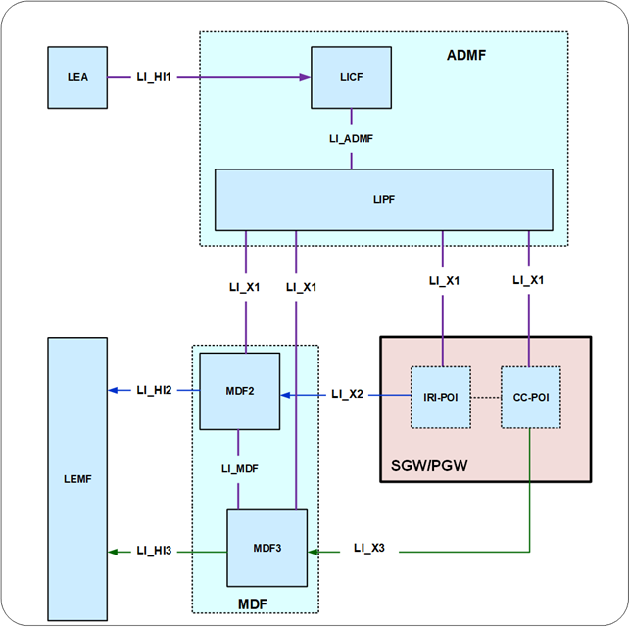
Figure 6.3-2: LI architecture for LI at non-CUPS SGW/PGW
The LICF present in the ADMF receives the warrant from an LEA, derives the intercept information from the warrant and provides the same to the LIPF.
The LIPF present in the ADMF provisions IRI-POI present in the SGW/PGW, MDF2 and MDF3 over the LI_X1 interfaces. To enable the interception of the target's user plane packets (e.g. when the warrant requires the interception of communication contents), the CC-POI present in the SGW/PGW is also provisioned with the intercept data.
NOTE 2: The IRI-POI and CC-POI represented in figure 6.3-2 are logical functions and require correlation information be shared between them; they may be handled by the same process within the SGW/PGW.
The IRI-POI present in the SGW/PGW detects the target UE's bearer activation, modification and deactivation, generates and delivers the xIRI to the MDF2 over LI_X2. The MDF2 delivers the IRI messages to the LEMF over LI_HI2.
The CC-POI present in the SGW/PGW generates the xCC from the user plane packets and delivers the xCC (that includes the correlation number and the target identity) to the MDF3. The MDF3 delivers the CC to the LEMF over LI_HI3.
A warrant that does not require the interception of communication contents, may require IRI messages that have to be derived from the user plane packets. To support the generation of related xIRI (i.e. that requires access to the user plane packets), the present document supports two implementation approaches described in clause 7.C1.2.

6.3.3.1.C3 EPS CUPS Architecture
Figure 6.3-Fi1 shows the LI architecture for EPS CUPS SGW/PGW based interception.
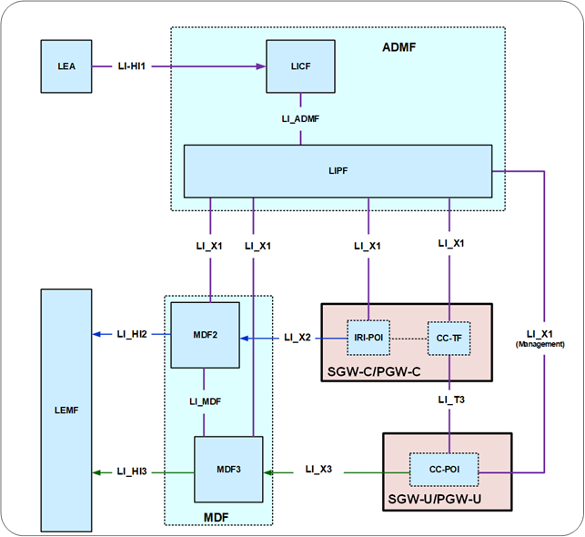
Figure 6.3-Fi1: LI architecture for LI at EPS CUPS SGW/PGW
The LICF present in the ADMF receives the warrant from an LEA, derives the intercept information from the warrant and provides the same to the LIPF.
The LIPF present in the ADMF provisions IRI-POI present in the SGW-C/PGW-C and the MDF2 over the LI_X1 interfaces. To enable the interception of the target's user plane packets (e.g. when the warrant requires the interception of communication contents), the CC-TF present in the SGW-C/PGW-C is also provisioned with the intercept data.
NOTE 1: The IRI-POI and CC-TF represented in figure 6.3-Fi1 are logical functions and require correlation information be shared between them; they may be handled by the same process within the SGW-C/PGW-C.
The IRI-POI present in the SGW-C/PGW-C detects the target UE's bearer activation, modification and deactivation and generates and delivers the xIRI to the MDF2 over LI_X2. The MDF2 delivers the IRI messages to the LEMF over LI_HI2.
The CC-TF present in the SGW-C/PGW-C detects the target UE's bearer activation, modification and deactivation and provisions the CC-POI in the SGW-U/PGW-U.
The CC-POI present in the SGW-U/PGW-U generates the xCC from the user plane packets and delivers the xCC (that includes the correlation number and the target identity) to the MDF3. The MDF3 delivers the CC to the LEMF over LI_HI3.
A warrant that does not require the interception of communication contents, may require IRI messages that have to be derived from the user plane packets. To support the generation of related xIRI (i.e. that requires access to the user plane packets), the present document supports two implementation approaches described in clause 7.C1.2.

6.3.3.2 Target identities
The target identities which the LIPF provisions to the IRI-POI and CC-POI present in the SGW/PGW with the following target identities:
- IMSI.
- MSISDN.
- ME (Mobile Equipment) Identity.
The interception performed on the above three identities are mutually independent, even though, an xIRI may contain the information about the other identities when available.

6.3.3.3 IRI events
The IRI-POI present in the SGW/PGW shall generate xIRI, when it detects the applicable events specified in TS 33.107 [11].

6.3.3.4 Common IRI parameters
The list of xIRI parameters are specified in TS 33.128 [15]. All xIRI shall include the following:
- Target identity.
- Time stamp.
- Correlation information.
- Location information.

6.3.3.5 Specific IRI parameters
The parameters in each xIRI are defined in TS 33.128 [15].

6.3.3.6 Network topologies
The SGW shall provide the IRI-POI and CC-POI functions (and the IRI-TF and CC-TF in CUPS architecture) in the following network topology cases:
- Based on the deployment option, in a non-roaming case for E-UTRAN.
- Roaming case, in VPLMN.
The PGW shall provide the IRI-POI and CC-POI functions (and the IRI-TF and CC-TF in CUPS architecture) in the following network topology cases:
- Based on the deployment option, in a non-roaming case for E-UTRAN.
- Roaming case, in HPLMN.
- Non-3GPP access case, in the HPLMN.
For the case of access to EPC via E-UTRAN, in case of non-roaming, at least one between SGW and PGW shall provide the IRI-POI and CC-POI (and the IRI-TF and CC-TF in CUPS architecture).
When the target UE has multiple bearers active, the generation and delivery of xCC for each bearer shall be done independently, each with separate correlation information.

7.C1 Data

7.C1.1 General
This clause provides additional details on LI architecture, requirements and functionality for data services.

7.C1.2 Packed Header Information Reporting
A warrant that does not require the interception of communication contents, may require IRI messages that have to be derived from the user plane packets. To support the generation of related xIRI (i.e. that requires access to the user plane packets), the present document supports two implementation approaches:
- In approach 1, xIRI (that includes the correlation number and the target identity) is generated by the IRI-POI in the UP Entity. The IRI-POI generates the xIRI from the user plane packets and sends it to the MDF2. The MDF2 generates the IRI messages and send them to the LEMF.
- In approach 2, xCC is generated by the CC-POI in the UP Entity as if the warrant involves the interception of communication contents. To enable this, the CC-POI is presumed to be present and provisioned in the UP Entity even when the warrant does not require the interception of communication contents. The CC-POI generates the xCC and sends it to the MDF3. The MDF3 (based on the provisioned intercept information) does not generate and deliver the CC to the LEMF. Instead, the MDF3 forwards the xCC to the MDF2 over LI_MDF interface. The MDF2 then generates the IRI messages from xCC and delivers those IRI messages to the LEMF.
In 5GS and CUPS EPS, the POI in the UP Entity requires a trigger to enable it to detect the user plane packets. The corresponding Triggering Function (IRI-TF or CC-TF) resides in the CP Entity that has the IRI-POI for the generation of other xIRI. The trigger sent by the IRI-TF or CC-TF to the corresponding POI includes the following:
- User plane packet detection rules.
- Target identity.
- Correlation information.
- MDF2 address.
*** End of all Changes ***

