3GPP SA3LI#81-e-b s3i210325

eMeeting, , 19-21 May 2021
CR-Form-v12.1
CHANGE REQUEST
 | 33.127 | CR | 0126 | rev | 1 | Current version: | 16.7.0
For HELP on using this form: comprehensive instructions can be found at
http://www.3gpp.org/Change-Requests.

Proposed change affects: | UICC apps |  | ME |  | Radio Access Network |  | Core Network | X

Title: | LI state transfers in SMF sets
Source to WG: | SA3 LI (PIDS)
Source to TSG: | SA3
Work item code: | LI16 |  |  |  |  |  | Date: |  |  | 2021-05-19
Category: | B |  |  |  |  |  | Release: |  |  | Rel-16
 | Use one of the following categories:  F (correction)  A (mirror corresponding to a change in an earlier release)  B (addition of feature),  C (functional modification of feature)  D (editorial modification)  Detailed explanations of the above categories can  be found in 3GPP TR 21.900. |  |  |  |  |  |  |  | Use one of the following releases:  Rel-8 (Release 8)  Rel-9 (Release 9)  Rel-10 (Release 10)  Rel-11 (Release 11)  …  Rel-15 (Release 15)  Rel-16 (Release 16)  Rel-17 (Release 17)  Rel-18 (Release 18)
Reason for change: |  | SMF sets share SM context information and together handle PDU sessions for a group of users. The same PDU session can be managed by different SMs, requiring the TF in the SMF sets to share LI state information. The behaviour of LI functions in SMF sets is currently undefined and can violate LI requirements. This might also be an issue for other LI functions in the future.
Summary of change: |  | Defining LISSF function and LI_ST interface.
Consequences if not approved: |  | Implementation of LI for SMF sets remains undefined and confusing.
Clauses affected: |  | 3.3, 6.2.3.1, 6.2.3.X, 6.2.7
 |  | Y | N
Other specs |  | X |  | Other core specifications |  |  |  | TS 33.128 CR 0200
affected: |  |  | X | Test specifications |  |  |  | TS/TR ... CR ...
(show related CRs) |  |  | X | O&M Specifications |  |  |  | TS/TR ... CR ...
Other comments:
This CR's revision history:

--------------------------FIRST CHANGE------------------------

3.3 Abbreviations
For the purposes of the present document, the abbreviations given in 3GPP TR 21.905 [1] and the following apply. An abbreviation defined in the present document takes precedence over the definition of the same abbreviation, if any, in 3GPP TR 21.905 [1].
5GC 5G Core Network
5GS 5G System
ADMF LI Administration Function
AMF Access and Mobility Management Function
AS Application Server
AUSF Authentication Server Function
BBIFF Bearer Binding Intercept and Forward Function
BSS Business Support System
CAG Closed Access Group
CC Content of Communication
CP Control Plane
CSI Cell Supplemental Information
CSP Communication Service Provider
CUPS Control and User Plane Separation
DN Data Network
DNAI Data Network Access Identifier
E-CSCF Emergency – Call Session Control Function
GPSI Generic Public Subscription Identifier
HMEE Hardware Mediated Execution Enclave
HR Home Routed
IBCF Interconnection Border Control Functions
ICF Identifier Caching Function
IEF Identifier Event Function
IMS-AGW IMS Access Gateway
IM-MGW IM Media Gateway
IP Interception Product
IQF Identifier Query Function
IRI Intercept Related Information
LALS Lawful Access Location Services
LBO Local Break Out
LEA Law Enforcement Agency
LEMF Law Enforcement Monitoring Facility
LI Lawful Interception
LI CA Lawful Interception Certificate Authority
LICF Lawful Interception Control Function
LI_HI1 Lawful Interception Handover Interface 1
LI_HI2 Lawful Interception Handover Interface 2
LI_HI3 Lawful Interception Handover Interface 3
LI_HI4 Lawful Interception Handover Interface 4
LI_HIQR Lawful Interception Handover Interface Query Response
LIID Lawful Interception Identifier
LIPF Lawful Interception Provisioning Function
LIR Location Immediate Request
LI_SI Lawful Interception System Information Interface
LISSF Lawful Interception State Storage Function
LI_ST Lawful Interception State Transfer Interface
LI_T1 Lawful Interception Internal Triggering Interface 1
LI_T2 Lawful Interception Internal Triggering Interface 2
LI_T3 Lawful Interception Internal Triggering Interface 3
LI_X0 Lawful Interception Internal Interface 0
LI_X1 Lawful Interception Internal Interface 1
LI_X2 Lawful Interception Internal Interface 2
LI_X3 Lawful Interception Internal Interface 3
LI_X3A Lawful Interception Internal Interface 3 Aggregator
LI_XEM1 Lawful Interception Internal Interface Event Management Interface 1
LI_XER Lawful Interception Internal Interface Event Record
LI_XQR Lawful Interception Internal Interface Query Response
LMF Location Management Function
LMISF LI Mirror IMS State Function
LMISF-CC LMISF for the handling of CC
LMISF-IRI LMISF for the handling of IRI
LTF Location Triggering Function
MA Multi-Access
MANO Management and Orchestration
MDF Mediation and Delivery Function
MDF2 Mediation and Delivery Function 2
MDF3 Mediation and Delivery Function 3
MRFP Multimedia Resource Function Processor
N9HR N9 Home Routed
N3IWF Non 3GPP Inter Working Function
NFV Network Function Virtualisation
NFVI Network Function Virtualisation Infrastructure
NFVO Network Function Virtualisation Orchestrator
NPLI Network Provided Location Information
NR New Radio
NRF Network Repository Function
NSSF Network Slice Selection Function
OSS Operations Support System
PAG POI Aggregator
PCF Policy Control Function
P-CSCF Proxy - Call Session Control Function
PEI Permanent Equipment Identifier
PGW PDN Gateway
PGW-U PDN Gateway User Plane
POI Point Of Interception
PLMN Public Land Mobile Network
PTC Push to Talk over Cellular
S8HR S8 Home Routed
SIRF System Information Retrieval Function
S-CSCF Serving - Call Session Control Function
SMF Session Management Function
SMSF SMS-Function
SUCI Subscriber Concealed Identifier
SUPI Subscriber Permanent Identifier
TF Triggering Function
TrGW Transit Gateway
UDM Unified Data Management
UDR Unified Data Repository
UDSF Unstructured Data Storage Function
UPF User Plane Function
VNF Virtual Network Function
VNFC Virtual Network Function Component
xCC LI_X3 Communications Content
xIRI LI_X2 Intercept Related Information
------------------------SECOND CHANGE-----------------------

6.2.3.1 Architecture
In the 5GC network, user plane functions are separated from the control plane functions. The SMF that handles control plane actions (e.g. establishing, modifying, deleting) for the PDU sessions shall include an IRI-POI that has the LI capability to generate the related xIRI. The UPF that handles the user plane data shall include a CC-POI that has have the capability to duplicate the user plane packets from the PDU sessions based on the interception rules received from the SMF. Figure 6.2-4 shows the LI architecture for SMF/UPF based interception.
Figure 6.2-4: LI architecture showing LI at SMF/UPF
The LICF present in the ADMF receives the warrant from an LEA, derives the intercept information from the warrant and provides it to the LIPF.
The LIPF present in the ADMF provisions IRI-POI (present in the SMF), MDF2 and MDF3 over the LI_X1 interfaces. To enable the interception of the target's user plane packets (e.g. when the warrant requires the interception of communication contents), the CC-TF present in the SMF is also provisioned with the intercept data.
NOTE 1: The IRI-POI and CC-TF represented in figure 6.2-4 are logical functions and require correlation information be shared between them; they may be handled by the same process within the SMF.
The LIPF may interact with the SIRF (over LI_SI) present in the NRF to discover the SMFs and UPFs in the network. The IRI-POI present in the SMF detects the PDU session establishment, modification, and deletion related events, generates and delivers the related xIRI to the MDF2 over LI_X2. The MDF2 delivers the IRI messages to the LEMF over LI_HI2.
When interception of communication contents is required, the CC-TF present in the SMF sends a trigger to the CC-POI present in the UPF over the LI_T3 interface. The CC-POI in the UPF shall present itself as the same CC-POI to all the CC-TFs in the same SMF set, such that a CC-TF is capable of modifying or deactivating a task activated in the CC-POI by a different CC-TF in the same SMF set.

The trigger sent from the CC-TF to CC-POI includes the following information:
- User plane packet detection rules.
- Target identity.
- Correlation information.
- MDF3 address.
NOTE 2: When LI_T3 is used, the LI_X1 between LIPF and CC-POI present in the UPF is used to monitor the user plane data.
The CC-POI present in the UPF generates the xCC from the user plane packets and delivers the xCC (that includes the correlation number and the target identity) to the MDF3. The MDF3 delivers the CC to the LEMF over LI_HI3.
A warrant that does not require the interception of communication contents, may require IRI messages that have to be derived from the user plane packets. To support the generation of related xIRI (i.e. that requires access to the user plane packets), the present document supports two implementation approaches:
- In approach 1, the IRI-POI responsible for the generation of such xIRI resides in the UPF. Such an IRI-POI requires a trigger to enable it to detect the user plane packets. The corresponding Triggering Function (IRI-TF) resides in the same SMF that has the IRI-POI for the generation of other xIRI.
- The trigger sent by the IRI-TF (present in the SMF) to the IRI-POI (present in the UPF) includes the following:
- User plane packet detection rules.
- Target identity.
- Correlation information.
- MDF2 address.
- The IRI-POI present in the UPF generates the xIRI (that includes the correlation number and the target identity) from the user plane packets and sends it to the MDF2. The MDF2 generates the IRI messages and send them to the LEMF.
- The IRI-POI present in the UPF shall present itself as the same function to all the IRI-TFs in the same SMF set, such that a TF is capable of modifying or deactivating a task activated by a different IRI-TF in the same SMF set.
- In approach 2, xCC is generated by the CC-POI present in the UPF as if the warrant involves the interception of communication contents. To enable this, the CC-TF presumed to be present in the SMF even when the warrant does not require the interception of communication contents. As explained before, the CC-POI generates the xCC and sends it to the MDF3. The MDF3 (based on the provisioned intercept information) does not generate and deliver the CC to the LEMF. Instead, the MDF3 forwards the xCC to the MDF2 over LI_MDF interface. The MDF2 then generates the IRI messages from xCC and delivers those IRI messages to the LEMF.
NOTE 3: The IRI-POI and IRI-TF present in the SMF may be handled by the same process in the SMF.
NOTE 4: When multiple warrants are active on a target with one requiring the interception of communication contents and the other not (in other words, this other one requiring xIRI from user plane packets), the first approach requires the UPF to have both CC-POI and IRI-POI and the SMF to have IRI-POI, IRI-TF and CC-TF. Alternatively, the interception of communication contents is required anyway for one warrant, and hence, the second approach will become simpler and therefore, may be preferable.
NOTE 5: Directly provisioned CC-POI is not considered in the present document.
Clause 8.6.2 defines a CC-PAG (CC-POI Aggregator) as an architectural extension option that is located between the MDF3 and CC-POI and performs the function of aggregating the xCC from different CC-POIs towards the MDF3.
-------------------------THIRD CHANGE----------------------

6.2.3.X LI state transfers in SMF sets

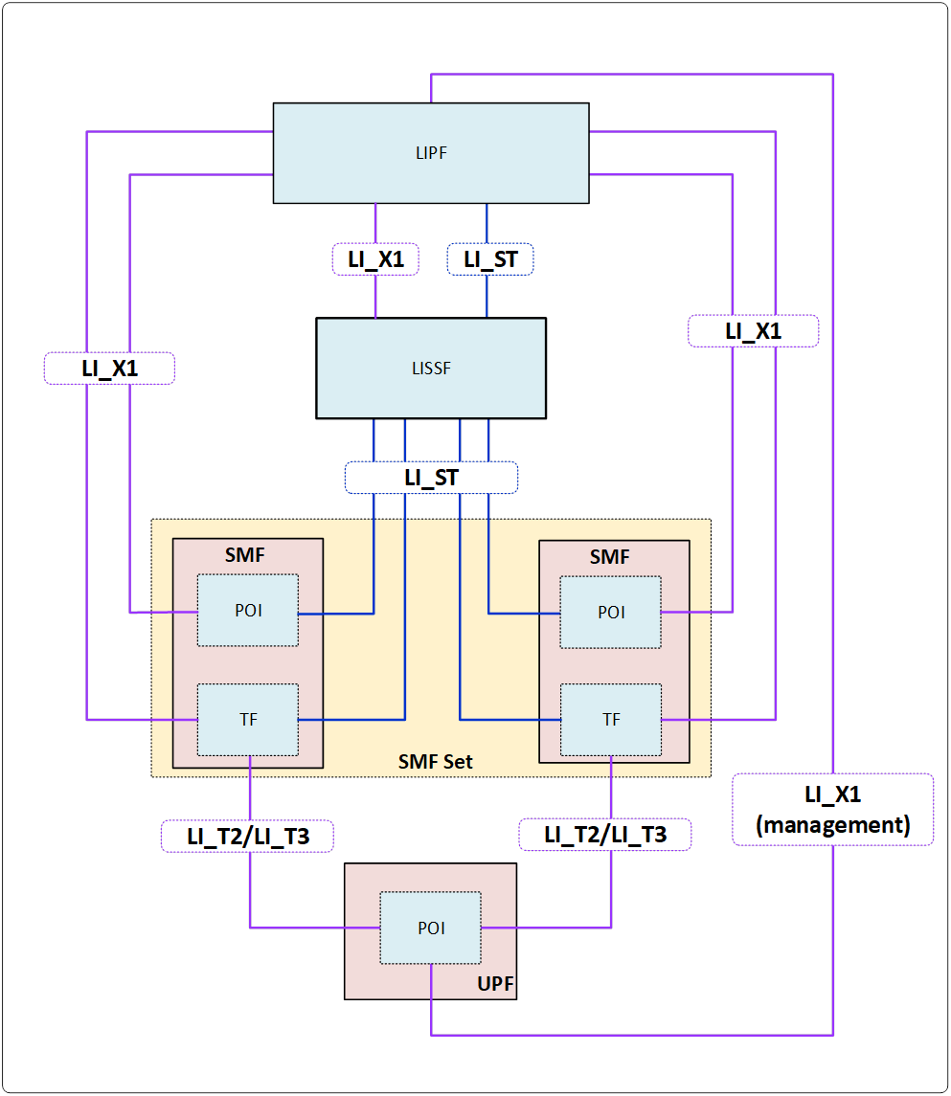
Figure 6.2-X: LI architecture diagram for SMF/UPF interception when using SMF sets and LISSF.
If an SMF belongs to an SMF set, then the TF present in the SMF shall have the ability to modify or stop the interceptions in the POIs present in the UPF irrespective of which TF present in an SMF from that SMF set had previously initiated the interception. A TF in one SMF of an SMF set may initiate the interception at a POI present in the UPF, the TF present in another SMF of the SMF set may make changes to the interception in that POI, and a TF in a different SMF of the SMF set may stop the interception in that POI.
In order to allow the TFs present in different SMFs of an SMF set to manage the interceptions at the POI present in an UPF, a new LI function referred to as LI State Storage Function (LISSF) is introduced. The TF that initiates the interception at a POI present in the UPF stores the related necessary information (e.g. correlation information) in case a different TF has to manage the interception at that POI. This necessary related information is referred to as LI state information (see TS 33.128 [15] for the details).
If an SMF belongs to an SMF set, then the POI present in the SMF shall have the ability to continue the interception using the same correlation information or stop the interception even when the SMF that manages the PDU session changes.
In order to allow the POIs present in different SMFs of an SMF set to continue the interception by maintaining a continuity, the LISSF mentioned above is used by storing the LI state information. Whenever an interception begins, the POI present in the SMF of an SMF set stores the LI state information in the LISSF. The POI present in another SMF of the same SMF can retrieve the LI state information from that LISSF to provide a continued interception.
When an SMF in an SMF set requests SM context information related to a target from a UDSF or receives SM conxtext information from another SMF, the TF and POI within the SMF shall retrieve also the relevant LI state information from the shared LISSF.
If the implementation of the SMF set does not ensure that active SM contexts are always present in some SMF of the SMF set, the TF shall also retrieve the relevant LI state information when an existing task is deactivated by the LIPF.
NOTE: The race conditions between the LI_X1, LI_ST operations, and network events are possible and need to be accounted for in the implementation.

6.2.3.X+1 Interface LI_ST
LI_ST is an interface between the LISSF and the LIPF and between the LISSF and other LI functions. It is used for transferring LI state information. The LI functions may request, store or erase LI state information from the LISSF using this interface. LI functions need to be authorized by the LIPF to have access to a specific instance of the LISSF before using the LI_ST interface.
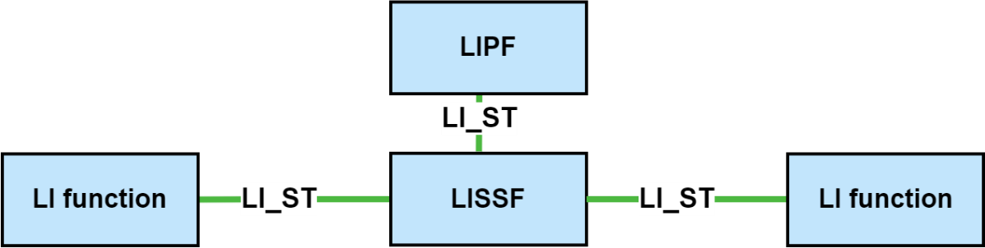
Figure 6.2-X+1: Use of the LI_ST interface in the LI architecture.

------------------------FOURTH CHANGE-----------------------

6.2.7 External data storage

6.2.7.1 UDSF or UDR
The UDSF or UDR as defined in TS 23.501 [2] are used to externally store data relating to one or more NFs, separating the compute and storage elements of an NF. Where the NF contains a POI the following restrictions on the use of the UDSF/UDR shall apply:
- The UDSF/UDR shall be subject to the same location, geographic, security and other physical environment constraints as the NF POI for which it is storing data.
- No LI specific POI data (e.g. target list) shall be stored in the UDSF/UDR unless storage is directly under the control of the POI within the NF.
- LI data stored in a UDSF/UDR shall only be accessible by the specific individual POI for which the UDSF/UDR is storing data and that data shall not be shared between POIs unless specifically authorised by the LICF within the ADMF.
- By default, LI data shall not be stored in a UDSF/UDR which is shared by multiple NFs unless specifically authorised by the LICF.
- Any storage of LI data outside of the POI in the UDSF/UDR shall be auditable by the LICF.
- The interface between the POI/NF and the UDSF/UDR shall be protected such that an attacker cannot identify targeted users based on observation of this interface. (i.e. access to the UDSF/UDR shall be identical for both intercepted and non-intercepted user communications).
- The use and placement of a UDSF/UDR within an NF/POI design shall not introduce additional interception delay compared with non-separated compute and storage.
- Where the POI requires access to NF data that is stored in the UDSF/UDR, non-LI network functions and processes or non-LI authorised personnel shall not be able to detect POI access to that data in the UDSF/UDR.
- The POI and LICF/MDF shall be responsible for managing encryption of LI data stored in the UDSF/UDR for the POI in addition to any default encryption applied by the NF.
The above requirements shall apply when the UDSF/UDR provide data storage for TF/NF.

6.2.7.2 LI State Storage Function (LISSF)
The LISSF is a function that makes it possible for other LI functions to share information with each other. There can be multiple instances of the LISSF in the network being handled by the same ADMF. The LISSF can be implemented as a separate function or within the ADMF. The LISSF may be used to transfer LI state information between LI functions. The following restrictions on the use of the LISSF shall apply:
- The LISSF shall be subject to the same location, geographic, security and other physical environment constraints as the LI functions for which it is storing data.
- LI state information stored in an LISSF shall only be accessible by the LI functions specifically authorised by the LICF within the ADMF.
- Other than the time required to acquire the LI state information, the use and placement of an LISSF within the LI architecture shall not introduce additional delay.
- The LISSF shall be directly under the control of the ADMF, and it shall be directly accessible and auditable by the ADMF.
--------------------THE END OF CHANGES--------------------

