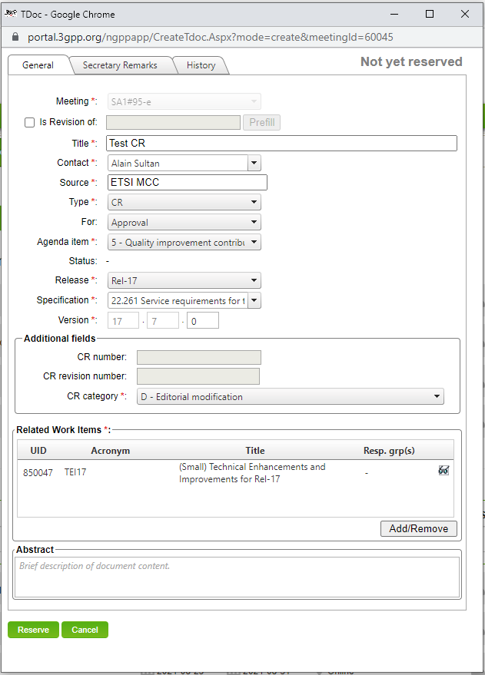
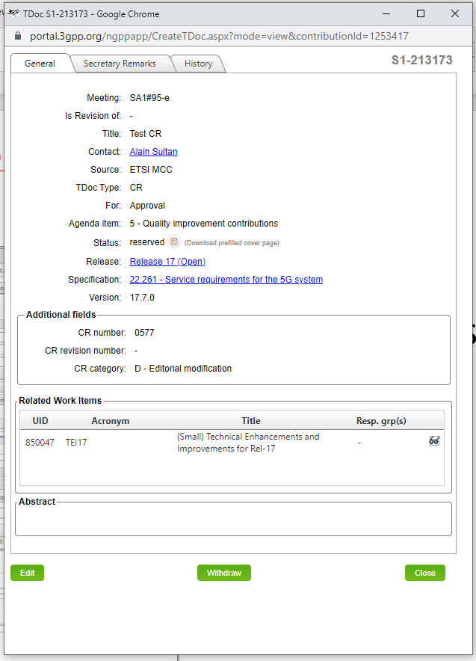
Note that you can also download the prefilled cover page after your tdoc/CR number request, by editing your tdoc details in the tdoc list (glasses icon).
How to get the CR Cover Page
- Download the pre-filled cover page
Tdoc/CR number Request form
Portal’s answer
This one here

