3GPP TSG-SA3 Meeting #109Adhoc-e S3-230154-r1

Online, 16 - 20 January 2023

Source: Huawei, HiSilicon

Title: update to solution 3

Document for: Approval
Agenda Item: 5.19

1 Decision/action requested
It is proposed to approve the change described in this document.

2 References
N/A.

3 Rationale
As UE2 may be not reachable, how to acquire the location of /UE2 and how to notify UE2 need to be taken into consideration.

4 Detailed proposal
*** 1st CHANGE ***

6.3 Solution #3: Authorization of Application Server for Ranging/SL positioning service exposure

6.3.1 Introduction
The solution addresses Key Issue #2: Authorization for Ranging/SL Positioning Services. It aims to meet one of the potential requirements in Key issue #2 on authorization of a third party server for triggering Ranging/Sidelink Positioning services.
As per TR 23.700-86 [2] solution #13, a Ranging/SL Positioning service request may be initiated by an application server. In the AF-initiated Ranging/SL Positioning procedure, the authorization on service permission is indispensable for protecting the UE’s privacy, for which the application server needs to be authorized at two levels:
- The first level of authorization is for service access. That means, when the NEF/GMLC receives the Ranging service request initiated by the Ranging application server (e.g. hosted in an AF), the NEF/GMLC can determine whether the application server/AF is authorized to request the Ranging service from the 5GC, according to clause 12.4 in TS 33.501 [8].
- The second level of authorization is for preserving UE privacy. This is because, even if the application server/AF is authorized to send requests to the 5GC for Ranging service, it does not mean that the service can always be exposed to the application server/AF. For example, it is possible that the application server/AF is allowed to request Ranging info between UE1 and UE2, but may not be allowed to request Ranging info between UE3 and UE4. Without further check on the authorization info of the involved UEs, there is still the risk that unauthorized Ranging/SL positioning information could be exposed to the application server/AF. Therefore, the application server/AF needs to be further authorized on whether it is allowed to acquire Ranging info of the involved specific UEs.
This solution proposes a method to meet the security requirement in AF-initiated procedure by using the existing network function GMLC/NEF. The GMLC/NEF interacts with the UDM to obtain the UE’s subscription data and interacts with the AMF to get the network provided location of the UE. Based on the above information, the GMLC/NEF is able to check the authorization of Ranging/SL positioning services and protect the ranging UE’s privacy.

6.3.2 Solution details
The solution proposes that, when the GMLC/NEF checks with the UDM to discover the serving AMF(s) of the UEs, it also needs to check with the UDM to authorize the application server for acquiring Ranging information of the UEs, based on e.g. the privacy related parameters in UE’s subscription data stored in the UDM/UDR.
1. Service authorization policy/parameters are provisioned to UE1 and UE2.
2. The AF sends Ranging/SL positioning Service Request to the GMLC/NEF. If the Ranging/SL positioning Service Request is transmitted by the NEF/GMLC, the NEF/GMLC first determines whether the AF is authorized to request Ranging/SL Positioning service as defined in TS 33.501 [8], clause 12.4.
NOTE 1: UE1 can be either the target UE or the reference UE, which can be requested by the AF or can be decided during step #12.
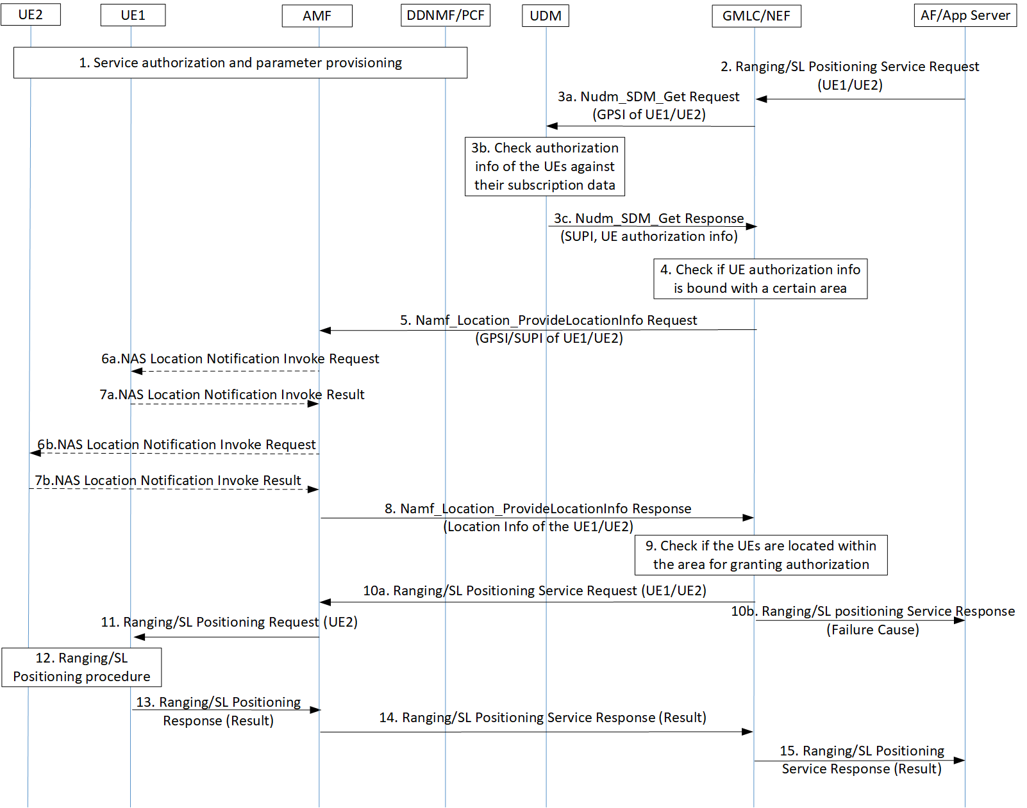Figure 6.3.2-1: Authorization of Application Server for Ranging/SL Positioning Service Exposure
3. The GMLC/NEF invokes a Nudm_SDM_Get service operation towards the UDM of the UE1/UE2 to get the authorization information of the UEs against e.g. their privacy profiles.
NOTE 2: If UE1 and UE2 are managed by different UDMs, the GMLC/NEF sends the Nudm_SDM_Get message to the corresponding UDMs respectively.
4. The GMLC/NEF checks the authorization results of both UEs. Since Ranging service concerns location of the UE, it could be possible that the authorization info of the UE is location specific (e.g. the UE allows its location to be exposed in area A but does not allow its location to be exposed in area B).
If none of the UE grants or one of the UEs does not grant permission for the requested Ranging/SL positioning service, the GMLC/NEF proceeds to step #10b.
If both UEs grant authorization without location restriction, the GMLC/NEF proceeds to step #10a.
Conditionally, if both UEs grant authorization which is restricted in a certain area, the GMLC/NEF proceeds to step #5. In addition, the GMLC/NEF invokes a Nudm_UECM_Get service operation towards the UDM of UE1/UE2. The UDM returns the network addresses of the current serving AMF of UE1/UE2.

5. [Conditional] If both UEs grant permission which is however restricted in a certain area, the GMLC/NEF invokes the Namf_Location_ProvideLocationInfo service operation towards the AMF to request the Network provided location of the UE. This location request may also carry the result of the privacy check in step #3 which may include the Ranging/SL positioning service code or the identity of Ranging/SL positioning client provided by the AF and an indication of a privacy check related action (i.e. no action, notification, notification and verification, etc.)
NOTE 3: If UE1 and UE2 are managed by different AMFs, the GMLC/NEF shall send messages to the corresponding AMFs respectively.
6. [Conditional] If the indicator of privacy check related action indicates that the UE must either be notified or notified with privacy verification and if the UE supports Ranging notification (according to the UE capability information), a notification invoke message is sent by the AMF to the UE1/UE2, indicating the Ranging/SL positioning service code or the identity of Ranging/SL positioning client and whether privacy verification is required. If signalling connection establishment between UE2 and AMF fails, step 6 and step 7 are skipped, and the AMF answers to the GMLC with the last known location of the UE2 (i.e. Cell ID) together with the age of this location.
7. [Conditional] The UE1/UE2 returns a notification result to the AMF indicating, if privacy verification was requested, whether permission is granted or denied for the current Ranging request.
8. [Conditional] The AMF returns the Namf_Location_ProvideLocationInfo Response towards the GMLC/NEF to return the network provided location of the UE.
9. [Conditional] Based on the Network provided location of UE1/UE2, the GMLC/NEF checks whether the UE1/UE2 is within the area for granting service authorization to the application server/AF.
10a. If the privacy requirements are met, the GMLC/NEF forwards the Ranging/SL Positioning service request to the serving AMF.
10b. If none of the UEs grants or one of the UEs does not grant authorization in its current location, the GMLC/NEF responds to the application server/AF with a failure cause.
11~15. The rest of the Ranging service procedure is performed between the UE, the network and the application server/AF. If notification or notification with privacy verification fails in step 6, UE2 will be notified or notified with privacy verification via ranging layer before ranging measurement.
Alternatively, after the GMLC/NEF checks the authorization info of both UEs in step #4, if both UEs grant authorization which is however restricted in a certain area, the GMLC/NEF sends the Nudm_ParameterProvision_Get Request to the UDM and the UDM sends the Namf_Location_ProvideLocationInfo Request to the AMF. Then the AMF responds the Namf_Location_ProvideLocationInfo Response to the UDM and the UDM responds the Nudm_ParameterProvision_Get Response to the GMLC/NEF.

6.3.3 Evaluation
This consolidated solution addresses the third requirement on the authorization of a third party server for triggering Ranging services.
On top of the existing authorization of a third party server on service level, the authorization in this solution is further perform on specific UE level, which ensures the privacy of all involved UEs in a service, as Ranging/SL Positioning services per se request UE location information which is privacy sensitive.
This solution requires the GMLC/NEF to interact with the UDM to check the UE’s subscription data and interact with the AMF directly or indirectly to get the network provided location of the UE.
This solution assumes that the GMLC is involved in Ranging/Sidelink Positioning services if location-based service procedure defined in TS 23.273 [9] is reused.
*** END OF 1st CHANGE***

