3GPP TSG-SA3 Meeting #106-e draft_S3-220153-r2

e-meeting, 14 - 25 February 2022
CR-Form-v12.1
DRAFT CHANGE REQUEST
 | 33.926 | CR |  | rev | - | Current version: | 17.3.0
For HELP on using this form: comprehensive instructions can be found at
http://www.3gpp.org/Change-Requests.

Proposed change affects: | UICC apps |  | ME |  | Radio Access Network | X | Core Network | X

Title: | add annex for aspects specific to MnF network product class
Source to WG: | Nokia, Nokia Shanghai Bell
Source to TSG: | S3
Work item code: | SCAS_5G_MF |  |  |  |  |  | Date: |  |  | 2022-01-30
Category: | B |  |  |  |  |  | Release: |  |  | Rel-18
 | Use one of the following categories:  F (correction)  A (mirror corresponding to a change in an earlier release)  B (addition of feature),  C (functional modification of feature)  D (editorial modification)  Detailed explanations of the above categories can  be found in 3GPP TR 21.900. |  |  |  |  |  |  |  | Use one of the following releases:  Rel-8 (Release 8)  Rel-9 (Release 9)  Rel-10 (Release 10)  Rel-11 (Release 11)  …  Rel-15 (Release 15)  Rel-16 (Release 16)  Rel-17 (Release 17)  Rel-18 (Release 18)
Reason for change: |  | The existing Security Assurance Specification (SCAS) defined in 3GPP is focused 3GPP defined network function (NF), product for 3GPP defined management function (MnF) has not been considered. The CR proposes to add annex for SCAS of MnF product.
Summary of change: |  | add annex for aspects specific to MnF network product class.
Consequences if not approved: |  | The security assurance of product for 3GPP defined management function cannot be tested and evaluated in standardized way.
Clauses affected: |  | Annex XX (new)
 |  | Y | N
Other specs |  |  | X | Other core specifications |  |  |  | TS/TR ... CR ...
affected: |  |  | X | Test specifications |  |  |  | TS/TR ... CR ...
(show related CRs) |  |  | X | O&M Specifications |  |  |  | TS/TR ... CR ...
Other comments:
This CR's revision history:

************** START OF CHANGES

2 References
The following documents contain provisions which, through reference in this text, constitute provisions of the present document.
- References are either specific (identified by date of publication, edition number, version number, etc.) or non-specific.
- For a specific reference, subsequent revisions do not apply.
- For a non-specific reference, the latest version applies. In the case of a reference to a 3GPP document (including a GSM document), a non-specific reference implicitly refers to the latest version of that document in the same Release as the present document.
[28] 3GPP TS 23.501: "System Architecture for 5G System; Stage 2" (Release 16).
[x] 3GPP TS 28.533: "Management and orchestration; Architecture framework".
[y] 3GPP TS 28.530: "Management and orchestration; Concepts, use cases and requirements".

************** END OF CHANGE 1

3.2 Abbreviations
For the purposes of the present document, the abbreviations given in 3GPP TR 21.905 [1] and the following apply.
An abbreviation defined in the present document takes precedence over the definition of the same abbreviation, if any, in 3GPP TR 21.905 [1].
GNP Generic Network Product
SCAS Security Assurance Specification
SECAM Security Assurance Methodology
MnF Management Function
OAM Operation and Management
NP Network Product
BSS Business Support System
AAA Authentication, Authorization, Account
TN Transport Network

************** END OF CHANGE 2

Annex X:
Aspects specific to the network product class MnF

X.1 Network product class description for the MnF

X.1.1 Introduction

The present document captures the network product class descriptions, threats and critical assets that have been identified in the course of the work on 3GPP security assurance specifications. The main body of the present document contains generic aspects that are believed to apply to more than one network product class, while this clause covers the aspects specific to the MnF network product class.
As shown in the Figure 4.3-1 (GNP model), a MnF NP includes (management) functions defined by 3GPP, other functions, OAM functions, operating system and hardware. However, the functionalities and interfaces supported by NP for cross domain MnF and NP for domain MnF are different. Figure XX.1.1-1 shows MnF NPs as blackbox and typical interfaces supported by the both types of NPs.
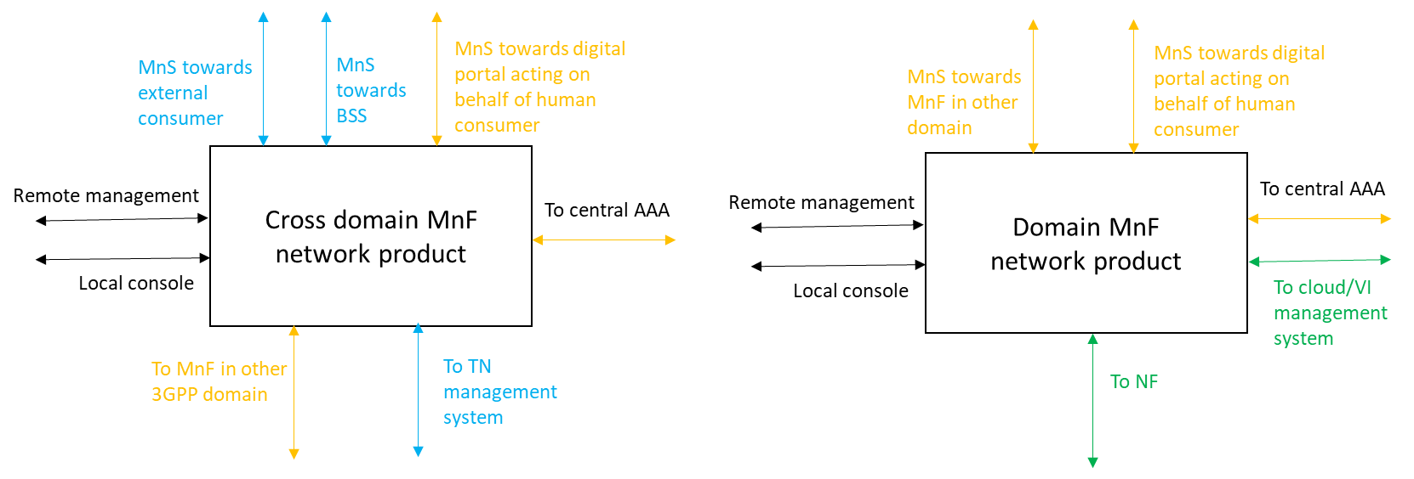

The generic interfaces supported by both MnF NP classes are interfaces for remote management, local console, towards digital portal, to central AAA, to MnF in other domain. The cross domain MnF specific interfaces are interfaces towards external consumer, towards BSS, to TN management system. The domain MnF specific interfaces are interfaces for cloud and virtualized infrastructure management, to NF in the domain.
Editor's Note: The notion of domains is FFS.

X.1.2 Minimum set of functions defining the MnF network product class
According to TR 33.916 [2], a network product class is a class of products that all implement a common set of 3GPP-defined functionalities. Therefore, in order to define the MnF network product class, it is necessary to define the common set of 3GPP-defined functionalities that is constitutive for a MnF. As part of the MnF network product, it is expected that the MnF contains MnF application, a set of running processes (typically more than one) executing the software package for the MnF functions and OAM functions that are specific to the MnF network product model. Functionalities specific to the MnF network product introduce additional critical assets and/or threats as described below. Related security requirements and test cases have been captured in TS 33.526 [x].
Note: For the purposes of the present document, this common set is defined to be the list of functions contained in TS 28.533 [y], TS 28.530 [z].
************** END OF CHANGES

