3GPP TSG-SA3 Meeting #103-e draft-S3-211624

e-meeting, 17 – 28 May 2021
CR-Form-v12.1
CHANGE REQUEST
 | 33501 | CR | 1087 | rev | <Rev#> | Current version: | 16.6.0
For HELP on using this form: comprehensive instructions can be found at
http://www.3gpp.org/Change-Requests.

Proposed change affects: | UICC apps |  | ME |  | Radio Access Network |  | Core Network | X

Title: | Slice privacy protection in NSSAA related procedures
Source to WG: | S3
Source to TSG: | Huawei, HiSilicon
Work item code: | eNS |  |  |  |  |  | Date: |  |  | 2021-05-10
Category: | F |  |  |  |  |  | Release: |  |  | Rel-16
 | Use one of the following categories:  F (correction)  A (mirror corresponding to a change in an earlier release)  B (addition of feature),  C (functional modification of feature)  D (editorial modification)  Detailed explanations of the above categories can  be found in 3GPP TR 21.900. |  |  |  |  |  |  |  | Use one of the following releases:  Rel-8 (Release 8)  Rel-9 (Release 9)  Rel-10 (Release 10)  Rel-11 (Release 11)  …  Rel-15 (Release 15)  Rel-16 (Release 16)  Rel-17 (Release 17)  Rel-18 (Release 18)
Reason for change: |  | In clause 16.3 of 33.501, the following Editor’s Note need to be resolved.  Editor’s Note: It is ffs whether S-NSSAIs can be sent to AAA-S.  In clause 5.9.2.3 of 33.501 for NEF security requirements, it defines that,  - Internal 5G Core information such as DNN, S-NSSAI etc., shall not be sent outside the 3GPP operator domain.  Similarly, considering that the AAA-S may be owned by an external 3rd party enterprise, the S-NSSAI shall also not be sent to AAA-S.
Summary of change: |  | NSSAAF maps the S-NSSAI to extenal slice identifier.
Consequences if not approved: |  | The S-NSSAI is sent outside the 3GPP operator domain which may cause security privacy issue.
Clauses affected: |  | 16.3; 16.4; 16.5
 |  | Y | N
Other specs |  |  | X | Other core specifications |  |  |  | TS/TR ... CR ...
affected: |  |  | X | Test specifications |  |  |  | TS/TR ... CR ...
(show related CRs) |  |  | X | O&M Specifications |  |  |  | TS/TR ... CR ...
Other comments:
This CR's revision history:

********** START OF THE CHANGE **********

3.2 Abbreviations
For the purposes of the present document, the abbreviations given in 3GPP TR 21.905 [1] and the following apply. An abbreviation defined in the present document takes precedence over the definition of the same abbreviation, if any, in 3GPP TR 21.905 [1].
5GC 5G Core Network
5G-AN 5G Access Network
5G-RG 5G Residential Gateway
NG-RAN 5G Radio Access Network
5G AV 5G Authentication Vector
5G HE AV 5G Home Environment Authentication Vector
5G SE AV 5G Serving Environment Authentication Vector
ABBA Anti-Bidding down Between Architectures
AEAD Authenticated Encryption with Associated Data
AES Advanced Encryption Standard
AKA Authentication and Key Agreement
AMF Access and Mobility Management Function
AMF Authentication Management Field

NOTE: If necessary, the full word is spelled out to disambiguate the abbreviation.
ARPF Authentication credential Repository and Processing Function
AUSF Authentication Server Function
AUTN AUthentication TokeN
AV Authentication Vector
AV' transformed Authentication Vector
BAP Backhaul Adaptation Protocol
BH Backhaul
CCA Client Credentials Assertion
Cell-ID Cell Identity as used in TS 38.331 [22]
CHO Conditional Handover
CIoT Cellular Internet of Things
cIPX consumer's IPX
CK_{SRVCC} Cipher Key for Single Radio Voice Continuity
CP Control Plane
cSEPP consumer's SEPP
CTR Counter (mode)
CU Central Unit
DN Data Network
DNN Data Network Name
DU Distributed Unit
EAP Extensible Authentication Protocol
EDT Early Data Transmission
EMSK Extended Master Session Key
ENSI External Network Slice Inforamtion
EPS Evolved Packet System
FN-RG Fixed Network RG
gNB NR Node B
GUTI Globally Unique Temporary UE Identity
HRES Hash RESponse
HXRES Hash eXpected RESponse
IAB Integrated Access and Backhaul
IKE Internet Key Exchange
IK_{SRVCC} Integrity Key for Single Radio Voice Continuity
IPUPS Inter-PLMN UP Security
IPX IP exchange service
KSI Key Set Identifier
KSI_{SRVCC} Key Set Identifier for Single Radio Voice Continuity
LI Lawful Intercept
MN Master Node
MO-EDT Mobile Originated Early Data Transmission
MT-EDT Mobile Terminated Early Data Transmission
MR-DC Multi-Radio Dual Connectivity
MSK Master Session Key
N3IWF Non-3GPP access InterWorking Function
NAI Network Access Identifier
NAS Non Access Stratum
NDS Network Domain Security
NEA Encryption Algorithm for 5G
NF Network Function
NG Next Generation
ng-eNB Next Generation Evolved Node-B
ngKSI Key Set Identifier in 5G
N5CW Non-5G-Capable over WLAN
N5GC Non-5G-Capable
NIA Integrity Algorithm for 5G
NR New Radio
NR-DC NR-NR Dual Connectivity
NSSAI Network Slice Selection Assistance Information
NSSAA Network Slice Specific Authentication and Authorization
PDN Packet Data Network
PEI Permanent Equipment Identifier
pIPX producer's IPX
PRINS PRotocol for N32 INterconnect Security
pSEPP producer's SEPP
PUR Preconfigured Uplink Resource
QoS Quality of Service
RES RESponse
SCG Secondary Cell Group
SEAF SEcurity Anchor Function
SCP Service Communication Proxy
NOTE: Void. Security Gateway
SEPP Security Edge Protection Proxy
SIDF Subscription Identifier De-concealing Function
SMC Security Mode Command
SMF Session Management Function
SN Secondary Node
SN Id Serving Network Identifier
SUCI Subscription Concealed Identifier
SUPI Subscription Permanent Identifier
TLS Transport Layer Security
TNAN Trusted Non-3GPP Access Network
TNAP Trusted Non-3GPP Access Point
TNGF Trusted Non-3GPP Gateway Function
TWAP Trusted WLAN Access Point
TWIF Trusted WLAN Interworking Function
TSC Time Sensitive Communication
UE User Equipment
UEA UMTS Encryption Algorithm
UDM Unified Data Management
UDR Unified Data Repository
UIA UMTS Integrity Algorithm
ULR Update Location Request
UP User Plane
UPF User Plane Function
URLLC Ultra Reliable Low Latency Communication
USIM Universal Subscriber Identity Module
XRES eXpected RESponse
********** START OF THE CHANGE **********

16.3 Network slice specific authentication and authorization
This clause specifies the optional-to-use NSSAA between a UE and an AAA server (AAA-S) which may be owned by an external 3rd party enterprise. NSSAA uses a User ID and credentials, different from the 3GPP subscription credentials (e.g. SUPI and credentials used for PLMN access) and takes place after the primary authentication.
The EAP framework specified in RFC 3748 [27] shall be used for NSSAA between the UE and the AAA server. The SEAF/AMF shall perform the role of the EAP Authenticator and communicates with the AAA-S via the NSSAAF. The NSSAAF undertakes any AAA protocol interworking with the AAA-S. Multiple EAP methods are possible for NSSAA. If the AAA-S belongs to a third party the NSSAAF contacts the AAA-S via a AAA-P. The NSSAAF and the AAA-P may be co-located.
To protect privacy of the EAP ID used for the EAP based NSSAA, a privacy-protection capable EAP method is recommended, if privacy protection is required.

The steps involved in NSSAA are described below.

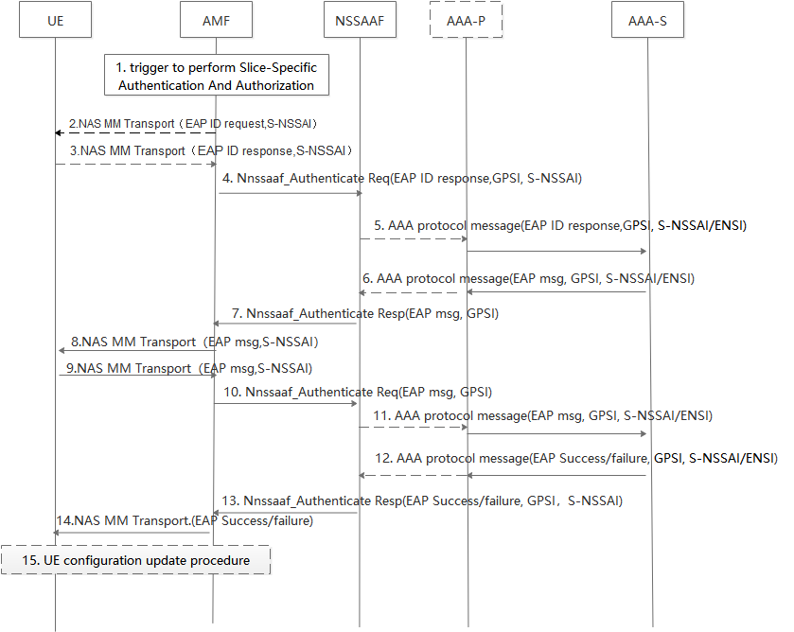
Figure 16.3-1: NSSAA procedure
1. For S-NSSAIs that are requiring NSSAA, based on change of subscription information, or triggered by the AAA-S, the AMF may trigger the start of the NSSAA procedure.
If NSSAA is triggered as a result of Registration procedure, the AMF may determine, based on UE Context in the AMF, that for some or all S-NSSAI(s) subject to NSSAA, the UE has already been authenticated following a Registration procedure on a first access. Depending on NSSAA result (e.g. success/failure) from the previous Registration, the AMF may decide, based on Network policies, to skip NSSAA for these S-NSSAIs during the Registration on a second access.
If the NSSAA procedure corresponds to a re-authentication and re-authorization procedure triggered as a result of AAA Server-triggered UE re-authentication and re-authorization for one or more S-NSSAIs, as described in clause 4.2.9.2 of TS 23.502 [8], or triggered by the AMF based on operator policy or a subscription change and if S-NSSAIs that are requiring Network Slice-Specific Authentication and Authorization are included in the Allowed NSSAI for each Access Type, the AMF selects an Access Type to be used to perform the NSSAA procedure based on network policies.
2. The AMF may request the UE User ID for EAP authentication (EAP ID) for the S-NSSAI in a NAS MM Transport message including the S-NSSAI.
3. The UE provides the EAP ID for the S-NSSAI alongside the S-NSSAI in an NAS MM Transport message towards the AMF.
4. The AMF sends the EAP ID to the NSSAAF which provides interface with the AAA, in an Nnssaaf_NSSAA_Authenticate Request (EAP ID Response, GPSI, S-NSSAI).
5. If the AAA-P is present (e.g. because the AAA-S belongs to a third party and the operator deploys a proxy towards third parties), the NSSAAF forwards the EAP ID Response message to the AAA-P, otherwise the NSSAAF forwards the message directly to the AAA-S. NSSAAF routes to the AAA-S based on the S-NSSAI. The NSSAAF/AAA-P forwards the EAP Identity message to the AAA-S together with S-NSSAI and GPSI. The AAA-S stores the GPSI to create an association with the EAP ID in the EAP ID response message so the AAA-S can later use it to revoke authorisation or to trigger reauthentication. The AAA-S uses the EAP-ID and S-NSSAI to identify for which UE and slice authorisation is requested.

NOTE : If the AAA-S belongs to the 3rd party, the NSSAAF optionally maps the S-NSSAI to External Network Slice Inforamtion (ENSI), and forwards the EAP Identity message to the AAA-S together with ENSI and GPSI. In this case, the AAA-S uses the EAP-ID and ENSI to identify the UE for which slice authorisation is requested.
6 -11. EAP-messages are exchanged with the UE. One or more than one iterations of these steps may occur.
12. EAP authentication completes. An EAP-Success/Failure message is delivered to the NSSAAF/AAA-P along with GPSI and S-NSSAI/ENSI.
13. The NSSAAF sends the Nnssaaf_NSSAA_Authenticate Response (EAP-Success/Failure, S-NSSAI, GPSI) to the AMF.
14. The AMF transmits a NAS MM Transport message (EAP-Success/Failure) to the UE.
15. Based on the result of Slice specific authentication (EAP-Success/Failure), if a new Allowed NSSAI or new Rejected NSSAIs needs to be delivered to the UE, or if the AMF re-allocation is required, the AMF initiates the UE Configuration Update procedure, for each Access Type, as described in clause 4.2.4.2 of TS 23.502 [8].

********** START OF THE CHANGE **********

16.4 AAA Server triggered Network Slice-Specific Re-authentication and Re-authorization procedure

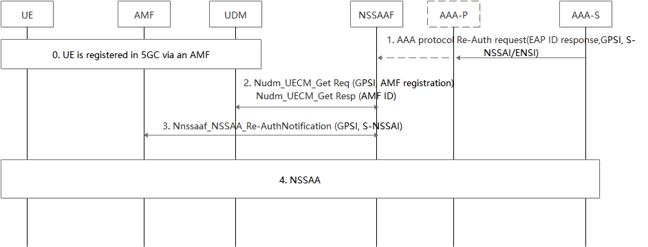
Figure 16.4-1: AAA Server initiated Network Slice-Specific Re-authentication and Re-authorization procedure
0. The UE is registered in 5GC via an AMF. The AMF ID is stored in the UDM.
1. The AAA-S requests the re-authentication and re-authorization for the Network Slice specified by the S-NSSAI/ENSI in the Re-Auth Request message, for the UE identified by the GPSI in this message. This message is sent to an AAA-P, if the AAA-P is used (e.g. the AAA Server belongs to a third party), otherwise it may be sent directly to the NSSAAF. If an AAA-P is present, the AAA-P relays the Reauthentication Request to the NSSAAF.
2. The NSSAAF requests UDM for the AMF serving the UE using the Nudm_UECM_Get (GPSI, AMF Registration) service operation. The UDM provides the NSSAAF with the AMF ID of the AMF serving the UE.
3. The NSSAAF requests the relevant AMF to re-authenticate/re-authorize the S-NSSAI for the UE using the Nnssaaf_NSSAA_Re-authenticationNotification service operation. The AMF is implicitly subscribed to receive Nnssaaf_NSSAA_Re-authenticationNotification service operations. The NSSAAF may discover the Callback URI for the Nnssaaf_NSSAA_Re-authenticationNotification service operation exposed by the AMF via the NRF.
The AMF acknowledges the notification of Re-authentication request.
4. The AMF triggers the NSSAA procedure defined in clause 16.3 for the UE identified by the GPSI and the Network Slice identified by the S-NSSAI received from the NSSAAF.
********** START OF THE CHANGE **********

16.5 AAA Server triggered Slice-Specific Authorization Revocation

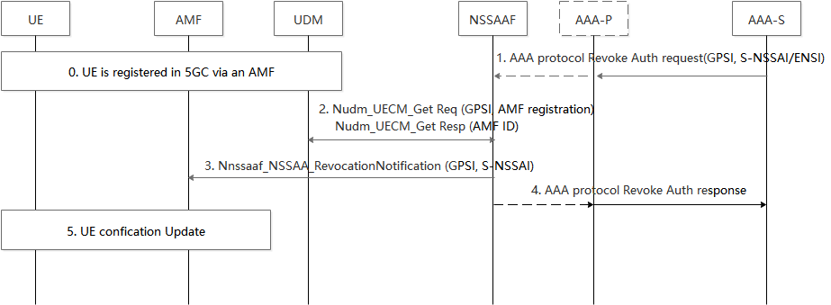
Figure 16.5-1: AAA Server-initiated Network Slice-Specific Authorization Revocation procedure
0. The UE is registered in 5GC via an AMF. The AMF ID is stored in the UDM.
1. The slice specific AAA-S requests the revocation of authorization for the Network Slice identified by the GPSI in the AAA Protocol Revoke Authorization Request message. This message is sent to NSSAAF instance interfacing with AAA-S or AAA-P if it is used.
The AAA-P, if present, relays the request to the NSSAAF.
2. The NSSAAF requests UDM for the AMF serving the UE using the Nudm_UECM_Get (GPSI, AMF Registration) service operation. The UDM provides the NSSAAF with the AMF ID of the AMF serving the UE.
3. The NSSAAF request the relevant AMF to revoke the S-NSSAI authorization for the UE using the Nnssaaf_NSSAA_RevocationNotification service operation.
The AMF is implicitly subscribed to receive Nnssaaf_NSSAA_RevocationNotification service operations. The NSSAAF may discover the Callback URI for the Nnssaaf_NSSAA_RevocationNotification service operation exposed by the AMF via the NRF. The AMF acknowledges the Notification of Revocation request.
4. The NSSAAF sends an acknowledgement to the the AAA-S/AAA-P with AAA Protocol Revoke Authorization Response message.
5. The AMF sends the UE Configuration Update message to revoke the S-NSSAI from the current Allowed NSSAI, for any Access Type for which NSSAA had been successfully run on this S-NSSAI. The AMF provides a new Allowed NSSAI to the UE by removing the S-NSSAI for which authorization has been revoked. The AMF provides new rejected NSSAIs to the UE including the S-NSSAI for which authorization has been revoked. If no S-NSSAI is left in Allowed NSSAI for an access after the revocation, and a Default NSSAI exists that requires no NSSAA or for which a NSSAA did not previously fail over this access, then the AMF may provide a new Allowed NSSAI to the UE containing the Default NSSAI. If no S-NSSAI is left in Allowed NSSAI for an access after the revocation, and no Default NSSAI can be provided to the UE in the Allowed NSSAI or a previous NSSAA failed for the Default NSSAI over this access, then the AMF shall execute the Network-initiated Deregistration procedure for the access as described in subclause 4.2.2.3.3 in TS 23.502 [8], and it shall include in the explicit De-Registration Request message the list of Rejected S-NSSAIs, each of them with the appropriate rejection cause value.
**********End OF CHANGES **********

