**3GPP TSG-WG SA2 Meeting #171 *S2-250xxxx***

**Wuhan, CN, 13th Oct – 17th Oct, 2025 (revision of S2-250xxxx)**

**Source: Huawei, HiSilicon**

**Title: KI1 New Solution: UE Reader Identification and Reader Selection by RAN, CN and AF**

**Document for: Approval**

**Agenda Item: 20.5.1**

**Work Item / Release: FS_AmbientIoT_Ph2_ARC / Rel-20**

*Abstract: UE Reader selection supporting AF requests for operations within an area or towards a specific UE.*

# 1. Introduction/Discussion

UE Reader selection for topology 2 supports 2 scenarios, a) the AF requesting operations in an area and the AF requestion operations targeting a specific UE. This solution provides ways to support these AF requests.

# 2. Text Proposal

It is proposed to capture the following changes vs. TR 23.700-30.

* * * * First change * * * *

## 6.0 Mapping of Solutions to Key Issues

Table 6.0-1: Mapping of Solutions to Key Issues

|  |  |  |
| --- | --- | --- |
|  | Key Issues | |
| Solutions | Key Issue #1 | <Key Issue #2> |
| #1 |  | X |
| #2 |  | X |
| #3 |  | X |
| #4 |  | X |
| #X | X |  |

* * * * Second change (all new) * * * *

## 6.X Solution #X: UE Reader Identification and Selection by RAN, CN and AF

### 6.X.0 High-level solution Principles

The solution provides mechanism to select UE Readers considering 2 types of request from the AF, a) when it makes a request targeting a specific area and b) when it makes a request targeting a specific UE. If a UE Reader has been selected by the CN then what to include in the NGAP AIoT Information to the UEs serving RAN node, along with which UE the NG-RAN node should control.

### 6.X.1 Description

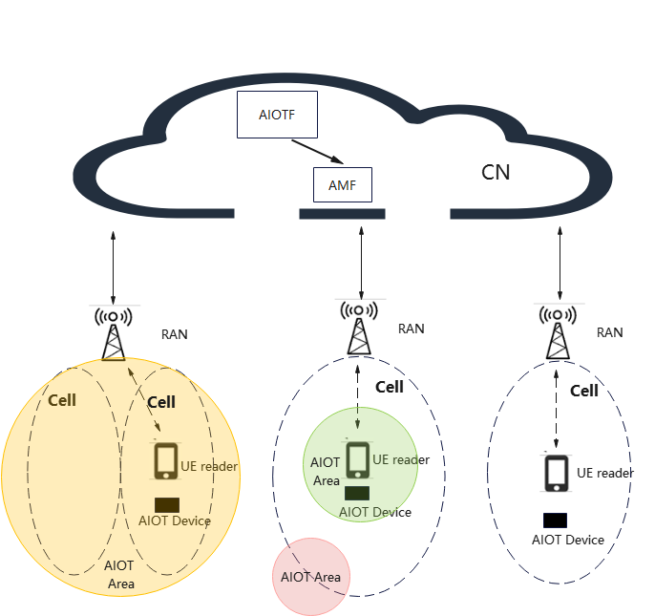

Figure 6.x.1-1: UE Reader Selection Scenarios

To perform Reader Selection 3 scenarios are considered:

1. AIoT Areas and NR cells are aligned, with an AIoT Area matching the coverage of 1 or more cells. In this case all the UE (and RAN) Readers within the cell could be considered as the target for the operation.

This can be supported by NG-RAN selecting UE Readers (and RAN Readers) In this case NG-RAN is provided with the AIoT Areas, and can use UE Readers or RAN Readers which are available for the operation and the CN does not need to select any UE Readers directly.

2. An AIoT Area is smaller or partially overlaps a cell. In this case only some of the UE Readers within a cell should be considered as the target for an operation.

This scenario can be supported by the network assisting NG-RAN by providing the AIoT Area and a list of UE Readers. NG-RAN can then use RAN Readers within the AIoT Area and the UE Readers provided for an operation.

3. The AF indicated which UE Reader to use for an operation.

This scenario can be support by the network providing NG-RAN with only UE Reader(s) to use and the NG-RAN only using the indicated UE Reader for an operation. There is no need to provide NG-RAN with any AIoT Areas.

To enable the AIOTF to target specific UE Reader(s) there needs to be a common identifier known to the AIOTF and NG-RAN for each potential UE Reader. To enable this, the AMF assigns a UE Reader ID which is then shared with NG-RAN and the AIOTF for each UE Reader when it enters CM_CONNECTED. This assignment then avoids any deployment assumptions about all UE Readers having the same Serving AMF and the UEs Serving AMF being the AMF the AIOTF uses to send messages to NG-RAN.

This solution assumes that a UE is in CM_CONNECTED to be available for an AIOTF to select it. If the UE is authorised for AIoT UE Reader operations, then the AMF should not initiate the release of the signalling connection after the completion of the Registration procedure. The release of the signalling connection relies on the decision of NG-RAN, as specified in TS 23.502 [5].

### 6.X.2 Procedures

#### 6.x.2.1 Assignment of UE Reader ID when a UE enters CM_CONNECTED

When a UE enters CM_CONNECTED state, and the AMF determines that the UE is authorised to act as a UE Reader, the AMF provides authorisation information to NG-RAN. When providing the authorisation to NG-RAN the AMF additionally allocates a UE Reader ID, stores it in the UE Context in the AMF, and provides it to NG-RAN along with the authorisation.

If the UE is deauthorised, or the UE leaves CM_CONNECTED then the AMF and NG-RAN may discard the UE Reader ID.

#### 6.x.2.2 UE Reader Selection

The existing Reader Selection process in TS 23.369 [x] clause 5.3.3 determines NG-RAN nodes and optionally RAN Readers based on the Target Area information. The Target Area information is a list of AIoT Areas.

The AIOTF may select UE Readers in addition to, or instead of, RAN Readers. If the AIOTF does select UE Readers then this procedure is used. If the AF indicated a specific UE Reader to use for the requested service operation instead of External Target Area information then this procedure shall be used and in this case the AIOTF selects the specific UE Reader to use for the operation using this procedure.

The UE Readers shall be in CM_CONNECTED state, so there is a UE Context in NG-RAN for each UE Reader and NG-RAN is aware of the UE Readers ID and that the UE Reader is authorised.



Figure 6.x.2.2-1: Reader Selection and UE Reader ID Determination

1. The AIOTF receives an AIOT Inventory or Command Request. The request may include a Permanent identifier of a UE to use.

2. If there is a Permanent identifier of a UE included in the request then only the requested UEs shall selected.

If there is no Permanent identifier of a UE included, then the AIOTF may determine the selected UE Readers. To do this then the AIOTF may, for example, determine which UE Readers to select based on configuration, e.g., those that are within the AIoT Area(s) (for example for fixed location UEs).

3. The AIOTF determines the serving AMF from the UDM, for each selected UE Reader, using the existing procedures defined in TS 23.501 [x] and TS 23.502 [x].

4. The AIOTF then determines the UE Reader ID assigned to a UE from the UEs serving AMF. The AIOTF sends a Namf_AIoT_Get UE Reader ID Request (list of Permanent identifier of a UE) to each serving AMF. The request can include a list of Permanent identifiers of UEs to reducing the amount of signalling, if the AIOTF determines multiple UEs have the same Serving AMF.

5. The Serving AMF provides the UE Reader ID and the serving NG-RAN node for each Permanent identifier of a UE received in step 4.

The AIOTF uses the NG-RAN node information to determine the NG-RAN node(s) to send a request to, to reach a specific UE.

6. Shown for information only. The AMF used to send the request to NG-RAN does not need to a UEs serving AMF. The procedure to send the request to is NG-RAN defined in TS 23.369 [x] clause 6.2.4.2.

7. Shown for information only. Any responses messages from NG-RAN are routed via the requesting AMF used in step 6. The procedure to send the responses from NG-RAN is defined in TS 23.369 [x] clause 6.2.4.3.

#### 6.x.2.3 Inventory and Command Procedure when using UE Readers

The Inventory procedure as defined in clause 6.2.2 of TS 23.369 [x], is used with the following modifications to support UE Readers:

Step 1:

The AF provides either:

a. Only a Target UE Identifier, i.e., External Target Area information is not provided. The Target UE Identifier Indicates the AF is requesting a specific UE.

b. External Target Area information. In this case the AF is requesting an operation in a specific area, using any available Readers.

Step 3:

If a Target UE Identifier is provided by the AF, the NEF determines the Permanent identifier of the UE, as described in TS 23.501 [x] clause 5.20, using the procedure described in clause 4.15.3.2.13 of TS 23.502 [3] and includes the Permanent identifier of the UE in the Naiotf_AIoT_Inventory Request.

Step 4:

The AIOTF performs Reader Selection, taking into account UE Reader selection as described in clause 6.x.2.2.

Step 7:

The AIOTF sends NGAP AIOT Information to NG-RAN and optionally includes UE Reader ID(s) in the message sent to NG-RAN.

Step 9:

NG-RAN matches the UE Reader ID(s) included the NGAP AIOT Information against the UE Reader ID provided by the AMF when a UE Context is created in NG-RAN for a UE to determined which UE(s) the AIOTF indicated to be considered for the request. NG-RAN uses RRC to send/receive messages to the identified UE Reader(s).

If UE Reader ID(s) are included and no AIoT Area is included in the NGAP AIOT Information, then NG-RAN shall only use the UE Reader IDs provided.

If no UE Reader ID(s) are included in the NGAP AIOT Information, then NG-RAN can consider any UE Readers for which it as a UE Context and are within the requested AIOT Area(s).

Step 10:

If a UE Reader is used then the UE Reader ID is included in the Inventory Report instead of the RAN Reader ID.

The updates to inventory steps above can be applied to the equivalent steps in the command procedure.

### 6.X.3 Impacts on Services, Entities and Interfaces

**NEF:**

- Use existing procedures to determines the Permanent identifier of the UE.

**AIOTF:**

- Determine UE Readers and NG-RAN nodes.

- Determine a UEs serving AMF, using the existing procedures and obtain UE Reader ID(s) from the UEs serving AMF.

- Include UE Reader ID(s) in the NGAP AIoT Information sent to NG-RAN.

**AMF:**

- Assign UE Reader IDs and provide them to NG-RAN when a UE that is authorised to be a UE Reader enters CM_CONNECTED state.

- Support the service operation to provide UE Reader IDs.

**NG-RAN:**

Support UE Readers and UE Reader IDs in NGAP AIOT Information and determine a specific UE from it.

* * * * End of changes * * * *