**3GPP TSG-WG SA2 Meeting #154 *S2-220xxxx***

**Toulouse, France, November 14 – 18, 2022 (revision of S2-220xxxx)**

**Source: Huawei, HiSilicon**

**Title: KI#3: Updates of conclusions**

**Document for: Approval**

**Agenda Item: 9.9**

**Work Item / Release: FS_VMR / Rel-18**

*Abstract: Updates of conclusions for KI#3 based on RAN’s feedback.*

# 1. Introduction

This contribution proposes to update the conclusion for KI#3 based on the RAN’s feedback as described in the Reply LS on FS_VMR solutions review from RAN WGs (R3-226048, R2-2211062).

# 2. Discussion

### 2.1 RAN’s feedback on MBSR’s cell information

RAN thinks the NCGI of the mobile IAB-DU cell is changed when it changes serving donor gNB. Regarding the TAC of the mobile IAB-DU cell, it is still open in RAN.

|  |
| --- |
| **SA2 point #2:** With regard to Key Issue#3 (as defined in clause 5.3), SA2 would like to understand if the MBSR, i.e. mobile-IAB node, would keep the same TAC, and Cell ID, when it changes serving donor gNB. SA2 has documented different solutions based on different options and needs RAN2 and RAN3 feedbacks for down selection.  **RAN2’s feedback on point #2:** The mobile IAB-node’s NCGI does not have to change during partial migration. The mobile IAB-node’s NCGI is changed during inter-donor migration of the IAB-DU. RAN2 is presently discussing if the mobile IAB-node’s PCI has to change during inter-donor-migration of the IAB-DU. RAN2 is presently also discussing if the mobile IAB-node’s TAC broadcast needs to change when the IAB-node is moving.  **RAN3’s feedback on point #2:** RAN3 achieved the following agreement on NCGI:  **The NCGI of the mobile IAB-DU cell is changed when the F1-terminating donor CU of the mobile IAB-DU is changed.**  RAN3 is still discussing the handling of the mIAB-node’s TAC. |

**Proposal#1: It is proposed to add the RAN’s agreement on the Cell ID into the conclusion for KI#3.**

Regarding the MBSR’s TAC, in the last meeting SA2 already made an interim conclusion that the TAC broadcasted by the MBSR is the same as the TAC of the cell where the IAB-UE is located. This solution highlights that the MBSR can reuse the TAC where the IAB-UE is located. Whether the TAC is changed or not during MBSR’s mobility depends on the TAC planning of the macro network. For example, if the MBSR moves across different cells and these cells are configured with the same TAC, the TAC broadcasted by the MBSR will not be changed (see Figure 2.2-1).

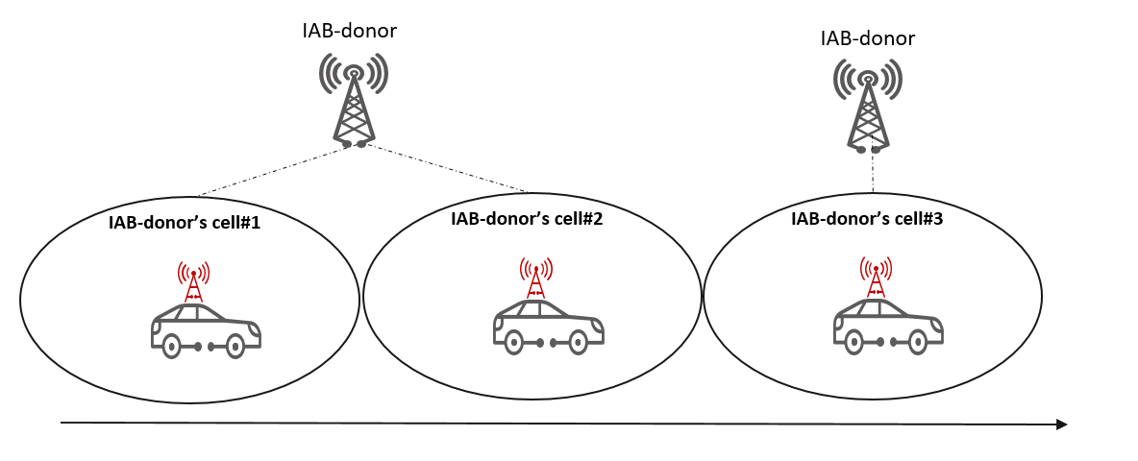

**Figure 2.2-1: TAC broadcasted by the MBSR**

There were some discussion that whether in SA2 we can have both options (i.e., broadcasting TAC same as the TAC of the IAB-UE camping cell, and using a dedicated TAC). However, having both is less implementation-friendly, given that both options have to be realized (which will introduce unwanted complexities), and the option "Broadcasting TAC same as the TAC of the IAB-UE camping cell" can sufficiently cover all cases.

**Proposal#2: it is proposed bring the option that broadcasting the TAC same as the TAC of the cell where the IAB-UE is located to the normative text, and use it as the final decision.**

### 2.2 RAN’s feedback on group mobility

RAN3 thinks the benefits and whether to support group mobility in a single NGAP message will be discussed after baseline procedures have been established.

|  |
| --- |
| - **SA2 point #3:** Also, with regard to Key Issue#3, SA2 would like to understand details of the inter-IAB donor gNB mobility procedure for a MBSR, e.g. the feasibility of supporting NGAP messages containing multiple UE information during the handover procedure.  **RAN2’s feedback on point #3:** This topic is not in RAN2 scope.  **RAN3’s feedback on point #3:** RAN3 achieved the following agreement:  **After baseline procedures have been established, RAN3 to discuss the benefit and whether to support signaling of information related to multiple UE contexts in a single message for UE handover preparation, path switch, and context release procedures.** |

**Proposal#2: It is proposed to wait for the RAN’s progress and further discuss the benefits and feasibility of group mobility in SA2.**

# 2. Text Proposal

It is proposed to capture the following changes into TR 23.700-05 V1.1.0.

* * * * First change * * * *

## 8.3 Conclusions for KI#3

For KI#3, the interim conclusions are as follows:

- During MBSR’s mobility, the TAC broadcasted by the MBSR is the same as the TAC of the cell where the IAB-UE is located. When the IAB-UE enters to a new TA, the cell broadcasting information is updated accordingly.

- During MBSR’s mobility, the cell ID broadcasted by MBSR is changed when the F1-terminating donor CU of the mobile IAB-DU is changed.

- The UE’s mobility management is performed using the legacy mechanism as defined in the TS 23.501 [2] and TS 23.502 [5]. The UE in CM-Idle shall follow legacy procedure when detecting a TAC which is not in the TA list.

- Each UE connected via the MBSR may have different serving AMFs e.g., due to slicing and individual PDU sessions/QoS service flows configured. UE context handling and path switching would be handled per each individual UE.

Editor's note: The group mobility are subject to RAN Rel-18 study.

Editor's note: For UEs in RRC-Connected/CM-Connected state via an MBSR, whether and how to guarantee UE’s service continuity is subject to the IAB full migration/mobility in the RAN Rel-18 study.

* * * * End of changes * * * *