3GPP TSG-SA WG1 Meeting #99e S1-22xxxx
Electronic Meeting, 22 Aug. –1 Sep. 2022 (revision of S1-22xxxx)

Source: ZTE
pCR Title: Pseudo-CR on Guaranteed sensing in NLOS scenario
Draft Spec: 3GPP TS / TR 22.837 0.1.0
Agenda item: 7.2
Document for: Approval
Contact: zheng.shuang@zte.com.cn
xu.ling@zte.com.cn

Abstract: This contribution describes a new use case about guaranteed sensing when the sensing target objects in NLOS scenario
4. Proposal
It is proposed to agree the following changes to 3GPP TS / TR 22.837 0.1.0.

* * * First Change * * * *

2 References
The following documents contain provisions which, through reference in this text, constitute provisions of the present document.
- References are either specific (identified by date of publication, edition number, version number, etc.) or non-specific.
- For a specific reference, subsequent revisions do not apply.
- For a non-specific reference, the latest version applies. In the case of a reference to a 3GPP document (including a GSM document), a non-specific reference implicitly refers to the latest version of that document in the same Release as the present document.
[1] 3GPP TR 21.905: "Vocabulary for 3GPP Specifications".
[2] W. Favoreel, "Pedestrian sensing for increased traffic safety and efficiency at signalized intersections," 2011 8th IEEE International Conference on Advanced Video and Signal Based Surveillance (AVSS), 2011, pp. 539-542, doi: 10.1109/AVSS.2011.6027406.
[3] Advances in Wildlife Crossing Technologies: https://highways.dot.gov/public-roads/septoct-2009/advances-wildlife-crossing-technologies.
[4] Protection Detection: Making Roads Safe for Drivers and Wildlife: https://onlinepubs.trb.org/onlinepubs/webinars/201118.pdf.
[5] F. Liu et al., "Integrated Sensing and Communications: Towards Dual-functional Wireless Networks for 6G and Beyond," in IEEE Journal on Selected Areas in Communications, doi: 10.1109/JSAC.2022.3156632.
[6] T. S. Rappaport, G. R. MacCartney, M. K. Samimi and S. Sun, "Wideband Millimeter-Wave Propagation Measurements and Channel Models for Future Wireless Communication System Design," in IEEE Transactions on Communications, vol. 63, no. 9, pp. 3029-3056, Sept. 2015, doi: 10.1109/TCOMM.2015.2434384.
[7] C. Han, Y. Bi, S. Duan and G. Lu, "Rain Rate Retrieval Test From 25-GHz, 28-GHz, and 38-GHz Millimeter-Wave Link Measurement in Beijing," in IEEE Journal of Selected Topics in Applied Earth Observations and Remote Sensing, vol. 12, no. 8, pp. 2835-2847, Aug. 2019, doi: 10.1109/JSTARS.2019.2918507.
[8] I. Sobron, I. Landa, I. Eizmendi and M. Velez, "Adaptive TOA Estimation with Imperfect LOS and NLOS Knowledge in UWB Positioning Systems," 2020 IEEE SENSORS, 2020, pp. 1-4.
[9] L. Wang, Z. Zhang, X. Di and J. Tian, "A Roadside Camera-Radar Sensing Fusion System for Intelligent Transportation," 2020 17th European Radar Conference (EuRAD), 2021, pp. 282-285.

* * * Next Change * * * *

3.1 Terms
For the purposes of the present document, the terms given in 3GPP TR 21.905 [1] and the following apply. A term defined in the present document takes precedence over the definition of the same term, if any, in 3GPP TR 21.905 [1].
sensing measurement: obtaining sensing measurement data about a target object.
sensing result: the information about a target object after processing, such as being present and object dimension, which is related to a particular sensing service.
Interval between two consecutive sensing fixes: time difference between two consecutive sensing operations.
Sensing latency: time elapsed between the event that triggers the determination of the sensing-related data and the availability of the sensing-related data at the sensing system interface.
Sensing service area: an area including both LOS and NLOS areas, where the sensing service with certain quality is provided and guaranteed by 5G system.
Passive assistant RAN node: it is one kind of RAN node which relays sensing signal from the 5G base stations without any processing operation and with little or even without energy consumption.

* * * Next Change * * * *

3.3 Abbreviations
For the purposes of the present document, the abbreviations given in 3GPP TR 21.905 [1] and the following apply. An abbreviation defined in the present document takes precedence over the definition of the same abbreviation, if any, in 3GPP TR 21.905 [1].
LOS Line-Of-Sight
NLOS Non-Line-Of-Sight

* * * Next Change * * * *
Follows are all new texts

5.4 Use case on guaranteed sensing in NLOS scenario

5.4.1 Description
The various ways of transportation (e.g., walking, motor vehicle, non-motor vehicle) and the dense buildings make the traffic condition complicated. Typically, traffic accidents often happen at the crossroads since the pedestrians or vehicles suddenly rush to the road from the invisible place (e.g., behind the high buildings, behind the tall trees), which cause an urgent need from the intelligent transportation system (ITS) to monitor the real-time road status for all days, thus the ITS management platform can provide timely driving warning or assistant driving information to vehicles.

The road status includes VRU(Vulnerable road user) information (e.g. VRU location, VRU moving direction, VRU moving speed, etc.), abnormal vehicle behavior, road obstacles and road condition.

The road status information can be sensed by the cameras and radars on RSU (Road Side Unit). But considering the crossroad condition is very complicated, there are always some blind points. 5G based sensing can provide sensing information to fill these gaps.
The radio signal transmitted by the 5G base stations can be used to collect sensing measurement data in its coverage and then the 5G network provides sensing result of the road condition to ITS system. But in some cases of above, there could be some areas without LOS with any 5G base station (i.e. NLOS areas), which means the obstacles (e.g., high buildings or trees) block the transmission of radio signals. The availability and accuracy of the sensing service for the target objects which are located in the NLOS area of base stations will be greatly impacted.
In order to provide guaranteed sensing service for the NLOS area, one possibility is to consider multiple sensing points (e.g., BS, UEs) which can work together to provide sensing service to cover the NLOS area. However it will cost the overall system more energy because every sensing point needs to process the sensing signal which consumes extra energy. Similar to the energy-efficient assistant node which is used in the communication system to relay signals between the base stations and the NLOS UEs, the passive assistant RAN node can also be used to improve the availability and accuracy of the sensing service for the target objects in NLOS areas. The radio signal transmitted from the 5G base stations can be relayed via the passive assistant RAN nodes and reach the target objects in NLOS area.. Then the signal is reflected back to the base stations again with the help of passive assistant RAN node. Compared with the sensing points, the passive assistant RAN node simply relays the signals to/from the base stations without any additional processing, and hence, with little or no additional energy consumption.

5.4.2 Pre-conditions
Network operator “VV” has released a sensing service for road status sensing, and has deployed base stations at multiple crossroads to continuously sense the road status.
Due to the high buildings (e.g. Building A) near the crossroads, there are some NLOS areas for 5G base stations. The energy-effective passive assistant RAN nodes are further deployed by the network operator ‘VV’ to assist radio signal transmission and collect sensing measurement data.
Network operator “VV” has a collaboration with the ITS management department that the user who has registered the Network operator “VV”’s road status sensing service can receive real-time road status information, driving warning or assistant driving information from ITS management platform.
Bob has registered the road status sensing service.

5.4.3 Service Flows
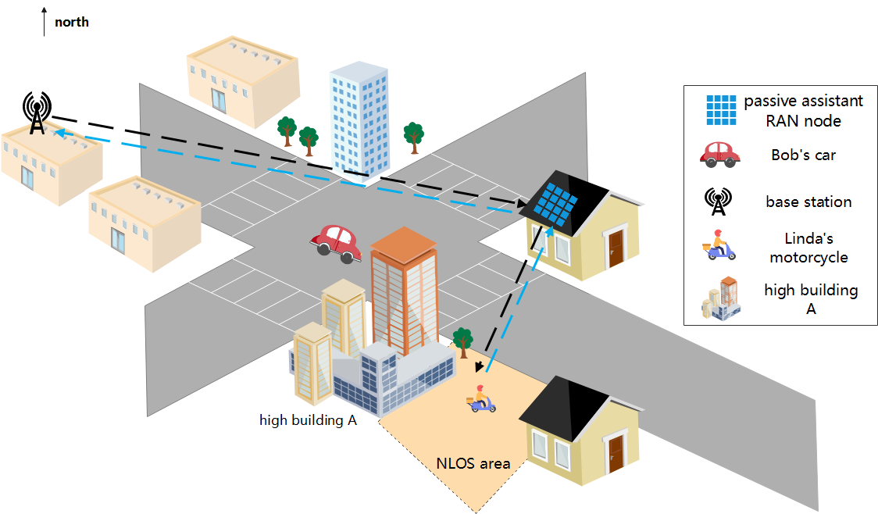
Figure 5.4.3.1. Guaranteed sensing in NLOS area at crossroads
- The 5G base station continuously collects sensing measurement data of the road status and the sensing result is continuously reported to the ITS management platform by 5G network according to the preconfigured refresh rate (e.g. slow refresh rate with 0.2Hz, normal report 1Hz, fast report10Hz, very fast report 50Hz). The refresh rate can be adjusted according to user’s request.
- Bob has started his road status sensing service when he begins driving his vehicle. He selects normal report refresh rate (i.e. 1Hz), thus he can receive the road status information with once per second. When he is near the crossroad e.g. 100m distance, he requests faster road status information refresh rate e.g. 10 Hz. Then the ITS management platform asks 5G network to report sensing result with the refresh rate of 10Hz.
- Bob is driving his vehicle and crossing the crossroad with a speed of 40km/h toward the southeast of the crossroad. Linda is driving her motorcycle on a side road toward the main road which is also the southeast of the crossroad. Linda is in the NLOS area of the serving base station. Also, the line of sight between Bob and Linda is blocked by the high building A which is at a corner of the intersection. Linda’s motorcycle activity is sensed by the base station with the help of the passive assistant RAN node.
- The motorcycle sensing result which includes the motorcycles moving speed, moving direction, position etc. is reported to the ITS management platform.
- Linda’s motorcycle activity is continuously sensed by the base stations with the help of the passive assistant RAN node.
- The motorcycle sensing result is reported to the ITS management platform with the refresh rate of 10Hz.
- According to the continuously received motorcycle sensing results, the ITS management platform can analyze and identify that there will be a potential collision risk between Bob and Linda. The collision warning then is sent to Bob.

5.4.4 Post Conditions
Bob receives the warning and drives safely through the crossroads and Linda can also ride safely to the road. The potential risk of collision is avoided.
Thanks to the passive assistant RAN nodes and the 5G based wireless sensing, the sensing service availability especially in NLOS area can be guaranteed.

5.4.5 Existing features partly or fully covering the use case functionality
None

5.4.6 Potential New Requirements needed to support the use case
[PR 5.4.6-1] The 5G system shall be able to support an energy efficient mechanism to provide available sensing service whether the object targets are in the LOS or NLOS area.
[PR 5.4.6-2] According to operator’s policy, the 5G system shall be able to continuously collect sensing measurement data from requested area.
[PR 5.4.6-3] The 5G system shall be able to report the sensing result to the trusted 3rd party with refresh rate configured or adjusted by the trusted 3rd party.
NOTE: The sensing result may be the target object’s size, shape, position, moving direction, moving speed, etc.
[PR 5.4.6-4] According to operator’s policy, the 5G system shall be able to provide a mechanism to enable the trusted 3rd party to configure/adjust refresh rate of sensing result report.
[PR. 5.4.6-5] The 5G system shall able to support the sensing service with given KPIs in Table 5.4.6-1.
Table 5.4.6-1 KPI Table of Sensing
Scenario | Sensing Distance |  |  | Sensing Angle/direction |  |  | Moving Speed of target object |  |  | Interval between two consecutive sensing fixes | Latency
 | Accuracy(m) | Resolution(cm) | Distance Range | Accuracy | Resolution | Angle range | Accuracy | Resolution(m/s) | Speed range(km/h)
Guaranteed Sensing for NLOS area at crossroads | 2(note1) | 36.6  (note2) | FFS | FFS | FFS | FFS | FFS | 0.52  (note2) | <=90  (note2) | FFS | FFS
NOTE1: The value is sourced from [8].
NOTE2: The values are sourced from [9]

