3GPP TSG-SA WG1 Meeting #92e S1-204046r1_oppo
Electronic Meeting, 16 – 25 November 2020 (revision of S1-20xxxx)
Title: FS_AMMT: Flocking Use Case
Agenda Item: 7.4.1 (FS_AMMT)
Document for: Approval
Source: Samsung, OPPO
Contact: Erik Guttman <erik.guttman@samsung.com>

Abstract: Federated learning many involve many communicating devices. This use case explores a service enabler to improve the performance of ‘straggling contributors’ and not to waste resources on ‘vanguard’ members of the federation.

7.x.1 Federated Learning Flocking Use Case

7.x.1 Description
A new ‘service enabler’ is introduced that allows a federated learning service provider to achieve effective performance for the entire flock of federated devices.
Federated learning involves a set of contributing terminals, as described in clause 7 of this TR. In a federation, a hierarchy exists that provides an effective delegation of work and information. This federation functions as if it were a single (non-federated) system to the extent that the distributed components can operate within the same expectations. If some number of the federation’s components lag, these become stragglers. Information and function availability of the whole federation suffers when the performance of individual components fall significantly behind the others.
This use case introduces the notion of a federated “flock.” The 5GS normally considers performance objectives and QoS for individual communicating terminals. Here, the 5GS QoS objective relates to the entire set of terminals making up the federation, the “flock” of UEs.

7.x.2 Pre-conditions
A set of UEs that participated in federated learning exists. These UEs have registered with a PLMN and operate in a federation to perform federated learning tasks.
The federated learning service provider “Avian” organizes the work of these UEs so that repeated iterations of training will occur over time.
It is assumed that the UEs provide federated learning input using the same network resources (e.g. network slice) and that the policy for this network communication is distinct from the policy for other activities that the UE performs. In this way, the network can adjust the QoS policy for federated learning communication for individual UEs without any service impact except to the federated learning service.

7.x.3 Service Flows
As the performance of the entire set of UEs is bounded by the performance of the weakest members of the group, Avian provides the 5GS with a policy identifying the reporting interval for which different iterations should conclude. Avian also provides reports on the progress of different UEs as they proceed. The 5GS is then in a position to adjust the QoS policies of some UEs to allocate more resources for those UEs that lag, and less resources for those that are ahead of the flock. The resource allocated to UE is maintained for at leat one iteration. The 5GS can inform Avian of any additional UEs with good communication performance (e.g. due to radio resources) and/or existing UEs whose connection has degraded to a level which is no longer sufficient for FL tasks. This enables Avian to determine when to add new UEs into the flock or remove existing UEs from the flock.
NOTE: While it is clear that the speed with which training occurs and reports are generated by UEs is only partially bounded by communication, it is assumed that the communication resources available to the UE is a significant contributor to the time it requires to complete a training iteration.
When a new UE joins the federation, it will register with Avian. Avian can then notify the 5GS (by means of a standard interface) of this addition. This interface is depicted logically in Figure 7.x.3-1 below.
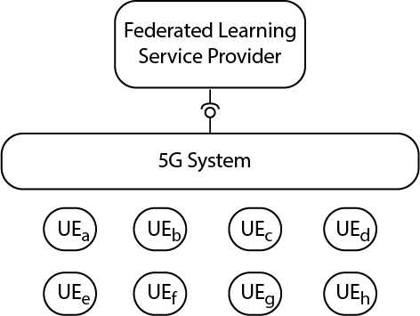
Figure 7.x.3-1: 5G Service Enabler interface for Federated Learning
Similarly, when a UE leaves the federation, the 5GS is notified. This allows the 5GS to modify the policy to balance the QoS policy to achieve the most consistent performance across the involved UEs.

7.x.4 Post-conditions
The ‘flock’ of UEs performs consistently. The slowest UEs (at producing a report after a federated learning task) achieve an improved performance and the fastest UEs (at producing a report after a federated learning task) do not need network resources (higher QoS), so the 5GS saves these resources. The overall result is more efficient for the Federated Learning service and for the network operator.
In addition, UEs with inadequate communication performance (e.g. due to radio conditions) may be removed while UEs with excellent communication performance (e.g. good radio conditions) may be added to the group.

7.x.5 Existing features partly or fully covering the use case functionality
The existing QoS features controlled by the network with reconfigurable policy provide necessary but not sufficient functionality to support the use case.

7.x.6 Potential New Requirements needed to support the use case
[PR7.x.6-1] The 5G system shall support ‘aggregated performance’ for a group of UEs where that the worst performing UE defines the performance of the entire group. The 5G system should achieve communication performance for the entire group so as to avoid UEs achieving either significantly less or more performance than others in the group.
[PR7.x.6-2] The 5G system shall be able to maintain a required QoS for each member in a FL group for at least one iteration. The 5G system shall be able to inform FL service provider of new UEs with good communication performance (e.g. excellent radio resources) and/or of existing UEs whose connection has degraded to a level in which they can no longer perform sufficiently in the group. This enables the FL service provider to add new UEs to the group or remove existing UEs from the group.

