3GPP TSG-SA WG1 Meeting #92e S1-204101r2
Online, 11 Nov – 20 Nov 2020

Title: Use case of Smart Distribution Transformer Terminal
Agenda Item: 7.9.1
Source: CEPRI, ZTE, China Telecom
Contact: yangdelong@epri.sgcc.com.cn;
chenjie@epri.sgcc.com.cn;
zhoufeiyan@epri.sgcc.com.cn
xu.ling@zte.com.cn

Abstract: This contribution proposes a new use case for Smart Distribution Transformer Terminal in Distribution Transformer Area.

Proposed Text:
----------------------------------------------------- Start of the 1st change -------------------------------------------------

2 References
The following documents contain provisions which, through reference in this text, constitute provisions of the present document.
- References are either specific (identified by date of publication, edition number, version number, etc.) or non-specific.
- For a specific reference, subsequent revisions do not apply.
- For a non-specific reference, the latest version applies. In the case of a reference to a 3GPP document (including a GSM document), a non-specific reference implicitly refers to the latest version of that document in the same Release as the present document.
[1] 3GPP TR 21.905: "Vocabulary for 3GPP Specifications".
[2] SunWeiqing etc. Generalized Energy Storage Control Strategies on User Side in Power Ancillary Service Market. Automation of Electric Power System Vol.44 No.2 Jan.25, 2020
[3] China Southern Power Grid, China Mobile, HuaWei: "White Paper: 5G enables smart grid applications".http://www.sgcio.com/technology/anli/2018/0716/86656.html
[4] GB/T 1936-2018 Guidelines of cyber security protection for electric power system supervision and control http://www.howtoabc.com/book8/14078-0.html, https://www.secrss.com/articles/24761
[5] IEEE C37.2-2008 IEEE Standard Electrical Power System Device Function Numbers, Acronyms, and Contact Designations.
[6] IEC TR 61850-90-1:2010, Communication Networks and Systems for Power Utility automation – Part 90-1: Use of IEC61850 for the communication between substations.
[7] IEEE 1588-2019 – IEEE Standard for a precision clock synchronization protocol for networked measurement and control systems.
[8] IEEE Guide for Application of Digital Line Current Differential Relays Using Digital Communication.
[9] 61850-9-3-2016 – IEC/IEEE International Standard - Communication Networks and Systems for Power Utility automation – Part 90-3: Precision time protocol profile for power utility
[10] 3GPP TR 22.804: "Study on Communication for Automation in Vertical domains (CAV)".
[11] Sendin, A., et. al., “Telecommunication Networks for the Smart Grid,” Artech House, 2016.
[12] Goel, S., S. F. Bush, and D. Bakken, (eds.), IEEE Vision for Smart Grid Communications: 2030 and Beyond, New York: IEEE, 2013.
[13] US Department of Energy, “Communications Requirements of Smart Grid Technologies, 2010”, accessed 14.08.20, http://energy.gov/sites/prod/files/gcprod/documents/Smart_Grid_Communications_Requirements_Report_10-05-2010.pdf
[x] China Innovation Alliance for Power Distribution Internet of Things, “Technical Specifications of Smart Distribution Transformer Terminal”
----------------------------------------------------- End of 1st change ------------------------------------------------------

----------------------------------------------------- Start of the 2nd change ------------------------------------------------

3 Definitions and abbreviations

3.1 Definitions

Smart Distribution Transformer Terminal: The smart terminal is usually deployed in the distribution transformer area. It can support multiple energy applications simultaneously. On the one hand, it connects with multiple energy application platforms through 5G communication system to exchange collected data and management data with multiple energy application platforms; on the other hand, it connects with diverse energy end equipment to collect related electricity data, some of which can be analysed and take action in the smart terminal.

----------------------------------------------------- End of 2nd change -----------------------------------------------------

----------------------------------------------------- Start of the 3rd change ------------------------------------------------

5.x Use case of Smart Distribution Transformer Terminal

5.x.1 Description
The Smart Distribution Transformer Terminal is usually deployed in the distribution transformer area. It could support multiple energy applications simultaneously. Multiple kinds of energy data is collected firstly by the terminal and then delivered to related energy application platform. Some kind of data could be analysed, or even the terminal itself can make decision to perform real-time action. Figure 5.x.1-1 illustrates a work flow example of Smart Distribution Transformer Terminal.
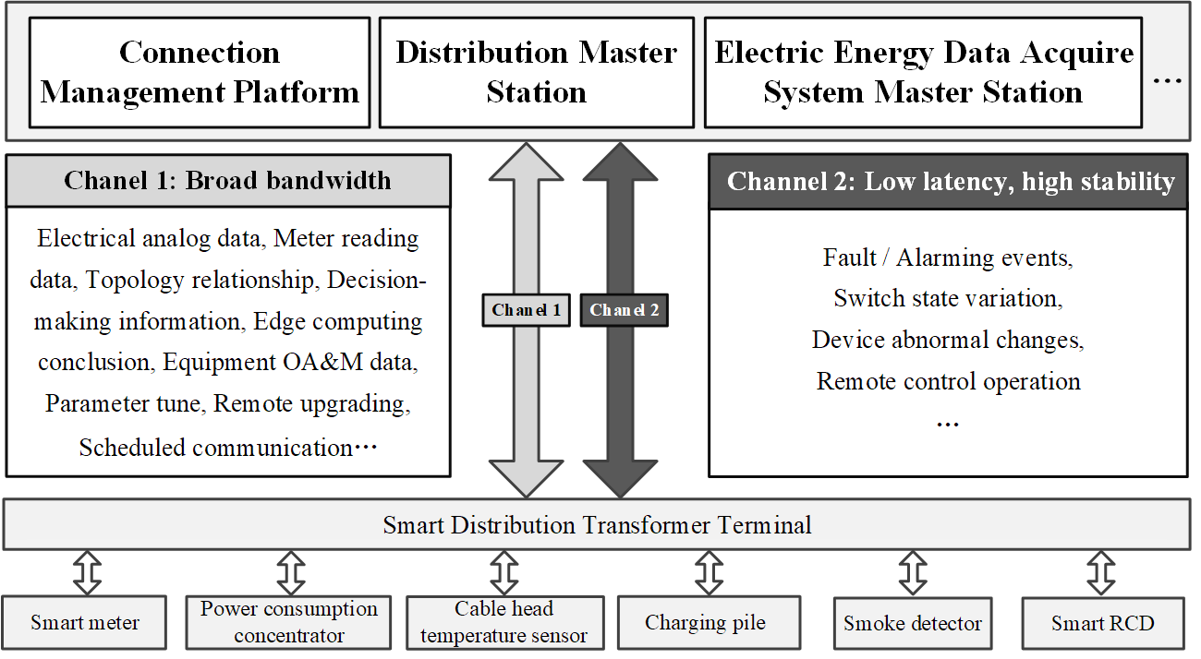
Figure 5.x.1-1 Example of Smart Distribution Transformer Terminal work flow
With the assistance of 5G system, it could reports massive energy data separately to multiple energy application platforms according to their requirements. And data from energy application platforms could also be sent to terminal through 5G network, no matter it is business data or management data. Typical interactive data includes fault / alarming events, switch state variation, device abnormal changes, remote control operation, electrical analog data, meter reading data, topology relationship, decision-making information, edge computing conclusion, equipment OA&M data, remote upgrading, scheduled communication, etc. Some of this data is event triggered and required a high priority real-time communication while others may need a regular latency but broad bandwidth channel to fit their demands.
The energy application platform could be connection management platform (AKA IoT platform), master station of distribution automation system and master station of electric energy data acquire system. In future, there might be more platforms that need to transfer data through the 5G network.
In general, the connections between the Smart Distribution Transformer Terminal and application platform are provided by 5G system, while the connections between energy end equipment and Smart Distribution Transformer Terminal are out of 3GPP scope.
These energy applications and different data flows in one application require different communication services and different safety & isolation protection according to the Industry regulation. So, the Smart Distribution Transformer Terminal is required to isolate these energy data according to different application demands.

5.x.2 Pre-Conditions
The energy company EE has a contract with Tele-Operator TT. TT will provide 5G communication service for EE’s energy services.
EE has deployed a lot of Smart Distribution Transformer Terminals which could utilize 5G communication links to connect with multiple energy application platforms. In general, each distribution transformer area could deploy a Smart Distribution Transformer Terminal.
The energy application platform could be connection management platform (AKA IoT platform), master station of distribution automation system and master station of electric energy data acquire system. In future, there might be more platforms that need to transfer data through this network.
EE configures different communication services demands and safety & isolation demands for different energy applications.

5.x.3 Service Flows
1. The 5G system gets the demands of communication and isolation to establish two 5G communication links between the Smart Distribution Transformer Terminal and the energy application platform. One link is required with high data rate to deliver data e.g. electrical analog data, meter reading data, topology relationship, decision-making information, edge computing conclusion, equipment OA&M data, remote upgrading, scheduled communication, etc. The other link is required with low latency and high stability to deliver data e.g. fault / alarming events, switch state variation, device abnormal changes, remote control operation, etc.
2. The energy end equipment e.g. smart meters, cable head temperature sensors, power consumption concentrators, smoke detectors, smart RCDs, charging piles and phase change switches, collect related data and deliver to the Smart Distribution Transformer Terminal.
3. The Terminal continues to deliver the collected data and analysis / decision information to different energy application platforms through above two 5G communication links and with different isolation demands.
- Some data e.g. energy consumption data in the distribution transformer, power line, and user point can be analysed by the Terminal and take some action e.g. adjust topology. Then the result data will be reported to related energy application platform.
- Some data is periodic collected and reported, e.g. energy quality data and energy equipment status data.
- Some data is event trigger and need to be reported in real time, e.g. the voltage, current, alarm data of each node in the low-voltage area.

5.x.4 Post-Conditions
The energy application platforms receive the collected data in time and with required isolation protection.
The communication links status also can be monitored by energy company EE.

5.x.5 Existing features partly or fully covering the use case functionality
The 5G system shall be able to provide suitable APIs for the energy application platform to monitor the quality of the communication link.

5.x.6 Potential New Requirements needed to support the use case
[PR 5.x.6 -1] Subject to regional or national regulation, the 5G system shall be able to provide dedicated communication resources per energy application to allow energy applications to remain unaffected in their communication e.g. in case of overload caused by another energy application.
Editor note: the further potential requirements will be studied.

----------------------------------------------------- End of 3rd change -----------------------------------------------------

