3GPP TSG-SA/CT/RAN Meeting #92e xP-21xxxx
Electronic Meeting, XX June 2021

Title: Clarifying the use of the F-BB-WT structure
Agenda Item: 20.1 – General project management issues
Source: Work Plan Manager (MCC)
Contact: alain.sultan@etsi.org

Abstract: This document explains that the “Feature-Building Block-Work Task” (F-BB-WT) structure is to identify the key elements of a Feature, not to replicate the 3GPP structure. Once cleaned-up, the F-BB-WT structure can be used for a high-level grouping of requirements.
**********************************************************************************

Background
The concept of structuring the 3GPP Work Items in 3 levels, namely “Feature-Building Block-Work Task” (F-BB-WT), has been loosely defined since its introduction, about 20 years ago. Because of this, it has been used in different ways, sometimes to reflect the 3GPP structure, sometimes to distinguish between different functionalities.
This paper proposes to finally clarify the concept. Once clarified, the F-BB-WT can be used as a high-level approach of tracking the main groups of requirements.

Proposal
The “Feature-Building Block-Work Tasks” structure was introduced to identify the different components of a Feature. It shall not be used to replicate the 3GPP TSG/WGs structure.
For instance, Mission Critical, introduced in Rel-13, was improved in Rel-14 according to 3 different aspects: "MCImp-MCData"/"MCImp-MCVideo"/"MCImp-eMCPTT". These 3 aspects are the “Building Blocks” of the “Mission Critical” (“MCImp”) Feature. All aspects common to the 3 Building Blocks can be grouped under the root (“MCImp”).
The following figure show how the Work Plan should have been ideally structured for MCImp:
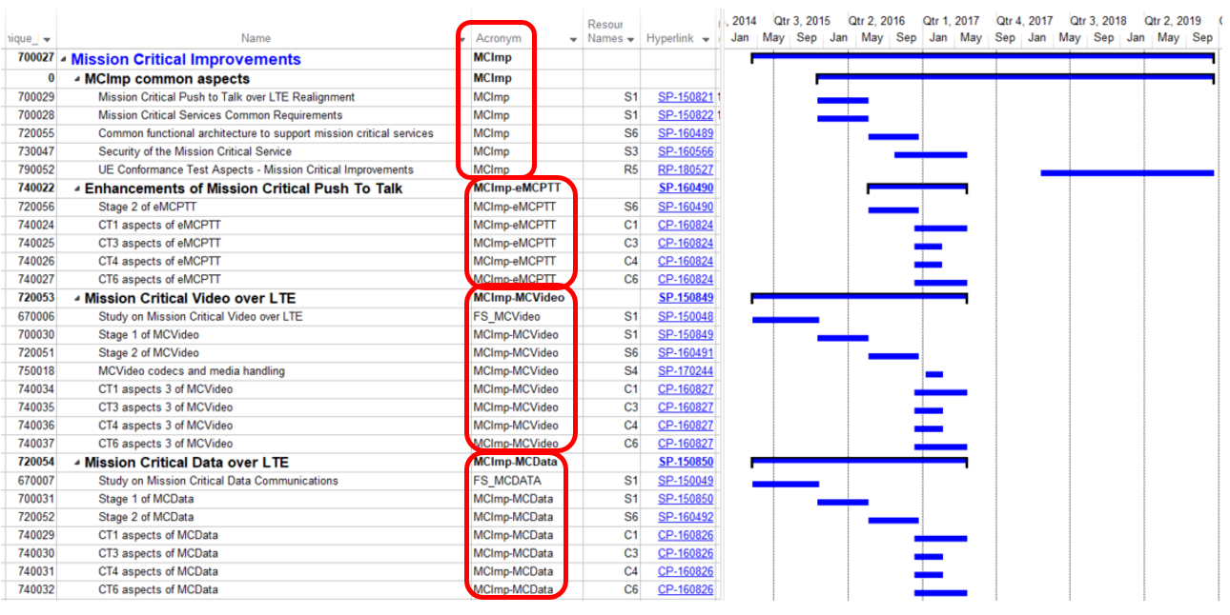
Figure 1: Correct usage of the “Feature-Building blocks-Work Tasks” structure: one building block identifies one key functionality
On the other hand, the following figure shows an incorrect usage of the “Feature-Building Block-Work Tasks” structure, where the F-BB-WT structure simply replicates the 3GPP structure:
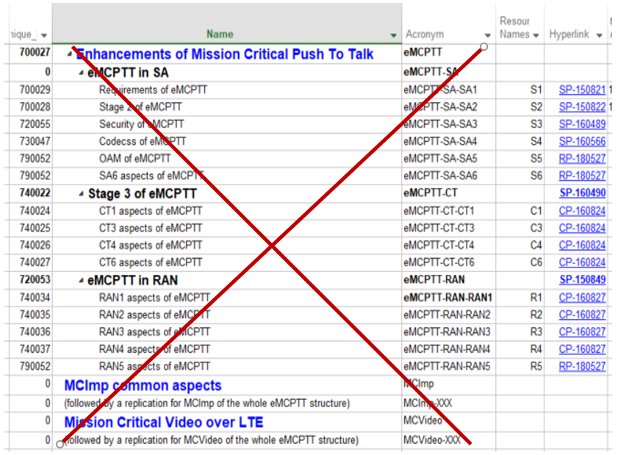
Figure 2: Incorrect usage of the “Feature-Building Block-Work Tasks” structure: the F-BB-WT just replicates the 3GPP structure: added complexity for no benefit
The "Feature-BBs-WTs" structure is TO BE USED ONLY for identifying key different topics within a Feature, e.g. the ones that might end up in different Releases, such as "MCImp-MCData" and "MCImp-MCVideo".
The "Feature-BBs-WTs" structure is NOT TO BE USED to reflect the 3GPP structure. All the necessary parts (Stage 1, 2, 3, OAM, Radio, Security, etc) form a flat structure within a single item, whatever its level (F, BB or WT).

To a certain extent, the “F-BB-WT” can reflect a high-level grouping of requirements. For instance, three WTs can be created under the MCVideo BB: “MCImp-MCVideo-onNetwork”, “MCImp-MCVideo-offNetwork” and “MCImp-MCVideo-common”.
The limitation of such an approach is the total number of lines in the Work Plan. This total number is the “number of Features” x “number of BBs within each Feature” x “number of WTs within each BB” x “number of involved WGs per WT”. For instance, a Feature with 7 BBs, with 7 WTs each, with 7 WGs involved per WT would generate 343 lines. This will definitely not allow to track every single SA1 requirement, otherwise the number of lines in the Work Plan will “explode”.
On the other hand, some Features are extremely simple - the minimum being one item with one single WG involved, i.e. one single line in the Work Plan - but this shows that using the F-BB-WT to group the requirements consumes a lot of lines in the Work Plan.

