3GPP TSG-RAN5 Meeting #96-e Draft_R5XXXXX
Electronic Meeting, 15th August – 26th August 2022

Title: LS on UE conformance testing for RedCap UE on SUL band
Response to:
Release: Release 17
Work Item: NR_redcap_plus_ARCH-UEConTest

Source: RAN WG5
To: RAN
Cc: N/A

Contact Person:

Name:

E-mail Address:

Send any reply LS to: 3GPP Liaisons Coordinator, 3GPPLiaison@etsi.org

Attachments:

1. Overall Description:
RAN5 has discussed the UE conformance testing for a RedCap UE. RAN5 has some observations towards RAN decision and RAN2, RAN4 specifications, and has made a few working assumptions accordingly.

Observation 1: Regarding RedCap supporting V2X, NR-U and SUL, RAN had following conclusions.

<Decision on RP-212634 at RAN#93>
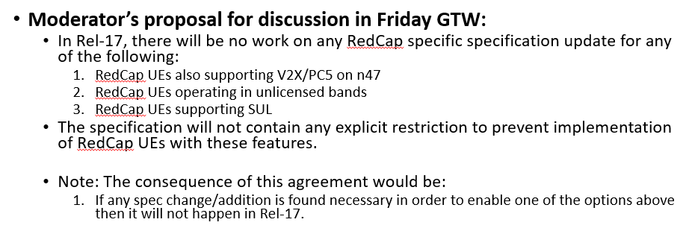

<Decision on RP-220836 at RAN#95>
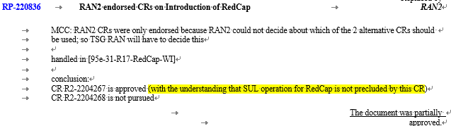

<Decision on RP-220462 at RAN#95>
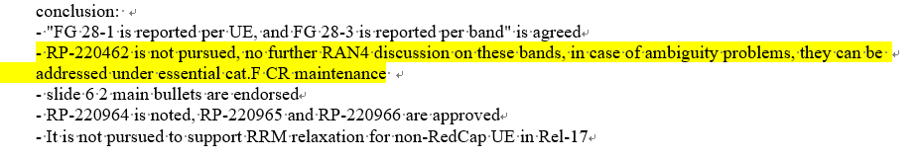

Observation 2: Based on TS 38.306, v17.1.0, the definition of RedCap UEs is specified as below.

4.2.21.1 Definition of RedCap UE
RedCap UE is the UE with reduced capability:
….
- CA, MR-DC, DAPS, CPAC and IAB (i.e., the RedCap UE is not expected to act as IAB node) related UE features and corresponding capabilities are not supported by RedCap UEs. All other feature groups or components of the feature groups as captured in TR 38.822 [24] as well as capabilities specified in this specification remain applicable for RedCap UEs same as non-RedCap UEs, unless indicated otherwise.

Observation 3: Based on TS 38.101-1 v17.6.0, the RF requirements for RedCap UE are specified as below.

6.2.1I Maximum output power for RedCap UE
For Redcap UE, the requirements for power class 3 specified in clause 6.2.1 apply.

Based on above RAN conclusions, RAN5 has made following working assumptions:
- RAN5 test cases will apply to RedCap UE except for the features explicitly excluded by RedCap in TS 38.306, i.e CA, MR-DC, DAPS, CPAC and IAB.
- All general requirements in TS 38.101-1 shall apply to RedCap UE. Additional feature requirement for RedCap UE in 6.2.1I, i.e. the maximum output power requirements apply to all bands in 6.2.1 according to TS 38.101-1 v17.6.0.

2. Actions:
To RAN.
ACTION: RAN5 respectfully requests RAN take above information into consideration.

3. Date of Next TSG-RAN WG5 Meetings:
TSG-RAN5 Meeting#97 14th – 18th November 2022 Canada
TSG-RAN5 Meeting#98 27th February – 3rd March 2022 Athens

References
- R5-225059, Discussion on SUL in RedCap WI, Ericsson, Nokia, Qualcomm
- R5-225186, WF for RedCap UE testing of SUL, Huawei, HiSilicon, China Unicom, China Telecom, China Mobile
- TS 38.101-1 User Equipment (UE) radio transmission and reception; Part: Range 1 Standalone (Release 17), v17.6.0
- TS 38.306 NR; User Equipment (UE) radio access capabilities, v17.1.0
- RP-211574 Revised WID on support of reduced capability NR devices
- RP-212634 Moderator's summary for discussion [93e-16-RedCap-WI], Intel
- RP-213550 Meeting Report for TSG RAN meeting #93e
- RP-221776 Meeting Report for TSG RAN meeting #95e

