3GPP TSG-RAN5 Meeting #92-e R5-215809_Draft
Electronic Meeting, 16th – 27th August 2021

Title: LS on AMPR edge RB allocation for NS
Response to:
Release: Release 15
Work Item: 5GS_NR_LTE-UEConTest

Source: TSG RAN WG5
To: TSG RAN WG4
Cc: N/A

Contact Person:

Name: Mohammad Omar Farooq
Tel. Number:

E-mail Address: mohammad_farooq@apple.com

Send any reply LS to: 3GPP Liaisons Coordinator, mailto:3GPPLiaison@etsi.org

Attachments:

1. Overall Description:
In TS 38.101-1 specification, it is observed that for edge RB, A-MPR value is not explicitly mentioned for several NS scenarios. However, A-MPR values for “Outer” and “Inner” values are indicated under a row below values for different regions but edge RB allocation is omitted. These tables from TS 38.101 are used in related sections in TS 38.521-1 specification for A-MPR test cases.
We can take an example of NS_21 table in TS 38.521-1 section 6.2.3.3.14. A-MPR values for “Outer” and “Inner” are indicated under a row below values for different regions (Regions A1a, A1b, A2, A3b and A3a). Interpreting regions A1a and A3a based on formula stated covers outermost allocations at the channel edges. If we consider 1RB@0 scenario which falls in Region A1a (RB_{start} ≤ 8, L_{CRB} ≤ 3), we should choose 6 dB AMPR for edge allocation but because of “Outer/Inner” row it creates confusion about selecting AMPR value for such scenario. As edge allocation is excluded in the table A-MPR can be mis-interpreted as 0 dB, which may create ambiguity in test/UE implementation.
It appears that row with phrases like “Outer/Inner” and “Outer” is redundant information and creating confusion for the A-MPR table for NS_21.

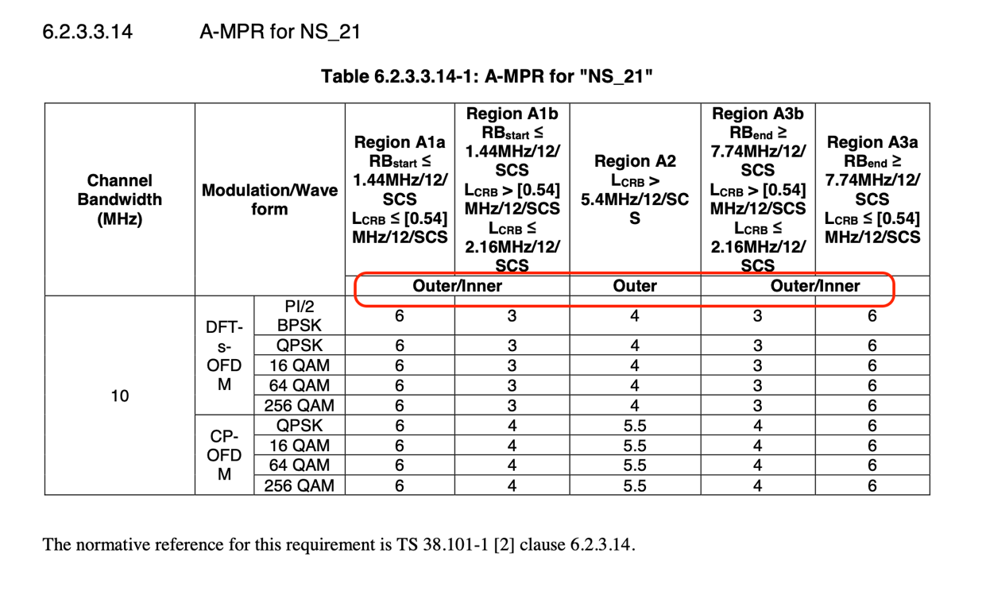

Similar issues are found for other NS (example: NS_24, NS_27, NS_46 etc.). This issue requires clarification and further analysis.

2. Actions:
To RAN4 group.
ACTION: RAN5 respectfully requesting RAN4 group to clarify band edge requirement for NS_21 and other NS values where AMPR requirement is defined as “Outer/Inner” but edge requirement is omitted.

3. Date of Next TSG-RAN WG5 Meetings:
TSG-RAN5 Meeting#93e 8th – 19th November 2021 Electronic Meeting
TSG-RAN5 Meeting#94 21st – 25th February 2022 Athens, GR

--- END ---

