**3GPP TSG-RAN WG4 Meeting #97-e *R4-2017641***

**Electronic Meeting, 2nd – 13th Nov 2020**

|  |  |  |  |  |  |  |  |  |
| --- | --- | --- | --- | --- | --- | --- | --- | --- |
| *CR-Form-v12.1* | | | | | | | | |
| **CHANGE REQUEST** | | | | | | | | |
|  | | | | | | | | |
|  | **38.827** | **CR** | **0007** | **rev** | **1** | **Current version:** | **16.0.0** |  |
|  | | | | | | | | |
| *For* [***HELP***](http://www.3gpp.org/3G_Specs/CRs.htm#_blank)*on using this form: comprehensive instructions can be found at* [*http://www.3gpp.org/Change-Requests*](http://www.3gpp.org/Change-Requests)*.* | | | | | | | | |
|  | | | | | | | | |

|  |  |  |  |  |  |  |  |  |
| --- | --- | --- | --- | --- | --- | --- | --- | --- |
| ***Proposed change affects:*** | UICC apps |  | ME | **X** | Radio Access Network |  | Core Network |  |

|  |  |  |  |  |  |  |  |  |  |  |
| --- | --- | --- | --- | --- | --- | --- | --- | --- | --- | --- |
|  | | | | | | | | | | |
| ***Title:*** | CR for 38.827 on corrections | | | | | | | | | |
|  |  | | | | | | | | | |
| ***Source to WG:*** | Huawei, HiSilicon, CAICT | | | | | | | | | |
| ***Source to TSG:*** | R4 | | | | | | | | | |
|  |  | | | | | | | | | |
| ***Work item code:*** | FS_NR_MIMO_OTA_test | | | | |  | ***Date:*** | | | 2020-11-09 |
|  |  | | | |  | |  | | |  |
| ***Category:*** | **F** |  | | | | | ***Release:*** | | | Rel-16 |
|  | *Use one of the following categories:* ***F*** *(correction)* ***A*** *(mirror corresponding to a change in an earlier release)* ***B*** *(addition of feature),* ***C*** *(functional modification of feature)* ***D*** *(editorial modification)*  Detailed explanations of the above categories can be found in 3GPP [TR 21.900](http://www.3gpp.org/ftp/Specs/html-info/21900.htm). | | | | | | | | *Use one of the following releases: Rel-8 (Release 8) Rel-9 (Release 9) Rel-10 (Release 10) Rel-11 (Release 11) … Rel-15 (Release 15) Rel-16 (Release 16) Rel-17 (Release 17) Rel-18 (Release 18)* | |
|  |  | | | | | | | | | |
| ***Reason for change:*** | | Corrections | | | | | | | | |
|  | |  | | | | | | | | |
| ***Summary of change:*** | | Section 4.3 FR1 frequency range  Section 6.2.3.2 reference section number  Section 6.5 editorial corrections and reference section number  Section 7.1 correction on reference table  Section 7.2 correction on Determination of beam directions ${\hat{r}}_{tx,max}$ Section 7.3 editorial correction  Section 7.4.1.5 incorrect table titles  Section B.2.2 corrections on subsection number, remove a duplicated subsection | | | | | | | | |
|  | |  | | | | | | | | |
| ***Consequences if not approved:*** | | Incorrect specs | | | | | | | | |
|  | |  | | | | | | | | |
| ***Clauses affected:*** | | 4.3, 6.2.3.2, 6.5, 7.1, 7.2, 7.3, 7.4.1.5, B.2.2 | | | | | | | | |
|  | |  | | | | | | | | |
|  | | **Y** | **N** |  | | | |  | | |
| ***Other specs*** | |  | **X** | Other core specifications | | | | TS/TR ... CR ... | | |
| ***affected:*** | |  | **X** | Test specifications | | | | TS/TR ... CR ... | | |
| ***(show related CRs)*** | |  | **X** | O&M Specifications | | | | TS/TR ... CR ... | | |
|  | |  | | | | | | | | |
| ***Other comments:*** | |  | | | | | | | | |
|  | |  | | | | | | | | |
| ***This CR's revision history:*** | |  | | | | | | | | |

(Start of changes)

## 4.3 Testing Bands

The present technical report covers both FR1 and FR2 operating bands.

Table 4.3-1: Definition of frequency ranges

|  |  |
| --- | --- |
| Frequency range designation | Corresponding frequency range |
| FR1 | 410 MHz – 7125 MHz |
| FR2 | 24250 MHz – 52600 MHz |

(Unchanged sections omitted)

#### 6.2.3.2 Test procedure

Before throughput testing, the initial conditions shall be confirmed to reach the correct measurement state for each test case.

1. Ensure environmental requirements of Annex C are met.

2. Configure the test system according to Clauses 8.2 and 7.2 for the applicable test case.

3. Verify the implementation of the channel model as specified in Clause 7.4.1.

4. Position the UE in the chamber according to Annex A.

5. Power on the UE.

6. Set up the connection.

Note: For step 3, the verification of the channel model implementation is usually performed once for each channel model as part of the laboratory accreditation process, and will remain valid as long as the setup and instruments remain unchanged. Otherwise the channel model validation may need to be performed prior to starting each throughput test.

For throughput testing, the following steps shall be followed in order to evaluate NR MIMO OTA performance of the DUT:

1. Position the DUT in the default P0 alignment option (Orientation 1), as defined in Section A.3

2. Measure MIMO OTA throughput, the maximum downlink power is TBD. MIMO OTA throughput is the minimum downlink signal power resulting in a pre-defined throughput value ([FFS]) of the maximum theoretical throughput. The downlink signal power step size shall be no more than 0.5 dB when RF power level is near the NR MIMO sensitivity level.

3. Rotate the UE to the next test point. Table 6.2.3.2-1 lists 36 evenly spaced test points determined using the charged particle approach and with test point #1 centred at (0,0).

4. Repeat the test from step 2 for each specified test point. If the re-positioning concept is applied, the device needs to be positioned in P0 Orientation 2 (either option 1 or option 2).

5. The postprocessing method and the performance metric are FFS.

(Unchanged sections omitted)

## 6.5 EUT positioning in the chamber

6.5.1 Minimum test zone size

The minimum test zone size for NR MIMO OTA test methods, both FR1 and FR2, is 20cm. Another test zone size larger than 20cm is FFS. “Black-box” testing approach is adopted for NR MIMO OTA testing, the physical center of the EUT shall be placed in the centre of the test zone, the EUT shall be completely contained within the test zone size defined by respective operation band. The detailed test zone size for each band is listed in Annex A.4.

6.5.2 EUT orientation within the test zone

In order to minimize measurement uncertainty, it’s important that test house ensure the EUT is oriented within the chamber’s test zone in a standardized manner. Annex A.3 provides a preliminary set of normative EUT orientation conditions.

For FR1 MIMO OTA, the DUT shall be tested under Free Space Data Mode Portrait (FS DMP), Free Space Data Mode Landscape (FS DML), and Free Space Data Mode Screen Up flat (FS DMSU), the DUT azimuthal rotation shall be performed over 360 degrees per orientation in 30 degree steps (12 total positions). Finer angular steps at FR1 high frequency for rotation is FFS.

For FR2 MIMO OTA, the DUT shall be tested using a 3D scan. With the DUT positioned in the default P0 alignment option, as defined in Section A.3, measurements on 36 evenly spaced test points with a constant density shall be performed.

(Unchanged sections omitted)

## 7.1 General

The different channel models are defined to create corresponding complex multipath radio propagation conditions for FR1 and FR2. The following scenarios are selected for NR MIMO OTA:

FR1 scenarios:

* For 2x2 MIMO: Urban Macro
* For 4x4 MIMO: Urban Micro

FR2 static testing scenarios:

* Urban Micro street canyon and Indoor

In order to describe unambiguously the procedure of generating realizations CDL channel models, various aspects need to be clarified, e.g., details of scaling procedure, inclusion of BS antenna arrays and beams to the model output, and removing unwanted randomness of model realizations.

The concept of angular scaling is based on rotating AoDs/ZoDs and scaling CDL model using the methods in TR 38.901 (section 7.7.5.1) to make them fit the median values in TR 38.901 Table 7.5-6 for the accepted scenarios.

For NR MIMO OTA testing, the following channel models are required to be measured: FR1 UMi CDL-A in table 7.2.1-1, FR1 UMa CDL-C in table 7.2.1-8; FR2 InO CDL-A in table 7.2.2-6, FR2 UMi CDL-C in table 7.2.2-3.

For NR FR1 and FR2 MIMO OTA testing, the number of samples for sequence length at each testing point is FFS.

## 7.2 Channel Models

This section describes amendments to the step-wise procedure of the CDL subclause 7.7.1 in TR 38.901 for generating fast fading radio channel realizations. This channel model methodology considers non-Jakes spectrum with the multi-path fading propagation conditions between the gNB emulator and test chamber probe modelled based on Clustered Delay Line (CDL) methodology.

First, the RMS delay spread values of CDL models are normalized first and they must be scaled in delay so that a desired RMS delay spread can be achieved. The scaled delays can be obtained according to the following equation:

, (7.2-1)

in which

*  is the normalized delay value of the *n*th cluster in a CDL in Tables 7.7.1.1 – 7.7.1.5 of [2]
*  is the new delay value (in [ns]) of the *n*th cluster
*  is the target delay spread (in [ns]).

Values of ${DS}_{desired}$ for FR1/FR2 and for different model scenarios are specified in Table 7.2-1.

Table 7.2-1. Target delay spread values.

|  |  |  |
| --- | --- | --- |
| Frequency | Scenario | DSdesired |
| FR1 | UMi | 100 ns |
| FR1 | UMa | 365 ns |
| FR2 | UMi | 60 ns |
| FR2 | InO | 30 ns |

Subsequently, the departure and arrival angles (based on subclause 7.7.1 step 1 in TR38.901 are generated by combining 7.7-5 and part of step 7 in subclause 7.5. The arrival angles of azimuth using are generated using the following equation

, (7.2-2)

where

*- n,*AOA and *c*ASA are the cluster AOA and the cluster-wise rms azimuth spread of arrival angles (cluster ASA), respectively, in Tables 7.7.1.1 – 7.7.1.5 of TR38.901

*- m* denotes the ray offset angles within a cluster given by Table 7.5-3,

*-*  is the mean angle of the original channel model table in NLOS case (equation is specified in Annex A.2 of TR38.901) and the LOS angle  in LOS case,

- Tables 7.2-2 and 7.2.-3 contain the non-circular angle spread values of the original CDL models of TR38.901 before any angular scaling, ASmodel are the angular spreads derived from the original CDL Tables 7.7.1.1 – 7.7.1.5 of TR38.901. TR25.996 describes $μ_{θ}$:

, (7.2-3)

The values are calculated for the AOD, AOA, ZOD, and ZOA angles after removing the mean angle following the definition of rms angular spread in TR25.996, without finding the minimum over circular shifts. Here, the calculation is performed after removing the mean angle first and subsequently equation A-2 from Annex A of TR38.901

, (7.2-4)

is used to rotate  to zero (and also wrap AOAs within +/-180). Equations A-3

, (7.2-5)

and A-1 of TR 25.996

, (7.2-6)

are used to calculate the ASmodel. Note that equation A-2 of TR 25.996 is not applied to ASmodel calculations, the following equation is used instead

ASdesired is the target angular spread. Table 7.2-4 specifies ASdesired values for CDL-A,B,C,D,E UMi and UMa at FR1 and Table 7.2-5 specifies the corresponding ASdesired values at FR2. These target values are obtained by determining median angular spreads of Table 7.5-6 of TR38.901.

The angular scaling is applied to the ray angles and no further scaling is performed. The generation of AOD (), ZOA (), and ZOD () follows a procedure similar to AOA as described above. Here, the azimuth angles may need to be wrapped around to be within [0, 360] degrees, while the zenith angles may need to be clipped to be within [0, 180] degrees.

Each CDL parameter table of contains two sets of three rows, i.e., three clusters, with exactly same angular parameters. This is harmful for the statistical properties of the models as they become non-WSS across the ensemble of model realizations. Instead of making the angular parameters non-equal by introducing small offsets to angles of the three rows, the problematic clusters are treated as midpaths as intended when the CDLs where drawn from statistical distributions which works across all frequency ranges. For the clusters that look like midpaths, e.g., Cluster 2-4 and 5-7 for CDL-A and Cluster 2-4 and 6-8 for CDL-C, the powers for each of the three clusters are added and using the regular midpath power distribution of 0.5, 0.3, and 0.2 specified in Table 7.5-5 of TR38.901, the powers for the each of the midpaths are calculated. Notice that the intra cluster delay spread in Table 7.5-5 of TR38.901 is not followed, and the same delays as the original CDL are followed for the midpaths (aka Sub-Cluster). This helps keeping the rms DS of the modified CDL to 1s.

Table 7.2-2: Original (non-circular) angle spreads of CDL models UMi and UMa (K-factor 9 dB)

|  |  |  |  |  |
| --- | --- | --- | --- | --- |
| Model | ASmodel [deg] | | | |
| ASD | ASA | ZSD | ZSA |
| CDL-A | 73.6985 | 85.2676 | 28.5575 | 21.0831 |
| CDL-B | 41.5917 | 59.3326 | 5.9633 | 10.3818 |
| CDL-C | 39.0949 | 71.1175 | 4.0666 | 10.4245 |
| CDL-D | 15.6771 | 17.3604 | 2.4462 | 1.5362 |
| CDL-E | 13.1544 | 37.5640 | 1.4577 | 2.4601 |

Table 7.2-3: Original (non-circular) angle spreads of CDL-D and CDL-E models InO (K-factor 7 dB)

|  |  |  |  |  |
| --- | --- | --- | --- | --- |
| Model | ASmodel [deg] | | | |
| ASD | ASA | ZSD | ZSA |
| CDL-D | 18.9859 | 21.0747 | 2.9629 | 1.8735 |
| CDL-E | 15.7784 | 45.3434 | 1.7692 | 2.9982 |

Table 7.2-4: Desired AS for UMi and UMa at 3.5 GHz (FR1)

|  |  |  |  |  |
| --- | --- | --- | --- | --- |
| Model | ASdesired [deg] | | | |
| ASD | ASA | ZSD | ZSA |
| UMi NLOS (CDL-A, B, C) | 23.9751 | 57.2457 | 0.7762 | 7.8320 |
| UMi LOS (CDL-D, E) | 15.0432 | 47.6149 | 0.6166 | 4.6204 |
| UMa NLOS (CDL-A, B, C) | 25.7620 | 74.1138 | 4.8978 | 18.2050 |
| UMa LOS (CDL-D, E) | 14.0180 | 64.5654 | 3.4674 | 8.9125 |
| Note: For UMa frequency fc = 6 as stated in [2], and other parameters hUMa = 25, hUMi = 10, hUT = 1.5, and D2D = 100. | | | | |

Table 7.2-5: Desired AS for UMi and InO at 28 GHz (FR2)

|  |  |  |  |  |
| --- | --- | --- | --- | --- |
| Model | ASdesired [deg] | | | |
| ASD | ASA | ZSD | ZSA |
| UMi NLOS (CDL-A, B, C) | 15.6188 | 49.3183 | 0.7762 | 7.2695 |
| UMi LOS (CDL-D, E) | 13.7050 | 41.0212 | 0.6166 | 3.8350 |
| InO NLOS (CDL-A, B, C) | 41.6869 | 50.3659 | 12.0226 | 14.7109 |
| InO LOS (CDL-D, E) | 39.8107 | 31.8526 | 1.3702 | 11.4756 |

Subsequently, the AOD angles are coupled to AOA angles within a cluster *n*. Instead of random procedure, the coupling is performed using the fixed coupling pattern specified in Table 7.2-6. The same fixed coupling pattern is applied for all clusters *n.*

Table 7.2-6: Fixed coupling pattern of ray angles to be applied for each cluster

|  |  |  |  |  |  |  |  |  |  |  |  |  |  |  |  |  |  |  |  |  |
| --- | --- | --- | --- | --- | --- | --- | --- | --- | --- | --- | --- | --- | --- | --- | --- | --- | --- | --- | --- | --- |
|  | m | | | | | | | | | | | | | | | | | | | |
|  | 6 | 12 | 5 | 10 | 8 | 11 | 16 | 14 | 18 | 9 | 20 | 4 | 2 | 15 | 7 | 13 | 19 | 17 | 3 | 1 |
|  | 20 | 9 | 12 | 1 | 13 | 18 | 10 | 4 | 8 | 2 | 6 | 14 | 11 | 19 | 7 | 3 | 17 | 5 | 15 | 16 |
|  | 2 | 16 | 3 | 11 | 18 | 9 | 5 | 17 | 4 | 19 | 15 | 20 | 13 | 7 | 10 | 1 | 8 | 12 | 6 | 14 |
|  | 15 | 18 | 13 | 1 | 12 | 9 | 6 | 7 | 5 | 3 | 2 | 8 | 14 | 17 | 19 | 16 | 11 | 20 | 10 | 4 |

In the next steps, the linear cross polarization power ratios (XPR) **  are calculated for each ray *m* of each cluster *n* as

, (7.2-7)

where *X* is the per-cluster XPR in dB from Tables 7.7.1.1 – 7.7.1.5 of TR38.901.

The gNB beam pattern including the assumptions for gNB antenna for definitions and symbols of subclause 7.3 of TR38.901 for FR1 and FR2 are summarized in Table 7.2-7.

Table 7.2-7: BS Antenna Parameters

|  |  |  |  |  |
| --- | --- | --- | --- | --- |
| Parameter description | Symbol | Parameter value | | |
| FR1 ≤2.5GHz | FR1 >2.5GHz | FR2 |
| Antenna panels in vertical dimension | *Mg* | 1 | 1 | 1 |
| Antenna panels in horizontal dimension | *Ng* | 1 | 1 | 1 |
| Elements per panel in vertical dimension | *Me* | 4 | 8 | 8 |
| Elements per panel in horizontal dimension | *Ne* | 8 | 8 | 16 |
| Number of polarizations per panel | *P* | 2 | 2 | 2 |
| Element spacing in horizontal dimension (λ) | *dH* | 0.5 | 0.5 | 0.5 |
| Element spacing in vertical dimension (λ) | *dV* | 0.5 | 0.5 | 0.5 |

Antenna element radiation patterns, including orientation of the element main polarization components as well as orientation of the antenna array for both FR1 and FR2 are as in the example pattern in Table 7.3-1 of TR38.901. The antenna element parameters are θ3dB = 65°, 3dB = 65°, Amax = 30dB,SLAv = 30dB, *GE,max* =8 dBi.

It is assumed the co-polarized elements of the array are combined to a single RF port, i.e. they compose an antenna array that can form beams by setting certain weights per element. Weight vector for the first polarization and for the second polarization is

, (7.2-8)



where is the location vector of transmit antenna element $m_{e}=1,… ,M_{e}$ and $n_{e}=1,… , N_{e}$, and ${\hat{r}}_{tx,max}$ is a spherical unit vector denoting the target beam direction. Determination of beam directions ${\hat{r}}_{tx,max}$ is described in section 7.3.



Random initial phase  are not used for the different polarization combinations (*θθ, θϕ, ϕθ, ϕϕ*). Instead, a fixed and pre-defined set of initial phases  of Table 7.2-8 and a scalar random initial phase term is used for each ray *m* of each cluster *n*.



The set of fixed initial phases can be same for all clusters, i.e. etc. for all four polarization combinations. These 20×4 initial phase values can be specified either by a table of values or by setting a random number generator and a fixed seed number. The distribution of scalar initial phases $∅_{n,m}$ is uniform within . Its purpose is to enable generation of different fading sequences on different uses of the model, but still maintaining the power angular distribution of the model. The scalar initial phases can be fixed (or removed) if completely deterministic process, i.e. exactly same fading sequences at each model use, is aimed at.



Table 7.2-8: Fixed initial phases for 2x2 polarization matrices. These values are drawn from uniform distribution

|  |  |  |  |  |
| --- | --- | --- | --- | --- |
| *m* | [rad] | [rad] | [rad] | [rad] |
| 1 | 1.7609 | -0.6928 | -1.6230 | -0.6037 |
| 2 | -2.5356 | -2.3124 | 2.7775 | 2.8660 |
| 3 | 0.4725 | -2.7660 | -1.6664 | -0.9226 |
| 4 | 2.0181 | -3.0448 | -2.8713 | -2.0798 |
| 5 | 0.9369 | 1.4560 | 0.9283 | -0.3084 |
| 6 | 0.2954 | -1.2798 | 1.5375 | -1.9544 |
| 7 | 1.1735 | -1.9886 | -0.8263 | 0.7893 |
| 8 | 1.7607 | -2.6319 | 2.6979 | 1.7324 |
| 9 | -0.0830 | -0.4030 | -0.3344 | -1.2167 |
| 10 | 0.0535 | 0.0677 | 1.9957 | 1.8525 |
| 11 | 0.9068 | -0.7627 | 1.9577 | 0.2062 |
| 12 | -0.9379 | 2.7583 | 2.3621 | 0.3151 |
| 13 | 0.7695 | 0.5469 | -1.8363 | -1.2488 |
| 14 | -0.1827 | -1.6934 | 2.1634 | -1.9179 |
| 15 | -1.7221 | -2.0690 | -1.7111 | -0.4040 |
| 16 | -1.1869 | 2.6602 | -0.4385 | -1.9804 |
| 17 | 2.5439 | 3.0143 | -0.3841 | -2.4434 |
| 18 | -1.5201 | -0.5735 | 0.5962 | -1.4941 |
| 19 | 0.6462 | 1.3271 | -1.7483 | -2.4038 |
| 20 | -1.2775 | -1.1386 | -0.4765 | 0.0494 |

To determine the channel all clusters are treated as "weaker cluster", i.e., no further sub-clusters in delay should be generated. The BS beamforming weights defined in Equation 7.2-8for antenna elements are used and the BS antenna signals are summed for BS beamforming. The BS transmits downlink signals with *S* beams. Index denotes the formed beam index. Each beam may have different and thus the beamforming weight of eq. (7.2-8) becomes specific for index *s* as ; it should be noted though that there are always two orthogonally polarized beams to the same direction. Here, the random initial phases ${∅|}_{n,m}$ are used for sub-paths, but not for the different polarization combinations (*θθ*, *θϕ,* *ϕθ,* *ϕϕ*). The channel coefficient for time instant *t*, Rx antenna/beam *u*, Tx beam *s*, and cluster *n* is defined by the following equations. They apply for the NLOS clusters and the LOS path, respectively:



, (7.2-9)



, (7.2-10)



where $F_{tx,s,m_{e},n_{e},θ}$, $F_{tx,s,m_{e},n_{e},φ}$, and are the theta and phi polarized radiation patterns and the position vector of the BS antenna element $m_{e},n_{e}$ of sub-array *s*, respectively.Symbols *Frx,u,θ* , *Frx,u,ϕ*, , , and , are determined as in TR 38.901. UE velocity vector is determined as



 (7.2-11)

UE velocity *v* is defined as follows: 30km/h for FR1 vs 3 km/h (Indoor Office) and 12 km/h (UMi) for FR2. The UE travelling direction (**v, **v) are as follows for FR1:

* (135°,90o) for UMi CDL A channel model
* ([127.0455°],90o) for UMi CDL C channel model
* ([182.1659°],90o) for UMa CDL A channel model
* (65°,90o) for UMa CDL C channel model

The UE travelling direction (**v, **v) are as follows for FR2:

* (112.51°,90°) for InO CDL-A channel model
* (74.11°,90°) for UMi CDL-C channel model

(Unchanged sections omitted)

### 7.3 Channel Model emulation of the Base Station beamforming configuration

The basic parameters of NR BS antenna is specified in table 7.2-7. The propagation environment generated in the test zone is channel model defined in section 7.2 with base station antenna filtering effect. For the channel model emulation in the chamber, the beamforming characteristic of the BS pattern is defined as follow:

* For FR1: A code book of 60 fixed beams is constructed to a grid of five elevation angles from –20° to +20° with 10° steps and 12 azimuth angles from –80° to +80° with ~15° steps；
* For FR2: A code book of 128 fixed beams is constructed to a grid of eight elevation angles from –25° to +25° with ~7.1° step size and 16 azimuth angles from –60° to +60° with 8° step size；

For NR FR1 MIMO OTA, 2 strongest transmitting beams are selected from the pre-defined beam grid based on their proximity to the strong clusters of each FR1 channel model.

For NR FR2 MIMO OTA, 1 strongest transmitting beam is generated from BS, the direction of this beam towards the strongest cluster of each FR2 channel model.

(Unchanged sections omitted)

#### 7.4.1.5 Power validation

**FR1 power validation procedure for MPAC system:**

This measurement checks the total power in the center of the test zone. The power validation is measured with a spectrum analyzer as shown in Figure 7.4.1.5-1.

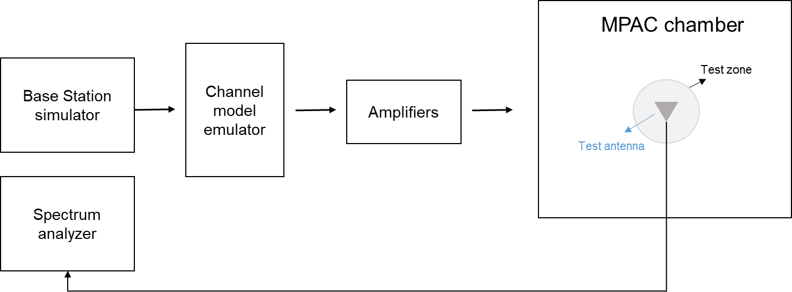

Figure 7.4.1.5-1: Setup for power validation measurements

**Spectrum analyzer settings:**

Table 7.4.1.5-1: Spectrum analyzer settings for Power validation measurements

| Item | Unit | Value |
| --- | --- | --- |
| Center frequency | MHz | Downlink center frequency  in Table 7.4.1-1 |
| Integrated Channel Span | Hz | 20MHz |
| RBW | Hz | 30 kHz |
| VBW | Hz | ≥10MHz |
| Number of points |  | ≥400 |
| Averaging |  | ≥100 |
| Detector |  | RMS |

**Measurement Procedure:**

1. Place a vertical reference dipole in the center of the test zone connected to a spectrum analyzer (or power meter) via a cable.

2. Record the cable and reference dipole gains.

3. Load the target channel model into the channel emulator.

4. Start the NR FR1 signaling in the base station emulator with the required parameter identical to the measurements conditions.

5. Average the power received by the spectrum analyzer for a sufficient amount of time to account for the fading channel – one full channel simulation might be unnecessary.

6. Repeat steps 1 to 4 with a magnetic loop for the horizontal polarization, or a horizontally polarized sleeve dipole measured in four orthogonal horizontal positions and summed to measure the H component.

7. Calculate the total power received at the test area as the sum of the power in the two polarizations.

**FR2 power validation procedure for 3D-MPAC system:**

This measurement checks the total power in the centre of the test zone. The power validation is measured with a spectrum analyser as shown in Figure 7.4.1.5-2.

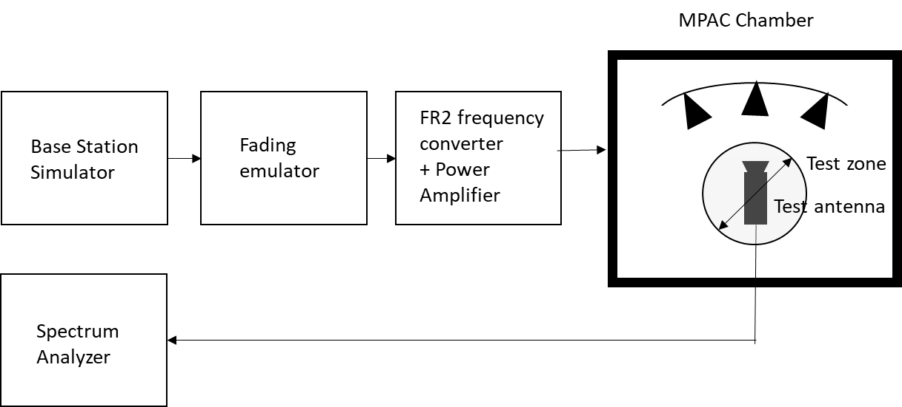

Figure 7.4.1.5-2: Setup for power validation measurements

**Spectrum analyzer settings:**

Table 7.4.1.5-2: Spectrum analyzer settings for Power validation measurements

| Item | Unit | Value |
| --- | --- | --- |
| Center frequency | MHz | Downlink center frequency  in Table 7.4.1-2 |
| Integrated Channel Span | Hz | 20MHz |
| RBW | Hz | 30 kHz |
| VBW | Hz | ≥10MHz |
| Number of points |  | ≥400 |
| Averaging |  | ≥100 |
| Detector |  | RMS |

**Measurement Procedure:**

1. Place a horn antenna with H polarization terminated in the centre of the test zone connected to a spectrum analyzer (or power meter) via a cable.

2. Record the cable and horn antenna gains.

3. Load the target channel model into the channel emulator.

4. Start the NR FR2 signalling in the base station emulator with the required parameter identical to the measurements conditions.

5. Average the power received by the spectrum analyzer for a sufficient amount of time to account for the fading channel – one full channel simulation might be unnecessary.

6. Repeat steps 1 to 4 with a horn antenna V polarization terminated for the horizontal polarization, in four orthogonal horizontal positions and summed to measure the H component.

7. Calculate the total power received at the test area as the sum of the power in the two polarizations.

#### 7.4.1.6 PAS similarity percentage (PSP)

The PSP validation measurements aim at evaluating PAS similarity percentage (PSP), which is one of the validation metrics for characterizing FR2 channel model under test in the quite zone of 3D-MPAC. For PSP validation measurement, only vertical polarization validation is required. The measurement array is essentially a virtual array configuration realized in 3D-MPAC through a -θ positioning system. The measurement array is a semi-circle and sectored array configuration illustrated in Figure 7.4.1.6-1 where complex channel frequency response is measured at each antenna location 0.5 λ apart using a vector network analyser (VNA) setup. The vertical sectors of the measurement array are limited to 60 (±30) and the horizontal sector to 180 (±90) with the broad side direction points towards the probes. Depending of the turntable architecture/implementation, the virtual array configuration for the PSP validation is composed of two alternative semi-circle arrangements (1 x horizontal and either 2 x crossed vertical or 2 x parallel vertical). The radius of the array element locations with respect to the centre of the test zone is 5 cm, which is equivalent to the half of the test zone radius at 28 GHz. For different frequency bands, the radius of the measurement array sectored semi-circles remains fixed at 5 cm while the spatial sampling of the array varies. This measurement validates the proper angular behaviour in the test zone*.*

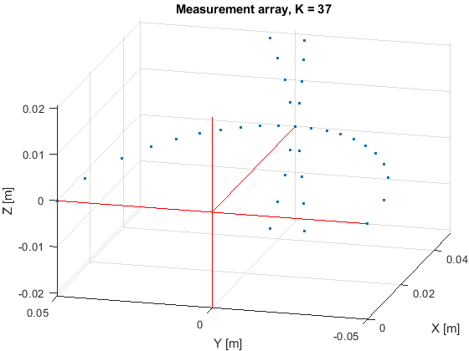 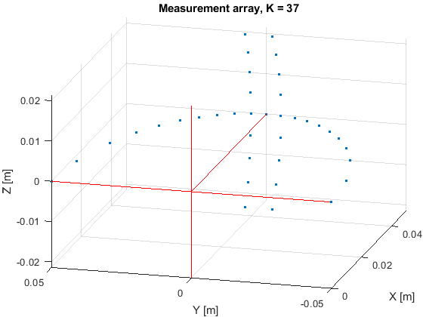

**Figure 7.4.1.6-1: Semi-circle measurement array configurations with K = 37 elements (at 28 GHz). On the left with two crossed vertical sectors, on the right with two parallel vertical sectors.**

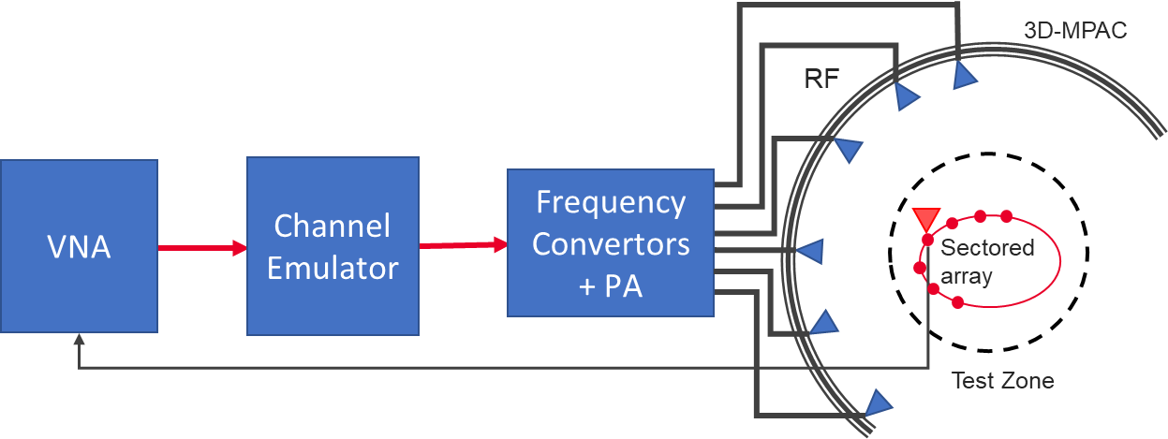

Figure 7.4.1.6-2: Setup for PSP validation measurements

The PSP validation is measured with a vector network analyser as shown in Figure 7.4.1.6-2 illustrating the PSP measurement setup. Port 1 of the VNA transmits signals through the fading emulator and radiate them through L probes within the anechoic chamber. The radiated signals are then received at the test antenna that is positioned inside the test zone. The test antenna is mounted on a -θ positioner which is capable of moving the antenna to pre-defined spatial locations on a fixed radius from the centre of the quiet zone according the measurement array configuration. Finally, the signal is received at port 2 of the VNA. The most suitable approach for the PSP validation is based on an omnidirectional antenna (omnidirectional pattern in AZ and wide BW in EL) as the test can be automated easily. Alternatively, a directional antenna could be used but requires frequent re-positioning.

The measurement and analysis procedure are given as follows:

1. Set the target channel model in the Channel Emulator.
2. For each position of the test antenna on the measurement array configuration in the test zone, step & pause the emulator to different time instances. Measure the complex frequency responses for all stepped channel snapshots , where the interval between frequency and time samples is and , respectively. The number of channel snapshots $N$ and frequency samples $M$.



1. Move the measurement antenna with a positioner to another location $k$ and repeat step 2 to record frequency responses of all stepped channel snapshots.



1. Repeat step 3 to record frequency responses at all spatial sample points.



1. Estimate the measured PAS through the following two-step processing:
   1. In the first step, calculate the discrete azimuth and elevation angles (DoA) for the measurement array configuration by applying the MUSIC algorithm. Estimate the powers from the DoA and auto-covariance matrix of the received signal acquired through VNA complex frequency response data. A near field to far-field conversion is then applied to the transfer function between probes and measurement array positions.
   2. In the second step, use the angle and power estimates, i.e. the discrete PAS of N azimuth and elevation directions and power values in conjunction with a 4x4 DUT sampling array for beamforming with the conventional Bartlett beamformer to estimate the “measured PAS seen by DUT” for PSP calculation.
2. Evaluate the reference OTA PAS for the 4x4 DUT array by applying the conventional Bartlett beamformer to the OTA probe weights and the strongest beam from the code book of 128 beam-grid with 4x4 DUT sampling array.
3. Calculate total variation distance (*D*p) from the reference and measured PAS. Mathematically,

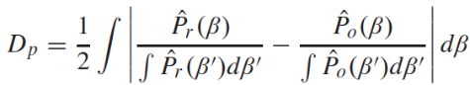

1. Calculate PSP values as PSP = (1-*Dp*) x 100%.

**VNA settings:**

Table 7.4.1.6-1: VNA settings for FR2 PSP measurements

|  |  |  |
| --- | --- | --- |
| Item | Unit | Value |
| Center frequency | MHz | Downlink center frequency  in Table 7.4.1-2 |
| Span | MHz | 0 (or the minimum) |
| Number of traces |  | 1000 |
| Number of points |  | 1 |

(Unchanged sections omitted)

# B.2 Measurement uncertainty budget for FR2

## B.2.1 Measurement Uncertainty assessment

Table B.2.1-1: Measurement uncertainty budget for FR2 3D-MPAC

| UID | Description of uncertainty contribution | Example value (26.5GHz≤f≤29.5GHz) | Example value (37GHz ≤f≤40GHz) | Distribution of the probability | Details in |
| --- | --- | --- | --- | --- | --- |
| Stage 2: DUT measurement | | | | | |
| 1 | Mismatch for measurement process |  |  | U-Shaped | B.2.2.1 |
| 2 | Measure distance uncertainty |  |  | Normal | B.2.2.2 |
| 3 | Quality of quiet zone |  |  | Rectangular | B.2.2.3 |
| 4 | Base Station simulator |  |  | Rectangular | B.2.2.4 |
| 5 | Channel Emulator  -absolute value  -stability  -linearity |  |  | Normal | B.2.2.5 |
| 6 | Amplifier uncertainties |  |  | Rectangular | B.2.2.6 |
| 7 | Random uncertainty |  |  | Normal | B.2.2.7 |
| 8 | Throughput measurement: output level step resolution |  |  | Rectangular | B.2.2.8 |
| 9 | DUT sensitivity drift |  |  | Rectangular | B.2.2.9 |
| 10 | Signal flatness |  |  | Normal | B.2.2.10 |
| Stage 1: Calibration measurement | | | | | |
| 11 | Mismatch for calibration process  - loopback cable path  - system input path  - reference antenna |  |  | U-Shaped | B.2.2.11 |
| 12 | Reference antenna positioning misalignment |  |  | Normal | B.2.2.12 |
| 13 | Quality of quiet zone |  |  | Rectangular | B.2.2.3 |
| 14 | Total uncertainty of the Network Analyzer |  |  | Rectangular | B.2.2.13 |
| 15 | Uncertainty of an absolute gain of the calibration antenna |  |  | Normal | B.2.2.14 |
|  |  |  |  |  |  |
| 16 | Offset of the Phase Center of the Reference Antenna |  |  | Normal | B.2.2.15 |

## B.2.2 Measurement error contribution descriptions

#### B.2.2.1 Mismatch for measurement process

This term comes from the mismatch between the system input cables connecting to the base station simulator output port.

#### B.2.2.2 Measure distance uncertainty

The cause of this uncertainty contributor is due to the reduction of distance between the measurement antenna and the DUT. Given that 0.75m is defined as the minimum range length for FR2 3D-MPAC system, this term could be set as 0 dB.

#### B.2.2.3 Quality of quiet zone

The quality of the quiet zone procedure characterizes the quiet zone performance of the anechoic chamber, specifically the effect of reflections within the anechoic chamber including any positioners and support structures.

#### B.2.2.4 Base Station simulator

gNB emulator is used to drive a signal to the channel emulator and then to the device under test. Generally there occurs uncertainty contribution from absolute level accuracy, non-linearity and frequency characteristic of the gNB emulator.

For practical reasons, in a case that a VNA is used as a calibration equipment, gNB emulator is connected to the system after the calibration measurement is performed by the VNA. Hence, the uncertainty on the absolute level of gNB emulator (transmitter device) cannot be assumed as systematic. This uncertainty should be calculated from the manufacturer’s data in logs with a rectangular distribution, unless otherwise informed. Furthermore, the uncertainty of the non-linearity is included in the absolute level uncertainty.

#### B.2.2.5 Channel Emulator

The channel emulator is also working as a signal source in the FR2 MIMO OTA system, therefore there occurs uncertainty contribution from absolute level accuracy, non-linearity, frequency characteristic and stability of the channel emulator. These uncertainty contributions shall be taken from the manufacturer’s data sheet. This uncertainty value shall be the final value after mmWave radio head.

#### B.2.2.6 Amplifier uncertainties

Any components in the setup can potentially introduce measurement uncertainty. It is then needed to determine the uncertainty contributors associated with the use of such components. For the case of external amplifiers, the following uncertainties should be considered but the applicability is contingent to the measurement implementation and calibration procedure.

- Stability

- An uncertainty contribution comes from the output level stability of the amplifier. Even if the amplifier is part of the system for both measurement and calibration, the uncertainty due to the stability shall be considered. This uncertainty can be either measured or determined by the manufacturers’ data sheet for the operating conditions in which the system will be required to operate.

- Linearity

- An uncertainty contribution comes from the linearity of the amplifier since in most cases calibration and measurements are performed at two different input/output power levels. This uncertainty can be either measured or determined by the manufacturers’ data sheet.

- Noise Figure

- When the signal goes into an amplifier, noise is added so that the SNR at the output is reduced with regard to the SNR of the signal at the input. This added noise introduces error on the signal which affects the Error Rate of the receiver thus the EVM (Error Vector Magnitude). An uncertainty can be calculated through the following formula:



- Where SNR is the signal to noise ratio in dB at the signal level used during the sensitivity measurement.

- Mismatch

- If the external amplifier is used for both stages, measurement and calibration the uncertainty contribution associated with it can be considered systematic and constant -> 0dB. If it is not the case, the mismatch uncertainty at its input and output shall be either measured or determined by the method described in [7].

- Gain

- If the external amplifier is used for both stages, measurement and calibration the uncertainty contribution associated with it can be considered systematic and constant -> 0dB. If it is not the case, this uncertainty shall be considered.

#### B.2.2.7 Random uncertainty

This contribution is used to account for all the unknown, unquantifiable, etc. uncertainties associated with the measurements. Random uncertainty MU contributions are normally distributed. The random uncertainty term, by definition, cannot be measured, or even isolated completely. A value of 0.2dB aligned with FR1 is suggested.

#### B.2.2.8 Throughput measurement: output level step resolution

The cause of this uncertainty contributor is due to the step size in the power level used in the throughput measurement stage. Depending on the system provider implementation, the power level adjustment is based on changing the output power of BS simulator or channel model emulator. Fixed 0.5dB step is defined for NR MIMO OTA testing, an uncertainty contribution of 0.25dB with a rectangular distribution should be reported.

#### B.2.2.9 DUT sensitivity drift

Due to statistical uncertainty of throughput measurement, drift in the TRMS can not be monitored. An uncertainty value of 0.2dB can be used, or the TRMS drift should be measured, with a setup corresponding to the actual MIMO OTA measurement.

#### B.2.2.10 Signal flatness

For wireless technologies with wide channel bandwidths, the test system might not have a flat frequency response across the entire channel. While the range calibration corrects for any variation of frequency response as a function of the center frequency of the channel, the broadband radiated power measured or delivered to the test zone will be a function of the entire channel bandwidth as opposed to just the center frequency. Thus, any deviation of the rest of the channel from the signal level at the center frequency will result in an error in the measured result. The determination of the MU element is FFS.

#### B.2.2.11 Mismatch for calibration process

During calibration stage, there will be impendence mismatch between the various RF cables and components used within the system. Standing waves are created by the reflections between any two components and uncertainty in the signal level will be generated. In general, three mismatch for calibration process should be considered:

* Loopback cable path: This item comes from the mismatch between the reference cable and the loopback cable during the loopback cable measurement step.
* System input path: This item comes from the mismatch between the loopback cable and the system input cable (generally the output cable after BS simulator). The reflectivity of the source output port is measured at the end of the loopback cable connecting to the system input cable.
* Reference antenna: This item comes from the mismatch between the VNA input port and the reference antenna. The reflectivity of the VNA input port is measured at the end of the reference cable connecting to the reference antenna.

#### B.2.2.12 Reference antenna positioning misalignment

This contribution originates from reference antenna alignment and pointing error. In this measurement if the maximum gain directions of the reference antenna and the receiving antenna are aligned to each other, this contribution can be considered negligible and therefore set to zero.

#### B.2.2.13 Total Uncertainty of the Network Analyzer

This contribution originates from all uncertainties involved transmission magnitude measurement (including drift and frequency flatness) with a network analyser. The uncertainty value will be indicated in the manufacturer's data sheet. It needs to be ensured that appropriate manufacturer's uncertainty contribution is specified for the absolute levels measured.

#### B.2.2.14 Uncertainty of an absolute gain of the calibration antenna

The calibration antenna only appears in calibration phase (Stage 1). Therefore, the gain uncertainty has to be taken into account. This uncertainty will come from a calibration report with traceability to a National Metrology Institute with measurement uncertainty budgets generated following the guidelines outlined in internationally accepted standards.

#### B.2.2.15 Offset of the Phase Center of the Reference Antenna

Gain is defined at the phase centre of the antenna. If the phase centre of the calibration antenna is not aligned at the centre of the set up during the calibration, then there will be uncertainty related to the measurement distance.

(End of changes)