**3GPP TSG-RAN4 Meeting #97-e *R4-2016211***

**Online, , 2nd Nov 2020 - 13th Nov 2020**

|  |  |  |  |  |  |  |  |  |
| --- | --- | --- | --- | --- | --- | --- | --- | --- |
| *CR-Form-v12.1* | | | | | | | | |
| **CHANGE REQUEST** | | | | | | | | |
|  | | | | | | | | |
|  | **38.827** | **CR** | **0003** | **rev** | **-** | **Current version:** | **16.0.0** |  |
|  | | | | | | | | |
| *For* [***HE******LP***](http://www.3gpp.org/3G_Specs/CRs.htm#_blank)*on using this form: comprehensive instructions can be found at* [*http://www.3gpp.org/Change-Requests*](http://www.3gpp.org/Change-Requests)*.* | | | | | | | | |
|  | | | | | | | | |

|  |  |  |  |  |  |  |  |  |
| --- | --- | --- | --- | --- | --- | --- | --- | --- |
| ***Proposed change affects:*** | UICC apps |  | ME |  | Radio Access Network |  | Core Network |  |

|  |  |  |  |  |  |  |  |  |  |  |
| --- | --- | --- | --- | --- | --- | --- | --- | --- | --- | --- |
|  | | | | | | | | | | |
| ***Title:*** | Update of FR2 probe configuration | | | | | | | | | |
|  |  | | | | | | | | | |
| ***Source to WG:*** | Keysight Technologies UK Ltd | | | | | | | | | |
| ***Source to TSG:*** | R4 | | | | | | | | | |
|  |  | | | | | | | | | |
| ***Work item code:*** | FS_NR_MIMO_OTA_test | | | | |  | ***Date:*** | | | 2020-10-23 |
|  |  | | | |  | |  | | |  |
| ***Category:*** | **F** |  | | | | | ***Release:*** | | | Rel-16 |
|  | *Use one of the following categories:* ***F*** *(correction)* ***A*** *(mirror corresponding to a change in an earlier release)* ***B*** *(addition of feature),* ***C*** *(functional modification of feature)* ***D*** *(editorial modification)*  Detailed explanations of the above categories can be found in 3GPP [TR 21.900](http://www.3gpp.org/ftp/Specs/html-info/21900.htm). | | | | | | | | *Use one of the following releases: Rel-8 (Release 8) Rel-9 (Release 9) Rel-10 (Release 10) Rel-11 (Release 11) … Rel-15 (Release 15) Rel-16 (Release 16) Rel-17 (Release 17) Rel-18 (Release 18)* | |
|  |  | | | | | | | | | |
| ***Reason for change:*** | | The previous probe configuration does not perform a true 3D AoA test | | | | | | | | |
|  | |  | | | | | | | | |
| ***Summary of change:*** | | Probes aligned towards z direction | | | | | | | | |
|  | |  | | | | | | | | |
| ***Consequences if not approved:*** | | FR2 MIMO OTA scan does not perform a true 3D AoA test. | | | | | | | | |
|  | |  | | | | | | | | |
| ***Clauses affected:*** | | 6.2.3 | | | | | | | | |
|  | |  | | | | | | | | |
|  | | **Y** | **N** |  | | | |  | | |
| ***Other specs*** | |  |  | Other core specifications | | | | TS/TR ... CR ... | | |
| ***affected:*** | |  |  | Test specifications | | | | TS/TR ... CR ... | | |
| ***(show related CRs)*** | |  |  | O&M Specifications | | | | TS/TR ... CR ... | | |
|  | |  | | | | | | | | |
| ***Other comments:*** | |  | | | | | | | | |
|  | |  | | | | | | | | |
| ***This CR's revision history:*** | |  | | | | | | | | |

<<< START OF CHANGES >>>

<<< START OF CHANGE #1 >>>

### 6.2.3 3D Multi-Probe Anechoic Chamber (MPAC) for FR2

The 3D MPAC test method is the reference methodology for FR2 NR MIMO OTA testing. By arranging an array of antennas around the Equipment Under Test (EUT), a spatial distribution of angles of arrival in the 3D MPAC system may be simulated to expose the EUT to a near field environment that appears to have originated from a complex multipath far field environment.

As illustrated schematically in Figure 6.2.3-1, signals propagate from the base station/communication tester to the EUT through a simulated multipath environment known as a spatial channel model, where appropriate channel impairments such as Doppler and fading are applied to each path prior to injecting all of the directional signals into the chamber simultaneously through the probe array. The resulting field distribution in the test zone is then integrated by the EUT antenna(s) and processed by the receiver(s) just as it would do so in any non-simulated multipath environment. The 3D MPAC system with 6 dual-polarized probes (illustrated with black dots in Figure 6.2.3-1) placed on a sector with minimum radius of 0.75m from the centre of the test zone is permitted for NR FR2 MIMO OTA testing.

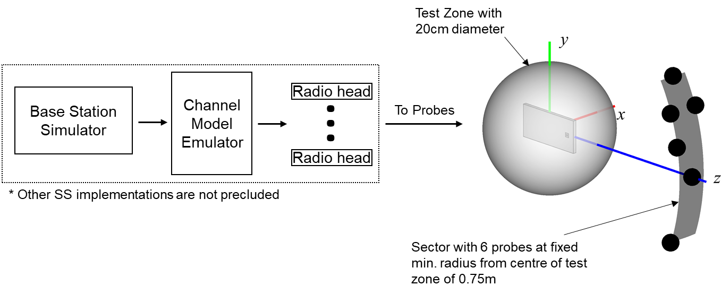

**Figure** **6.2.3-1: 3D MPAC system layout for NR FR2 MIMO OTA testing**

The exact probe locations with respect to the OTA test system coordinate system are tabulated in Table 6.2.3-1.

Table 6.2.3-1. FR2 3D MPAC Probe Locations in OTA test system coordinate system

|  |  |  |
| --- | --- | --- |
| Probe Number | Theta [deg] | Phi  [deg] |
| 1 | 0.0 | 0.0 |
| 2 | 11.2 | 116.7 |
| 3 | 20.6 | -104.3 |
| 4 | 20.6 | 104.3 |
| 5 | 20.6 | 75.7 |
| 6 | 30.0 | 90.0 |

The 3D MPAC probes in Table 6.2.3-1 can be implemented using conventional millimetre-wave probes as well as IFF-based probes as long as the same probe configuration and same number of probes is used.

The channel model parameters and probe locations for channel model implementation are defined in a channel model coordinate system, which is illustrated in figure 6.2.3-2. The channel model coordinate axes *x*CM, *y*CM, and *z*CM correspond to the OTA test system coordinate axes *z*, *y*,and -*x*, respectively.

**Figure 6.2.3-2: Channel Model Coordinate Axes**

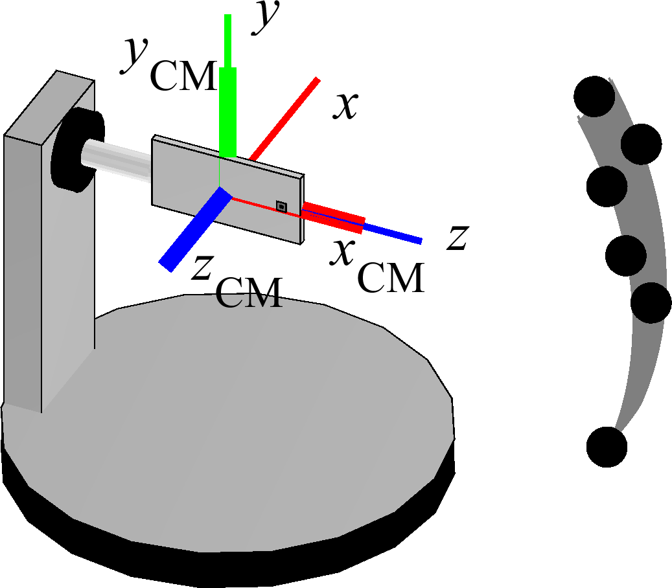

The probe locations with respect to channel model coordinate axes are tabulated in table 6.2.3-2.

Table 6.2.3-2. FR2 3D MPAC Probe Locations in Channel Model Coordinate System

|  |  |  |
| --- | --- | --- |
| Probe Number | Theta [deg] | Phi [deg] |
| 1 | 0 | 0 |
| 2 | 85 | 10 |
| 3 | 85 | -20 |
| 4 | 85 | 20 |
| 5 | 95 | 20 |
| 6 | 90 | 30 |



<<< Skip unchanged sections >>>

<<< END OF CHANGES >>>