3GPP TSG-WG4 Meeting #97-e R4-2017581

Electronic Meeting, 2nd – 13th November, 2020
CR-Form-v12.1
CHANGE REQUEST
 | 38.827 | CR | 0002 | rev | 1 | Current version: | 16.0.0
For HELP on using this form: comprehensive instructions can be found at
http://www.3gpp.org/Change-Requests.

Proposed change affects: | UICC apps |  | ME | X | Radio Access Network |  | Core Network

Title: | Addition of Time Domain Alternative for Spatial Correlation Validation
Source to WG: | Spirent Communications
Source to TSG: | R4
Work item code: | FS_NR_MIMO_OTA_test |  |  |  |  |  | Date: |  |  | 2020-10-15
Category: | B |  |  |  |  |  | Release: |  |  | Rel-16
 | Use one of the following categories:  F (correction)  A (mirror corresponding to a change in an earlier release)  B (addition of feature),  C (functional modification of feature)  D (editorial modification)  Detailed explanations of the above categories can  be found in 3GPP TR 21.900. |  |  |  |  |  |  |  | Use one of the following releases:  Rel-8 (Release 8)  Rel-9 (Release 9)  Rel-10 (Release 10)  Rel-11 (Release 11)  …  Rel-15 (Release 15)  Rel-16 (Release 16)  Rel-17 (Release 17)  Rel-18 (Release 18)
Reason for change: |  | Time Domain Techniques to validate Spatial Correlation have been agreed during R4#96e. In [1], the FR1 spatial correlation validation procedure based on time domain techniques is presented. This revision CR addresses the coments received during the first round. The settings of the signal analyser are chosen as follows:  Sampling Frequency: Sampling a random process needs to fulfil one requirement, namely, it must be be greater than twice the maximum frequency content (i.e. maximum Doppler shift).  Observation Time: To characterize random processes, enough samples must be observed.  The two parameters above are related to the UE speed (v) and center frequency (f_{c}), as those two determine the maximum Doppler frequency shift f_{d}=(v•fc)/c, where c is the speed of light.  When the UE speed is low, and the center frequency is low, the maximum Doppler shift is also low. One could set the sampling rate to a low value, but the observation time would need to be long to observe enough samples.  When the UE speed is high, and the center frequency is high, the maximum Doppler shift is also high. One needs to set the sampling rate to a high value, and the observation time to a low value as well. But the observation time should not be too low because enough samples as needed to obtain statistical significance.  Since the values of center ferequency for FR1 are relatively wide, the observation time is lower bounded to cover the cases of low center frequencies to at least 16 seconds. Larger observation times are allowed to obtain better statistical convergence.  The sampling frequency is also lower bounded to at least 15 times the maximum Doppler to obtain a smoothly sampled set of data. Higher sampling rates are allowed to cover high UE speeds and/or higher center frequencies.  The above discussion makes it clear that both parameters are frequency dependent, but lower bounded to obtain enough samples and smooth signals.  References  [1] R4-2014289 Addition of Time Domain Alternative for Spatial Correlation Validation, RAN4#97e November 2020.
Summary of change: |  | Addition to Spatial Correlation validation section
Consequences if not approved: |  | Time domain techniques are faster by a factor of 37.5. It would take days to validate spatial correlation using the current techniques instead of hours.
Clauses affected: |  | 7.4.1.3
 |  | Y | N
Other specs |  |  | X | Other core specifications |  |  |  | TS/TR ... CR ...
affected: |  |  | X | Test specifications |  |  |  | TS/TR ... CR ...
(show related CRs) |  |  | X | O&M Specifications |  |  |  | TS/TR ... CR ...
Other comments:
This CR's revision history:

<Start of Changes>

7.4.1.3 Spatial correlation

Time Domain Alternative Method:
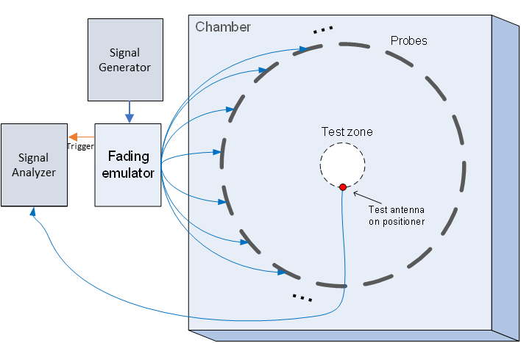
Time domain techniques can also be used to validate the spatial correlation. The spatial correlation validation measurement setup is illustrated in Figure 7.4.1.3-3. In this case a Signal generator transmits a CW signal through the MIMO test system. The signal is received by a test antenna within the test area. Finally, the signal is collected by a signal analyzer and the measured signal is stored for postprocessing.

Figure 7.4.1.3-3: Configuration for spatial correlation validation based on time domain techniques
For each spatial point, the channel emulator should issue a trigger signal each time fading is started. For each point collect a time domain trace with the signal analyzer, when done, stop fading. Data recording is synchronized with the channel emulator trigger.
Follow the same procedure to postprocess the data and calcalate the spatial correlation by setting m to 1. The settings for the Signal Generator and Signal Analyzer are in Table 7.4.1.3-2 and 7.4.1.3-3 respectively.
Table 7.4.1.3-2: Signal Generator Settings
Item | Unit | Value
Center frequency | MHz | Downlink centre frequency in 3GPP as required per band
Output power | dBm | Function of the CE. Sufficiently above Noise Floor

Table 7.4.1.3-3: Signal Analyzer Settings
Item | Unit | Value
Center frequency | MHz | Downlink centre frequency in 3GPP as required per band
Sampling | Hz | At least 15 times bigger than the max Doppler spread (f_{d}=v/λ)
Observation time | s | At least 16s. Channel Model length should be the same or greater than the observation time.

<End of Changes>

