**3GPP TSG-RAN WG4 Meeting #97-eR4-2017539**

**Electronic, 2nd – 13th November, 2020**

|  |  |  |  |  |  |  |  |  |
| --- | --- | --- | --- | --- | --- | --- | --- | --- |
| *CR-Form-v12.1* | | | | | | | | |
| **CHANGE REQUEST** | | | | | | | | |
|  | | | | | | | | |
|  | **.101-4** | **CR** | **0091** | **rev** | **1** | **Current version:** |  |  |
|  | | | | | | | | |
| *For* [***HE******LP***](http://www.3gpp.org/3G_Specs/CRs.htm#_blank)*on using this form: comprehensive instructions can be found at* [*http://www.3gpp.org/Change-Requests*](http://www.3gpp.org/Change-Requests)*.* | | | | | | | | |
|  | | | | | | | | |

|  |  |  |  |  |  |  |  |  |
| --- | --- | --- | --- | --- | --- | --- | --- | --- |
| ***Proposed change affects:*** | UICC apps |  | ME | **X** | Radio Access Network |  | Core Network |  |

|  |  |  |  |  |  |  |  |  |  |  |
| --- | --- | --- | --- | --- | --- | --- | --- | --- | --- | --- |
|  | | | | | | | | | | |
| ***Title:*** | CR to TS 38.101-4: Propagation conditions for HST scenarios | | | | | | | | | |
|  |  | | | | | | | | | |
| ***Source to WG:*** | Intel Corporation | | | | | | | | | |
| ***Source to TSG:*** | RAN4 | | | | | | | | | |
|  |  | | | | | | | | | |
| ***Work item code:*** | NR_HST-Perf | | | | |  | ***Date:*** | | | 2020-10-23 |
|  |  | | | |  | |  | | |  |
| ***Category:*** |  |  | | | | | ***Release:*** | | | Rel-16 |
|  | *Use one of the following categories:* ***F*** *(correction)* ***A*** *(mirror corresponding to a change in an earlier release)* ***B*** *(addition of feature),* ***C*** *(functional modification of feature)* ***D*** *(editorial modification)*  Detailed explanations of the above categories can be found in 3GPP [TR 21.900](http://www.3gpp.org/ftp/Specs/html-info/21900.htm). | | | | | | | | *Use one of the following releases: Rel-8 (Release 8) Rel-9 (Release 9) Rel-10 (Release 10) Rel-11 (Release 11) … Rel-15 (Release 15) Rel-16 (Release 16) Rel-17 (Release 17) Rel-18 (Release 18)* | |
|  |  | | | | | | | | | |
| ***Reason for change:*** | | Add Propagation conditions description for HST test cases | | | | | | | | |
|  | |  | | | | | | | | |
| ***Summary of change:*** | | 1. Add HST multi-path fading propagation conditions 2. Add HST single tap propagation conditions 3. Add HST-SFN propagation conditions 4. Add HST-DPS propagation conditions | | | | | | | | |
|  | |  | | | | | | | | |
| ***Consequences if not approved:*** | | Demodulation perfromacne in HST conditions will not be guaranteed | | | | | | | | |
|  | |  | | | | | | | | |
| ***Clauses affected:*** | | B.2.2, B.3 | | | | | | | | |
|  | |  | | | | | | | | |
|  | | **Y** | **N** |  | | | |  | | |
| ***Other specs*** | |  | **x** | Other core specifications | | | |  | | |
| ***affected:*** | | **x** |  | Test specifications | | | | TS 38.521-4 | | |
| ***(show related CRs)*** | |  | **x** | O&M Specifications | | | |  | | |
|  | |  | | | | | | | | |
| ***Other comments:*** | |  | | | | | | | | |
|  | |  | | | | | | | | |
| ***This CR's revision history:*** | | 1. Update title of Table B.3.2-1 2. Update Figures B.3.3-2 and B.3.3-3 | | | | | | | | |

**START OF 1st CHANGE**

## B.2.2 Combinations of channel model parameters

The propagation conditions used for the performance measurements in multi-path fading environment are indicated as a combination of a channel model name and a maximum Doppler frequency, i.e., TDLA<DS>-<Doppler>, TDLB<DS>-<Doppler> or TDLC<DS>-<Doppler> where '<DS>' indicates the desired delay spread and '<Doppler>' indicates the maximum Doppler frequency (Hz).

Table B.2.2-1 and Table B.2.2-2 show the propagation conditions that are used for the performance measurements in multi-path fading environment for low, medium and high Doppler frequencies for FR1 and FR2, respectively.

Table B.2.2-1 Channel model parameters for FR1

|  |  |  |
| --- | --- | --- |
| **Combination name** | **Model** | **Maximum Doppler frequency** |
| TDLA30-5 | TDLA30 | 5 Hz |
| TDLA30-10 | TDLA30 | 10 Hz |
| TDLB100-400 | TDLB100 | 400 Hz |
| TDLC300-100 | TDLC300 | 100 Hz |
| TDLC300-600 | TDLC300 | 600 Hz |
| TDLC300-1200 | TDLC300 | 1200 Hz |

Table B.2.2-2 Channel model parameters for FR2

|  |  |  |
| --- | --- | --- |
| **Combination name** | **Model** | **Maximum Doppler frequency** |
| TDLA30-35 | TDLA30 | 35 Hz |
| TDLA30-75 | TDLA30 | 75 Hz |
| TDLA30-300 | TDLA30 | 300 Hz |
| TDLC60-300 | TDLC60 | 300 Hz |

**END OF 1st CHANGE**

**START OF 2nd CHANGE**

## B.3.1 Single Tap Channel Profile

The high speed train condition for the test of the baseband performance is a non fading propagation channel with one tap. Doppler shift is given by

 (B.3.1.1)

where  is the Doppler shift and  is the maximum Doppler frequency. The cosine of angle is given by

,  (B.3.1.2)

,  (B.3.1.3)

,  (B.3.1.4)

where  is the initial distance of the train from gNB, and  is gNB Railway track distance, both in meters;  is the velocity of the train in m/s,  is time in seconds.

Doppler shift and cosine angle are given by equation B.3.1.1 and B.3.1.2-B.3.1.4 respectively, where the required input parameters listed in table B.3.1-1 and the resulting Doppler shift shown in Figures B.3.1-1, B.3.1-2, B.3.1-3, B.3.1-4 are applied for all frequency bands.

Table B.3.1-1: High speed train scenario

|  |  |  |  |  |
| --- | --- | --- | --- | --- |
| Parameter | Value | | | |
| HST-750 | HST-972 | HST-1000 | HST-1667 |
|  | 300 m | 300 m | 300 m | 300 m |
|  | 2 m | 2 m | 2 m | 2 m |
|  | 300 km/h | 500 km/h | 300 km/h | 500 km/h |
|  | 750 Hz for 15 kHz SCS test | 972 Hz for 15 kHz SCS test | 1000 Hz for 30 kHz SCS test | 1667 Hz for 30 kHz SCS test |

NOTE 1: Parameters for HST conditions in table B.3.1-1 including  and Doppler shift trajectories presented on figures B.3.1-1 for 750 Hz and B.3.1-3 for 972 Hz for 15 kHz SCS and figures B.3.1-2 for 1000 Hz and B.3.1-4 for 1667 Hz for 30 kHz SCS are applied for performance verification in all frequency bands.

NOTE 2: The propagation conditions used for the performance requirements under high speed train condition are indicated as a combination of "HST" and Doppler shift, i.e. HST-<Doppler shift>, where '<Dopper shift>' indicates the maximum Doppler shift (Hz) .

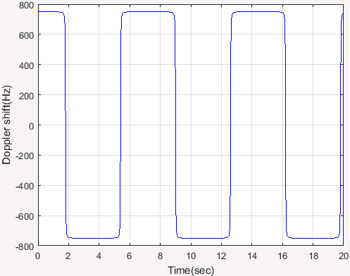

Figure B.3.1-1: Doppler shift trajectory (= 750 Hz)

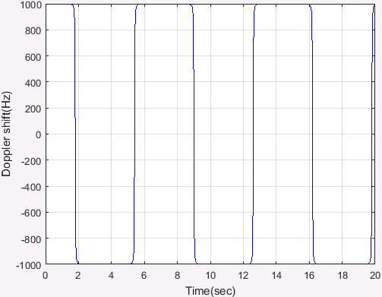

Figure B.3.1-2: Doppler shift trajectory (= 1000 Hz)



Figure B.3.1-3: Doppler shift trajectory (= 972 Hz)



Figure B.3.1-4: Doppler shift trajectory (= 1667 Hz)

For 1x2 antenna configuration, the same *h*(*t*,*τ*) is used to describe the channel between every pair of Tx and Rx.

For 1x4 antenna configuration, the same *h*(*t*,*τ*) is used to describe the channel between every pair of Tx and Rx.

Static channel matrix will be used as defined in Annex B.1.

## B.3.2 HST-SFN Channel Profile

There is an infinite number of RRHs distributed equidistantly along the track with the same Cell ID as depicted in figure B.3.2-1.



Figure B.3.2-1: Deployment of HST-SFN

The location of RRH *k* is given as:

 (B.3.2.1)

where: ,  and is the distance between the RRHs and railway track, while  is the distance of two RRHs, both in meters.

The train location is denoted as:

 (B.3.2.2)

where:  and *a* means distance in meters, which means the train is right on the track.

The HST-SFN scenario for the test of the baseband performance is a non fading propagation channel with four taps, namely the four nearest RRHs. Thus, RRH *k* is visible for the train only in the range:

 (B.3.2.3)

Power level  (dB) for the signal from *k*th RRH, normalized to the total power received from all visible RRHs, is given by:

 for  (B.3.2.4)

Doppler shift (Hz) from *k*th RRH is given by:

 for  (B.3.2.5)

The relative delay  (s) for the signal from *k*th RRH can be derived as:

 for  (B.3.2.6)

In the above *v* (m/s) is the moving speed of the train, *f*C (Hz) is the center frequency, and *C* (m/s) is the velocity of light.

Power level, Doppler shift and relative delay are given by equations B.3.2.4 ~ B.3.2.6 respectively, where the required input parameters listed in table B.3.2-1 and the resulting Doppler shift shown in Figures B.3.2-3 and B.3.2-4 are applied for all requency bands.

Table B.3.2-1: HST-SFN scenario

|  |  |
| --- | --- |
| Parameter | Value |
|  | 700 m |
|  | 150 m |
|  | 500 km/h |
|  | 870 Hz for 15 kHz SCS test;  1667 Hz for 30 kHz SCS test |

NOTE 1: The trajectories of ralative power, Doppler shifts and absolute delays presented in Figures B.3.2-2, B.3.2-3, B.3.2-4 and B.3.2-5 are derived from the equations B.3.2.4 ~ B.3.2.6 respectively.

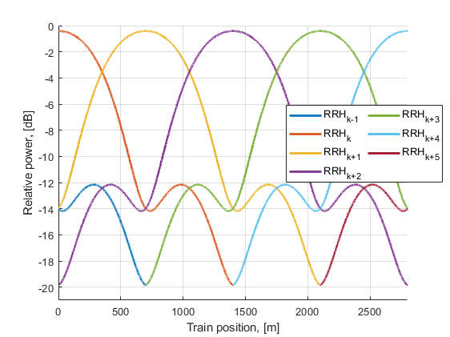

Figure B.3.2-2 Relative power level trajectories

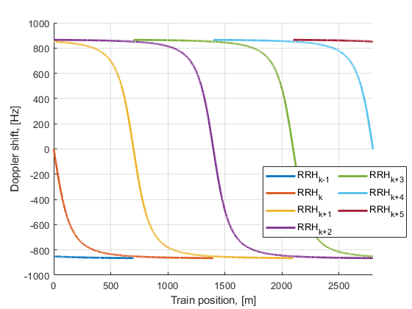

Figure B.3.2-3 Doppler shift trajectories (= 870 Hz)

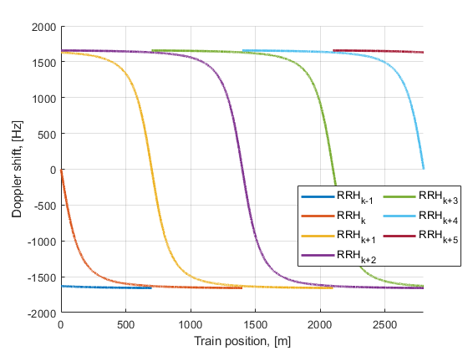

Figure B.3.2-4 Doppler shift trajectories (= 1667 Hz)

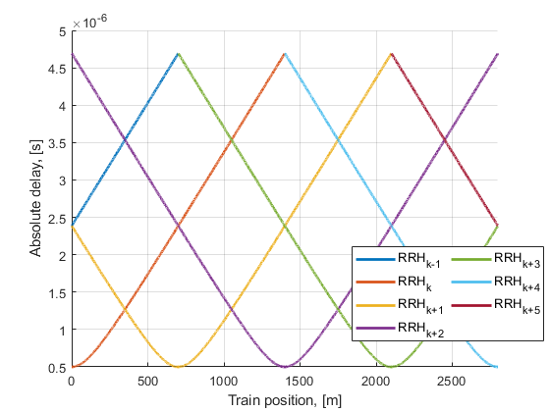

Figure B.3.2-5 Absolute delay trajectories

Static channel matrix will be used as defined in Annex B.1.

## B.3.3 HST-DPS Channel Profile

There is an infinite number of RRHs distributed equidistantly along the railway track with the same Cell ID as illustrated in Figure B.3.3-1.



Figure B.3.3-1: Deployment of HST-DPS

The location of RRH *k* is given as:

 (B.3.3.1)

where: ,  and is the distance between the RRHs and railway track, while  is the distance of two RRHs, both in meters.

The train location is denoted as:

 (B.3.3.2)

where:  and *a* means distance in meters, which means the train is right on the track.

The HST DPS multi-RRH scenario for the test of the baseband performance is a single tap propagation channel at each time with switching of transmission point in the middle point between two RRHs. Thus, RRH *k* is visible for the train only in the range:

 (B.3.3.3)

Power level  (dB) for the signal from *k*th RRH equals to 0. Doppler shift (Hz) from *k*th RRH is given by:

 for  (B.3.3.4)

In the above v (m/s) is the moving speed of the train, fC (Hz) is the centre frequency, and C (m/s) is the velocity of light.

Doppler shift is given by equation B.3.3.4, where the required input parameters listed in table B.3.3-1 and the resulting Doppler shift shown in Figures B.3.3-2 and B.3.3-3 are applied for all requency bands.

Table B.3.2-1: HST-DPS scenario

|  |  |
| --- | --- |
| Parameter | Value |
|  | 700 m |
|  | 150 m |
|  | 500 km/h |
|  | 870 Hz for 15 kHz SCS test;  1667 Hz for 30 kHz SCS test |



Figure B.3.3-2 Doppler shift trajectory (= 870 Hz)



Figure B.3.3-3 Doppler shift trajectory (= 1667 Hz)

Static channel matrix will be used as defined in Annex B.1.

.**END OF 2nd CHANGE**