**3GPP TSG-RAN WG4 Meeting #97e R4-2015200**

**Electronic Meeting, November 2 - 13, 2020**

**Agenda item:** 13.2.2

**Source:** Nokia, Nokia Shanghai Bell

**Title: TP to TR 38.808:** BS RF for NR beyond 52.6 GHz

**Document for:** Approval

# Introduction

The study item on supporting NR from 52.6 GHz to 71 GHz [1] was approved at RAN#86. Before that, 3GPP RAN studied requirements for NR beyond 52.6GHz up to 114.25GHz, potential use cases and deployment scenarios, and NR system design requirements and considerations on top of regulatory requirements [2].

This contribution discusses the reasonable antenna arrangements for beyond 52.6 GHz range taking into the output powers allowed in regulation. The arrangements include size of the array, number of elements, and the achievable gain, etc. Meanwhile, the comparison of the requirements needs from FR2 are addressed as well.

# Discussion

## Antenna arrangement

The overall dimensions of the antenna array effect most notably the achievable directivity of the antenna, but there are also consequences on efficiency and beamforming capability.

For aperture antennas, the antenna gain *G* and the physical aperture size *A*phys have a dependence through the following equation:

$G=\frac{4π}{λ^{2}}{η_{ap}A}_{phys}$,

where *λ* is the wavelength of the radiation and *η*ap is the aperture efficiency. The *η*ap depends on illumination of the antenna (e.g. tapering), polarization of the wave (polarization mismatch), antenna surface (mainly through phase distribution), and the efficiency of the antenna itself (power loss and impedance mismatch). In the two following figures, the achievable gain vs. size at several mm-wave frequencies is illustrated assuming a square aperture and a very optimistic 80% (-1 dB) aperture efficiency. If the aperture was an array constituting a similar current distribution as the corresponding continuous aperture, the achievable gains for given size would correspond as well. Assuming *λ*/2 spacing in the array, the numbers of elements per side for a given gain would correspond to the intersections of the solid and dotted lines in the figures. For example, a 16-element (4x4) array can achieve a gain of approximately 16 dB, while a 1024-element (32x32) array can achieve 34 dB of gain. A 20x20 mm2 area at 30 GHz can accommodate 4x4 elements, while at 120 GHz the same physical area can fit 16x16 elements.



Figure 1. Achievable gain of a square aperture antenna of given dimension at frequencies 30 – 120 GHz. The intersections of the dotted and solid lines give numbers of elements and achievable gain in a λ/2-spaced array for given square side.



Figure 2. Achievable gain of a square aperture antenna of given dimension at frequencies 30 – 90 GHz. The intersections of the dotted and solid lines give numbers of elements and achievable gain in a λ/2-spaced array for given square side. The approximate half power beamwidths are given for some gain values.

In reality, an array does not constitute identical current distribution (and therefore the same radiation pattern) compared to a continuous aperture of same size. An array of microstrip patches, for example, could reach 3 dB higher directivity due to ground plane effect. In practice, losses and mutual coupling degrade the performance of any antenna array to some extent.

The losses of the feeding and power distribution network affect the possible implementations of the antenna array. It is expected that the feeding network losses increase faster than the directivity as the number of elements increases. This means that the antenna gain cannot be infinitely improved by adding more elements. In the case of mm-wave frequencies, the losses of the feed network are even more critical than in cm wave frequencies.

## Radiated power considerations

The above section outlines the theoretical or more optimistic considerations of the square antenna array arrangement (MxM) for mmW frequencies. The actual implementation is expected to be different varies with deployment scenarios. For instance, the coverage needs for azimuth and elevation are different which results in different number of elements in row and column. Besides the antenna array arrangement, there are plenty other parameters need to be taken into account when calculating the radiated power, e.g. the PA maximum output power, the power backoff which depends on the modulation and coding selection, etc.

We assume that each antenna array element has its own power stage, and having 16x8 arrangement with 60% aperture coupling efficiency, then the EIRP can be obtained in the following table. The PA OP1dB is 16 dBm with a 9 dB backoff. With the current output power assumptions per antenna element, higher EIRP e.g. 59 dBm can be obtained by having more of elements (16x16). Correspondingly, the regulatory limit for unlicensed operation in some regions is 40 dBm EIRP, which is easily met using 4x8 array.

It should be noted that the estimates are very conservative, given that the PA study presented in [6] states that saturated power for CMOS technology is between 22 and 23 dBm. Therefore, plenty of design margin for possible front-end losses have been included.

Table 1 Example of 16x8 antenna array at 70 GHz

|  |  |  |
| --- | --- | --- |
| **Frequency** |  | **70.0GHz** |
| **System Gain & Coverage Analysis** |  |  |
| Total Conducted Power | dBm | 28.0 |
| Tx Arrayed Antenna Gain | dBi | 24.8 |
| **EIRP per polarization** | **dBm** | **52.8** |
| Number of antenna polarizations |  | 2 |
| Number of streams / polarizations |  | 1 |
| **Transmitter Array Information (per polarization)** |  |  |
| # elements in X |  | 16 |
| # elements in Y |  | 8 |
| Number of antenna elements |  | 128 |
| Element spacing | lamda | 0.5 |
| Array size, X dimension | mm | 34.3 |
| Array size, Y dimension | mm | 17.1 |
| Element directivity | dB | 6.0 |
| Array factor | dB | 21.0 |
| Antenna directive gain | dB | 27.0 |
| Antenna coupling efficiency | % | 60 % |
| Antenna coupling efficiency | dB | -2.2 |
| **Tx Arrayed Antenna Gain** | **dB** | **24.8** |
| **Transmitter Power Amplifier Info (per polarization)** |  |  |
| PA OP1dB | dBm | 16 |
| Backoff, i.e. modulated signal PAPR | dB | 9.0 |
| Average power output per PA | dBm | 7 |
| Power into each sub-array or antenna element | dBm | 7 |
| Number of Tx sub-array PAs or antenna elements |  | 128 |
| Multi element or sub-array power gain | dB | 21 |
| **Total Conducted Power** | **dBm** | **28.0** |

**Observation 1: 40 dBm EIRP can be expected to be met with 4x8 array whereas 60 dBm EIRP requires an 16x16 array.**

**Observation 2: The antenna array sizes do not significantly differ from current FR2 operation and therefore also beamwidths are similar.**

**Proposal 1: Use the above array sizes as baseline for RAN4 evaluations, when needed.**

## Co-existence performance

One major part of the work in defining requirements for a new frequency range is to run co-existence simulations to find out what is the required ACLR and ACS performance required to guarantee co-existence between operators in the network. Co-existence study for 45 GHz and 70 GHz frequency range was already done as part of NR study item, and the parameters used in the study reflect the device characteristics sufficiently well. Therefore, we propose that no new co-existence simulation study is done, but instead the applicable ACLR and ACS performance for BS is extracted from co-existence study results documented in TR 38.803.

**Observation 3: Co-existence study for this frequency range has already been documented in TR 38.803**

**Proposal 2: Extract the ACLR and ACS requirements from TR 38.803**

Normally detailed antenna array modelling is required as part of defining requirements for a new frequency range as the antenna modelling is needed for the co-existence study. As no further co-existence study is needed, there is no immediate reason to start new work for improved antenna modelling.

**Observation 4: As co-existence study is already done, justification is needed to start more detailed antenna modelling exercise**

## Specification impacts

When ACLR is agreed based on the results in TR 38.803, a slightly lower ACLR compared to lower FR2 operating bands is expected. As ACLR is modified it is reasonable to verify that related requirements, like operating band unwanted emissions and absolute ACLR work together with ACLR as intended, i.e. complementing each other. Naturally, regulatory requirements need to be taken into account when emission requirements are set.

In addition to emission considerations, it would be useful to evaluate, and update if needed, the ON-OFF transient times. As subcarrier spacings get wider, transient time starts to eat into the usable symbol, which has negative performance impact. Therefore, transient times from current FR2 operating bands should not be automatically applied for operation above 52.6 GHz.

When core requirements are being specified RAN4 should consider what are reasonable measurement bandwidths to be used, especially considering that with wider subcarrier spacings a single resource block also gets wider in frequency. Therefore, using the traditional 1 MHz measurement bandwidth everywhere may not be optimal. Naturally, whenever regulatory requirements mandate a certain measurement bandwidth, it needs to be followed. For actual measurements it should be allowed to measure using lower resolution bandwidth and integrate the power up to the specified measurement bandwidth.

**Proposal 3: If ACLR value is adjusted compared to current FR2 operating bands, also other related emission requirements, like OBUE and absolute ACLR, should be re-evaluated and adjusted if there is a need. Regulatory requirements need to be respected.**

**Proposal 4: Evaluate if transient times can be improved.**

**Proposal 5: Using wider measurement bandwidths should be considered for NR operation above 52.6 GHz.**

Finally, a text proposal to TR 38.808 has been compiled including the co-existence study, phase noise performance [4] and base station antenna array considerations.

**Proposal 6: Agree the TP to 38.808 to reflect the antenna configurations, co-existence study status and phase noise performance.**

# Conclusion

In this contribution BS RF aspects related to NR operation above 52.6 GHz were discussed. Following observation and proposals were made.

**Observation 1: 40 dBm EIRP can be expected to be met with 4x8 array whereas 60 dBm EIRP requires an 16x16 array.**

**Observation 2: The antenna array sizes do not significantly differ from current FR2 operation and therefore also beamwidths are similar.**

**Observation 3: Co-existence study for this frequency range has already been documented in TR 38.803**

**Observation 4: As co-existence study is already done, justification is needed to start more detailed antenna modelling exercise.**

**Proposal 1: Use the above array sizes as baseline for RAN4 evaluations, when needed.**

**Proposal 2: Extract the ACLR and ACS requirements from TR 38.803**

**Proposal 3: If ACLR value is adjusted compared to current FR2 operating bands, also other related emission requirements, like OBUE and absolute ACLR, should be re-evaluated and adjusted if there is a need. Regulatory requirements need to be respected.**

**Proposal 4: Evaluate if transient times can be improved.**

**Proposal 5: Using wider measurement bandwidths should be considered for NR operation above 52.6 GHz.**

**Proposal 6: Agree the TP to 38.808 to reflect the antenna configurations, co-existence study status and phase noise performance.**

# References

1. RP-193259, “*New SID: Study on supporting NR from 52.6GHz to 71 GHz*”, Intel Corporation
2. TR 38.807, “*Study on requirements for NR beyond 52.6 GHz*”, 3GPP
3. R4-2011838, “WF on numerologies for FS_NR_52_to_71GHz”, Intel Corporation
4. R4-2015443, “Draft LS: Phase noise and RF impairment considerations”, Nokia, Nokia Bell Labs
5. R1-2003813, “*Performance of existing DL NR waveform at beyond 52.6 GHz*”, Nokia, Nokia Shanghai Bell.
6. R4-2011268, “Initial discussion on the BS-related aspects for 52.6 - 71 GHz range SI”, Huawei

# Text proposal to TR 38.808

**<Start of text proposal>**

# 2 References

The following documents contain provisions which, through reference in this text, constitute provisions of the present document.

- References are either specific (identified by date of publication, edition number, version number, etc.) or non‑specific.

- For a specific reference, subsequent revisions do not apply.

- For a non-specific reference, the latest version applies. In the case of a reference to a 3GPP document (including a GSM document), a non-specific reference implicitly refers to the latest version of that document *in the same Release as the present document*.

[1] 3GPP TR 21.905: "Vocabulary for 3GPP Specifications".

[2] 3GPP TR 38.807: " Study on requirements for NR beyond 52.6 GHz".

[3] ETSI EN 302 567 v2.1.20: "Multiple-Gigabit/s radio equipment operating in the 60 GHz band; Harmonised Standard covering the essential requirements of article 3.2 of Directive 2014/53/EU".

[4] 3GPP TR 38.803: “Study on new radio access technology; Radio Frequency (RF) and co-existence aspects”.

[5] Hua Wang, Fei Wang, Sensen Li, Tzu-Yuan Huang, Amr S. Ahmed, Naga Sasikanth Mannem, Jeongseok Lee, Edgar Garay, David Munzer, Christopher Snyder, Sanghoon Lee, Huy Thong Nguyen, and Michael Edward Duffy Smith, "Power Amplifiers Performance Survey 2000-Present," [Online]. Available: <https://gems.ece.gatech.edu/PA_survey.html>

[6] ETSI TR 101 854: “Fixed Radio Systems; Point-to-point equipment; Derivation of receiver interference parameters useful for planning fixed service point-to-point systems operating different equipment classes and/or capacities”

# 3 Definitions of terms, symbols and abbreviations

**<Unchanged sections omitted>**

## 4.2 RAN4 aspects

### 4.2.1 General description of study in RAN4

RAN4 and RAN1 had one common objective for the study on supporting NR from 52.6 GHz to 71 GHz, which is reproduced here from study item description

* Study of required changes to NR using existing DL/UL NR waveform to support operation between 52.6 GHz and 71 GHz
  + Study of applicable numerology including subcarrier spacing, channel BW (including maximum BW), and their impact to FR2 physical layer design to support system functionality considering practical RF impairments [RAN1, RAN4].

Aligned with this objective, RAN4 has studied practical RF impairments and captured relevant technology status in this TR. On top of aspects impacting FR2 physical layer design, aspects impacting RAN4 requirements have also been considered and documented.

### 4.2.2 Timing considerations

### 4.2.3 Phase noise characteristics

It was considered which level of detail of the RF architecture is considered. The actual LO-architecture of an antenna array can vary ranging from a single LO driving the whole antenna array up to small sub-arrays each having their own LO. When multiple LOs are considered, the phase noise output of those can have a varying degree of correlation. Accurate modelling of those details does not achieve a meaningful improvement comparing to evaluating the composite performance of an array, independent of how the actual array is implemented. Overall, the LO-structure is on implementation specific aspect, and does not need to be considered in the standard.

### 4.2.4 BS aspects

#### 4.2.4.1 Power amplifiers trends

The PA technology trends are based on PA performance survey in [5]. The referred PA survey captures a large power amplifier database consisting of more than 3400 data points with over 1200 data points for CMOS, SiGe PAs and over 1700 power amplifier data points has been collected for GaN, GaAs, InP. This database covers published results, both from the open literature, as well as commercial amplifiers from various vendors.

Based on the information in [4], the PA database information was summarized for all the considered RF technologies in figure 4.2.1.1-1 and 4.2.1.1-2, where the 52.6 – 71 GHz frequency range was highlighted. It can be observed that based on the available information, there is no data for the LDMOS technology for the 52.6 – 71 GHz range.

In order to derive more accurate PA trends data, figure 4.2.1.1-1 was plotted with PA operating frequencies much wider then just 52.6 – 71 GHz range. More detailed technology-specific plots (e.g. PAE vs. Psat, or Psat vs. frequency) can be found in the Excel spreadsheet capturing all the PA survey data in [5].

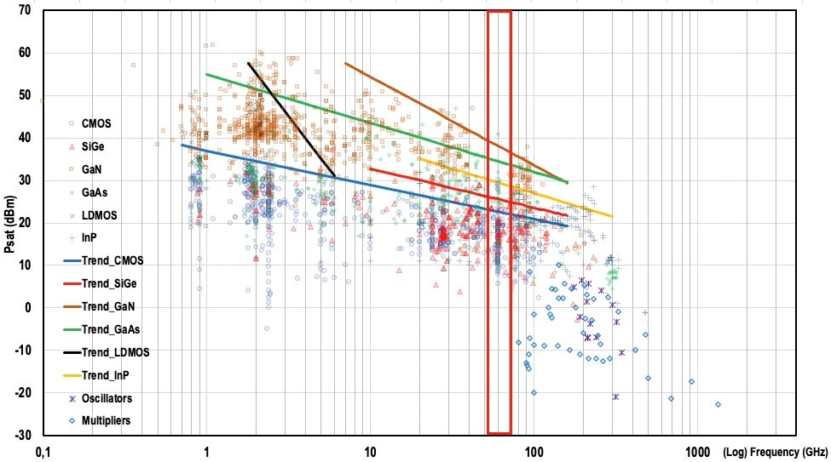

**Figure 4.2.1.1-1: Saturated output power versus frequency (red box depicts 52.6 – 71 GHz range) [3]**

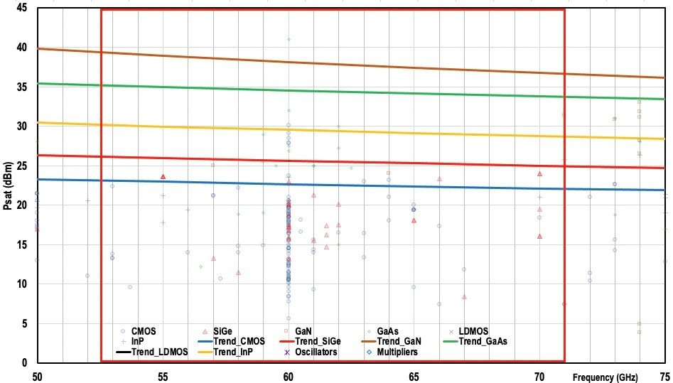**Figure 4.2.1.1-2: Saturated output power versus frequency – focus on 52.6 – 71 GHz range [4]**

Based on the analysis of the achievable Psat trends over the 52.6 – 71 GHz range, the saturated output power maximum trend values for 52.6 GHz and 71 GHz from [5] were extracted in table 4.2.1.1-1.

**Table 4.2.1.1-1: Maximum trend values of the saturated output power**

|  |  |  |
| --- | --- | --- |
| RF technology | Estimated maximum trend value of the saturated output power @52.6 GHz (dBm) | Estimated maximum trend value of the saturated output power @71 GHz (dBm) |
| CMOS | 23 | 22 |
| SiGe | 26 | 25 |
| GaN | 39 | 37 |
| GaAs | 35 | 34 |
| InP | 30 | 29 |

#### 4.2.4.2 BS antenna arrays

Antenna array configurations were evaluated with respect to target output power. It is assumed that each antenna array element has its own power stage and antenna elements have 60% aperture coupling efficiency. The EIRP can be calculated as shown in Table 4.2.3.2-1. While the example in table 4.2.3.2-1 is provided for 16x8 element array, the same principle can be used to evaluate the array sizes required to reach 40 dBm and 60 dBm EIRP, which we set for targets for system evaluations according to Annex A.2 The result is that reaching 40 dBm EIRP requires an 4x8 element array whereas 60 dBm EIRP requires 16x16 element array.

It should be noted that the estimates are very conservative, given that the power amplifier study [5] outlines the saturated power for CMOS technology between 22 and 23 dBm for 52.6 – 71 GHz frequency range. Therefore, plenty of design margin for possible front-end losses have been included.

Table 4.2.3.2-1: Example of 16x8 antenna array at 70 GHz

|  |  |  |
| --- | --- | --- |
| **Frequency** |  | **70.0GHz** |
| **System Gain & Coverage Analysis** |  |  |
| Total Conducted Power | dBm | 28.0 |
| Tx Arrayed Antenna Gain | dBi | 24.8 |
| **EIRP per polarization** | **dBm** | **52.8** |
| Number of antenna polarizations |  | 2 |
| Number of streams / polarizations |  | 1 |
| **Transmitter Array Information (per polarization)** |  |  |
| # elements in X |  | 16 |
| # elements in Y |  | 8 |
| Number of antenna elements |  | 128 |
| Element spacing | lamda | 0.5 |
| Array size, X dimension | mm | 34.3 |
| Array size, Y dimension | mm | 17.1 |
| Element directivity | dB | 6.0 |
| Array factor | dB | 21.0 |
| Antenna directive gain | dB | 27.0 |
| Antenna coupling efficiency | % | 60 % |
| Antenna coupling efficiency | dB | -2.2 |
| **Tx Array Antenna Gain** | **dB** | **24.8** |
| **Transmitter Power Amplifier Info (per polarization)** |  |  |
| PA OP1dB | dBm | 16 |
| Backoff, i.e. modulated signal PAPR | dB | 9.0 |
| Average power output per PA | dBm | 7 |
| Power into each sub-array or antenna element | dBm | 7 |
| Number of Tx sub-array PAs or antenna elements |  | 128 |
| Multi element or sub-array power gain | dB | 21 |
| **Total Conducted Power** | **dBm** | **28.0** |

The array sizes are similar to FR2 array in 24.25 – 52.6 GHz frequency range, and therefore also the beamwidths are similar. Therefore no need was found to start further studies on antenna array modelling and or other antenna evaluations.

#### 4.2.4.3 Adjacent channel leakage ratio

Co-existence study on NR operation at 45 GHz and 70 GHz frequencies was performed as part of NR study item and is documented in 3GPP TR 38.803 [4]. The co-existence study investigated adjacent channel co-existence in urban macro and indoor scenarios for both UL and DL. As the co-existence study assumptions are still applicable, no new co-existence study was performed. Instead, it was agreed to extract the required ACLR and ACS requirements from the earlier study.

#### 4.2.4.4 Noise figure

Referring to ETSI technical report TR 101 854 [6] on fixed radio point-to-point systems, one can find information on typical NF and associated industrial margins (IMF) values across wide range of frequencies. The IMF considers various performance variations of system elements over e.g. temperature extremes, voltage variations, or aging by capturing production spread of RF circuits.

For the 52.6 – 71 GHz range, the above NF values are in range of 10 – 13 dB.

Table 4.2.1.2-1: Typical Noise Figures (NF) and associated Industrial Margins (IMF)

|  |  |  |
| --- | --- | --- |
| Frequency band  (GHz) | Typical Noise Figure (NF)  (dB) | Industrial margin (IMF)  (dB) |
| 48 - 50 | ~9 | +3 |
| 52 - 55 | ~10 | +3 |
| 71 - 76 | ~13 | +4 |
| 81 - 86 | ~13 | +4 |

NOTE: The above ETSI originated Industrial Margins (IMF) shall not be confused with the Implementation Margins (IM) used in process of RAN4 conformance requirements derivation.

Referring to the system level evaluation assumptions in annex A, the BS NF was assumed as 7 dB, while UE NF was assumed as 10 dB (13 dB optionally).

### Link level and system level simulation assumptions in annex A are assuming UE mobility (i.e. 3km/h), while the above referred ETRI TR treats about the fixed point-to-point applications. Still one can observe good alignment of NF values among the ETSI TR and those in this 52.6-71 GHz performance evaluation. This can be interpreted that the RF technology to be used for both static and mobile applications in 52.6-71 GHz frequency range will have similar and comparable capabilities, making the ETSI TR 101 854 [6] a valid reference for this technical report. 4.2.5 UE aspects

### 4.2.6 RAN4 conclusions on numerologies and channel bandwidths

# 5 Study of channel access mechanism for 60 GHz

**<End of text proposal>**