3GPP TSG-RAN4 Meeting #97-e draft R4-2016925
Online, , 2nd Nov 2020 - 13th Nov 2020

Source: Huawei
Title: WF on Min and Max Channel Bandwidths in 52 to 71 GHz
Agenda Item: 13.2.1
Document for: Approval

Introduction
Number of contributions in [3 - 14] were submitted to RAN4#97-e meeting on the SCS and channel bandwidth aspects for the NR operation in 52.6 – 71 GHz frequency range.
Based on the 1st round summary of topic [140], the following was captured for the minimum and maximum channel bandwidth for NR operation in 52.6 – 71GHz range, in [1]: SCS aspects are also listed as related to channel bandwidth discussion (Moderator’s suggestion on channel bandwidth for the second round discussion in bold):
 | Status summary
Sub-topic#1 Min SCS | Tentative agreements: Follow RAN1 decision. Note that RAN1 has already decided on 120 SCS  Candidate options:  Recommendations for 2nd round: No further discussion
Sub-topic#2 Maximum SCS | Tentative agreements: Three options are up for discussion  Candidate options:480 kHz, 960 kHz, or follow RAN1  Recommendations for 2nd round: Since both 480 and 960 being discussed in RAN1 we can follow the RAN1 decision.
Sub-topic#3 Minimum CBW | Tentative agreements: options are up for discussion  Candidate options: 50(4), 400(4), 800(2),wait for min SCS(2)  Recommendations for 2nd round: Discuss this in round2 WF
Issue 1-4: Maximum CBW | Tentative agreements: options are up for discussion  Candidate options: 2160(4),2000(4),1600(1),800(2),400(1),275 RBs/carrier(1),pending maximum SCS(2)  Recommendations for 2nd round: This topic is coupled to maximum SCS which makes it difficult to decide without that being known. We should continue to discuss this in WF and see if we can make progress. Discuss this in round2 WF
Issue 1-5: Carrier aggregation | Tentative agreements: Continue to discuss CA in the WID phase.  Candidate options:  Recommendations for 2nd round: no further discussion in this meeting and expect companies to share their analysis and their views during the WID. Discussion of CA will be more effective once the SCS limits, the CBWs, and the available bands are discussed during the WID.

Furthermore, minimum and maximum channel bandwidth was further discussed during the GTW session, with the following conclusions captured in [2]:
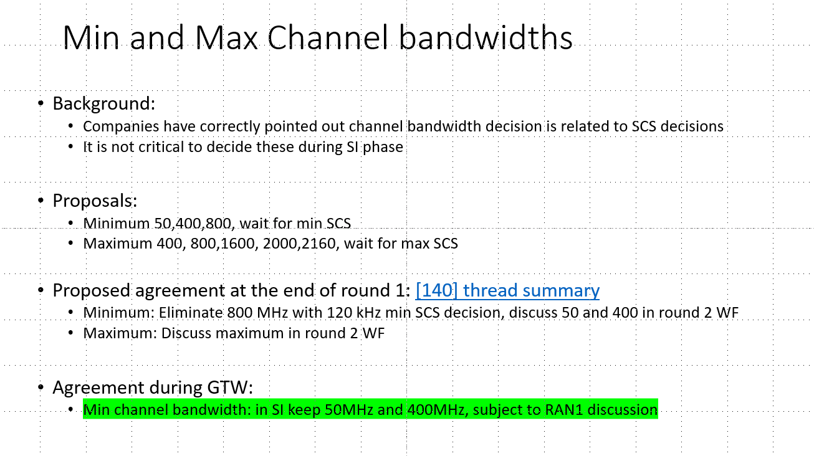

Based on the above inputs, WF on minimum and maximum channel bandwidth for NR operation in 52.6 – 71 GHz frequency range is proposed in this contribution.

Way Forward
The following Way Forward is formulated for approval, subject to further RAN1 decisions:
WF#1: Minimum channel bandwidth for 52-6 – 71 GHz NR operation: both 50MHz and 400MHz channel bandwidths are considered as conclusion of RAN4 part of SI and as inputs to the followup WI discussions.
WF#2: Maximum channel bandwidth for 52-6 – 71 GHz NR operation: depends on the decision on the max SCS in RAN1 (i.e. both 480 and 960 kHz SCS under consideration) and further RAN4 discussion in followup WI phase.
WF#3: Carrier aggregation is considered to be used for NR operation in 52.6 – 71GHz range. Decision on intra/inter band operation in contiguous/non-contiguous allocation is out of scope of this SI.

References
[1] R4-2016642, Email discussion summary for [97e Bis]140 FS_NR_52_GHz_Part_1, first round, 97-e, Moderator (Qualcomm Incorporated)
[2] 52 – 71 GHz Numerology, Chan BW GTW WF, GTW slideset, Moderator (Qualcomm Incorporated)
[3] R4-2014382, Further discussion on numerology and CBW for above 52.6 GHz CATT
[4] R4-2014737, Bandwidth and numerology for NR in 52.6GHz ~ 71GHz CMCC
[5] R4-2014892, Further considerations on the numerology and channel bandwidth sizes for the 60GHz frequency range Apple Inc.
[6] R4-2014974, Further discussion on channel bandwidths and numerology for B52.6G vivo
[7] R4-2015206, Numerology and channel bandwidth discussion for NR beyond 52.6 GHz Nokia, Nokia Shanghai Bell
[8] R4-2015307, Channel bandwidth and subcarrier spacing for 52.6 GHz to 71GHz NEC
[9] R4-2015563, On numerology and channel bandwidth in 52.6 - 71 GHz Intel Corporation
[10] R4-2015700, Discussion on 52.6 GHz to 71 GHz SI Huawei, HiSilicon
[11] R4-2015727, On 52.6 to 71 GHz numerology evaluation and channel bandwidths Ericsson
[12] R4-2015886, Views on numerologies above 52 GHz Sony
[13] R4-2016110, Further discussion on numerology and BW for 52.6GHz-71GHz ZTE Corporation
[14] R4-2016299, Subcarrier spacing and minimum channel bandwidth Qualcomm Incorporated

