3GPP TSG-WG Meeting #97e R4-20xxxxx

Electronic meeting, 2nd November - 13th November 2020
CR-Form-v12.0
CHANGE REQUEST
 | 38.104 | CR | <#> | rev | <#> | Current version: | 16.5.0
For HELP on using this form: comprehensive instructions can be found at
http://www.3gpp.org/Change-Requests.

Proposed change affects: | UICC apps |  | ME |  | Radio Access Network | X | Core Network

Title: | Introduction of LTE/NR spectrum sharing in band 48/n48 frequency ranges
Source to WG: | Apple Inc., Comcast
Source to TSG: | R4
Work item code: | NR_n48_LTE_48_coex-Core |  |  |  |  |  | Date: |  |  | 10-11-2020
Category: | B |  |  |  |  |  | Release: |  |  | Rel-16
 | Use one of the following categories:  F (correction)  A (mirror corresponding to a change in an earlier release)  B (addition of feature),  C (functional modification of feature)  D (editorial modification)  Detailed explanations of the above categories can  be found in 3GPP TR 21.900. |  |  |  |  |  |  |  | Use one of the following releases:  Rel-8 (Release 8)  Rel-9 (Release 9)  Rel-10 (Release 10)  Rel-11 (Release 11)  Rel-12 (Release 12)  Rel-13 (Release 13)  Rel-14 (Release 14)  Rel-15 (Release 15)  Rel-16 (Release 16)
Reason for change:
Summary of change:
Consequences if not approved:
Clauses affected: |  | 5.3.3
 |  | Y | N
Other specs |  |  | X | Other core specifications
affected: |  |  | X | Test specifications
(show related CRs) |  |  | X | O&M Specifications
Other comments:
This CR's revision history:

5.3.3 Minimum guardband and transmission bandwidth configuration
The minimum guardband for each BS channel bandwidth and SCS is specified in table 5.3.3-1 for FR1 and in table 5.3.3-2 for FR2.
Table 5.3.3-1: Minimum guardband (kHz) (FR1)
SCS (kHz) | 5  MHz | 10  MHz | 15  MHz | 20  MHz | 25  MHz | 30  MHz | 40  MHz | 50  MHz | 60  MHz | 70  MHz | 80  MHz | 90  MHz | 100  MHz
15 | 242.5 | 312.5 | 382.5 | 452.5 | 522.5 | 592.5 | 552.5 | 692.5 | N/A | N/A | N/A | N/A | N/A
30 | 505 | 665 | 645 | 805 | 785 | 945 | 905 | 1045 | 825 | 965 | 925 | 885 | 845
60 | N/A | 1010 | 990 | 1330 | 1310 | 1290 | 1610 | 1570 | 1530 | 1490 | 1450 | 1410 | 1370

Table: 5.3.3-2: Minimum guardband (kHz) (FR2)
SCS (kHz) | 50 MHz | 100 MHz | 200 MHz | 400 MHz
60 | 1210 | 2450 | 4930 | N/A
120 | 1900 | 2420 | 4900 | 9860

The minimum guardband of SCS 240 kHz SS/PBCH block for each BS channel bandwidth is specified in table 5.3.3-3 for FR2.
Table: 5.3.3-3: Minimum guardband (kHz) of SCS 240 kHz SS/PBCH block (FR2)
SCS (kHz) | 100 MHz | 200 MHz | 400 MHz
240 | 3800 | 7720 | 15560

NOTE: The minimum guardband in Table 5.3.3-3 is applicable only when the SCS 240 kHz SS/PBCH block is placed adjacent to the edge of the BS channel bandwidth within which the SS/PBCH block is located.
The number of RBs configured in any BS channel bandwidth shall ensure that the minimum guardband specified in this clause is met.
NOTE: For the dynamic spectrum sharing operation in band 48/n48 frequency range, if the number of configured RBs does not meet minimum guardband specified in this clause, then edge RB(s) should be blanked to ensure UE emission requirements.
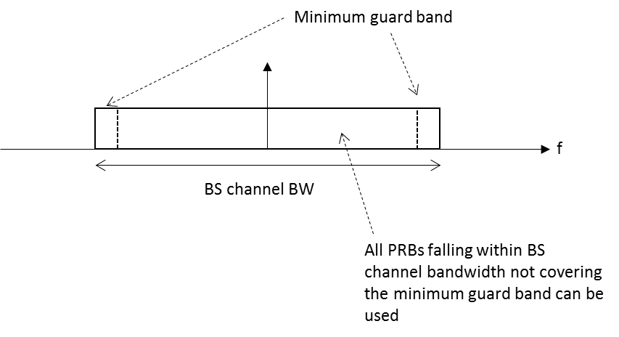
Figure 5.3.3-1: BS PRB utilization
In the case that multiple numerologies are multiplexed in the same symbol, the minimum guardband on each side of the carrier is the guardband applied at the configured BS channel bandwidth for the numerology that is transmitted/received immediately adjacent to the guard band.
For FR1, if multiple numerologies are multiplexed in the same symbol and the BS channel bandwidth is >50 MHz, the guardband applied adjacent to 15 kHz SCS shall be the same as the guardband defined for 30 kHz SCS for the same BS channel bandwidth.
For FR2, if multiple numerologies are multiplexed in the same symbol and the BS channel bandwidth is >200 MHz, the guardband applied adjacent to 60 kHz SCS shall be the same as the guardband defined for 120 kHz SCS for the same BS channel bandwidth.

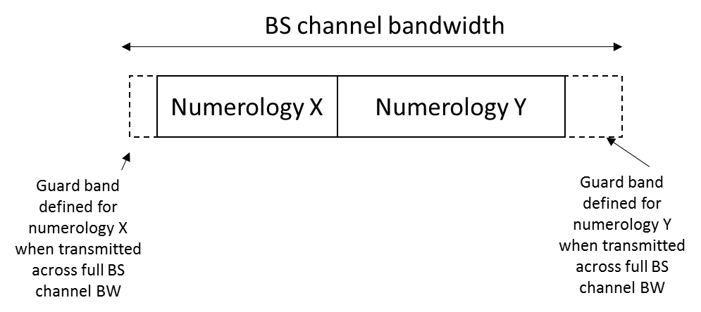
Figure 5.3.3-2: Guard band definition when transmitting multiple numerologies

NOTE: Figure 5.3.3-2 is not intended to imply the size of any guard between the two numerologies. Inter-numerology guard band within the carrier is implementation dependent.
Figure 5.3.3-3: Void
Figure 5.3.3-4: Void
Figure 5.3.3-5: Void

