3GPP TSG-RAN WG4 Meeting#97-e REV_R4-2015972

Electronic meeting, 2 – 13 November 2020
CR-Form-v12.1
CHANGE REQUEST
 | 38.101-1 | CR | 0550 | rev | 1 | Current version: | 16.5.0
For HELP on using this form: comprehensive instructions can be found at
http://www.3gpp.org/Change-Requests.

Proposed change affects: | UICC apps |  | ME | X | Radio Access Network |  | Core Network

Title: | Correction to the intra-cell guard band definition for wideband operation
Source to WG: | Ericsson
Source to TSG: | R4
Work item code: | NR_unlic-Core |  |  |  |  |  | Date: |  |  | 2020-10-23
Category: | F |  |  |  |  |  | Release: |  |  | Rel-16
 | Use one of the following categories:  F (correction)  A (mirror corresponding to a change in an earlier release)  B (addition of feature),  C (functional modification of feature)  D (editorial modification)  Detailed explanations of the above categories can  be found in 3GPP TR 21.900. |  |  |  |  |  |  |  | Use one of the following releases:  Rel-8 (Release 8)  Rel-9 (Release 9)  Rel-10 (Release 10)  Rel-11 (Release 11)  …  Rel-15 (Release 15)  Rel-16 (Release 16)  Rel-17 (Release 17)  Rel-18 (Release 18)
Reason for change: |  | For operations with shared spectrum access, the UE is configured with intra-cell guard bands by the IE intraCellGuardBandsDL-List and intraCellGuardBandsUL-List for the DL and UL, respectively. If these IEs as defined din 38.331 are absent, the guard-band sizes specified in sub-clause 5.3.3 of 38.101-1 applies, from 38.331,  intraCellGuardBandsDL-List, intraCellGuardBandsUL-List  List of intra-cell guard bands in a serving cell for operation with shared spectrum channel access. If not configured, the guard bands are defined according to 38.101-1 [15], see TS 38.214 [19], clause 7. For operation in licensed spectrum, and no UE action is required.  The 38.101-1 defines ‘wideband operation’ as  Wideband operation: For a UE that supports shared spectrum channel access, wideband operation refers to operation within a channel larger than 20 MHz in which intra-cell guard bands may be configured to distinguish individual RB-sets  hence not including operations with the 10 MHz and 20 MHz channel bandwidths. However, it is not obvious from sub-clause 5.3.3 that that there are no intra-cell GB for these bandwidths; the 20 MHz channel bandwidth is nevertheless included in Table 5.3.3-2 defining the nominal GB for wideband operations.  Since 38.331 refers to 38.101-1 for the guard-band sizes when the above IEs are absent, the intra-cell GB configuration must be clearly defined for all channel bandwidths.
Summary of change: |  | Clause 5.3.3:  Table 5.3.3-2: the column for 20 MHz is removed (not wideband operation).  The intra-cell GB configuration are defined for the 10 MHz and 20 MHz bandwidths; there are no intra-cell GB for these bandwidths. Then it follows form 38.214 that N_{RB-set} = 1. There is also a reference to the maximum transmission bandwidth configuration in clause 5.3.2 consistent with the provision in 38.214 that the UE can expect a size of an RB-set between 100-110 RBs for μ = 0 and 50-55(56) RBs for μ = 1 (the latter is not correct for the 10 MHz channel bandwidth).  The IE names are corrected to be in accordance with 38.331.
Consequences if not approved: |  | Intra-cell GB configurations are undefined for the 10 MHz and 20 MHz in the absence of the IE intraCellGuardBandsDL-List and intraCellGuardBandsUL-List.
Clauses affected: |  | 5.3.3
 |  | Y | N
Other specs |  |  | X | Other core specifications
affected: |  |  | X | Test specifications |  |  |  | .
(show related CRs) |  |  | X | O&M Specifications
Other comments:
This CR's revision history:

< start of changes >

5.3.3 Minimum guardband and transmission bandwidth configuration
The minimum guardband for each UE channel bandwidth and SCS is specified in Table 5.3.3-1,
Table 5.3.3-1: Minimum guardband for each UE channel bandwidth and SCS (kHz)
SCS (kHz) | 5 MHz | 10 MHz | 15 MHz | 20 MHz | 25 MHz | 30 MHz | 40 MHz | 50 MHz | 60 MHz | 70 MHz | 80 MHz | 90 MHz | 100 MHz
15 | 242.5 | 312.5 | 382.5 | 452.5 | 522.5 | 592.5 | 552.5 | 692.5 | N/A | N/A | N/A | N/A | N/A
30 | 505 | 665 | 645 | 805 | 785 | 945 | 905 | 1045 | 825 | 965 | 925 | 885 | 845
60 | N/A | 1010 | 990 | 1330 | 1310 | 1290 | 1610 | 1570 | 1530 | 1490 | 1450 | 1410 | 1370

NOTE: The minimum guardbands have been calculated using the following equation: (BW_{Channel} x 1000 (kHz) - N_{RB} x SCS x 12) / 2 - SCS/2, where N_{RB} are from Table 5.3.2-1.
Figure 5.3.3-1: Void
The number of RBs configured in any channel bandwidth shall ensure that the minimum guardband specified in this clause is met.
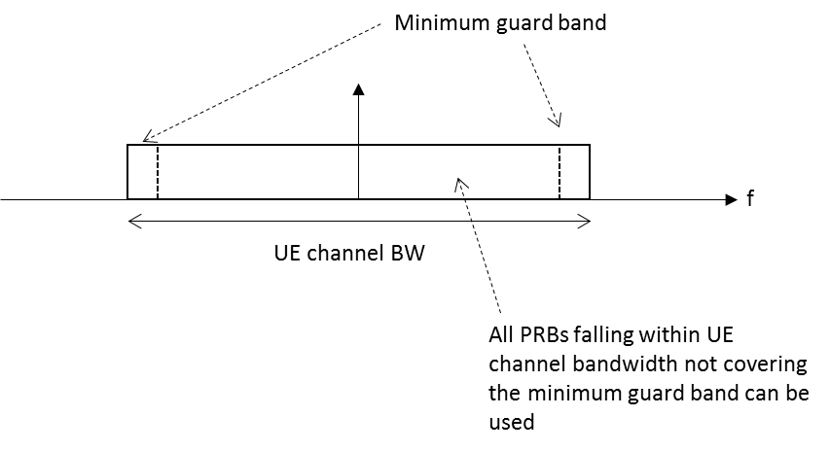
Figure 5.3.3-2: UE PRB utilization
In the case that multiple numerologies are multiplexed in the same symbol due to BS transmission of SSB, the minimum guardband on each side of the carrier is the guardband applied at the configured channel bandwidth for the numerology that is received immediately adjacent to the guard.
If multiple numerologies are multiplexed in the same symbol and the UE channel bandwidth is >50 MHz, the minimum guardband applied adjacent to 15 kHz SCS shall be the same as the minimum guardband defined for 30 kHz SCS for the same UE channel bandwidth.

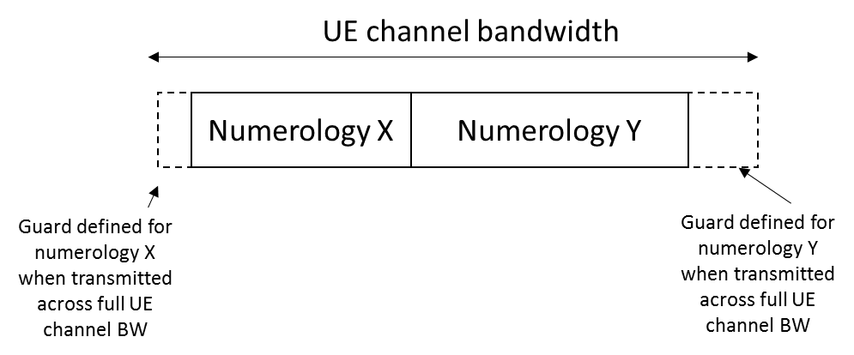
Figure 5.3.3-3 Guard band definition when transmitting multiple numerologies
NOTE: Figure 5.3.3-3 is not intended to imply the size of any guard between the two numerologies. Inter-numerology guard band within the carrier is implementation dependent.
For a UE supporting wideband operation, the nominal intra-cell guard bands and the corresponding sizes of the RB sets separated by the said guard bands are as specified in Table 5.3.3-2 for each UE channel bandwidth and sub-carrier spacing for the downlink and uplink. The nominal intra-cell guard bands in Table 5.3.3-2 are applicable when the respective IE intraCellGuardBandsUL-List and intraCellGuardBandsDL-List [7] for the uplink and downlink are not provided, as specified in [10] clause 7.
Table 5.3.3-2: Nominal intra-cell guard bands for wideband operation
SCS  (kHz) | 40 MHz | 60 MHz | 80 MHz
15 | 105-6-105  (216) | N/A | N/A
30 | 50-6-50  (106) | 50-6-50-6-50  (162) | 50-6-50-5-50-6-50  (217)
NOTE 1: The intra-cell guard band is denoted TBW₀-GB₀-…-GB_{N_RBset-2}-TBW_{N_RBset-1} for N_RBset > 1 number of RB-sets with TBW_{r} the maximum transmission bandwidth (PRB) of RB-set r and GB_{r} the guard band (PRB) above the upper edge of RB-set r. The RB-set 0 is starting at the first common resource block (CRB) of the carrier as indicated by offsetToCarrier. The total transmission bandwidth configuration (size of resource grid) including guard bands is given in between parentheses.

For a UE that supports shared spectrum channel access, there are no uplink or downlink intra-cell guard bands for operation with 10 MHz and 20 MHz channel bandwidths; the maximum transmission bandwidth configurations for these channel bandwidths are in accordance with clause 5.3.2.
For each UE channel bandwidth and sub-carrier spacing given by Table 5.3.3-2, the maximum transmission bandwidth configuration of the carrier including intra-cell guard bands, if configured for the uplink and downlink by the respective IE intraCellGuardBandsUL-List and intraCellGuardBandsDL-List [7], and corresponding RB-set(s) shall be in accordance with clause 5.3.2 with a minimum inter-cell guard band of the UE channel bandwidth as specified in Table 5.3.3-1 for the uplink and downlink. Minimum requirements specified for wideband operation in Clause 6 and Clause 7 also apply for intra-cell guard bands larger than the nominal sizes in Table 5.3.3-2 as listed in Table 5.3.3-3 for each sub-carrier spacing; each guard band in order of CRB index must be larger than or equal to the corresponding nominal guard band specified in Table 5.3.3-2 for each channel bandwidth.
Table 5.3.3-3: Applicable intra-cell guard bands for wideband operation
Parameter | Unit | SCS
 |  | 15 kHz | 30 kHz
Intra-cell guard band (size) | PRB | 6,7 | 5,6,7
Transmission bandwidth (size) of RB-set | PRB | 104,105 | 49,50,51

If the UE is configured with zero width intra-cell guard bands for the uplink and downlink by the IE intraCellGuardBandsUL-List and intraCellGuardBandsDL-List [7] on a carrier greater than 20 MHz, the maximum transmission bandwidth configuration for the uplink and downlink shall be in accordance with clause 5.3.2 with a minimum inter-cell guard band of the UE channel bandwidth as specified in Table 5.3.3-1.

5.3.4 RB alignment

< end of changes >

