3GPP TSG-RAN WG4 Meeting # 96-e R4-200xxxx
Electronic Meeting, 17-28 Aug., 2020

Agenda item: 7.19.1
Source: Moderator (CMCC)
Title: Email discussion summary for [96e] [119]_UE transient period
Document for: Information

Introduction
In RAN4#95-e meeting, RAN4 discussed the feasibility of testing transient period capability and WF was agreed in last meeting (R4-2008477)：
- “Option 4 is agreed: RF requirement on transient period capability (section 6.3.3 for on-on time mask ) is introduced in Rel-16. The testability discussion will continue in TEI16 to address the existing issues 1-1-1 to 1-1-10. RAN4 will decide which release to apply the transient period test to UEs once the testability discussion is concluded”
This email discussion includes contributions in agenda 7.19.1, the targets of email discussion based on companies’ contributions submitted in this e-meeting are as below:
- 1st round:
Discuss the testability issues and provide comments on the CR and LS.
- 2nd round:
Discuss left open issues for 2nd round and strive to approve CR and LS.

Topic #1: Testability of transient period capability
Main technical topic overview. The structure can be done based on sub-agenda basis.

Companies’ contributions summary
T-doc number | Company | Proposals / Observations
R4-2010915 | Qualcomm Incorporated | Observation: ~55dB power change between transmission cannot be a typical scenario for real deployments. 20dB should be used for this test.
R4-2011475 | Huawei, HiSilicon | Proposal 1: RAN4 agrees to define the relation between UE supported SCS and transient period capability requirement as in Table 1 when implementing RF requirement into TS 38.101-1.  Table 1. relation between UE supported SCS and transient period capability requirement  UE Supported SCS Transient period capability requirement  15kHz 7us, 10us  30kHz 4us, 10us  60kHz 2us, 10us  15kHz and 30kHz 7us ,4us and 10us  15kHz and 60kHz 7us ,2us and 10us  30kHz and 60kHz 2us, 4us and 10us  15kHz, 30kHz and 60kHz 2us,4us ,7us and 10us  Proposal 2: Transient period capability requirement is specified symmetrically which should be within the time window of the default 10us transient period. It can be seen as below figure:  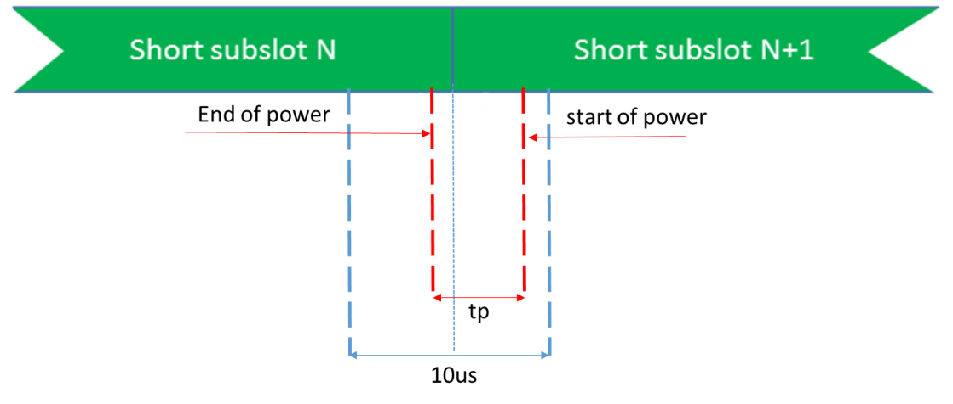
R4-2011523 | Skyworks Solutions Inc. | Proposal 1: To minimize impact on legacy test equipment, the EVM definition that leads to an effective EVM exclusion period shall rely solely on the legacy FFT_low, FFT_high measurement windows.  Proposal 2: 1μs UE capability is not needed as it brings no benefit to operation at any FR1 SCS (15,30 or 60kHz)  Proposal 3: To align as closely as possible the UE declared ‘tp’ with the effective EVM ‘ep’ width, introduce UE ‘tp’ capability of 2.2, 4 and 7.5μs with the set of EVM definitions proposed in Table 3:  Table 3 EVM definition set counter-proposal to verify UE 'tp' capability declaration  Counter proposal Evaluation Results  Calculated EVM exclusion period boundaries (μs) Measured EVM exclusion period boundaries (μs)  Reported transient capability (μs) EVM definition SCS (kHz) Lower Edge Upper Edge Exclusion Period “Width” Lower Edge Upper Edge Exclusion Period “Width”  1 Capability not needed  2.2² $$EVM=min⁡(\overline{{EVM}_{l},}\overline{{EVM}_{h})}$$ 60 -0.878 1.400 2.278 ≈ -0.9 ≈ +1.2 ≈ 2.1  4 $$EVM=min⁡(\overline{{EVM}_{l},}\overline{{EVM}_{h})}$$ 30 -1.758 2.279 4.036 ≈ -1.7 ≈ +2.2 ≈ 3.9  7.5 $$EVM=min⁡(\overline{{EVM}_{l},}\overline{{EVM}_{h})}$$ 15 -3.515 4.036 7.552 ≈ -3.5 ≈ +4.0 ≈ 7.5  NOTE 1: $\overline{{EVM}_{l}}$, $\overline{{EVM}_{h}}$, are defined in Annex F  NOTE 2: $2.2$μs capability is restricted to UEs supporting SCS 60kHz  Proposal 4: Since 2.2μs ‘tp’ capability brings no benefit to operation at SCS 15kHz or at SCS 30kHz, introduce 2.2μs ‘tp’ capability as being restricted to UEs supporting SCS60kHz.  Proposal 5: If no capability is signaled, the default transient period value of 10μs applies and the UE is tested against legacy static EVM requirements only.  Proposal 6: When a UE signals a transient period capability, the UE must pass 2 core requirements using time-mask in Figure 1:  - For the each PUSCH symbols where the transient occurs:  - rmsEVM shall not exceed [10%] for 64QAM and [5%] for 256 QAM.  - The rms average of the basic EVM is averaged over [108] subframes for each symbol where the transient occurs,  - For the remaining PUSCH symbols where the transient does not occur:  - rmsEVM shall not exceed [8%] for 64QAM and [3.5%] for 256QAM (Table 6.4.2.1-1 requirements),  - The rms average of the basic EVM is averaged over [12] subframes.  Proposal 7: : When a UE signals a transient period capability, the static EVM does not need to be verified since it is verified in symbols where the transient does not occur (see proposal 6).  Observation 8: All measurements presented in this paper verified all EVM definitions using off the shelf commercial NR EVM meter equipment. This proves there are no testability issues.
R4-2010916 | Qualcomm Incorporated | RAN4 has discussed the introduction of shorter transient periods and agreed to introduce a new capability for the transient period of 2, 4 or 7us. The UE can support one of these transient periods. If the UE does not signal the support of any value then it will support the legacy value of 10us.  Actions to RAN 2:  RAN4 respectfully asks RAN2 to take the above agreement into account and define a new UE capability accordingly.

Open issues summary
Before e-Meeting, moderators shall summarize list of open issues, candidate options and possible WF (if applicable) based on companies’ contributions.

Sub-topic 1-1 Testability issues for Transient period
Issue 1-1-3: For RMS EVM over 1 symbol, how to define EVM measurement procedure in the spec
- Proposals
  - Option 1: Adding a new section/annex for EVM to include symbols with transient period.
  - Option 2: It is not an issue whether we create a new section in TS 38.101, we should ensure the procedure could be correct, aligned among TE vendors, high-precision.

- Recommended WF
  - TBA. Collect companies’ view in 1st round
Issue 1-1-4: Whether 20dB power change can represent the maximum power change in the network, if not, whether TE can provide the test condition for the maximum power change
- Proposals
  - Option 1: 20 dB power step is reasonable for on-on power change.
  - Option 2: no, power change>20dB is common case under real network. If the reference power change for transient period is 20dB, it will have performance impact on network, if the reference power change for transient period is worst case(e.g.58dB), how UE vendor get known our capability without reliable test environment.
- Recommended WF
  - TBA. Collect companies’ view in 1st round
Issue 1-1-5: How to ensure the transient period is symmetrically positioned
- Proposals
  - Option 1: The exclusion window is defined be symmetric about the symbol boundaries. Symmetric exclusion window has been specified from Rel-15 in TS 38.101-1.
  - Option 2: Need a baseline on how to position transient period.
- Recommended WF
  - TBA. Collect companies’ view in 1st round
Issue 1-1-7: Whether RMS EVM with DFT-OFDM measurement similar with LTE can be tested for transient period
- Proposals
  - Option 1: There is not a case that we need to remove the influence of transient period with DFT-s-OFDM symbol during the EVM calculation process.
  - Option 2: no. There is not test on transient period for LTE, 25us exclusion window is specified. The concept cannot be used for transient period test.
- Recommended WF
  - TBA. Collect companies’ view in 1st round
Issue 1-1-9: How to calculate EVM for symbols in which the transient occurs
- Proposals
  - Option 1: Test procedure detail that needs to be discussed in RAN5.
  - Option 2: Transient period is different for ramp up and ramp down, it should be clearly clarified.
- Recommended WF
  - TBA. Collect companies’ view in 1st round
Issue 1-1-10: EVM budget for symbol where the transient occurs
- Proposals
  - Option 1: Keeping EVM budget in square brackets. EVM values can be discussed after agreement is reached on the feasibility of testing transient periods.
  - Option 2: EVM requirement should decide based on simulation results which can meet network performance on high order modulation.
- Recommended WF
  - TBA. Collect companies’ view in 1st round

Sub-topic 1-2 CR on introduction of shorter Transient Period Capability
- Proposals
  - Shorter transient periods for On-On time mask is introduced and current time masks are clarified that they apply to 10us transient period (R4-2010914)
- Recommended WF
  - TBA. Collect companies’ view in 1st round

Sub-topic 1-3 LS to RAN2 on Shorter Transient Period Capability
- Proposals
  - RAN4 has discussed the introduction of shorter transient periods and agreed to introduce a new capability for the transient period of 2, 4 or 7us. The UE can support one of these transient periods. If the UE does not signal the support of any value then it will support the legacy value of 10us.
  - RAN4 respectfully asks RAN2 to take the above agreement into account and define a new UE capability accordingly.
- Recommended WF
  - TBA. Collect companies’ view in 1st round

Companies views’ collection for 1st round

Open issues
Company | Comments
XXX | Issue 1-1-1:  Issue 1-1-2:  ….  Others:

CRs/TPs comments collection
Major close-to-finalize WIs and Rel-15 maintenance, comments collections can be arranged for TPs and CRs. For Rel-16 on-going WIs, suggest to focus on open issues discussion on 1st round.
CR/TP number | Comments collection
R4-2010914 | Company A
 | Company B

Summary for 1st round

Open issues
Moderator tries to summarize discussion status for 1st round, list all the identified open issues and tentative agreements or candidate options and suggestion for 2nd round i.e. WF assignment.
 | Status summary
Sub-topic#1 | Tentative agreements:  Candidate options:  Recommendations for 2nd round:

Recommendations on WF/LS assignment
 | WF/LS t-doc Title | Assigned Company,  WF or LS lead
#1

CRs/TPs
Moderator tries to summarize discussion status for 1st round and provides recommendation on CRs/TPs Status update
CR/TP number | CRs/TPs Status update recommendation
XXX | Based on 1st round of comments collection, moderator can recommend the next steps such as “agreeable”, “to be revised”

Discussion on 2nd round (if applicable)

Summary on 2nd round (if applicable)
Moderator tries to summarize discussion status for 2nd round and provided recommendation on CRs/TPs/WFs/LSs Status update suggestion
CR/TP/LS/WF number | T-doc Status update recommendation
XXX | Based on 2nd round of comments collection, moderator can recommend the next steps such as “agreeable”, “to be revised”

