TSG-RAN Working Group 4 (Radio) meeting #94bis-E R4-2005511
Electronic Meeting, April 20th – 30th 2020

Source: Ericsson
Title: TP to TR 37.941: Correction to reverberation description
Agenda item: 6.19.2
Document for: Approval

Introduction
At the last RAN4 meeting (RAN4#94-E) the first version of TR 37.941 was created [1]. This version is based on information from TR 37.840, TR 37.842, TR 37.843 and TR 38.817-02.
In this contribution corrections to some details to the technical background relevant for the reverberation chamber test method is presented as a text proposal. At the end of this contribution a text proposal is attached for approval.

Discussion
Summary of change;
- In subclause 7.8.1, correct error related to the description to r_{lim}.
- In subclause 7.8.1, update figure reference.
- In subclause 7.8.1, update reference to MU tables.

Conclusion
At the end of this contribution a text proposal for the technical description of the reverberation test method is attached for approval.

References
[1] R4-2002430, “Draft TR 37.941”, Huawei

TEXT PROPOSAL:

7.8 Reverberation chamber

7.8.1 Measurement system description
A reverberation chamber (RC) is an electrically large shielded metal enclosure that employs one or several “stirring” methods to randomize the fields, such as moving paddles, turntables, etc. In this way, a large number of uncorrelated samples is obtained. The volume in the room where the field is well-stirred is the working volume. Here the E-field, averaged over an entire stirring cycle, is independent of the location in the room, i.e. the field is spatially uniform.
For a proper analysis of the measured data a sufficient number of uncorrelated samples is required. The auto-correlation function is used to calculate the offset between statistically uncorrelated samples using the following expression [11]:
where the modulus operator mod(x,y) is the remainder of x/y, here performing a circular shift of the measurement samples over a distance k. The symbols ⟨x⟩ and σ = "std" (x) denote the average value and standard deviation. The threshold value for uncorrelated samples, r_{lim}, is defined as [11]:
rklim≤0.37(1-7.22/N0.64)
The distance $k_{lim}$$k_{\text{lim}}$between uncorrelated samples is calculated as the minimum k-value satisfying r(k)≤rklim$r\left(k\right)≤r_{\text{lim}}$. The number of uncorrelated samples is calculated as:
When properly designed, this facility can be used for non-directional antenna measurements, such as TRP. In fact, a well-stirred RC is capable of measuring TRP in a reliable way, regardless of the directivity pattern of the emission or frequency range. When measuring TRP of sources with a directive pattern, special care must be taken to characterize the working volume of the chamber.
The purpose of the chamber characterization is to ensure that the effect of a non-uniform field distribution in the chamber has a negligible influence on the measurement result when the BS is placed in the working volume. Lack of chamber uniformity is a major contributor to measurement uncertainty in reverberation chambers and should be handled with care.
The uniformity test can be quite time consuming and the test can be performed separate from the BS measurement. Due to the non-negligible size of BS equipment the BS can have a significant influence on the uniformity. To take this effect into account, either the BS itself must be present in the room during characterization or an absorber with dimensions equal or larger than the BS must be placed at the BS’s location in the room.
The characterization procedure consists of placing a reference transmitter antenna (REF TX ant) at different locations and with different orientations in the room and measuring the Power Transfer (PTF) function between the REF TX and chamber’s RX antenna, see figure 7.8.1-1. The actual mode of RC operation shall be used, including stirrer movement, BS movement, diversity antenna usage, etc. The directivity of the REF TX ant will influence the spatial uniformity of the room, a more directive REF TX ant is better at detecting parts of the room that are less-well stirred. Therefore, the REF TX ant chosen for the uniformity test should excite the chamber in a similar way as the BS.
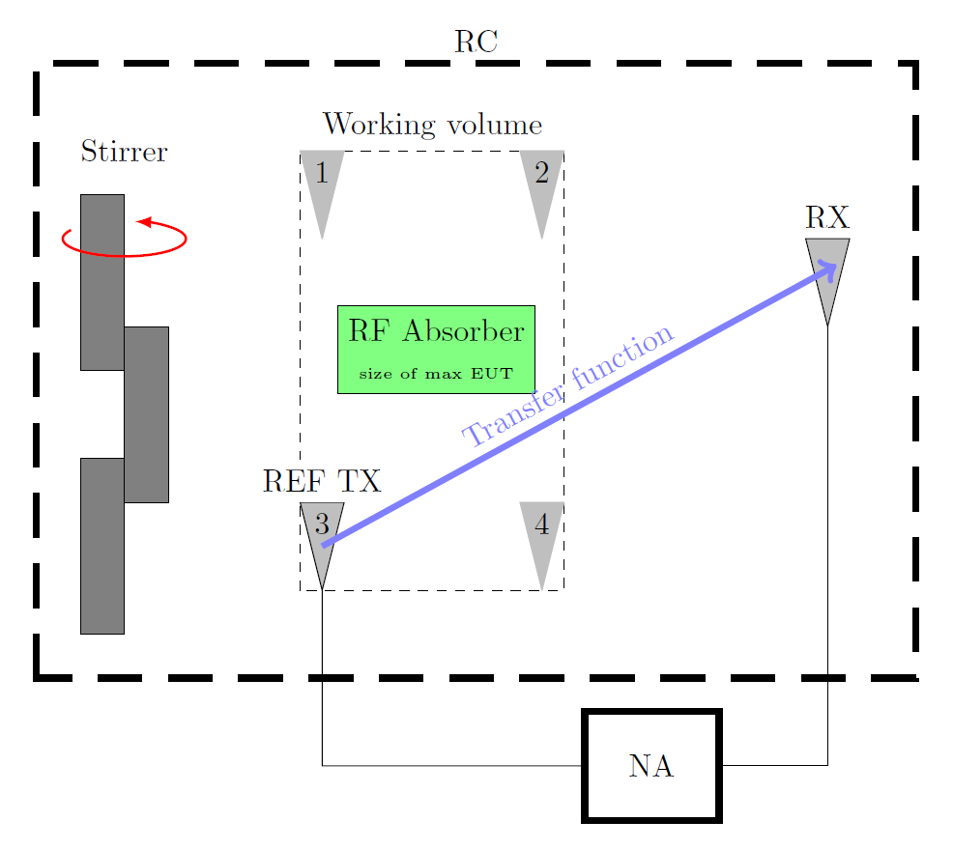
Figure 7.8.1-1: Setup for characterization of a reverberation chamber
The working volume shall be at least half a wavelength from the chamber walls and other electromagnetic reflective objects according to [12]. According to [11] this distance may be restricted to 0.75 m below 100 MHz. The number of positions and orientations to use depends on the chamber size and the directivity of the REF TX ant. Measurements made at positions and orientations at the edges of the working volume are used to characterize the chamber and derive certain components of uncertainty.
The exact number of positions and orientations remain for further study, but at least (3) uncorrelated locations should be used and (6) uncorrelated orientations per position when directive spurs are to be detected.
Different test equipment set ups can be used for the acquisition of the PTF between REF TX and RX. Such as devices capable of directly extracting the PTF, like a Vector Network Analyzer (VNA) or a set up with separate transmitter and receiver test equipment, such as a Signal Generator (SG) and Spectrum/signal Analyzer (SA) configuration. In the latter case the operator should account for the losses in the set up originating from cables, mismatch, etc.
When using a VNA, the REF TX ant and the measurement receive antenna (RX) are connected to the test equipment. For each location/orientation n of the REF TX ant, RC sample, and desired frequency f$f$, the power transfer function
$P_{n}=〈{\left|S_{21}\right|}^{2}〉$
is measured. The explicit dependence on RC sample and frequency is not written out here.
In case of using a SG and SA the PTF is calculated as follows:
$P_{n} = \frac{〈\left|{U_{r}}^{2}\right|〉}{50 P_{t}M_{t}L_{s}}$
with U_{r} the received voltage, 50 Ω being the reference impedance of the SA, P_{t} the transmit power of the signal source, L_{s} the losses in in the cables, Mt the mismatch efficiency at the TX antenna calculated as $M_{t}= 1-{\left|S_{11}\right|}^{2}$.
At least 250 uncorrelated samples shall be used per position/orientation. Using a lower number is not compatible with the underlying analysis on measurement uncertainty, see [11, 13].
The following tests are performed and shall be verified for each frequency:
a) Uniformity of transfer function: For each location/orientation evaluate $P_{n}$P_{n}. The standard deviation of these average values shall be below the assumed measurement uncertainty level for UID 9, captured in table xx.
b) Dynamic range: The dynamic range of each $P_{n}$P_{n} shall be at least 20 dB.
c) Uncorrelated samples: At least 250 uncorrelated samples shall be used.
It is important to note that spatial uniformity (and number of uncorrelated samples) in an RC is harder to achieve for more directive antenna patterns. As such, the measurement uncertainty of a sub-optimally configured room will be higher and additional measures to randomize the fields should be considered. Optimization of the BS position in the chamber and positional stirring are good starting points.

7.8.2 Test method limitations
The reverberation chamber test method is not suitable for testing spurious emissions at very low frequencies. The MU evaluation is applicable for the frequency above 380 MHz.

