3GPP TSG-RAN WG4 Meeting #94-e R4-20xxxxx
Electronic Meeting, Feb.24th – Mar.6th 2020

Agenda item: 8.1.1
Source: Ericsson
Title: Email discussion summary for RAN4#94e_#9_NR_unlic_SysParameters
Document for: Information

Introduction
In the agenda item, systems parameters related issues for Rel-16 NR-U work item are discussed. The main topics under this AI are as follows:
- Wideband operation
- Band definition
- Intra-band operation and raster definitions
- Spectrum emission mask
List of candidate target of email discussion for 1st round and 2nd round
- 1st round: TBA
- 2nd round: TBA

Topic #1: Wideband operation
Main technical topic overview. The structure can be done based on sub-agenda basis.

Companies’ contributions summary
T-doc number | Company | Proposals / Observations
R4-2000818 | Huawei, HiSilicon | Proposal 1: Alt.2 for 60kHz intra-carrier guardbands should be supported.  Proposal 2: The intra-carrier guardbands should be defined based on the common PRB grid and no shift is needed.
R4-2000981 | ZTE Corporation | Proposal 1: 25 PRBs for NR-U 20MHz carrier is mandatory without capability or IOT bit is needed.  Observation: slightly longer filter length seems necessary for 25PRB@20MHz, 60KHz SCS compared with 24PRB@20MHz, 60KHz SCS, however this is still much simpler compared with other SCS cases  Proposal 2: not to define RB shift for PRB grid alignment and leave up to the implementation.
R4-2001732 | FUTUREWEI | Observation 1: The proposed RB allocations for 20 MHz subchannels meet the minimum guard band sizes.  Observation 2: the proposed table does not provide guard band for some combinations with 40 MHz and some combinations with 60 MHz subchannels.  Analysis provided some corrections to the table.  Proposal 1: Table 4 provides sufficient minimum guard band for the various subchannels.  In general, a table is not needed because the base station provides the allocations.  Observation 3: It may not be necessary to capture subchannel bandwidths in the standards since the allocations are already specified.
R4-2000820 | Huawei, HiSilicon | Draft CR
R4-2000967 | Qualcomm Incorporated | Proposal 1: Adopt Alternative 1 in [1] for 60kHz SCS.  Alt.1 is also listed in the table in Section 2.1.  Proposal 2: RAN4 specifications should clearly state that requirements apply under the assumptions of using subbands that are multiples of 20MHz.  Proposal 3: Only the configurations in [1] should be used in 3GPP testing.
R4-2001319 | Ericsson | Proposal 1: a nominal channel raster for which minimum requirements apply is specified without a ±200 kHz shift (offset); increased adjacent interference rejection between NR-U and victims, if desired, can be achieved by increasing the guard within the restrictions already agreed by RAN4.  Proposal 2: changes to 38.101-1 in accordance with Section 3.
R4-2001320 | Ericsson | Draft CR

Open issues summary
Before e-Meeting, moderators shall summarize list of open issues, candidate options and possible WF (if applicable) based on companies’ contributions.

Sub-topic 1-1: Handling 60kHz SCS and guard band
Sub-topic description: NR-U spectral utilization and intra carrier guardbands have been extensively discussed in previous meetings. A WF on intra carrier guardbands was agreed in RAN4#93. The open issue is related to 60kHz SCs case only. Two options are available:
SCS | 20MHz Channels | 40MHz Channels |  | 60MHz Channels |  | 80MHz Channels
Alt. 1 60KHz | 24 | [23-5-23] | Max. 51 | [23-5-23-5-23] | Max. 79 | [23-5-23-5-23-5-23] | Max. 107
Alt. 2 60KHz | [25] | [24-3-24] | Max. 51 | [24-3-25-3-24] | Max. 79 | [24-4-24-3-24-4-24] | Max. 107

Open issues and candidate options before e-meeting:
Issue 1-1: Guardbands for 60kHz SCS
- Proposals
  - Option 1: Adopt Alternative 1
  - Option 2: Alt.2 for 60kHz intra-carrier guardbands should be supported
- Recommended WF
  - TBA

Sub-topic 1-2: Guardband grid and shift
Sub-topic description
Open issues and candidate options before e-meeting:
Issue 1-2: TBA
- Proposals
  - Option 1: The intra-carrier guardbands should be defined based on the common PRB grid and no shift is needed.
  - Option 2: not to define RB shift for PRB grid alignment and leave up to the implementation.
  - Option-3: a nominal channel raster for which minimum requirements apply is specified without a ±200 kHz shift (offset); increased adjacent interference rejection between NR-U and victims, if desired, can be achieved by increasing the guard within the restrictions already agreed by RAN4.
- Recommended WF
  - TBA

Sub-topic 1-2: Testing for spectral utilization
Sub-topic description
Open issues and candidate options before e-meeting:
Issue 1-2: TBA
- Proposals
  - Option 1:
    - Only the configurations in R4-1916160 should be used in 3GPP testing.
    - RAN4 specifications should clearly state that requirements apply under the assumptions of using subbands that are multiples of 20MHz.
- Recommended WF
  - Adopt option 1 above.

Companies views’ collection for 1st round

Open issues
Company | Comments
Qualcomm | Sub topic 1.2: R4-2000981 states that filter complexity is slightly increased for higher SU. Do you expect that all UE’s should use a Hanning window for WOLA? Which requirement was checked? For example, we don’t even have agreement on ACLR yet.  ZTE: this is just example how GB reducation and sampling rate impacts on the window length. Here ACLR is assumed as 45dBc which could definitely meet UE ACLR. It’s expected that UE ACLR will be smaller than legacy 30dBc, then I think window length impacts will be even more reduced. We are also open to other windowing/filtering length analysis and comparsion.  R4-2001732 we think it would be simpler to limit sub-band bandwidths to be 20 MHz only. That would seem to eliminate most of the problems presented in this paper. Would that be an acceptable solution?  Sub topic 1-2:  ….  Others:
Skyworks | Sub topic 1.1 issue 1.1: Skyworks supports Alt 2. based on 25RB in 20MHz for 60kHz SCS
Huawei | Sub-topic 1-1 issue 1.1: Huawei supports Alt 2. It have been discussed for a long time and reached the agreement on 25 RB SU (WF R4-1910388)  Sub-topic 1-2 Issue 1-2: Huawei supports Option 1
ZTE | Sub-topic 1-1 issue 1.1: support Alt 2 as It has been agreed long time ago in the WF R4-1910388  Sub-topic 1-2 issue 1.2: we support not to define RB shift and regarding the common PRB grid for wide band operation is common understanding I think. The background why we mention leaving up to implementation, because point 0 can be configuredany as any value, then based on the point 0 todefine common PRB grid.

CRs/TPs comments collection
Major close-to-finalize WIs and Rel-15 maintenance, comments collections can be arranged for TPs and CRs. For Rel-16 on-going WIs, suggest to focus on open issues discussion on 1st round.
CR/TP number | Comments collection
XXX | Company A
 | Company B
YYY | Company A
 | Company B

Summary for 1st round

Open issues
Moderator tries to summarize discussion status for 1st round, list all the identified open issues and tentative agreements or candidate options and suggestion for 2nd round i.e. WF assignment.
 | Status summary
Sub-topic#1 | Tentative agreements:  Candidate options:  Recommendations for 2nd round:

Recommendations on WF/LS assignment
 | WF/LS t-doc Title | Assigned Company,  WF or LS lead
#1

CRs/TPs
Moderator tries to summarize discussion status for 1st round and provides recommendation on CRs/TPs Status update
CR/TP number | CRs/TPs Status update recommendation
XXX | Based on 1st round of comments collection, moderator can recommend the next steps such as “agreeable”, “to be revised”

Discussion on 2nd round (if applicable)

Summary on 2nd round (if applicable)
Moderator tries to summarize discussion status for 2nd round and provided recommendation on CRs/TPs/WFs/LSs Status update suggestion
CR/TP/LS/WF number | T-doc Status update recommendation
XXX | Based on 2nd round of comments collection, moderator can recommend the next steps such as “agreeable”, “to be revised”

Topic #2: Band definition
Main technical topic overview. The structure can be done based on sub-agenda basis.

Companies’ contributions summary
T-doc number | Company | Proposals / Observations
R4-2001958 | Ericsson | draftCR to 38.104 on NR-U band paln in 5GHz
R4-2001959 | Ericsson | draftCR to 38.101-1 on introduction of band n46

Open issues summary
Before e-Meeting, moderators shall summarize list of open issues, candidate options and possible WF (if applicable) based on companies’ contributions.

Sub-topic 2-1: CR for inclusion of band n46 in TS 38.104
Sub-topic description: In the previous meetings, we have agreed on refarming band 46 for NR-U, as band n46. So, it is technically agreed, and now the relevant CR needs to be agreed for TS 38.104.
Open issues and candidate options before e-meeting:
Issue 2-1: TBA
- Proposals
  - Based on the proposals available in R4-2001958
    - Section 5.2
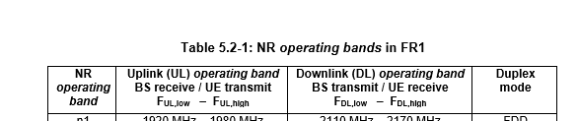´
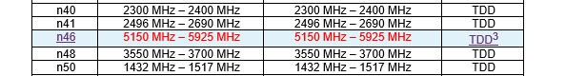
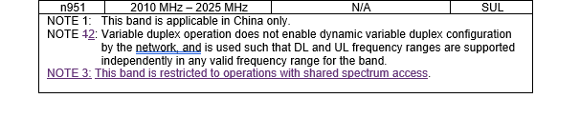
    - Section 5.3.5
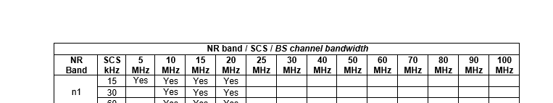
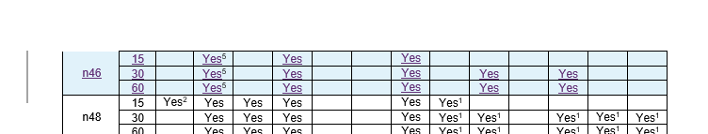
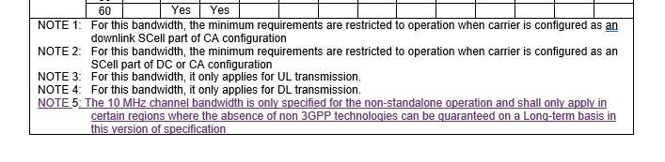
- Recommended WF
  - Propose to agree on the changes as proposed in the CR

Sub-topic 2-2: CR for inclusion of band n46 in TS 38.101-1
Sub-topic description: Similar to previous CR proposal, the band definition need to be introduced to the spec.
Open issues and candidate options before e-meeting:
Issue 2-2: TBA
- Proposals
  - Table 5.2-1
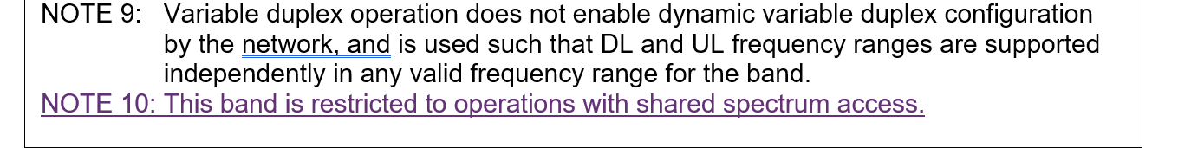
  - Option 2: Table 5.3.5
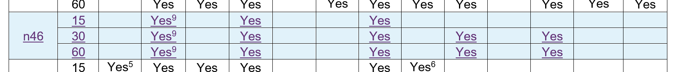
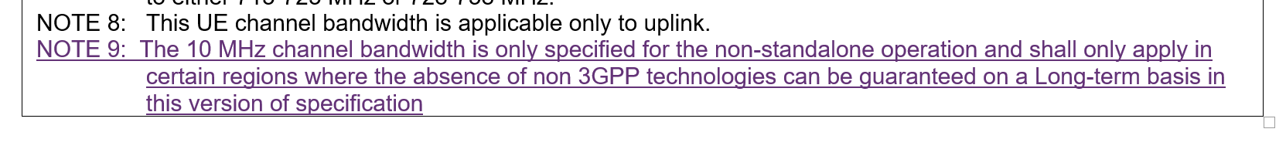
- Recommended WF
  - Propose to agree on the changes as proposed in the CR

Companies views’ collection for 1st round

Open issues
Company | Comments
Qualcomm | Sub topic 2.2: It is premature and difficult to manage these partial draft CR’s. These draft CR’s are missing large sections of the specification needed to NR-U. Even the sub-sections within these CR’s are incomplete or incorrect. For example, this CR only introduces Band n46, but there was also an agreement to introduce 6 GHz band, at least band numbering, which is not included here. Also, these CR’s include 100 MHz channel bandwidth which has not yet been agreed to be included for Rel-16 NR-U; i.e., we don’t have SEM definition of it.  Sub topic 2-2:  ….  Others:
Skyworks | Sub topic 2.2: 100MHz is not agreed and requirement are missing for this channel bandwidth. For band definition should a note explicitly exclude 5350 to 5470MHz?
Huawei | Sub topic 2.2: 100 MHz is not agreed yet. We are ok not to introduce 6 GHz band number since the requirements cannot be finalized for Rel-16. Hence we would like to propose to capture the agreements somewhere other than the TS.
ZTE | Sub topic 2.2: 100MHz is not agreed yet and i think it is just mentioned in reasons and not implemented in the actual CR.

CRs/TPs comments collection
Major close to finalize WIs and Rel-15 maintenance, comments collections can be arranged for TPs and CRs. For Rel-16 on-going WIs, suggest to focus on open issues discussion on 1st round.
CR/TP number | Comments collection
XXX | Company A
 | Company B
YYY | Company A
 | Company B

Summary for 1st round

Open issues
Moderator tries to summarize discussion status for 1st round, list all the identified open issues and tentative agreements or candidate options and suggestion for 2nd round i.e. WF assignment.
 | Status summary
Sub-topic#1 | Tentative agreements:  Candidate options:  Recommendations for 2nd round:

Suggestion on WF/LS assignment
 | WF/LS t-doc Title | Assigned Company,  WF or LS lead
#1

CRs/TPs
Moderator tries to summarize discussion status for 1st round and provided recommendation on CRs/TPs Status update suggestion
CR/TP number | CRs/TPs Status update recommendation
XXX | Based on 1st round of comments collection, moderator can recommend the next steps such as “agreeable”, “to be revised”

Discussion on 2nd round (if applicable)

Summary on 2nd round (if applicable)
Moderator tries to summarize discussion status for 2nd round and provided recommendation on CRs/TPs/WFs/LSs Status update suggestion
CR/TP/LS/WF number | T-doc Status update recommendation
XXX | Based on 2nd round of comments collection, moderator can recommend the next steps such as “agreeable”, “to be revised”

Topic #3: Intra-band operation and raster definitions
Main technical topic overview. The structure can be done based on sub-agenda basis.

Companies’ contributions summary
T-doc number | Company | Proposals / Observations
R4-2001318 | Ericsson | Proposal 1: define three new NR CA bandwidth classes to allow intra-band contiguous CA in Band n46 for all component carrier bandwidths as follows  - class “M”: 50 MHz ≤ BWChannel_CA ≤ [240] MHz (3 CC)  - class “N”: 80 MHz ≤ BWChannel_CA ≤ [320] MHz (4 CC)  - class “O”: 100 MHz ≤ BWChannel_CA ≤ [400] MHz (5 CC)  belonging to the same fall-back group.  Proposal 2: define CA nominal channel spacings based on the agreed channel raster for all bandwidths supported in Band n46.
R4-20001731 | Futurewei | Proposal 1: a 38.104 CR can be based on the endorsed CR (R4-1915982) and the addition of “[Case C]” for the “SS block pattern” column in band n46.  Proposal 2: a 38.101-1 CR for the sync raster for 30 kHz SCS can be based on the TP below.

Open issues summary
Before e-Meeting, moderators shall summarize list of open issues, candidate options and possible WF (if applicable) based on companies’ contributions.

Sub-topic 3-1: New intra-band BW class
Sub-topic description: The existing bandwidth classes only allow aggregation of two 20 MHz carriers, that is, class B with an aggregated bandwidth of 20 MHz ≤ BWChannel_CA ≤ 100 MHz, the bandwidth classes with three or more carriers are defined for larger aggregated bandwidth with component carrier bandwidth larger than 20 MHz, typically 50 MHz channel bandwidth for bands in the 3 GHz range. So, new bandwidth classes are needed to support aggregation of multiple 20MHz carriers in NR-U band.
Open issues and candidate options before e-meeting:
Issue 2-1: TBA
- Proposals
  - Option 1:
    - Define three new classes as listed below:
      - class “M”: 50 MHz ≤ BWChannel_CA ≤ [240] MHz (3 CC)
      - class “N”: 80 MHz ≤ BWChannel_CA ≤ [320] MHz (4 CC)
      - class “O”: 100 MHz ≤ BWChannel_CA ≤ [400] MHz (5 CC)
    - define CA nominal channel spacings based on the agreed channel raster for all bandwidths supported in Band n46.

- Recommended WF
  - Agree on these new BW classes
  - Agree on the proposal to define nominal channel spacing based on agreed channel rasters

Sub-topic 3-2: CR for Sync raster
Sub-topic description
Open issues and candidate options before e-meeting:
Issue 2-2: TBA
- Proposals
  - Option 1:
    - Proposal 1: a 38.104 CR can be based on the endorsed CR (R4-1915982) and the addition of “[Case C]” for the “SS block pattern” column in band n46.
    - Proposal 2: a 38.101-1 CR for the sync raster for 30 kHz SCS can be based on the TP below.
- Recommended WF
  - For CR to TS 38.104, case C can be added in brackets.
  - Similar changes proposed for 38.101-1, can be agreed also.

Companies views’ collection for 1st round

Open issues
Company | Comments
Qualcomm | Sub topic 3.2.1: General requirements do not exist yet for these new bandwidth classes. Adding all of these new bandwidth classes would greatly increase the size of the bandwidth class table that applies not only to NR-U but also NR. We would prefer not to introduce all of these new bandwidth classes if another way can be found instead.  Sub topic 2-2:  ….  Others:
Skyworks | Sub topic 3.2.1issue 2-1: 400MHz 5CC BW class seems premature at this point (remember we have only 200MHz BW class C only for UL NR today and Wifi limits to 320MHz) also 400MHz@5.15GHz is 8% BW for UL, 320MHz is>6%
Huawei | Sub topic 3.2.1: when 100 MHz CBW is defined, the existing classes might be ok.
ZTE | Sub topic 3.2.1: it’s late to introduce BW class at this stage as requirements should be also defined.

CRs/TPs comments collection
Major close to finalize WIs and Rel-15 maintenance, comments collections can be arranged for TPs and CRs. For Rel-16 on-going WIs, suggest to focus on open issues discussion on 1st round.
CR/TP number | Comments collection
XXX | Company A
 | Company B
YYY | Company A
 | Company B

Summary for 1st round

Open issues
Moderator tries to summarize discussion status for 1st round, list all the identified open issues and tentative agreements or candidate options and suggestion for 2nd round i.e. WF assignment.
 | Status summary
Sub-topic#1 | Tentative agreements:  Candidate options:  Recommendations for 2nd round:

Suggestion on WF/LS assignment
 | WF/LS t-doc Title | Assigned Company,  WF or LS lead
#1

CRs/TPs
Moderator tries to summarize discussion status for 1st round and provided recommendation on CRs/TPs Status update suggestion
CR/TP number | CRs/TPs Status update recommendation
XXX | Based on 1st round of comments collection, moderator can recommend the next steps such as “agreeable”, “to be revised”

Discussion on 2nd round (if applicable)

Summary on 2nd round (if applicable)
Moderator tries to summarize discussion status for 2nd round and provided recommendation on CRs/TPs/WFs/LSs Status update suggestion
CR/TP/LS/WF number | T-doc Status update recommendation
XXX | Based on 2nd round of comments collection, moderator can recommend the next steps such as “agreeable”, “to be revised”

Topic #4: Spectrum emission mask
Main technical topic overview. The structure can be done based on sub-agenda basis.

Companies’ contributions summary
T-doc number | Company | Proposals / Observations
R4-2001306 | Nokia, Nokia Shanghai Bell | This contribution presents the agreements for the SEM as stands after the RAN#93 meeting and compares that to the basis for discussion in ETSI BRAN. As the RAN#94 meeting will be an E-meeting and no draft CRs are accepted for this topic it is suggested that how to capture the agreements presented in this document in TS are discussed and aligned such that a CR either can be issued during RAN#94-e or prepared for RAN#94bis.
R4-2000709 | Skyworks Solutions Inc. | Proposal on spectrum mask: the 802.11ax test procedure is adopted for 3GPP measurements and should be reflected in BRAN.  Proposal on image exception: exception at 28 dBr is confirmed to have acceptable impact to power capability [Discussed in AI 8.1.2]  Proposal on carrier leakage exception: with NRU mask measurement procedure proposed in [3] that uses 100 kHz resolution bandwidth, the exception bandwidth is reduced to 200 kHz  MPR definition of PC5: [Discussed in AI 8.1.2]  - For DFT-s-OFDM QPSK waveforms 0.5 dB additional MPR compared to single carrier operation  - For CP-OFDM QPSK waveforms 1 dB additional MPR compared to single carrier operation  - TBC wideband operation with interlace waveforms (the design of these should be clarified)  MPR definition for PC3: given that PC3 has 3 dB better ACLR by default, no additional MPR is needed for the wideband operation compared to single CC case [Discussed in AI 8.1.2]

Open issues summary
Before e-Meeting, moderators shall summarize list of open issues, candidate options and possible WF (if applicable) based on companies’ contributions.

Sub-topic 4-1: SEM measurement procedure
Sub-topic description: Its been discussed for some time to coordinate the mask measurement procedures between 3GPP and ETSI BRAN.
Open issues and candidate options before e-meeting:
Issue 2-1: TBA
- Proposals
  - Option 1: Proposal on spectrum mask: the 802.11ax test procedure is adopted for 3GPP measurements and should be reflected in BRAN.
- Recommended WF
  - Agree on the above proposal.

Sub-topic 4-2: Capturing SEM in spec
Sub-topic description: Many aspects of the SEM for NR-U has been agreed in RAN4#93. Now all these agreements need to be captured in the specs.
Open issues and candidate options before e-meeting:
Issue 2-1: TBA
- Proposals
  - Option 1:
  - In TS 38.104 the addition of the SEM applicable for NR-U and band n46 is proposed to be done as a subclause of 6.6.4.2.4 Basic limits for Local Area BS (Category A and B) and additional requirements for Band n46 as subclause 6.6.4.2.5.4 Additional operating band unwanted emissions limits for Band n46.
  - In TS 38.101-1 the addition of the SEM applicable for NR-U is proposed to be done either as a subclause to 6.5.2.3 Additional spectrum emission mask or by adding a suffix (e.g. E) section to 6.5 Output RF spectrum emissions.

- Recommended WF
  - [Nokia to draft a CR for 38.104 and 38.101-1 to include the SEM related requirements.]

Sub-topic 4-3: LO leakage exception
Sub-topic description: It was agreed in RAN4#93 [R4-1915979] that, LO leakage exception will be accommodated.
Open issues and candidate options before e-meeting:
Issue 2-2: TBA
- Proposals
  - Option 1:
    - Proposal on image exception: exception at 28 dBr is confirmed to have acceptable impact to power capability
    - Proposal on carrier leakage exception: with NRU mask measurement procedure proposed in [3] that uses 100 kHz resolution bandwidth, the exception bandwidth is reduced to 200 kHz
- Recommended WF
  - TBA

Companies views’ collection for 1st round

Open issues
Company | Comments
Qualcomm | Sub topic 4.1: It is not clear what is meant by “802.11ax test procedure”. It would be more clear to state exactly what is the proposed 3GPP test procedure rather than refer to another test defined elsewhere. It is of course not possible for 3GPP to define what gets reflected by BRAN so that cannot be agreed here either.  Sub topic 4-2: R4-2001306 states that different masks might apply “for application where some of the sub-channels in a multi-channel configuration fails LBT and therefor becomes unavailable (punctured)”. In general, we need to be aware of the timing requirement for LBT and the fact that filters even digital may not be either available or may not be able to be switched quickly enough to accommodate different mask requirements. Masks should only apply to configured or scheduled allocations and even for these, there may be limitations. We don’t have a strong view on where SEM is captured, either as a separate suffix or as part of the main, but the details of the SEM requirement itself when/how ie applies may need further discussion.  Sub topic 4-3: What does “confirmed to have acceptable impact to power capability” mean? We haven’t even agreed on power class definition or MPR, so I don’t know how to interpret acceptable impact. For 200 kHz exception, we have not yet agreed to 100 kHz RBW. My understanding is that 100 kHz RBW is only applied in the 1 MHz transition from 0 to -20 dBr and everywhere else is 1 MHz. Even the 100 kHz in the 1 MHz transition was tentative.  ….  Others:
Skyworks | Sub topic 4.1: It is recognized that test procedure may require a more detailed and formal description. Still the method is described in the paper [3] R4-2000708. The 0dBr level is reffered to the in-band peak power in 1MHz. then the mask is applied as is with 100kHz resolution bandwidth  and a video bandwidth of 7.5 kHz  Agree that 3GPP cannot anticipate what will be decided in BRAN but it would still be of interest that test procedure is similar.  Sub topic 4-3: acceptable is described in the observations above proposal: 1dB extra MPR with worst case 28dBc image, 0.3dB for more typical 30dB image. No impact if transmitter upport image leackage compatible with 256QAM. This is obviously open for discussion if such additional MPR is acceptable to all
Huawei | Sub topic 4.1:  “802.11ax test procedure” is not clear  Sub topic 4.3:  What is the clarification of the exception bandwidth is reduced to 200 kHz?

CRs/TPs comments collection
Major close to finalize WIs and Rel-15 maintenance, comments collections can be arranged for TPs and CRs. For Rel-16 on-going WIs, suggest to focus on open issues discussion on 1st round.
CR/TP number | Comments collection
XXX | Company A
 | Company B
YYY | Company A
 | Company B

Summary for 1st round

Open issues
Moderator tries to summarize discussion status for 1st round, list all the identified open issues and tentative agreements or candidate options and suggestion for 2nd round i.e. WF assignment.
 | Status summary
Sub-topic#1 | Tentative agreements:  Candidate options:  Recommendations for 2nd round:

Suggestion on WF/LS assignment
 | WF/LS t-doc Title | Assigned Company,  WF or LS lead
#1

CRs/TPs
Moderator tries to summarize discussion status for 1st round and provided recommendation on CRs/TPs Status update suggestion
CR/TP number | CRs/TPs Status update recommendation
XXX | Based on 1st round of comments collection, moderator can recommend the next steps such as “agreeable”, “to be revised”

Discussion on 2nd round (if applicable)

Summary on 2nd round (if applicable)
Moderator tries to summarize discussion status for 2nd round and provided recommendation on CRs/TPs/WFs/LSs Status update suggestion
CR/TP/LS/WF number | T-doc Status update recommendation
XXX | Based on 2nd round of comments collection, moderator can recommend the next steps such as “agreeable”, “to be revised”

