3GPP TSG-WG RAN4 Meeting #94-e R4-2002568

Online, 24th February – 6th March, 2020
Source: Charter Communications
Title: TP for Rel-16 Intra-band CA for x CC DL/ y CC UL including contiguous and non-contiguous spectrum (x>=y) Bandwidth combination set, REFSENS and insertion loss parameters for CA_48B, CA_48A 48B, CA_48B-48B, CA_48B-48C, CA_48B-48D, CA_48B-48E with 1UL and 2UL configurations

Agenda item: 7.1.2
Document for: Approval

1. Introduction
This contribution provides a TP for TR 36.716-01-01 to include the requirements for CA_48B, CA_48A-48B, CA48B-48B, CA_48B-48C, CA_48B-48D, CA_48B-48E with 1UL and 2UL configurations as defined in RP-192444 [1].

2. Text Proposal

---Start of changes---

5.x CA_48B

CA_48A-48B

CA_48B-48B

CA_48B-48C

CA_48B-48D

CA_48B-48E

CA_48B CA_48B

CA_48A-48B CA_48B

CA_48B-48B CA_48B

CA_48B-48C CA_48B

CA_48B-48D CA_48B

CA_48B-48E CA_48B

5.x.1 Channel bandwidths per operating band for CA
Table 5.x.1-1: Supported E-UTRA bandwidths per CA configuration for Intra-band CA for x CC DL/ y CC UL including contiguous and non-contiguous spectrum (x>=y)
 |  | E-UTRA CA configuration / Bandwidth combination set
E-UTRA CA configuration | Uplink CA configurations  (NOTE 3) | Component carriers in order of increasing carrier frequency |  |  |  |  | Maximum aggregated  bandwidth [MHz] | Bandwidth combination set
E-UTRA CA configuration | Uplink CA configurations  (NOTE 3) | Channel bandwidths for carrier [MHz] | Channel bandwidths for carrier [MHz] | Channel bandwidths for carrier [MHz] | Channel bandwidths for carrier [MHz] | Channel bandwidths for carrier [MHz] | Maximum aggregated  bandwidth [MHz] | Bandwidth combination set
CA_48B | CA_48B | 10 | 10 |  |  |  | 20 | 0

E-UTRA CA Configuration | Uplink CA configurations (NOTE 4) | 1.4 |  | 3 |  | 5 | 10 | 15 | 20 | Maximum aggregated bandwidth | Bandwidth combination set
E-UTRA CA Configuration | Uplink CA configurations (NOTE 4) | MHz |  | MHz |  | MHz | MHz | MHz | MHz | [MHz] | Bandwidth combination set
CA_48A-48B | CA_48B |  |  |  |  | Yes | Yes | Yes | Yes | 40 | 0
CA_48A-48B | CA_48B | See CA_48B Bandwidth combination set 0 in 36.101 Table 5.6A.1-3 |  |  |  |  |  |  |  | 40 | 0
CA_48B-48B | CA_48B | See CA_48B Bandwidth combination set 0 in 36.101 Table 5.6A.1-3 |  |  |  |  |  |  |  | 40 | 0
CA_48B-48B | CA_48B | See CA_48B Bandwidth combination set 0 in 36.101 Table 5.6A.1-3 |  |  |  |  |  |  |  | 40 | 0
CA_48B-48C | CA_48B | See CA_48B Bandwidth combination set 0 in 36.101 Table 5.6A.1-3 |  |  |  |  |  |  |  | 40 | 0
CA_48B-48C | CA_48B | See CA_48C Bandwidth combination set 0 in 36.101 Table 5.6A.1-3 |  |  |  |  |  |  |  | 40 | 0
CA_48B-48D | CA_48B | See CA_48B Bandwidth combination set 0 in 36.101 Table 5.6A.1-3 |  |  |  |  |  |  |  | 80 | 0
CA_48B-48D | CA_48B | See CA_48D Bandwidth combination set 0 in 36.101 Table 5.6A.1-3 |  |  |  |  |  |  |  | 80 | 0
CA_48B-48E | CA_48B | See CA_48B Bandwidth combination set 0 in 36.101 Table 5.6A.1-3 |  |  |  |  |  |  |  | 100 | 0
CA_48B-48E | CA_48B | See CA_48E Bandwidth combination set 0 in 36.101 Table 5.6A.1-3 |  |  |  |  |  |  |  | 100 | 0

 |  | E-UTRA CA configuration / Bandwidth combination set
E-UTRA CA configuration | Uplink CA configurations  (NOTE 3) | Component carriers in order of increasing carrier frequency |  |  |  |  | Maximum aggregated  bandwidth [MHz] | Bandwidth combination set
E-UTRA CA configuration | Uplink CA configurations  (NOTE 3) | Channel bandwidths for carrier [MHz] | Channel bandwidths for carrier [MHz] | Channel bandwidths for carrier [MHz] | Channel bandwidths for carrier [MHz] | Channel bandwidths for carrier [MHz] | Maximum aggregated  bandwidth [MHz] | Bandwidth combination set
CA_48B | CA_48B | 10 | 10 |  |  |  | 20 | 0

5.x.2 Co-existence studies

Table 5.x.2-1 summarizes frequency ranges where harmonics occur due to Band 48 CA with 1 UL.
Table 5.x.2-1: Impact of 1 UL Harmonic Interference
 |  |  |  |  | 2nd Harmonic |  |  | 3rd Harmonic |  |  | 4th Harmonic |  |  |  | 5th Harmonic
Band |  | UL Low Band Edge |  | UL High Band Edge |  | UL Low Band Edge | UL High Band Edge |  | UL Low Band Edge | UL High Band Edge |  | UL Low Band Edge | UL High Band Edge | UL Low Band Edge |  | UL High Band Edge
48 |  | 3550 |  | 3700 |  | 7100 | 7400 |  | 10650 | 11100 |  | 14200 | 14800 | 17750 |  | 1850

Table 5.x.2-1 shows there are no harmonic issues for this combination.
So we can conclude that there is no issue on both DL/UL harmonic interference.

5.x.3 ΔT_{IB,c} and ΔR_{IB,c} values
No ΔT_{IB,c} and ΔR_{IB,c} values for intra-band combinations are needed

5.x.4 MSD
Table 5.4.1A-0eA: Reference sensitivity QPSK P_{REFSENS} (CA 48)
Channel bandwidth
EUTRA CA Configuration | EUTRA band | 1.4 MHz  (dBm) | 3 MHz  (dBm) | 5 MHz  (dBm) | 10 MHz  (dBm) | 15 MHz  (dBm) | 20 MHz  (dBm) | Duplex mode
CA_48B | 48 |  |  | -99 | -96 | -94.2 | -93 | TDD

The MSD analysis was conducted when CA_48Awas discussed. Because of similarity of CA_48B, we apply the MSD specified for CA_48A to that for CA_48

5.X.5 Vendor A, A-MPR for uplink CA bandwidth class B

5.X.5.1 Contiguous RB Transmission
Results from these simulations are shown in the figures below.
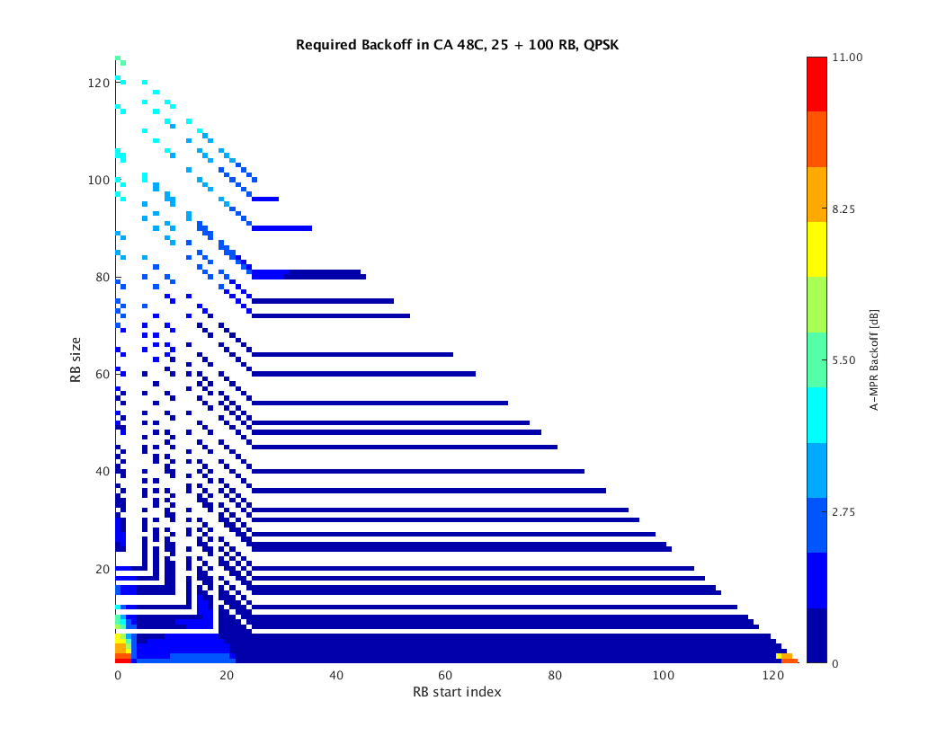
Figure 5.x.5..1-1. Required A-MPR for 25 + 100 RB, QPSK

Based on the simulation results presented from Figure 5.x.5.1-1, the A-MPR requirements for contiguously allocated CA_48B is given in Table 5.x.5.1-1.

Table 5.x.5.1-1: A-MPR requirements for contiguously allocated CA_48B configuration
CA_48B:  CA_NS_xx | RB_{Start} | L_CRB [RBs] | A-MPR for QPSK [dB]
25 RB / 100 RB  and  100 RB / 25 RB | 0 – 2 and 121 - 124 | >0 | ≤11dB
25 RB / 100 RB  and  100 RB / 25 RB | 3 – 27 | <85 | ≤3dB
25 RB / 100 RB  and  100 RB / 25 RB | 3 – 27 | >85 | ≤5dB
25 RB / 100 RB  and  100 RB / 25 RB | 27 – 120 | >0 | ≤2dB

5.X.5.2 2-cluster RB transmission
The simulations for 2-cluster RB transmission shall have the same simulation assumptions and requirement as Contiguous RB transmission.
Because of the large number of scenarios (almost 5 million combinations for 20 + 20 MHz) a set of around 20 000 randomly created allocation scenarios were simulated per bandwidth combination and appropriate back off value was searched.
Results from these simulations with proposed A-MPR mask are shown in the figures below

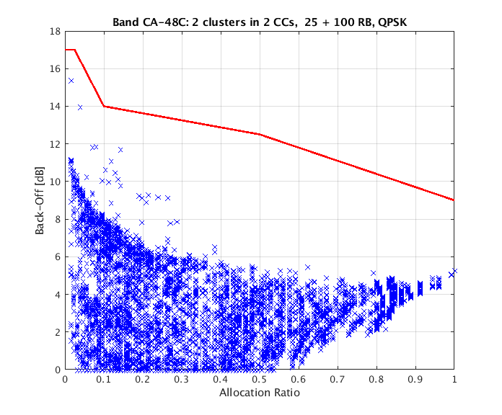
Figure 5.x.5.2-1: 2 clusters in 2CCs vs. allocation ratio, 25 RB + 100 RB

The mask shown in figure 5.X.5.2-1 can be formally defined as follows
A-MPR = CEIL {M_{A,} 0.5}
Where M_{A} is defined as follows
M_{A} = 17; 0 ≤ A < 0.025
-40A + 18; 0.025 ≤ A < 0.1
-3.75A + 14.375; 0.1 ≤ A < 0.5
-7A + 16; 0.5 ≤ A ≤ 1
Where A = N_{RB_alloc} / N_{RB_agg.}

5.X.5.3 Vendor B, A-MPR for uplink CA bandwidth class B

5.x.5.3.1 A-MPR concept
Emission requirements are tighter outside of the band compared to inside the band with an exception that first 10 MHz on high side of that band has same -13 dBm requirement as within the band. Therefore, it would be beneficial to define two different A-MPRs firstly the band edge A-MPR which has higher -25 dBm...-40 dBm emission requirement on IMD3 region and secondly an inner-band A-MPR which would have lower A-MPR as -13 dBm requirement would apply on IMD3 region. This concept is presented in Figure 5.2.5.1-1.
Figure 5.X.5.3.1-1: Two different A-MPRs per CC combination

5.x.5.3.2 Simulation assumptions
Simulation assumptions were as follows
IQ-Image and LO leakage = 28 dBc
CIM3 = 60 dBc
PA calibration point was 20 MHz, 15 kHz, QPSK, DFT-S-OFMA, 100 RB at lower channel edge with 0.5 dB MPR
SEM, ACLR, spurious emission and additional CBRS emission limits are calculated for A-MPR.
The simulated A-MPR is assumed applied as max(A-MPR, MPR), where MPR is the 1CC MPR.

5.X.5.3.3 Results for Contiguous CA Resource Allocations
The A-MPR regions illustrated in Figure5.X.5.3 1-1 are defined in Table 5.2.5.3-1.
Table 5.X.5.3-1: A-MPR regions for CA_48C
Channel Bandwidth, MHz | Carrier Centre Frequency, Fc, MHz | A-MPR
20+5 / 5 + 20 | F_{L} + BW_{CA}/2 ≤ F_{C} ≤ F_{H} - BW_{CA}/2 | A
20+5 / 5 + 20 | FL + 3*BWCA/2 - 10 MHz ≤ F_{C} ≤ FH - 3*BWCA/2 + 10 MHz | B
20+10 / 10 + 20 | F_{L} + BW_{CA}/2 ≤ F_{C} ≤ F_{H} - BW_{CA}/2 | A
20+10 / 10 + 20 | F_{L} + 3*BW_{CA}/2 - 10 MHz ≤  F_{C} ≤ F_{H} - 3*BW_{CA}/2 + 10 MHz | B
20+15 / 15 + 20 | F_{L} + BW_{CA}/2 ≤ F_{C} ≤ F_{H} - BW_{CA}/2 | A
20+15 / 15 + 20 | F_{L} + 3*BW_{CA}/2 - 10 MHz ≤  F_{C} ≤ F_{H} - 3*BW_{CA}/2 + 10 MHz | B
20+20 | F_{L} + BW_{CA}/2 ≤ F_{C} ≤ F_{H} - BW_{CA}/2 | A
20+20 | F_{L} + 3*BW_{CA}/2 - 10 MHz ≤  F_{C} ≤ F_{H} - 3*BW_{CA}/2 + 10 MHz | B
NOTE: F_{L} = 3550 MHz, F_{H} = 3700 MHz and BW_{CA} is the combined bandwidth of the contiguous CCs in the CA combination indicated.

A-MPR at the band edge positions defined in Table 5.X.5.3-1 is given in Table 5.X.5.3-2 this is the A-case. For the lower A-MPR region, the results are given in Table 5.2.5.3-3 this is the B-case.
Herein, applied A-MPR should be considered as max(A-MRP, MPR), where A-MPR is given in Table 5.X.5.3-2 and Table 5.X.5.3-3 and MPR for single CC scenario in Table 6.2.3-1 of LTE specification 36.101.
Table 5.X.5.3-2: A-MPR regions for CA_48C at the band edge, (A)
BWs [MHz] | RB_start | L_CRB | A-MPR [dB]
BWs [MHz] | RB_start | L_CRB | max(mods)
20+5 / 5 + 20 | 0 – 7 and 117 - 124 |  | ≤ 12
20+5 / 5 + 20 | 5 - 25 | < 85 | ≤ 5.5
20+5 / 5 + 20 | 5 - 25 | > 85 | ≤ 6.5
20+5 / 5 + 20 | 26 - 120 |  | ≤ 5
20+10 / 10 + 20 | 0 - 13 and 135 - 149 |  | ≤ 11
20+10 / 10 + 20 | 14 - 33 | < 85 | ≤ 5
20+10 / 10 + 20 | 14 - 33 | > 85 | ≤ 7
20+10 / 10 + 20 | 34 - 134 |  | ≤ 6
20+15 / 15 + 20 | 0 - 22 and 152 -174 |  | ≤ 11
20+15 / 15 + 20 | 23 - 42 | < 95 | ≤ 5.5
20+15 / 15 + 20 | 23 - 42 | > 95 | ≤ 7
20+15 / 15 + 20 | 43 - 151 |  | ≤ 6
20+20 | 0 - 31 and 165 - 199 |  | ≤ 11
20+20 | 31 - 51 | < 100 | ≤ 5.5
20+20 | 31 - 51 | > 100 | ≤ 7
20+20 | 52 - 164 | < 100 | ≤ 4.5
20+20 | 52 - 164 | > 100 | ≤ 6

Table 5.X.5.3-3: A-MPR regions for CA_48C at the band center (“range for lower A-MPR”) (B)
BWs [MHz] | RB_start | L_CRB | A-MPR [dB]
BWs [MHz] | RB_start | L_CRB | max(mods)
20+5 / 5 + 20 | 0 – 7 and 117 - 124 |  | ≤ 4
20+5 / 5 + 20 | 5 - 25 | < 85 | ≤ 2
20+5 / 5 + 20 | 5 - 25 | > 85 | ≤ 2.5
20+5 / 5 + 20 | 26 - 120 |  | ≤ 2
20+10 / 10 + 20 | 0 - 13 and 135 - 149 |  | ≤ 4.5
20+10 / 10 + 20 | 14 - 33 | < 85 | ≤ 1.5
20+10 / 10 + 20 | 14 - 33 | > 85 | ≤ 2.5
20+10 / 10 + 20 | 34 - 134 |  | ≤ 1.5
20+15 / 15 + 20 | 0 - 22 and 152 -174 |  | ≤ 4.5
20+15 / 15 + 20 | 23 - 42 | < 95 | ≤ 1
20+15 / 15 + 20 | 23 - 42 | > 95 | ≤ 2.5
20+15 / 15 + 20 | 43 - 151 |  | ≤ 1
20+20 | 0 - 31 and 165 - 199 |  | ≤ 4.5
20+20 | 31 - 51 | < 100 | ≤ 1
20+20 | 31 - 51 | > 100 | ≤ 1.5
20+20 | 52 - 164 | < 100 | ≤ 1
20+20 | 52 - 164 | > 100 | ≤ 1

Furthermore, an example A-MPR scenario of 20+20 MHz CA combination with QPSK modulation is shown in Figure 3 with contiguous CA allocations, considering both the band edge scenario (“0 Hz offset”) and the lower A-MPR region (“29.8 MHz offset”).
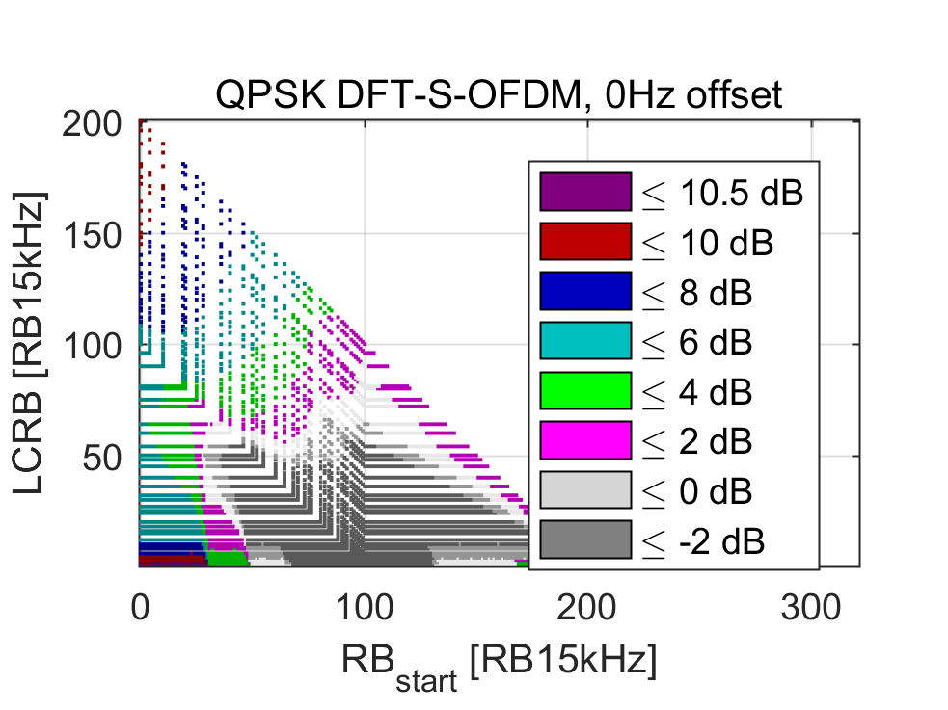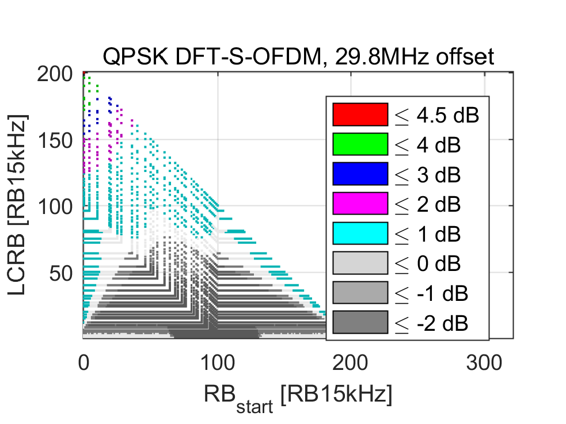
Figure 5.X.5.3-1: The A-AMPR triangles for contiguous resource allocations of 20+20 MHz CA combination at the lower band edge (left) and at the lower edge of the range for lower A-MPR (right). EVM and IBE are not consider for A-MPR.

5.X.5.3.4 Results for Non-contiguous CA Resource Allocations
As illustrated, with an example scenario of 20+20 MHz CA combination, in Figure 5.X.5.3-1 with non-contiguous CA allocations higher A-MPR is needed. In here, non-contiguous channel edge allocations are simulated as a worst-case-scenario.
For the channel edge positions indicated in Figure 5.X.5.1-1, 18 dB A-MPR is needed for the smallest allocation ratio resource allocations, i.e. the narrowest non-contiguous edge allocations.
For the lower A-MPR range indicated in Figure 5.X.5.1-1, 12 dB A-MPR is needed for the smallest allocation ratio resource allocations, i.e. the narrowest non-contiguous edge allocations.
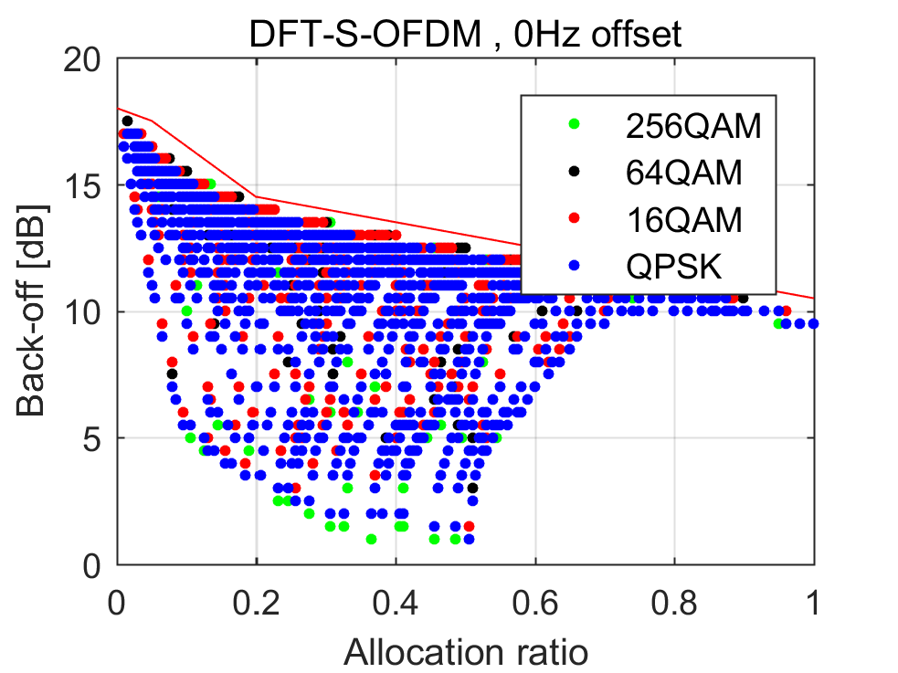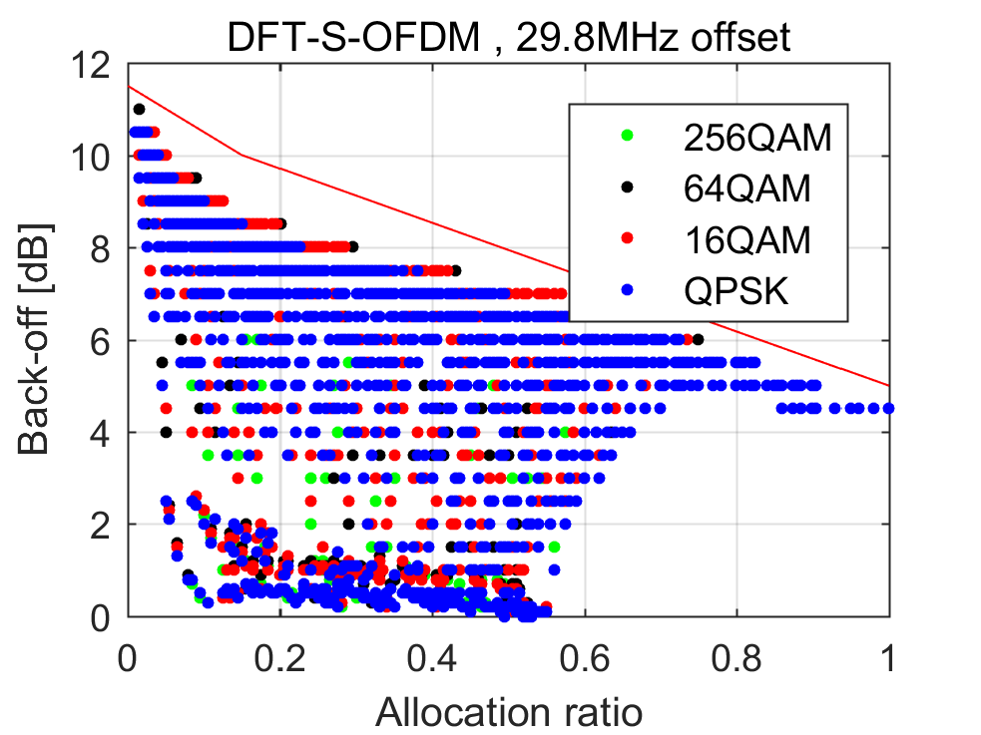
Figure 5.2.5.4-1: The A-MPR for non-contiguous edge allocations of 20+20 MHz CA combination at the lower band edge (left) and at the lower edge of the range for lower A-MPR (right). EVM and IBE are not consider for A-MPR.
Considering the maximum A-MPR needed in the case of small allocation ratio, the results for other BW combinations are quite consistent with 20+20 MHz scenario presented in Figure 5.X.5.3-1.
Based on these results, the following formulation for A-MPR is proposed for the edge scenario:
A-MPR = CEIL {M_{A,} 0.5}
where M_{A} is defined as follows
M_{A} = 18.00 - 10.00 A; 0 ≤ A < 0.05
18.50 - 20.00 A; 0.05 ≤ A < 0.2
15.50 - 5.00 A; 0.2 ≤ A < 1
where A = N_{RB_alloc} / N_{RB_agg.}
Furthermore, the following formulation for A-MPR is proposed for the center scenario:
A-MPR = CEIL {M_{A,} 0.5}
where M_{A} is defined as follows
M_{A} = 11.50 - 10.00 A; 0 ≤ A < 0.15
10.88 - 5.88*A; 0.15 ≤ A < 1
where A = N_{RB_alloc} / N_{RB_agg.}

---End of changes---

Reference
[1] RP-192444, “New WID on Rel16 LTE Intra-band CA for x DL/y UL including contiguous and non-contiguous spectrum(x>=y)”, RAN#80, Ericsson

