3GPP TSG-RAN WG4 Meeting #94-e R4-2002846
Electronic Meeting, 24th February – 6th March, 2020

Source: Huawei, HiSilicon, CBN
Title: TP on UE Tx RF requirements for adding channel bandwidth in band n28
Agenda Item: 9.18.1
Document for: Approval

Introduction
A new WI [1] was approved during RAN#85 meeting, aiming to add wider channel bandwidth in band n28. In this paper, we would like to capture the analysis of UE RF requirements, such as MPR, AMPR and REFSENS.

Text proposal
----- < Unchanged sections omitted > -----TR 38.888

2 References
The following documents contain provisions which, through reference in this text, constitute provisions of the present document.
- References are either specific (identified by date of publication, edition number, version number, etc.) or non-specific.
- For a specific reference, subsequent revisions do not apply.
- For a non-specific reference, the latest version applies. In the case of a reference to a 3GPP document (including a GSM document), a non-specific reference implicitly refers to the latest version of that document in the same Release as the present document.
[1] 3GPP TR 21.905: "Vocabulary for 3GPP Specifications".
[2] RP-192261: " Addition of wider channel bandwidth in NR band n28".
[3] 3GPP TS 38.101-1: "NR; User Equipment (UE) radio transmission and reception; Part 1: Range 1 Standalone".
[4] TR36.820: "LTE for 700 MHz digital dividend".
[5] R4-1913618, "BS-BS co-existence analysis for the new wider channel bandwidth band n28" (ZTE Corporation).
[6] 3GPP TS 38.104: "NR; Base Station (BS) radio transmission and reception".
[x] R4-1914501, “[n28BW] initial MPR simulations results for UL 30MHz channel bandwidth in band n28”
[y] R4-1913132, “n28 30MHz AMPR”
[z] R4-2001089, “Updated AMPR 30MHz simulation results for NS_18 in band n28”
< Next of change >

5.1.2.1 MPR requirements
The relative channel bandwidth of n28 30MHz is around 4.1%. It’s larger than the 3% criteria of FDD bands. So it’s necessary to specify the MPR requirements for n28 30MHz. Referring to MPR simulation results [x], we can find that the MPR requirements in the current spec can be met for UL 30MHz channel bandwidth in band n28. But considering different implementations, the delta MPR need to be considered as margin. The proposed delta MPR (dB) are listed in Table 5.1.2.1-1.
Table 5.1.2.1-1: The proposed delta MPR (dB)
Company | Huawei
The proposed delta MPR (dB) | 1

For band n28 30MHz, the allowed maximum power reduction (MPR) is defined in Table 5.1.2.1-2.
Table 5.1.2.1-2: The proposed delta MPR (dB)
UL channel bandwidth Conditions | Power class | The allowed maximum power reduction (MPR)
Band n28 30MHz | Power class 3 | Table 6.2.2-1 from 38.101-1 + [1] dB

5.1.2.2 AMPR requirements
There are two network signalling labels for n28 in current spec. For 30MHz channel bandwidth, as announced by Japanese operators, it is concluded that NS_17 extension is not needed at this stage because allocation of such wider CBWs won't be foreseen in the near future in Japan.
In China, the TV system has own standard based on 8MHz bandwidth instead of NS_18/NS_17’s 6MHz MBW. Furthermore, Chinese spectrum regulations for 700MHz haven’t been specified at this stage. So NS_17 and NS_18 aren’t applicable to China.
It’s possible for n28 30MHz deployment in EU.
Referring to the paper [y], Frequency range of UL transmission bandwidth configuration placed at 703~733MHz will require AMPR. The updated AMPR simulation results are captured in the paper [z]. Based on the updated AMPR simulation results, we propose the NS_18 AMPR requirements as below.
Table 5.1.2.2-1 A-MPR regions for NS_18
Channel Bandwidth, MHz | Frequency range of UL transmission bandwidth configuration, MHz | Regions |  | A-MPR
Channel Bandwidth, MHz |  | RB_{start}*12*SCS  MHz | L_{CRB}*12*SCS  MHz | A-MPR
30 | 703~733 | > (L_{CRB}*12*SCS)/2+5.22 | ≥Max(0, 12*SCS*N_{RB} – 1.8 – RB_{start}*12*SCS) | A3
30 | 703~733 | ≤(L_{CRB}*12*SCS)/2+5.22 | ≥5.4 | A4
30 | 703~733 | ≤7.92 | <5.4 | A5

Table 5.1.2.2-2 A-MPR for NS_18
Modulation/Waveform |  | A3 | A4 | A5
 |  | Outer/Inner | Outer/Inner | Outer/Inner
DFT-s-OFDM | PI/2 BPSK | [3] | [8] | [3]
DFT-s-OFDM | QPSK | [3] | [8] | [3]
DFT-s-OFDM | 16 QAM | [3] | [8] | [3]
DFT-s-OFDM | 64 QAM | [3] | [8] | [4.5]
DFT-s-OFDM | 256 QAM | [3] | [8] | [5.5]
CP-OFDM | QPSK | [4.5] | [9.5] | [5]
CP-OFDM | 16 QAM | [4.5] | [9.5] | [5]
CP-OFDM | 64 QAM | [4.5] | [9.5] | [5.5]
CP-OFDM | 256QAM | [4.5] | [9.5] | [7.5]

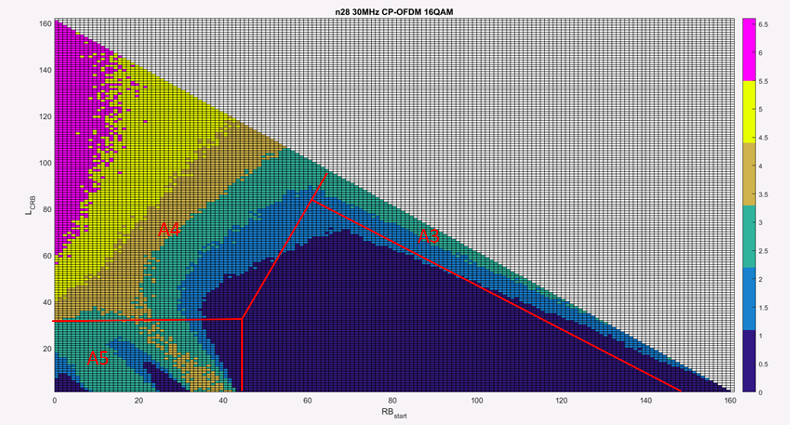
Figure 5.1.2.2-1 NS_18 AMPR regions
< End of change >

References
- RP-192261, New WI proposal: Addition of wider channel bandwidth in NR band n28, CBN, Huawei, HiSilicon

