3GPP TSG-RAN WG4 Meeting #94-e R4-20xxxxx
Electronic Meeting, Feb.24th – Mar.6th 2020

Agenda item: 8.14.1.9
Source: Moderator (Samsung)
Title: Email discussion summary for RAN4#94e_#24_NR_RF_FR2_req_enh_Part_5
Document for: Information

Introduction
The Rel-16 work item on FR2 RF enhancements contains the following study objective:
“This work item will also study if FR2 UE spherical coverage requirements for PC3 for >20%-tile can be defined”
During the RAN4 #93 meeting a way forward of R4-1916184 captured potential alternatives related to this objective:
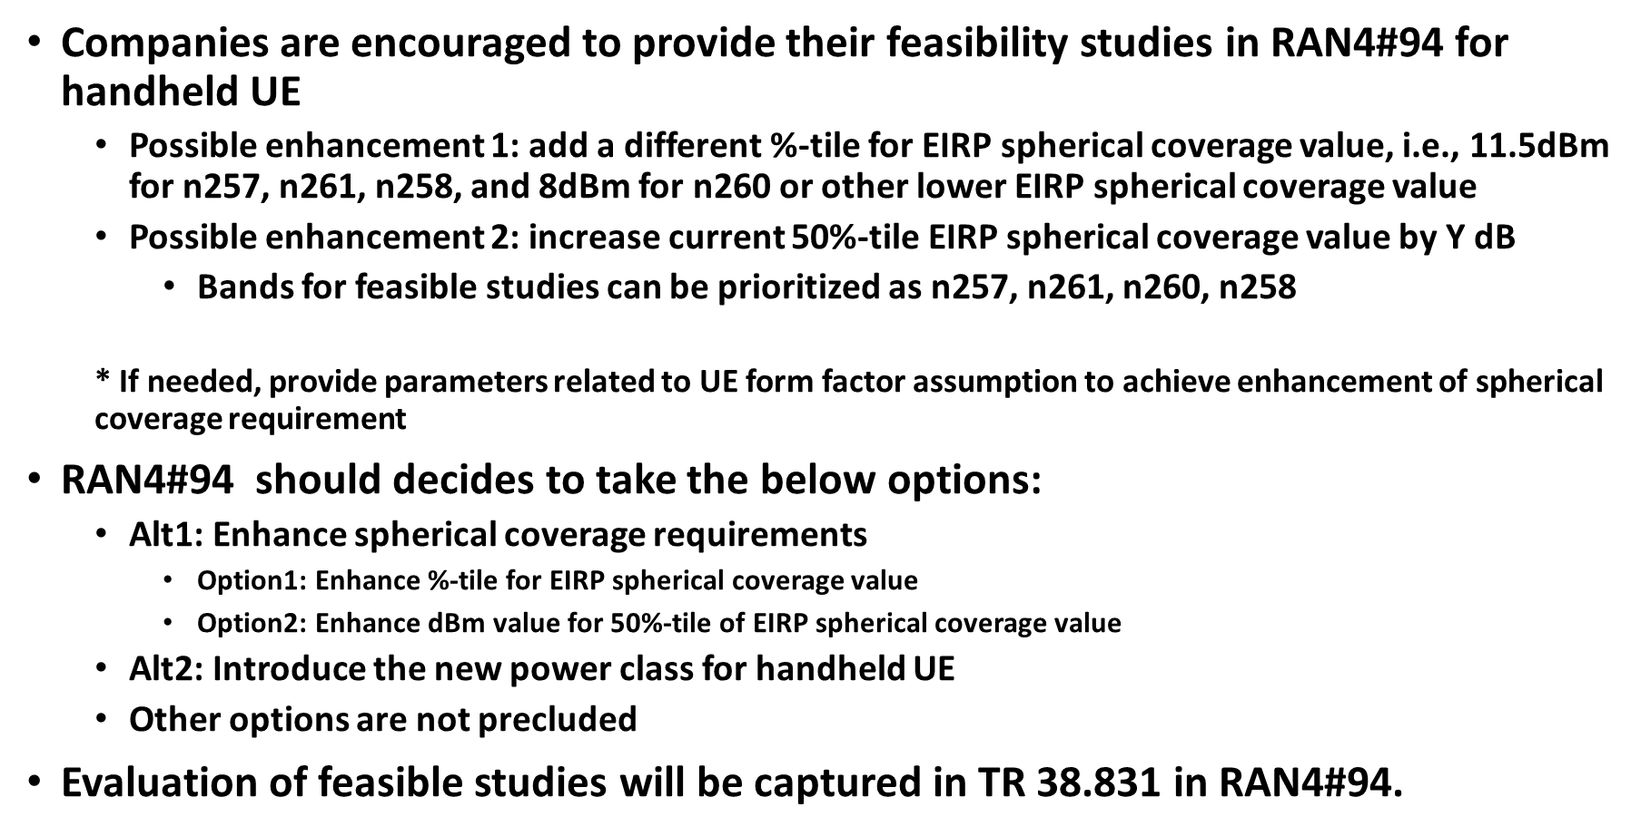
The scope of RAN4 #94-e is to collect the companies view and discuss whether/how to enhance the current requirement during the WI period given the study objective and previous WF.
In this regard, the email discussion using this thread aims to have a common understanding of whether/how RAN4 moves forward for the spherical coverage improvement. To support that target and to make a progress, the email discussion will focus on following three open issues based on the contributions:
- Contributing factors/parameters for re-evaluating spherical coverage for handheld UE type
- Method to specify possible enhancements
- Work plan for possible enhancements
Further details can be found in Section 1.2, and the candidate target for each round can be set up as below.
- 1st round: Collect companies view on the open issues, and summarize the possible way forwards of each open issue
- 2nd round: Further discuss the summary of 1st round, and find the tentative agreements on whether/how to move forward for the spherical coverage improvement in RAN4.
Companies are strongly encouraged to provide comments/concerns within the period of each stage as RAN4 chair announced. It is also guided that each company/delegate consolidate their comments/views and send them out in one email.

Topic #1: Improvement of spherical coverage requirements for PC3

Companies’ contributions summary
T-doc number | Company | Proposals / Observations
R4-2000020  [1] | Apple | Proposal 1: Any change to the %-tile value or dBm value of the EIRP spherical coverage requirement for an already defined Rel-15 power class in any subsequent release violates the assumption on power class release independence and shall be precluded.
R4-2000317  [2] | Samsung | Observation 1: The current spherical coverage requirement is based on the result of extensive discussions such as real product considerations and network performance analysis during the Rel-15 timeframe.  Observation 2: Parameters considered during the Rel-15 is thorough enough in UE design aspect, hence no further parameters can be considered to enhance spherical coverage requirement.  Observation 3: RAN4 should consider how to improve the future UE or to design a new work plan for the enhancement rather than how to overturn the previous agreement from the same data provided 2 years ago.  Observation 4: Current Rel-15 spherical coverage requirement does not have implication on the number of panel UE implements, and the panel number does not necessarily mean a criterion of the spherical coverage or UE performance unless all UEs shall share the same form factor and design principle.  Observation 5: Multiple requirements for various possible UE designs would not only limit the UE implementation flexibility, but also might break out of the role of RAN4 specifications.  Observation 6: In view of the history of RAN4, current requirement of 50%-tile is inevitable decision considering the UE implementation impact and its network performance.  Observation 7: Alt 2 will lead the new power class to a sub part of the current PC3 since there is no upper tolerance in each power class of FR2.  Proposal 1: The spherical coverage enhancement can be discussed only if there is a common understanding of its necessity or benefits.  Proposal 2: If needed according to the discussion, RAN4 should set up a new work plan and consider other parameters that might help the spherical coverage but missed in the previous work.
R4-2000750  [3] | Vivo | Observation1: Rel-15 spherical coverage for PC3 were settled for handheld UE after long evaluation and are results of balance and difficult compromises.  Observation 2: RAN4 usually doing RF requirements enhancement based on long evolvement of implementation and sufficient test on commercial products.  Observation 3: Basic assumptions could be discussed when enhancement requirements would be discussed, however, serious technical analysis is not likely to be done considering Rel-16 time frame.  Proposal: Discuss basic assumptions in Rel-16 and starting technical analysis in Rel-17.
R4-2000956  [4] | Intel | Observation 1: Keeping a singular percentile point for each power class is sufficient and preferred.  Proposal 1: Each FR2 power class will have a single percentile point. This can be considered the default or baseline assumption.  Observation 2: Increasing the current EIRP level of the 50%-tile point can a reasonable enhancement, but it may take time to reach an agreement on the tightening value.  Observation 3: Introducing a new power class for an enhanced handheld UE needs to be supported by sufficient data to indicate the enhancements are achievable with the constraints of the form factor.  Observation 4: The significantly greater impact removing multi-band relaxations will have beyond the spherical coverage requirements of PC3, make this a more complicated option.  Proposal 2: Do not remove multi-band relaxations in Rel-16.
R4-2001233  [5] | OPPO | Observation 1: Rel-15 spherical coverage requirement definition is based on the assumption of UE implemented with one or two antenna panels implemented.  Observation 2: Without big improvement in UE design and antenna panel design, the implementation constrains will be same as Rel-15, and spherical coverage performance is expected to be the same.  Proposal 1: The Alt 1, i.e. enhance spherical coverage requirements by enhance %-tile or dBm, is not considered before there is big improvement in UE design and antenna panel design.  Observation 3: FR2 power class is mapped to certain UE type, and it is not clear what kind of new handheld UE type with less constrains in antenna module implementation that the alt 2 actually is targeting.  Proposal 2: Further clarify which kind of new handheld UE type that the Alt 2 is targeting before discuss the spherical coverage enhancement and the introduction of new power class.
R4-2001495  [6] | Sony | Observation 1: The EIRP spherical coverage performance of many currently available handheld UEs exceeds the current requirements set for power class 3 (PC3). Therefore, there is room for enhancing the PC3 spherical coverage.  Observation 2: Improvements of EIRP spherical coverage values of handheld UEs (see Figure 1) translate directly into NR network performance improvements (see Figure 5).  Proposal 1: A new power class for high performance handheld UEs, which should have significantly more stringent EIRP spherical coverage requirements than those of current PC3 but still based on a handheld UE form factor.  Proposal 2: For the optional new power class for handheld devices, the EIRP spherical coverage requirements of the new power class can be formulated as  • 50%-tile EIRP spherical coverage value of [15.5] dBm or better  and/or  • 20%-tile EIRP spherical coverage value of [11.5] dBm or better  Other power class related parameter can be for further study.  Proposal 3: Supporting the new power class can be designed be an optional and dynamic feature of handheld UEs.
R4-2002113  [7] | NTT DOCOMO | Proposal 1: Define the enhanced spherical coverage requirement using the improved practical factors  - The number of antenna panels is assumed to be more than 2 panels.  - Other improved practical factors is not precluded.  Proposal 2: Evaluate the required practical factors to achieve the targeted value of enhanced spherical coverage requirement of 18dBm@CDF 35%-tile.  Proposal 3:  - RAN4#94-e:  > Capture the input of the feasibility studies in TR  > Clarify which practical factors need to be improved to enhance spherical  coverage requirements  - RAN4#94bis:  > Decide the value of the enhanced spherical coverage requirements.  : Option1: Specify a X %-tile for 11.5dBm EIRP spherical coverage  value  : Option2: Specify a 50%-tile for Y dBm EIRP spherical coverage value  : Option3: Specify a X%-tile for Y dBm EIRP spherical coverage value  > Decide how to specify the new requirements, and send LS to RAN2 if it  has impact on RAN2 signalling.  : Option A: Introduce new power class  : Option B: Introduce new UE capability to enhance the spherical  coverage value of power class 3  > Other options are not precluded.  - RAN4#95:  > Approve final CR in Rel-16, or/and make RAN4 agreement to introduce  Rel-17 WI related to enhanced spherical coverage requirements.  > Approve TP about the summary of the feasibility studies in TR if needed.

Open issues summary

Sub-topic 1-1: Contributing factors/parameters for re-evaluating spherical coverage for handheld UE type
Sub-topic description: As noted in WID, i.e. “study if FR2 UE spherical coverage requirements for PC3 for >20%-tile can be defined”, it is highly recommended to clarify the factors that might improve the spherical coverage performance of PC3 UE before the discussion on enhancements of the requirement. The factors already have been considered in Rel-15 can be found in [2].
Related contributions: [2], [3], [5], [6], [7]
- Proposals
  - Option 1: No more at this stage / FFS
  - Option 2: Based on more than 1 panel assumptions of Rel-15
- Companies view
Company | Comments
MediaTek | We support “Option 1”. Furthermore, Rel-15 is actually not limited to 1 antenna panel in our understanding.

- Recommended WF
  - TBA

Sub-topic 1-2: Method to specify possible enhancements
Sub-topic description: Currently, the FR2 power classes are specified based on the UE type assumptions. Since PC3 is already designed for handheld UEs which is the objective of this topic, it is important to discuss how to specify the possible enhanced requirement if it is necessary in the future.
Related contributions: [1], [2], [3], [4], [5], [6], [7]
- Proposals
  - Option 1: No change
  - Option 2: Update the requirement of PC3
    - Change or add to the Rel-15 requirements
  - Option 3: Introduce new power class for handheld UE
- Optional and dynamic feature of handheld UEs
- Companies view
Company | Comments
MediaTek | We support “Option 1”.  About “Option 3”, whether or not to introduce another power class for handheld UE can be further discussed. But there is no need to rush it in Rel-16.

- Recommended WF
  - TBA

Sub-topic 1-3: Work plan for possible enhancements
Sub-topic description: Given the insufficient discussion until last meeting and limited time schedule of the WI and Rel-16 to go, the work plan for possible enhancements also need to be discussed. Based on the work plan, a way forward for this objective can be further clarified with the discussion about other sub-topics.
Related contributions: [2], [3], [4], [5], [7]
- Proposals
  - Option 1: Discuss additional factors in Rel-16, and technical analysis in Rel-17 if necessary
  - Option 2: Discuss and decide the enhanced value of the requirements in Rel-16 (until RAN4 #95)
- Companies view
Company | Comments
XXX

- Recommended WF
  - TBA

Companies views’ collection for 1st round

Open issues
Company | Comments
XXX | Sub topic 1-1:  Sub topic 1-2:  ….  Others:

CRs/TPs comments collection
Major close-to-finalize WIs and Rel-15 maintenance, comments collections can be arranged for TPs and CRs. For Rel-16 on-going WIs, suggest to focus on open issues discussion on 1st round.
CR/TP number | Comments collection
XXX | Company A
 | Company B
YYY | Company A
 | Company B

Summary for 1st round

Open issues
Moderator tries to summarize discussion status for 1st round, list all the identified open issues and tentative agreements or candidate options and suggestion for 2nd round i.e. WF assignment.
 | Status summary
Sub-topic#1 | Tentative agreements:  Candidate options:  Recommendations for 2nd round:

Recommendations on WF/LS assignment
 | WF/LS t-doc Title | Assigned Company,  WF or LS lead
#1

CRs/TPs
Moderator tries to summarize discussion status for 1st round and provides recommendation on CRs/TPs Status update
CR/TP number | CRs/TPs Status update recommendation
XXX | Based on 1st round of comments collection, moderator can recommend the next steps such as “agreeable”, “to be revised”

Discussion on 2nd round (if applicable)

Summary on 2nd round (if applicable)
Moderator tries to summarize discussion status for 2nd round and provided recommendation on CRs/TPs/WFs/LSs Status update suggestion
CR/TP/LS/WF number | T-doc Status update recommendation
XXX | Based on 2nd round of comments collection, moderator can recommend the next steps such as “agreeable”, “to be revised”

