3GPP TSG-WG RAN4 Meeting #94-e Revised R4-2000133

Electronic Meeting, 24 Feb. - 6 Mar., 2020
CR-Form-v12.0
CHANGE REQUEST
 | 38.101-3 | CR | 0160 | rev | 1 | Current version: | 16.2.0
For HELP on using this form: comprehensive instructions can be found at
http://www.3gpp.org/Change-Requests.

Proposed change affects: | UICC apps |  | ME | X | Radio Access Network |  | Core Network

Title: | CR to TS 38.101-3: Switching time mask between two uplink carriers in EN-DC
Source to WG: | China Telecom, ZTE, LGE, CMCC, China Unicom, KDDI…
Source to TSG: | R4
Work item code: | NR_RF_FR1-Core |  |  |  |  |  | Date: |  |  | 2020-02-01
Category: | B |  |  |  |  |  | Release: |  |  | Rel-16
 | Use one of the following categories:  F (correction)  A (mirror corresponding to a change in an earlier release)  B (addition of feature),  C (functional modification of feature)  D (editorial modification)  Detailed explanations of the above categories can  be found in 3GPP TR 21.900. |  |  |  |  |  |  |  | Use one of the following releases:  Rel-8 (Release 8)  Rel-9 (Release 9)  Rel-10 (Release 10)  Rel-11 (Release 11)  Rel-12 (Release 12)  Rel-13 (Release 13)  Rel-14 (Release 14)  Rel-15 (Release 15)  Rel-16 (Release 16)
Reason for change: |  | For UE supporting maximum two concurrent transmission, Tx switching between two uplink carriers can enable 1 Tx on E-UTRA carier and 2 Tx on NR carrier.
Summary of change: |  | Introduce UE time mask requirements to allow switching between two uplink carriers for inter-band EN-DC.
Consequences if not approved: |  | UE is not allowed to support Tx switching between two uplink carriers.
Clauses affected: |  | New section 6.3B.4
 |  | Y | N
Other specs |  |  | X | Other core specifications |  |  |  | TS/TR ... CR ...
affected: |  | X |  | Test specifications |  |  |  | TS 38.521-3
(show related CRs) |  |  | X | O&M Specifications |  |  |  | TS/TR ... CR ...
Other comments:
This CR's revision history:

< Start of change >

6.3B.4 Output power dynamics for switching between two uplink carriers

6.3B.4.1 E-UTRA and NR switching time mask between two uplink carriers
The switching time mask specified in clause 6.3B.4.1 is applicable when switching between an uplink band pair of an EN-DC configuration is supported, and is only applicable when uplink transmission is switched between E-UTRA UL carrier 1 capable of one transmit antenna connector and NR UL carrier 2 capable of two transmit antenna connectors, where the two uplink carriers are in different bands with different carrier frequencies.
The switching periods described in 6.3B.4-1 are only located in NR carrier, and the length of uplink switching period X depends on UE capability [TBD].
The requirements apply for the case of co-located and synchronized network deployment for the two uplink carriers.

For UE supporting uplink transmission switching, the UE is mandated to support 2-layer UL-MIMO transmission and single-layer transmission on carrier 2 following the BS scheduling and rank adaptation (if rank adaptation is applicable).
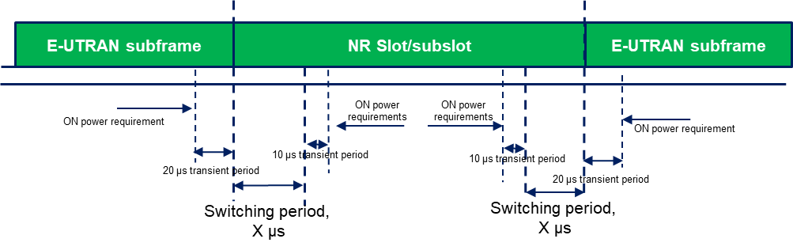
Figure 6.3B.4.1-1: Time mask for switching between E-UTRA UL carrier and NR UL carrier, where the switching period is located in NR carrier

< Start of change >

