3GPP TSG-WG RAN4 Meeting #94-e Revised R4-2000133

Electronic Meeting, 24 Feb. - 6 Mar., 2020
CR-Form-v12.0
CHANGE REQUEST
 | 38.101-3 | CR | 0160 | rev | 1 | Current version: | 16.2.0
For HELP on using this form: comprehensive instructions can be found at
http://www.3gpp.org/Change-Requests.

Proposed change affects: | UICC apps |  | ME | X | Radio Access Network |  | Core Network

Title: | CR to TS 38.101-3: Switching time mask between two uplink carriers in EN-DC
Source to WG: | China Telecom, ZTE, LGE …
Source to TSG: | R4
Work item code: | NR_RF_FR1-Core |  |  |  |  |  | Date: |  |  | 2020-02-01
Category: | B |  |  |  |  |  | Release: |  |  | Rel-16
 | Use one of the following categories:  F (correction)  A (mirror corresponding to a change in an earlier release)  B (addition of feature),  C (functional modification of feature)  D (editorial modification)  Detailed explanations of the above categories can  be found in 3GPP TR 21.900. |  |  |  |  |  |  |  | Use one of the following releases:  Rel-8 (Release 8)  Rel-9 (Release 9)  Rel-10 (Release 10)  Rel-11 (Release 11)  Rel-12 (Release 12)  Rel-13 (Release 13)  Rel-14 (Release 14)  Rel-15 (Release 15)  Rel-16 (Release 16)
Reason for change: |  | For UE supporting maximum two concurrent transmission, Tx switching between two uplink carriers can enable 1 Tx on E-UTRA carier and 2 Tx on NR carrier.
Summary of change: |  | Introduce UE time mask requirements to allow switching between two uplink carriers for inter-band EN-DC.
Consequences if not approved: |  | UE is not allowed to support Tx switching between two uplink carriers.
Clauses affected: |  | New section 6.3B.4
 |  | Y | N
Other specs |  |  | X | Other core specifications |  |  |  | TS/TR ... CR ...
affected: |  | X |  | Test specifications |  |  |  | TS 38.521-3
(show related CRs) |  |  | X | O&M Specifications |  |  |  | TS/TR ... CR ...
Other comments:
This CR's revision history:

< Start of first change >

2 References
The following documents contain provisions which, through reference in this text, constitute provisions of the present document.
- References are either specific (identified by date of publication, edition number, version number, etc.) or non-specific.
- For a specific reference, subsequent revisions do not apply.
- For a non-specific reference, the latest version applies. In the case of a reference to a 3GPP document (including a GSM document), a non-specific reference implicitly refers to the latest version of that document in the same Release as the present document.
[1] 3GPP TR 21.905: "Vocabulary for 3GPP Specifications".
[2] 3GPP TS 38.101-1: "NR; User Equipment (UE) radio transmission and reception; Part 1: Range 1 Standalone"
[3] 3GPP TS 38.101-2: "NR; User Equipment (UE) radio transmission and reception; Part 2: Range 2 Standalone"
[4] 3GPP TS 36.101: "Evolved Universal Terrestrial Radio Access (E-UTRA); User Equipment (UE) radio transmission and reception"
[5] 3GPP TS 38.521-3: "NR; User Equipment (UE) conformance specification; Radio transmission and reception; Part 3: Range 1 and Range 2 Interworking operation with other radios"
[6] Recommendation ITU-R M.1545: "Measurement uncertainty as it applies to test limits for the terrestrial component of International Mobile Telecommunications-2000"
[7] 3GPP TS 36.211: "E-UTRA; Physical channels and modulation"
[8] 3GPP TS 36.331: " Evolved Universal Terrestrial Radio Access (E-UTRA); Radio Resource Control (RRC); Protocol specification"
[9] 3GPP TS 38.331: "NR; Radio Resource Control (RRC) protocol specification"
[10] 3GPP TS 38.213: "NR; Physical layer procedures for control"
[11] 3GPP TS 38.306: "NR; User Equipment (UE) radio access capabilities"
[12] 3GPP TS 38.133: "NR; Requirements for support of radio resource management"
[13] 3GPP TS 38.214: "NR; Physical layer procedures for data".
< End of first change >

< Start of second change >

6.3B.4 Output power dynamics for switching between two uplink carriers

6.3B.4.1 E-UTRA and NR switching time mask between two uplink carriers
The switching time mask specified in clause 6.3B.4.1 is applicable when switching between an uplink band pair of an EN-DC configuration is supported, where the two uplink carriers are in different bands with different carrier frequencies. The condition of the presence of the switching period is described in TS 38.214 [13].
The switching periods described in 6.3B.4-1 are only located in NR carrier, and the length of switching period X depends on UE capability [TBD].
The requirements apply for the case of co-located and synchronized network deployment for the two uplink carriers.
Power class delcaration for the uplink transmission switching follows the general definition of power class.
For UE supporting uplink transmission switching, the UE is mandated to support 2-layer UL-MIMO transmission and single-layer transmission on carrier 2 following the BS scheduling and rank adaptation (if rank adaptation is applicable).
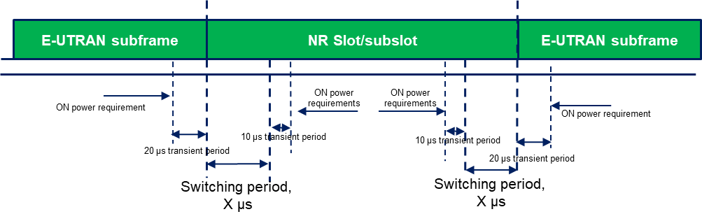
Figure 6.3B.4.1-1: Time mask for switching between E-UTRA UL carrier and NR UL carrier, where the switching period is located in E-UTRA carrier

< End of second change >

