3GPP TSG-WG RAN4 Meeting #94-e Revised R4-2000132

Electronic Meeting, 24 Feb. - 6 Mar., 2020
CR-Form-v12.0
CHANGE REQUEST
 | 38.101-1 | CR | 0190 | rev | 1 | Current version: | 16.2.0
For HELP on using this form: comprehensive instructions can be found at
http://www.3gpp.org/Change-Requests.

Proposed change affects: | UICC apps |  | ME | X | Radio Access Network |  | Core Network

Title: | CR to TS 38.101-1: Switching time mask between two uplink carriers in UL CA and SUL
Source to WG: | China Telecom, …
Source to TSG: | R4
Work item code: | NR_RF_FR1-Core |  |  |  |  |  | Date: |  |  | 2020-02-01
Category: | B |  |  |  |  |  | Release: |  |  | Rel-16
 | Use one of the following categories:  F (correction)  A (mirror corresponding to a change in an earlier release)  B (addition of feature),  C (functional modification of feature)  D (editorial modification)  Detailed explanations of the above categories can  be found in 3GPP TR 21.900. |  |  |  |  |  |  |  | Use one of the following releases:  Rel-8 (Release 8)  Rel-9 (Release 9)  Rel-10 (Release 10)  Rel-11 (Release 11)  Rel-12 (Release 12)  Rel-13 (Release 13)  Rel-14 (Release 14)  Rel-15 (Release 15)  Rel-16 (Release 16)
Reason for change: |  | For UE supporting maximum two concurrent transmission, Tx switching between two uplink carriers can enable 1 Tx on one carier and 2 Tx on the other carrier.
Summary of change: |  | Introduce UE time mask requirements to allow switching between two uplink carriers for inter-band UL CA and SUL.
Consequences if not approved: |  | UE is not allowed to support Tx switching between two uplink carriers.
Clauses affected: |  | 3.3, New section 6.3A.3.4 and 6.3C
 |  | Y | N
Other specs |  |  | X | Other core specifications |  |  |  | TS/TR ... CR ...
affected: |  | X |  | Test specifications |  |  |  | TS 38.521-1
(show related CRs) |  |  | X | O&M Specifications |  |  |  | TS/TR ... CR ...
Other comments:
This CR's revision history:

< Start of first change >

3.3 Abbreviations
For the purposes of the present document, the abbreviations given in 3GPP TR 21.905 [1] and the following apply. An abbreviation defined in the present document takes precedence over the definition of the same abbreviation, if any, in 3GPP TR 21.905 [1].
< Unchanged part omitted >
TAE Time Alignment Error
TAG Timing Advance Group
Tx Transmitter
UL MIMO Uplink Multiple Antenna transmission

< End of first change >

< Start of second change >

6.3A.3 Transmit ON/OFF time mask for CA

6.3A.3.1 Void

6.3A.3.2 Void

6.3A.3.3 Transmit ON/OFF time mask for inter-band CA
For inter-band carrier aggregation with uplink assigned to two NR bands, the general output power ON/OFF time mask specified in clause 6.3.3.1 is applicable for each component carrier during the ON power period and the transient periods. The OFF period as specified in clause 6.3.3.1 shall only be applicable for each component carrier when all the component carriers are OFF.

6.3A.3.4 Time mask for switching between two uplink carriers
The switching time mask specified in clause 6.3A.3.4 is applicable when switching between an uplink band pair of a CA configuration is supported, and is only applicable when uplink transmission is switched between NR UL carrier 1 with 1 antenna port and NR UL carrier 2 with 2 antenna ports, where the two uplink carriers are in different bands with different carrier frequencies.
The switching periods described in Figure 6.3A.3.4-1a and Figure 6.3A.3.4-1b are located in either NR carrier 1 or carrier 2 as indicated in RRC signalling [7], and the length of switching period X depends on UE capability [TBD].
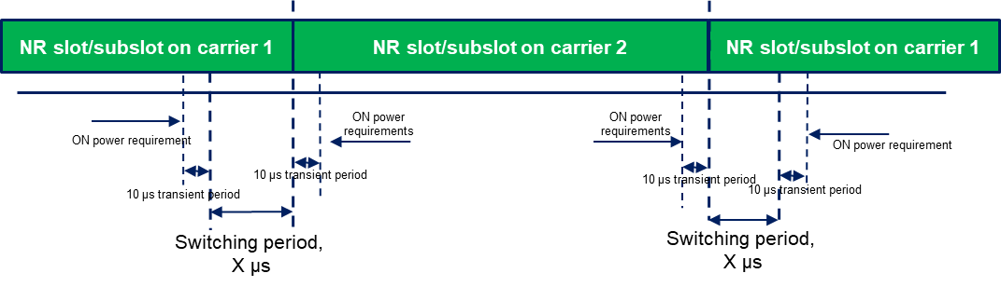
Figure 6.3A.3.4-1a: Time mask for switching between UL carrier 1 and UL Carrier 2, where the switching period is located in carrier 1
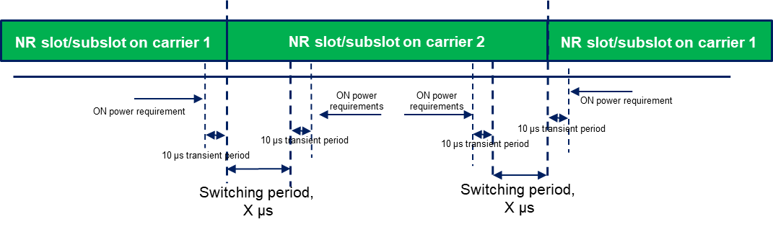
Figure 6.3A.3.4-1b: Time mask for switching between UL carrier 1 and UL Carrier 2, where the switching period is located in carrier 2
NOTE 1: The requirements apply for the case of co-located and synchronized network deployment for the two uplink carriers.
NOTE 2: The requirements apply for the case of single TAG for the two uplink carriers, i.e., the same uplink timing for the two carriers as described in sub-clause 4.2 of TS 38.213 [8].
NOTE 3: Power class delcaration for the uplink transmission switching follows the general definition of power class.
NOTE 4: For UE supporting uplink transmission switching, it is mandated to support 2-layer UL-MIMO transmission and single-layer transmission on carrier 2 following the BS scheduling and rank adaptation (if rank adaptation is applicable).
< End of second change >

< Start of third change >

6.3C Output power dynamics for SUL

6.3C.1 Void

6.3C.2 Void

6.3C.3 Transmit ON/OFF time mask for SUL

6.3C.3.1 Time mask for switching between two uplink carriers
The switching time mask specified clause 6.3C.3.1 is applicable when switching between an uplink band pair in a SUL configuration is supported, and is only applicable when uplink transmission is switched between NR SUL carrier 1 with 1 antenna port and NR UL carrier 2 with 2 antenna ports, where the two uplink carriers are in different bands with different carrier frequencies.
The switching periods described in Figure 6.3C.3.1-1a and Figure 6.3C.3.1-1b are located in either NR carrier 1 or carrier 2 as indicated in RRC signalling [7], and the length of switching period X depends on UE capability [TBD].
Figure 6.3C.3.1-1a: Time mask for switching between SUL carrier 1 and UL Carrier 2, where the switching period is located in carrier 1
Figure 6.3C.3.1-1b: Time mask for switching between SUL carrier 1 and UL Carrier 2, where the switching period is located in carrier 2
NOTE 1: The requirements apply for the case of co-located and synchronized network deployment for the two uplink carriers.
NOTE 2: The requirements apply for the case of single TAG for the two uplink carriers, i.e., the same uplink timing for the two carriers as described in sub-clause 4.2 of TS 38.213 [8].
NOTE 3: Power class delcaration for the uplink transmission switching follows the general definition of power class.
NOTE 4: For UE supporting uplink transmission switching, it is mandated to support 2-layer UL-MIMO transmission and single-layer transmission on carrier 2 following the BS scheduling and rank adaptation (if rank adaptation is applicable).
< End of third change >

