|  |  |
| --- | --- |
| 3GPP TR 38.755 V0.4.0 (2025-05) | |
| Technical Report | |
| 3rd Generation Partnership Project;  Technical Specification Group Radio Access Networks;  Study on NR FR1 DL fragmented carriers  (Release 19) | |
|  | |
|  | 3GPP-logo_web |
|  | |
| The present document has been developed within the 3rd Generation Partnership Project (3GPP TM) and may be further elaborated for the purposes of 3GPP. The present document has not been subject to any approval process by the 3GPPOrganizational Partners and shall not be implemented. This Specification is provided for future development work within 3GPPonly. The Organizational Partners accept no liability for any use of this Specification. Specifications and Reports for implementation of the 3GPP TM system should be obtained via the 3GPP Organizational Partners’ Publications Offices. | |

|  |
| --- |
|  |
| ***3GPP***  Postal address  3GPP support office address  650 Route des Lucioles – Sophia Antipolis  Valbonne – FRANCE  Tel.: +33 4 92 94 42 00 Fax: +33 4 93 65 47 16  Internet  <http://www.3gpp.org> |
| ***Copyright Notification***  No part may be reproduced except as authorized by written permission. The copyright and the foregoing restriction extend to reproduction in all media.  © 2025, 3GPP Organizational Partners (ARIB, ATIS, CCSA, ETSI, TSDSI, TTA, TTC).  All rights reserved.  UMTS™ is a Trade Mark of ETSI registered for the benefit of its members  3GPP™ is a Trade Mark of ETSI registered for the benefit of its Members and of the 3GPP Organizational Partners LTE™ is a Trade Mark of ETSI registered for the benefit of its Members and of the 3GPP Organizational Partners  GSM® and the GSM logo are registered and owned by the GSM Association |

Contents

Foreword 5

1 Scope 7

2 References 7

3 Definitions of terms, symbols and abbreviations 9

3.1 Terms 9

3.2 Symbols 9

3.3 Abbreviations 10

4 Background 10

4.1 Objective 10

5 Study of methods for reducing the number of UE Rx chains 11

5.1 Scenarios of fragmented carriers 11

5.2 RF architectures 12

5.3 Reference architecture and RF performance 17

5.4 General aspects of fragmented CA 20

5.4.1 SCell control for fragmented CA 20

6 Study on power spectral density difference between carriers of co-located adjacent channel operators 20

7 Study on RF requirements for the inter-operator co-located BS scenario 24

7.1 RF requirements evaluation from company A (MediaTek) 26

7.1.1 Analysis on Band n25 26

7.1.1.1 Case 1, 5 + 5 MHz 26

7.1.1.2 Case 2, 40 + 5 MHz 27

7.1.1a Analysis on Band n25 with PCC SCC Swapping 28

7.1.2 Analysis on Band n2 30

7.1.3 Analysis on Band n3 31

7.1.4 Analysis on Band n7 32

7.1.5 Analysis on Band n26 33

7.1.6 Analysis on Band n41 34

7.1.6.1 Case 1, 10 + 10 MHz 34

7.1.6.2 Case 2, 40 + 40 MHz 35

7.1.7 Summary results for example bands 36

7.1.8 Discussion on in-gap requirements 36

7.2 RF requirements evaluation from company B (Apple) 38

7.3 RF requirements evaluation from company C (Xiaomi) 42

7.4 RF requirements evaluation from company D (Samsung) 45

7.5 RF requirements evaluation from company E (Spreadtrum) 51

7.6 RF requirements evaluation from company F (ZTE) 57

7.7 RF requirements evaluation from company G (Huawei) 62

7.7.1 Band n3 62

7.7.2 Band n2 67

7.7.3 Band n7 69

7.7.4 Band n25 71

7.7.5 Band n26 74

7.8 Considerations on guardbands and suppression of outer interference from company H (Nokia) 76

7.8.1 Analogue Rx channel filter 76

7.8.2 Applicable guardband 76

7.8.3 Spectrum utilization 77

7.8.4 ACS and blocking requirements 78

7.8.5 REFSENS requirements 78

7.9 Summary of evaluation results 78

7.9.1 ΔRIBNC evaluation on example bands for one Rx RF chain mode 78

7.9.2 In-Gap Blocking for one Rx RF chain mode 80

7.9.3 Discussion on applicable scenarios when enabling one Rx RF chain mode 80

8 Study of means for a UE to inform the network of appropriate CA configuration it can support 81

8.1 Indication of one Rx RF chain mode for DL fragmented CA 81

8.1.1 Indication of fragmented CA alternative 1: Legacy band combination reporting scheme + Rx sharing capability indication 81

8.1.2 Indication of fragmented CA alternative 1a: Legacy band combination reporting scheme + Rx sharing capability indication and other related information including the frequency separation between two carriers 82

8.1.3 Indication of fragmented CA alternative 2: New notation for CA configurations with single Rx RF Chain 83

8.1.4 Indication of fragmented CA alternative 2a: use the new bandwidth class conditioned on the frequency separation between two carriers 83

8.1.4.1 Configuration of nXA + nXA with separate RX chains 84

8.1.4.2 Configuration of nXA”+nXA”+nYA with single RX chains 84

8.1.4.3 Configuration of nXA”+nXA”+nYA+nZA with single Rx chains and with modified MIMO capability 85

8.2 CA fallback and architecture switching 87

8.2.1 Case1: Partially shared switch to fully shared & fallback behaviour 89

8.2.2 Case2: Fully separate switch to fully shared & fallback behaviour 91

8.3 Triggering condition to enable ”One Rx RF chain” 92

8.3.1 Triggering condition proposal for option 1: Rely on existing channel quality reporting and procedures 92

8.3.2 Triggering condition proposal for option 2: UE measurement to determine and indicate to the network 94

9 Summary for NR FR1 DL fragment carriers study 99

Annex A (informative): Change history 101

# Foreword

This Technical Report has been produced by the 3rd Generation Partnership Project (3GPP).

The contents of the present document are subject to continuing work within the TSG and may change following formal TSG approval. Should the TSG modify the contents of the present document, it will be re-released by the TSG with an identifying change of release date and an increase in version number as follows:

Version x.y.z

where:

x the first digit:

1 presented to TSG for information;

2 presented to TSG for approval;

3 or greater indicates TSG approved document under change control.

y the second digit is incremented for all changes of substance, i.e. technical enhancements, corrections, updates, etc.

z the third digit is incremented when editorial only changes have been incorporated in the document.

In the present document, modal verbs have the following meanings:

**shall** indicates a mandatory requirement to do something

**shall not** indicates an interdiction (prohibition) to do something

The constructions “shall” and “shall not” are confined to the context of normative provisions, and do not appear in Technical Reports.

The constructions “must” and “must not” are not used as substitutes for “shall” and “shall not”. Their use is avoided insofar as possible, and they are not used in a normative context except in a direct citation from an external, referenced, non-3GPP document, or so as to maintain continuity of style when extending or modifying the provisions of such a referenced document.

**should** indicates a recommendation to do something

**should not** indicates a recommendation not to do something

**may** indicates permission to do something

**need not** indicates permission not to do something

The construction “may not” is ambiguous and is not used in normative elements. The unambiguous constructions “might not” or “shall not” are used instead, depending upon the meaning intended.

**can** indicates that something is possible

**cannot** indicates that something is impossible

The constructions “can” and “cannot” are not substitutes for “may” and “need not”.

**will** indicates that something is certain or expected to happen as a result of action taken by an agency the behaviour of which is outside the scope of the present document

**will not** indicates that something is certain or expected not to happen as a result of action taken by an agency the behaviour of which is outside the scope of the present document

**might** indicates a likelihood that something will happen as a result of action taken by some agency the behaviour of which is outside the scope of the present document

**might not** indicates a likelihood that something will not happen as a result of action taken by some agency the behaviour of which is outside the scope of the present document

In addition:

**is** (or any other verb in the indicative mood) indicates a statement of fact

**is not** (or any other negative verb in the indicative mood) indicates a statement of fact

The constructions “is” and “is not” do not indicate requirements.

# 1 Scope

The present document is a technical report for study of NR FR1 DL Fragmented Carriers.

# 2 References

The following documents contain provisions which, through reference in this text, constitute provisions of the present document.

- References are either specific (identified by date of publication, edition number, version number, etc.) or non‑specific.

- For a specific reference, subsequent revisions do not apply.

- For a non-specific reference, the latest version applies. In the case of a reference to a 3GPP document (including a GSM document), a non-specific reference implicitly refers to the latest version of that document *in the same Release as the present document*.

[1] 3GPP TR 21.905: “Vocabulary for 3GPP Specifications”.

[2] RP-241669, “New SID: Study on NR FR1 DL Fragmented Carriers”.

[3] 3GPP TS 38.101-1: “NR; User Equipment (UE) radio transmission and reception; Part 1: Range 1 Standalone”.

[4] 3GPP TS 38.101-2: “NR; User Equipment (UE) radio transmission and reception; Part 2: Range 2 Standalone”.

[5] 3GPP TS 38.101-3: “NR; User Equipment (UE) radio transmission and reception; Part 3: Range 1 and Range 2 Interworking operation with other radios”.

[6] R4-2413339 Discussion on methods for reducing the number of UE Rx chains for Fragmented Carriers, RAN4#112, Nokia

[7] R4-2415390 Discussion on methods for reducing the number of UE Rx RF chains for Fragmented Carriers, RAN4#112bis, Nokia

[8] RP-233374, Fragmented carriers in the DL, TELUS, Bell Mobility, T-Mobile USA, Telstra Limited, US Cellular Corporation, Nokia, Nokia Shanghai Bell

[9] R4-2411691 On general aspects of fragmented carriers, RAN4#112, Huawei

[10] RP-241269, On Fragmented Carriers in Rel-19, Apple

[11] RP-241361, Recommended WF on Fragmented Carriers, MediaTek

[12] R4-2417201 WF on NR FR1 DL fragmented carriers study, RAN4#112bis

[13] R4-2413031 On architecture options for fragmented spectrum reception, RAN4#112, Skyworks

[14] R4-2416138 Discussion on UE Rx chain architecture and network assumption, RAN4#112bis, MediaTek

[15] R4-2420519 WF on NR FR1 DL fragmented carriers study, RAN4#113

[16] R4-2415804 On methods for reducing the number of UE Rx chain, RAN4#112bis, Huawei

[17] R4-2503479 TP to TR 38.755 on Clause 5, RAN4#114bis, CATT

[18] R4-2503558 TP for TR38.755: Company C evaluation results, RAN4#114bis, Qualcomm

[19] R4-2504452 TP on UE RF requirements impact for fragmented carriers, RAN4#114bis, Apple

[20] R4-2504214 Further discussion of impacts on UE RF requirements and DL performance impacts, RAN4#114bis, MediaTek

[21] R4-2504129 General aspects of Fragmented CA, RAN4#114bis, Nokia

[22] R4-2505109 WF on NR FR1 DL fragmented carriers study, RAN4#114bis, MediaTek, Apple, Qualcomm

[23] R4-2503556 Procedures for fragmented carriers, RAN4#114bis, Qualcomm

[24] R4-2501397 Discussion of impacts on UE RF requirements and DL performance impacts, RAN4#114, MediaTek

[25] R4-2504214 Further discussion of impacts on UE RF requirements and DL performance impacts, RAN4#114bis, MediaTek

[26] R4-2504239 Discussion of impacts on UE RF requirements and DL performance, RAN4#114bis, Spreadtrum, UNISOC

[27] R4-2506270 TP on RF requirements evaluation for fragmented carriers from company S, RAN4#115, Samsung

[28] R4-2504451 On UE RF requirements for fragmented carriers, RAN4#114bis, Apple

[29] R4-2506378 TP to TR38.755 on UE RF requirements impact for fragmented carriers, RAN4#115, ZTE

[30] R4-2504284 On RF requirements of fragmented carriers, RAN4#114bis, Huanwe

[31] R4-2503338 Impacts on UE RF requirements and DL performance, RAN4#114bis, Xiaomi

[32] R4-2502873 WF on NR FR1 DL fragmented carriers study, RAN4#114, Moderator (Mediatek Inc.), OPPO, vivo, ZTE, Nokia, Ericsson, Xiaomi, Apple, Samsung, Huawei

[33] R4-2500676 Topic summary for [114][124] FS\_NR\_FR1\_DL\_Frag\_Carrier, RAN4#114, Moderator

[34] R4-2507939 TP for RRM aspect of FS\_NR\_DL\_Frag\_Carrier, RAN4#115, Nokia

[35] R4-2507951 TP for TR38.755: Summary for NR FR1 DL fragment carriers study, RAN4#115, MediaTek

[36] R4-2507952 TP for TR Summary on the evaluation results and further discussion on the one Rx RF chain mode applicability, RAN4#115, MediaTek

[37] R4-2508114 TP for TR indication of fragmented CA alternative 1, RAN4#115, vivo, apple, MediaTek

[38] R4-2505885 On methods for reducing the number of UE Rx chains for fragmented carriers, RAN4#115, Apple

[39] R4-2507953 TP to TR 38.755: on UE indication of supporting FR1 fragmented carriers, RAN4#115, CHTTL

[40] R4-2508113 TP for TR signaling indication for Option 2 new notations, RAN4#115, vivo, Apple, MediaTek

[41] R4-2507949 TP to TR 38.755 on UE indication to the network, RAN4#115, Ericsson, Xiaomi

[42] R4-2504039, "Discussion on UE capability indication for single Rx chain," Ericsson

[43] R4-2507950 TP to TR 38.755 on fallback behaviour, RAN4#115, Huawei, vivo, OPPO, Mediatek, Apple, ZTE

[44] R4-2503366 On fallback behavior and signaling aspect for fragmented carriers, RAN4#114bis, Samsung

[45] R4-2504213 Discussion on remaining signalling aspects for DL fragmented carriers study, RAN4#114bis, MediaTek

[46] R4-2504450 On methods for reducing the number of UE Rx chains for fragmented carriers, RAN4#114bis, Apple

[47] R4-2504260 Views on the usage of the FR1 fragmented carriers, RAN4#114bis, CHTTL

[48] R4-2411310 Views on UE RF architecture and NW deployment assumption for fragmented carriers, RAN4#112, Samsung, TELUS, Bell mobility.

[49] R4-2507938 TP for triggering condition option1 in FS\_NR\_DL\_Frag\_Carrier, RAN4#115, OPPO, Huawei, Apple, Nokia

[50] R4-2507947 TP for TR Discussion on signalling aspects, RAN4#115, MediaTek

[51] R4-2505784 Methods for reducing the number of UE Rx chains, RAN4#115, Xiaomi

[52] R4-2507476 TP for TR 38.755 on triggering condition, RAN4#115, Huawei

[53] R4-2505783 TP to TR 38.755 on RF requirements evaluation, RAN4#115, Xiaomi

[54] R4-2506376 TP to TR 38.755 on UE RF requirements evaluation for fragmented carriers, RAN4#115, Spreadtrum,UNISOC

[55] R4-2506378 TP to TR38.755 on UE RF requirements impact for fragmented carriers, RAN4#115, ZTE

[56] R4-2507477 TP for TR 38.755 on RF performance, RAN4#115, Huawei

[57] R4-2507948 TPs to TR 38.755 with aspects of Fragmented CA, RAN4#115, Nokia

[58] R4-2508114 TP for TR indication of fragmented CA alternative 1, RAN4#115, vivo, Apple, MediaTek

[59] R4-2507953 TP to TR 38.755: on UE indication of supporting FR1 fragmented carriers, RAN4#115, CHTTL

[60] R4-2507951 TP for TR38.755: Summary for NR FR1 DL fragment carriers study, RAN4#115, MediaTek

# 3 Definitions of terms, symbols and abbreviations

## 3.1 Terms

For the purposes of the present document, the terms given in 3GPP TR 21.905 [1] and the following apply. A term defined in the present document takes precedence over the definition of the same term, if any, in 3GPP TR 21.905 [1].

## 3.2 Symbols

For the purposes of the present document, the following symbols apply:

<symbol> <Explanation>

## 3.3 Abbreviations

For the purposes of the present document, the abbreviations given in 3GPP TR 21.905 [1] and the following apply. An abbreviation defined in the present document takes precedence over the definition of the same abbreviation, if any, in 3GPP TR 21.905 [1].

ACLR Adjacent Channel Leakage Ratio

ACS Adjacent Channel Selectivity

A-MPR Additional Maximum Power Reduction

BCS Bandwidth Combination Set

CA Carrier Aggregation

CC Component Carrier

DC Dual Connectivity

EIRP Equivalent Isotropically Radiated Power

EN-DC E-UTRA/NR DC

EVM Error Vector Magnitude

FDM Frequency Division Multiplexing

FR Frequency Range

ENBW The aggregated bandwidth of an E-UTRA sub-block and an adjacent NR sub-block

ITS Intelligent Transportation System

ITU-R Radiocommunication Sector of the International Telecommunication Union

MBW Measurement bandwidth defined for the protected band

MPR Allowed maximum power reduction

MSD Maximum Sensitivity Degradation

MCG Master Cell Group

NR New Radio

NS Network Signalling

NSA Non-Standalone, a mode of operation where operation of an other radio is assisted with an other radio

OOB Out-of-band

OOBE Out-of-band emission

OTA Over The Air

PRB Physical Resource Block

RE Resource Element

REFSENS Reference Sensitivity

RF Radio Frequency

Rx Receiver

SCG Secondary Cell Group

SCS Subcarrier spacing

SEM Spectrum Emission Mask

SUL Supplementary uplink

TDM Time Division Multiplex

Tx Transmitter

UE User Equipment

UL MIMO Up Link Multiple Antenna transmission

ULSUP Uplink sharing from UE perspective

# 4 Background

## 4.1 Objective

The objectives of the NR FR1 DL Fragmented Carriers SI are as follows:

- Identify methods for reducing the number of UE Rx chains (e.g. from separate Rx RF chains per CC to one Rx RF chain ) needed for single DL band with frequency span ≤ 100 MHz, containing two non-contiguous CCs within a CA combination for the inter-operator co-located scenario, considering:

- Which RF requirements could be adjusted for the inter-operator co-located BS scenario, e.g. existing UE RF requirements such as ΔRIBNC, ACS and in-band blocking [RAN4];

- Other requirements are not precluded, if identified

- The ability to semi-statically switch hardware resources (i.e. Rx RF chains) [RAN4, RAN2 – See note 2];

- Up to 6 dB DL received power spectral density imbalance between the two non-contiguous CCs [RAN4];

- Determine a reasonable level for the power spectral density difference between carriers of co-located adjacent channel operators for study [RAN4]

- Impacts on DL performance [RAN4] ;

- Means for a UE to inform the network of appropriate CA configuration it can support with adjusted RF requirements [RAN4, RAN2 – See note 2].

NOTE 1: No RAN1 impact is foreseen

NOTE 2: RAN2 work, if necessary, will be triggered by RAN4 LS

NOTE 3: This study starts from single DL band. One Rx RF chain is not considered among inter-band DL carriers.

Whether and how to apply the conclusions to intra-band component of inter-band CA will be decided after the study on 2CC in a single DL band is completed.

# 5 Study of methods for reducing the number of UE Rx chains

## 5.1 Scenarios of fragmented carriers

An example to present the case of fragmented carriers is shown in the figure below from [6][7].

Figure 5.1-1: Example of fragmented carriers [8]

Fragmented carriers are not something completely new for RAN4, since it is essentially non-contiguous intra-band carrier aggregation (NC IB CA). However, proponents of the new SI have chosen the name as “Fragmented Carriers”, since this is how it is perceived mainly from an operator perspective. Adding a specific name also indicates a special way of handling non-contiguous intra-band carrier aggregation where UEs may support downlink reception of the fragmented spectrum block with a single “receive chain”, “receive path” or “receive branch”.

The conventional DL fragmented carriers reception containing more than one non-contiguous CC in the same band consuming multiple Rx RF chains may limit the UE CA capabilities as the maximum supported number of component carriers (CCs) in a CA combination is limited by the number and capabilities of the Rx RF chains as well as the baseband processor capabilities in the UEs.

From [9], a reference RF architecture of non-contiguous CA was initially introduced in LTE Rel-11, and captured in TR 36.823 as below.



Figure 5.1-2: Reference RF architecture of non-contiguous CA (Figure 6.2.3.1-1 of TR 36.823)

According to this reference RF architecture, the LNA is shared by two non-contiguous carriers, while the mixer, LPF and A/D are independent for each carrier. This reference RF architecture continues to be used in deriving the NR requirements for non-contiguous CA, i.e., the current RF receiving requirements in TS 38.101-1 for non-contiguous CA are based on this partially shared architecture.

## 5.2 RF architectures

The primary motivation of current study item is to reduce the number of UE Rx chains that are used to receive the fragmented carriers. To serve this motivation, different RF architectures were mentioned during early discussions, e.g. from separate RF chains per CC to shared RF chains.

Apple has in [10] provided what in their view is meant by a single Rx chain: “A single Rx chain consists of one main Rx and one diversity Rx for a UE with 2Rx”.

In [11] MediaTek shows a block diagram on the definition of a single Rx chain by applying Apple's definition in [13] of a Rx chain to the main and diversity branch in MediaTek’s block diagram, as shown in Figure 5.2-1 and labelled as “Type 1” receiver.

It can be observed Type 1 UE receiver does not have the ability to suppress/attenuate in-gap interference via analogue filtering.

**Type 1 – Single RX chain**

|  |  |
| --- | --- |
| Single RX chain (consists of one main Rx and one diversity Rx) | |
|  |  |
| Main receiver with RF carrier cantered between CCs | Diversity receiver with RF carrier centred between CCs |

Figure 5.2-1: Single RX chain as presented in [11], where DAC must mean ADCs, since this is at the receiver.

This is also illustrated in Figure 5.2-2 with the main and diversity receiver branch.

Figure 5.2-2: Single Rx Chain for a 2Rx UE consisting of a main and diversity receiver branch (FDD).

It would be beneficial for further discussion to agree on what the underlying assumptions are, as a basis for a common understanding, to align terminologies which can help companies to ensure they discuss the same thing.

Similar to the previous discussion for 2Rx UEs, it becomes even more inconsistent what is meant by a Rx chain for 4Rx UEs when reviewing literature and previous contributions in RAN4. However, it seems the most predominant interpretation is to have 1 main receiver branch and 3 diversity receiver branches. Meaning, when using Figure 5.2-2 as a reference, there will be an addition of two diversity receiver branches.

For the current UE implementation, the descriptions in [10] and [11] assume a separate UE RF chain per fragmented carrier which results in the limitations of the maximum number of supported CCs. For the current UE implementation, a separate UE RF chain per fragmented carrier is assumed.

This study item challenges the need for applying a separate UE Rx chain per fragment. In other words, the ambition is to reduce the number of needed Rx chains for fragmented carrier operation.

As previously mentioned, the concept of fragmented carries is in some way similar to non-contiguous intra-band carrier aggregation (NC IB CA). The reception at the UE of non-contiguous intra-band carrier aggregation in a system with a single Rx chain will be impacted by interference especially in the “gap” between the fragments of the carrier. The impact on UE requirements is further discussed in R4-2413340 while the following focuses on the UE receiver architectures.

The in-gap interference will, in a single analogue Rx chain system, pass un-attenuated as the UE does not have the ability to suppress/attenuate the in-gap interference via analogue filtering. Suggested solutions are shown in [9] where the UE, by utilizing additional Rx chains, can attend to this presence of an in-gap interferer. In [9] the single Rx chain system, as also shown in Figure 5.2-1, is denoted Type 1 while two other multi-chain systems are denoted Type 2 and Type 3.

There are two ways that the signal can be treated by separate Rx chains. It may be split at the front-end components (eLNA), which is seen as Type 3, and it may also be split inside the transceiver, which is seen as Type 2.

**Type 2 – Internal RX path split:**

For Type 2 a full picture without the iLNA (internal LNA) split is discussed here. The UE has two Rx chains active, and this allows the UE to set the LO1 and LO2 at the respective centers of each CC, so that the subsequent filtering (channel filters) may attenuate also the in-gap interferer as shown here. In one example it considers non-collocation, where the in-gap interferer is seen as a “worst case” condition. In the collocated case, the wanted to interference ratio will be less.



Figure 5.2-3: Type 2 – Internal Rx path split. A single Rx chain after frontend filtering is marked with a dashed square.

If this UE is to transition to a single Rx chain state (Type 1), it will have to accept an in-gap interferer as shown in the next view of Type 2, that visualizes the “Extra Receiver chain” as toned-out colours:



Figure 5.2-4: Type 2 – Internal Rx path split. Unused Rx chain is toned-out. Type 2 becomes Type 1.

In this state, the UE is without analogue filtering to suppress the interferer, and RAN4 will have to discuss the relaxation of the receiver requirements for the UE to tolerate some level of in-gap interference presence. Since the requirement is based on the presence of an interfering signal, it is closer related to the ACS requirement than to the Reference sensitivity requirement for non-contiguous intra-band carrier aggregation, and a new set of requirements must capture the conditions and the relaxation for the UE state that uses a single Rx chain for the reception of the two fragmented carriers in the presence of an in-gap interferer.

This means that when a Type 2 implementation is using a subset of its Rx chains operating in fragmented carrier mode the new set of requirements will apply.

**Type 3 – External Rx path split:**

The second way that the signal can be treated by separate Rx chains is a split at the front-end components by multiple external LNAs (eLNA). This can either be within the main/diversity module, or at an extension from the main/diversity module that allows connection to another receive pin at the transceiver. For Type 3 the study would like to show a full picture and without discussion of detail whether front-end modules splits internally at the eLNA or if there’s a separate front-end module that accompanies the main/diversity modules to extend the connection possibilities towards the transceiver(s). Some solutions also have 2 transceivers that allow split of reception in NC IB CA between the two transceivers. The full system view is that the UE has two Rx chains active, and this allows the UE to set the LO1 and LO2 at the respective centers of each CC, so that the following filtering (channel filters) may attenuate also the in-gap interferer as shown here.



Figure 5.2-5: Type 3 – External Rx path split. A single Rx chain after frontend filtering is marked with a dashed square.

Details on the differences between the Type 2 and Type 3 UE architectures may be found in [10], where there is a split at the eLNA (external transceiver LNA) towards two iLNA (internal transceiver LNA) (Type2) and a split only at the DACs (Edit: it should mean ADCs, since this is at the receiver) for CC0 and CC1 (Type 3). However, it is not explaining how the UE actually may receive the two carriers individually.

To extend the understanding of the different choices for transceiver implementation, it would have been chosen to follow the principal presented by other companies and also split into three different types with emphasis on Type 2 and Type 3 in the following. This as Type 1 is the hardware state it is wanted to free up hardware resources i.e. Rx chains as described in the introduction.

It can be noted that there is also the possibility to suppress some of the in-gap interference in the digital domain. However, this does not solve the dynamic range issues given by the near-far problem. It can mitigate some of the adjacent channel interference but only when within proper dynamic range provided from the analog and mixed signal Rx chain. Hence, the focus of this work is on solutions related to the analog Rx path. Even though there may be a possibility to suppress some of the in-gap interference in the digital domain, the objective of the SI is to free up Rx resources hence the focus is on the analog Rx chains.

If this UE is to transition to a single Rx chain state (Type 1) it will have to tolerate an in-gap interferer as shown in the next view of Type 3, that visualizes the “Extra Receiver chain” as toned-out colours:

Figure 5.2-6: Type 3 – External Rx path split. Unused Rx chain is toned-out. Type 3 becomes Type 1.

In this state, the UE is in the same conditions as in Type 2, bringing both Type 3 and Type 2 into the state of Type 1 single Rx chain reception, so the relaxation of the requirements is the same for Type 2 and Type 3, and the same set of requirements can apply regardless of how the UE supports non-contiguous intra-band carrier aggregation.

As presented previously it has been shown that with both a Type 2 and a Type 3 transceiver implementation it is possible to separate the Rx chains (i.e. operate as Type 1). When separating or freeing up Rx chains in the Type 2 and Type implementations it is possible to apply these now idle Rx chains for reception of other carries if new RAN4 requirements for this type of operation is introduced to the specification.

## 5.3 Reference architecture and RF performance

In the RAN4#112bis meeting, it was agreed the reference architecture is based on fully shared RF chain [12].

The terminology of “One Rx RF Chain” is from single antenna to the end of ADC (before digital BB filter) with a single down-converter

- To reduce the number of Rx RF chains, a fully shared RF chain (one Rx RF chain) is the reference architecture for fragmented carriers

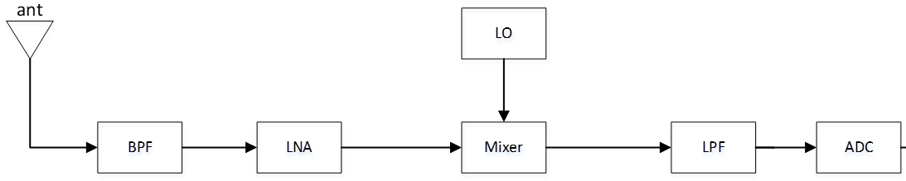

Figure 5.3-1: Reference architecture of one Rx RF chain

- A partially shared RF chain architecture is the reference architecture for existing DL NCCA requirements (refer to TR 36.823)

There are also some discussion on baseband assumptions i.e., shared/separated BB filter that may relate to rejection ability toward unwanted signal for the study as well as “single FFT” or “separate FFT” assumption evaluation.

Referring to [13], there may be different digital BB chain approaches:

o Separate digital BB chains per CC after digital down conversion which would enable a dedicated digital BB filter and thus good ACS.

o Common digital BB chain assuming that CCs are SCS aligned such that a shared FFT/digital filter are used. In this case it may be difficult to maintain good ACS and blocking performance, especially in the gap.

• Note that if a single FFT is used to receive two non-contiguous CCs/cluster that are SCS aligned, if the CCs are 15kHz SCS the maximum BW is 50MHz and if 30kHz it is 100MHz.

Figure 5.3-2 illustrates some of the above aspects and terminology. The CCs in the illustration are the co-located operator non-contiguous CCs/clusters to be received.

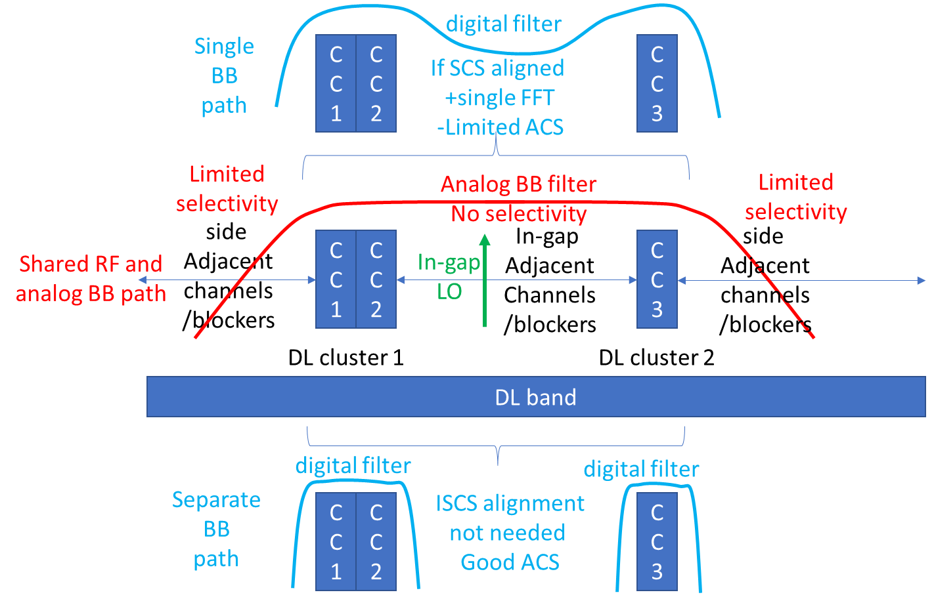

Figure 5.3-2 illustration of shared Analog path and shared/separate digital BB paths

For the baseband signal processing, referring to[14], separate FFT is legacy implement to handle DL NCCA carriers since it provides better rejection on interference and unwanted signal. Single FFT that can receive both NCCA carriers including in-gap interference (with poor rejection) at a time. There are some constraint for single FFT. The channel raster of PCC and SCC shall align to orthogonal grid that can avoid unnecessary ICI after FFT. This would need to be guaranteed by network scheduling. And due to the max FFT size is 4096, for the fragment carriers that span larger than 50MHz, only 30KHz or 60KHz SCS would be applicable for the case.

With above assumptions, the evaluated RF performance when there exists in-gap interference applying single FFT together is shown below. The fc of interference was assumed in the middle of two FFT grid as worst-case simulation.

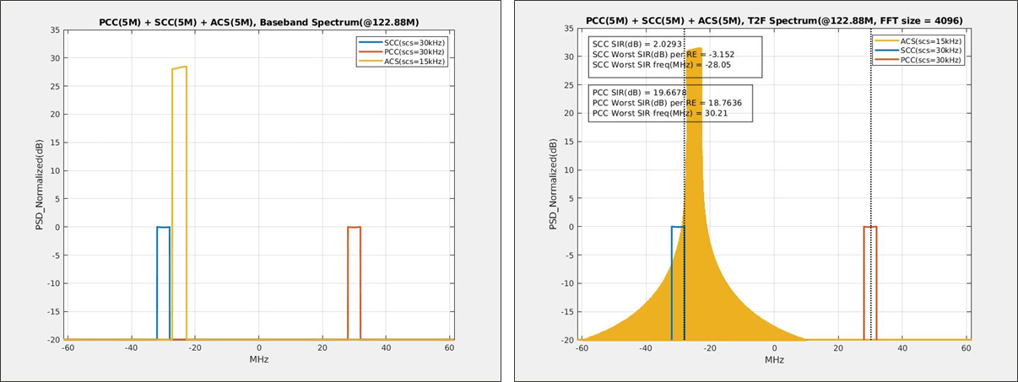

Figure 5.3-3: SCC: 5M, PCC: 5M + ACS single FFT simulated spectrum plot

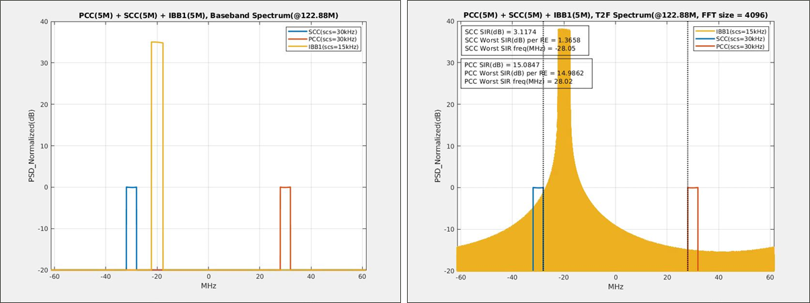

Figure 5.3-4: SCC: 5M, PCC: 5M + IBB1 single FFT simulated spectrum plot

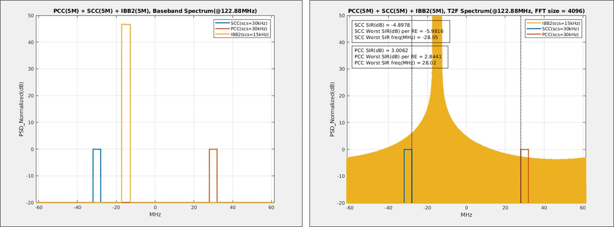

Figure 5.3-5: SCC: 5M, PCC: 5M + IBB2 single FFT simulated spectrum plot

It can be seen from simulated results, the spectrum of interference was spread out due to allocated on non-orthogonal FFT grid. UE would be able to pass ACS1/2 and IBB1 requirements without relaxation but would fail on IBB2. And due to wide frequency span for a single FFT, the baseband power consumption could be higher. It is expected single FFT may have worse rejection ratio to interference signal and this is not common baseband implementation for DL NCCA carriers.

If UE apply separate FFT baseband, it is foreseen the digital filter can provide better rejection on the in-gap interference signal so that performance of wanted CCs would not be degraded except when the interference falls in the Rx image range of wanted signal. Separate FFT for DL NCCA carriers has been widely used for modern modem design.

It has been agreed in [15] single FFT or separate FFT can be left to UE implementation, and however the condition of single FFT compared to separate FFT can be captured in the technical report.

## 5.4 General aspects of fragmented CA

### 5.4.1 SCell control for fragmented CA

If a change in HW configuration between UE using 1 Rx chain or 2 Rx chains for reception in a fragmented carrier aggregation deployment does impact the UE performance, system performance or the network, there is a need to ensure that whatever ‘mode’ the UE is operating in, this is aligned between the UE and the network. Hence, it needs to be well aligned between UE and network whether the UE is applying 1Rx chain or 2 Rx chain.

In many scenarios, where the UE can change between using 1Rx or 2Rx chains without performance impact, such UE autonomous switching could be possible without specification impact. However, if the UE change between using 1Rx or 2Rx in a Fragmented CA setup, does have system impact, it needs to be clear how and when such HW reconfiguration is allowed and can be performed.

If RAN4 explores solutions which operates differently than the current network controlled SCell operations, RAN4 may involve other working groups if needed.

A fragmented carrier configuration can consist of PCell + SCell and SCell + SCell.

# 6 Study on power spectral density difference between carriers of co-located adjacent channel operators

It is also intended to study on power spectral density difference between carriers of collocated adjacent channel inter-operators impact on the UE in the objective of current SI. The PSD difference between operators is for further study. Here evaluation results contributed by different companies are captured as below.

**Evaluation from company A:**

Referring to [16], according the discussion in RAN4#112, it’s very difficult to ensure different operators are always co-located. Even in some cases the operators share the same site, it’s very common that the infrastructures are not shared. As a result, the coverage of different operators is not fully aligned. Below Figure 6-1 shows a possible multi-operator deployment case.

Figure 6-1: Multi-operator deployment case

In this example, the UE is at the edge of its serving cell, while almost in the center of the neighbouring operator cell. Taking the BS antenna pattern from TR 38.769 (fixed beam direction) as the assumption for both cells, the UE’s maximum receiving RSRP difference is equal to the antenna gain difference between horizontal angle = 0 degree and +/-60 degree. The Figure 6-2 shows the RSRP difference could achieve 10dB in this case.

Figure 6-2: Delta RSRP Multi-operator deployment case

If the deployment includes both macro cell and micro cell, the possible RSRP difference will increase. Also the fast fading will bring more fluctuation to the RSRP difference. For the purpose of study, it can be considered a higher level RSRP difference, e.g. 20dB.

**Evaluation from company B:**

Referring to [14], some system level simulation results which follows coexistence frame work considering large-scale parameters were also provided. The environment and configuration assumptions are as following bullets:

Co-site case

Same BW/Power/ANT # of 2 operators at n25 (1.9GHz)

10 MHz(wanted)+10 MHz(unwanted) BW

Care interference from the same site.

Log RSRP difference between 2 operators à CDF

The detailed parameters are listed in the table below:

Table 6-1: Simulation parameters of PSD difference from UE reception point of view

|  |  |
| --- | --- |
| Parameter | setting |
| Scenario | Dense Urban |
| Channel model | UMa |
| ISD | 200m |
| Number of operators | 2 |
| Number of sites | 7/operator, each with 3 sectors |
| Number of UEs | 10/sectors |
| Carrier frequency | 1.9GHz |
| Channel BW | 10MHz |
| Antenna pattern | AAS is assumed (same as that in coexistence study) |
| BS antenna configuration | 32 ANT# : (M,N,P) = (4,4,2) 128 ANT# : (M,N,P) = (8,8,2) |
| Note: The simulation follows coexistence framework, which considers large-scale parameters only. | |

Figure 6-3: Antenna patterns for the simulation

Figure 6-4: Simulated PSD difference at UE receiving antenna

From simulation result, it can be seen there’s no “interference level larger than wanted CC case” if the BW of both wanted CCs and unwanted CC(=Wgap) are same. The maximum ratio of unwanted CC level to wanted CC level is 0dB in this case. Other different BW/Wgap configurations can be scalable estimated that existing requirements at in-gap ACS1/ACS2/IBB1/IBB2/NBB can fulfil the need for coexistence. On the other hand, collocation inter-operator assumption might be too much simplified and different with real deployment. Some company propose to keep same ACS/IBB requirements and the proposal can be further considered for non-collocated BS cases. And even applying the new UE capability that RF parts can support higher order CA configurations with more CCs, the baseband processing capability may need to extend to handle higher order CA combos including more DL carriers as well as more MIMO-layer processing capability.

**Evaluation from company C:**

This evaluation is based on system level simulation procedure long established in 3GPP, according to the assumptions listed in this section. The result metric provided is the CDF of the difference in RSRP between the serving operator BS and the strongest interfering BS from the other operator. We have varied some large scale deployment parameters (Antenna Panel, Network Shift).

NW shift of 50% and 100% are computed respectively using ISD\*sqrt(3)/3/2 and ISD\*sqrt(3)/3.

Table 6-2: System Level Simulation Parameters for Company C evaluation

|  |  |  |
| --- | --- | --- |
| Parameter | Value | Unity of Measure |
| Number of Operators | 2 | - |
| Deployment Scenario | Dense Urban | - |
| Channel Model | UMa (38.901) | - |
| Building Entry Loss Model | P.2109 | - |
| Frequency | 1.9 | GHz |
| Channel Bandwidth | 10 | MHz |
| ISD | 750 | meters |
| Antenna Model | Sector Antenna,  32Tx AAS (4,4,2)  128Tx AAS (8,8,2) | - |
| Active UEs per sector | 1 | - |
| Number of sites/sectors | 19 sites with 3 sectors each | - |
| Network shift across different operators | Co-site  50%  100% | - |
| Sector orientation across different operators | Same | - |

Figure 6-5: Difference between Own BS RSRP and Strongest Interfering BS RSRP [ISD = 750m]

The Figure 6-5 is in agreement with the Figure 6-4 but more broader view is taken[18].

# 7 Study on RF requirements for the inter-operator co-located BS scenario

It has been agreed baseline UE architecture is one Rx RF chain from single antenna to the end of ADC with a single down-converter. The evaluation assumptions were also agreed as summarized and re-organized bellow[4][5]:

Example bands and CBW/BCS assumptions:

n2/n25, n3, n7, n66, n41, n26

Prioritize the frequency bands of ≤2700MHz

The example band(s) should already have NC DLCA specified

Don’t consider 3MHz channel bandwidth for fragmented carriers

Both the symmetric CC scenario and the asymmetric CC scenario should be considered in the DL fragmented carrier SI, and companies are encouraged, but not limited, to study the CC scenarios shared by the operators

Assumptions for collocated adjacent channel inter-operator:

To evaluate acceptable [PSD] difference from UE side between wanted signal and un-wanted signal based on the deployment where BSs from different operators are collocated but their radio units (RUs) are not shared.

The [PSD] difference means the difference between unwanted signal and the wanted carrier with the lower PSD

Start evaluation with wanted signal level currently existing ACS requirements as baseline and to see the performance difference

Assumptions for Tx:

Re-use same assumptions for NR PC3 PA i.e., ACLR=30dB, with MPR=1dB, Full RB allocation. Tx LO leakage and image rejection ratio are 28dB

One UL carrier is prioritized

UL power class PC3 is prioritized. Both PC3 and PC2 should be considered

No relaxation on any Tx RF requirements should be assumed in this study item

Assumptions for Rx:

One Rx RF chain (fully shared Rx) is assumed

Reuse the Rx chain image rejection, which is 25dB, as the starting point

Baseband assumptions:

Consider only same SCS for both CCs for one Rx RF chain architecture in this SI

15KHz SCS is used as the starting point

Single FFT or separate FFT can be left to UE implementation, and however the condition of single FFT compared to separate FFT can be captured in the TR

Assumptions for test conditions:

The configuration defined in Table 7.3A.2.2-1 and Table 7.3A.2.2-2 of TS 38.101-1 could be re-used

Evaluation may consider impairment factors such as ACLR, phase noise or IMDx of aggressor ability, duplexer isolation…etc

The minimum Wgap for ACS, narrow band blocking and in-band blocking verification should meet

Wgap ≥ 2∙|FInterferer (offset),j| – BWChannel(j)

It is the condition to apply the requirements

~~[~~Adjusted requirements for fragmented carriers, if any, shall be separated from the existing requirements~~]~~

The requirements shall be discussed and decided case by case manner per operators’ request on target band and associated configuration

RAN4 also agreed a common table format to demonstrate evaluation parameters and results. Companies can provide evaluation results for example bands in bellow:

## 7.1 RF requirements evaluation from company A (MediaTek)

### 7.1.1 Analysis on Band n25

If the Rx chain is shared by the two non-contiguous CCs, (fully-shared Rx chain), the channel selection filter would need to be adjusted to wider bandwidth to accommodate the two DL carriers including Wgap between the two CCs. The Tx rejection of shared Rx chain would be much worse. Not only SCC would still impacted by self-band UL Tx, PCC may also be impacted due to worse filter rejection ratio toward UL Tx transmission. It is foreseen the DL AGC would need to be adjusted to tolerate larger Tx leakage portion thus the gain setting would become lower that brings noise level raised up for both PCC and SCC. Another potential degradation may happen on in-gap ACS/IBB/NBB performance, these requirements would also need to be evaluated.

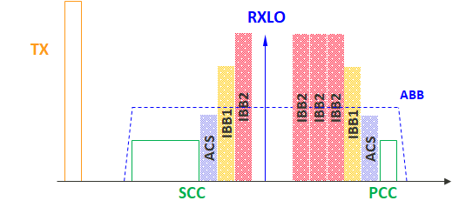

Figure 7.1.1-1: Rx requirements to be evaluated

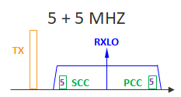 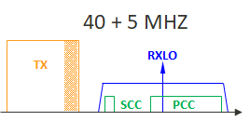

Figure 7.1.1-2: Illustration on the two BCS for DL NCCA test

The existing requirements of n25(2A) is copied below:

|  |  |  |  |  |  |  |
| --- | --- | --- | --- | --- | --- | --- |
| CA configuration | SCS  (PCC/SCC)  (kHz) | Aggregated channel bandwidth (PCC+SCC) | Wgap / [MHz] | UL PCC allocation  (LCRB) | SCC  ΔRIBNC (dB) | Duplex mode |
| CA\_n25(2A) 9 | 15/15 | 5MHz + 5MHz | Wgap = 55.0 | 105 | 5.0 | FDD |
|  |  |  | Wgap = 30.0 | 25 | 0.0 |  |
| CA\_n25(2A) 10 | 15/15 | 40MHz + 5MHz | Wgap = 20.0 | 40 (RBstart = 176) | [24.6] 8 | FDD |

#### 7.1.1.1 Case 1, 5 + 5 MHz

Based on the agreed assumptions and reference table format, we put our evaluation parameters in the table 1 with proper change. We think assuming 0dBFS for the ADC input target level may not be a proper setting. In most cases, there would be PAPR, radio signal fluctuation and fading effect for the input signal. So we would suggest not to consider this case. The table is modified as below:

Table 7.1.1.1-1: Link budget of Self-interference for 5+5 MHz on band n25

|  |  |  |  |  |  |
| --- | --- | --- | --- | --- | --- |
|  | **Tx leakage** | **Wanted Carrier** | **Wanted Carrier** | **Noise floor** | **ADC noise (11 bit): -68.0dBFs** |
| **(PCC)** | **(SCC)** | **(6.02N+1.76)** |
|  |  | **Tx leakage mapping to** |
|  |  | **-12dBFS (PAPR is considered)** |
| **PA out** | 27 | / | / | / | / |
| **Duplexer isolation** | 50 | / | / | / | / |
| **Rx Antenna input** | / | -96.5 | -91.5 | / | / |
| **FE loss** | / | 5 | 5 | / | / |
| **Duplexer output** | **-23** | **-101.5** | **-96.5** | / | **/** |
| **LPF attenuation** | 6.1 | 1 | 1 | / | / |
| **LPF output (dBm)** | **-29.1** | **-102.5** | **-97.5** | / | **/** |
| Noise floor for basic REFSENS | **/** | **/** | **/** | -101.5 | **/** |
| NF increase due to AGC adjustment | **/** | **/** | **/** | 13.1 | **/** |
| **Noise floor** | **/** | **/** | **/** | **-88.4** | **/** |
| **In-band noise caused by Tx leakage (Derived based on MSD and -1dB SNR)** | **/** | **/** | **-96.5** | **/** | **/** |
| **ADC output (dBm)** | **/** | **/** | **/** | **/** | **-96.2** |
| **SNR after ADC (dB)** | **/** | / | **/** | / | -13.8(PCC) |
|  |  |  |  |  | -14.3(SCC) |

#### 7.1.1.2 Case 2, 40 + 5 MHz

The REFSENS of 40MHz is not linear scaling from 5MHz in existing specs. So we had calculated excessive Tx leakage level fall in the DL receiving channel in. The evaluation parameters and results are demonstrated in below table.

Table 7.1.1.2-1: Link budget of Self-interference for 40+5 MHz on band n25

|  |  |  |  |  |  |  |
| --- | --- | --- | --- | --- | --- | --- |
|  | **Tx leakage** | **Wanted Carrier** | **Wanted Carrier** | **Noise floor(PCC)** | **Noise floor(SCC)** | **ADC noise (11 bit): -68.0dBFs** |
| **(PCC)** | **(SCC)** | **(6.02N+1.76)** |
|  |  | **Tx leakage mapping to** |
|  |  | **-12dBFS (PAPR is considered)** |
| **PA out** | 27 | / | / | / | / | / |
| **Duplexer isolation** | 50 | / | / | / | / | / |
| **Rx Antenna input** | / | -79.5 | -71.9 | / | / | / |
| **FE loss** | / | 5 | 5 | / | / | / |
| **Duplexer output** | **-23** | **-84.5** | **-76.9** | / | **/** | **/** |
| **LPF attenuation** | 6.1 | 1 | 1 | / | / | / |
| **LPF output (dBm)** | **-29.1** | **-85.5** | **-77.9** | / | **/** | **/** |
| Noise floor for basic REFSENS | **/** | **/** | **/** | -92.5 | -101.5 | **/** |
| NF increase due to AGC adjustment | **/** | **/** | **/** | 13.1 | 13.1 | **/** |
| **Noise floor** | **/** | **/** | **/** | **-79.4** | **-88.4** | **/** |
| **In-band noise caused by Tx leakage (Derived based on MSD and -1dB SNR)** | **/** | **/** | **-76.9** | **/** | **/** | **/** |
| **ADC output (dBm)** | **/** | **/** | **/** | **/** | **/** | **-87.2** |
| **SNR after ADC (dB)** | **/** | / | **/** | / | **/** | -6.5(PCC) |
|  |  |  |  |  | **/** | -24.9(SCC) |

### 7.1.1a Analysis on Band n25 with PCC SCC Swapping

In the last RAN4 meeting, concerns on PCC performance degradation were raised and an alternative approach was also provided. In the network scheduling control, PCC SCC can be swapped to make Tx-Rx frequency gap larger to reduce performance degradation. The spectrum plot is illustrated below Figure 7.1.1a-1. With the swapping, it is expected the Rx performance degradation can be much reduced.

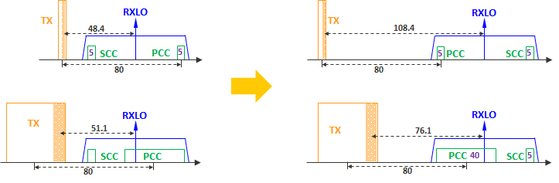

Figure 7.1.1a-1. Illustration on PCC/SCC swapping for the two cases for DL NCCA test

The evaluation results are as following.

**Case 1, 5 + 5 MHz**

Based on the agreed assumptions and reference table format,

Evaluation results on PCC/SCC swapping are in the updated table below:

Table 7.1.1a-1: Link budget of Self-interference for 5+5 MHz on band n25

|  |  |  |  |  |  |
| --- | --- | --- | --- | --- | --- |
|  | **Tx leakage** | **Wanted Carrier** | **Wanted Carrier** | **Noise floor** | **ADC noise (11 bit): -68.0dBFs** |
| **(PCC)** | **(SCC)** | **(6.02N+1.76)** |
|  |  | **Tx leakage mapping to** |
|  |  | **-12dBFS (PAPR is considered)** |
| **PA out** | 27 | / | / | / | / |
| **Duplexer isolation** | 50 | / | / | / | / |
| **Rx Antenna input** | / | -96.5 | -96.5 | / | / |
| **FE loss** | / | 5 | 5 | / | / |
| **Duplexer output** | **-23** | **-101.5** | **-101.5** | / | **/** |
| **LPF attenuation** | 22.2 | 1 | 1 | / | / |
| **LPF output (dBm)** | **-45.2** | **-102.5** | **-102.5** | / | **/** |
| Noise floor for basic REFSENS | **/** | **/** | **/** | -101.5 | **/** |
| NF increase due to AGC adjustment | **/** | **/** | **/** | 4 | **/** |
| **Noise floor** | **/** | **/** | **/** | **-97.5** | **/** |
| **In-band noise caused by Tx leakage (Derived based on MSD and -1dB SNR)** | **/** | **/** | **-101.5** | **/** | **/** |
| **ADC output (dBm)** | **/** | **/** | **/** | **/** | **-112.3** |
| **SNR after ADC (dB)** | **/** | / | **/** | / | -4.0(PCC) |
|  |  |  |  |  | -3.4(SCC) |

**Case 2, 40 + 5 MHz**

The REFSENS of 40MHz is not linear scaling from 5MHz in existing specs. Excessive Tx leakage level fall in the DL receiving channel is calculated in the table. The evaluation parameters and results are demonstrated in below table.

Table 7.1.1a-2: Link budget of Self-interference for 40+5 MHz on band n25

|  |  |  |  |  |  |  |
| --- | --- | --- | --- | --- | --- | --- |
|  | **Tx leakage** | **Wanted Carrier** | **Wanted Carrier** | **Noise floor(PCC)** | **Noise floor(SCC)** | **ADC noise (11 bit): -68.0dBFs** |
| **(PCC)** | **(SCC)** | **(6.02N+1.76)** |
|  |  | **Tx leakage mapping to** |
|  |  | **-12dBFS (PAPR is considered)** |
| **PA out** | 27 | / | / | / | / | / |
| **Duplexer isolation** | 50 | / | / | / | / | / |
| **Rx Antenna input** | / | -79.5 | -89.3 | / | / | / |
| **FE loss** | / | 5 | 5 | / | / | / |
| **Duplexer output** | **-23** | **-84.5** | **-94.3** | / | **/** | **/** |
| **LPF attenuation** | 11.1 | 1 | 1 | / | / | / |
| **LPF output (dBm)** | **-34.1** | **-85.5** | **-95.3** | / | **/** | **/** |
| Noise floor for basic REFSENS | **/** | **/** | **/** | -92.5 | -101.5 | **/** |
| NF increase due to AGC adjustment | **/** | **/** | **/** | 7.2 | 7.2 | **/** |
| **Noise floor** | **/** | **/** | **/** | **-85.3** | **-94.3** | **/** |
| **In-band noise caused by Tx leakage (Derived based on MSD and -1dB SNR)** | **/** | **/** | **-94.3** | **/** | **/** | **/** |
| **ADC output (dBm)** | **/** | **/** | **/** | **/** | **/** | **-92.2** |
| **SNR after ADC (dB)** | **/** | / | **/** | / | **/** | -2.2(PCC) |
|  |  |  |  |  | **/** | -8(SCC) |

**Summary results for band n25 with PCC/SCC swapping**

Evaluated results are summarized in the table below:

Table 7.1.1a-3: Proposed ΔRIBNC for example band n25 on Rx RF chain mode with P/S cell swapping

|  |  |  |  |  |  |  |  |
| --- | --- | --- | --- | --- | --- | --- | --- |
| CA configuration | SCS  (PCC/SCC)  (kHz) | Aggregated channel bandwidth (PCC+SCC) | Wgap / [MHz] | UL PCC allocation  (LCRB) | PCC  ΔRIBNC (dB) | SCC  ΔRIBNC (dB) | Duplex mode |
| CA\_n25(2A) | 15/15 | 5MHz + 5MHz | Wgap = 55.0 | 10 | 13.8 **🡺 4.0** | 14.3 **🡺3.4** | FDD |
| Wgap = [10 🡺 **20**] | 25 | 0 | 0 |  |
| CA\_n25(2A) | 15/15 | 40MHz + 5MHz | Wgap = 20.0 | 40 (RBstart = 176) | 6.5 **🡺2.2** | 24.9 **🡺8** | FDD |

**Observation1:** It can be observed if P/S cell are swapped, the REFSENS degradation can be lower to ~4dB for 5+5MHz case. For 40+5MHz case, the degradation can be lower to 2~8dB

### 7.1.2 Analysis on Band n2

The frequency span of band n2 is 5MHz smaller than band n25. So the gap between Tx and Rx can be slightly larger so that the evaluated result may be a bit better (less ΔRIBNC). Following common assumptions, the evaluation result are demonstrated in below tables.

Table 7.1.2-1: Link budget of Self-interference for 5+5 MHz on band n2

|  |  |  |  |  |  |
| --- | --- | --- | --- | --- | --- |
|  | **Tx leakage** | **Wanted Carrier** | **Wanted Carrier** | **Noise floor** | **ADC noise (11 bit): -68.0dBFs** |
| **(PCC)** | **(SCC)** | **(6.02N+1.76)** |
|  |  | **Tx leakage mapping to** |
|  |  | **-12dBFS (PAPR is considered)** |
| **PA out** | 27 | / | / | / | / |
| **Duplexer isolation** | 50 | / | / | / | / |
| **Rx Antenna input** | / | -98 | -93 | / | / |
| **FE loss** | / | 5 | 5 | / | / |
| **Duplexer output** | **-23** | **-103** | **-98** | / | **/** |
| **LPF attenuation** | 11.8 | 1 | 1 | / | / |
| **LPF output (dBm)** | **-34.8** | **-104** | **-99** | / | **/** |
| Noise floor for basic REFSENS | **/** | **/** | **/** | -103 | **/** |
| NF increase due to AGC adjustment | **/** | **/** | **/** | 11.6 | **/** |
| **Noise floor** | **/** | **/** | **/** | **-91.4** | **/** |
| **In-band noise caused by Tx leakage (Derived based on MSD and -1dB SNR)** | **/** | **/** | **-98** | **/** | **/** |
| **ADC output (dBm)** | **/** | **/** | **/** | **/** | **-101.6** |
| **SNR after ADC (dB)** | **/** | / | **/** | / | -12(PCC) |
|  |  |  |  |  | -12.8(SCC) |

### 7.1.3 Analysis on Band n3

Band n3 is a similar case with band n2, 5+5 MHz configuration. The evaluated results are demonstrated in below tables.

Table 7.1.3-1: Link budget of Self-interference for 5+5 MHz on band n3

|  |  |  |  |  |  |
| --- | --- | --- | --- | --- | --- |
|  | **Tx leakage** | **Wanted Carrier** | **Wanted Carrier** | **Noise floor** | **ADC noise (11 bit): -68.0dBFs** |
| **(PCC)** | **(SCC)** | **(6.02N+1.76)** |
|  |  | **Tx leakage mapping to** |
|  |  | **-12dBFS (PAPR is considered)** |
| **PA out** | 27 | / | / | / | / |
| **Duplexer isolation** | 50 | / | / | / | / |
| **Rx Antenna input** | / | -97 | -92.3 | / | / |
| **FE loss** | / | 5 | 5 | / | / |
| **Duplexer output** | **-23** | **-102** | **-97.3** | / | **/** |
| **LPF attenuation** | 9 | 1 | 1 | / | / |
| **LPF output (dBm)** | **-32** | **-103** | **-98.3** | / | **/** |
| Noise floor for basic REFSENS | **/** | **/** | **/** | -102 | **/** |
| NF increase due to AGC adjustment | **/** | **/** | **/** | 11.7 | **/** |
| **Noise floor** | **/** | **/** | **/** | **-90.3** | **/** |
| **In-band noise caused by Tx leakage (Derived based on MSD and -1dB SNR)** | **/** | **/** | **-97.3** | **/** | **/** |
| **ADC output (dBm)** | **/** | **/** | **/** | **/** | **-99.8** |
| **SNR after ADC (dB)** | **/** | / | **/** | / | -12.2(PCC) |
|  |  |  |  |  | -12.9(SCC) |

### 7.1.4 Analysis on Band n7

The band n7 evaluated results are demonstrated in below tables.

Table 7.1.4-1: Link budget of Self-interference for 10+5 MHz on band n7

|  |  |  |  |  |  |  |
| --- | --- | --- | --- | --- | --- | --- |
|  | **Tx leakage** | **Wanted Carrier** | **Wanted Carrier** | **Noise floor(PCC)** | **Noise floor(SCC)** | **ADC noise (11 bit): -68.0dBFs** |
| **(PCC)** | **(SCC)** | **(6.02N+1.76)** |
|  |  | **Tx leakage mapping to** |
|  |  | **-12dBFS (PAPR is considered)** |
| **PA out** | 27 | / | / | / | / | / |
| **Duplexer isolation** | 50 | / | / | / | / | / |
| **Rx Antenna input** | / | -94.8 | -98 | / | / | / |
| **FE loss** | / | 5 | 5 | / | / | / |
| **Duplexer output** | **-23** | **-99.8** | **-103** | / | **/** | **/** |
| **LPF attenuation** | 17.2 | 1 | 1 | / | / | / |
| **LPF output (dBm)** | **-40.2** | **-100.8** | **-104** | / | **/** | **/** |
| Noise floor for basic REFSENS | **/** | **/** | **/** | -99.8 | -103 | **/** |
| NF increase due to AGC adjustment | **/** | **/** | **/** | 6.1 | 6.1 | **/** |
| **Noise floor** | **/** | **/** | **/** | **-93.7** | **-96.9** | **/** |
| **In-band noise caused by Tx leakage (Derived based on MSD and -1dB SNR)** | **/** | **/** | **-103** | **/** | **/** | **/** |
| **ADC output (dBm)** | **/** | **/** | **/** | **/** | **/** | **-104.7** |
| **SNR after ADC (dB)** | **/** | / | **/** | / | **/** | -6.4(PCC) |
|  |  |  |  |  | **/** | -6.4(SCC) |

### 7.1.5 Analysis on Band n26

The band n26 evaluated results are demonstrated in below tables.

Table 7.1.5-1: Link budget of Self-interference for 15+10 MHz on band n26

|  |  |  |  |  |  |  |
| --- | --- | --- | --- | --- | --- | --- |
|  | **Tx leakage** | **Wanted Carrier** | **Wanted Carrier** | **Noise floor(PCC)** | **Noise floor(SCC)** | **ADC noise (11 bit): -68.0dBFs** |
| **(PCC)** | **(SCC)** | **(6.02N+1.76)** |
|  |  | **Tx leakage mapping to** |
|  |  | **-12dBFS (PAPR is considered)** |
| **PA out** | 27 | / | / | / | / | / |
| **Duplexer isolation** | 50 | / | / | / | / | / |
| **Rx Antenna input** | / | -92.7 | -69.3 | / | / | / |
| **FE loss** | / | 5 | 5 | / | / | / |
| **Duplexer output** | **-23** | **-97.7** | **-74.3** | / | **/** | **/** |
| **LPF attenuation** | 9.7 | 1 | 1 | / | / | / |
| **LPF output (dBm)** | **-32.7** | **-98.7** | **-75.3** | / | **/** | **/** |
| Noise floor for basic REFSENS | **/** | **/** | **/** | -97.7 | -93.5 | **/** |
| NF increase due to AGC adjustment | **/** | **/** | **/** | 13.3 | 13.3 | **/** |
| **Noise floor** | **/** | **/** | **/** | **-84.4** | **-80.2** | **/** |
| **In-band noise caused by Tx leakage (Derived based on MSD and -1dB SNR)** | **/** | **/** | **-74.3** | **/** | **/** | **/** |
| **ADC output (dBm)** | **/** | **/** | **/** | **/** | **/** | **-92.4** |
| **SNR after ADC (dB)** | **/** | / | **/** | / | **/** | -13.9(PCC) |
|  |  |  |  |  | **/** | -26.2(SCC) |

### 7.1.6 Analysis on Band n41

The main difference of evaluation results between TDD band and FDD band is due to there’s no Tx leakage fall into DL receiving channel since there’s no UL transmission during receiving mode.

#### 7.1.6.1 Case 1, 10 + 10 MHz

Table 7.1.6.1-1 Link budget of Self-interference for 10+10 MHz on band n41

|  |  |  |  |  |  |
| --- | --- | --- | --- | --- | --- |
|  | **Tx leakage** | **Wanted Carrier** | **Wanted Carrier** | **Noise floor** | **ADC noise (11 bit): -68.0dBFs** |
| **(PCC)** | **(SCC)** | **(6.02N+1.76)** |
|  |  | **Tx leakage mapping to** |
|  |  | **-12dBFS (PAPR is considered)** |
| **PA out** | 27 | / | / | / | / |
| **Duplexer isolation** | NA | / | / | / | / |
| **Rx Antenna input** | / | -94.8 | -94.8 | / | / |
| **FE loss** | / | 5 | 5 | / | / |
| **Duplexer output** | **NA** | **-99.8** | **-99.8** | / | **/** |
| **LPF attenuation** | 0 | 1 | 1 | / | / |
| **LPF output (dBm)** | **NA** | **-100.8** | **-100.8** | / | **/** |
| Noise floor for basic REFSENS | **/** | **/** | **/** | -99.8 | **/** |
| NF increase due to AGC adjustment | **/** | **/** | **/** | 0 | **/** |
| **Noise floor** | **/** | **/** | **/** | **-99.8** | **/** |
| **In-band noise caused by Tx leakage (Derived based on MSD and -1dB SNR)** | **/** | **/** | **-99.8** | **/** | **/** |
| **ADC output (dBm)** | **/** | **/** | **/** | **/** | **NA** |
| **SNR after ADC (dB)** | **/** | / | **/** | / | 0(PCC) |
|  |  |  |  |  | 0(SCC) |

#### 7.1.6.2 Case 2, 40 + 40 MHz

Table 7.1.6.2-1 Link budget of Self-interference for 40+40 MHz on band n41

|  |  |  |  |  |  |
| --- | --- | --- | --- | --- | --- |
|  | **Tx leakage** | **Wanted Carrier** | **Wanted Carrier** | **Noise floor** | **ADC noise (11 bit): -68.0dBFs** |
| **(PCC)** | **(SCC)** | **(6.02N+1.76)** |
|  |  | **Tx leakage mapping to** |
|  |  | **-12dBFS (PAPR is considered)** |
| **PA out** | 27 | / | / | / | / |
| **Duplexer isolation** | NA | / | / | / | / |
| **Rx Antenna input** | / | -88.6 | -88.6 | / | / |
| **FE loss** | / | 5 | 5 | / | / |
| **Duplexer output** | **NA** | **-93.6** | **-93.6** | / | **/** |
| **LPF attenuation** | 0 | 1 | 1 | / | / |
| **LPF output (dBm)** | **NA** | **-94.6** | **-94.6** | / | **/** |
| Noise floor for basic REFSENS | **/** | **/** | **/** | -93.6 | **/** |
| NF increase due to AGC adjustment | **/** | **/** | **/** | 0 | **/** |
| **Noise floor** | **/** | **/** | **/** | **-93.6** | **/** |
| **In-band noise caused by Tx leakage (Derived based on MSD and -1dB SNR)** | **/** | **/** | **-93.6** | **/** | **/** |
| **ADC output (dBm)** | **/** | **/** | **/** | **/** | **NA** |
| **SNR after ADC (dB)** | **/** | / | **/** | / | 0(PCC) |
|  |  |  |  |  | 0(SCC) |

### 7.1.7 Summary results for example bands

Evaluated results are summarized in the table below:

Table 7.1.7-1: Proposed ΔRIBNC for example bands on Rx RF chain mode

|  |  |  |  |  |  |  |  |
| --- | --- | --- | --- | --- | --- | --- | --- |
| CA configuration | SCS  (PCC/SCC)  (kHz) | Aggregated channel bandwidth (PCC+SCC) | Wgap / [MHz] | UL PCC allocation  (LCRB) | PCC  ΔRIBNC (dB) | SCC  ΔRIBNC (dB) | Duplex mode |
| CA\_n2(2A) | 15/15 | 5MHz + 5MHz | Wgap = 50.0 | 10 | 12 | 12.8 | FDD |
| Wgap = [10] | 25 | 0 | 0 |  |
| CA\_n3(2A) | 15/15 | 5MHz + 5MHz | Wgap = 65.0 | 12 | 12.2 | 12.9 | FDD |
| Wgap = [20] | 25 | 0 | 0 |  |
| CA\_n7(2A) | 15/15 | 10MHz + 5MHz | Wgap = 55.0 | 32 | 6.4 | 6.4 | FDD |
| Wgap = [25] | 25 | 0 | 0 |  |
| CA\_n25(2A) | 15/15 | 5MHz + 5MHz | Wgap = 55.0 | 10 | 13.8 | 14.3 | FDD |
| Wgap = [10] | 25 | 0 | 0 |  |
| CA\_n25(2A) | 15/15 | 40MHz + 5MHz | Wgap = 20.0 | 40 (RBstart = 176) | 6.5 | 24.9 | FDD |
| CA\_n26(2A) | 15/15 | 15MHz + 10MHz | Wgap = 10.0 | 5 (RBstart = 74) | 13.9 | 26.2 | FDD |
| CA\_n41(2A) | 15/15 | 10MHz + 10MHz | Wgap = 80.0 | N/A | 0 | 0 | TDD |
| CA\_n41(2A) | 15/15 | 40MHz + 40MHz | Wgap = 20.0 | N/A | 0 | 0 | TDD |

### 7.1.8 Discussion on in-gap requirements

In last RAN4 meeting, it was agreed evaluate performance impact on the cases:

a image of in-gap interference overlaps with wanted carrier

- For the cases, image of ACS/IBB1/IBB2/NBB overlaps with wanted CC

b image of in-gap blocking interference does not overlap with wanted carrier

Let’s take a look on the potential performance impact with the agreed assumptions. It can be seen for example, a DL NCCA composed of unequal CBW, such as 40+5MHz. When testing in-gap ACS/IBB1/IBB2 on CC0, if BW of CC0 is larger than CC1, the image of in-gap interference may also fall into co-channel of CC0 that result in performance degradation as illustrated in Figure 7.1.8-1. The agreed assumption of Rx chain image rejection is 25dB and general assumption of receiver SNR is -1dB.

*For the cases image of in-gap ACS/IBB1/IBB2/NBB overlaps with wanted CC, the maximum blocker to wanted signal power ratio shall not be larger than 26dB.*

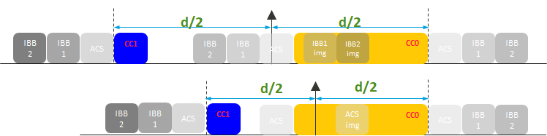

Figure 7.1.8-1: Illustration on impacts of the unwanted/interference image fall into co-channel CC

Then we also calculate the ACS case1 blocker level and the results are summarized in the table below:

Table 7.1.8-1: ACS case 1 blocker level for example bands on Rx RF chain mode

|  |  |  |  |  |  |  |  |  |
| --- | --- | --- | --- | --- | --- | --- | --- | --- |
| **CA configuration** | **SCS** | **UL PCC allocation** | **PCC REFSENS** | **PCC** | **ACS case1 PCC** | **SCC REFSENS** | **SCC** | **ACS case1 SCC** |
| **(PCC/SCC)** | **(LCRB)** | **15KHz SCS** | **ΔRIBNC (dB)** |  | **15KHz SCS** | **ΔRIBNC (dB)** |  |
| **(kHz)** |  |  |  |  |  |  |  |
| CA\_n2(2A) | 15/15 | 10 | -98 | 12 | -40.5 | -98 | 12.8 | -39.7 |
| CA\_n3(2A) | 15/15 | 12 | -97 | 12.2 | -39.3 | -97 | 12.9 | -38.6 |
| CA\_n7(2A) | 15/15 | 32 | -94.8 | 6.4 | -42.9 | -98 | 6.4 | -46.1 |
| CA\_n25(2A) | 15/15 | 10 | -96.5 | 13.8 | -37.2 | -96.5 | 14.3 | -36.7 |
| CA\_n25(2A) | 15/15 | 40 (RBstart = 176) | -79.5 | 6.5 | -36.5 | -96.5 | 24.9 | -26.1 |
| CA\_n26(2A) | 15/15 | 5 (RBstart = 74) | -92.7 | 13.9 | -36.3 | -94.5 | 26.2 | -22.8 |
| CA\_n41(2A) | 15/15 | N/A | -94.8 | 0 | -49.3 | -94.8 | 0 | -49.3 |
| CA\_n41(2A) | 15/15 | N/A | -88.6 | 0 | -52.1 | -88.6 | 0 | -52.1 |

From the calculation we can see the ACS case 1 blocker level are mostly less than that of Tx leakage except baand n26. In the current TS38.101-1, it has been specified “The UE shall fulfil the minimum requirements all values of a single adjacent channel interferer in-gap and out-of-gap up to a –25 dBm interferer power while all downlink carriers are active”. The UE design shall at least fulfil above requirement so it would be able to pass the -25dBm maximum acceptable absolute power of in-gap and out-of-gap interferers.

*For the cases image of ACS/IBB/IBB2/NBB does not overlap with wanted CC, no relaxation would be needed based on evaluated ΔRIBNC on both PCC and SCC. Referring to current specification, the maximum acceptable absolute power of in-gap interferer should be less than or equal to -25dBm*

On the other hand, when measuring ACS/IBB1/IBB2 of CC0, the image of interference may fall into the co-channel range of CC1. Though this may not be an issue for the conformance test since the conformance test does measure REFSENS of CC1 when testing ACS/IBB1/IBB2 of CC0, this may be an implementation issue in the field as illustrated in Figure 7.1.8-2.

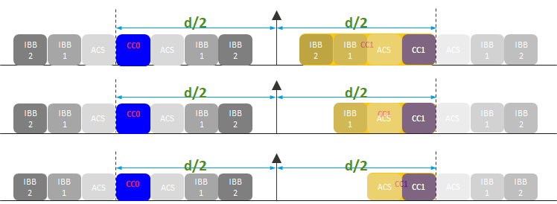

Figure 7.1.8-2: Illustration on impacts of the unwanted/interference image fall into the other CC

## 7.2 RF requirements evaluation from company B (Apple)

With common RF chain architecture, the TX noise at SCC from the PCC remains the same as the analog BB filter cannot provide any help. However, besides TX noise, there is TX leakage at TX band that may benefit from analog filtering before it goes into digital BB. In this case, since common RF chain architecture uses a wide analog BB filter to cover the overall frequency span from the lower edge of CC1 to the upper edge of CC2, as compared to the separate RF chain architecture where two separate narrow BB filters to cover CC1 and CC2, there is less filter rejection. As a result, both the PCC and SCC performance may take some hit[19].

We first provided analysis on the impact of self-interference, i.e., the NF increase due to AGC adjustment (i.e., RX gain backoff). Table 1 and Table 2 show our analysis for CA configuration CA\_n3(2A) (5MHz PCC+ 5MHz SCC, Wgap = 65MHz) and CA\_n25(2A) (5MHz PCC + 5MHz SCC, Wgap = 55MHz), respectively.

Table 7.2-1: Link budget of Self-interference for CA\_n3(2A)

|  |  |  |  |  |  |
| --- | --- | --- | --- | --- | --- |
|  | **Tx leakage** | **Wanted Carrier**  **(PCC)** | **Wanted Carrier**  **(SCC)** | **Noise floor** | **ADC noise included in noise floor** |
| **Tx leakage mapping to a suitable setpoint (PAPR is considered)** |
| **PA out** | 27 | - | - | - | - |
| **Duplexer isolation** | 50 | - | - | - | - |
| **Rx Antenna input** | - | -97 | -92.3 | - | - |
| **FE loss** | - | 4 | 4 | - | - |
| **Duplexer output** | **-23** | **-101** | **-96.3** | - | - |
| **LPF attenuation** | 13.4 | 1 | 1 | - | - |
| **LPF output (dBm)** | **-36.4** | **-102** | **-97.3** | - | - |
| Noise floor for basic REFSENS | - | - | - | -101 | - |
| **NF increase due to AGC adjustment**  **(including effects due to ADC setpoint adjustment)** | - | - | - | 10.5 | - |
| **Noise floor (including ADC noise)** | - | - | - | **-90.5** | - |
| **In-band noise caused by Tx (Derived based on MSD and SNR = -1dB)** | - | - | **-98.1** | - | - |
| **SNR after ADC (dB)** | - | - | - | - | **-11.5(PCC)** |
| **-7.5(SCC)** |

Table 7.2-2: Link budget of Self-interference for CA\_n25(2A)

|  |  |  |  |  |  |
| --- | --- | --- | --- | --- | --- |
|  | **Tx leakage** | **Wanted Carrier**  **(PCC)** | **Wanted Carrier**  **(SCC)** | **Noise floor** | **ADC noise included in noise floor** |
| **Tx leakage mapping to a suitable setpoint (PAPR is considered)** |
| **PA out** | 27 | - | - | - | - |
| **Duplexer isolation** | 50 | - | - | - | - |
| **Rx Antenna input** | - | -96.5 | -91.5 | - | - |
| **FE loss** | - | 4 | 4 | - | - |
| **Duplexer output** | **-23** | **-100.5** | **-95.5** | - | - |
| **LPF attenuation** | 12.9 | 1 | 1 | - | - |
| **LPF output (dBm)** | **-35.9** | **-101.5** | **-96.5** | - | - |
| Noise floor for basic REFSENS | - | - | - | -100.5 | - |
| **NF increase due to AGC adjustment**  **(including effects due to ADC setpoint adjustment)** | - | - | - | 11 | - |
| **Noise floor (including ADC noise)** | - | - | - | **-89.5** | - |
| **In-band noise caused by Tx (Derived based on MSD and SNR = -1dB)** | - | - | **-98.1** | - | - |
| **SNR after ADC (dB)** | - | - | - | - | **-12(PCC)** |
| **-7.7(SCC)** |

Next, we consider the impact of blocker in the gap in addition to the self-interference. In the analysis, we consider two cases, where the image of the blocker overlaps and does not overlap with a wanted CC.

Case 1: The image of the blocker does not overlap with a wanted CC

Based on our analysis, the results are shown in Table 3 and Table 4 for CA\_n3(2A) and CA\_n25(2A), respectively.

Note the following in the analysis:

1 In ACS Case 1, both the receiver sensitivity (REFSENS) and blocker power are increased by the proposed ΔRIBNC adjustment due to self-interference.

2 adjustment due to self-interference, but the blocker power is not. This is because in ACS Case 2, the wanted signal power is fixed at -56.5dBm and the blocker power is fixed at -25dBm in ACS Case 2, -56dBm in IBB Case 1, and -44dBm in IBB Case 2, respectively.

Table 7.2-3: Link budget of Blocker for CA\_n3(2A)

|  |  |  |
| --- | --- | --- |
| **Duplexer isolation (dB)** | 50 | |
| **LPF attenuation (dB)** | 13.4 | |
| **NF increase due to AGC adjustment (dB)** | 10.5 | |
| **Proposed ΔRIBNC adjustment due to self-interference** | 10.5dB for PCC | 6.5dB for SCC |
|  | **PCC SNR (dB) after ADC** | **SCC SNR (dB) after ADC** |
| **REFSENS** | -1 | -1 |
| **ACS Case 1** | 13 | 13 |
| **ACS Case 2** | 4.1 | 4.1 |
| **IBB Case 1** | 5 | 5 |
| **IBB Case 2** | 5 | 5 |

Table 7.2-4: Link budget of Blocker for CA\_n25(2A)

|  |  |  |
| --- | --- | --- |
| **Duplexer isolation (dB)** | 50 | |
| **LPF attenuation (dB)** | 12.9 | |
| **NF increase due to AGC adjustment (dB)** | 11 | |
| **Proposed ΔRIBNC adjustment due to self-interference** | 11dB for PCC | 6.7dB for SCC |
|  | **PCC SNR (dB) after ADC** | **SCC SNR (dB) after ADC** |
| **REFSENS** | -1 | -1 |
| **ACS Case 1** | 13 | 13 |
| **ACS Case 2** | 4.1 | 4.1 |
| **IBB Case 1** | 5 | 5 |
| **IBB Case 2** | 5 | 5 |

Based on the analysis, with the proposed ΔRIBNC adjustment due to self-interference, the ACS/IBB requirements can be met with some margin. However, we note that this conclusion may depend on the CA band combination. For instance, if the duplex gap between UL and DL bands are wide enough, in other words, the TX leakage is of little issue and little ΔRIBNC adjustment is needed to meet the REFSENS requirement, there may be some adjustment needed for ACS/IBB requirements.

Case 2: The image of the blocker overlaps with a wanted CC

When the image of the block overlaps with a wanted CC, the results are shown in Table 5 and Table 6 for CA\_n3(2A) and CA\_n25(2A), respectively.

Note the following for the analysis:

1 Image rejection ratio at the UE is assumed to be 25dB.

2 Other assumptions are the same as in Case 1 where the image of the blocker does not overlap with a wanted CC.

For the two CA configurations, CA\_n3(2A) (5MHz PCC + 5MHz SCC, Wgap = 65MHz) and CA\_n25(2A) 3 (5MHz PCC + 5MHz SCC, Wgap = 55MHz), because the PCC and SCC have the same channel bandwidth, the image of the blocker does not overlap with a wanted CC. Therefore, the analysis shown below are aimed to provide an initial assessment of the impact. Further analysis is needed to address the CA configurations where the image of the blocker does overlap with a wanted CC.

Table 7.2-5: Link budget of Blocker for CA\_n3(2A)

|  |  |  |
| --- | --- | --- |
| **Image rejection ratio (IRR) (dB)** | 25 | |
|  | **PCC SNR (dB) after ADC** | **SCC SNR (dB) after ADC** |
| **REFSENS** | -1 | -1 |
| **ACS Case 1** | -6.5 | -6.5 |
| **ACS Case 2** | -6.5 | -6.5 |
| **IBB Case 1** | 0.5 | 1.2 |
| **IBB Case 2** | -11.5 | -10.8 |

Table 7.2-6: Link budget of Blocker for CA\_n25(2A)

|  |  |  |
| --- | --- | --- |
| **Image rejection ratio (IRR) (dB)** | 25 | |
|  | **PCC SNR (dB) after ADC** | **SCC SNR (dB) after ADC** |
| **REFSENS** | -1 | -1 |
| **ACS Case 1** | -6.5 | -6.5 |
| **ACS Case 2** | -6.5 | -6.5 |
| **IBB Case 1** | 1.5 | 2.2 |
| **IBB Case 2** | -10.5 | -9.8 |

It can be seen that the SNR for ACS Case 1, ACS Case 2 and IBB Case 2 is 5-10dB below -1dB, showing the image of the blocker causes strong interference to the receiver.

Another way to address the image interference issue is to limit the blocker to wanted CC power ratio of 26dB. If this is the case, SNRs for ACS/IBB Case 1 and 2 in Table 5 and Table 6 will be -1dB or higher.

## 7.3 RF requirements evaluation from company C (Xiaomi)

The major impact on REFSENS requirements was Tx leakage due to reduced attenuation on UL carrier frequency with wideband LPF under “single Rx chain mode”. The performance impact is diverse pending on the configuration (DL and UL frequency separation, operating frequency) and UE implementation (ADC performance, and NF increase due to AGC adjustment, LPF performance).

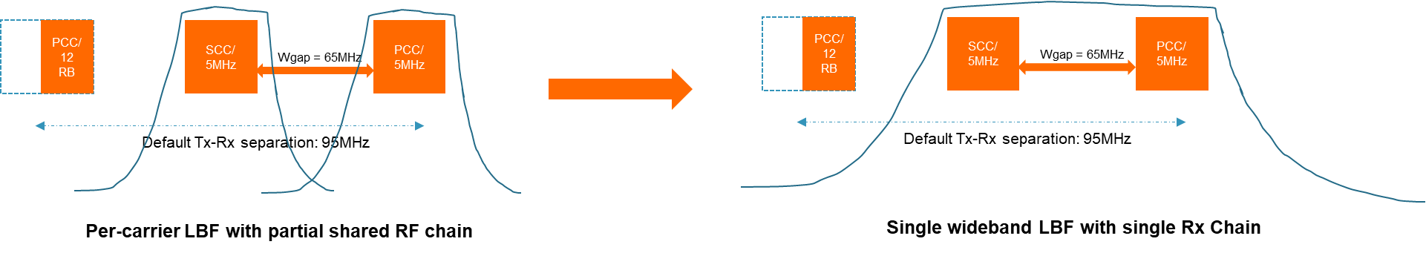

Figure 7.3-1: Per-carrier LBF vs single wideband LBF for CA\_n3(2A)

Initial evaluation results based on experienced performance from products were provided in below table for band n3 with configuration as CA\_n3(2A), 5MHz-65MHz-5MHz (PCC-Wgap-SCC).

Table 7.3-1: Link-budget for Self-interference of CA\_n3(2A)

|  |  |  |  |  |  |
| --- | --- | --- | --- | --- | --- |
|  | **Tx leakage** | **Wanted Carrier**  **(PCC)** | **Wanted Carrier**  **(SCC)** | **Noise floor** | **ADC noise (11 bit): -68.0dBFs** |
| **PA out** | 27 | / | / | / | / |
| **Duplexer isolation** | 50 | / | / | / | / |
| **Rx Antenna input** | / | -97 | -92.3 | / | / |
| **FE loss** | / | 4 | 4 | / | / |
| **Duplexer output** | -23 | -101 | -96.3 | / | / |
| **LPF attenuation** | 12 | 1 | 1 | / | / |
| **LPF output (dBm)** | -36.4 | -102 | -97.3 | / | / |
| **Noise floor for basic REFSENS** | / | / | / | -101 | / |
| **NF increase due to AGC adjustment** | / | / | / | 10 | / |
| **Noise floor** | / | / | / | -91 | / |
| **In-band noise caused by Tx leakage (Derived based on MSD and -1dB SNR)** | / | / | -96.3 | / | / |
| **ADC output (dBm)** | / | / | / | / | -104.4 |
| **SNR after ADC (dB)** | / | / | / | / | -14.0 (PCC)  -14.6 (SCC) |

REFSENS performance degradation (ΔRIBNC ) is around 13 dB for PCC and 13.6dB for SCC for CA\_n3(2A) with 5MHz-65MHz-5MHz (PCC-Wgap-SCC).

For in-gap interference, we evaluated whether relaxation on ACS/IBB is needed or not:

• For ACS case 1, both wanted carrier power and interference power are configured relative to REFSENS with fixed offset value(s). We assume the input power for both wanted signal and interference signal can be adjusted based on REFSENS relaxation with ΔRIBNC.

• For ACS case 2, both wanted carrier power and interference power are fixed as -56.5dBm/-25dBm. The received power of wanted carrier is much higher than Tx leakage power and the impact due to Tx leakage is negligible considering duplex can provide ~50dBc attenuation.

• For IBB1/IBB2, wanted signal power is configured relative to REFSENS with fixed offset value (6dBc). We assume the input power for wanted signal can be adjusted based on REFSENS relaxation with ΔRIBNC. The interference signal power is fixed value as -56dBm (IBB case 1)/-44dBm (IBB case 2).

**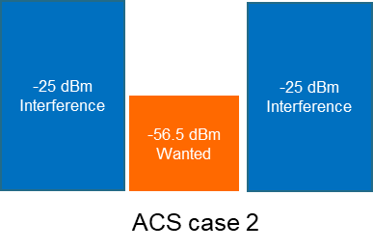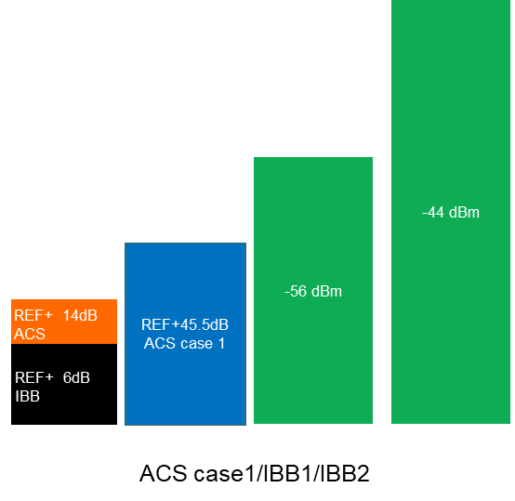**

Figure 7.3-2: ACS/IBB requirements

Two scenarios were evaluated with results summarized in table 7.3-2 and 7.3-3:

• Scenario 1: In-gap blocker w/o image overlapped with wanted carrier(s)

• Scenario 2: Image of in-gap interference overlapped with wanted carriers(s)

**Scenario 1: In-gap blocker w/o image overlapping with wanted carrier(s)**

Table 7.3-2: Link-budget for in-gap blocker w/o image overlapping of CA\_n3(2A)

|  |  |  |
| --- | --- | --- |
| **Duplexer isolation (dB)** | 50 | |
| **LPF attenuation (dB)** | 12 | |
| **NF increase due to AGC adjustment (dB)** | 10 | |
| **ΔRIBNC adjustment due to self-interference** | 13dB for PCC | 13.6 dB for SCC |
|  | **PCC SNR (dB) after ADC** | **SCC SNR (dB) after ADC** |
| **REFSENS** | -1 | -1 |
| **ACS Case 1** | -1.2 | -1 |
| **ACS case 2** | -1 | -1 |
| **IBB Case 1** | 4.2 | 5 |
| **IBB Case 2** | 4.2 | 5 |

There is no impact to ACS case 2 requirements due to Tx leakage. If same relaxation on REFSENS can be applied for ACS1/IBB1/IBB2 test cases, then the Tx leakage impact to ACS/IBB requirements is marginal.

**Scenario 2: Image of in-gap interference overlap with wanted CC**

With in-gap interference overlapping with wanted CC, we assume UE receiver has 25dBc image rejection ratio capability.

Table 7.3-3: Link-budget for in-gap blocked with image overlapping of CA\_n3(2A)

|  |  |  |
| --- | --- | --- |
| **Duplexer isolation (dB)** | 50 | |
| **LPF attenuation (dB)** | 12 | |
| **Image rejection ratio (dB)** | 25 | |
| **NF increase due to AGC adjustment (dB)** | 10 | |
| **ΔRIBNC adjustment due to self-interference** | 13dB for PCC | 13.6 dB for SCC |
|  | **PCC SNR (dB) after ADC** | **SCC SNR (dB) after ADC** |
| **REFSENS** | -1 | -1 |
| **ACS Case 1** | -6.5 | -6 |
| **ACS case 2** | -6.5 | -6.5 |
| **IBB Case 1** | 0.6 | 1.2 |
| **IBB Case 2** | -9.2 | -8.6 |

For the case in gap interference overlapped with wanted carriers, performance degradation will be observed once power ration between In-gap interference and wanted carriers is over than UE image rejection capability.

To avoid the impact to ACS/IBB requirements with image overlapped with wanted carrier(s), restriction with power difference between wanted carrier and interference in gap less than 20dB can solve the issue.

## 7.4 RF requirements evaluation from company D (Samsung)

In the following content, we conduct link budget calculation for several intra-band non-contiguous combos. It is evident that the Tx leakage level of the shared Rx RF Chain at the RFIC output is unacceptable high. Though the AGC can be utilized to reduce the Tx leakage level in the RFIC block, it is important to note that the Tx leakage level is already quite strong in the analog block of the RFIC, which has the potential to reach the saturation limit. When the analog block saturates, it loses its ability to effectively amplify the received signal, resulting in distortion and degradation of the signal-to-noise ratio (SNR). The primary reason for the higher Tx leakage is the wider cut-off frequency of the analog filter. When using a partially shared Rx RF Chain, separate analog filters can be employed for the PCC and SCC, narrow filter response can be applied to both carrier components. However, the filter response becomes wider with the implementation of a shared Rx RF Chain, resulting in inadequate filter rejection at the Tx frequency. Additionally, we have taken into account other impairment such as “NF increase due to AGC adjustment”to determine the extent of extra relaxation needed to support the shared Rx RF chain architecture through AGC operation.These factors in the end leads to the REFSENS degradation for both PCC and SCC. Similarly for ACS and IBB, these factors also lead to the performance degradation to some extent.

**Analysis on CA\_n3(2A):**

The link budget of Self-interference for 5+5MHz with WGAP=65MHz on band n3 can be found in table 7.4.1-1.

Table 7.4.1-1: Link budget of Self-interference for 5+5 MHz on band n3

|  |  |  |  |  |  |
| --- | --- | --- | --- | --- | --- |
|  | **Tx leakage** | **Wanted Carrier** | **Wanted Carrier** | **Noise floor** | **Tx leakage mapping to -12dBFS (PAPR is considered)** |
| **(PCC)** | **(SCC)** |  |
| **PA out** | 27 | / | / | / | / |
| **Duplexer isolation** | 50 | / | / | / | / |
| **Rx Antenna input** | / | -97 | -92.3 | / | / |
| **FE loss** | / | 4 | 4 | / | / |
| **Duplexer output** | -23 | -101 | -96.3 | / | **/** |
| **LPF attenuation** | 7.9 | 1 | 1 | / | / |
| **LPF output (dBm)** | -30.9 | -102 | -97.3 | / | **/** |
| Noise floor for basic REFSENS | / | / | / | -101 | **/** |
| NF increase due to AGC adjustment | / | / | / | 9.3 | **/** |
| **Noise floor** | / | / | / | -91.7 | **/** |
| **In-band noise caused by Tx leakage (Derived based on MSD and -1dB SNR)** | / | / | -96.3 | / | **/** |
| **ADC output (dBm)** | **/** | **/** | **/** | **/** | -86.9 |
| **SNR after ADC (dB)** | **/** | / | **/** | / | -16.3(PCC) |
|  |  |  |  |  | -12 (SCC) |

The Link budget of ACS case 1 and case 2 with and without Rx image on band n3 can be found in table 7.4.1-2. 25dB rejection Rx image is used for the calculation.

**ACS: with and without Rx image**

Table 7.4.1-2. Link budget of ACS cases on band n3

|  |  |  |  |  |
| --- | --- | --- | --- | --- |
| **LPF attenuation (dB)** | 7.9 | | | |
| **NF increase due to AGC adjustment(dB)** | 9.3 | | | |
|  | Without Rx image | | With Rx image | |
|  | Case 1 | Case 2 | Case 1 | Case 2 |
| **SNR after ADC (dB) for PCC** | -4.7 | -1 | -4.7 | -1 |
| **SNR after ADC (dB) for SCC** | -2.6 | -1 | -5.3 | -7.6 |

The Link budget of IBB case 1 and case 2 with and without Rx image on band n3 can be found in table 7.4.1-3. 25dB rejection Rx image is used for the calculation.

**IBB: with and without Rx image**

Table 7.4.1-3. Link budget of IBB cases on band n3

|  |  |  |  |  |
| --- | --- | --- | --- | --- |
| **LPF attenuation (dB)** | 7.9 | | | |
| **NF increase due to AGC adjustment(dB)** | 9.3 | | | |
|  | Without Rx image | | With Rx image (25dB rejection) | |
|  | Case 1 | Case 2 | Case 1 | Case 2 |
| **SNR after ADC (dB) for PCC** | -10.8 | -10.8 | -10.8 | -10.8 |
| **SNR after ADC (dB) for SCC** | -6.9 | -6.9 | -9.2 | -17.7 |

**Analysis on CA\_n2(2A):**

The link budget of Self-interference for 5+5MHz with WGAP=50MHz on band n2 can be found in table 7.4.1-4, respectively.

Table 7.4.1-4: Link budget of Self-interference for 5+5 MHz on band n2

|  |  |  |  |  |  |
| --- | --- | --- | --- | --- | --- |
|  | **Tx leakage** | **Wanted Carrier** | **Wanted Carrier** | **Noise floor** | **Tx leakage mapping to -12dBFS (PAPR is considered)** |
| **(PCC)** | **(SCC)** |  |
| **PA out** | 27 | / | / | / | / |
| **Duplexer isolation** | 50 | / | / | / | / |
| **Rx Antenna input** | / | -98 | -93 | / | / |
| **FE loss** | / | 4 | 4 | / | / |
| **Duplexer output** | -23 | -102 | -97 | / | / |
| **LPF attenuation** | 13 | 1 | 1 | / | / |
| **LPF output (dBm)** | -36 | -103 | -98 | / | / |
| Noise floor for basic REFSENS | / | / | / | -102 | / |
| NF increase due to AGC adjustment | / | / | / | 5 | / |
| **Noise floor** | / | / | / | -97 | / |
| **In-band noise caused by Tx leakage (Derived based on MSD and -1dB SNR)** | / | / | -97 | / | / |
| **ADC output (dBm)** | / | / | / | / | -92 |
| **SNR after ADC (dB)** | / | / | / | / | -12.2 (PCC) |
|  |  |  |  |  | - 8.1 (SCC) |

The Link budget of ACS case 1 and case 2 with and without Rx image on band n2 can be found in table 7.4.1-5. 25dB rejection Rx image is used for the calculation.

**ACS: with and without Rx image**

Table 7.4.1-5. Link budget of ACS cases on band n2

|  |  |  |  |  |
| --- | --- | --- | --- | --- |
| **LPF attenuation (dB)** | 13 | | | |
| **NF increase due to AGC adjustment(dB)** | 5 | | | |
|  | Without Rx image | | With Rx image | |
|  | Case 1 | Case 2 | Case 1 | Case 2 |
| **SNR after ADC (dB) for PCC** | -2.8 | -1 | -2.8 | -1 |
| **SNR after ADC (dB) for SCC** | -1.7 | -1 | -4.6 | -7.6 |

The Link budget of IBB case 1 and case 2 with and without Rx image on band n2 can be found in table 7.4.1-6. 25dB rejection Rx image is used for the calculation.

**IBB: with and without Rx image**

Table 7.4.1-6. Link budget of IBB cases on band n2

|  |  |  |  |  |
| --- | --- | --- | --- | --- |
| **LPF attenuation (dB)** | 13 | | | |
| **NF increase due to AGC adjustment(dB)** | 5 | | | |
|  | Without Rx image | | With Rx image (25dB rejection) | |
|  | Case 1 | Case 2 | Case 1 | Case 2 |
| **SNR after ADC (dB) for PCC** | -7.3 | -7.3 | -7.3 | -7.3 |
| **SNR after ADC (dB) for SCC** | -4.1 | -4.1 | -8.2 | -18.2 |

**Analysis on CA\_n25(2A):**

The link budget of Self-interference for 5+5MHz with WGAP=55MHz on band n25 can be found in table 7.4.1-7.

Table 7.4.1-7: Link budget of Self-interference for 5+5 MHz on band n25

|  |  |  |  |  |  |
| --- | --- | --- | --- | --- | --- |
|  | **Tx leakage** | **Wanted Carrier** | **Wanted Carrier** | **Noise floor** | **Tx leakage mapping to -12dBFS (PAPR is considered)** |
| **(PCC)** | **(SCC)** |  |
| **PA out** | 27 | / | / | / | / |
| **Duplexer isolation** | 50 | / | / | / | / |
| **Rx Antenna input** | / | -96.5 | -91.5 | / | / |
| **FE loss** | / | 4 | 4 | / | / |
| **Duplexer output** | -23 | -100.5 | -95.5 | / | / |
| **LPF attenuation** | 8.6 | 1 | 1 | / | / |
| **LPF output (dBm)** | -31.6 | -101.5 | -96.5 | / | / |
| Noise floor for basic REFSENS | / | / | / | -100.5 | / |
| NF increase due to AGC adjustment | / | / | / | 9.2 | / |
| **Noise floor** | / | / | / | -91.3 | / |
| **In-band noise caused by Tx leakage (Derived based on MSD and -1dB SNR)** | / | / | -95.5 | / | / |
| **ADC output (dBm)** | / | / | / | / | -87.6 |
| **SNR after ADC (dB)** | / | / | / | / | -15.4 (PCC) |
|  |  |  |  |  | -10.9 (SCC) |

The Link budget of ACS case 1 and case 2 with and without Rx image on band n25 can be found in table 7.4.1-8. 25dB rejection Rx image is used for the calculation.

**ACS: with and without Rx image**

Table 7.4.1-8. Link budget of ACS cases on band n25

|  |  |  |  |  |
| --- | --- | --- | --- | --- |
| **LPF attenuation (dB)** | 8.6 | | | |
| **NF increase due to AGC adjustment(dB)** | 9.2 | | | |
|  | Without Rx image | | With Rx image | |
|  | Case 1 | Case 2 | Case 1 | Case 2 |
| **SNR after ADC (dB) for PCC** | -4.2 | -1 | -4.2 | -1 |
| **SNR after ADC (dB) for SCC** | -2.3 | -1 | -4.9 | -7.6 |

The Link budget of IBB case 1 and case 2 with and without Rx image on band n25 can be found in table 7.4.1-9. 25dB rejection Rx image is used for the calculation.

**IBB: with and without Rx image**

Table 7.4.1-9. Link budget of IBB cases on band n25

|  |  |  |  |  |
| --- | --- | --- | --- | --- |
| **LPF attenuation (dB)** | 8.6 | | | |
| **NF increase due to AGC adjustment(dB)** | 9.2 | | | |
|  | Without Rx image | | With Rx image (25dB rejection) | |
|  | Case 1 | Case 2 | Case 1 | Case 2 |
| **SNR after ADC (dB) for PCC** | -10 | -10 | -10 | -10 |
| **SNR after ADC (dB) for SCC** | -6.1 | -6.1 | -8.4 | -16.9 |

## 7.5 RF requirements evaluation from company E (Spreadtrum)

With common RF chain architecture, the TX noise at SCC from the PCC remains the same as the analog BB filter cannot provide any help. However, besides TX noise, there is TX leakage at TX band that may benefit from analog filtering before it goes into digital BB. In this case, since common RF chain architecture uses a wide analog BB filter to cover the overall frequency span from the lower edge of CC1 to the upper edge of CC2, as compared to the separate RF chain architecture where two separate narrow BB filters to cover CC1 and CC2, there is less filter rejection. As a result, both the PCC and SCC performance may take some hit.

We have provided analysis on the impact of tx leakage, i.e., the NF increase due to AGC adjustment (i.e., RX gain backoff). From table 1 to table 5 to show our analysis for CA configuration CA\_n3(2A) (5MHz PCC+ 5MHz SCC, Wgap = 65MHz), CA\_n25(2A) (5MHz PCC + 5MHz SCC, Wgap = 55MHz),CA\_n2 (2A (5MHz PCC+5MHz SCC, Wgap=50MHz), n7 (2A (10MHz PCC+5MHz SCC, Wgap=55MHz) and n26 (2A (15MHz+10MHz, Wgap=10MHz) respectively.

Table 7.5-1: Link budge of self-interference for CA\_3(2A)(5MHz+5MHz,Wgap=65MHz)

|  |  |  |  |  |  |
| --- | --- | --- | --- | --- | --- |
|  | **Tx leakage** | **Wanted Carrier**  **(PCC)** | **Wanted Carrier**  **(SCC)** | **Noise floor** | **ADC noise included in noise floor** |
| **Tx leakage mapping to a suitable setpoint (PAPR is considered)** |
| **PA out** | 27 | - | - | - | - |
| **Duplexer isolation** | 50 | - | - | - | - |
| **Rx Antenna input** | - | -97 | -93.3 | - | - |
| **FE loss** | - | 4 | 4 | - | - |
| **Duplexer output** | **-23** | **-101** | **-97.3** | - | - |
| **LPF attenuation** | 13.4 | 1 | 1 | - | - |
| **LPF output (dBm)** | **-36.4** | **-102** | **-98.3** | - | - |
| Noise floor for basic REFSENS | - | - | - | -94 | - |
| **NF increase due to AGC adjustment**  **(including effects due to ADC setpoint adjustment)** | - | - | - | 10.6 | - |
| **Noise floor (including ADC noise)** | - | - | - | **-83.4** | - |
| **In-band noise caused by Tx (Derived based on MSD and SNR = -1dB)** | - | - | **-88** | - | - |
| **SNR after ADC (dB)** | - | - | - | - | **-10(PCC)** |
| **-10.7(SCC)** |

Table 7.5-2: Link budge of self-interference for CA\_25(2A)(5MHz+5MHz,Wgap=55MHz)

|  |  |  |  |  |  |
| --- | --- | --- | --- | --- | --- |
|  | **Tx leakage** | **Wanted Carrier**  **(PCC)** | **Wanted Carrier**  **(SCC)** | **Noise floor** | **ADC noise included in noise floor** |
| **Tx leakage mapping to a suitable setpoint (PAPR is considered)** |
| **PA out** | 27 | - | - | - | - |
| **Duplexer isolation** | 50 | - | - | - | - |
| **Rx Antenna input** | - | -96.5 | -91.5 | - | - |
| **FE loss** | - | 4 | 4 | - | - |
| **Duplexer output** | **-23** | **-110.5** | **-95.5** | - | - |
| **LPF attenuation** | 6 | 1 | 1 | - | - |
| **LPF output (dBm)** | **-29** | **-111.5** | **-96.5** | - | - |
| Noise floor for basic REFSENS | - | - | - | -93.5 | - |
| **NF increase due to AGC adjustment**  **(including effects due to ADC setpoint adjustment)** | - | - | - | 10.6 | - |
| **Noise floor (including ADC noise)** | - | - | - | **-82.9** | - |
| **In-band noise caused by Tx (Derived based on MSD and SNR = -1dB)** | - | - | **-85** | - | - |
| **SNR after ADC (dB)** | - | - | - | - | **-10.9 (PCC)** |
| **-11.5(SCC)** |

Table 7.5-3: Link budge of self-interference for CA\_2(2A)(5MHz+5MHz,Wgap=50MHz)

|  |  |  |  |  |  |
| --- | --- | --- | --- | --- | --- |
|  | **Tx leakage** | **Wanted Carrier**  **(PCC)** | **Wanted Carrier**  **(SCC)** | **Noise floor** | **ADC noise included in noise floor** |
| **Tx leakage mapping to a suitable setpoint (PAPR is considered)** |
| **PA out** | 27 | - | - | - | - |
| **Duplexer isolation** | 50 | - | - | - | - |
| **Rx Antenna input** | - | -98 | -93 | - | - |
| **FE loss** | - | 4 | 4 | - | - |
| **Duplexer output** | **-23** | **-112** | **-97** | - | - |
| **LPF attenuation** | 8 | 1 | 1 | - | - |
| **LPF output (dBm)** | **-31** | **-113** | **-98** | - | - |
| Noise floor for basic REFSENS | - | - | - | -95 | - |
| **NF increase due to AGC adjustment**  **(including effects due to ADC setpoint adjustment)** | - | - | - | 10.6 | - |
| **Noise floor (including ADC noise)** | - | - | - | **-84.4** | - |
| **In-band noise caused by Tx (Derived based on MSD and SNR = -1dB)** | - | - | **-87** | - | - |
| **SNR after ADC (dB)** | - | - | - | - | **-10.6 (PCC)** |
| **-11.1(SCC)** |

Table 7.5-4: Link budge of self-interference for CA\_7(2A)(10MHz+5MHz,Wgap=55MHz)

|  |  |  |  |  |  |
| --- | --- | --- | --- | --- | --- |
|  | **Tx leakage** | **Wanted Carrier**  **(PCC)** | **Wanted Carrier**  **(SCC)** | **Noise floor** | **ADC noise included in noise floor** |
| **Tx leakage mapping to a suitable setpoint (PAPR is considered)** |
| **PA out** | 27 | - | - | - | - |
| **Duplexer isolation** | 50 | - | - | - | - |
| **Rx Antenna input** | - | -98 | -93 | - | - |
| **FE loss** | - | 4 | 4 | - | - |
| **Duplexer output** | **-23** | **-112** | **-97** | - | - |
| **LPF attenuation** | 8 | 1 | 1 | - | - |
| **LPF output (dBm)** | **-31** | **-113** | **-98** | - | - |
| Noise floor for basic REFSENS | - | - | - | -95 | - |
| **NF increase due to AGC adjustment**  **(including effects due to ADC setpoint adjustment)** | - | - | - | 8.6 | - |
| **Noise floor (including ADC noise)** | - | - | - | **-86.4** | - |
| **In-band noise caused by Tx (Derived based on MSD and SNR = -1dB)** | - | - | **-85.8** | - | - |
| **SNR after ADC (dB)** | - | - | - | - | **-7.6 (PCC)** |
| **-7.7(SCC)** |

Table 7.5-5: Link budge of self-interference for CA\_26(2A)(15MHz+10MHz,Wgap=10MHz)

|  |  |  |  |  |  |
| --- | --- | --- | --- | --- | --- |
|  | **Tx leakage** | **Wanted Carrier**  **(PCC)** | **Wanted Carrier**  **(SCC)** | **Noise floor** | **ADC noise included in noise floor** |
| **Tx leakage mapping to a suitable setpoint (PAPR is considered)** |
| **PA out** | 27 | - | - | - | - |
| **Duplexer isolation** | 50 | - | - | - | - |
| **Rx Antenna input** | - | -92.7 | -69.3 | - | - |
| **FE loss** | - | 4 | 4 | - | - |
| **Duplexer output** | **-23** | **-106.7** | **-73.3** | - | - |
| **LPF attenuation** | 11.5 | 1 | 1 | - | - |
| **LPF output (dBm)** | **-33.5** | **-107.7** | **-74.3** | - | - |
| Noise floor for basic REFSENS | - | - | - | -89.7 | - |
| **NF increase due to AGC adjustment**  **(including effects due to ADC setpoint adjustment)** | - | - | - | 8.6 | - |
| **Noise floor (including ADC noise)** | - | - | - | **-81.1** | - |
| **In-band noise caused by Tx (Derived based on MSD and SNR = -1dB)** | - | - | **-59.5** | - | - |
| **SNR after ADC (dB)** | - | - | - | - | **-11.1 (PCC)** |
| **-25.7(SCC)** |

## 7.6 RF requirements evaluation from company F (ZTE)

For FDD band intra-band non-contiguous CA, the UL Tx noise caused by Tx chain/PA leakage and Tx spectrum spreading into DL Rx path shall be taken into account since the duplexer gap for some FDD bands are small, and such small duplexer gap cannot provide enough attenuation for the filters design. When the separated Rx RF chain is replaced with sharing Rx RF chain, the shared filter cannot filter out each carrier anymore. the interference appeared in the gap is located in the pass band of the filter, and the filter cannot provide the attenuation in the gap between the two DL carriers. Thus the ΔRIBNC requirements for FDD intra-band NC CA would become larger which are needed to be re-evaluated for both PCC and SCC.

Unlike FDD, there is no duplex gap for TDD band, and there are no ΔRIBNC requirements defined for TDD intra-band non-contiguous CA. Thus no matter separated Rx RF chain or sharing Rx RF chain is used, there are need to no re-evaluated or define ΔRIBNC requirements for TDD intra-band non-contiguous CA.

Below we provide the link budget calculation for self-interference/ACS/IBB based on the template for CA\_n3(2A), CA\_n7(2A) and CA\_n25(2A).

**Analysis on CA\_n3(2A):**

The link budget of Self-interference for 5+5MHz on band n3 can be found in table 7.6-1.

Table 7.6-1: Link budget of Self-interference for 5+5 MHz on band n3

|  |  |  |  |  |  |
| --- | --- | --- | --- | --- | --- |
|  | **Tx leakage** | **Wanted Carrier (PCC)** | **Wanted Carrier (SCC)** | **Noise floor** | **Tx leakage mapping to -12dBFS (PAPR is considered)** |
| **PA out** | 27.0 | - | - | - | - |
| **Duplexer isolation** | 50.0 | - | - | - | - |
| **Rx Antenna input** | - | -97.0 | -92.3 | - | - |
| **FE loss** | - | 4.0 | 4.0 | - | - |
| **Duplexer output** | -23.0 | -101.0 | -96.3 | - | - |
| **LPF attenuation** | 12.1 | 1.0 | 1.0 | - | - |
| **LPF output (dBm)** | -35.1 | -102.0 | -97.3 | - | - |
| **Noise floor for basic REFSENS** | - | - | - | -101.0 | - |
| **NF increase due to AGC adjustment** | - | - | - | 11.0 | - |
| **Noise floor** | - | - | - | -90.0 | - |
| **In-band noise (Derived based on MSD and SNR = -1dB)** | - | - | -96.3 | - | - |
| **ADC output (dBm)** | - | - | - | - | -91.1 |
| **SNR after ADC (dB)** | - | - | - | - | -14.5(PCC) |
| -10.3(SCC) |

The Link budget of ACS case 1 and case 2 with and without Rx image on band n3 can be found in table 7.6-2, respectively. 25dB rejection Rx image is used for the calculation.

**ACS: with and without Rx image**

Table 7.6-2. Link budget of ACS case with and without Rx image on band n3

|  |  |  |  |  |
| --- | --- | --- | --- | --- |
| **LPF attenuation (dB)** | 12.1 | | | |
| **NF increase due to AGC adjustment(dB)** | 11 | | | |
|  | Without Rx image | | With Rx image | |
|  | Case 1 | Case 2 | Case 1 | Case 2 |
| **SNR after ADC (dB) for PCC** | -3.8 | -1 | -3.8 | -1 |
| **SNR after ADC (dB) for SCC** | -2.1 | -1 | -5 | -7.6 |

The Link budget of IBB case 1 and case 2 with and without Rx image on band n3 can be found in table 7.6-3. 25dB rejection Rx image is used for the calculation.

**IBB: with and without Rx image**

Table 7.6-3. Link budget of IBB case with and without Rx image on band n3

|  |  |  |  |  |
| --- | --- | --- | --- | --- |
| **LPF attenuation (dB)** | 12.1 | | | |
| **NF increase due to AGC adjustment(dB)** | 11 | | | |
|  | Without Rx image | | With Rx image (25dB rejection) | |
|  | Case 1 | Case 2 | Case 1 | Case 2 |
| **SNR after ADC (dB) for PCC** | -9.2 | -9.2 | -9.2 | -9.2 |
| **SNR after ADC (dB) for SCC** | -5.6 | -5.6 | -8.5 | -17.6 |

**Analysis on CA\_n7(2A):**

The link budget of Self-interference for 10+5MHz on band n7 can be found in table 7.6-4, respectively.

Table 7.6-4: Link budget of Self-interference for 10+5 MHz on band n7

|  |  |  |  |  |  |  |
| --- | --- | --- | --- | --- | --- | --- |
|  | **Tx leakage** | **Wanted Carrier (PCC)** | **Wanted Carrier (SCC)** | **Noise floor**  **(PCC)** | **Noise floor**  **(SCC)** | **Tx leakage mapping to -12dBFS (PAPR is considered)** |
| **PA out** | 27.0 | - | - | - |  | - |
| **Duplexer isolation** | 50.0 | - | - | - |  | - |
| **Rx Antenna input** | - | -94.8 | -98.0 | - |  | - |
| **FE loss** | - | 4.0 | 4.0 | - |  | - |
| **Duplexer output** | **-23.0** | **-98.8** | **-102.0** | - |  | - |
| **LPF attenuation** | 17.3 | 1.0 | 1.0 | - |  | - |
| **LPF output (dBm)** | **-40.3** | **-99.8** | **-103.0** | - |  | - |
| **Noise floor for basic REFSENS** | - | - | - | -98.8 | -102.0 | - |
| **NF increase due to AGC adjustment** | - | - | - | 6.0 | 6.0 | - |
| **Noise floor** | - | - | - | **-92.8** | **-96.0** | - |
| **In-band noise (Derived based on MSD and SNR = -1dB)** | - | - | **-102.0** | - |  | - |
| **ADC output (dBm)** | - | - | - | - |  | **-96.3** |
| **SNR after ADC (dB)** | - | - | - | - |  | -8.6(PCC) |
| -10.4(SCC) |

The Link budget of ACS case 1 and case 2 with and without Rx image on band n7 can be found in table 7.6-5. 25dB rejection Rx image is used for the calculation.

**ACS: with and without Rx image**

Table 7.6-5. Link budget of ACS case with and without Rx image on band n7

|  |  |  |  |  |
| --- | --- | --- | --- | --- |
| **LPF attenuation (dB)** | 17.3 | | | |
| **NF increase due to AGC adjustment(dB)** | 6 | | | |
|  | Without Rx image | | With Rx image | |
|  | Case 1 | Case 2 | Case 1 | Case 2 |
| **SNR after ADC (dB) for PCC** | -1.9 | -1 | -1.9 | -1 |
| **SNR after ADC (dB) for SCC** | -2.2 | -1 | -10.4 | -7.6 |

The Link budget of IBB case 1 and case 2 with and without Rx image on band n7 can be found in table 7.6-6. 25dB rejection Rx image is used for the calculation.

**IBB: with and without Rx image**

Table 7.6-6. Link budget of IBB case with and without Rx image on band n7

|  |  |  |  |  |
| --- | --- | --- | --- | --- |
| **LPF attenuation (dB)** | 17.3 | | | |
| **NF increase due to AGC adjustment(dB)** | 6 | | | |
|  | Without Rx image | | With Rx image (25dB rejection) | |
|  | Case 1 | Case 2 | Case 1 | Case 2 |
| **SNR after ADC (dB) for PCC** | -4.9 | -4.9 | -4.9 | -4.9 |
| **SNR after ADC (dB) for SCC** | -5.7 | -5.7 | -12.1 | -23.1 |

**Analysis on CA\_n25(2A):**

The link budget of Self-interference for 5+5MHz on band n25 can be found in table 7.6-7.

Table 7.6-7: Link budget of Self-interference for 5+5 MHz on band n25

|  |  |  |  |  |  |
| --- | --- | --- | --- | --- | --- |
|  | **Tx leakage** | **Wanted Carrier (PCC)** | **Wanted Carrier (SCC)** | **Noise floor** | **Tx leakage mapping to -12dBFS (PAPR is considered)** |
| **PA out** | 27.0 | - | - | - | - |
| **Duplexer isolation** | 50.0 | - | - | - | - |
| **Rx Antenna input** | - | -96.5 | -91.5 | - | - |
| **FE loss** | - | 4.0 | 4.0 | - | - |
| **Duplexer output** | **-23.0** | **-100.5** | **-95.5** | - | - |
| **LPF attenuation** | 12.6 | 1.0 | 1.0 | - | - |
| **LPF output (dBm)** | **-35.6** | **-101.5** | **-96.5** | - | - |
| **Noise floor for basic REFSENS** | - | - | - | -100.5 | - |
| **NF increase due to AGC adjustment** | - | - | - | 10.5 | - |
| **Noise floor** | - | - | - | **-90.0** | - |
| **In-band noise (Derived based on MSD and SNR = -1dB)** | - | - | **-95.5** | - | - |
| **ADC output (dBm)** | - | - | - | - | **-91.6** |
| **SNR after ADC (dB)** | - | - | - | - | -13.8(PCC) |
| -9.5(SCC) |

The Link budget of ACS case 1 and case 2 with and without Rx image on band n25 can be found in table 7.6-8. 25dB rejection Rx image is used for the calculation.

**ACS: with and without Rx image**

Table 7.6-8. Link budget of ACS case with and without Rx image on band n25

|  |  |  |  |  |
| --- | --- | --- | --- | --- |
| **LPF attenuation (dB)** | 12.6 | | | |
| **NF increase due to AGC adjustment(dB)** | 10.5 | | | |
|  | Without Rx image | | With Rx image | |
|  | Case 1 | Case 2 | Case 1 | Case 2 |
| **SNR after ADC (dB) for PCC** | -3.4 | -1 | -3.4 | -1 |
| **SNR after ADC (dB) for SCC** | -1.9 | -1 | -4.7 | -7.6 |

The Link budget of IBB case 1 and case 2 with and without Rx image on band n25 can be found in table 7.6-9. 25dB rejection Rx image is used for the calculation.

**IBB: with and without Rx image**

Table 7.6-9. Link budget of IBB case with and without Rx image on band n25

|  |  |  |  |  |
| --- | --- | --- | --- | --- |
| **LPF attenuation (dB)** | 12.6 | | | |
| **NF increase due to AGC adjustment(dB)** | 10.5 | | | |
|  | Without Rx image | | With Rx image (25dB rejection) | |
|  | Case 1 | Case 2 | Case 1 | Case 2 |
| **SNR after ADC (dB) for PCC** | -8.6 | -8.6 | -8.6 | -8.6 |
| **SNR after ADC (dB) for SCC** | -5 | -5 | -7.8 | -16.8 |

## 7.7 RF requirements evaluation from company G (Huawei)

The performance evaluation in this clause is generated based on agreed link budget template in [15]. The evaluation covers REFSENS, ACS and IBB requirements.

### 7.7.1 Band n3

The REFSENS performance of Single Rx RF Chain will be impacted by the Tx leakage when the UL signal is close to the DL carrier as shown in below Figure 7.7.1-1.

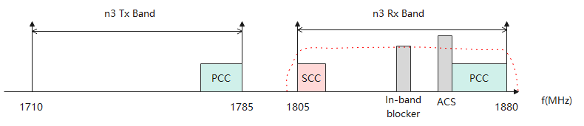

Figure 7.7.1-1 REFSENS on band n3 with Tx leakage

Taking band n3 as an example, the estimated SNR on PCC and SCC could be derived as in Table 7.7.1-1.

Table 7.7.1-1. Link budget of Self-interference for 1st configuration on band n3

|  |  |  |  |  |  |  |
| --- | --- | --- | --- | --- | --- | --- |
|  | **Tx leakage** | **Wanted Carrier**  **(PCC)** | **Wanted Carrier**  **(SCC)** | **Noise floor** | **ADC noise (12 bit):**  **-74.0dBFs (6.02N+1.76)** | |
| **Tx leakage mapping to -6dBFs** | **Tx leakage mapping to**  **-12dBFS** |
| **out** | 27 | - | - | - | - | - |
| **Duplexer isolation** | 50 | - | - | - | - | - |
| **Rx Antenna input** | - | -97 | -92.3 | - | - | - |
| **FE loss** | - | 4 | 4 | - | - | - |
| **Duplexer output** | **-23** | **-101** | **-96.3** | - | - | - |
| **LPF attenuation** | 12.8 | 0.5 | 0.5 | - | - | - |
| **LPF output (dBm)** | **-35.8** | **-101.5** | **-96.8** | - | - | - |
| Noise floor for basic REFSENS | - | - | - | -100.5 | - | - |
| NF increase due to AGC adjustment | - | - | - | 5 | - | - |
| **Noise floor** | - | - | - | **-95.5** | - | - |
| **In-band noise (Derived based on MSD and SNR = -1dB)** | - | - | **-97.6** | - | - | - |
| **ADC output (dBm)** | - | - | - | - | **-103.8** | **-97.8** |
| **SNR after ADC (dB)** | - | - | - | - | -6.6(PCC) | -8.0(PCC) |
| -4.8(SCC) | -5.7(SCC) |

Table 7.7.1-2 summaries the evaluation using different assumption of the key parameters. To achieve the -1dB demodulation threshold, extra 3.1~7.0dB relaxation would be required on PCC, and 1.3~4.7dB relaxation is required on SCC.

Table 7.7.1-2 Estimated SNR on band n3 with a strong Tx leakage

|  |  |  |  |  |  |
| --- | --- | --- | --- | --- | --- |
|  | | Case 1 | Case 2 | Case 3 | Case 4 |
| Duplexer isolation @Tx Fc | | 50 | 50 | 50 | 50 |
| LPF attenuation @Tx Fc | | 12 | 12 | 12 | 12 |
| NF increase due to AGC adjustment | | 5 | 5 | 2 | 2 |
| ADC (12bit) | | -12dBFS | -6dBFS | -12dBFS | -6dBFS |
| SNR (dB) | REFSENS (PCC) | -8.0 | -6.6 | -6.4 | -4.1 |
| REFSENS (SCC) | -5.7 | -4.8 | -3.6 | -2.3 |

**Observation 1**: When the UL signal is close to DL carrier, the REFSENS performance is impacted by the Tx leakage. The estimated SNR varies with different assumptions of key parameters, including the duplexer isolation @Tx, the LPF attenuation @Tx, the NF increase due to AGC adjustment and the ADC setting.

**Observation 2**: On band n3, extra 4.6~7.0dB relaxation would be required on PCC, and 2.7~3.7dB relaxation is required on SCC to achieve the -1dB demodulation threshold with the existence of a strong Tx leakage.

Using the similar link budget method, the SNR of ACS/IBB cases with parameters of Case 4 in Table 7.7.1-2 are summarized as below Table 7.7.1-3.

Table 7.7.1-3 SNR for ACS/IBB with fully shared RF chain

|  |  |  |  |  |
| --- | --- | --- | --- | --- |
|  | ACS case 1 | ACS case 2 | IBB case 1 | IBB case 2 |
| PCC | -1.4 | -1.0 | -3.2 | -3.2 |
| SCC | 3.0 | 3.7 | 0.4 | 0.4 |

The Tx leakage has impact on RF performance especially when the PCC is located close to the DL spectrum. If the PCC and SCC are swapped, there will be less RF performance loss. Table 7.7.1-4 summarises the estimated SNR. No extra relaxation is needed.

Table 7.7.1-4 Estimated SNR on band n3 when PCC and SCC are swapped

|  |  |  |
| --- | --- | --- |
| Parameters | | Value |
| Duplexer isolation @Tx Fc | | 50 |
| LPF attenuation @Tx Fc | | 34.9 |
| NF increase due to AGC adjustment | | 0 |
| ADC (12bit) | | -6dBFS |
| SNR (dB) | REFSENS (PCC) | -1.0 |
| REFSENS (SCC) | -1.0 |
|  | ACS Case 1 (PCC) | -1.0 |
|  | ACS Case 1 (SCC) | -1.0 |
|  | ACS Case 2 (PCC) | -1.0 |
|  | ACS Case 2 (SCC) | -1.0 |
|  | IBB Case 1 (PCC) | -1.0 |
|  | IBB Case 1 (SCC) | -1.0 |
|  | IBB Case 2 (PCC) | -1.0 |
|  | IBB Case 2 (SCC) | -1.0 |

As a summary, the performance on band n3 is captured in below Table 7.7.1-5.

Table 7.7.1-5 Estimated SNR on band n3

|  |  |  |  |  |  |  |  |  |  |  |  |  |  |  |  |  |  |  |
| --- | --- | --- | --- | --- | --- | --- | --- | --- | --- | --- | --- | --- | --- | --- | --- | --- | --- | --- |
|  | band | PCC bandwidth | SCC bandwidth | Wgap | PCC SCC Swap | LPF antennuation @Tx leakage | Tx leakage post LPF | PCC @ Rx antenna | SCC @ Rx antenna | noisefloor | NF increase comparing with separate RF chain | coChanNoise SCC | coChanNoise PCC | ADCnoise | SNR PCC | SNR SCC | MSD PCC | MSD SCC |
| REFSENS | 3 | 5 | 5 | 65 | 0 | -12.8 | -35.8 | -101.5 | -101.5 | -100.5 | 5.0 | -97.6 | N/A | -103.8 | -6.6 | -8.5 | 5.6 | 7.5 |
| ACS case 1 | 3 | 5 | 5 | 65 | 0 | -12.8 | -35.8 | -87.5 | -87.5 | -100.5 | 5.0 | -97.6 | -86.7 | -103.8 | -1.4 | -1.7 | 0.4 | 0.7 |
| ACS case 2 | 3 | 5 | 5 | 65 | 0 | -12.8 | -35.8 | -61.0 | -61.0 | -100.5 | 12.0 | -97.6 | -60.0 | -96.6 | -1.0 | -1.0 | 0.0 | 0.0 |
| IBB case 1 | 3 | 5 | 5 | 65 | 0 | -12.8 | -35.8 | -95.5 | -95.5 | -100.5 | 5.0 | -97.6 | -95.8 | -103.8 | -3.2 | -4.3 | 2.2 | 3.3 |
| IBB case 2 | 3 | 5 | 5 | 65 | 0 | -12.8 | -35.8 | -95.5 | -95.5 | -100.5 | 5.0 | -97.6 | -95.8 | -103.6 | -3.2 | -4.3 | 2.2 | 3.3 |
| REFSENS | 3 | 5 | 5 | 65 | 1 | -35.0 | -58.0 | -101.5 | -101.5 | -100.5 | 0.0 | N/A | N/A | -126.0 | -1.0 | -1.0 | 0.0 | 0.0 |
| ACS case 1 | 3 | 5 | 5 | 65 | 1 | -35.0 | -58.0 | -87.5 | -87.5 | -100.5 | 0.0 | N/A | -86.7 | -125.6 | -1.0 | -1.0 | 0.0 | 0.0 |
| ACS case 2 | 3 | 5 | 5 | 65 | 1 | -35.0 | -58.0 | -61.0 | -61.0 | -100.5 | 12.0 | N/A | -60.0 | -97.5 | -1.0 | -1.0 | 0.0 | 0.0 |
| IBB case 1 | 3 | 5 | 5 | 65 | 1 | -35.0 | -58.0 | -95.5 | -95.5 | -100.5 | 0.0 | N/A | -95.8 | -124.0 | -1.0 | -1.0 | 0.0 | 0.0 |
| IBB case 2 | 3 | 5 | 5 | 65 | 1 | -35.0 | -58.0 | -95.5 | -95.5 | -100.5 | 0.0 | N/A | -95.8 | -116.1 | -1.0 | -1.0 | 0.0 | 0.0 |
| REFSENS | 3 | 5 | 5 | 45 | 0 | -25.6 | -48.6 | -101.5 | -101.5 | -100.5 | 0.0 | N/A | N/A | -116.6 | -1.1 | -1.1 | 0.1 | 0.1 |
| ACS case 1 | 3 | 5 | 5 | 45 | 0 | -25.6 | -48.6 | -87.5 | -87.5 | -100.5 | 0.0 | N/A | -86.7 | -116.6 | -1.0 | -1.0 | 0.0 | 0.0 |
| ACS case 2 | 3 | 5 | 5 | 45 | 0 | -25.6 | -48.6 | -61.0 | -61.0 | -100.5 | 12.0 | N/A | -60.0 | -97.5 | -1.0 | -1.0 | 0.0 | 0.0 |
| IBB case 1 | 3 | 5 | 5 | 45 | 0 | -25.6 | -48.6 | -95.5 | -95.5 | -100.5 | 0.0 | N/A | -95.8 | -116.4 | -1.0 | -1.0 | 0.0 | 0.0 |
| IBB case 2 | 3 | 5 | 5 | 45 | 0 | -25.6 | -48.6 | -95.5 | -95.5 | -100.5 | 0.0 | N/A | -95.8 | -113.6 | -1.1 | -1.1 | 0.1 | 0.1 |
| REFSENS | 3 | 5 | 5 | 45 | 1 | -42.8 | -65.8 | -101.5 | -101.5 | -100.5 | 0.0 | N/A | N/A | -133.8 | -1.0 | -1.0 | 0.0 | 0.0 |
| ACS case 1 | 3 | 5 | 5 | 45 | 1 | -42.8 | -65.8 | -87.5 | -87.5 | -100.5 | 0.0 | N/A | -86.7 | -131.9 | -1.0 | -1.0 | 0.0 | 0.0 |
| ACS case 2 | 3 | 5 | 5 | 45 | 1 | -42.8 | -65.8 | -61.0 | -61.0 | -100.5 | 12.0 | N/A | -60.0 | -97.5 | -1.0 | -1.0 | 0.0 | 0.0 |
| IBB case 1 | 3 | 5 | 5 | 45 | 1 | -42.8 | -65.8 | -95.5 | -95.5 | -100.5 | 0.0 | N/A | -95.8 | -127.4 | -1.0 | -1.0 | 0.0 | 0.0 |
| IBB case 2 | 3 | 5 | 5 | 45 | 1 | -42.8 | -65.8 | -95.5 | -95.5 | -100.5 | 0.0 | N/A | -95.8 | -116.4 | -1.0 | -1.0 | 0.0 | 0.0 |

### 7.7.2 Band n2

With the same link budget method, the performance on band n2 is evaluated and summarized in below Table 7.7.2-1.

Table 7.7.2-1 Estimated SNR on band n2

|  |  |  |  |  |  |  |  |  |  |  |  |  |  |  |  |  |  |  |
| --- | --- | --- | --- | --- | --- | --- | --- | --- | --- | --- | --- | --- | --- | --- | --- | --- | --- | --- |
|  | band | PCC bandwidth | SCC bandwidth | Wgap | PCC SCC Swap | LPF antennuation @Tx leakage | Tx leakage post LPF | PCC @ Rx antenna | SCC @ Rx antenna | noisefloor | NF increase comparing with separate RF chain | coChanNoise SCC | coChanNoise PCC | ADCnoise | SNR PCC | SNR SCC | MSD PCC | MSD SCC |
| REFSENS | 2 | 5 | 5 | 50 | 0 | -15.2 | -38.2 | -102.5 | -102.5 | -101.5 | 2.0 | -98.2 | N/A | -106.2 | -3.8 | -7.1 | 2.8 | 6.1 |
| ACS case 1 | 2 | 5 | 5 | 50 | 0 | -15.2 | -38.2 | -88.5 | -88.5 | -101.5 | 2.0 | -98.2 | -87.7 | -106.2 | -1.2 | -1.5 | 0.2 | 0.5 |
| ACS case 2 | 2 | 5 | 5 | 50 | 0 | -15.2 | -38.2 | -61.0 | -61.0 | -101.5 | 12.0 | -98.2 | -60.0 | -97.0 | -1.0 | -1.0 | 0.0 | 0.0 |
| IBB case 1 | 2 | 5 | 5 | 50 | 0 | -15.2 | -38.2 | -96.5 | -96.5 | -101.5 | 2.0 | -98.2 | -96.8 | -106.2 | -1.9 | -3.5 | 0.9 | 2.5 |
| IBB case 2 | 2 | 5 | 5 | 50 | 0 | -15.2 | -38.2 | -96.5 | -96.5 | -101.5 | 2.0 | -98.2 | -96.8 | -105.8 | -1.9 | -3.5 | 0.9 | 2.5 |
| REFSENS | 2 | 5 | 5 | 50 | 1 | -36.1 | -59.1 | -102.5 | -102.5 | -101.5 | 0.0 | N/A | N/A | -127.1 | -1.0 | -1.0 | 0.0 | 0.0 |
| ACS case 1 | 2 | 5 | 5 | 50 | 1 | -36.1 | -59.1 | -88.5 | -88.5 | -101.5 | 0.0 | N/A | -87.7 | -126.7 | -1.0 | -1.0 | 0.0 | 0.0 |
| ACS case 2 | 2 | 5 | 5 | 50 | 1 | -36.1 | -59.1 | -61.0 | -61.0 | -101.5 | 12.0 | N/A | -60.0 | -97.5 | -1.0 | -1.0 | 0.0 | 0.0 |
| IBB case 1 | 2 | 5 | 5 | 50 | 1 | -36.1 | -59.1 | -96.5 | -96.5 | -101.5 | 0.0 | N/A | -96.8 | -124.7 | -1.0 | -1.0 | 0.0 | 0.0 |
| IBB case 2 | 2 | 5 | 5 | 50 | 1 | -36.1 | -59.1 | -96.5 | -96.5 | -101.5 | 0.0 | N/A | -96.8 | -116.2 | -1.0 | -1.0 | 0.0 | 0.0 |
| REFSENS | 2 | 5 | 5 | 30 | 0 | -31.7 | -54.7 | -102.5 | -102.5 | -101.5 | 0.0 | N/A | N/A | -122.7 | -1.0 | -1.0 | 0.0 | 0.0 |
| ACS case 1 | 2 | 5 | 5 | 30 | 0 | -31.7 | -54.7 | -88.5 | -88.5 | -101.5 | 0.0 | N/A | -87.7 | -122.6 | -1.0 | -1.0 | 0.0 | 0.0 |
| ACS case 2 | 2 | 5 | 5 | 30 | 0 | -31.7 | -54.7 | -61.0 | -61.0 | -101.5 | 12.0 | N/A | -60.0 | -97.5 | -1.0 | -1.0 | 0.0 | 0.0 |
| IBB case 1 | 2 | 5 | 5 | 30 | 0 | -31.7 | -54.7 | -96.5 | -96.5 | -101.5 | 0.0 | N/A | -96.8 | -121.7 | -1.0 | -1.0 | 0.0 | 0.0 |
| IBB case 2 | 2 | 5 | 5 | 30 | 0 | -31.7 | -54.7 | -96.5 | -96.5 | -101.5 | 0.0 | N/A | -96.8 | -115.6 | -1.0 | -1.0 | 0.0 | 0.0 |
| REFSENS | 2 | 5 | 5 | 30 | 1 | -47.0 | -70.0 | -102.5 | -102.5 | -101.5 | 0.0 | N/A | N/A | -138.0 | -1.0 | -1.0 | 0.0 | 0.0 |
| ACS case 1 | 2 | 5 | 5 | 30 | 1 | -47.0 | -70.0 | -88.5 | -88.5 | -101.5 | 0.0 | N/A | -87.7 | -134.6 | -1.0 | -1.0 | 0.0 | 0.0 |
| ACS case 2 | 2 | 5 | 5 | 30 | 1 | -47.0 | -70.0 | -61.0 | -61.0 | -101.5 | 12.0 | N/A | -60.0 | -97.5 | -1.0 | -1.0 | 0.0 | 0.0 |
| IBB case 1 | 2 | 5 | 5 | 30 | 1 | -47.0 | -70.0 | -96.5 | -96.5 | -101.5 | 0.0 | N/A | -96.8 | -128.1 | -1.0 | -1.0 | 0.0 | 0.0 |
| IBB case 2 | 2 | 5 | 5 | 30 | 1 | -47.0 | -70.0 | -96.5 | -96.5 | -101.5 | 0.0 | N/A | -96.8 | -116.5 | -1.0 | -1.0 | 0.0 | 0.0 |

### 7.7.3 Band n7

With the same link budget method, the performance on band n7 is evaluated and summarized in below Table 7.7.3-1.

Table 7.7.3-1 Estimated SNR on band n7

|  |  |  |  |  |  |  |  |  |  |  |  |  |  |  |  |  |  |  |
| --- | --- | --- | --- | --- | --- | --- | --- | --- | --- | --- | --- | --- | --- | --- | --- | --- | --- | --- |
|  | band | PCC bandwidth | SCC bandwidth | Wgap | PCC SCC Swap | LPF antennuation @Tx leakage | Tx leakage post LPF | PCC @ Rx antenna | SCC @ Rx antenna | noisefloor | NF increase comparing with separate RF chain | coChanNoise SCC | coChanNoise PCC | ADCnoise | SNR PCC | SNR SCC | MSD PCC | MSD SCC |
| REFSENS | 7 | 10 | 5 | 55 | 0 | -25.1 | -48.1 | -99.3 | -102.5 | -98.3 | 0.0 | N/A | N/A | -116.1 | -1.1 | -1.1 | 0.1 | 0.1 |
| ACS case 1 | 7 | 10 | 5 | 55 | 0 | -25.1 | -48.1 | -85.3 | -88.5 | -98.3 | 0.0 | N/A | -84.5 | -116.1 | -1.0 | -4.1 | 0.0 | 3.1 |
| ACS case 2 | 7 | 10 | 5 | 55 | 0 | -25.1 | -48.1 | -58.0 | -61.2 | -98.3 | 12.0 | N/A | -57.0 | -97.4 | -1.0 | -4.2 | 0.0 | 3.2 |
| IBB case 1 | 7 | 10 | 5 | 55 | 0 | -25.1 | -48.1 | -93.3 | -96.5 | -98.3 | 0.0 | N/A | -93.6 | -115.9 | -1.0 | -3.6 | 0.0 | 2.6 |
| IBB case 2 | 7 | 10 | 5 | 55 | 0 | -25.1 | -48.1 | -93.3 | -96.5 | -98.3 | 0.0 | N/A | -93.6 | -113.3 | -1.0 | -3.6 | 0.0 | 2.6 |
| REFSENS | 7 | 10 | 5 | 55 | 1 | -41.5 | -64.5 | -99.3 | -102.5 | -98.3 | 0.0 | N/A | N/A | -132.5 | -1.0 | -1.0 | 0.0 | 0.0 |
| ACS case 1 | 7 | 10 | 5 | 55 | 1 | -41.5 | -64.5 | -85.3 | -88.5 | -98.3 | 0.0 | N/A | -84.5 | -131.2 | -1.0 | -4.1 | 0.0 | 3.1 |
| ACS case 2 | 7 | 10 | 5 | 55 | 1 | -41.5 | -64.5 | -58.0 | -61.2 | -98.3 | 12.0 | N/A | -57.0 | -97.5 | -1.0 | -4.2 | 0.0 | 3.2 |
| IBB case 1 | 7 | 10 | 5 | 55 | 1 | -41.5 | -64.5 | -93.3 | -96.5 | -98.3 | 0.0 | N/A | -93.6 | -127.1 | -1.0 | -3.6 | 0.0 | 2.6 |
| IBB case 2 | 7 | 10 | 5 | 55 | 1 | -41.5 | -64.5 | -93.3 | -96.5 | -98.3 | 0.0 | N/A | -93.6 | -116.4 | -1.0 | -3.6 | 0.0 | 2.6 |
| REFSENS | 7 | 10 | 5 | 30 | 0 | -43.5 | -66.5 | -99.3 | -102.5 | -98.3 | 0.0 | N/A | N/A | -134.5 | -1.0 | -1.0 | 0.0 | 0.0 |
| ACS case 1 | 7 | 10 | 5 | 30 | 0 | -43.5 | -66.5 | -85.3 | -88.5 | -98.3 | 0.0 | N/A | -84.5 | -132.6 | -1.0 | -4.1 | 0.0 | 3.1 |
| ACS case 2 | 7 | 10 | 5 | 30 | 0 | -43.5 | -66.5 | -58.0 | -61.2 | -98.3 | 12.0 | N/A | -57.0 | -97.5 | -1.0 | -4.2 | 0.0 | 3.2 |
| IBB case 1 | 7 | 10 | 5 | 30 | 0 | -43.5 | -66.5 | -93.3 | -96.5 | -98.3 | 0.0 | N/A | -93.6 | -127.5 | -1.0 | -3.6 | 0.0 | 2.6 |
| IBB case 2 | 7 | 10 | 5 | 30 | 0 | -43.5 | -66.5 | -93.3 | -96.5 | -98.3 | 0.0 | N/A | -93.6 | -116.5 | -1.0 | -3.6 | 0.0 | 2.6 |
| REFSENS | 7 | 10 | 5 | 30 | 1 | -56.4 | -79.4 | -99.3 | -102.5 | -98.3 | 0.0 | N/A | N/A | -147.2 | -1.0 | -1.0 | 0.0 | 0.0 |
| ACS case 1 | 7 | 10 | 5 | 30 | 1 | -56.4 | -79.4 | -85.3 | -88.5 | -98.3 | 0.0 | N/A | -84.5 | -136.7 | -1.0 | -4.1 | 0.0 | 3.1 |
| ACS case 2 | 7 | 10 | 5 | 30 | 1 | -56.4 | -79.4 | -58.0 | -61.2 | -98.3 | 12.0 | N/A | -57.0 | -97.5 | -1.0 | -4.2 | 0.0 | 3.2 |
| IBB case 1 | 7 | 10 | 5 | 30 | 1 | -56.4 | -79.4 | -93.3 | -96.5 | -98.3 | 0.0 | N/A | -93.6 | -128.5 | -1.0 | -3.6 | 0.0 | 2.6 |
| IBB case 2 | 7 | 10 | 5 | 30 | 1 | -56.4 | -79.4 | -93.3 | -96.5 | -98.3 | 0.0 | N/A | -93.6 | -116.5 | -1.0 | -3.6 | 0.0 | 2.6 |

### 7.7.4 Band n25

With the same link budget method, the performance on band n25 is evaluated and summarized in below Table 7.7.4-1.

Table 7.7.4-1 Estimated SNR on band n25

|  |  |  |  |  |  |  |  |  |  |  |  |  |  |  |  |  |  |  |
| --- | --- | --- | --- | --- | --- | --- | --- | --- | --- | --- | --- | --- | --- | --- | --- | --- | --- | --- |
|  | band | PCC bandwidth | SCC bandwidth | Wgap | PCC SCC Swap | LPF antennuation @Tx leakage | Tx leakage post LPF | PCC @ Rx antenna | SCC @ Rx antenna | noisefloor | NF increase comparing with separate RF chain | coChanNoise SCC | coChanNoise PCC | ADCnoise | SNR PCC | SNR SCC | MSD PCC | MSD SCC |
| REFSENS | 25 | 5 | 5 | 55 | 0 | -11.9 | -34.9 | -101.0 | -101.0 | -100.0 | 5.0 | -96.7 | N/A | -102.9 | -6.7 | -8.7 | 5.7 | 7.7 |
| ACS case 1 | 25 | 5 | 5 | 55 | 0 | -11.9 | -34.9 | -87.0 | -87.0 | -100.0 | 5.0 | -96.7 | -86.2 | -102.9 | -1.4 | -1.8 | 0.4 | 0.8 |
| ACS case 2 | 25 | 5 | 5 | 55 | 0 | -11.9 | -34.9 | -61.0 | -61.0 | -100.0 | 12.0 | -96.7 | -60.0 | -96.4 | -1.0 | -1.0 | 0.0 | 0.0 |
| IBB case 1 | 25 | 5 | 5 | 55 | 0 | -11.9 | -34.9 | -95.0 | -95.0 | -100.0 | 5.0 | -96.7 | -95.3 | -102.9 | -3.2 | -4.5 | 2.2 | 3.5 |
| IBB case 2 | 25 | 5 | 5 | 55 | 0 | -11.9 | -34.9 | -95.0 | -95.0 | -100.0 | 5.0 | -96.7 | -95.3 | -102.7 | -3.2 | -4.5 | 2.2 | 3.5 |
| REFSENS | 25 | 5 | 5 | 55 | 1 | -34.2 | -57.2 | -101.0 | -101.0 | -100.0 | 0.0 | N/A | N/A | -125.2 | -1.0 | -1.0 | 0.0 | 0.0 |
| ACS case 1 | 25 | 5 | 5 | 55 | 1 | -34.2 | -57.2 | -87.0 | -87.0 | -100.0 | 0.0 | N/A | -86.2 | -124.9 | -1.0 | -1.0 | 0.0 | 0.0 |
| ACS case 2 | 25 | 5 | 5 | 55 | 1 | -34.2 | -57.2 | -61.0 | -61.0 | -100.0 | 12.0 | N/A | -60.0 | -97.5 | -1.0 | -1.0 | 0.0 | 0.0 |
| IBB case 1 | 25 | 5 | 5 | 55 | 1 | -34.2 | -57.2 | -95.0 | -95.0 | -100.0 | 0.0 | N/A | -95.3 | -123.6 | -1.0 | -1.0 | 0.0 | 0.0 |
| IBB case 2 | 25 | 5 | 5 | 55 | 1 | -34.2 | -57.2 | -95.0 | -95.0 | -100.0 | 0.0 | N/A | -95.3 | -116.0 | -1.0 | -1.0 | 0.0 | 0.0 |
| REFSENS | 25 | 5 | 5 | 30 | 0 | -31.7 | -54.7 | -101.0 | -101.0 | -100.0 | 0.0 | N/A | N/A | -122.7 | -1.0 | -1.0 | 0.0 | 0.0 |
| ACS case 1 | 25 | 5 | 5 | 30 | 0 | -31.7 | -54.7 | -87.0 | -87.0 | -100.0 | 0.0 | N/A | -86.2 | -122.5 | -1.0 | -1.0 | 0.0 | 0.0 |
| ACS case 2 | 25 | 5 | 5 | 30 | 0 | -31.7 | -54.7 | -61.0 | -61.0 | -100.0 | 12.0 | N/A | -60.0 | -97.5 | -1.0 | -1.0 | 0.0 | 0.0 |
| IBB case 1 | 25 | 5 | 5 | 30 | 0 | -31.7 | -54.7 | -95.0 | -95.0 | -100.0 | 0.0 | N/A | -95.3 | -121.7 | -1.0 | -1.0 | 0.0 | 0.0 |
| IBB case 2 | 25 | 5 | 5 | 30 | 0 | -31.7 | -54.7 | -95.0 | -95.0 | -100.0 | 0.0 | N/A | -95.3 | -115.6 | -1.0 | -1.0 | 0.0 | 0.0 |
| REFSENS | 25 | 5 | 5 | 30 | 1 | -47.0 | -70.0 | -101.0 | -101.0 | -100.0 | 0.0 | N/A | N/A | -138.0 | -1.0 | -1.0 | 0.0 | 0.0 |
| ACS case 1 | 25 | 5 | 5 | 30 | 1 | -47.0 | -70.0 | -87.0 | -87.0 | -100.0 | 0.0 | N/A | -86.2 | -133.8 | -1.0 | -1.0 | 0.0 | 0.0 |
| ACS case 2 | 25 | 5 | 5 | 30 | 1 | -47.0 | -70.0 | -61.0 | -61.0 | -100.0 | 12.0 | N/A | -60.0 | -97.5 | -1.0 | -1.0 | 0.0 | 0.0 |
| IBB case 1 | 25 | 5 | 5 | 30 | 1 | -47.0 | -70.0 | -95.0 | -95.0 | -100.0 | 0.0 | N/A | -95.3 | -128.1 | -1.0 | -1.0 | 0.0 | 0.0 |
| IBB case 2 | 25 | 5 | 5 | 30 | 1 | -47.0 | -70.0 | -95.0 | -95.0 | -100.0 | 0.0 | N/A | -95.3 | -116.5 | -1.0 | -1.0 | 0.0 | 0.0 |
| REFSENS | 25 | 40 | 5 | 20 | 0 | -11.9 | -34.9 | -84.0 | -101.0 | -83.0 | 5.0 | -75.4 | N/A | -102.9 | -6.0 | -25.6 | 5.0 | 24.6 |
| ACS case 1 | 25 | 40 | 5 | 20 | 0 | -11.9 | -34.9 | -70.0 | -87.0 | -83.0 | 5.0 | -75.4 | -69.2 | -102.9 | -1.4 | -18.8 | 0.4 | 17.8 |
| ACS case 2 | 25 | 40 | 5 | 20 | 0 | -11.9 | -34.9 | -51.5 | -68.5 | -83.0 | 12.0 | -75.4 | -50.5 | -96.4 | -1.0 | -18.0 | 0.0 | 17.0 |
| IBB case 1 | 25 | 40 | 5 | 20 | 0 | -11.9 | -34.9 | -78.0 | -95.0 | -83.0 | 5.0 | -75.4 | -78.3 | -102.9 | -2.9 | -21.4 | 1.9 | 20.4 |
| IBB case 2 | 25 | 40 | 5 | 20 | 0 | -11.9 | -34.9 | -78.0 | -95.0 | -83.0 | 5.0 | -75.4 | -78.3 | -102.7 | -2.9 | -21.4 | 1.9 | 20.4 |
| REFSENS | 25 | 40 | 5 | 20 | 1 | -22.8 | -45.8 | -84.0 | -101.0 | -83.0 | 0.0 | N/A | N/A | -113.8 | -1.0 | -1.2 | 0.0 | 0.2 |
| ACS case 1 | 25 | 40 | 5 | 20 | 1 | -22.8 | -45.8 | -70.0 | -87.0 | -83.0 | 0.0 | N/A | -69.2 | -113.6 | -1.0 | -17.8 | 0.0 | 16.8 |
| ACS case 2 | 25 | 40 | 5 | 20 | 1 | -22.8 | -45.8 | -51.5 | -68.5 | -83.0 | 12.0 | N/A | -50.5 | -97.4 | -1.0 | -18.0 | 0.0 | 17.0 |
| IBB case 1 | 25 | 40 | 5 | 20 | 1 | -22.8 | -45.8 | -78.0 | -95.0 | -83.0 | 0.0 | N/A | -78.3 | -113.7 | -1.0 | -16.8 | 0.0 | 15.8 |
| IBB case 2 | 25 | 40 | 5 | 20 | 1 | -22.8 | -45.8 | -78.0 | -95.0 | -83.0 | 0.0 | N/A | -78.3 | -111.9 | -1.0 | -16.8 | 0.0 | 15.8 |

### 7.7.5 Band n26

With the same link budget method, the performance on band n26 is evaluated and summarized in below Table 7.7.5-1.

Table 7.7.5-1 Estimated SNR on band n26

|  |  |  |  |  |  |  |  |  |  |  |  |  |  |  |  |  |  |  |
| --- | --- | --- | --- | --- | --- | --- | --- | --- | --- | --- | --- | --- | --- | --- | --- | --- | --- | --- |
|  | band | PCC bandwidth | SCC bandwidth | Wgap | PCC SCC Swap | LPF antennuation @Tx leakage | Tx leakage post LPF | PCC @ Rx antenna | SCC @ Rx antenna | noisefloor | NF increase comparing with separate RF chain | coChanNoise SCC | coChanNoise PCC | ADCnoise | SNR PCC | SNR SCC | MSD PCC | MSD SCC |
| REFSENS | 26 | 15 | 10 | 10 | 0 | -14.6 | -37.6 | -97.2 | -99.0 | -96.2 | 2.0 | -72.8 | N/A | -105.6 | -3.3 | -26.2 | 2.3 | 25.2 |
| ACS case 1 | 26 | 15 | 10 | 10 | 0 | -14.6 | -37.6 | -83.2 | -85.0 | -96.2 | 2.0 | -72.8 | -82.4 | -105.6 | -1.1 | -12.7 | 0.1 | 11.7 |
| ACS case 2 | 26 | 15 | 10 | 10 | 0 | -14.6 | -37.6 | -55.0 | -56.8 | -96.2 | 12.0 | -72.8 | -54.0 | -96.9 | -1.0 | -2.9 | 0.0 | 1.9 |
| IBB case 1 | 26 | 15 | 10 | 10 | 0 | -14.6 | -37.6 | -91.2 | -93.0 | -96.2 | 2.0 | -72.8 | -91.5 | -105.6 | -1.7 | -20.3 | 0.7 | 19.3 |
| IBB case 2 | 26 | 15 | 10 | 10 | 0 | -14.6 | -37.6 | -91.2 | -93.0 | -96.2 | 2.0 | -72.8 | -91.5 | -105.3 | -1.7 | -20.3 | 0.7 | 19.3 |
| REFSENS | 26 | 15 | 10 | 10 | 1 | -29.0 | -52.0 | -97.2 | -99.0 | -96.2 | 0.0 | N/A | N/A | -120.0 | -1.0 | -1.0 | 0.0 | 0.0 |
| ACS case 1 | 26 | 15 | 10 | 10 | 1 | -29.0 | -52.0 | -83.2 | -85.0 | -96.2 | 0.0 | N/A | -82.4 | -119.9 | -1.0 | -2.7 | 0.0 | 1.7 |
| ACS case 2 | 26 | 15 | 10 | 10 | 1 | -29.0 | -52.0 | -55.0 | -56.8 | -96.2 | 12.0 | N/A | -54.0 | -97.5 | -1.0 | -2.8 | 0.0 | 1.8 |
| IBB case 1 | 26 | 15 | 10 | 10 | 1 | -29.0 | -52.0 | -91.2 | -93.0 | -96.2 | 0.0 | N/A | -91.5 | -119.4 | -1.0 | -2.4 | 0.0 | 1.4 |
| IBB case 2 | 26 | 15 | 10 | 10 | 1 | -29.0 | -52.0 | -91.2 | -93.0 | -96.2 | 0.0 | N/A | -91.5 | -114.9 | -1.0 | -2.4 | 0.0 | 1.4 |

## 7.8 Considerations on guardbands and suppression of outer interference from company H (Nokia)

### 7.8.1 Analogue Rx channel filter

The analogue Rx channel filter bandwidth may have an impact on the received fragmented carriers, in particular in the case of the minimum carrier bandwidth of 5 MHz of the CCs and a large frequency offset – a frequency span of up to 100 MHz needs to be considered according to the SID.

For two fragmented carriers with 5 MHz channel BW each (-25 MHz to -20 MHz, 20 MHz to 25 MHz) and a gap of 40 MHz between them, Fig. x sketches two dedicated Rx channel filter responses in blue colour and, at the same filter order, an Rx channel filter with a passband of 50 MHz in red colour. The sketch indicates a challenge for the single, 50 MHz wide Rx channel filter in red colour to provide the same low attenuation inside the fragmented carriers' transmission BW configurations and the same stop-band attenuation outside the Rx channel filter BW as the two dedicated Rx channel filters in blue colour.

Figure 7.8.1-1: 50 MHz channel filter and 5 MHz channel filters at the top and the bottom of the 50 MHz span, same filter order

At a fixed filter order, supporting a narrow guard band between a wanted carrier's transmission BW configuration (passband) and a potential adjacent channel interferer (stopband) is the more difficult, the wider the Rx channel filter is.

### 7.8.2 Applicable guardband

Figure 7.8.2-1 shows the exemplary band n25. Let us focus on the operator with the grey spectrum. We see that the span needed for receiving the fragmented carriers is 50 MHz – this determines the Rx channel filter BW for the fragmented carrier operation. The minimum CC BW is 10 MHz, and the minimum guard band for a 10 MHz wide carrier is, according to TS 38.101-1 table 5.3.3-1 for 15 kHz SCS, 312.5 kHz. An Rx channel filter with a BW of 50 MHz, however, usually needs to be only designed for a guard band of 692.5 kHz according to the same table. The difference in guard band size is more than 2 RBs wide. This means that, to avoid too large attenuation of the outermost 2 RBs by a transition BW of the Rx channel filter designed according to the minimum guard band of a 50 MHz wide carrier instead of a 10 MHz wide CC, a UE supporting fragmented carrier operation may need a rather high filter order of the Rx channel filter.



Figure 7.8.2-1: Fragment separation in band n25

There is a precedent for the need of a rather high filter order of the Rx channel filter: In the case of contiguous intra-band CA – assuming that the aggregated CCs are received by a single Rx RF chain – the Rx channel filter for the joint reception of the adjacent CCs needs to be at least twice as wide as for the smallest CC. The requirements for the minimum guard bands, however, are rather based on the respective minimum guard bands for each CC than on the total BW of the Rx channel filter. UEs supporting contiguous intra-band CA using a single Rx RF chain can obviously cope with a guard band that is narrower than the minimum guard band listed in TS 38.101-1 table 5.3.3-1 for the actual Rx channel filter BW. TS 38.101-1 table 5.5A.1-1 shows, for example, a combination of 5 MHz channel BW with 25 MHz channel BW, resulting in a minimum guard band of 242.5 kHz for 5 MHz instead of 592.5 kHz for 30 MHz. In fragmented carrier operation, however, the ratio between the narrowest CC BW and the total Rx channel filter BW can be more extreme. Thus, the difference in minimum guard band according to TS 38.101-1 table 5.3.3-1 for the actual Rx channel filter BW and the minimum guard band for the narrowest CC of the fragmented carriers may be more challenging than in contiguous intra-band CA. Furthermore, contrary to the channel spacing flexibility in contiguous intra-band CA according to TS 38.101-1 subclause 5.4A.1, the network cannot increase the outermost guard bands of the fragmented carriers.

In CA using one Rx RF chain, the Rx channel filter may need to support a narrower guard band than what is needed for a single carrier filling the entire Rx channel filter BW, and this aspect may require a higher filter order for fragmented carrier operation than for contiguous intra-band CA.

### 7.8.3 Spectrum utilization

In order to achieve the same throughput as in legacy non-contiguous intra-band CA, the transmission BW configuration in terms of number of RBs cannot be reduced for increasing the guard band.

Furthermore, if, in an operating band with 2 fragments of the serving operator's spectrum, one of which is initially received, a CA is started by

- making the current carrier the PCell,

- changing the center frequency and increasing the channel filter's passband bandwidth for receiving both fragments using one Rx RF chain and

- adding the other fragment as SCell,

it is highly desirable to keep the PCell's BWP as it was before. Since the purpose of the CA is to increase the DL bandwidth that the UE can use, it can be assumed that the active DL BWP is the carrier's maximum transmission BW configuration. The network should not have to reconfigure (narrow) a UE's DL BWP of a carrier when this carrier becomes part of a CA. In order to keep the PCell's BWP when the CA begins, the transmission BW configuration must remain the maximum transmission BW configuration for the PCell, and thus the guard band must remain the minimum guard band for the PCell's channel BW. Slightly lower performance of the subcarriers at the edge of the channel filter's passband may be compensated by a good implementation margin of the remaining subcarriers so that the overall throughput requirement can be fulfilled.

In a WI phase RAN4 can consider UEs supporting fragmented carrier operation to support the CC's respective guard bands as in legacy non-contiguous intra-band CA although they are narrower than the minimum guard band specified for a single carrier filling the entire Rx channel filter BW.

### 7.8.4 ACS and blocking requirements

A high filter order of the analog channel filter may also be useful:

for fulfilling the out-of-gap ACS and blocking requirements and

for (in addition to a duplex filter) further attenuating the UE's own TX signal.

Inside the gap between the fragments, relaxations of the required Rx performance robustness against ACI and blocking will be needed, but outside the fragments and the gap between them, the legacy ACS and blocking requirements for the non-contiguous intra-band CA to prevent link performance degradation when the UE starts the fragmented carrier operation using one Rx RF chain current requirements are expected to be fulfilled. Additional measurements by the UE for checking the expected Rx performance of the fragmented carrier operation may include the gap between the fragments but should not need to cover frequencies below the lower or above the upper fragment.

To prevent an unexpected link performance degradation when fragmented carrier operation starts, the UE's Rx channel filter needs to support, w.r.t. interference below the lower and above the upper CC, the ACS and blocking requirements of a legacy non-contiguous intra-band CA which are tighter than what is needed for a single carrier filling the entire Rx channel filter bandwidth.

In a WI phase RAN4 can for the non-contiguous intra-band CA using a single Rx RF chain, consider the ACS and in-band blocking requirements are only relaxed inside the gap between the CCs.

### 7.8.5 REFSENS requirements

If, in the DL, the PCell (having DL+UL) is closer to the UL band than the SCell (having only DL), the UE should, even in fragmented carrier operation, still fulfil the normal sensitivity requirements. If, in the DL, the SCell is closer to the UL band than the PCell, ΔRIBNC should not be worse than what is required for legacy non-contiguous intra-band CA because otherwise, there could be a considerable and potentially rather unpredictable DL desensitization.

In a WI phase RAN4 can consider the non-contiguous intra-band CA using a single Rx RF chain, i.e. fragmented carrier operation, ΔRIBNC can be as for a legacy non-contiguous intra-band CA.

## 7.9 Summary of evaluation results

The ΔRIBNC evaluation results for example bands are provided by companies and summarized in below tables:

### 7.9.1 ΔRIBNC evaluation on example bands for one Rx RF chain mode

Table 7.9.1-1: Band n2(2A)

|  |  |  |  |  |  |  |  |  |
| --- | --- | --- | --- | --- | --- | --- | --- | --- |
| CA configuration | Aggregated channel bandwidth (PCC+SCC) | Company | Wgap / [MHz] | UL PCC allocation  (LCRB) | PCC  ΔRIBNC (dB) | SCC  ΔRIBNC (dB) | ABB LPF Rejection | NF raised |
| CA\_n2(2A) | 5MHz + 5MHz | MediaTek | Wgap = 50.0 | 10 | 12 | 12.8 | 11.8 | 11.6 |
| Wgap = [10] | 25 | 0 | 0 |  |  |
| Spreadtrum | Wgap = 50.0 | 10 | 10.6 | 11.1 | 8 | 10.6 |
| Samsung | 12.2 | 8.1 | 13 | 5 |
| Huawei | Wgap = 50.0 | 10 | 2.8 | 6.1 | 15.2 | 2 |
| 0.0/swap | 0.0/swap | 36.1 | 0 |
| Wgap = 30.0 | 10 | 0.0 | 0.0 | 31.7 | 0.0 |
| 0.0/swap | 0.0/swap | 47.0 | 0 |

Table 7.9.1-2: Band n25(2A)

|  |  |  |  |  |  |  |  |  |
| --- | --- | --- | --- | --- | --- | --- | --- | --- |
| CA configuration | Aggregated channel bandwidth (PCC+SCC) | Company | Wgap / [MHz] | UL PCC allocation  (LCRB) | PCC  ΔRIBNC (dB) | SCC  ΔRIBNC (dB) | ABB LPF Rejection | NF raised |
| CA\_n25(2A) | 5MHz + 5MHz | MediaTek | Wgap = 55.0 | 10 | 13.8 | 14.3 | 6.1 | 13.1 |
| **4.0/swap** | **3.4/swap** | **22.2** | **4** |
| Wgap = [10 ( 20] | 25 | 0 | 0 |  |  |
| 40MHz + 5MHz | Wgap = 20.0 | 40 (RBstart = 176) | 6.5 | 24.9 | 6.1 | 13.1 |
| **2.2/swap** | **8/swap** | **11.1** | **7.2** |
| 5MHz + 5MHz | Spreadtrum | Wgap = 55.0 | 10 | 10.9 | 11.5 | 6 | 10.6 |
| Apple | 12 | 12.7 | 12.9 | 11 |
| Samsung | 15.4 | 15.9 | 8.6 | 9.2 |
|  | ZTE | 13.8 | 9.5 | 12.6 | 9.5 |
| 5MHz + 5MHz | Huawei | Wgap = 55.0 | 10 | 5.7 | 7.7 | 11.9 | 5 |
| 0.0/swap | 0.0/swap | 47.0 | 0 |
| 40MHz + 5MHz | Wgap = 20.0 | 40 (RBstart = 176) | 5.0 | 24.6 | 11.9 | 5 |
| 0.0/swap | 0.2/swap | 22.8 | 0 |

Table 7.9.1-3: Band n3(2A)

|  |  |  |  |  |  |  |  |  |
| --- | --- | --- | --- | --- | --- | --- | --- | --- |
| CA configuration | Aggregated channel bandwidth (PCC+SCC) | Company | Wgap / [MHz] | UL PCC allocation  (LCRB) | PCC  ΔRIBNC (dB) | SCC  ΔRIBNC (dB) | ABB LPF Rejection | NF raised |
| CA\_n3(2A) | 5MHz + 5MHz | MediaTek | Wgap = 65.0 | 12 | 12.2 | 12.9 | 9 | 11.7 |
|  |  | 0 | 0 |  |  |
| Murata | Wgap = 65.0 | 12 | 9.3 | 10.2 | 13.4 | 10(P)/8(D) |
| ZTE | 14.5 | 10.3 | 12.1 | 11 |
| Spreadtrum | 10 | 10.7 | 13.4 | 10.6 |
| Apple | 11.5 | 12.2 | 13.4 | 10.5 |
| Xiaomi  (set 1) | 14 | 14.3 | 12 | 10 |
| Samsung | 16.3 | 12 | 7.9 | 9.3 |
| Huawei | 5.6 | 7.5 | 12.8 | 5 |
| 0.0/swap | 0.0/swap | 35.0 | 0 |

Table 7.9.1-4: Band n7(2A)

|  |  |  |  |  |  |  |  |  |
| --- | --- | --- | --- | --- | --- | --- | --- | --- |
| CA configuration | Aggregated channel bandwidth (PCC+SCC) | Company | Wgap / [MHz] | UL PCC allocation  (LCRB) | PCC  ΔRIBNC (dB) | SCC  ΔRIBNC (dB) | ABB LPF Rejection | NF raised |
| CA\_n7(2A) | 10MHz + 5MHz | MediaTek | Wgap = 55.0 | 32 | 6.4 | 6.4 | 17.2 | 6.1 |
| Wgap = [25] | 25 | 0 | 0 |  |  |
| ZTE | Wgap = 55.0 | 32 | 8.6 | 10.4 | 17.3 | 6 |
| Spreadtrum | 7.6 | 7.7 | 8 | 8.6 |
| Huawei | 0.1 | 0.1 | 25 | 0 |
| 0.0/swap | 0.0/swap | 41.5 | 0 |

Table 7.9.1-5: Band n26(2A)

|  |  |  |  |  |  |  |  |  |
| --- | --- | --- | --- | --- | --- | --- | --- | --- |
| CA configuration | Aggregated channel bandwidth (PCC+SCC) | Company | Wgap / [MHz] | UL PCC allocation  (LCRB) | PCC  ΔRIBNC (dB) | SCC  ΔRIBNC (dB) | ABB LPF Rejection | NF raised |
| CA\_n26(2A) | 15MHz + 10MHz | MediaTek | Wgap = 10.0 | 5 (RBstart = 74) | 13.9 | 26.2 | 9.7 | 13.3 |
| Spreadtrum | 11.7 | 25.7 | 11.5 | 8.6 |
| Huawei | 2.3 | 25.2 | 14.6 | 2 |
| 0.0/swap | 0.0/swap | 29.0 | 0 |

### 7.9.2 In-Gap Blocking for one Rx RF chain mode

The in-gap blocking performance has also been evaluated and summarized in R4-2500676. It was agreed the requirements can be evaluated in two aspects:

Image of in-gap interference (ACS/IBB) not overlap with wanted CC.

Image of in-gap interference overlap with wanted CC.

Based on companies analysis, the case A in-gap blocking performance degradation is not serious based on evaluated ΔRIBNC. For the case B, the interference to wanted signal power ratio of [15-26]dB to the ΔRIBNC for PCC and SCC.

### 7.9.3 Discussion on applicable scenarios when enabling one Rx RF chain mode

The adjusted RF requirements for example bands have also been evaluated by companies. There would be REFSENS degradation due to one Rx RF chain mode on both PCC and SCC in the FDD bands due to self-Tx leakage impact. The network vendor express strong concerns to the degradation on the Pcell when one Rx RF chain mode is configured. It was agreed in WF[22] to further discuss on the applicable scenarios. Evaluation results also shows when the channel BW of the CCs plus Wgap are small enough, the REFSENS would not be degraded. If the two CCs are configured as SCCs that may be fallback of higher order CA combination when there’s no scheduled self-band UL transmission, the REFSENS are not degraded also. Sor for TDD bands the situation would be similar that REFSENS of CCs would not be degraded if UE is configured in one Rx RF chain mode. One possible approach to reduce ΔRIBNC is PCC/SCC swapping, the degradation may be largely improved to a few dB form the worst case configuration. Another use case is when UE is at the location near the gNB, the received level of wanted CCs can be much higher than the REFSENS level while the configured UL transmission power level does not need to be large, Pcell REFSENS would also not be degraded due to one Rx RF chain configuration or the degradation can be tolerable.

In summary, to manage the impact of Pcell degradation, the following operation scenarios can be considered for intra-band non-contiguous DL CA:

a.) FDD band DL fragmented carriers

i. CBW of both DL fragmented carriers + Wgap are small enough

ii. UE located so near to the gNB that UL Tx power level is not too large

iii. For higher order CA combination, both intra-band DL fragmented carriers are SCC (Pcell UL is in another band)

iv. When UE is capable of interference measurement, self-assessment and/or reporting

v. The frequency allocation of PCC and SCC to avoid worst case configuration on DL performance i.e., PCC/SCC assignment

b.) TDD band DL fragmented carriers

# 8 Study of means for a UE to inform the network of appropriate CA configuration it can support

It has been agreed to consider the following aspects for how to indicate UE capability for supporting ”one Rx RF chain” for DL fragmented carriers[22]:

Alternative 1: use the legacy band combination reporting scheme + Rx sharing capability indication

Alternative 1 has no modification of CA configurations in RAN4

Alternative 1a: use the legacy band combination reporting scheme + Rx sharing capability and other related information including the frequency separation between two carriers.

Alternative 1a has no modification of CA configurations in RAN4

Alternative 2: use the new notation for CA configurations with single Rx RF Chain

Alternative 2a: use the new bandwidth class conditioned on the frequency separation between two carriers

RAN4 also agreed to clarify CA fallback and architecture switching as following aspects:

CA fallback with/without UE architecture switching

Consider the fall back

from high order CA to lower order CA

from CA to single carrier mode

Decided by network

UE architecture switching:

Switching between 2 Rx RF chains and 1 Rx RF chain on CCs of intra-band NC CA

When discussing UE behaviours, it is also agreed to consider triggering condition to enable the “one Rx RF chain” mode as following aspects:

Option 1: Rely on existing channel quality reporting and procedures. No new indication from UE is needed

Option 2: The UE need the measurement to determine and indicate to the network whether it can support non-contiguous CCs with one RX RF chain or not, assuming the associated degradation is no greater than allowed degradation that is specified

Note: detailed conditions to enable/disable can be further discussed and decided separately

## 8.1 Indication of one Rx RF chain mode for DL fragmented CA

### 8.1.1 Indication of fragmented CA alternative 1: Legacy band combination reporting scheme + Rx sharing capability indication

For Alt.1, it has no modification of CA configurations in RAN4. The UE would report its supported CA configuration with corresponding UE capability indicating whether Rx sharing capability is needed to support the CA configuration in RAN2 signaling. (The granularity of the capability is FFS and could be decided in the WI stage)

For example, if the UE supports CA\_n7(2A)-n25(2A) with 1 bit indicating Rx sharing capability and supports CA\_n7A-n25(2A) without, UE will report CA\_n7(2A)-n25(2A) with the bit set to 1 and CA\_n7A-n25(2A) with the bit set to 0. Such UE capability reporting is done when the UE camps on a cell. [38]

Any backwards compatibility issues with a network which does not understand the capability for supporting CA with “one Rx RF chain” would have to be analysed during the WI phase.

### 8.1.2 Indication of fragmented CA alternative 1a: Legacy band combination reporting scheme + Rx sharing capability indication and other related information including the frequency separation between two carriers

In this section, two alternative solutions are proposed based on the legacy band combination reporting scheme + Rx sharing capability and other related information including the frequency separation between two carriers.

The first solution is based on the goal of supporting higher order CA configuration. In this approach, the UE is not able to support a specific high order CA configuration including an intra-band non-contiguous component under non-FC mode, but can support this specific high order CA configuration with FC mode in the intra-band component with frequency separation restriction between the two non-contiguous carriers.

An example scenario is provided below.

- FC mode: CA\_nXA-nYA-nZA-nPA-nQ(2A)

- non-FC mode: CA\_nXA-nYA-nZA-nPA-nQA

In the above scenario, the UE can only support the combination CA\_nXA-nYA-nZA-nPA-nQ(2A) under the FC mode for nQ(2A) due to the limitation on the Rx chains, and in order to support the FC mode in band nQ, the UE may have a limitation on the maximum frequency separation restriction between the two non-contiguous DL carriers in band nQ. This restriction should be considered and managed by the network.

In this solution, the UE can still leverage the legacy band combination reporting scheme to report the supported combinations in the FC mode. However, additional signalling is required to indicate the UE's Rx sharing capability, along with other related information such as the frequency separation between the two carriers.

The UE might also report the suggested condition to enable the FC mode such as receive signal strength of the 2CCs and/or the in-gap interference limit between the two non-contiguous intra-band DL carriers.

Then, the second solution is to enable support for more downlink MIMO layers in fragmented CA mode. In this approach, the UE might support FC mode and non-FC mode for a specific intra-band CA NC configuration, and the total maximum MIMO layers supported in the FC mode can be higher than in the non-FC mode.

An example scenario is provided below.

- FC mode: the UE supports up to DL 4x4 MIMO layers in both CCs for CA\_nX(2A) in the band X.

- non-FC mode: the UE supports up to DL 4x4 MIMO layers in one CC, but can only support up to DL 2x2 MIMO layers in another CC for CA\_nX(2A).

- The network is capable of controlling the activation/de-activation of the FC mode.

The scenario on enabling this feature is provided as below.

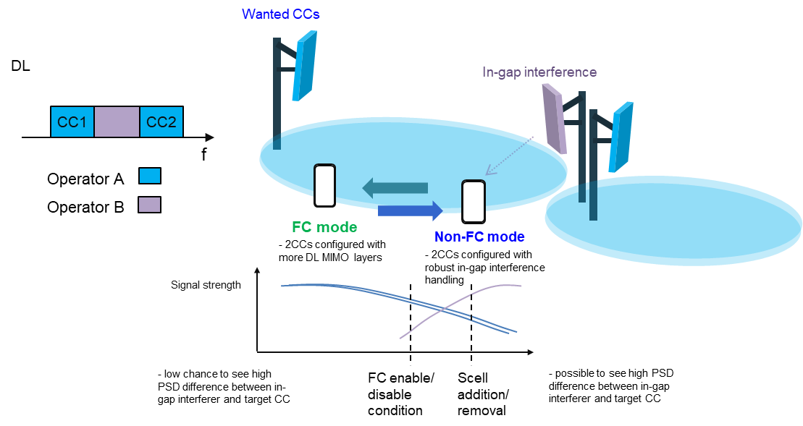

Figure 8.1.2-1: Possible switching scenario between “FC” and “non-FC” targeting more DL MIMO layer support

In the above scenario, when the 2CC of the intra-band DL CA are already configured, the network will control and might enable the UE switching to the FC mode when the signal strength of both CCs are already strong enough, and the in-gap interference is limited. Higher total DL MIMO layer transmission is possible when switching to the FC mode. And when the network controls the UE switch to the non-FC mode, the 2CCs might still remain configured. Similar to the first solution, the UE may have a limitation on the maximum frequency separation between the two non-contiguous downlink carriers when operating in FC mode. This restriction should be considered and managed by the network.

Then in this solution, the UE will report the same CA configuration (intra-band NR CA configuration or higher order inter-band CA configuration with intra-band CA components.) with different maximum DL MIMO layer support per CC, the configuration with higher total maximum DL MIMO layer support will include an additional indication in the capability signalling in order to indicate it is supported under the “FC mode”. Based on this approach, the UE can still leverage the legacy band combination reporting scheme to report the supported combinations in the FC mode. However, additional signalling is required to indicate the UE's Rx sharing capability, along with other related information such as the frequency separation between the two carriers.

The UE might also report the suggested condition to enable the FC mode such as receive signal strength of the 2CCs and/or the in-gap interference limit between the two non-contiguous intra-band DL carriers.

### 8.1.3 Indication of fragmented CA alternative 2: New notation for CA configurations with single Rx RF Chain

Regarding how to indicate UE capability for supporting “one Rx RF chain” for DL fragmented carriers, a new notation FnA could be used to represent there are n NC CCs in one band sharing one RX RF chain. For example: When there are 2 NC CCs of band nX receiving in the separate mode (e.g., fully separate mode or partially shared mode), the CA combination type is CA(2A). When the receiving state switches to one RX RF chain mode, the CA combination type should change to CA(F2A), F represents there are two NC CCs in the one RX RF chain mode and in the sharing chain.

Similarly, CA\_nX(F2A-A) means there are 3 NC CCs and two of them are in the sharing chain (one RX RF chain mode), CA\_nX(F2A-F2A) means there are 4 NC CCs and two of them are in one sharing chain, the other two are in another sharing chain.

Any backwards compatibility issues with a network which does not understand the capability for supporting CA with “one Rx RF chain” would have to be analysed during the WI phase.

### 8.1.4 Indication of fragmented CA alternative 2a: use the new bandwidth class conditioned on the frequency separation between two carriers

The network only configured supported band combination based on the UE capability and the gNB band support, not the RF requirements in 38.101-1. For instance, a slight relaxation of an RF requirement by a few dB on SCell (if necessary) may be considered if this means that a UE would be able to indicate support of a more complex band combination. However, the REFSENS degradation in PCell might increase the risk that the PCell coverage may be lost and lead to radio link failure.

A new indication of bandwidth class conditioned on the frequency separation between two carriers might allow the UE to indicate to the network with the configurations without any REFSENS degradation in PCell

Three example configurations are presented based on the above assumption in the sub-sections below to elaborate on how the UE would indicate to the network to support a fragmented carriers with a single Rx chain.

#### 8.1.4.1 Configuration of nXA + nXA with separate RX chains

It is assumed that bands nX and nY share the antenna and have 8 Rx chains available in the frequency range. As shown in Figure 8.1.4.1-1, two carriers in band nX are aggregated, each carrier supports 4 layers (4L). The PCell and SCell are supported by separate Rx chains and no relaxation of PCell REFSENS.

Figure 8.1.4.1-1. Example configuration with PCell (dark grey) and SCell (light grey): (a) nXA + nXA.

#### 8.1.4.2 Configuration of nXA”+nXA”+nYA with single RX chains

In case the fragmented carriers in nX are supported by a single RX chain when the frequency span is <=100MHz, an additional band nY can be supported with 4 layers without increasing the total number of Rx chains. The PCell is configured in band nY as shown in Figure 8.1.4.2-1 assuming that the UE cannot be configured a PCell in band nX due to REFSENS degradation.

This band combination is indicated in the UE capability, but for the network to correctly parse the capability in nX a condition on the maximum frequency separation shall be added. This could be done by specifying a new bandwidth class A only applicable to intra-band NCCA and *conditioned* on a maximum frequency separation between the lowest and highest carrier edges by 100 MHz. For example, a UE might only indicate 50 MHz bandwidth class on certain FDD band to ensure there is no PCell degradation. A network does not comprehend the new BW class would not configure a band combination containing it, thereby ensuring that this feature does not interfere with the operation of legacy networks.

A limited frequency spacing in band nX will thus enable a single Rx implementation. In this case, a larger number of carriers can be supported with the same 8 Rx chains if the frequency separation of nX is ≤ 50 MHz while maintaining the number of MIMO layers possibly with a slight REFSENS relaxation in SCells. i.e. the spared Rx chains would be used in band nY.

Figure 8.1.4.2-1. Example configuration with PCell (dark grey) and SCell (light grey): nXA” + nXA” + nYA

#### 8.1.4.3 Configuration of nXA”+nXA”+nYA+nZA with single Rx chains and with modified MIMO capability

Furthermore, an additional configuration in Figure 8.1.4.3-1 illustrates that reducing the number of supported layers in one of the bands allows for reducing the number of Rx chains. The Rx chain that are freed-up can then be reallocated to support more CCs. In the example below the fragmented carriers with a single Rx chain are configured only in SCells to avoid PCell degradation.

Figure 8.1.4.3-1. Example configuration with PCell (dark grey) and SCell (light grey): nXA” + nXA” + nYA + nZA.

As illustrated by the examples above, all supported band combinations, regardless of the UE implementation, must be explicitly included in the UE capability signaling. The UE cannot inform the NW that it has a spare Rx chain and expects the NW’s action based on this information without corresponding capability reporting. The network can not only use RF requirements to configure, release, activate, or deactivate carriers, and the network’s action is based on corresponding capability reporting.

To facilitate this, introducing a new BW class capability for the fragmented carriers within a band with restricted frequency separations and MRTD (to ensure collocated scenarios) could indicate the support for such fragmented carriers with a single Rx chain.

The example frequency separation class table is shown below. The capabilities of the corresponding band entry (i.e. feature set) would then be conditioned on a maximum frequency separation of the carriers.

Table 8.1.4-1: NR intra-band non-contiguous DL CA frequency separation classes with single Rx chain mode

|  |  |  |
| --- | --- | --- |
| NR NC DL CA frequency separation class | Maximum allowed frequency separation | Maximum allowed number of CCs |
| I | 100 MHz | 2 |
| II | 200MHz | 2 |
| III | 200 MHz | 4 |

Another example is to use the currently undefined NR CA bandwidth class (BCS) ‘F’ for indicating a CA configuration with fragmented carrier operation.

Table 8.1.4-2: NR CA bandwidth classes

|  |  |  |  |
| --- | --- | --- | --- |
| **NR CA bandwidth class** | **Aggregated channel bandwidth** | **Number of contiguous CC** | **Fallback group** |
| A | BWChannel ≤ BWChannel,max | 1 | 1, 2, 3**4, 4** |
| B | 20 MHz ≤ BWChannel\_CA ≤ 100 MHz | 2 | 2, 34 |
| C | 100 MHz < BWChannel\_CA ≤ 2 x BWChannel,max | 2 | 1, 34 | |
| D | 200 MHz < BWChannel\_CA ≤ 3 x BWChannel,max | 3 |  | |
| E | 300 MHz < BWChannel\_CA ≤ 4 x BWChannel,max | 4 |  | |
| **F** | **BWChannel ≤ 100 MHz** | **1, NOTE 5** | **4** | |
| G | 100 MHz < BWChannel\_CA ≤ 150 MHz | 3 | 2 | |
| H | 150 MHz < BWChannel\_CA ≤ 200 MHz | 4 |  | |
| I | 200 MHz < BWChannel\_CA ≤ 250 MHz | 5 |  | |
| J | 250 MHz < BWChannel\_CA ≤ 300 MHz | 6 |  | |
| K | 300 MHz < BWChannel\_CA ≤ 350 MHz | 7 |  | |
| L | 350 MHz < BWChannel\_CA ≤ 400 MHz | 8 |  | |
| M3 | 50 MHz ≤ BWChannel\_CA ≤ 200 MHz | 3 | 34 | |
| N3 | 80 MHz ≤ BWChannel\_CA ≤ 300 MHz | 4 |  | |
| O3 | 100 MHz ≤ BWChannel\_CA ≤ 400 MHz | 5 |  | |
| NOTE 1: BWChannel, max is maximum channel bandwidth supported among all bands in a release  NOTE 2: It is mandatory for a UE to be able to fallback to lower order NR CA bandwidth class configuration within a fallback group. It is not mandatory for a UE to be able to fallback to lower order NR CA bandwidth class configuration that belong to a different fallback group.  NOTE 3: This bandwidth class is only applicable to bands identified for use with shared spectrum channel access in Table 5.2-1.  NOTE 4: Fallback group 3 is only applicable to bands identified for use with shared spectrum channel access in Table 5.2-1.  **NOTE 5: For fragmented carrier operation with a single contiguous frequency range configured for the UE with multiple fragmented carriers as indicated by IE [*FragmentedCarrier*].** | | | |

In the table above, where the newly added parts are highlighted with bold font, F is inserted with a corresponding number of contiguous CCs as ‘1’, as the intention is to treat the multiple fragmented carriers as a single CC regarding the number of occupied Rx RF chains. Adding Note 5 clarifies that this single contiguous CC can consist of multiple fragmented carriers assumed occupying 1 Rx chain. The new BCS, F, is then added with fallback group 4, which is added correspondingly for the single CC BCS, A, as the fallback from fragmented carrier operation would be single CC operation. However, if the UE can fallback to 2 Rx RF chains from single Rx RF chain (due to high in-gap interference) this should also be possible.

By adding the new NR CA bandwidth class, this can be used to identify fragmented carrier operation and the number of fragments. Examples using band n25 with two fragments are shown in Fig 8.1.4.3-1.

****

Figure 8.1.4.3-3: Example of CA\_n25(2F)



## 8.2 CA fallback and architecture switching

When either the in-gap interference or the self-interference is too high, the receiver is hard to maintain the shared receiving state, i.e., one Rx RF chain, and the “fallback” behaviour needs to be studied. In order to make the application of this function more future-oriented, some higher CA combinations are also considered.

In total, two aspects should be involved when discussing fallback behaviour: “CA fallback” and “architecture switching”.

“CA fallback” means releasing at least one SCell in one band of the band combination, while the “architecture switching” means the switching from “One Rx RF chain (aka. full shared Rx RF chain)” to legacy CA architecture [44], where legacy CA architecture includes fully separated Rx chain and partially shared Rx chain.When there is only one component carrier in one band, it is nature that UE RF hardware is also configured to legacy architecture for single carrier in the band.

When categorizing “CA fallback”, the following scenarios are involved:

a.) Legacy CA combination falls back to lower order CA

- Legacy CA combination belongs to mix of inter-band CA and intra-band CA with more than 2CCs, etc.

b.) Legacy CA combination falls back to “non-CA” mode

- Legacy CA combination belongs to intra-band CA combination with 2CCs.

When categorizing “architecture switching”, the following scenarios are involved:

a.) Architecture switches between “partially shared Rx RF chain” mode and “one Rx RF chain” mode

b.) Architecture switches between “fully separate Rx RF chain” mode and “one Rx RF chain” mode

Based on the analysis above, the fallback behaviour should be totally divided into the following three scenarios:

a.) Scenario 1: CA fallback without architecture switching

b.) Scenario 2: CA fallback with architecture switching

c.) Scenario 3: architecture switching without CA fallback

Below Figure 8.2-1 is an example to illustrate how the UE’s work mode transfers from “one Rx RF chain” to scenarios 1~3. The figure is generated based on Figure 3 in [45] and Figure 1 in [44].

**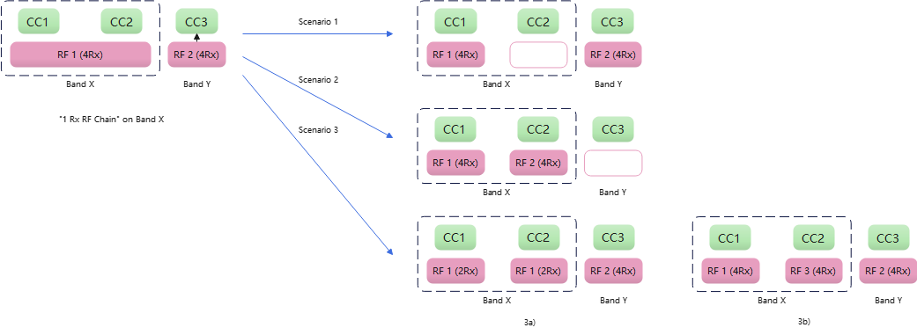**

Figure 8.2-1: Fall-back behaviour, scenarios 1~3

For scenario 1, it doesn’t require additional UE capability and network configuration. As a default, any UE supports the “one Rx RF chain” will support the Scenario 1 as the legacy CA fallback configuration. From network point of view, if the performance on CC2 is not at satisfactory level, the network could just release the CC2 using existing CA operation process. Based on the evaluation result in section 7, the performance loss of “one Rx RF chain” is comparable with that of the other CA configurations in the RAN4 specification. It’s therefore feasible to handle the CA configuration with “one Rx RF chain” as a normal CA configuration. It is also beneficial for early deployment of the fragmented carrier feature without requiring upgrading the network. On the other hand, as [46] pointed out, in some cases the Scenario 1 might not be the best choice from network’s point of view if the CC2 has larger bandwidth than CC3, or the CC2 could achieve better channel quality using legacy CA architecture than CC3. The Scenario 2 is thus considered.

For scenario 2, it keeps the CC2 and releases CC3 if the network decides the CC2 could provide what the network expects with better performance than CC3. This Scenario requires architecture switching, which means the RF chains previously used by CC3 need to be retuned to CC2 in case all the Rx chains are used up. However, whether the RF chains for different bands could be flexibly switched across the bands depends on UE implementation and is band combination specific, which means such info, e.g., UE capability, may need to be indicated to the network. Whether and how such information is indicated to network is for further study. The Scenario 2 would be useful especially when the performance of CC2(CC1) could be improved a lot when switching back to legacy CA architecture, such as when there is serious Tx leakage, or the in-gap interference is quite high considering the non-collocated scenario. Additional UE measurement might be needed to assist the network to compare the performance of CC2 and CC3.

For Scenario 3, it doesn’t reduce the number of CCs, but requires architecture switching with reduced DL MIMO layers (Scenario 3a) or the same DL MIMO layers (Scenario 3b). Similar to Scenario 2,whether the switching is feasible depends on UE implementation and is band combination specific, and whether and how such information is indicated to network is for further study. The Scenario 3b assumes there are enough spare Rx chains. [47] mentions the benefit of adopting “one Rx RF Chain” is not very clear from the RF performance aspect if there are spare Rx chains. On the other hand, the UE might get the benefit of power saving from “one Rx RF Chain” if the relevant conditions could ensure a satisfactory Rx performance.

It needs to be considered whether the transition from “one Rx RF Chain” to Scenario 1~3 is ‘network initiated’ or ‘UE initiated’. ‘Network initiated’ means the network will send a command to the UE to trigger the transition, with or without assistant indication or measurement report from the UE. ‘UE initiated’ means the UE could execute the transition without receiving the network’s command. UE may inform the network after the transition happened.

- Scenario 1, 2 and 3a involve the change of number of CCs or number of DL MIMO layers, which has to be configured by the network, i.e. ‘network initiated’.

- For Scenario 2, the network configuration might explicitly indicate the architecture switching, or the switching could be done by the UE autonomously.

- The Scenario 3b could be transparent to the network if the UE has spare Rx chains. Although some interruption is needed. The network could also intentionally configure the Scenario 3b. Therefore both ‘network initiated’ or ‘UE initiated’ could apply to Scenario 3b.

More details on how the UE’s work mode switching from separate mode to “one RX RF chain” and falling back to scenarios 1~3 are achieved are as follows:

### 8.2.1 Case1: Partially shared switch to fully shared & fallback behaviour

According to session 5.2, the partially shared architectures contain both internal Rx path split and external Rx path split. These two partially shared architectures are expressed in the same form as below, i.e., the antenna is shared between CC1/2/3, and the other devices before down-conversion such as LNA, BPF are omitted here.

When partially shared architecture switches to fully shared architecture, for band nX CC1 and CC2 would be received by one RX RF chain together instead of each CC taking up one chain. Therefore, there would be one chain being released after each antenna.

According to the utilization of the released chain, there are two sub-scenarios: the released chain is not used (Fig 8.2.1-1), or the released chain is used to aggregate more CCs in the same band (Fig 8.2.1-3). As the new aggregated CCs belong to the same band and there is no new demand in the UE's hardware capability, it could be predicted that there is no new capability needed except for supporting the “one Rx RF chain” architecture.

a.) After sharing, the released chain is not used.

- Partially shared→ “one Rx RF chain”



Figure 8.2.1-1: Partially shared switch to “one Rx RF chain” mode

As can be seen in Fig 8.2.1-1, before sharing the partially shared architecture composes of one set of RX chain (one main Rx + one diversity Rx). After sharing half of the chain is released and unused which may have the benefit of power saving.

- Fallback behaviour:



Figure 8.2.1-2: Fallback to lower order CA combination (scenario1), or CA combination unchanged (scenario3)

b.) After one Rx RF chain is enabled, the released chain is used to aggregate more CCs in the same band.

- Partially shared→ “one Rx RF chain” & Fallback behaviour

The following analysis takes the 4Rx RFchain architecture as an example, and the analysis of the 2Rx RFchain architecture is similar. 4Rx UE contains one main receiver branch and three diversity receiver branches, which could be seen in Fig 8.2.1-3.



Figure 8.2.1-3: 4RX UE, switch to “one Rx RF chain” mode



Figure 8.2.1-4: 4RX UE, fall-back to a lower order CA combination

In Fig 8.2.1-4, for 4Rx UE the fallback behaviour would lead to a lower order CA combination with architecture changed (scenario1) or unchanged (scenario2).

### 8.2.2 Case2: Fully separate switch to fully shared & fallback behaviour

According to the discussion before, there is another implementation architecture before sharing: fully separate mode, which means each CC has exclusive access to one single Rx RF chain from antenna to ADC.[48]

The following analysis primarily focuses on the utilization of idle links after switching to “one Rx RF chain” mode and its differences from the partially shared architecture. The fallback behaviour is similar and therefore omitted here.



Figure 8.2.2-1: After switching to “one Rx RF chain” mode, more CC from another band could be aggregated (case A), or MIMO layer could be higher

When fully separate architecture switch to fully shared architecture, some RX chains would also be released and the band combination or MIMO layer could be increased. Since the switching scheme of case A may involve changes in frequency and/or bandwidth of some devices as the part of the architecture would switch to receive the CC3 from another band, it should be supported by additional capability(ies).

## 8.3 Triggering condition to enable ”One Rx RF chain”

When discussing a method to enable or disable using one Rx RF chain RAN4 would need a common understanding of ‘Triggering condition’. RAN4 can consider triggering a switch between using one Rx RF chain or separate Rx RF chains for reception of multiple CCs in a fragmented deployment can be performed using different but not limited in the following approaches:

• Controlled by network based on UE assistance information.

• Controlled by UE based on network assistance/configuration and with/without network knowledge.

• Controlled by UE autonomously without network assistance/configuration and with/without network knowledge.

When considering triggering conditions RAN4 needs to consider possible assistance information related to such triggering type (for example measurements, thresholds etc.), and necessary UE requirements related to providing such information to the network.

### 8.3.1 Triggering condition proposal for option 1: Rely on existing channel quality reporting and procedures

One possible option of the triggering condition is to rely on existing channel quality reporting and procedures.

Below Figure 8.3.1-1 shows an existing channel quality reporting procedures related to CA. Before the SCell is added/activated, L3-measurement is available, including measurement quantities of RSRP/RSRQ/SINR. Measurement gap or interruption is specified depending on the measurement type, i.e. inter-frequency/intra-band CA/inter-band CA. L3-measurement is filtered and could reflect relatively long-term channel quality. After the SCell is activated, CQI measurement and report is available. The L3-measurement is also available, but no interruption is allowed.

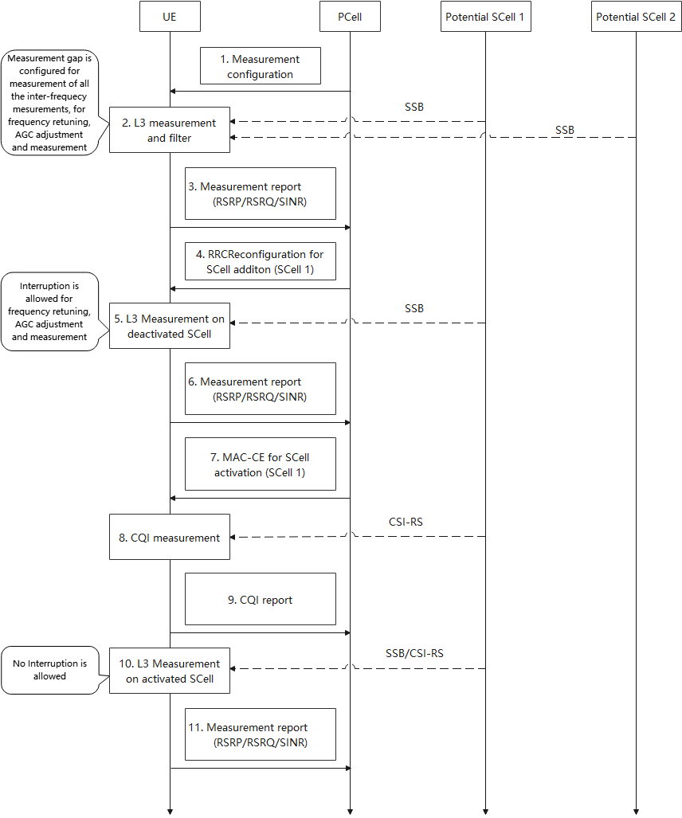

Figure 8.3.1-1 Existing channel quality reporting and procedures

Option 1-1: Reuse the existing channel quality reporting procedure without any change.

In this option, the measurements are done with separate Rx RF chains. With this approach, the CA with “One Rx RF chain” is handled in the same way of all the other CA configurations. One of the reasons is that the observed RF performance degradation of “One Rx RF chain” is comparable with many CA configurations in existing specification. It may not be necessary to distinguish the REFSENS MSD caused by “One Rx RF chain” and caused by other factors such as harmonics and intermodulation, although the degradation due to “One Rx RF chain” and the degradation due to channel fading may require the network to take different actions. This approach may be simpler in a commercial deployment if there is no need to upgrade or no impact to an existing network deployment. This option is feasible especially when the RF performance degradation caused by “One Rx RF chain” is small, such as TDD bands, inter-operator collocated scenario, or UE locates in the cell centre. If the RF performance degradation is very large, there might be ping-pong effect of SCell adding/releasing due to inaccurate measurement results.

Option 1-2: Reuse the existing channel quality reporting procedure with “One Rx RF chain” measurement.

In this option, the measurements can be done with “One Rx RF chain” for two CCs simultaneously. Some companies suggested refining the procedures and monitoring the impact of “One Rx RF chain” to get a better decision on CA configuration and UE RF architecture. In current channel quality reporting procedure, the L3-measurement or CQI measurement on an SCell is based on separate RF chain architecture. The measurement results can’t reflect the degradation of RF performance due to strong self-interference or strong in-gap interference. To improve the CA 1 Rx RF chain configuration decision, it is useful having the UE to additionally perform the measurement based on “One Rx RF chain”. For example, before configuring SCells as intra-band CA, the network will indicate the UE to measure the potential CCs within the same band. Depending on UE’s ability to measure the channel quality for two CCs simultaneously using “One Rx RF chain”, or if the UE has more Rx chains, the UE can use either “One Rx RF chain” or separate RF chains to perform the measurement.

### 8.3.2 Triggering condition proposal for option 2: UE measurement to determine and indicate to the network

Triggering condition to enable ”One Rx RF chain” with UE assisted in-gap interference measurement and indication

When the UE enables one Rx RF chain to receive two non-contiguous carriers under the network, it was assumed another adjacent channel downlink carrier, from collocated second operator, in the gap may also exists at the same time. From companies’ simulation, when the power difference between the in-gap blocker and wanted carriers are higher than the image rejection ratio, i.e. 25dBc, it may seriously degrade the receiving signal quality of wanted carriers. A new measurement mechanism can be needed to judge the in-gap blocker power level and compare with the wanted signal power levels. Referring [23], an example UE states and example flow of state change are proposed as following:

State 1: UE is configured for CC1 on the band and meets the requirements accordingly

State 2: UE is configured for non-contiguous CC1 and CC2 on the band and uses two Rx chains to receive them and meets existing DL NCCA requirements accordingly

State 3: UE is configured for non-contiguous CC1 and CC2 on the band and uses one Rx RF chain to receive them and meets possible new requirements accordingly

Stete 4: UE is configured same as state 1 (CC1, Pcell) and has been checked no more available Rx RF chain to receive intra-band non-contiguous CC2 using second Rx RF chain

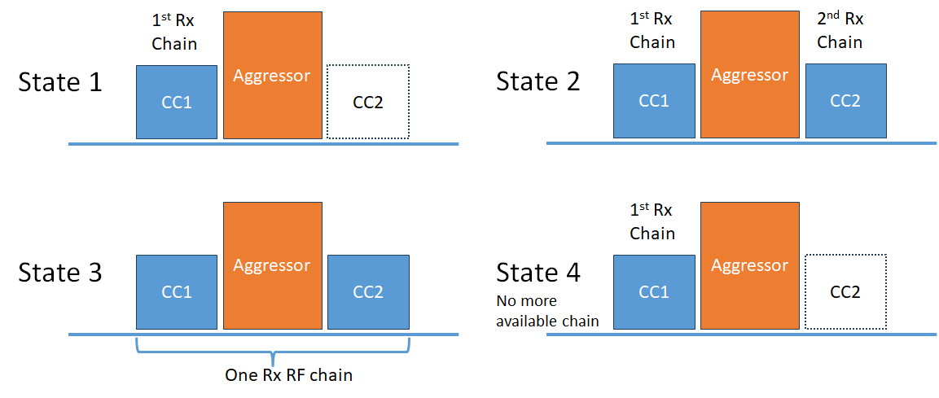

Figure 8.3.2-1: Description of different UE states for fragmented carriers

**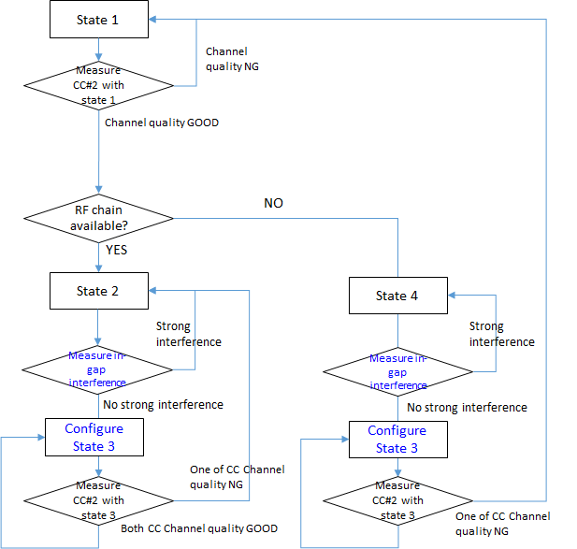**

Figure 8.3.2-2: State diagram for switching between the states

When UE has more available Rx RF chain, UE can just apply legacy DL NCCA architecture to maintain best performance on receiving each CC as illustrated in Figure 8.3.2-2. UE can also be configured for measurement by network to check whether the large interference exists and whether UE is capable to receive one more CC when needed while UE is in state 2.

When UE don’t have more available Rx RF chain (state 4), UE can still be configured for measurement by network doing same check. UE can just report to network capable or not-capable for the one Rx RF chain as UE assisted information.

When UE is configured by network to do measurement on both wanted CCs and in-gap interference, UE can simply using existing RSSI measurement approach for in-gap interference measurement. Network can configure the measurement bandwidth and the virtual RB location to the UE, wherein the RB location to be measured in the in-gap region can be referring to PCC or one of the CCs. The details of measurement flow can be further discussed during WI phase if there is work item in the future.

The benefit if UE can measure in-gap interference can be observed from the state chart is ping-pong between state 2 and state 3 or between state 4 and state 3 can be reduced if large in-gap interference can be discovered.

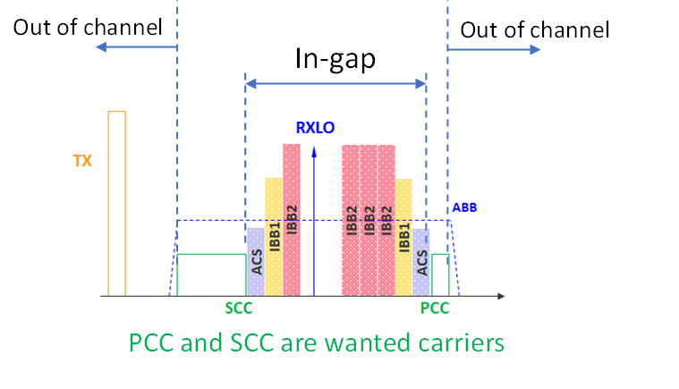

Figure 8.3.2-3: Spectrum plot of DL fragmented carriers and in-gap interference

It would be possible to measure noise level of both wanted CCs and in-gap range if total BW is within the 100MHz under one Rx RF chain mode. One possible method to measure in-gap interference level is to referring existing RSSI measurement procedure with virtual RB ranking in the in-gap region or refer to measuring neighbour cell procedure. The measurement would be applicable in both one Rx RF chain mode and legacy (partial-separated Rx RF chain) mode.

The ping-pong between state 2/4 and state 3 can be reduced if UE can measure in-gap interference.

An alternative example to avoid frequent interruption due to UE measurement with self-assessment, single shot measurement/interruption can be applied before UE indication to Network. The workflow can be refereed to below figure.

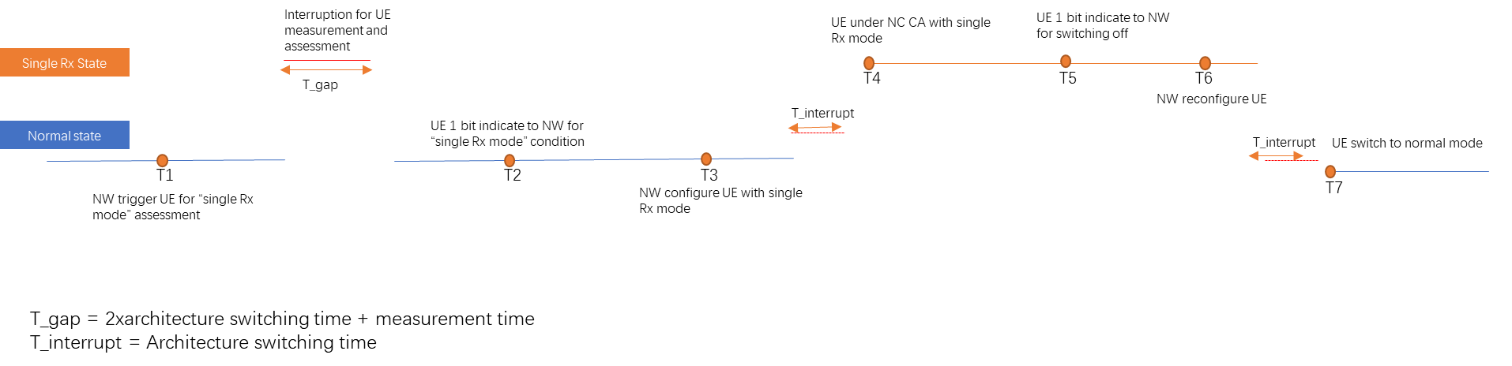

Figure 8.3.2-4: Work flow on UE switching between normal mode and single Rx mode

In-gap inter-operator interference may not be the only factor that has impact on DL receiving performance when one Rx RF chain mode is configured. During Rx performance evaluation and discussion between companies, it was found self-band Tx leakage also plays an important role. It would be more clear to understand these impacts via evaluating the two factors with the help from system level simulation. The simulation assumptions are listed in the Table 8.3.2-1 below.

Table 8.3.2-1: Assumptions for system level simulation

|  |  |
| --- | --- |
| Parameter | NR |
| Carrier | 2G Hz |
| DL BW | 20MHz |
| UL BW | 20MHz |
| Antenna pattern | TR 38.901 Table 7.3-1 |
| Network layout | 19-sites (57 sectors) with wrap-around |
| Inter-site distance in meter | 500 for 2GHz band for UMA |
| System loading and activity | Full buffer 100% |
| Network layout | 19-sites [57 sectors] with wrap-around |
| DL power control | No |
| UL power control | TR 36.942[8] section 5.1.1.6 (set 1) by bandwidth scale, target SNR at BS is 15 dB |
| NR UE dropping | NR UE: 100% outdoor  UE number: DL active UE: 10 UE per cell |
| Pathloss model | TR 38.901 UMA |
| O2I penetration loss | High penetration loss as in TR 38.901 |

It is assumed co-located inter-operators, taking 19-sites with 3 sectors in each site. 10 UEs in every sector per operator. These are illustrated below:

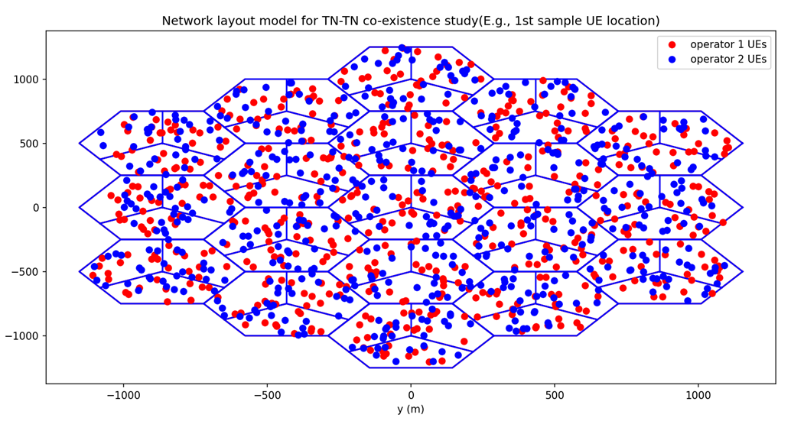

Figure 8.3.2-5: Network layout model for system level simulation

For the UE parameter assumptions, they are listed in the Table 8.3.2-2. One Rx RF chain ACS performance is evaluated with values of 15 and 26 dB. 33dB is assumed as performance reference of partial separated Rx RF chain configuration.

Table 8.3.2-2: UE assumptions for system level simulation

|  |  |  |
| --- | --- | --- |
|  |  | NR |
| UE | Tx ACLR | 30dB (ACLR1)  43dB (ACLR2) |
| Duplexer isolation between T/R | 50dB |
| Rx baseband analog filter Tx leakage rejection | 5dB (one Rx RF chain)  15dB (partial separated Rx RF chain) |
| Rx ACS | 15, 26dB (one Rx RF chain)  33dB (partial separated Rx RF chain) |

Simulation result is illustrated in below figures.

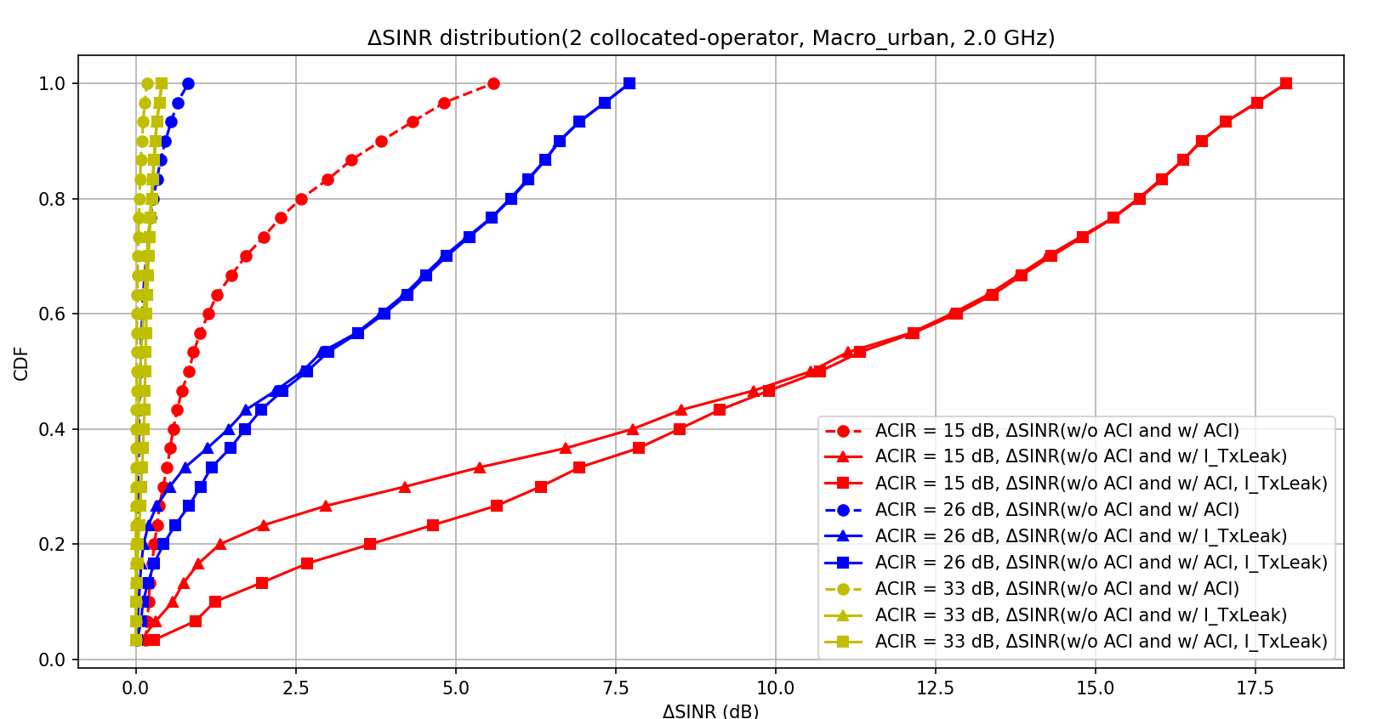

Figure 8.3.2-6: CDF of DL signal and interference distribution w w/o ACI of Tx leakage

From the simulation results, some important aspects can be observed:

a.) In-gap interference and Tx leakage both have impact on DL receiving SINR performance. Which one occupies larger portion may depend on UE implementation and the distance/channel condition between UE and gNB.

b.) UE self-judgement mechanism would be needed with considering both in-gap interference and Tx leakage. As long as UE can guarantee pass the adjusted minimum requirements, if specified. How to judge whether UE is capable for one Rx RF chain mode can be left to UE implementation.

c.) Even though there are some degradations on the DL receiving SINR, there are certain percentage of UEs can still benefit from enabling one Rx RF chain when higher order CA combo is configured, with acceptable degradation.

On how to decide to enable ”one RF Rx chain“ or fall-back to normal mode, this can be left to UE implemention as long as UE can guranteen the Rx performance. Once UE detect ”single Rx chain operation” is not suitable, then UE can indiate to NW and NW can reconfigure UE with single CC or normal CA mode.

There are several ways to enable triggering condition, those options were summarized in below table.

Table 8.3.2-3: Options for triggering condition to enable ”One Rx RF chain”

|  |  |  |  |  |
| --- | --- | --- | --- | --- |
| **Options** | **Spec impact** | **Signaling overhead** | **UE implementation complexity** | **Potential performance impact** |
| **Option 1-1: Existing channel quality reporting and procedures without any change** | Minimal | No additional signaling | No additional reporting | Not possible to monitor Tx leakage and in gap interference before UE switched to single RX mode.  Ping-pong effect between different states with frequently switching on/off when the RF performance degradation caused by “One Rx RF chain” is very large |
| **Option 1-2: Reuse the existing channel quality reporting procedure with “One Rx RF chain”share Rx architecture measurement.** | Small | Update to measurement configuration is needed to request UE performs measurement in “One Rx RF chain” | No additional reporting | NW is fully aware of the UE’s performance difference between “One Rx RF chain” state and legacy state  Measurement gap and interruption required before UE enter into Single RX mode for reporting |
| **Option 2a: UE measurement reporting for in gap interference** | Big impact with NW configuration and UE reporting (RAN1, RAN2 also need to be involved) | Signaling on measurement configuration and reporting | UE needs to follow NW configuration for measurement and reporting | NW can manage interference  Measurement gap and interruption required before UE enter into Single RX mode for reporting  Measurement reliability and/or accuracy has not been analyzed |
| **Option 2b: UE self-assessment with 1bit indication to network** | Small impact with 1bits indication  FFS whether measurement gap interruption required for monitoring interference before UE enter into CA mode | Limited signaling overhead on indication | UE self-judgment, no measurement reporting required | NW can aware whether UE state is suitable for single Rx mode  Measurement gap and interruption required before UE enter into Single RX mode for reporting  The UE indication may imply UE can pass RF minimum requirements  NW doesn’t have accurate expectation of how good UE could behave with the “One Rx RF chain” |

The UE could evaluate how good it could behave with the “One Rx RF chain” based on the measurements it needs, such as the self-interference, the strength and location of the in-gap interference, etc. Then the UE indicate the evaluation result to the network, either a simple indication of “yes” or “no”, or in some finer granularity.

With the discussion above, option 1 Existing channel quality reporting and procedures or option 2b UE self-assessment with 1bit indication to network may be more preferable

There are ways to limit the potential impacts on the DL performance for PCell, e.g., 1) TDD CA configuration or FDD CA configurations that have large duplex gap would experience no or little self-interference issue. 2) In case of self-interference for FDD CA configurations, PCC SCC Swapping can be used. 3) The use of 1 Rx RF chain can be enabled when the UE is not located at cell edge

# 9 Summary for NR FR1 DL fragment carriers study

The intra-band non-contiguous carrier aggregation (Intra-band NC CA) has been introduced in the RAN4 specs for years. The requirements defined in the current specification for intra-band DL NC CA are based on the partially-shared architecture which requires separate Rx RF chains and Rx LOs for receiving each of the non-contiguous carriers that limit the CA capabilities as the maximum supported number of component carriers. In this study, RAN4 has investigated an architecture with one Rx RF chain (fully shared receiver) architecture to reduce the number of Rx chains for receiving intra-band DL NC CA carriers in the case of the frequency span between the DL carriers within 100MHz so that the UE can support receiving more DL carriers with remaining Rx RF chains.

From the study on power spectral density difference between carriers of co-located adjacent channel operators, the in-gap interference to wanted signal ratio (ISR ratio) can range from 20dB to less than 0dB due to different gNB antenna pattern assumptions as shown in system level simulation. The simulation further shows if the network shifts i.e., non-collocated adjacent channel operators, the delta RSRP can range from tens of dBs to negative tens of dBs which implies the in-gap interference rejection capability needs to be as good as possible.

The adjusted receiver RF requirements for one Rx RF chain architecture for example bands have also been evaluated by companies. There may be additional REFSENS degradation for FDD bands in some scenarios in comparison with the existing requirement due to one Rx RF chain mode on both PCC and SCC in the FDD bands due to self-Tx leakage impact and insufficient filter attenuation. The network vendors have expressed strong concerns regarding the degradation of the Pcell when one Rx RF chain mode is configured.

In summary, to manage the impact of Pcell performance degradation, the following operation scenarios can be considered for intra-band non-contiguous DL CA:

a.) FDD band DL fragmented carriers

i. CBW of both DL fragmented carriers + Wgap are small enough

ii. UE located so near to the gNB that UL Tx power level is not too large

iii. For higher order CA combination, both intra-band DL fragmented carriers are SCC (Pcell UL is in another band)

iv. When UE is capable of interference measurement, self-assessment and/or reporting

v. The frequency allocation of PCC and SCC to avoid worst case configuration on DL performance i.e., PCC/SCC assignment

b.) TDD band DL fragmented carriers

There are different opinions about what UE Rx RF requirements should be relaxed for receiving the Intra-band NC CA using one Rx RF chain and, where applicable, how much in what band. Further candidates for a relaxation are e.g. the adjacent channel selectivity and the in-band blocking inside the gap between the NC CCs, in particular in the asymmetric case of different channel bandwidths of the NC CCs because then the image of an in-gap interferer can overlap with the wider of the NC CCs.

The signalling indication has also been discussed and agreed on the following two aspects[22]. The down-selection or final decision can be made during work item phase:

Alternative 1: use the legacy band combination reporting scheme + Rx sharing capability indication

Alternative 2: use the new notation or new bandwidth class for CA configurations with single Rx RF Chain

The UE behaviour regarding CA fallback with/without UE architecture switching has also been discussed. One option is for a UE that is configured with one Rx RF chain mode to fallback to a single CC. As for other fallback configurations, scenario 2 and scenario 3 as illustrated in clause 8.2, Fig 8.2-1, that may happen with architecture switching together and depend on UE implementation, which means such info, e.g., UE capability, may need to be indicated to the network. Whether and how such information is indicated to network is for further study.

The criteria of enabling one Rx RF chain mode have also been discussed. One approach is to rely on existing channel quality reporting and procedures without a new indication from the UE. The measurement can be performed in one Rx RF chain mode or legacy mode (e.g., with partially-shared Rx RF chain). The other approach is for a UE to perform measurements to determine and indicate to the network whether it can support non-contiguous CCs with one Rx RF chain. An exemplary flow of UE state change is also captured in the technical report for reference.

Based on the study outcome, RAN4 concludes that it is feasible under certain conditions for a NR UE to operate one Rx RF chain mode to receive two DL non-contiguous carriers.

Annex A (informative):  
Change history

|  |  |  |  |  |  |  |  |
| --- | --- | --- | --- | --- | --- | --- | --- |
| **Change history** | | | | | | | |
| **Date** | **Meeting** | **Tdoc** | **CR** | **Rev** | **Cat** | **Subject/Comment** | **New version** |
| 2024-08 | RAN4 #112 | R4-2411553 |  |  |  | TR skeleton for Study on NR FR1 DL Fragmented Carriers | 0.0.0 |
| 2024-08 | RAN4 #112bis | R4-2416132 |  |  |  | Editorial update of TR for Study on NR FR1 DL Fragmented Carriers | 0.0.1 |
| 2025-03 | RAN4  #114bis | R4-2504105 |  |  |  | Updated version including agreed TP:  R4-2502925 TP for TR38.755 | 0.1.0 |
| 2025-03 | RAN4  #114bis | R4-2505158 |  |  |  | Updated version including agreed TPs | 0.2.0 |
| 2025-05 | RAN4#115 | R4-2506984 |  |  |  | Reorganize directory based on WF in RAN4#114bis | 0.3.0 |
| 2025-05 | RAN4#115 | R4-2508123 |  |  |  | Capture agreed TPs in RAN4#115  R4-2507938 TP for triggering condition option1 in FS\_NR\_DL\_Frag\_Carrier  R4-2507939 TP for RRM aspect of FS\_NR\_DL\_Frag\_Carrier  R4-2508113 TP for TR signaling indication for Option 2 new notations  R4-2508114 TP for TR indication of fragmented CA alternative 1  R4-2506065 TP to TR 38.755 on Clause 6  R4-2507950 TP to TR 38.755 on fallback behaviour  R4-2507951 TP for TR38.755: Summary for NR FR1 DL fragment carriers study  R4-2507948 TPs to TR 38.755 with aspects of Fragmented CA  R4-2507949 TP to TR 38.755 on UE indication to the network  R4-2507947 TP for TR Discussion on signalling aspects  R4-2505783 TP to TR 38.755 on RF requirements evaluation  R4-2507953 TP to TR 38.755: on UE indication of supporting FR1 fragmented carriers  R4-2506270 TP for TR 38.755 on RF requirements evaluation for fragmented carriers from company S  R4-2506376 TP to TR 38.755 on UE RF requirements evaluation for fragmented carriers  R4-2506378 TP to TR38.755 on UE RF requirements impact for fragmented carriers  R4-2507952 TP for TR Summary on the evaluation results and further discussion on the one Rx RF chain mode applicability  R4-2507477 TP for TR 38.755 on RF performance | 0.4.0 |