**3GPP TSG-RAN WG4 Meeting #104-e *R4-22xxxxx***

**Electronic Meeting, 15-26 August, 2022**

|  |  |  |  |  |  |  |  |  |
| --- | --- | --- | --- | --- | --- | --- | --- | --- |
| *CR-Form-v12.2* | | | | | | | | |
| **CHANGE REQUEST** | | | | | | | | |
|  | | | | | | | | |
|  | **38.151** | **CR** | **xx** | **rev** |  | **Current version:** | **17.1.0** |  |
|  | | | | | | | | |
| *For* [***HE******LP***](http://www.3gpp.org/3G_Specs/CRs.htm#_blank)*on using this form: comprehensive instructions can be found at* [*http://www.3gpp.org/Change-Requests*](http://www.3gpp.org/Change-Requests)*.* | | | | | | | | |
|  | | | | | | | | |

|  |  |  |  |  |  |  |  |  |
| --- | --- | --- | --- | --- | --- | --- | --- | --- |
| ***Proposed change affects:*** | UICC apps |  | ME | **X** | Radio Access Network |  | Core Network |  |

|  |  |  |  |  |  |  |  |  |  |  |
| --- | --- | --- | --- | --- | --- | --- | --- | --- | --- | --- |
|  | | | | | | | | | | |
| ***Title:*** | Big CR to 38.151: Introduction MIMO OTA performance requirements (Rel-17, CAT B) | | | | | | | | | |
|  |  | | | | | | | | | |
| ***Source to WG:*** | vivo, CAICT | | | | | | | | | |
| ***Source to TSG:*** | R4 | | | | | | | | | |
|  |  | | | | | | | | | |
| ***Work item code:*** | NR_MIMO_OTA-Perf | | | | |  | ***Date:*** | | | 2022-08-30 |
|  |  | | | |  | |  | | |  |
| ***Category:*** | **B** |  | | | | | ***Release:*** | | | Rel-17 |
|  | *Use one of the following categories:* ***F*** *(correction)* ***A*** *(mirror corresponding to a change in an earlier release)* ***B*** *(addition of feature),* ***C*** *(functional modification of feature)* ***D*** *(editorial modification)*  Detailed explanations of the above categories can be found in 3GPP [TR 21.900](http://www.3gpp.org/ftp/Specs/html-info/21900.htm). | | | | | | | | *Use one of the following releases: Rel-8 (Release 8) Rel-9 (Release 9) Rel-10 (Release 10) Rel-11 (Release 11) … Rel-16 (Release 16) Rel-17 (Release 17) Rel-18 (Release 18)*  *Rel-19 (Release 19)* | |
|  |  | | | | | | | | | |
| ***Reason for change:*** | | R4-2211826 Draft CR to update Number of HARQ Processes  < The number of HARQ Processes was defined incorrectly >  R4-2211987 Draft CR to TS 38.151 on editorial correction  < editorial change >  R4-2212644 draft CR to TS38.151 on maximum downlink power and additional criterion for FR1 MIMO OTA test  < In TS 38.151, the maximum downlink power and the additional criterion for FR1 MIMO OTA test are not fully confirmed >  R4-2212828 draft CR to TS38.151 on MIMO OTA requirements  < The criterion in azimuthal orientations for 90% throughput is not confirmed, and whether different criterion on 90%TP for bands ≥3GHz and bands <3GHz is FFS. Based on the commercial terminal testing results from several companies in RAN4#103-e meeting, no results fail to meet 90% throughput in 10 of total 12 azimuthal orientations for both bands ≥3GHz and bands <3GHz. Therefore, same criteria should be used and 10 of total 12 azimuthal orientation should be concluded for targeting the completion of WI.  In addtion, the requirements table for FR1 and FR2 MIMO OTA is not specfied.>  R4-2214794 draft CR to TS38.151 on minmum requirements  < In TS 38.151, the minimum requirements for FR1 and FR2 MIMO OTA are not specified.>  R4-2214816 draft CR to 38.151 on Validation Passfail limit  < Specific PDP, PAS, V/H and TCF pass/fail limits >  R4-2214818 CR to 38.151 on Channel model calidation  <Spec context inconsistency may lead to confusion.> | | | | | | | | |
|  | |  | | | | | | | | |
| ***Summary of change:*** | | R4-2211826 Draft CR to update Number of HARQ Processes  < Update the number of HARQ Processes from 1 to 8 for TDD and from 1 to 4 for FDD >  R4-2211987 Draft CR to TS 38.151 on editorial correction  < addition of TS 38.101-4 in reference clause;  addition of several missing abbrevations;  clarifying that FR2 stands for FR2-1 only for present specification;  other editorial corrections.>  R4-2212644 draft CR to TS38.151 on maximum downlink power and additional criterion for FR1 MIMO OTA test  < Remove the square brackets on the maximum downlink power and the additional criterion for FR1 MIMO OTA test, comfirm the same criterion on 90%TP for bands ≥3GHz and bands <3GHz can be defined.>  R4-2212828 draft CR to TS38.151 on MIMO OTA requirements  < Confirm the criterion in azimuthal orientations for 90%TP, by removing the square bracket. Confirm the same criterion on 90%TP for bands ≥3GHz and bands <3GHz, by removing the note in Clause 6.1.  Add requirements table for FR1 and FR2 MIMO OTA in Clause 6.2.>  R4-2214794 draft CR to TS38.151 on minmum requirements  < The minimum requirements for FR1 and FR2 MIMO OTA are added.>  R4-2214816 draft CR to 38.151 on Validation Passfail limit  < Remove the square bracket for PDP, PAS, V/H pass/fail limits. The same wording for Temporal Correlation pass/fail limits is applied for FR1 and FR2.>  R4-2214818 CR to 38.151 on Channel model calidation  < Regarding Doppler/Temporal correlation, absolute values are applied for normalization instead of real numbers.  Regarding FR1 Spatial correlation, span is consistent with number of points in VNA settings. Add note: Span and number of points may be increased to estimate reliably.  Regarding FR2 PSP, H(m∆f,n∆t) is consistent with VNA settings. Add note: Span and number of points may be increased to estimate reliably.> | | | | | | | | |
|  | |  | | | | | | | | |
| ***Consequences if not approved:*** | | R4-2211826 Draft CR to update Number of HARQ Processes  < Test cases are not aligned with 38.101-4 patterns >  R4-2211987 Draft CR to TS 38.151 on editorial correction  < editorial errors remain>  R4-2212644 draft CR to TS38.151 on maximum downlink power and additional criterion for FR1 MIMO OTA test  < FR1 MIMO OTA test cannot be accurately performed, and FR1 MIMO OTA performance of UEs cannot be firmly verified >  R4-2212828 draft CR to TS38.151 on MIMO OTA requirements  < MIMO OTA requirement is not concluded >  R4-2214794 draft CR to TS38.151 on minmum requirements  < The MIMO OTA performance of NR UEs cannot be verified..>  R4-2214816 draft CR to 38.151 on Validation Passfail limit  < PDP, PAS, V/H and TCF pass/fail limits are not specified.>  R4-2214818 CR to 38.151 on Channel model calidation  < Spec context inconsistency > | | | | | | | | |
|  | |  | | | | | | | | |
| ***Clauses affected:*** | | 2, 3.2, 3.3, 5.1, 6, 7, B.1, C.3.3, C.3.4, C.4.3, D.3.3, D.3.4, D.4.2, D.4.3, D.4.4, D.4.5, E-1, E-2 | | | | | | | | |
|  | |  | | | | | | | | |
|  | | **Y** | **N** |  | | | |  | | |
| ***Other specs*** | |  | **X** | Other core specifications | | | | TS/TR ... CR ... | | |
| ***affected:*** | |  | **X** | Test specifications | | | | TS/TR ... CR ... | | |
| ***(show related CRs)*** | |  | **X** | O&M Specifications | | | | TS/TR ... CR ... | | |
|  | |  | | | | | | | | |
| ***Other comments:*** | |  | | | | | | | | |
|  | |  | | | | | | | | |
| ***This CR's revision history:*** | |  | | | | | | | | |

<<< START OF CHANGE 1>>>

# 2 References

The following documents contain provisions which, through reference in this text, constitute provisions of the present document.

- References are either specific (identified by date of publication, edition number, version number, etc.) or non‑specific.

- For a specific reference, subsequent revisions do not apply.

- For a non-specific reference, the latest version applies. In the case of a reference to a 3GPP document (including a GSM document), a non-specific reference implicitly refers to the latest version of that document *in the same Release as the present document*.

[1] 3GPP TR 21.905: "Vocabulary for 3GPP Specifications".

[2] 3GPP TR 38.827: “Study on radiated metrics and test methodology for the verification of multi-antenna reception performance of NR User Equipment (UE)”.

[3] 3GPP TS 38.101-1: "NR; User Equipment (UE) radio transmission and reception; Part 1: Range 1 Standalone"

[4] 3GPP TS 38.101-2: "NR; User Equipment (UE) radio transmission and reception; Part 2: Range 2 Standalone"

[5] 3GPP TS 38.101-3: "NR; User Equipment (UE) radio transmission and reception; Part 3: Range 1 and Range 2 Interworking operation with other radios"

[6] 3GPP TS 36.101: "Evolved Universal Terrestrial Radio Access (E-UTRA); User Equipment (UE) radio transmission and reception"

[7] 3GPP TS 38.508-1: "5GS; User Equipment (UE) conformance specification; Part 1: Common test environment"

[8] 3GPP TR 38.901: "Study on channel model for frequencies from 0.5 to 100 GHz"

[9] F. Zhang, L. Hentilä, P. Kyösti and W. Fan, "Millimeter-wave New Radio Test Zone Validation for MIMO Over-the-air Testing," in IEEE Transactions on Antennas and Propagation, doi: 10.1109/TAP.2021.3111326.

[10] 3GPP TS 38.101-4: "NR; User Equipment (UE) radio transmission and reception; Part 4: Performance requirements"

# 3 Definitions of terms, symbols and abbreviations

## 3.1 Terms

For the purposes of the present document, the terms given in 3GPP TR 21.905 [1] and the following apply. A term defined in the present document takes precedence over the definition of the same term, if any, in 3GPP TR 21.905 [1].

**PSP (PAS Similarity Percentage):** The similarity of the PAS produced by the OTA system and the reference PAS, which is presented by the Total Variation Distance (TVD) of power angular spectrum (PAS). PSP is defined as (1-TVD)*100%. PSP=100% denotes full similarity and PSP=0% denotes full dissimilarity.

## 3.2 Symbols

For the purposes of the present document, the following symbols apply:

*PRS-EPRE-MAX* Maximum downlink RS-EPRE

## 3.3 Abbreviations

For the purposes of the present document, the abbreviations given in 3GPP TR 21.905 [1] and the following apply. An abbreviation defined in the present document takes precedence over the definition of the same abbreviation, if any, in 3GPP TR 21.905 [1].

AOA Azimuth angle Of Arrival

AOD Azimuth angle Of Departure

BS Base Station

CDL Clustered Delay Line

CW Continuous Wave

DML Data Mode Landscape

DMP Data Mode Portrait

DMSU Data Mode Screen Up

DUT Device Under Test

EUT Equipment Under Test

FR1 Frequency Range 1

FR2 Frequency Range 2

FS Free Space

MASC MIMO Average Spherical Coverage

MIMO Multiple Input Multiple Output

MPAC Multi-Probe Anechoic Chamber

NR New Radio

NSA Non-Standalone, a mode of operation where operation of an other radio is assisted with an other radio

OTA Over The Air

PAS Power Angular Spectrum

PDP Power Delay Profile

PSP PAS Similarity Percentage

RS-EPRE Reference Signal-Energy Per Resource Element

SS System Simulator

SSS Secondary Synchronization Signal

TRMS Total Radiated Multi-antenna Sensitivity

UE User Equipment

UMa Urban Macro

UMi Urban Micro

XPR Cross-Polarization Ratio

ZOA Zenith angle Of Arrival

ZOD Zenith angle Of Departure

ZSA Zenith angle Spread of Arrival

ZSD Zenith angle Spread of Departure

**< Unchanged sections omitted >**

# 5 Frequency bands

## 5.1 General

NR MIMO OTA Requirements are defined separately for different frequency ranges (FR). The frequency ranges in which NR can operate according to this version of the specification are identified as described in Table 5.1-1.

**Table 5.1-1: Definition of frequency ranges**

|  |  |
| --- | --- |
| Frequency range designation | Corresponding frequency range |
| FR1 | 410 MHz – 7125 MHz |
| FR2 | 24250 MHz – 52600 MHz |

The present specification covers both FR1 and FR2 operating bands. For FR2, only FR2-1 bands are applicable.

**< Unchanged sections omitted >**

6.1.2 Total Radiated Multi-antenna Sensitivity (TRMS)

The average TRMS of free space data mode portrait (FS DMP), free space data mode landscape (FS DML), and free space data mode screen up (FS DMSU), is defined as the FR1 MIMO OTA requirement. The averaging shall be done in linear scale for the TRMS results at these DUT positions, according to the formula:



where



Such that *MODE* is one of {*FS_DMP, FS_DML, FS_DMSU*}, and {*PMODE,70,0, …, PMODE,70,11*} are the measured sensitivity values at each azimuth position at the 70% throughput outage.

If 1 azimuth position does not result in a defined measured sensitivity at 70% throughput, SMODE,70 is calculated using the 11 measured sensitivities and the maximum downlink RS-EPRE PRS-EPRE-MAX (substitution approach) for the one missing result. PRS-EPRE-MAX is the maximum downlink RS-EPRE supported by the test system, and is defined as -80dBm/15kHz (or equivalent -77dBm/30kHz) for FR1 MIMO OTA.

The TRMS shall be measured at the mid channel as specified in TS 38.508-1 subclause 4.3.1 [7]. The average TRMS shall be lower than the average TRMS requirements specified in Clause 6.2.

The additional criterion in azimuthal orientations shall be met:

- The EUT must meet 70% throughput in 11 of total 12 azimuthal orientations. If the EUT fails to meet this criterion even under maximum downlink power condition (i.e. PRS-EPRE-MAX), the EUT shall fail the FR1 MIMO OTA test.

- The EUT must meet 90% throughput in 10 of total 12 azimuthal orientations. If the EUT fails to meet this criterion even under maximum downlink power condition (i.e. PRS-EPRE-MAX), the EUT shall fail the FR1 MIMO OTA test.

6.2 Minimum requirement

FR1 TRMS minimum performance requirements for NR handheld UEs operating on SA mode in free space and the primary mechanical mode for 70% DL throughput with the corresponding measurement configurations (i.e., channel model and gNB configuration) specified in Annex C.1 and Annex E.1 are defined in Table 6.2-1.

**Table 6.2-1: FR1 TRMS minimum performance requirements for NR handheld UEs operating on SA mode in free space and the primary mechanical mode**

|  |  |  |  |  |  |
| --- | --- | --- | --- | --- | --- |
| NR bands | Bandwidth (MHz) | MIMO layer | Channel model | Reference channel | TRMSaverage,70 |
| n28 | 10 | 2x2 | FR1 UMi CDL-C | R.PDSCH.1-3.1 FDD | TBD dBm/15kHz |
| n41 | 40 | 4x4 | FR1 UMa CDL-C | R.PDSCH.2-2.4 TDD | -93.3 dBm/30kHz |
| n78 | 40 | 4x4 | FR1 UMa CDL-C | R.PDSCH.2-2.4 TDD | -94.8 dBm/30kHz |
| n79 | 40 | 4x4 | FR1 UMa CDL-C | R.PDSCH.2-2.4 TDD | TBD dBm/30kHz |

**< Unchanged sections omitted >**

7.1.1 MIMO Average Spherical Coverage (MASC)

The MIMO Average Spherical Coverage (MASC) is the Figure of Merit of FR2 MIMO OTA requirement. FR2 MIMO OTA is measured with 36 constant-density points within the 3D sphere. The MASC is determined by the averaging of the best 18 sensitivity values for power class 3 UE. The averaging shall be done in linear scale for the MASC result according to the formula:

$$MASC_{70}=10\log\left[\frac{18}{\left(\frac{1}{10^{\frac{P_{70,1}}{10}}}+\frac{1}{10^{\frac{P_{70,2}}{10}}}+⋅⋅⋅+\frac{1}{10^{\frac{P_{70,18}}{10}}}\right)}\right]$$

Such that {P70,1, …, P70,18} are the best 18 sensitivity values from all the 36 constant density measurement points, as defined in Annex B.2.3.

The MASC shall be measured at the mid channel as specified in TS 38.508-1 subclause 4.3.1 [7]. The MASC shall be lower than the requirements specified in Clause 7.2.

For FR2 MIMO OTA, PRS-EPRE-MAX, i.e., the maximum downlink RS-EPRE supported by the test system, is defined as [-79.1dBm/120kHz].

If the number of test points where the UE can meet 70% maximum throughput outage even under maximum downlink power condition (i.e., [-79.1dBm/120kHz]) is less than [18], then UE fails the test.

Other criteria for FR2 are FFS.

7.2 Minimum requirement

FR2 MASC minimum performance requirements for power class 3 NR handheld UEs in free space and the primary mechanical mode for averaging of the best 18 sensitivity values for 70% DL throughput with the corresponding measurement configurations (i.e., channel model and gNB configuration) specified in Annex D.1 and Annex E.2 are defined in Table 7.2-1.

**Table 7.2-1: FR2 MASC minimum performance requirements for NR handheld UEs in free space and the primary mechanical mode**

|  |  |  |  |  |  |
| --- | --- | --- | --- | --- | --- |
| NR bands | Bandwidth (MHz) | MIMO layer | Channel model | Reference channel | MASC70 [dBm/120kHz] |
| n257 | 100 | 2x2 | FR2 UMi CDL-C | R.PDSCH.5-2.2 TDD | TBD |
| n258 | 100 | 2x2 | FR2 UMi CDL-C | R.PDSCH.5-2.2 TDD | TBD |
| n260 | 100 | 2x2 | FR2 UMi CDL-C | R.PDSCH.5-2.2 TDD | TBD |
| n261 | 100 | 2x2 | FR2 UMi CDL-C | R.PDSCH.5-2.2 TDD | TBD |

**< Unchanged sections omitted >**

<<< END OF CHANGE1 >>>

<<< START OF CHANGE 2>>>

# B.1 General

FR2 MIMO OTA requirement testing is based on UE-noise limited environmental condition, i.e., UE throughput characterized as a function of signal power incident to the DUT antennas.

The minimum test zone size for FR2 MIMO OTA 3D-MPAC system is 20cm. “Black-box” testing approach is adopted for NR MIMO OTA testing, the physical centre of the EUT shall be placed in the centre of the test zone, the EUT shall be completely contained within the minimum test zone size.

**< Unchanged sections omitted >**

## C.3.3 Doppler/Temporal correlation

This measurement checks the Doppler/temporal correlation. For Doppler/Temporal correlation validation measurement, only Vertical validation is required.

The Doppler spectrum is measured with a spectrum analyser as shown in Figure C.3.3-1. In this case a signal generator transmits CW signal through the NR MIMO OTA test system. The signal is received by a test antenna within the test area. Finally, the signal is analysed by a spectrum analyser and the measured spectrum is compared to the target spectrum. This setup can be used to measure Doppler Spectrum of the Channel models defined in Annex C.1.

**Method of measurement:**

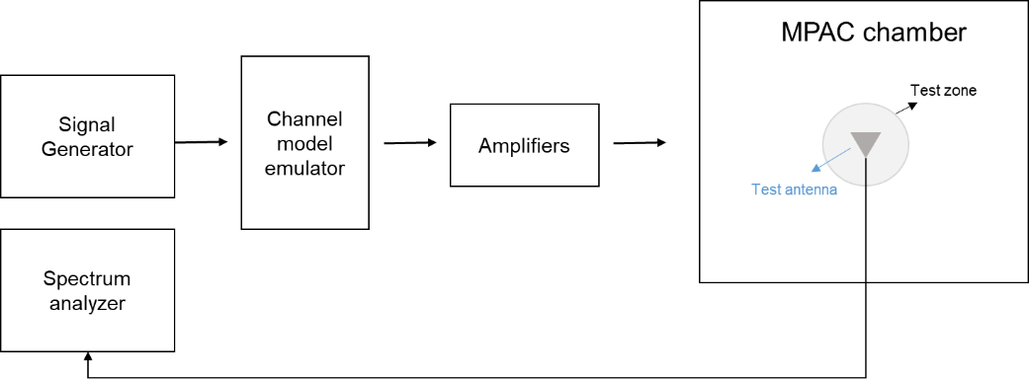

Figure C.3.3-1: Setup for Doppler measurements

Sine wave (CW, carrier wave) signal is transmitted from the signal generator. The signal is connected from the signal generator to fading emulator via cables. The fading emulator output signals are connected to power amplifier boxes via cables. The amplified signals are then transferred via cables to the probe antennas. The probe antennas radiate the signals over the air to the test antenna. The Doppler spectrum is measured by the spectrum analyser and the trace is saved.

**Signal generator settings:**

Table C.3.3-1: Signal generator settings for Doppler/Temporal correlation measurements

| Item | Unit | Value |
| --- | --- | --- |
| Centre frequency | MHz | Downlink centre frequency  in Table C.3.1-1 |
| Modulation |  | OFF |

**Spectrum analyser settings:**

Table C.3.3-2: Spectrum analyser settings for Doppler/Temporal correlation measurements

| Item | Unit | Value |
| --- | --- | --- |
| Centre frequency | MHz | Downlink centre frequency  in Table C.3.1-1 |
| Minimum Span | Hz | 4 kHz |
| RBW | Hz | 1 |
| VBW | Hz | 1 |
| Number of points |  | 16002 |
| Averaging |  | 100 |

**Channel model specification:**

Table C.3.3-3: Channel model specification for Doppler/Temporal correlation measurements

| Item | Unit | Value |
| --- | --- | --- |
| Centre frequency | MHz | Downlink centre frequency  in Table C.3.1-1 |
| Channel model |  | As specified in Annex C.1 |
| Mobile speed | km/h | 100 |

Method of measurement result analysis: Measurement data file (Doppler power spectrum) is saved into hard drive. The data is read into, e.g., Matlab. The analysis is performed by taking the Fourier transformation of the Doppler spectrum. The resulting temporal correlation function  is normalized such that max(abs(*Rt*(∆*t*)))=1. Then the function values left from the maximum i.e., the negative lags are cut out. Further on the function values after five periods are cut out.

**Time Domain Alternate Method**

Time domain techniques can also be used to validate the tempoal correlation. The temporal correlation validation measurement setup is illustrated in Figure C.3.3-2. In this case a Signal generator transmits a CW signal through the MIMO test system. The signal is received by a test antenna within the test area. Finally, the signal is collected by a signal analyser and the measured signal is stored as IQ data format for postprocessing.



Signal

Analyzer

Trigger

Figure C.3.3-2: Setup for Doppler measurements based on time domain technique

The time domain doppler spectrum is measured by the signal analyzer and the trace in IQ format is saved. Follow the same procedure to post process the data and calculate the temporal correlation curve. Data recording is synchronized with the channel emulator trigger.

The settings for the signal analyzer are in Table C.3.3-4:

Table C.3.3-4: Signal Analyser Settings

|  |  |  |
| --- | --- | --- |
| Item | Unit | Value |
| Centre frequency | MHz | Downlink centre frequency in Table C.3.1-1 |
| Sampling | Hz | At least 15 times bigger than the max Doppler spread (*fd=v/λ)* |
| Observation time | s | At least 16s. Channel Model length should be the same or greater than the observation time. |

**Beam-Specific Block Diagram**

It is assumed that the beams are mapped to the inputs of the channel emulator as follows:

- Beam 1: Input 1 and Input 2

- Beam 2: Input 3 and Input 4 (CDL-C UMa only)

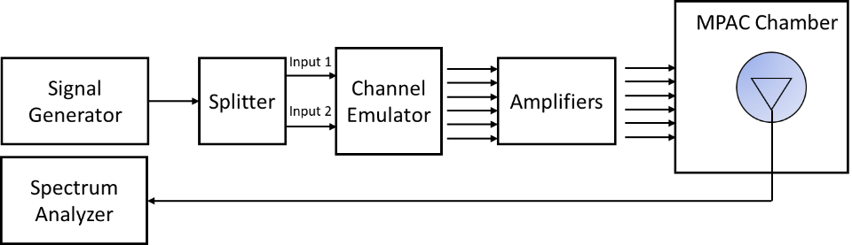

Figure C.3.3-3: Setup for Beam-Specific Doppler measurements (Beam 1)

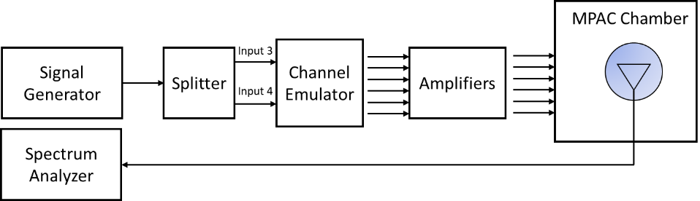

Figure C.3.3-4: Setup for Beam-Specific Doppler measurements (Beam 2 CDL-C UMa only)

The detailed Temporal correlation reference value for CDL-C UMa and CDL-C UMi channel model validation is defined is table C.3.3-5.

Table C.3.3-5: Autocorrelation Targets

|  |  |  |  |  |  |  |
| --- | --- | --- | --- | --- | --- | --- |
| Lambda Separation | CDL-C UMa beam 1 at  ≤ 2.5 GHz | CDL-C UMa beam 2 at ≤ 2.5 GHz | CDL-C UMa beam 1 at > 2.5 GHz | CDL-C UMa beam 2 at > 2.5 GHz | CDL-C UMi beam 1 at  ≤ 2.5 GHz | CDL-C UMi beam 1 at > 2.5 GHz |
| 0.0 | 1.000 | 1.000 | 1.000 | 1.000 | 1.000 | 1.000 |
| 0.1 | 0.986 | 0.974 | 0.985 | 0.973 | 0.995 | 0.995 |
| 0.2 | 0.945 | 0.907 | 0.942 | 0.904 | 0.982 | 0.982 |
| 0.3 | 0.882 | 0.832 | 0.874 | 0.825 | 0.962 | 0.961 |
| 0.4 | 0.801 | 0.776 | 0.787 | 0.765 | 0.936 | 0.935 |
| 0.5 | 0.709 | 0.738 | 0.689 | 0.723 | 0.906 | 0.905 |
| 0.6 | 0.613 | 0.695 | 0.586 | 0.675 | 0.872 | 0.871 |
| 0.7 | 0.518 | 0.623 | 0.486 | 0.599 | 0.834 | 0.834 |
| 0.8 | 0.430 | 0.525 | 0.394 | 0.496 | 0.793 | 0.793 |
| 0.9 | 0.353 | 0.426 | 0.315 | 0.391 | 0.750 | 0.749 |
| 1.0 | 0.289 | 0.360 | 0.252 | 0.319 | 0.705 | 0.704 |
| 1.1 | 0.240 | 0.335 | 0.206 | 0.290 | 0.659 | 0.658 |
| 1.2 | 0.204 | 0.320 | 0.174 | 0.273 | 0.614 | 0.612 |
| 1.3 | 0.181 | 0.287 | 0.154 | 0.239 | 0.569 | 0.568 |
| 1.4 | 0.167 | 0.233 | 0.143 | 0.185 | 0.527 | 0.525 |
| 1.5 | 0.159 | 0.176 | 0.137 | 0.129 | 0.487 | 0.485 |
| 1.6 | 0.155 | 0.141 | 0.135 | 0.096 | 0.450 | 0.448 |
| 1.7 | 0.153 | 0.135 | 0.134 | 0.092 | 0.417 | 0.415 |
| 1.8 | 0.150 | 0.137 | 0.134 | 0.095 | 0.387 | 0.385 |
| 1.9 | 0.144 | 0.132 | 0.130 | 0.093 | 0.361 | 0.358 |
| 2.0 | 0.135 | 0.117 | 0.122 | 0.089 | 0.337 | 0.335 |
| 2.1 | 0.121 | 0.097 | 0.109 | 0.086 | 0.316 | 0.313 |
| 2.2 | 0.105 | 0.076 | 0.090 | 0.076 | 0.296 | 0.293 |
| 2.3 | 0.085 | 0.062 | 0.069 | 0.064 | 0.277 | 0.274 |
| 2.4 | 0.065 | 0.071 | 0.047 | 0.067 | 0.258 | 0.255 |
| 2.5 | 0.048 | 0.090 | 0.031 | 0.088 | 0.239 | 0.236 |
| 2.6 | 0.039 | 0.099 | 0.033 | 0.103 | 0.219 | 0.216 |
| 2.7 | 0.038 | 0.088 | 0.046 | 0.099 | 0.198 | 0.195 |
| 2.8 | 0.042 | 0.058 | 0.057 | 0.073 | 0.178 | 0.175 |
| 2.9 | 0.043 | 0.037 | 0.062 | 0.038 | 0.158 | 0.154 |
| 3.0 | 0.041 | 0.067 | 0.060 | 0.045 | 0.138 | 0.135 |
| 3.1 | 0.037 | 0.103 | 0.050 | 0.080 | 0.120 | 0.116 |
| 3.2 | 0.036 | 0.120 | 0.036 | 0.100 | 0.103 | 0.100 |
| 3.3 | 0.044 | 0.115 | 0.019 | 0.099 | 0.089 | 0.085 |
| 3.4 | 0.056 | 0.097 | 0.010 | 0.081 | 0.076 | 0.073 |
| 3.5 | 0.068 | 0.082 | 0.019 | 0.061 | 0.066 | 0.063 |
| 3.6 | 0.075 | 0.083 | 0.029 | 0.053 | 0.057 | 0.055 |
| 3.7 | 0.076 | 0.090 | 0.034 | 0.060 | 0.051 | 0.049 |
| 3.8 | 0.068 | 0.089 | 0.036 | 0.073 | 0.046 | 0.044 |
| 3.9 | 0.051 | 0.079 | 0.044 | 0.091 | 0.042 | 0.041 |
| 4.0 | 0.027 | 0.068 | 0.062 | 0.111 | 0.039 | 0.038 |
| 4.1 | 0.007 | 0.063 | 0.090 | 0.127 | 0.037 | 0.035 |
| 4.2 | 0.036 | 0.062 | 0.123 | 0.133 | 0.036 | 0.034 |
| 4.3 | 0.067 | 0.057 | 0.155 | 0.129 | 0.038 | 0.036 |
| 4.4 | 0.093 | 0.052 | 0.182 | 0.126 | 0.043 | 0.040 |
| 4.5 | 0.111 | 0.055 | 0.200 | 0.131 | 0.051 | 0.048 |
| 4.6 | 0.119 | 0.063 | 0.207 | 0.139 | 0.061 | 0.058 |
| 4.7 | 0.116 | 0.066 | 0.200 | 0.138 | 0.073 | 0.070 |
| 4.8 | 0.101 | 0.058 | 0.180 | 0.117 | 0.085 | 0.082 |
| 4.9 | 0.078 | 0.047 | 0.149 | 0.079 | 0.096 | 0.093 |
| 5.0 | 0.051 | 0.048 | 0.110 | 0.034 | 0.107 | 0.104 |

## C.3.4 Spatial correlation

This measurement checks whether the measured correlation curve follows the theoretical curve. For spatial correlation validation measurement, only Vertical validation measurement is required. Spatial correlation validation is only adopted for FR1 MIMO OTA.

The spatial correlation validation measurement setup is illustrated in Figure C.3.4-1. The network analyser transmits signals through the fading emulator and probes. The 16 probes radiate the signals within the anechoic chamber and a receiving test antenna is placed within the test zone. The test antenna is attached to a positioner that can move the antenna to pre-defined spatial locations on a fixed radius from the centre of the quiet zone. The received signal is measured with the network analyser.

The measurement and analysis procedure are as follows:

Set the target channel model to fading emulator.

1. For each position of the test antenna in the test zone, step & pause the emulator to different time instances. Measure the frequency responses for all stepped channel snapshots , where the interval between frequency and time samples is and , respectively. The number of channel snapshots $N$ and frequency samples $M$ should be sufficiently high so that the matrix can be estimated reliably.



2. Move the measurement antenna with a positioner to another location and repeat step 2 to record frequency responses of all stepped channel snapshots.



3. Repeat step 3 to record frequency responses at all spatial sample points.



4. Stack measured time and frequency samples to a vector and calculate correlation between the first spatial sample point (i.e. $k=1$) and other spatial points



5.



6. Take the theoretical reference spatial correlation of the corresponding spatial sample points. Plot both the measured and theoretical curves.

7. Calculate the weighted RMS correlation error between the measured and the reference.



Figure C.3.4-1: Configuration for spatial correlation validation

**Beam-Specific Block Diagram**

It is assumed that the beams are mapped to the inputs of the channel emulator as follows:

- Beam 1: Input 1 and Input 2

- Beam 2: Input 3 and Input 4 (CDL-C UMa only)

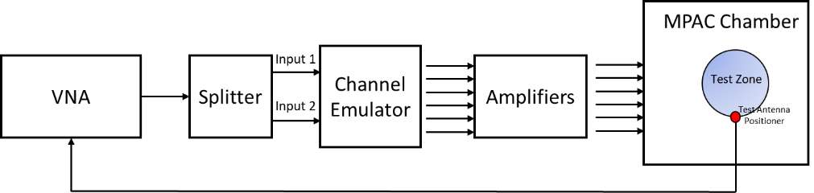

Figure C.3.4-2: Configuration for spatial correlation validation (CDL-C UMi)

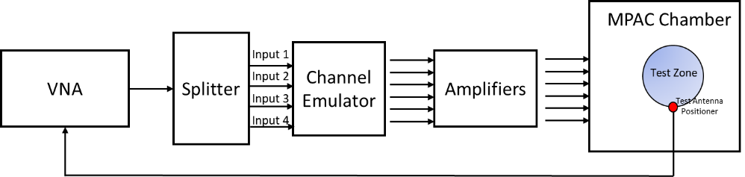

Figure C.3.4-3: Configuration for spatial correlation validation (CDL-C UMa)

**Time and frequency samples**

The number of temporal snapshots *N* and frequency samples *M* is shown in Table C.3.4-1. The channel model specification is presented in Table C.3.4-2.

Table C.3.4-1: VNA settings for spatial correlation

| Item | Unit | Value |
| --- | --- | --- |
| Center frequency | MHz | Downlink centre frequency  in Table C.3.1-1 |
| Span | MHz | 0 (Note 2) |
| RF output level | dBm | -15 |
| Number of traces |  | 1000 |
| Distance between traces in channel model | Wavelength (Note 1) | > 2 |
| Number of points |  | 1 (or the smallest possible)  (Note 2) |
| Averaging |  | 1 |
| NOTE 1:   Time in seconds = distance [] / MS speed [/s]                   MS speed [/s] = MS speed [m /s] / Speed of light [m/s] * Center frequency [Hz]  NOTE 2:   Span and number of points may be increased to estimate reliably. | | |

Table C.3.4-2: Channel model specification

| Item | Unit | Value |
| --- | --- | --- |
| Center frequency | MHz | Downlink centre frequency  in Table C.3.1-1 |
| Channel model samples | Wavelength | > 2000 |
| Channel model |  | As specified in Annex C.1 |
| Mobile speed | km/h | 30 |

**Spatial samples**

The spatial samples for the correlation validation measurement are on the circumference of the quiet zone, as illustrated in Figure C.3.4-2. The test zone is a circle with 20 cm diameter in the horizontal plane. The reference point (denoted by a red marker) is in AoA 270°. The mean AoAs of the CDL-C UMi and CDL-C UMa models are slightly different, but the underlying geometry for the CDL model indicates that the mean AoA (or assumed LoS direction) of the model is 180°. The reference point orientation of the validation measurement is proposed to be with 90° offset to the channel model reference AoA to enable accurate sampling of the main lobe of the spatial correlation curve. The reference point orientation must be defined in the channel model coordinate system instead of the chamber/probe coordinate system to enable optimization of OTA model implementation to achieve better alignment with the cluster AoAs and probe directions. In order to have spatial samples that yield reasonable measurement times and adequately capture the main lobe of the correlation curve, a non-uniform sampling is used where the first quadrant i.e., 270°-180°, is sampled with dense sampling compared to the rest of the circle. The spacing of the spatial samples is summarized in Table C.3.4-1 for test frequencies less than 1800 MHz and equal to or greater than 1800 MHz.

Table C.3.4-1: Spacing of Spatial Samples

| Test Frequencies [MHz] | First quadrant of test zone circumference (270o-180o) | Remaining quadrants |
| --- | --- | --- |
| 617, 722, 836.5 1575.42 | /15 | /4 |
| 1800, 2132.50, 2450, 3600, 4700 | /10 | /2 |

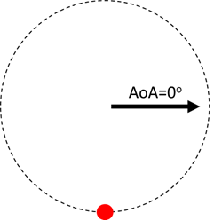



Figure C.3.4-2: Spatial sampling for spatial correlation validation measurement for test frequencies less than and equal to or greater than 1800 MHz: 617 MHz spatial sampling (left) and 4700 MHz spatial sampling (right).

**Reference Spatial Correlation Curves**

The spatial correlation validation reference curves are tabulated in Tables C.3.4-2 and C.3.4-3 for CDL-C UMi and CDL-C UMa, respectively, for a vertically polarized MPAC OTA setup with 16 uniformly spaced probes.

Table C.3.4-2: Spatial correlation reference curves for CDL-C UMi model for a vertically polarized MPAC OTA setup with 16 uniformly spaced probes at FR1 test frequencies

|  |  |  |  |  |  |  |  |  |  |
| --- | --- | --- | --- | --- | --- | --- | --- | --- | --- |
| 617 MHz | | 722 MHz | | 836.5 MHz | | 1575.42 MHz | | 1800 MHz | |
| Azim [] | || beam 1 | Azim [] | || beam 1 | Azim [] | || beam 1 | Azim [] | || beam 1 | Azim [] | || beam 1 |
| 270.0 | 1.00 | 270.0 | 1.00 | 270.0 | 1.00 | 270.0 | 1.00 | 270.0 | 1.00 |
| 251.4 | 1.00 | 254.1 | 1.00 | 256.3 | 1.00 | 262.7 | 1.00 | 260.9 | 1.00 |
| 232.9 | 1.00 | 238.3 | 1.00 | 242.6 | 1.00 | 255.5 | 1.00 | 251.7 | 1.00 |
| 214.3 | 0.99 | 222.4 | 1.00 | 228.9 | 1.00 | 248.2 | 1.00 | 242.6 | 0.99 |
| 195.8 | 0.99 | 206.6 | 0.99 | 215.2 | 0.99 | 240.9 | 0.99 | 233.5 | 0.99 |
| 110.4 | 0.87 | 190.7 | 0.98 | 201.6 | 0.98 | 233.7 | 0.99 | 224.3 | 0.98 |
| 40.8 | 0.87 | 120.5 | 0.84 | 187.9 | 0.96 | 226.4 | 0.99 | 215.2 | 0.97 |
| 331.2 | 0.98 | 61.1 | 0.80 | 128.7 | 0.82 | 219.1 | 0.98 | 206.0 | 0.95 |
|  |  | 1.6 | 0.91 | 77.3 | 0.73 | 211.9 | 0.97 | 196.9 | 0.92 |
|  |  | 302.1 | 0.99 | 26.0 | 0.81 | 204.6 | 0.96 | 187.8 | 0.87 |
|  |  |  |  | 334.7 | 0.95 | 197.3 | 0.94 | 134.3 | 0.39 |
|  |  |  |  | 283.3 | 1.00 | 190.0 | 0.91 | 88.6 | 0.15 |
|  |  |  |  |  |  | 182.8 | 0.87 | 43.0 | 0.24 |
|  |  |  |  |  |  | 152.7 | 0.66 | 357.3 | 0.62 |
|  |  |  |  |  |  | 125.5 | 0.44 | 311.6 | 0.94 |
|  |  |  |  |  |  | 98.2 | 0.30 |  |  |
|  |  |  |  |  |  | 71.0 | 0.28 |  |  |
|  |  |  |  |  |  | 43.7 | 0.37 |  |  |
|  |  |  |  |  |  | 16.5 | 0.54 |  |  |
|  |  |  |  |  |  | 349.2 | 0.75 |  |  |
|  |  |  |  |  |  | 321.9 | 0.91 |  |  |
|  |  |  |  |  |  | 294.7 | 0.99 |  |  |
| 2132.5 MHz | | 2450 MHz | | 3600 MHz | | 4700 MHz | |
| Azim [] | || beam 1 | Azim [] | || beam 1 | Azim [] | || beam 1 | Azim [] | || beam 1 |
| 270.0 | 1.00 | 270.0 | 1.00 | 270.0 | 1.00 | 270.0 | 1.00 |
| 261.9 | 1.00 | 263.0 | 1.00 | 265.2 | 1.00 | 266.3 | 1.00 |
| 253.9 | 1.00 | 256.0 | 1.00 | 260.5 | 1.00 | 262.7 | 1.00 |
| 245.8 | 0.99 | 249.0 | 0.99 | 255.7 | 0.99 | 259.0 | 0.99 |
| 237.8 | 0.99 | 242.0 | 0.99 | 250.9 | 0.99 | 255.4 | 0.99 |
| 229.7 | 0.98 | 234.9 | 0.99 | 246.1 | 0.99 | 251.7 | 0.99 |
| 221.7 | 0.97 | 227.9 | 0.98 | 241.4 | 0.98 | 248.1 | 0.98 |
| 213.6 | 0.96 | 220.9 | 0.97 | 236.6 | 0.98 | 244.4 | 0.98 |
| 205.6 | 0.93 | 213.9 | 0.95 | 231.8 | 0.97 | 240.8 | 0.98 |
| 197.5 | 0.89 | 206.9 | 0.92 | 227.1 | 0.97 | 237.1 | 0.97 |
| 189.5 | 0.84 | 199.9 | 0.88 | 222.3 | 0.95 | 233.5 | 0.97 |
| 181.4 | 0.77 | 192.9 | 0.83 | 217.5 | 0.93 | 229.8 | 0.96 |
| 139.7 | 0.27 | 185.9 | 0.76 | 212.7 | 0.90 | 226.1 | 0.95 |
| 99.5 | 0.14 | 144.9 | 0.19 | 208.0 | 0.86 | 222.5 | 0.93 |
| 59.2 | 0.14 | 109.9 | 0.26 | 203.2 | 0.81 | 218.8 | 0.91 |
| 18.9 | 0.26 | 74.8 | 0.37 | 198.4 | 0.75 | 215.2 | 0.87 |
| 338.6 | 0.71 | 39.8 | 0.19 | 193.7 | 0.68 | 211.5 | 0.83 |
| 298.4 | 0.97 | 4.7 | 0.29 | 188.9 | 0.59 | 207.9 | 0.78 |
|  |  | 329.7 | 0.74 | 184.1 | 0.49 | 204.2 | 0.72 |
|  |  | 294.6 | 0.97 | 156.1 | 0.23 | 200.6 | 0.64 |
|  |  |  |  | 132.3 | 0.62 | 196.9 | 0.56 |
|  |  |  |  | 108.4 | 0.85 | 193.3 | 0.47 |
|  |  |  |  | 84.6 | 0.93 | 189.6 | 0.37 |
|  |  |  |  | 60.7 | 0.92 | 185.9 | 0.27 |
|  |  |  |  | 36.9 | 0.79 | 182.3 | 0.18 |
|  |  |  |  | 13.0 | 0.42 | 161.7 | 0.51 |
|  |  |  |  | 349.1 | 0.15 | 143.5 | 0.83 |
|  |  |  |  | 325.3 | 0.60 | 125.2 | 0.95 |
|  |  |  |  | 301.4 | 0.90 | 106.9 | 0.89 |
|  |  |  |  | 277.6 | 1.00 | 88.6 | 0.80 |
|  |  |  |  |  |  | 70.4 | 0.78 |
|  |  |  |  |  |  | 52.1 | 0.88 |
|  |  |  |  |  |  | 33.8 | 0.98 |
|  |  |  |  |  |  | 15.5 | 0.91 |
|  |  |  |  |  |  | 357.3 | 0.53 |
|  |  |  |  |  |  | 339.0 | 0.09 |
|  |  |  |  |  |  | 320.7 | 0.50 |
|  |  |  |  |  |  | 302.4 | 0.82 |
|  |  |  |  |  |  | 284.2 | 0.97 |

Table C.3.4-3: Spatial correlation reference curves for CDL-C UMa model for a vertically polarized MPAC OTA setup with 16 uniformly spaced probes at FR1 test frequencies

|  |  |  |  |  |  |  |  |  |  |
| --- | --- | --- | --- | --- | --- | --- | --- | --- | --- |
| 617 MHz | | 722 MHz | | 836.5 MHz | | 1575.42 MHz | | 1800 MHz | |
| Azim [] | || comb | Azim [] | || comb | Azim [] | || comb | Azim [] | || comb | Azim [] | || comb |
| 270.0 | 1.00 | 270.0 | 1.00 | 270.0 | 1.00 | 270.0 | 1.00 | 270.0 | 1.00 |
| 251.4 | 0.99 | 254.1 | 0.99 | 256.3 | 0.99 | 262.7 | 0.99 | 260.9 | 0.99 |
| 232.9 | 0.99 | 238.3 | 0.98 | 242.6 | 0.98 | 255.5 | 0.98 | 251.7 | 0.96 |
| 214.3 | 0.98 | 222.4 | 0.97 | 228.9 | 0.97 | 248.2 | 0.96 | 242.6 | 0.93 |
| 195.8 | 0.96 | 206.6 | 0.96 | 215.2 | 0.96 | 240.9 | 0.94 | 233.5 | 0.90 |
| 110.4 | 0.61 | 190.7 | 0.94 | 201.6 | 0.95 | 233.7 | 0.92 | 224.3 | 0.89 |
| 40.8 | 0.47 | 120.5 | 0.58 | 187.9 | 0.92 | 226.4 | 0.91 | 215.2 | 0.88 |
| 331.2 | 0.85 | 61.1 | 0.30 | 128.7 | 0.56 | 219.1 | 0.90 | 206.0 | 0.87 |
|  |  | 1.6 | 0.56 | 77.3 | 0.19 | 211.9 | 0.89 | 196.9 | 0.84 |
|  |  | 302.1 | 0.95 | 26.0 | 0.27 | 204.6 | 0.88 | 187.8 | 0.79 |
|  |  |  |  | 334.7 | 0.70 | 197.3 | 0.87 | 134.3 | 0.16 |
|  |  |  |  | 283.3 | 0.99 | 190.0 | 0.84 | 88.6 | 0.30 |
|  |  |  |  |  |  | 182.8 | 0.79 | 43.0 | 0.22 |
|  |  |  |  |  |  | 152.7 | 0.42 | 357.3 | 0.36 |
|  |  |  |  |  |  | 125.5 | 0.13 | 311.6 | 0.57 |
|  |  |  |  |  |  | 98.2 | 0.30 |  |  |
|  |  |  |  |  |  | 71.0 | 0.31 |  |  |
|  |  |  |  |  |  | 43.7 | 0.29 |  |  |
|  |  |  |  |  |  | 16.5 | 0.33 |  |  |
|  |  |  |  |  |  | 349.2 | 0.29 |  |  |
|  |  |  |  |  |  | 321.9 | 0.48 |  |  |
|  |  |  |  |  |  | 294.7 | 0.88 |  |  |

|  |  |  |  |  |  |  |  |
| --- | --- | --- | --- | --- | --- | --- | --- |
| 2132.5 MHz | | 2450 MHz | | 3600 MHz | | 4700 MHz | |
| Azim [] | || comb | Azim [] | || comb | Azim [] | || comb | Azim [] | || comb |
| 270.0 | 1.00 | 270.0 | 1.00 | 270.0 | 1.00 | 270.0 | 1.00 |
| 261.9 | 0.99 | 263.0 | 0.99 | 265.2 | 0.98 | 266.3 | 0.98 |
| 253.9 | 0.95 | 256.0 | 0.95 | 260.5 | 0.95 | 262.7 | 0.94 |
| 245.8 | 0.92 | 249.0 | 0.91 | 255.7 | 0.90 | 259.0 | 0.89 |
| 237.8 | 0.89 | 242.0 | 0.87 | 250.9 | 0.84 | 255.4 | 0.83 |
| 229.7 | 0.86 | 234.9 | 0.85 | 246.1 | 0.80 | 251.7 | 0.78 |
| 221.7 | 0.85 | 227.9 | 0.83 | 241.4 | 0.77 | 248.1 | 0.73 |
| 213.6 | 0.85 | 220.9 | 0.82 | 236.6 | 0.75 | 244.4 | 0.70 |
| 205.6 | 0.83 | 213.9 | 0.82 | 231.8 | 0.73 | 240.8 | 0.68 |
| 197.5 | 0.80 | 206.9 | 0.80 | 227.1 | 0.72 | 237.1 | 0.66 |
| 189.5 | 0.75 | 199.9 | 0.77 | 222.3 | 0.71 | 233.5 | 0.65 |
| 181.4 | 0.67 | 192.9 | 0.73 | 217.5 | 0.70 | 229.8 | 0.64 |
| 139.7 | 0.22 | 185.9 | 0.66 | 212.7 | 0.69 | 226.1 | 0.63 |
| 99.5 | 0.24 | 144.9 | 0.26 | 208.0 | 0.67 | 222.5 | 0.62 |
| 59.2 | 0.03 | 109.9 | 0.23 | 203.2 | 0.64 | 218.8 | 0.61 |
| 18.9 | 0.16 | 74.8 | 0.19 | 198.4 | 0.61 | 215.2 | 0.60 |
| 338.6 | 0.37 | 39.8 | 0.13 | 193.7 | 0.56 | 211.5 | 0.59 |
| 298.4 | 0.73 | 4.7 | 0.15 | 188.9 | 0.49 | 207.9 | 0.57 |
|  |  | 329.7 | 0.38 | 184.1 | 0.41 | 204.2 | 0.55 |
|  |  | 294.6 | 0.74 | 156.1 | 0.42 | 200.6 | 0.52 |
|  |  |  |  | 132.3 | 0.19 | 196.9 | 0.48 |
|  |  |  |  | 108.4 | 0.64 | 193.3 | 0.42 |
|  |  |  |  | 84.6 | 0.47 | 189.6 | 0.35 |
|  |  |  |  | 60.7 | 0.44 | 185.9 | 0.26 |
|  |  |  |  | 36.9 | 0.28 | 182.3 | 0.18 |
|  |  |  |  | 13.0 | 0.16 | 161.7 | 0.59 |
|  |  |  |  | 349.1 | 0.16 | 143.5 | 0.26 |
|  |  |  |  | 325.3 | 0.41 | 125.2 | 0.79 |
|  |  |  |  | 301.4 | 0.40 | 106.9 | 0.43 |
|  |  |  |  | 277.6 | 0.95 | 88.6 | 0.68 |
|  |  |  |  |  |  | 70.4 | 0.63 |
|  |  |  |  |  |  | 52.1 | 0.75 |
|  |  |  |  |  |  | 33.8 | 0.87 |
|  |  |  |  |  |  | 15.5 | 0.67 |
|  |  |  |  |  |  | 357.3 | 0.09 |
|  |  |  |  |  |  | 339.0 | 0.25 |
|  |  |  |  |  |  | 320.7 | 0.32 |
|  |  |  |  |  |  | 302.4 | 0.42 |
|  |  |  |  |  |  | 284.2 | 0.73 |

**Time Domain Alternative Method:**

Time domain techniques can also be used to validate the spatial correlation. The spatial correlation validation measurement setup is illustrated in Figure C.3.4-3. In this case a Signal generator transmits a CW signal through the MIMO test system. The signal is received by a test antenna within the test area. Finally, the signal is collected by a signal analyser and the measured signal is stored for postprocessing.

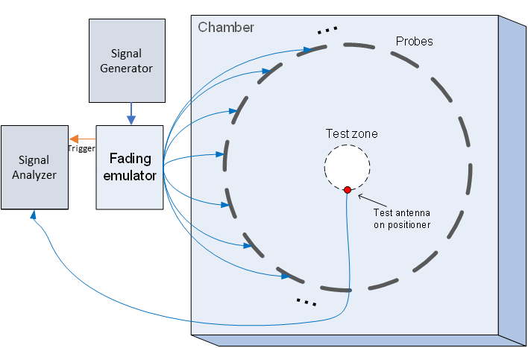

Figure C.3.4-3: Configuration for spatial correlation validation based on time domain techniques

For each spatial point, the channel emulator should issue a trigger signal each time fading is started. For each point collect a time domain trace with the signal analyser, when done, stop fading. Data recording is synchronized with the channel emulator trigger.

Follow the same procedure to postprocess the data and calcalate the spatial correlation by setting *m* to 1. The settings for the Signal Generator and Signal Analyser are in Table C.3.4-6 and C.3.4-7 respectively.

Table C.3.4-6: Signal Generator Settings

|  |  |  |
| --- | --- | --- |
| Item | Unit | Value |
| Centre frequency | MHz | Downlink centre frequency in Table C.3.1-1 |
| Output power | dBm | Function of the CE. Sufficiently above Noise Floor |

Table C.3.4-7: Signal Analyser Settings

|  |  |  |
| --- | --- | --- |
| Item | Unit | Value |
| Centre frequency | MHz | Downlink centre frequency in Table C.3.1-1 |
| Sampling | Hz | At least 15 times bigger than the max Doppler spread (*fd=v/λ)* |
| Observation time | s | At least 16s. Channel Model length should be the same or greater than the observation time. |

**Beam-Simultaneous Block Diagram**

It is assumed that the beams are mapped to the inputs of the channel emulator as follows:

- Beam 1: Input 1 and Input 2

- Beam 2: Input 3 and Input 4 (CDL-C UMa only)

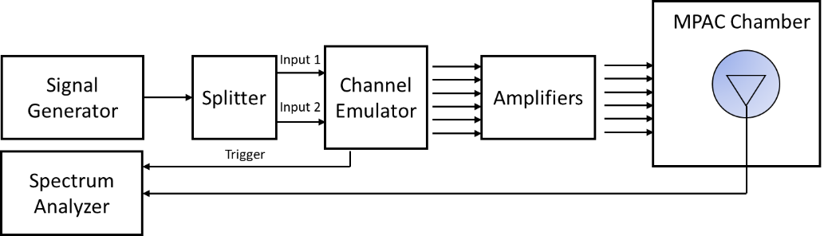

Figure C.3.4-4: Configuration for spatial correlation validation based on time domain techniques (CDL-C UMi)

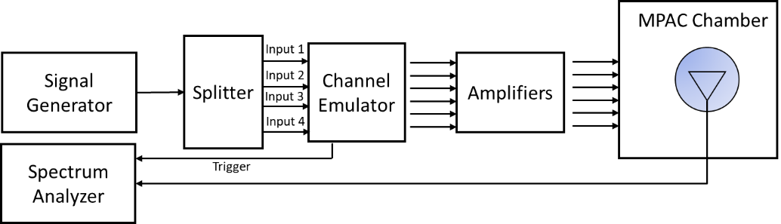

Figure C.3.4-5: Configuration for spatial correlation validation based on time domain techniques (CDL-C UMa)

**< Unchanged sections omitted >**

## C.4.3 Pass/Fail Criteria of Doppler/Temporal correlation

This clause defines the pass/fail criteria of doppler/temporal correlation, this pass/fail limits apply for all channel models in all FR1 frequency bands, for both combined and individual beams.

The pass/fail limits for theoretical temporal correlation defined in Clause C.3.3 above 0.3 are formed as bands of ±0.1 of correlation capped at 1 at the high end. Additionally, when the theoretical temporal correlation drops below 0.3, the limits are formed at bands of ±0.3 of correlation capped at 0 at the low end.

Table C.4.3-1: pass/fail limits for temporal correlation

|  |  |  |  |  |  |  |  |  |  |  |  |
| --- | --- | --- | --- | --- | --- | --- | --- | --- | --- | --- | --- |
| CDL-C UMa beam 1 at ≤ 2.5 GHz | | CDL-C UMa beam 2 at ≤ 2.5 GHz | | CDL-C UMa beam 1 at > 2.5 GHz | | CDL-C UMa beam 2 at > 2.5 GHz | | CDL-C UMi beam 1 at ≤ 2.5 GHz | | CDL-C UMi beam 1 at > 2.5 GHz | |
| Lower | Upper | Lower | Upper | Lower | Upper | Lower | Upper | Lower | Upper | Lower | Upper |
| 0.9 | 1 | 0.9 | 1 | 0.9 | 1 | 0.9 | 1 | 0.9 | 1 | 0.9 | 1 |
| 0.886 | 1 | 0.874 | 1 | 0.885 | 1 | 0.873 | 1 | 0.895 | 1 | 0.895 | 1 |
| 0.845 | 1 | 0.807 | 1 | 0.842 | 1 | 0.804 | 1 | 0.882 | 1 | 0.882 | 1 |
| 0.782 | 0.982 | 0.732 | 0.932 | 0.774 | 0.974 | 0.725 | 0.925 | 0.862 | 1 | 0.861 | 1 |
| 0.701 | 0.901 | 0.676 | 0.876 | 0.687 | 0.887 | 0.665 | 0.865 | 0.836 | 1 | 0.835 | 1 |
| 0.609 | 0.809 | 0.638 | 0.838 | 0.589 | 0.789 | 0.623 | 0.823 | 0.806 | 1 | 0.805 | 1 |
| 0.513 | 0.713 | 0.595 | 0.795 | 0.486 | 0.686 | 0.575 | 0.775 | 0.772 | 0.972 | 0.771 | 0.971 |
| 0.418 | 0.618 | 0.523 | 0.723 | 0.386 | 0.586 | 0.499 | 0.699 | 0.734 | 0.934 | 0.734 | 0.934 |
| 0.33 | 0.53 | 0.425 | 0.625 | 0.294 | 0.494 | 0.396 | 0.596 | 0.693 | 0.893 | 0.693 | 0.893 |
| 0.253 | 0.453 | 0.326 | 0.526 | 0.215 | 0.415 | 0.291 | 0.491 | 0.65 | 0.85 | 0.649 | 0.849 |
| 0.189 | 0.389 | 0.26 | 0.46 | 0.152 | 0.352 | 0.219 | 0.419 | 0.605 | 0.805 | 0.604 | 0.804 |
| 0.14 | 0.34 | 0.235 | 0.435 | 0.106 | 0.306 | 0.19 | 0.39 | 0.559 | 0.759 | 0.558 | 0.758 |
| 0.104 | 0.304 | 0.22 | 0.42 | 0 | 0.3 | 0.173 | 0.373 | 0.514 | 0.714 | 0.512 | 0.712 |
| 0 | 0.3 | 0.187 | 0.387 | 0 | 0.3 | 0.139 | 0.339 | 0.469 | 0.669 | 0.468 | 0.668 |
| 0 | 0.3 | 0.133 | 0.333 | 0 | 0.3 | 0 | 0.3 | 0.427 | 0.627 | 0.425 | 0.625 |
| 0 | 0.3 | 0 | 0.3 | 0 | 0.3 | 0 | 0.3 | 0.387 | 0.587 | 0.385 | 0.585 |
| 0 | 0.3 | 0 | 0.3 | 0 | 0.3 | 0 | 0.3 | 0.35 | 0.55 | 0.348 | 0.548 |
| 0 | 0.3 | 0 | 0.3 | 0 | 0.3 | 0 | 0.3 | 0.317 | 0.517 | 0.315 | 0.515 |
| 0 | 0.3 | 0 | 0.3 | 0 | 0.3 | 0 | 0.3 | 0.287 | 0.487 | 0.285 | 0.485 |
| 0 | 0.3 | 0 | 0.3 | 0 | 0.3 | 0 | 0.3 | 0.261 | 0.461 | 0.258 | 0.458 |
| 0 | 0.3 | 0 | 0.3 | 0 | 0.3 | 0 | 0.3 | 0.237 | 0.437 | 0.235 | 0.435 |
| 0 | 0.3 | 0 | 0.3 | 0 | 0.3 | 0 | 0.3 | 0.216 | 0.416 | 0.213 | 0.413 |
| 0 | 0.3 | 0 | 0.3 | 0 | 0.3 | 0 | 0.3 | 0.196 | 0.396 | 0.193 | 0.393 |
| 0 | 0.3 | 0 | 0.3 | 0 | 0.3 | 0 | 0.3 | 0.177 | 0.377 | 0.174 | 0.374 |
| 0 | 0.3 | 0 | 0.3 | 0 | 0.3 | 0 | 0.3 | 0.158 | 0.358 | 0.155 | 0.355 |
| 0 | 0.3 | 0 | 0.3 | 0 | 0.3 | 0 | 0.3 | 0.139 | 0.339 | 0.136 | 0.336 |
| 0 | 0.3 | 0 | 0.3 | 0 | 0.3 | 0 | 0.3 | 0.119 | 0.319 | 0.116 | 0.316 |
| 0 | 0.3 | 0 | 0.3 | 0 | 0.3 | 0 | 0.3 | 0 | 0.3 | 0 | 0.3 |
| 0 | 0.3 | 0 | 0.3 | 0 | 0.3 | 0 | 0.3 | 0 | 0.3 | 0 | 0.3 |
| 0 | 0.3 | 0 | 0.3 | 0 | 0.3 | 0 | 0.3 | 0 | 0.3 | 0 | 0.3 |
| 0 | 0.3 | 0 | 0.3 | 0 | 0.3 | 0 | 0.3 | 0 | 0.3 | 0 | 0.3 |
| 0 | 0.3 | 0 | 0.3 | 0 | 0.3 | 0 | 0.3 | 0 | 0.3 | 0 | 0.3 |
| 0 | 0.3 | 0 | 0.3 | 0 | 0.3 | 0 | 0.3 | 0 | 0.3 | 0 | 0.3 |
| 0 | 0.3 | 0 | 0.3 | 0 | 0.3 | 0 | 0.3 | 0 | 0.3 | 0 | 0.3 |
| 0 | 0.3 | 0 | 0.3 | 0 | 0.3 | 0 | 0.3 | 0 | 0.3 | 0 | 0.3 |
| 0 | 0.3 | 0 | 0.3 | 0 | 0.3 | 0 | 0.3 | 0 | 0.3 | 0 | 0.3 |
| 0 | 0.3 | 0 | 0.3 | 0 | 0.3 | 0 | 0.3 | 0 | 0.3 | 0 | 0.3 |
| 0 | 0.3 | 0 | 0.3 | 0 | 0.3 | 0 | 0.3 | 0 | 0.3 | 0 | 0.3 |
| 0 | 0.3 | 0 | 0.3 | 0 | 0.3 | 0 | 0.3 | 0 | 0.3 | 0 | 0.3 |
| 0 | 0.3 | 0 | 0.3 | 0 | 0.3 | 0 | 0.3 | 0 | 0.3 | 0 | 0.3 |
| 0 | 0.3 | 0 | 0.3 | 0 | 0.3 | 0 | 0.3 | 0 | 0.3 | 0 | 0.3 |
| 0 | 0.3 | 0 | 0.3 | 0 | 0.3 | 0 | 0.3 | 0 | 0.3 | 0 | 0.3 |
| 0 | 0.3 | 0 | 0.3 | 0 | 0.3 | 0 | 0.3 | 0 | 0.3 | 0 | 0.3 |
| 0 | 0.3 | 0 | 0.3 | 0 | 0.3 | 0 | 0.3 | 0 | 0.3 | 0 | 0.3 |
| 0 | 0.3 | 0 | 0.3 | 0 | 0.3 | 0 | 0.3 | 0 | 0.3 | 0 | 0.3 |
| 0 | 0.3 | 0 | 0.3 | 0 | 0.3 | 0 | 0.3 | 0 | 0.3 | 0 | 0.3 |
| 0 | 0.3 | 0 | 0.3 | 0 | 0.3 | 0 | 0.3 | 0 | 0.3 | 0 | 0.3 |
| 0 | 0.3 | 0 | 0.3 | 0 | 0.3 | 0 | 0.3 | 0 | 0.3 | 0 | 0.3 |
| 0 | 0.3 | 0 | 0.3 | 0 | 0.3 | 0 | 0.3 | 0 | 0.3 | 0 | 0.3 |
| 0 | 0.3 | 0 | 0.3 | 0 | 0.3 | 0 | 0.3 | 0 | 0.3 | 0 | 0.3 |
| 0 | 0.3 | 0 | 0.3 | 0 | 0.3 | 0 | 0.3 | 0 | 0.3 | 0 | 0.3 |

Based on the value defined in Table C.4.3-1, Figure C.4.3-1 shows the pass/fail and reference curve of temporal correlation.

     

Figure C.4.3-1: Pass/fail limits and targets of Temporal correlation for CDL-C UMa and CDL-C UMi channel model: red curve (reference), blue (upper limit) and green (lower limit) λρ

**< Unchanged sections omitted >**

## D.3.3 FR2 Doppler/Temporal correlation

This measurement checks the Doppler/temporal correlation. For Doppler/Temporal correlation validation measurement, only Vertical validation is required.

The Doppler spectrum is measured with a spectrum analyser as shown in Figure D.3.3-1. In this case a signal generator transmits CW signal through the NR MIMO OTA test system. The signal is received by a test antenna within the test area. Finally, the signal is analysed by a spectrum analyser and the measured spectrum is compared to the target spectrum. This setup can be used to measure Doppler Spectrum of the Channel models defined in Annex D.2.

**Method of measurement:**

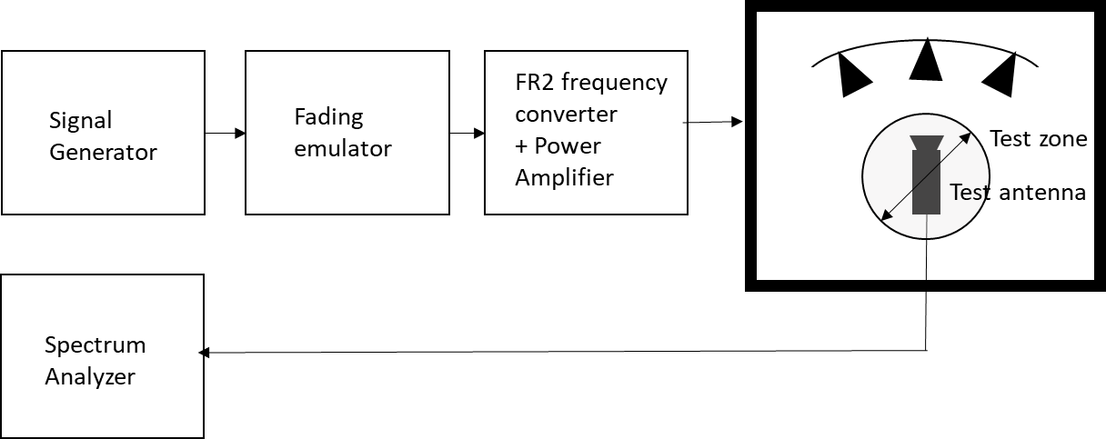

Figure D.3.3-1: Setup for FR2 Doppler measurements

Sine wave (CW, carrier wave) signal is transmitted from the signal generator. The signal is connected from the signal generator to fading emulator via cables. The fading emulator output signals are connected to frequency converter and power amplifier boxes via cables. The amplified signals are then transferred via cables to the probe antennas. The probe antennas radiate the signals over the air to the test antenna The Doppler spectrum is measured by the spectrum analyser and the trace is saved.

**Signal generator settings:**

Table D.3.3-1: Signal generator settings for FR2 Doppler/Temporal correlation measurements

| Item | Unit | Value |
| --- | --- | --- |
| Centre frequency | MHz | Downlink centre frequency  in Table D.3.1-1 |
| Modulation |  | OFF |

**Spectrum analyser settings:**

Table D.3.3-2: Spectrum analyser settings for FR2 Doppler/Temporal correlation measurements

| Item | Unit | Value |
| --- | --- | --- |
| Centre frequency | MHz | Downlink centre frequency  in Table D.3.1-1 |
| Minimum Span | Hz | 4 kHz |
| RBW | Hz | 1 |
| VBW | Hz | 1 |
| Number of points |  | 16002 |
| Averaging |  | 100 |

**Channel model specification:**

Table D.3.3-3: Channel model specification for FR2 Doppler/Temporal correlation measurements

| Item | Unit | Value |
| --- | --- | --- |
| Centre frequency | MHz | Downlink centre frequency  in Table D.3.1-1 |
| Channel model |  | As specified in Annex D.1 |
| Mobile speed | km/h | 3 |

Method of measurement result analysis: Measurement data file (Doppler power spectrum) is saved into hard drive. The data is read into, e.g., Matlab. The analysis is performed by taking the Fourier transformation of the Doppler spectrum. The resulting temporal correlation function  is normalized such that max(abs(*Rt*(∆*t*)))=1. Then the function values left from the maximum is cut out. Further on the function values after, e.g. seven periods is cut out.

The detailed Temporal correlation reference value for FR2 CDL-C UMi channel model validation is defined is table D.3.3-4.

Table D.3.3-4: Temporal correlation Targets

|  |  |  |  |
| --- | --- | --- | --- |
| Distance [λ] | X2V Corr. | Distance [λ] | X2V Corr. |
| 0 | 1.0000 | 2.5 | 0.1769 |
| 0.1 | 0.9929 | 2.6 | 0.1717 |
| 0.2 | 0.9717 | 2.7 | 0.1649 |
| 0.3 | 0.9379 | 2.8 | 0.1564 |
| 0.4 | 0.8937 | 2.9 | 0.1456 |
| 0.5 | 0.8414 | 3 | 0.1327 |
| 0.6 | 0.7834 | 3.1 | 0.1177 |
| 0.7 | 0.7223 | 3.2 | 0.1011 |
| 0.8 | 0.6601 | 3.3 | 0.0829 |
| 0.9 | 0.5986 | 3.4 | 0.0638 |
| 1 | 0.5387 | 3.5 | 0.0449 |
| 1.1 | 0.4817 | 3.6 | 0.0272 |
| 1.2 | 0.4284 | 3.7 | 0.0121 |
| 1.3 | 0.3796 | 3.8 | 0.0023 |
| 1.4 | 0.3362 | 3.9 | 0.0079 |
| 1.5 | 0.2984 | 4 | 0.0104 |
| 1.6 | 0.2667 | 4.1 | 0.0083 |
| 1.7 | 0.2416 | 4.2 | 0.0026 |
| 1.8 | 0.2221 | 4.3 | 0.0095 |
| 1.9 | 0.2081 | 4.4 | 0.0235 |
| 2 | 0.1987 | 4.5 | 0.0397 |
| 2.1 | 0.1921 | 4.6 | 0.0572 |
| 2.2 | 0.1879 | 4.7 | 0.0738 |
| 2.3 | 0.1844 | 4.8 | 0.0890 |
| 2.4 | 0.1812 | 4.9 | 0.1018 |
|  |  | 5 | 0.1109 |

## D.3.4 FR2 PAS similarity percentage (PSP)

The PSP validation measurements aim at evaluating PAS similarity percentage (PSP), which is one of the validation metrics for characterizing FR2 channel model under test in the quite zone of 3D-MPAC. For PSP validation measurement, only vertical polarization validation is required.

The measurement array is essentially a virtual array configuration realized in 3D-MPAC through a -θ positioning system. The measurement array is a semi-circle and sectored array configuration illustrated in Figure D.3.4-1 where complex channel frequency response is measured at each antenna location 0.5 λ apart using a vector network analyser (VNA) setup. The vertical sectors of the measurement array are limited to 60 (±30) and the horizontal sector to 180 (±90) with the broad side direction points towards the probes. Depending of the turntable architecture/implementation, the virtual array configuration for the PSP validation is composed of two alternative semi-circle arrangements (1 x horizontal and either 2 x crossed vertical or 2 x parallel vertical). The radius of the array element locations with respect to the centre of the test zone is 5 cm, which is equivalent to the half of the test zone radius at 28 GHz. For different frequency bands, the radius of the measurement array sectored semi-circles remains fixed at 5 cm while the spatial sampling of the array varies. This measurement validates the proper angular behaviour in the test zone*.*



**Figure D.3.4-1: Semi-circle measurement array configurations with K = 37 elements (at 28 GHz). On the left with two crossed vertical sectors, on the right with two parallel vertical sectors.**

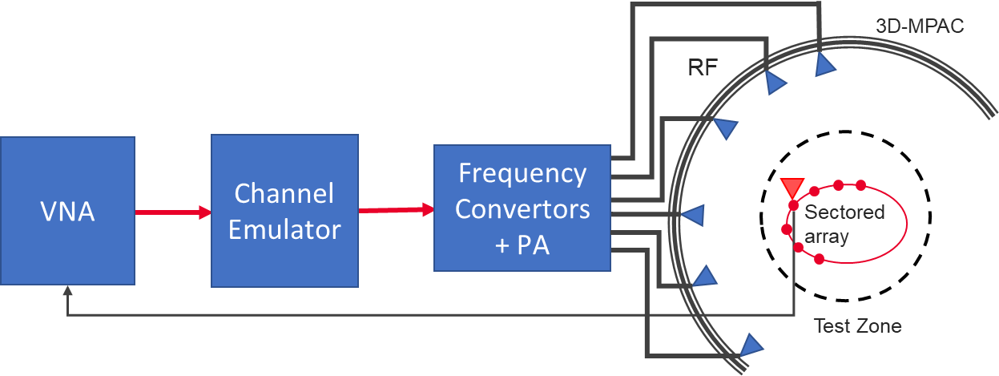

Figure D.3.4-2: Setup for FR2 PSP validation measurements

The PSP validation is measured with a vector network analyser as shown in Figure D.3.4-2 illustrating the PSP measurement setup. Port 1 of the VNA transmits signals through the fading emulator and radiate them through *L* probes within the anechoic chamber. The radiated signals are then received at the test antenna that is positioned inside the test zone. The test antenna is mounted on a -θ positioner which is capable of moving the antenna to pre-defined spatial locations on a fixed radius from the centre of the quiet zone according the measurement array configuration. Finally, the signal is received at port 2 of the VNA. The most suitable approach for the PSP validation is based on an omnidirectional antenna (omnidirectional pattern in AZ and wide BW in EL) as the test can be automated easily. Alternatively, a directional antenna could be used but requires frequent re-positioning.

The measurement and analysis procedure are given as follows:

1. Set the target channel model in the Channel Emulator.

2. For each position of the test antenna on the measurement array configuration in the test zone, step & pause the emulator to different time instances. Measure the complex frequency responses $H\left(f,t\right)=H\left(m∆f,n∆T\right), m=0,..., M-1$ for all stepped channel snapshots $n=0,..., N-1$, where the interval between frequency and time samples is $∆f$ and, respectively. The number of channel snapshots and frequency samples .



3. Move the measurement antenna with a positioner to another location and repeat step 2 to record frequency responses of all stepped channel snapshots.



4. Repeat step 3 to record frequency responses at all spatial sample points.



5. Estimate the measured PAS through the following two- stage processing:

a. In the first stage, calculate the discrete azimuth and elevation angles (DoA) for the measurement array configuration by applying the MUSIC algorithm. Estimate the powers from the DoA and auto-covariance matrix of the received signal acquired through VNA complex frequency response data.

i) Compose an estimate of the covariance matrix $R_{H}∈C^{K×K}$. The entry on the $k$ th row and $k'$ th column of $R_{H}$ is

$$R_{H}\left(k,k'\right)=\sum_{n=1}^{N}{\sum_{m=1}^{M}{H_{k}\left(m∆f,n∆T\right) \overline{H_{k'}}\left(m∆f,n∆T\right)}},$$

where is the complex conjugate operator.

ii) Compose pseudo-PAS of the chamber environment and channel model using the MUSIC algorithm. The intention of this step is to estimate DoAs of signals radiated by probes. Perform first the eigen decomposition of $R_{H}$ and pick the noise-subspace matrix $V$. The matrix $V$ is obtained from the eigen decomposition by removing eigenvectors, i.e. columns, that correspond to *X* strongest eigenvalues, where *X* is the number of active probes in the MPAC setup. The pseudo-PAS is [9]

$$P_{MUSIC}\left(β\right)=\frac{1}{ω\left(β\right) VV^{H} ω^{H}\left(β\right)} ,$$

where ${\left(\right)}^{H}$ is the matrix Hermitean operator and the near-field array factor of the virtual array composed by *K* spatial measurement antenna locations is

$$ω\left(β\right)=\frac{λ_{0}}{4π\left\|{\vec{r}}_{k}-R \vec{u}\left(β\right)\right\|}\exp\left(\frac{j2π\left\|{\vec{r}}_{k}-R \vec{u}\left(β\right)\right\|}{λ_{0}}\right),$$

where $λ_{0}$ is the wavelength at the carrier centre frequency, is the norm of a vector, ${\vec{r}}_{k}$ is a location vector of the *k*th virtual array element, $\vec{u}\left(β\right)$ is the unit vector to direction $β$, and *R* is the a priori known approximate range length [9]. Both vectors ${\vec{r}}_{k}$ and $\vec{u}\left(β\right)$ are defined with respect to same origin, which is the centre of the test zone.

iii) Find local maxima of $P_{MUSIC}\left(β\right)$ and pick directions $β_{x}$, $x=1,…,X$ of the *X* highest peaks.

iv) Perform Bartlett beamforming as defined in step 6 with the steering vector $ω\left(β_{x}\right)$ (instead of $a(β)$) to the *X* directions identified in iii). The output is *X* power estimates $P_{est}\left(β_{x}\right)$.

b. In the second stage, use the angle and power estimates, i.e. the discrete PAS of *X* azimuth and elevation directions and power values in conjunction with a 4x4 DUT sampling array for beamforming with the conventional Bartlett beamformer to estimate the “measured PAS seen by DUT” for PSP calculation. This is

$${\hat{P}}_{o}\left(β\right)=a^{H}\left(β\right)\left(\sum_{x=1}^{X}{a\left(β_{x}\right)P_{est}\left(β_{x}\right)a^{H}\left(β_{x}\right)}\right)a\left(β\right),$$

where $a(β)$ is the array steering vector of the 4x4 DUT array.

6. Evaluate the reference OTA PAS for the 4x4 DUT array by applying the conventional Bartlett beamformer. The theoretical PAS as reference is calculated for the ideal channel model as

$${\hat{P}}_{r}\left(β\right)=a^{H}\left(β\right) ∮a(\acute{β)} P(\acute{β)}a^{H}(\acute{β)}d\acute{β} a\left(β\right),$$

where $a(β)$ is the array steering vector of the 4x4 DUT array and $P(\acute{β)}$ is the PAS of the reference channel model.

7. Calculate total variation distance (*D*p) from the reference and measured PAS. Mathematically,

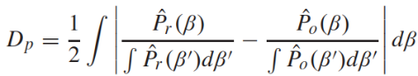

8. Calculate PSP values as PSP = (1-*Dp*) x 100%.

**VNA settings:**

Table D.3.4-1: VNA settings for FR2 PSP measurements

|  |  |  |
| --- | --- | --- |
| Item | Unit | Value |
| Centre frequency | MHz | Downlink centre frequency  in Table D.3.1-1 |
| Span | MHz | 0, or the minimum  (Note 1) |
| Number of traces |  | 1000 |
| Number of points |  | 1 (Note 1) |
| NOTE 1: Span and number of points may be increased to estimate reliably. | | |

**Channel model specification:**

Table D.3.4-2: Channel model specification for FR2 PSP measurements

| Item | Unit | Value |
| --- | --- | --- |
| Centre frequency | MHz | Downlink centre frequency  in Table D.3.1-1 |
| Distance between traces in channel model | wavelength (Note) | > 2 |
| Channel model |  | As specified in Annex D.1 |
| NOTE: Time [s] = distance [λ] / MS speed [λ/s]  MS speed [λ/s] = MS speed [m/s] / Speed of light [m/s] * Centre frequency [Hz] | | |

**Time Domain Alternative Method:**

PSP validation can also be implemented using time-domain techniques using the testing setup presented in Figure D.3.4-3. The VNA is substituted by a signal generator, and a signal analyser.

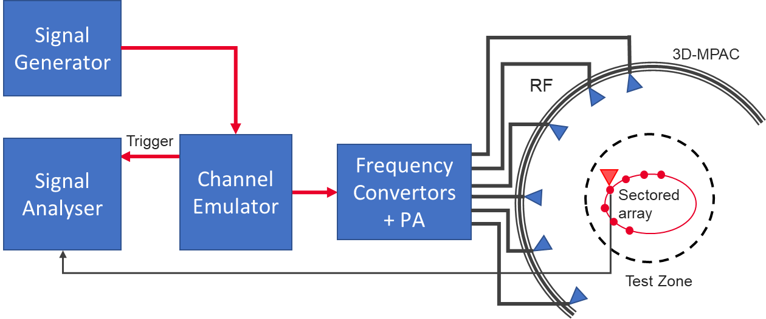

Figure D.3.4-3: Setup for FR2 PSP validation measurements based on time domain

Table D.3.4-3: Signal Generator Settings for FR2 PSP measurements based on time domain

|  |  |  |
| --- | --- | --- |
| Item | Unit | Value |
| Centre frequency | MHz | Downlink centre frequency in Table D.3.1-1 |
| Output power | dBm | Function of the CE. Sufficiently above Noise Floor |

Table D.3.4-4: Signal Analyser Settings for FR2 PSP measurements based on time domain

|  |  |  |
| --- | --- | --- |
| Item | Unit | Value |
| Centre frequency | MHz | Downlink centre frequency in Table D.3.1-1 |
| Sampling | Hz | At least 10 times bigger than the max Doppler spread (*fd=v/λ)* |
| Observation time | s | At least 32s |

The measurement and analysis procedure are given as follows:

Follow the same procedure as before, but M is set to 1. The Channel Emulator is not stepped, but it is allowed to play in free run mode for each of the K spatial points.

**< Unchanged sections omitted >**

## D.4.2 Pass/Fail Criteria of PDP

This clause defines the pass/fail criteria of PDP, this pass/fail limits apply for all FR2 frequency bands.

The detailed pass/fail limits for each cluster of FR2 CDL-C UMi are defined in Table D.4.2-1.

Table D.4.2-1: PDP pass/fail limits for FR2 CDL-C UMi channel model validation

|  |  |  |
| --- | --- | --- |
|  | Power Tolerance | Delay Tolerance |
| Paths from 0dB to 10dB | ±1dB | ±6ns |
| Paths from 10dB to 30dB | ±5dB | ±6ns |
| Paths from 30dB to 40dB | ±10dB | ±6ns |

## D.4.3 Pass/Fail Criteria of Doppler/Temporal correlation

This clause defines the pass/fail criteria of doppler/temporal correlation validation, this pass/fail limits apply for all FR2 frequency bands.

The pass/fail limits for theoretical temporal correlation defined in Clause D.3.3 above 0.3 are formed as bands of ±0.1 of correlation capped at 1 at the high end. Additionally, when the theoretical temporal correlation drops below 0.3, the limits are formed at bands of ±0.3 of correlation capped at 0 at the low end.

Table D.4.3-1: pass/fail limits for temporal correlation

|  |  |  |  |  |  |
| --- | --- | --- | --- | --- | --- |
| Distance [λ] | X2V Corr. | | Distance [λ] | X2V Corr. | |
| Lower | Upper | Lower | Upper |
| 0 | 0.9000 | 1.0000 | 2.5 | 0.0000 | 0.3000 |
| 0.1 | 0.8929 | 1.0000 | 2.6 | 0.0000 | 0.3000 |
| 0.2 | 0.8717 | 1.0000 | 2.7 | 0.0000 | 0.3000 |
| 0.3 | 0.8379 | 1.0000 | 2.8 | 0.0000 | 0.3000 |
| 0.4 | 0.7937 | 0.9937 | 2.9 | 0.0000 | 0.3000 |
| 0.5 | 0.7414 | 0.9414 | 3 | 0.0000 | 0.3000 |
| 0.6 | 0.6834 | 0.8834 | 3.1 | 0.0000 | 0.3000 |
| 0.7 | 0.6223 | 0.8223 | 3.2 | 0.0000 | 0.3000 |
| 0.8 | 0.5601 | 0.7601 | 3.3 | 0.0000 | 0.3000 |
| 0.9 | 0.4986 | 0.6986 | 3.4 | 0.0000 | 0.3000 |
| 1 | 0.4387 | 0.6387 | 3.5 | 0.0000 | 0.3000 |
| 1.1 | 0.3817 | 0.5817 | 3.6 | 0.0000 | 0.3000 |
| 1.2 | 0.3284 | 0.5284 | 3.7 | 0.0000 | 0.3000 |
| 1.3 | 0.2796 | 0.4796 | 3.8 | 0.0000 | 0.3000 |
| 1.4 | 0.2362 | 0.4362 | 3.9 | 0.0000 | 0.3000 |
| 1.5 | 0.1984 | 0.3984 | 4 | 0.0000 | 0.3000 |
| 1.6 | 0.1667 | 0.3667 | 4.1 | 0.0000 | 0.3000 |
| 1.7 | 0.1416 | 0.3416 | 4.2 | 0.0000 | 0.3000 |
| 1.8 | 0.1221 | 0.3221 | 4.3 | 0.0000 | 0.3000 |
| 1.9 | 0.1081 | 0.3081 | 4.4 | 0.0000 | 0.3000 |
| 2 | 0.0000 | 0.3000 | 4.5 | 0.0000 | 0.3000 |
| 2.1 | 0.0000 | 0.3000 | 4.6 | 0.0000 | 0.3000 |
| 2.2 | 0.0000 | 0.3000 | 4.7 | 0.0000 | 0.3000 |
| 2.3 | 0.0000 | 0.3000 | 4.8 | 0.0000 | 0.3000 |
| 2.4 | 0.0000 | 0.3000 | 4.9 | 0.0000 | 0.3000 |
|  |  |  | 5 | 0.0000 | 0.3000 |

Based on the value defined in Table D.4.3-1, Figure D.4.3-1 shows the pass/fail and reference curve of temporal correlation.

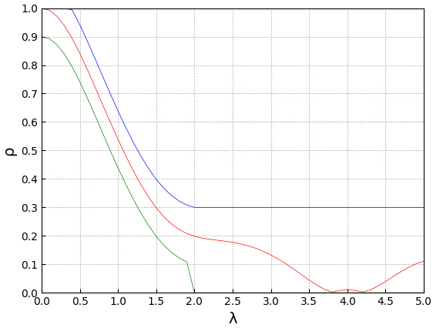

Figure D.4.3-1: Pass/fail limits and targets of Temporal correlation for CDL-C UMi channel model: red curve (reference), blue (upper limit) and green (lower limit)

## D.4.4 Pass/Fail Criteria of PSP

This clause defines the pass/fail criteria of PSP, this general pass/fail limits principle apply for all FR2 frequency bands.

The PSP pass/fail limit is specified as 84%.

## D.4.5 Pass/Fail Criteria of Cross-polarization

This clause defines the pass/fail criteria of cross-polarization, this pass/fail limits apply for all FR2 frequency bands.

The cross-polarization ratio pass/fail limit is specified as ±1.5 dB.

**< Unchanged sections omitted >**

# E.1 FR1 gNB configurations

The gNodeB emulator parameters shall be set according to Table E.1-1 for FR1 common parameters, Table E.1-2 for FR1 FDD 2x2 test parameters, Table E.1-3 for FR1 TDD 2x2 test parameters, Table E.1-4 for FR1 FDD 4x4 test parameters, and Table E.1-5 for FR1 TDD 4x4 test parameters.

Table E.1-1: FR1 Common test parameters

|  |  |  |  |  |  |
| --- | --- | --- | --- | --- | --- |
| **Parameter** | | | **Unit** | **Value** | |
| PDSCH transmission scheme | | |  | Transmission scheme 1 | |
| Carrier configuration | Offset between Point A and the lowest usable subcarrier on this carrier (Note 2) | | RBs | 0 | |
| Subcarrier spacing | | kHz | 15 or 30 | |
| DL BWP configuration #1 | Cyclic prefix | |  | Normal | |
| RB offset | | RBs | 0 | |
| Number of contiguous PRB | | PRBs | Maximum transmission bandwidth configuration as specified in clause 5.3.2 of TS 38.101-1 for tested channel bandwidth and subcarrier spacing | |
| Common serving cell parameters | Physical Cell ID | |  | 0 | |
| SSB position in burst | |  | First SSB in Slot #0 | |
| SSB periodicity | | ms | 20 | |
| First DMRS position for Type A PDSCH mapping | |  | 2 | |
| PDCCH configuration | Slots for PDCCH monitoring | |  | Each slot | |
| Symbols with PDCCH | | Symbols | 0, 1 | |
| Number of PRBs in CORESET | |  | Table 5.2-2 of TS 38.101-4 for tested channel bandwidth and subcarrier spacing | |
| Number of PDCCH candidates and aggregation levels | |  | 1/AL8 | |
| CCE-to-REG mapping type | |  | Non-interleaved | |
| DCI format | |  | 1_1 | |
| TCI state | |  | TCI state #1 | |
| Cross carrier scheduling | | |  | Not configured | |
| CSI-RS for tracking | First subcarrier index in the PRB used for CSI-RS | |  | k0=0 for CSI-RS resource 1,2,3,4 | |
| First OFDM symbol in the PRB used for CSI-RS | |  | l0 = 6 for CSI-RS resource 1 and 3  l0 = 10 for CSI-RS resource 2 and 4 | |
| Number of CSI-RS ports (X) | |  | 1 for CSI-RS resource 1,2,3,4 | |
| CDM Type | |  | ‘No CDM’ for CSI-RS resource 1,2,3,4 | |
| Density (ρ) | |  | 3 for CSI-RS resource 1,2,3,4 | |
| CSI-RS periodicity | | Slots | 15 kHz SCS: 20 for CSI-RS resource 1,2,3,4  30 kHz SCS: 40 for CSI-RS resource 1,2,3,4 | |
| CSI-RS offset | | Slots | 15 kHz SCS:  10 for CSI-RS resource 1 and 2  11 for CSI-RS resource 3 and 4  30 kHz SCS:  20 for CSI-RS resource 1 and 2  21 for CSI-RS resource 3 and 4 | |
| Frequency Occupation | |  | Start PRB 0  Number of PRB = BWP size | |
| QCL info | |  | TCI state #0 | |
| NZP CSI-RS for CSI acquisition | First subcarrier index in the PRB used for CSI-RS | |  | k0 = 0 | |
| First OFDM symbol in the PRB used for CSI-RS | |  | l0 = 12 | |
| Number of CSI-RS ports (X) | |  | Same as number of transmit antenna | |
| CDM Type | |  | ‘FD-CDM2’ | |
| Density (ρ) | |  | 1 | |
| CSI-RS periodicity | | Slots | 15 kHz SCS: 20  30 kHz SCS: 40 | |
| CSI-RS offset | | Slots | 0 | |
| Frequency Occupation | |  | Start PRB 0  Number of PRB = BWP size | |
| QCL info | |  | TCI state #1 | |
| ZP CSI-RS for CSI acquisition | First subcarrier index in the PRB used for CSI-RS | |  | k0 = 4 | |
| First OFDM symbol in the PRB used for CSI-RS | |  | l0 = 12 | |
| Number of CSI-RS ports (X) | |  | 4 | |
| CDM Type | |  | ‘FD-CDM2’ | |
| Density (ρ) | |  | 1 | |
| CSI-RS periodicity | | Slots | 15 kHz SCS: 20  30 kHz SCS: 40 | |
| CSI-RS offset | | Slots | 0 | |
| Frequency Occupation | |  | Start PRB 0  Number of PRB = BWP size | |
| PDSCH DMRS configuration | Antenna ports indexes | |  | {1000, 1001} for Rank 2 tests  {1000-1003} for Rank 4 tests | |
| Number of PDSCH DMRS CDM group(s) without data | |  | 1 for Rank 2 tests  2 for Rank 4 tests | |
| TCI state #0 | Type 1 QCL information | SSB index |  | SSB #0 | |
| QCL Type |  | Type C | |
| Type 2 QCL information | SSB index |  | N/A | |
| QCL Type |  | N/A | |
| TCI state #1 | Type 1 QCL information | CSI-RS resource |  | CSI-RS resource 1 from ‘CSI-RS for tracking’ configuration | |
| QCL Type |  | Type A | |
| Type 2 QCL information | CSI-RS resource |  | N/A | |
| QCL Type |  | N/A | |
| PT-RS configuration | | |  | PT-RS is not configured | |
| Maximum number of code block groups for ACK/NACK feedback | | |  | 1 | |
| Maximum number of HARQ transmission | | |  | 1 | |
| HARQ ACK/NACK bundling | | |  | Multiplexed | |
| Redundancy version coding sequence | | |  | N.A | |
| Precoding configuration | | |  | SP Type I, Random per slot with PRB bundling granularity | |
| Symbols for all unused REs | | |  | OCNG Annex A.5 of TS 38.101-4 | |
| Minimum Number of Slots per Stream | | |  | 20000 for 15kHz SCS  40000 for 30kHz SCS  (Note 3) |
| Transmit Power Control | | | dBm | 13 |
| DL power level  (RS EPRE of SSS) | | | dBm / SCS | Set at gNodeB simulator  with correction from calibration |
| EPRE ratio of PDSCH to SSS | | | dB | 0 |
| Note 1: UE assumes that the TCI state for the PDSCH is identical to the TCI state applied for the PDCCH transmission.  Note 2: Point A coincides with minimum guard band as specified in Table 5.3.3-1 from TS 38.101-1 for tested channel bandwidth and subcarrier spacing.  Note 3: For FR1 MIMO OTA test lab alignments and FR1 MIMO OTA UE performance requirements, the following values can be used:  For FR1 bands >1GHz: 20k for 30kHz SCS, 10k for 15kHz SCS;  For FR1 bands <1GHz: [20k] for 15kHz SCS; | | | | | |

Table E.1-2: Test parameters for FR1 FDD 2x2

|  |  |  |  |
| --- | --- | --- | --- |
| Parameter | | Unit | Value |
| Duplex mode | |  | FDD |
| Reference channel | |  | R.PDSCH.1-3.1 FDD (Note 1) |
| Bandwidth | | MHz | 10 |
| SCS | | kHz | 15 |
| Modulation DL | |  | 64QAM |
| Modulation UL | |  | QPSK |
| Active DL BWP index | |  | 1 |
| PDSCH configuration | Mapping type |  | Type A |
| k0 |  | 0 |
| Starting symbol (S) |  | 2 |
| Length (L) |  | 12 |
| PDSCH aggregation factor |  | 1 |
| PRB bundling type |  | Static |
| PRB bundling size |  | 2 |
| Resource allocation type |  | Type 0 |
| RBG size |  | Config2 |
| VRB-to-PRB mapping type |  | Non-interleaved |
| VRB-to-PRB mapping interleaver bundle size |  | N/A |
| PDSCH DMRS configuration | DMRS Type |  | Type 1 |
| Number of additional DMRS |  | 1 |
| Maximum number of OFDM symbols for DL front loaded DMRS |  | 1 |
| CSI-RS for tracking | CSI-RS periodicity | Slots | 20 |
| CSI-RS offset | Slots | Table 8.2-1. |
| Number of HARQ Processes | |  | 4 |
| The number of slots between PDSCH and corresponding HARQ-ACK information | |  | 2 |
| Note 1: “R.PDSCH.1-3.1 FDD” is defined in Table A.3.2.1.1-3 of TS 38.101-4 | | | |

Table E.1-3: Test parameters for FR1 TDD 2x2

|  |  |  |  |
| --- | --- | --- | --- |
| **Parameter** | | **Unit** | **Value** |
| Duplex mode | |  | TDD |
| Reference channel | |  | R.PDSCH.2-3.1 TDD (Note 1) |
| Bandwidth | | MHz | 40 |
| SCS | | kHz | 30 |
| Modulation DL | |  | 64QAM |
| Modulation UL | |  | QPSK |
| Active DL BWP index | |  | 1 |
| PDSCH configuration | Mapping type |  | Type A |
| k0 |  | 0 |
| Starting symbol (S) |  | 2 |
| Length (L) |  | Specific to each Reference channel |
| PDSCH aggregation factor |  | 1 |
| PRB bundling type |  | Static |
| PRB bundling size |  | 2 |
| Resource allocation type |  | Type 0 |
| RBG size |  | Config2 |
| VRB-to-PRB mapping type |  | Non-interleaved |
| VRB-to-PRB mapping interleaver bundle size |  | N/A |
| PDSCH DMRS configuration | DMRS Type |  | Type 1 |
| Number of additional DMRS |  | 1 |
| Maximum number of OFDM symbols for DL front loaded DMRS |  | 1 |
| CSI-RS for tracking | First OFDM symbol in the PRB used for CSI-RS |  | Table 8.2-1. |
| CSI-RS periodicity | Slots | 40 |
| CSI-RS offset | Slots | Table 8.2-1. |
| Number of HARQ Processes | |  | 8 |
| TDD UL-DL pattern | |  | FR1.30-1 (Note 2) |
| Note 1: “R.PDSCH.2-3.1 TDD” is defined in Table A.3.2.2.2-3 of TS 38.101-4  Note 2: “FR1.30-1” is defined in Annex A.1.2 of TS 38.101-4 | | | |

Table E.1-4: Test parameters for FR1 FDD 4x4

|  |  |  |  |
| --- | --- | --- | --- |
| Parameter | | Unit | Value |
| Duplex mode | |  | FDD |
| Reference channel | |  | R.PDSCH.1-2.4 FDD (Note 1) |
| Bandwidth | | MHz | 10 |
| SCS | | kHz | 15 |
| Modulation DL | |  | 16QAM |
| Modulation UL | |  | QPSK |
| Active DL BWP index | |  | 1 |
| PDSCH configuration | Mapping type |  | Type A |
| k0 |  | 0 |
| Starting symbol (S) |  | 2 |
| Length (L) |  | 12 |
| PDSCH aggregation factor |  | 1 |
| PRB bundling type |  | Static |
| PRB bundling size |  | 2 |
| Resource allocation type |  | Type 0 |
| RBG size |  | Config2 |
| VRB-to-PRB mapping type |  | Non-interleaved |
| VRB-to-PRB mapping interleaver bundle size |  | N/A |
| PDSCH DMRS configuration | DMRS Type |  | Type 1 |
| Number of additional DMRS |  | 1 |
| Maximum number of OFDM symbols for DL front loaded DMRS |  | 1 |
| CSI-RS for tracking | CSI-RS periodicity | Slots | 20 |
| CSI-RS offset | Slots | Table 8.2-1. |
| Number of HARQ Processes | |  | 4 |
| The number of slots between PDSCH and corresponding HARQ-ACK information | |  | 2 |
| Note 1: “R.PDSCH.1-2.4 FDD” is defined in Table A.3.2.1.1-2 of TS 38.101-4 | | | |

Table E.1-5: Test parameters for FR1 TDD 4x4

|  |  |  |  |
| --- | --- | --- | --- |
| Parameter | | Unit | Value |
| Duplex mode | |  | TDD |
| Reference channel | |  | R.PDSCH.2-2.4 TDD (Note 1) |
| Bandwidth | | MHz | 40 |
| SCS | | kHz | 30 |
| Modulation DL | |  | 16QAM |
| Modulation UL | |  | QPSK |
| Active DL BWP index | |  | 1 |
| PDSCH configuration | Mapping type |  | Type A |
| k0 |  | 0 |
| Starting symbol (S) |  | 2 |
| Length (L) |  | Specific to each Reference channel |
| PDSCH aggregation factor |  | 1 |
| PRB bundling type |  | Static |
| PRB bundling size |  | 2 |
| Resource allocation type |  | Type 0 |
| RBG size |  | Config2 |
| VRB-to-PRB mapping type |  | Non-interleaved |
| VRB-to-PRB mapping interleaver bundle size |  | N/A |
| PDSCH DMRS configuration | DMRS Type |  | Type 1 |
| Number of additional DMRS |  | 1 |
| Maximum number of OFDM symbols for DL front loaded DMRS |  | 1 |
| CSI-RS for tracking | First OFDM symbol in the PRB used for CSI-RS |  | Table 8.2-1. |
| CSI-RS periodicity | Slots | 40. |
| CSI-RS offset | Slots | Table 8.2-1. |
| Number of HARQ Processes | |  | 8 |
| TDD UL-DL pattern | |  | FR1.30-1 (Note 2) |
| Note 1: “R.PDSCH.2-2.4 TDD” is defined in Table A.3.2.2.2-2 of TS 38.101-4  Note 2: “FR1.30-1” is defined in Annex A.1.2 of TS 38.101-4 | | | |

# E.2 FR2 gNB configurations

The gNodeB emulator parameters for FR2 MIMO OTA testing shall be set according to Table E.2-1 for FR2 common parameters and Table E.2-2 for FR2 TDD 2x2 test parameters.

Table E.2-1: FR2 Common test parameters

|  |  |  |  |  |
| --- | --- | --- | --- | --- |
| Parameter | | | Unit | Value |
| PDSCH transmission scheme | | |  | Transmission scheme 1 |
| PTRS *epre-Ratio* | | |  | 0 |
| Actual carrier configuration | Offset between Point A and the lowest usable subcarrier on this carrier (Note 2) | | RBs | 0 |
| Subcarrier spacing | | kHz | 120 |
| DL BWP configuration #1 | Cyclic prefix | |  | Normal |
| RB offset | | RBs | 0 |
| Number of contiguous PRB | | PRBs | Maximum transmission bandwidth configuration as specified in clause 5.3.2 of TS 38.101-2 for tested channel bandwidth and subcarrier spacing |
| Common serving cell parameters | Physical Cell ID | |  | 0 |
| SSB position in burst | |  | 1 |
| SSB periodicity | | ms | 20 |
| First DMRS position for Type A PDSCH mapping | |  | 2 |
| PDCCH configuration | Slots for PDCCH monitoring | |  | Each slot |
| Symbols with PDCCH | |  | 0 |
| Number of PRBs in CORESET | |  | Table 7.2-2 of TS 38.101-4 for tested channel bandwidth and subcarrier spacing |
| Number of PDCCH candidates and aggregation levels | |  | 1/AL8 |
| CCE-to-REG mapping type | |  | Non-interleaved |
| DCI format | |  | 1_1 |
| TCI state | |  | TCI state #1 |
| Cross carrier scheduling | | |  | Not configured |
| CSI-RS for tracking | First subcarrier index in the PRB used for CSI-RS (*k0*) | |  | 0 for CSI-RS resource 1,2,3,4 |
| First OFDM symbol in the PRB used for CSI-RS (*l0*) | |  | 6 for CSI-RS resource 1 and 3 10 for CSI-RS resource 2 and 4 |
| Number of CSI-RS ports (*X*) | |  | 1 for CSI-RS resource 1,2,3,4 |
| CDM Type | |  | ‘No CDM’ for CSI-RS resource 1,2,3,4 |
| Density (*ρ*) | |  | 3 for CSI-RS resource 1,2,3,4 |
| CSI-RS periodicity | | Slots | 120 kHz SCS: 160 for CSI-RS resource 1,2,3,4 |
| CSI-RS offset | | Slots | 120 kHz SCS:  80 for CSI-RS resource 1 and 2  81 for CSI-RS resource 3 and 4 |
| Frequency Occupation | |  | Start PRB 0  Number of PRB = BWP size |
| QCL info | |  | TCI state #0 |
| NZP CSI-RS for CSI acquisition | First subcarrier index in the PRB used for CSI-RS (*k0*) | |  | 0 |
| First OFDM symbol in the PRB used for CSI-RS (*l0*) | |  | 12 |
| Number of CSI-RS ports (*X*) | |  | 2 |
| CDM Type | |  | FD-CDM2 |
| Density (*ρ*) | |  | 1 |
| CSI-RS periodicity | | Slots | 120 kHz SCS: 160 |
| CSI-RS offset | |  | 0 |
| Frequency Occupation | |  | Start PRB 0  Number of PRB = BWP size |
| QCL info | |  | TCI state #1 |
| ZP CSI-RS for CSI acquisition | First subcarrier index in the PRB used for CSI-RS (k0) | |  | 4 |
| First OFDM symbol in the PRB used for CSI-RS (*l0*) | |  | 12 |
| Number of CSI-RS ports (*X*) | |  | 4 |
| CDM Type | |  | FD-CDM2 |
| Density (*ρ*) | |  | 1 |
| CSI-RS periodicity | | Slots | 120 kHz SCS: 160 |
| CSI-RS offset | |  | 0 |
| Frequency Occupation | |  | Start PRB 0  Number of PRB = BWP size |
| CSI-RS for beam refinement | First subcarrier index in the PRB used for CSI-RS | |  | k0=0 for CSI-RS resource 1,2 |
| First OFDM symbol in the PRB used for CSI-RS | |  | l0 = 8 for CSI-RS resource 1  l0 = 9 for CSI-RS resource 2 |
| Number of CSI-RS ports (X) | |  | 1 for CSI-RS resource 1,2 |
| CDM Type | |  | ‘No CDM’ for CSI-RS resource 1,2 |
| Density (ρ) | |  | 3 for CSI-RS resource 1,2 |
| CSI-RS periodicity | | Slots | 60 kHz SCS: 80 for CSI-RS resource 1,2  120 kHz SCS: 160 for CSI-RS resource 1,2 |
| CSI-RS offset | | Slots | 0 for CSI-RS resource 1,2 |
| QCL info | |  | TCI state #1 |
| PDSCH DMRS configuration | Antenna ports indexes | |  | {1000} for Rank 1 tests {1000, 1001} for Rank 2 tests |
| Number of PDSCH DMRS CDM group(s) without data | |  | 1 |
| TCI state #0 | Type 1 QCL information | SSB index |  | SSB #0 |
| QCL Type |  | Type C |
| Type 2 QCL information | SSB index |  | SSB #0 |
| QCL Type |  | Type D |
| TCI state #1 | Type 1 QCL information | CSI-RS resource |  | CSI-RS resource 1 from ‘CSI-RS for tracking’ configuration |
| QCL Type |  | Type A |
| Type 2 QCL information | CSI-RS resource |  | CSI-RS resource 1 from ‘CSI-RS for tracking’ configuration |
| QCL Type |  | Type D |
| PTRS configuration | Frequency density (*KPT-RS*) | |  | 2 |
| Time density (*LPT-RS*) | |  | 1 |
| Maximum number of code block groups for ACK/NACK feedback | | |  | 1 |
| Maximum number of HARQ transmission | | |  | 1 |
| HARQ ACK/NACK bundling | | |  | Multiplexed |
| Redundancy version coding sequence | | |  | {0,2,3,1} |
| Precoding configuration | | |  | SP Type I, Random per slot with PRB bundling granularity |
| Symbols for all unused Res | | |  | OCNG in Annex A.5 of TS 38.101-4 |
| Minimum Number of Slots per Stream | | |  | 20000 for FR2 UMi CDL-C |
| Transmit Power Control | | | dBm | 13 dBm |
| Note 1: UE assumes that the TCI state for the PDSCH is identical to the TCI state applied for the PDCCH transmission.  Note 2: Point A coincides with minimum guard band as specified in Table 5.3.3-1 from TS 38.101-2 for tested channel bandwidth and subcarrier spacing. | | | | |

Table E.2-2: Test parameters for FR2 TDD 2x2

|  |  |  |  |
| --- | --- | --- | --- |
| Parameter | | Unit | Value |
| Duplex mode | |  | TDD |
| Reference channel | |  | R.PDSCH.5-2.2 TDD (Note 1) |
| Bandwidth | | MHz | 100 |
| SCS | | kHz | 120 |
| Modulation DL | |  | 16QAM |
| Modulation UL | |  | QPSK |
| Active DL BWP index | |  | 1 |
| CSI-RS for tracking | First OFDM symbol in the PRB used for CSI-RS (*l0*) |  | Table E.2-1 |
| CSI-RS offset | Slots | Table E.2-1 |
| PDCCH configuration | Number of PDCCH candidates and aggregation levels |  | 1/AL8 |
| PDSCH configuration | Mapping type |  | Type A |
| *k0* |  | 0 |
| Starting symbol (S) |  | 1 |
| Length (L) |  | Specific to each Reference channel as defined in A.3.2.2 of TS 38.101-4 |
| PDSCH aggregation factor |  | 1 |
| PRB bundling type |  | Static |
| PRB bundling size |  | WB for Test 1-1,  2 for other tests |
| Resource allocation type |  | Type 0 |
| RBG size |  | config2 |
| VRB-to-PRB mapping type |  | Non-interleaved |
| VRB-to-PRB mapping interleaver bundle size |  | N/A |
| PDSCH DMRS configuration | DMRS Type |  | Type 1 |
| Number of additional DMRS |  | 1 |
| Maximum number of OFDM symbols for DL front loaded DMRS |  | 1 |
| Number of HARQ Processes | |  | 8 |
| TDD UL-DL pattern | |  | FR2.120-1 (Note2) |
| Note 1: “R.PDSCH.5-2.2 TDD” is defined in Table A.3.2.2.5-2 of TS 38.101-4  Note 2: “FR2.120-1” is defined in Annex A.1.3 of TS 38.101-4 | | | |

**< Unchanged sections omitted >**

<<< END OF CHANGE2 >>>